Name – Raunak Jha
Question 1 : Configure Cortex Search Preview for Semantic Retrieval (Guides, Procedures, Policies)
TASK 1: CREATE TABLE/INSERT/ EXECUTION
- CREATE TABLE
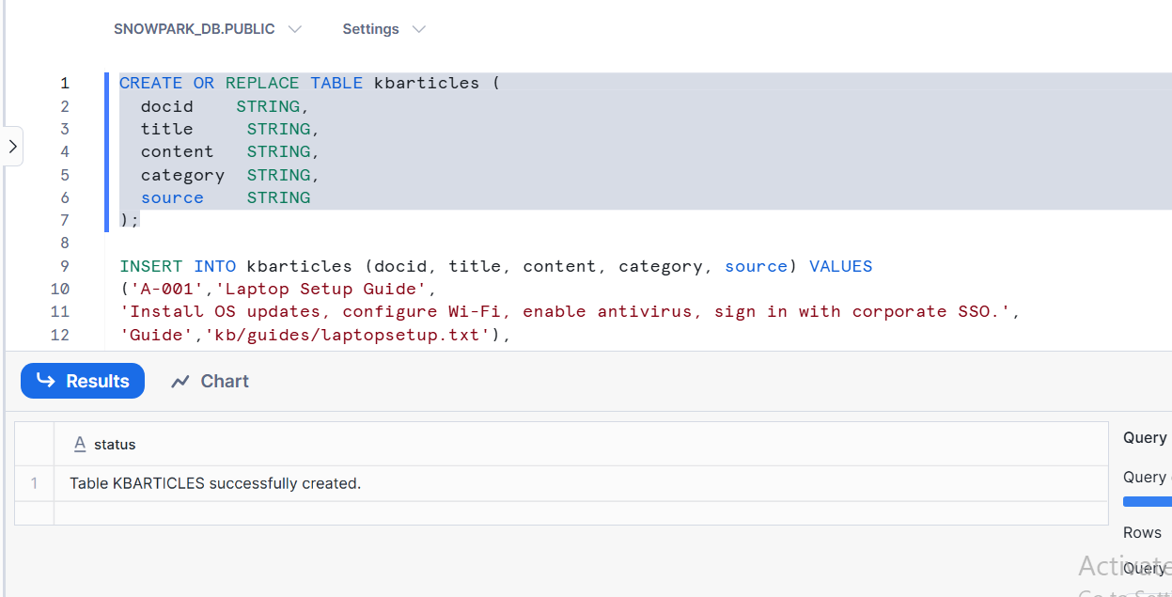

- INSERT TABLE
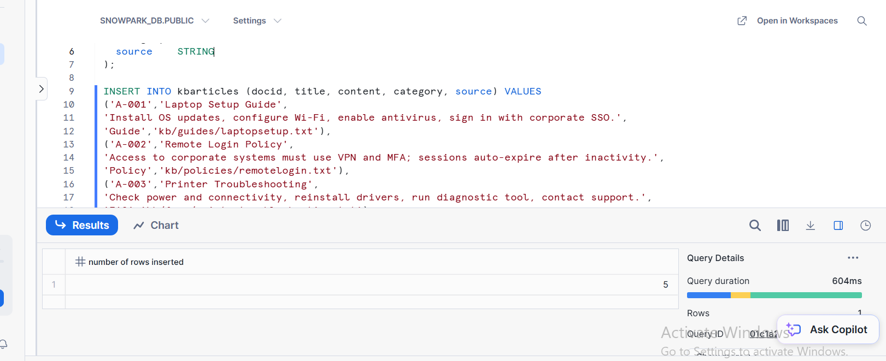

TASK 2 : CORTEX SEARCH PREVIEW CONFIGURATION CREATION
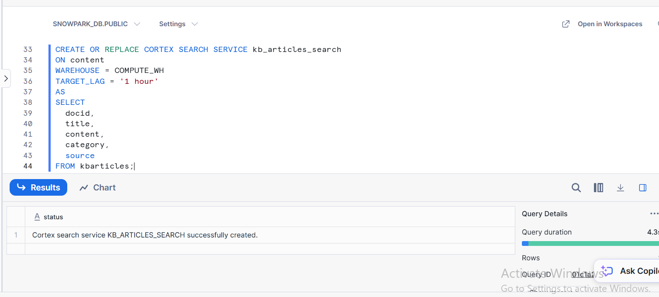

TASK 3 : TWO SEMANTIC QUERY EXECUTION WITH SCORES
- QUERY 1
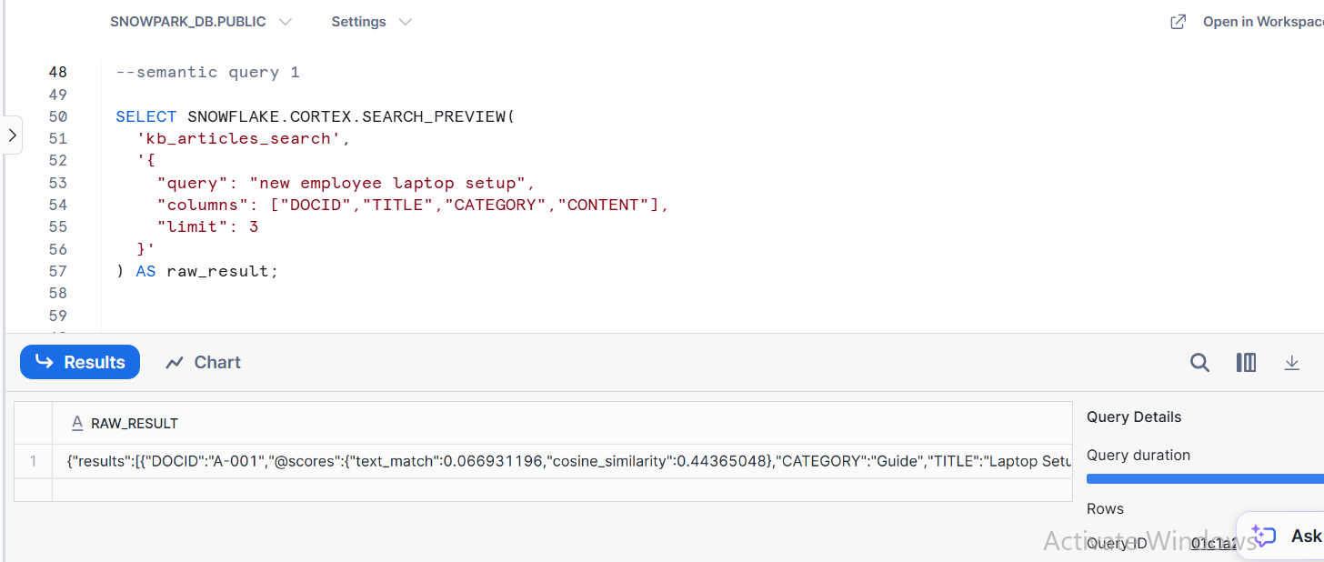

- QUERY 2
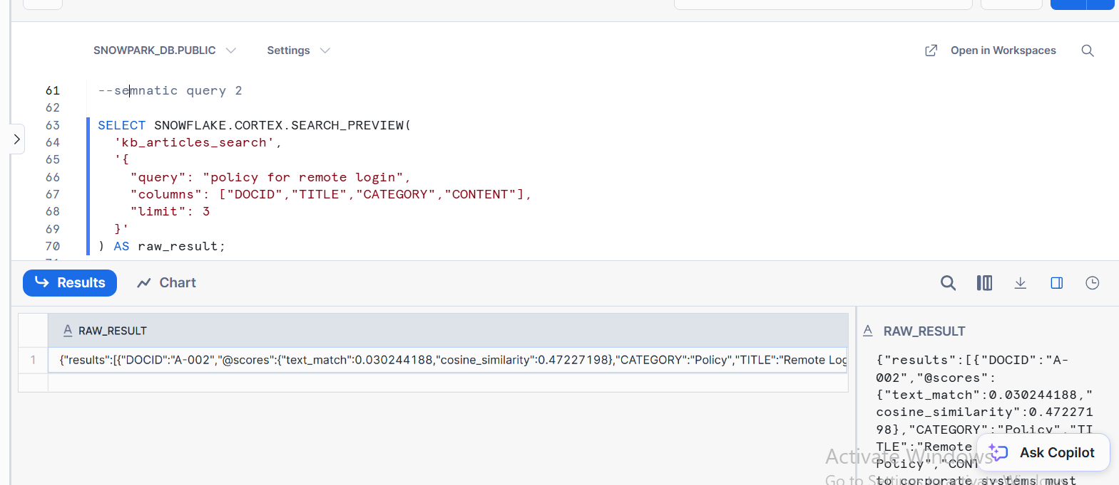

TASK 4 : FINAL TABULAR OUTPUT + WITH FILTER
(A) FINAL TABULAR OUTPUT
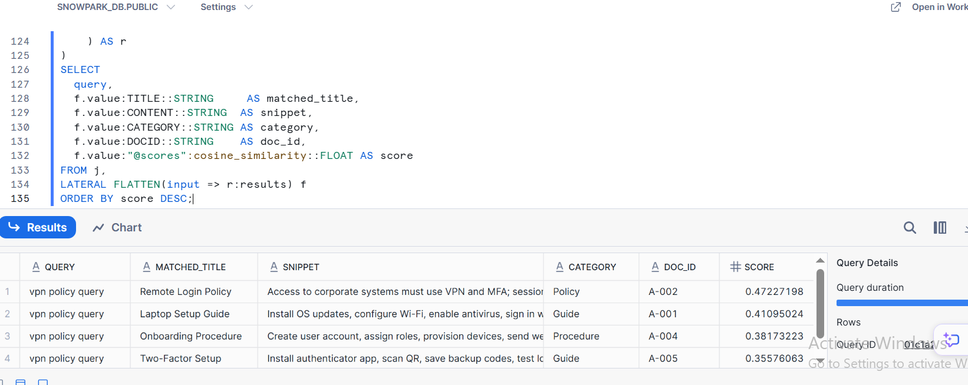

(B) FINAL TABULAR OUPUT WITH FILTER
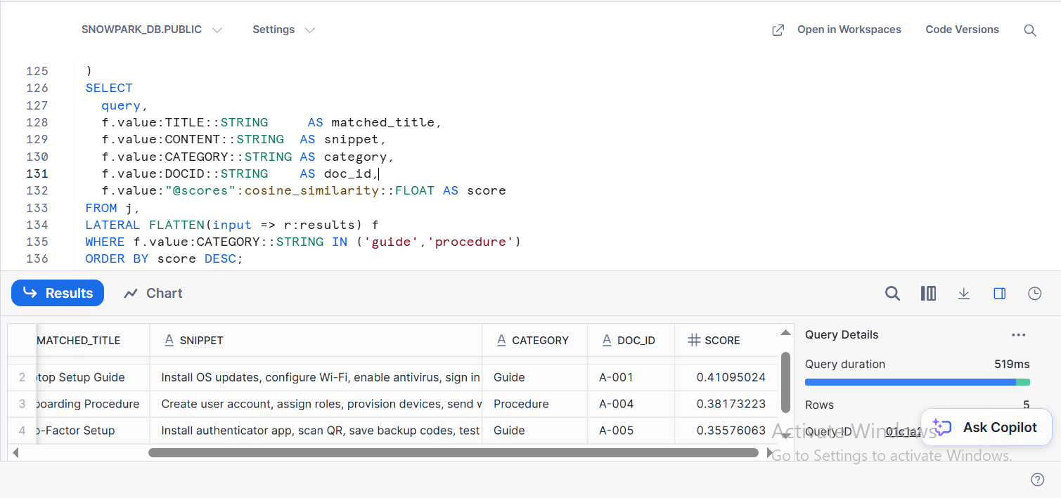

QUESTION 2: SNOWPARK : JOIN TWO DATAFRAMES, AGGREGATE, AND APPLY TWO POST AGGREGATION FILTERS
TASK 1 : SNOWPARK SESSION INTIALIZATION AND DATA FRAME CREATION
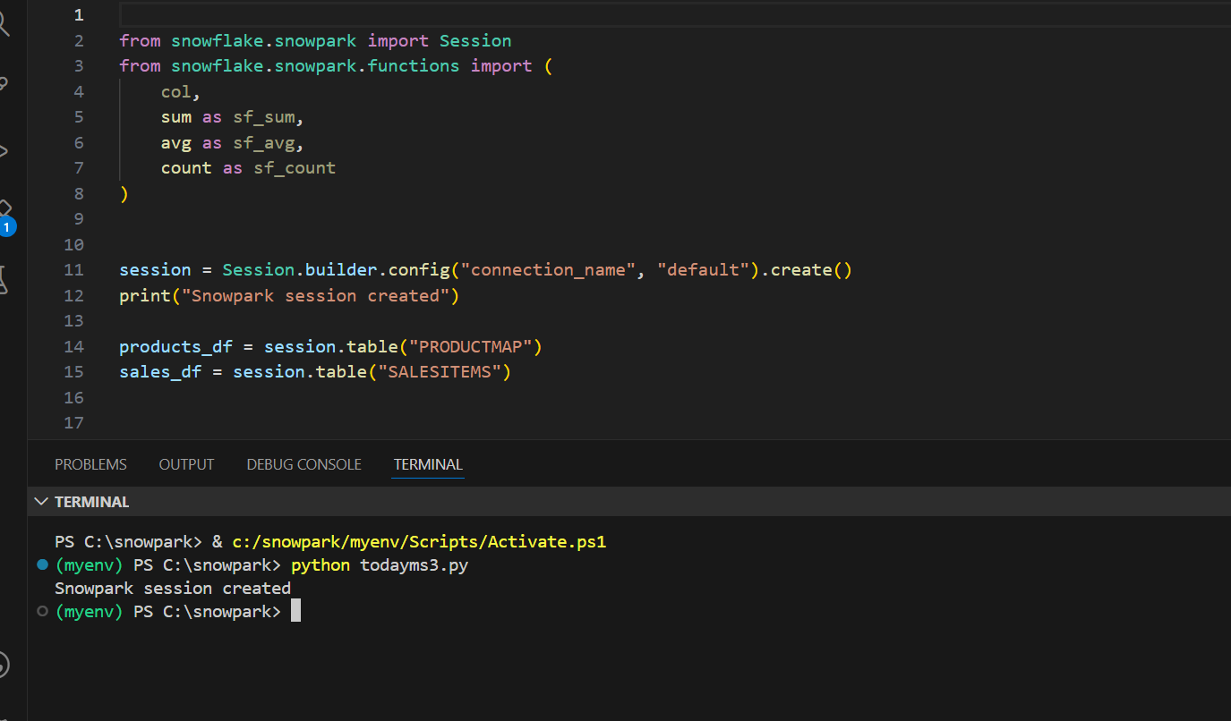

TASK 2: JOIN STEP AND REVENUE DERIVATION
(A) JOIN STEP
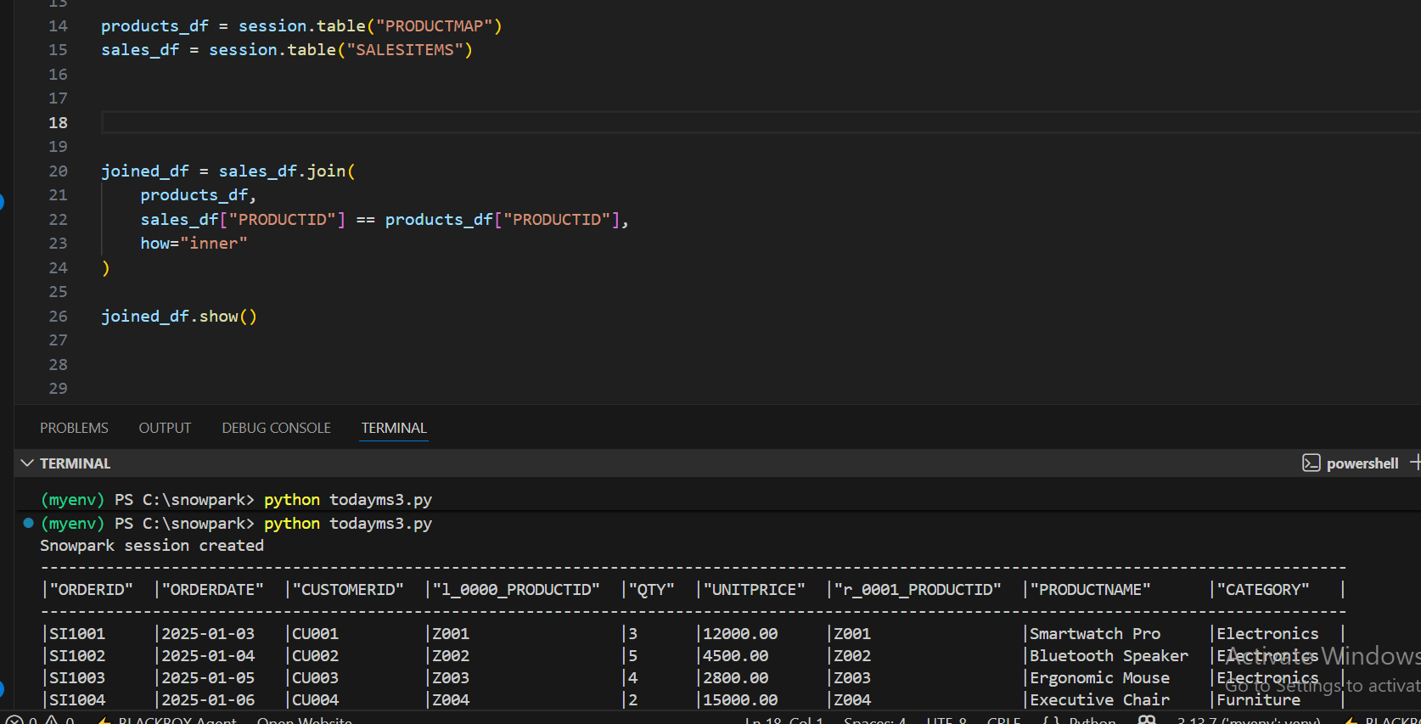
(B) REVENUE_DERIVATION
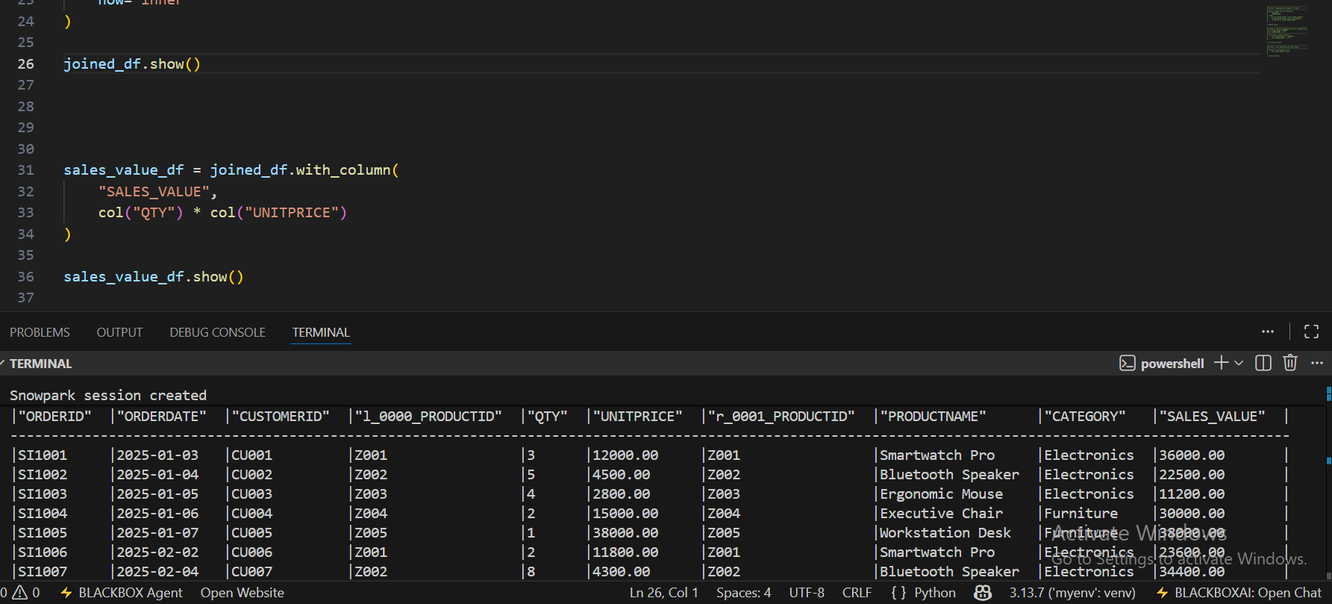

TASK 3 : AGGREGATE + TWO FILTER STEP
(A) AGGREGATE
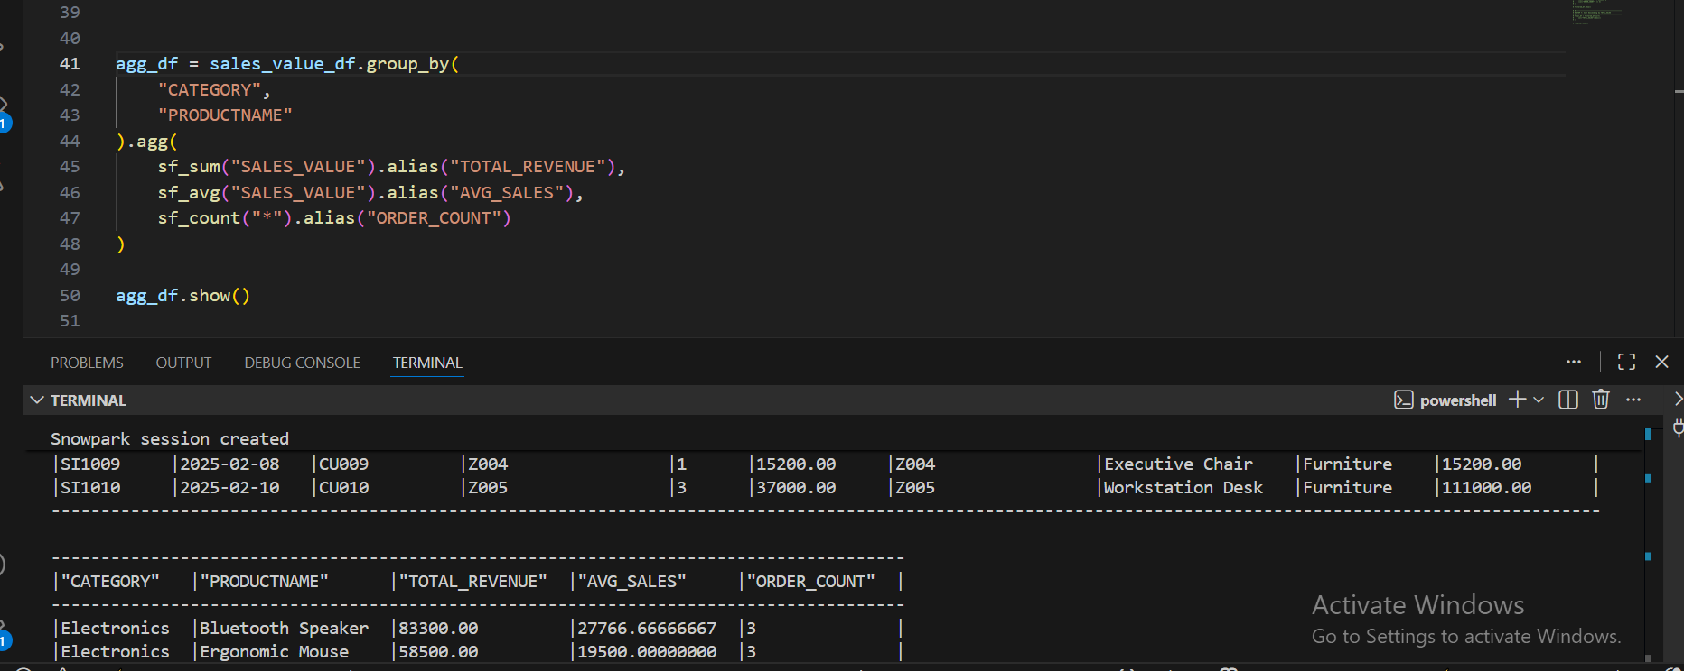

(B) TWO STEP FILTER
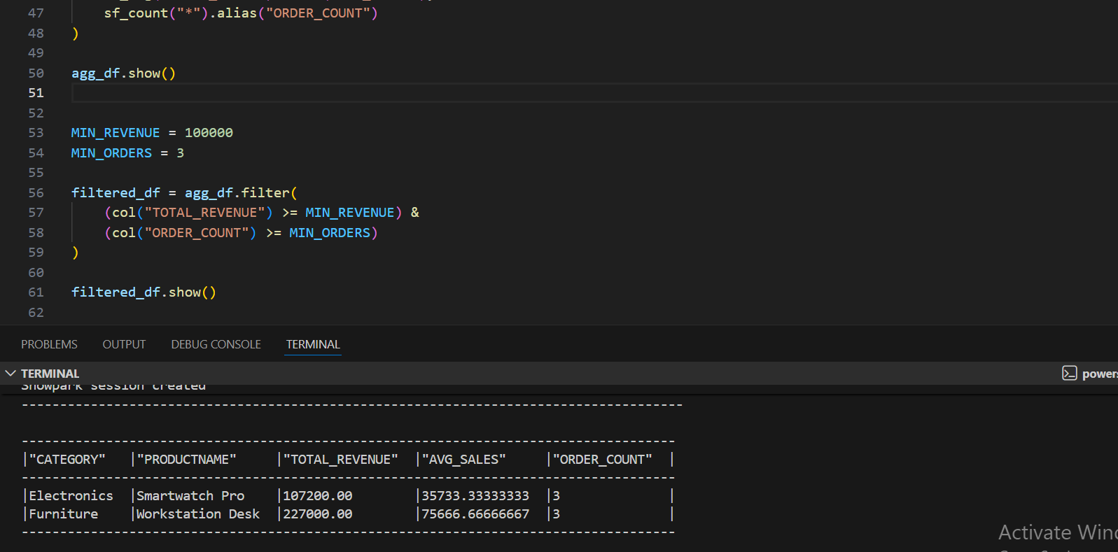

TASK 4: FINAL SORTED OUTPUT TABLE
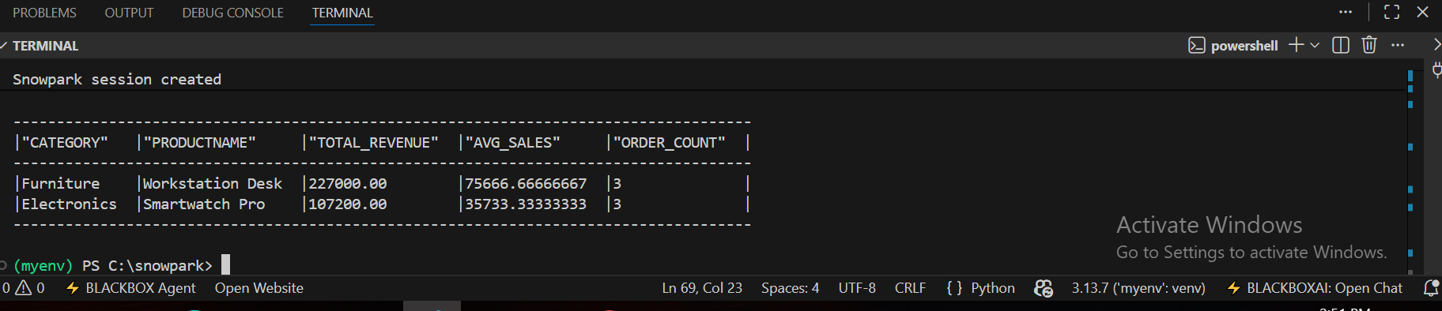
QUESTION 3 : BUILD A STREAMLIT APP WITH 3 NATIVE VISUALS ( NO MATPLOTLIB/SEABORN)
TASK 1 :APP WITH SIDEBAR FILTERS
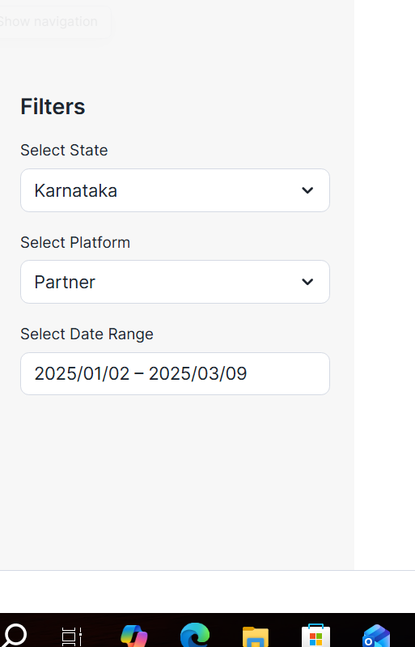

TASK 2 : AREA CHART CUMULATIVE REVENUE TREND
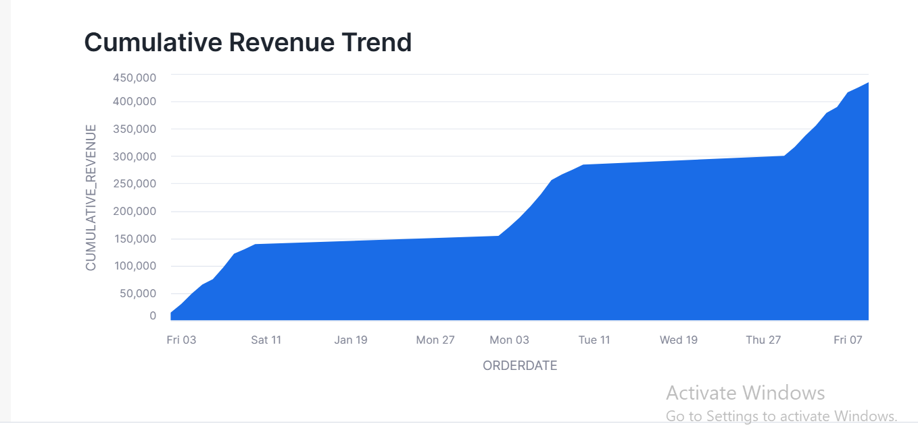

TASK 3 : SCATTER CHART (REVENUE VS ITEM COUNT) + TREEMAP (STATE -> PLATFORM REVENUE SHARE)
(A) SCATTER CHART
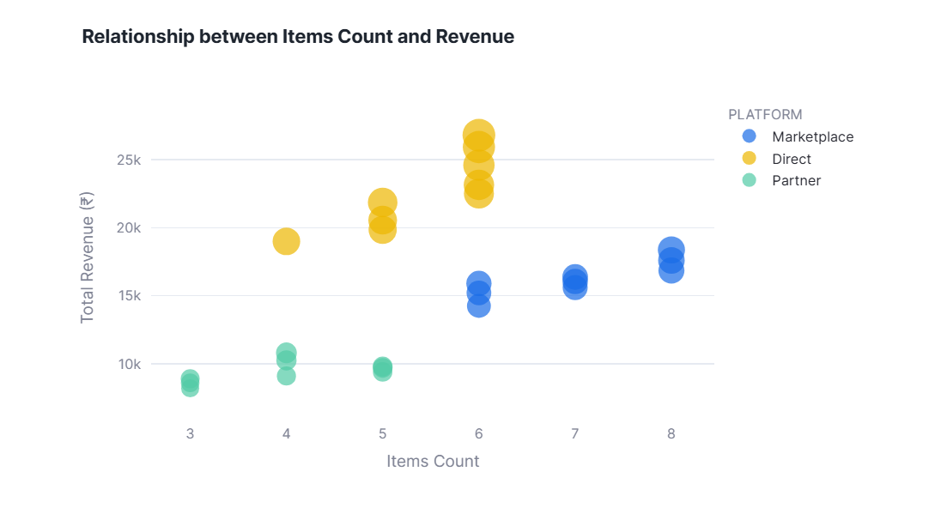

(B) TREE CHART
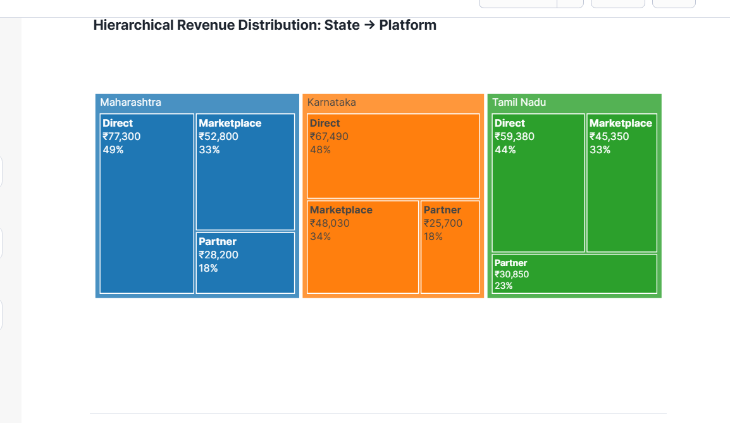

TASK 4 : SUMMARY TABLE
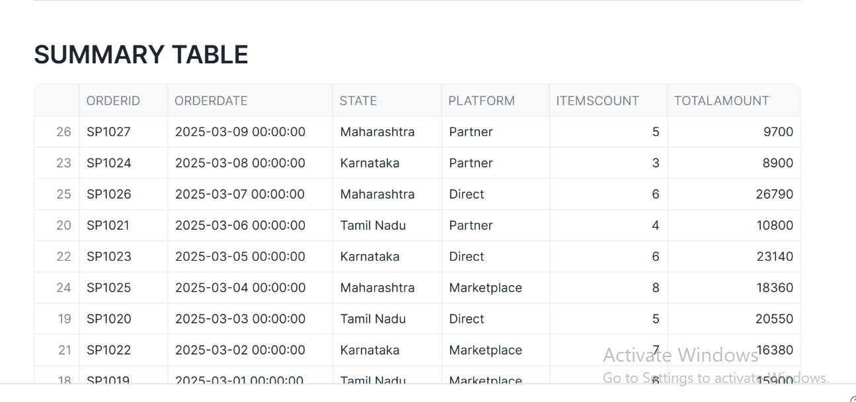

QUESTION 4 : CREATE AND USE A SNOWPARK PYTHON UDF FOR DATA CLEANSING & DERIVED METRICES
TASK 1: SNOWPARK SESSION INITIALIZATION
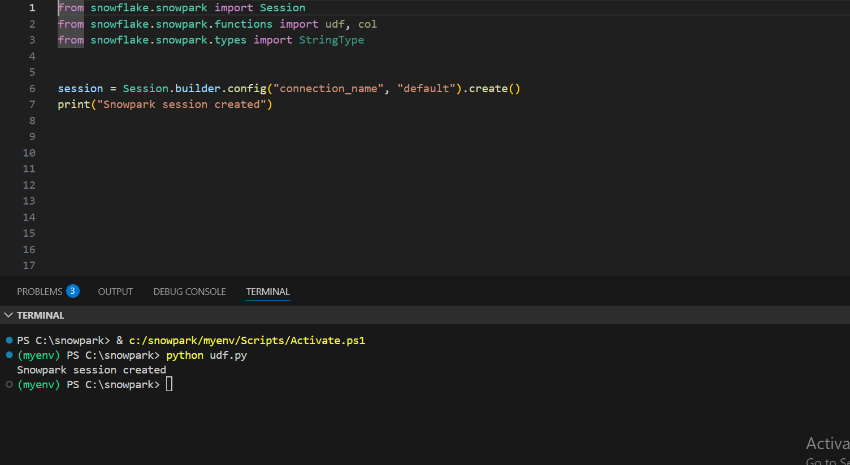

TASK 2 : UDF REGISTRATION CODE CELL
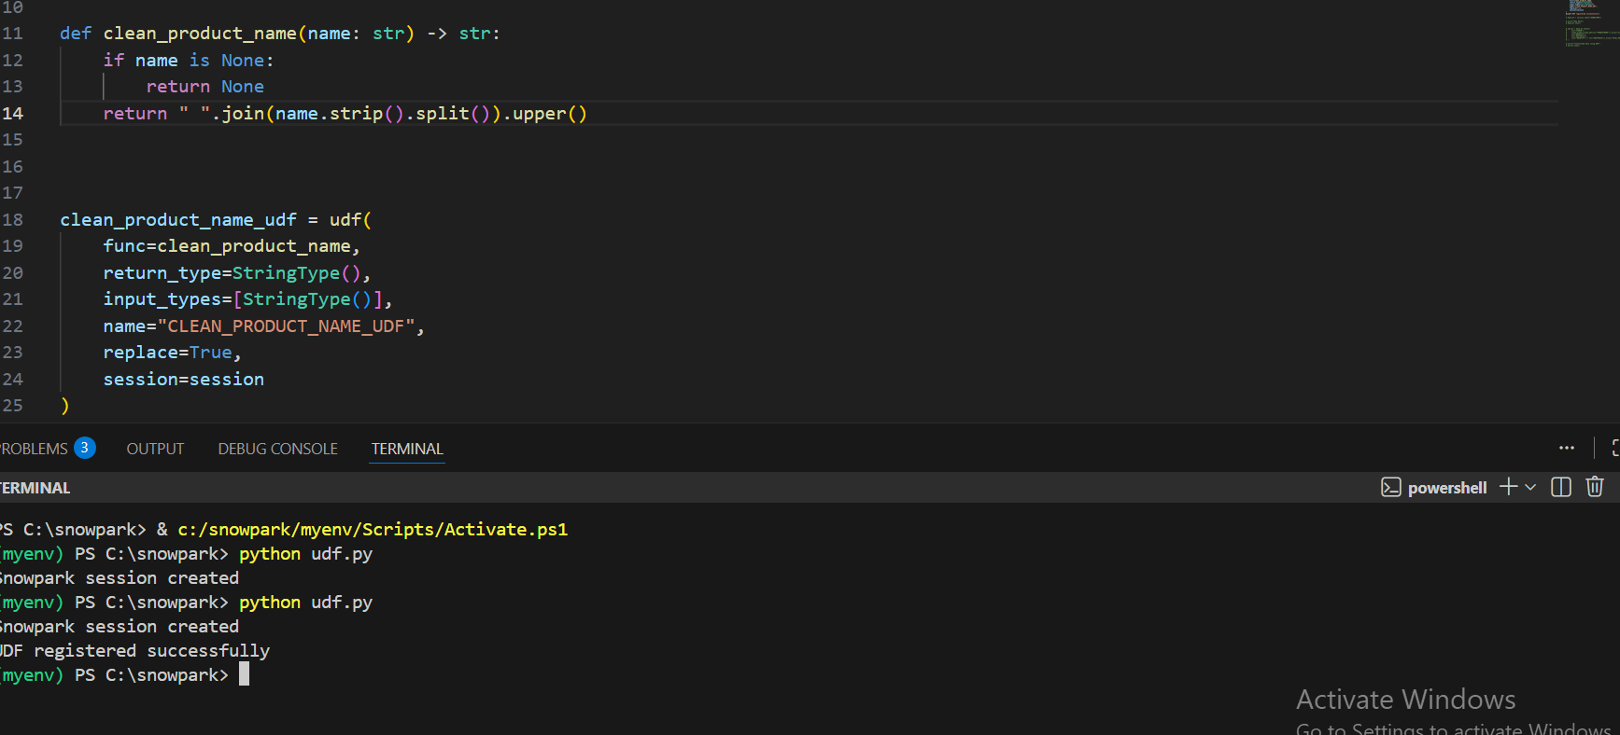

TASK 3: DATA FRAME TRANSFORMATION APPLYING UDF
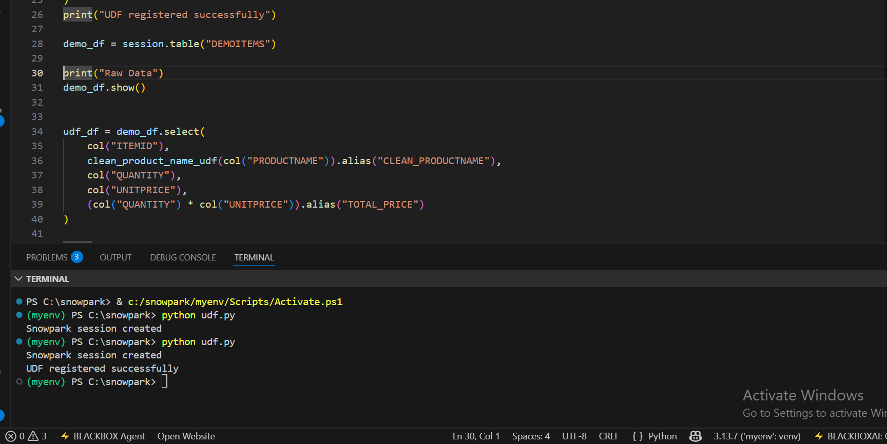

TASK 4 ; FINAL RESULT TABLE
