NAME – RAUNAK JHA
Q1 – SNOWPIPE AUTO-INGEST WITH INCREMENTAL VALIDATION AND ERROR MONITORING
TASK 1
SQL USED FOR EXTERNAL STAGE AND TABLE CREATION
TABLE CREATION
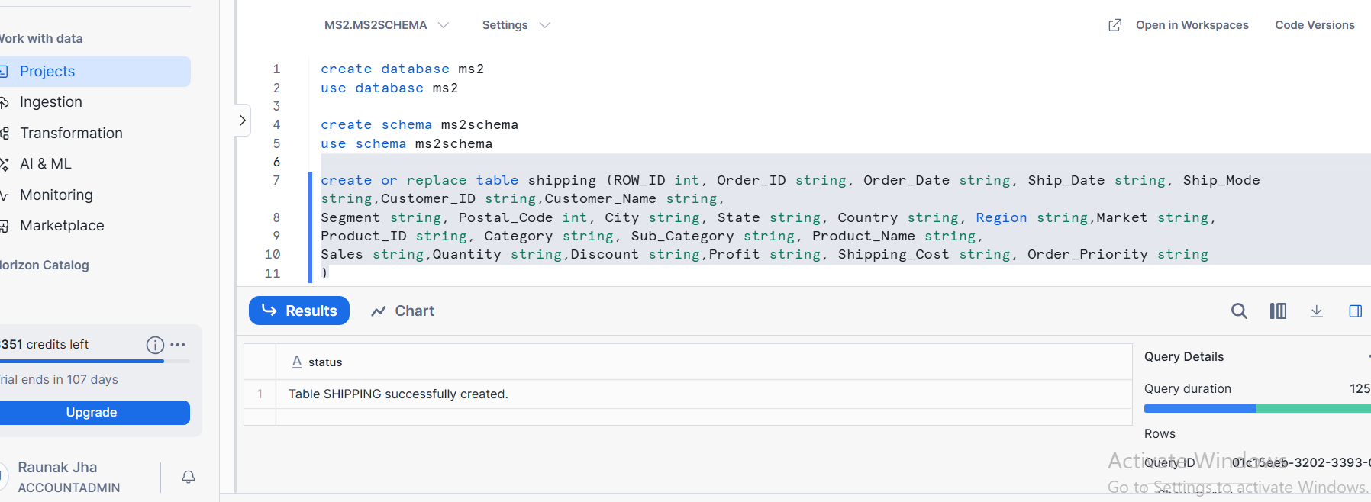
EXTERNAL STAGE CREATION
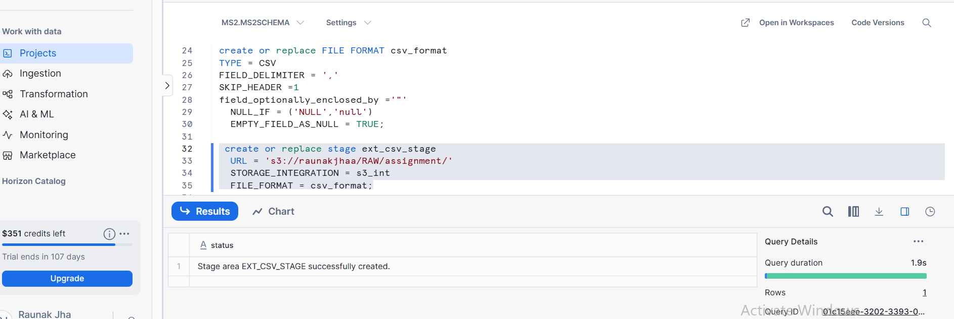

TASK 2:
SNOWPIPE CREATION
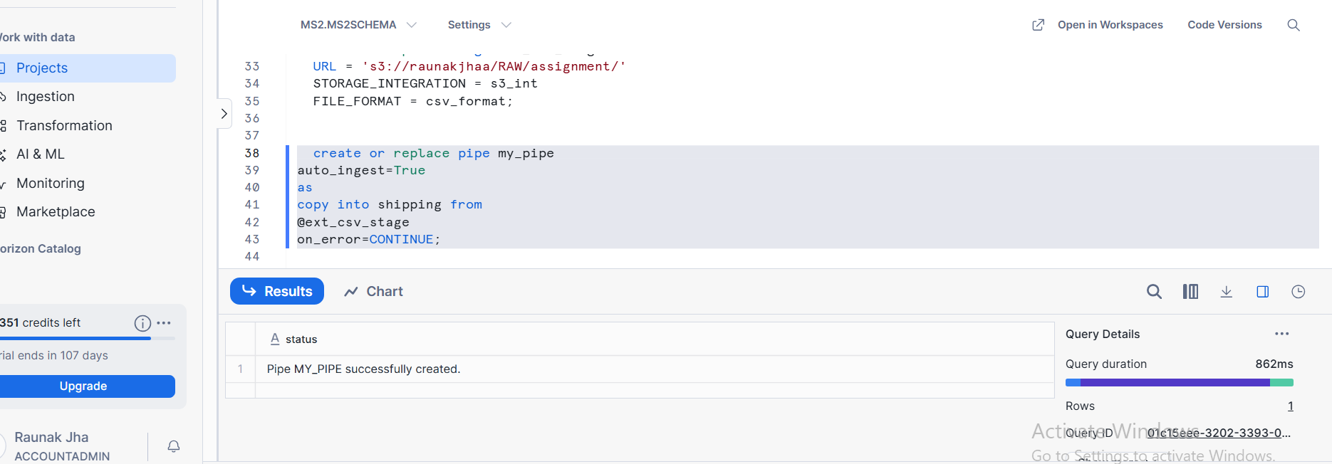

TASK3:
QUERY OUPUT SHOWING INCREMENTAL DATA INGESTION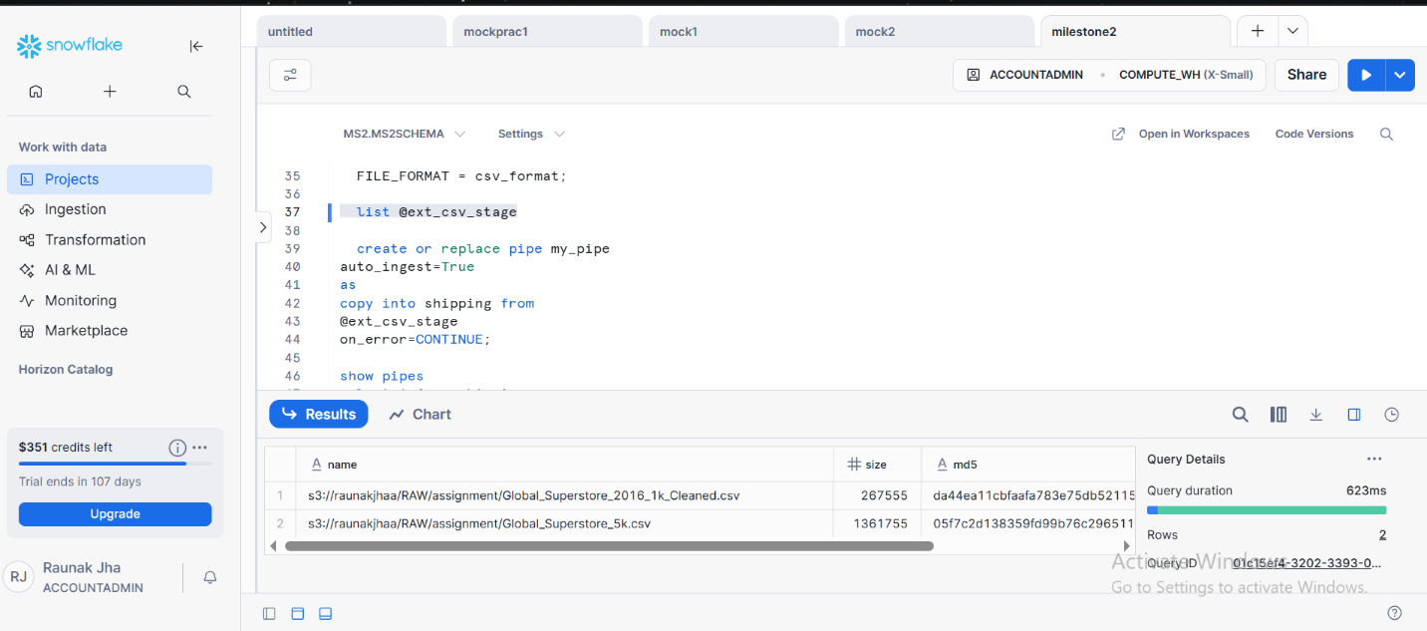

TASK 4:
SNOWPIPE LOAD HISTORY OUTPUT
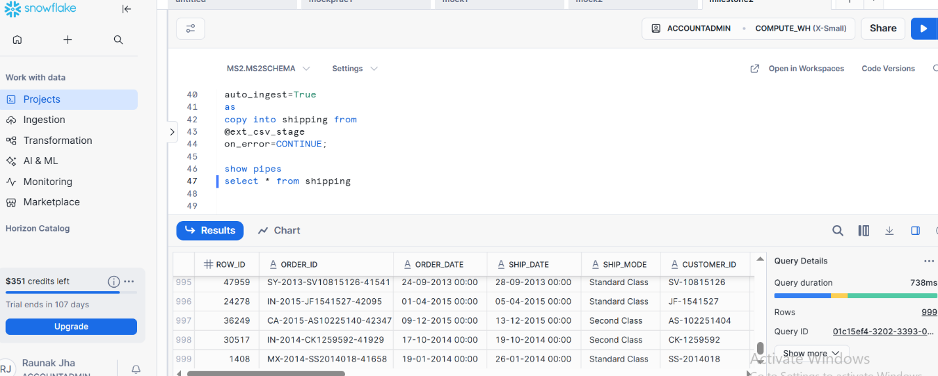

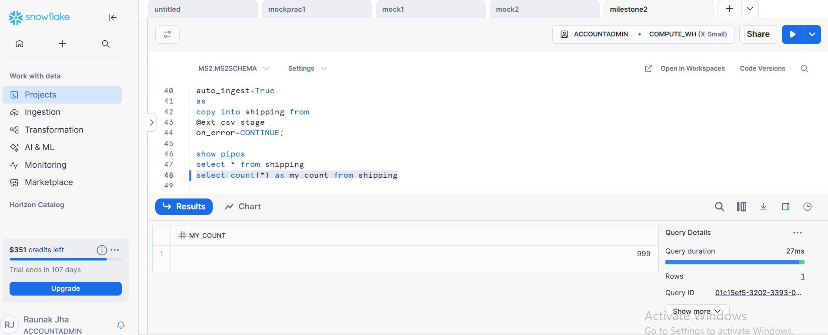

TASK 5:
EVIDENCE SHOWING NO FAILED RECORDS OR ERRORS
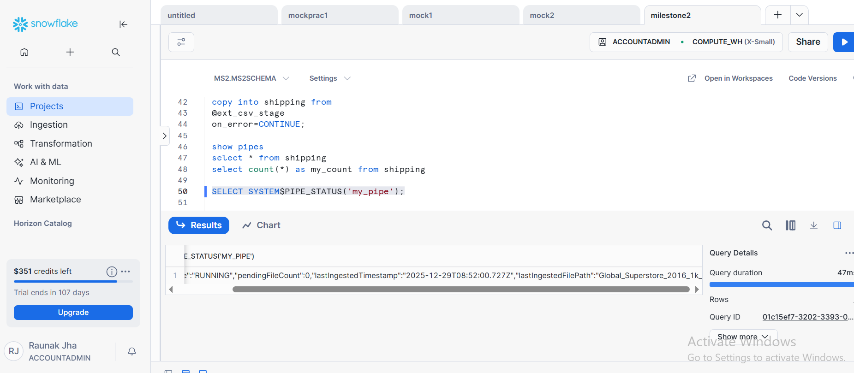

Q2 : AWS S3 DATA LOAD WITH ADVANCED RBAC, ROW ACCESS POLICY, AND COLUMN MASKING
TASK 1
EXTERNAL STAGE AND TABLE CREATION
TABLE CREATION

EXTERNAL STAGE CREATION

TASK 2:
ROLE CREATION AND PRIVILEGE GRANTS
ROLE CREATION
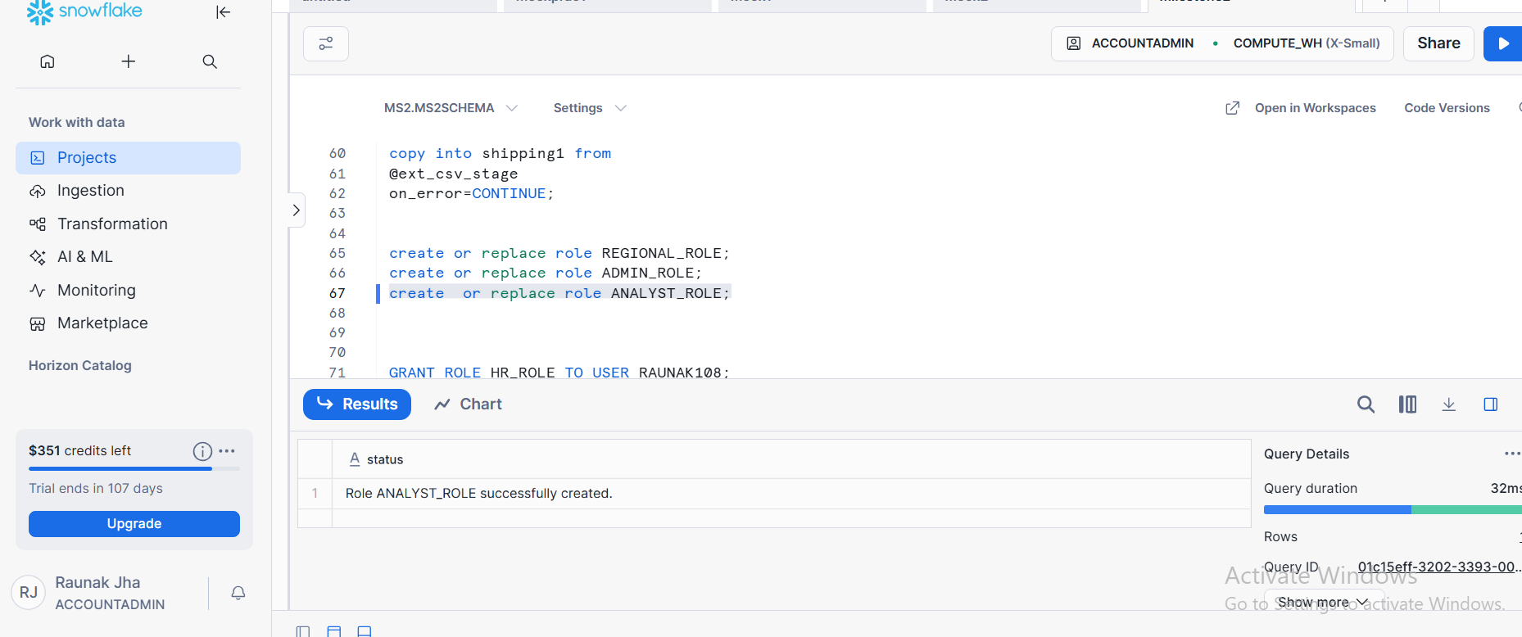

PRIVILEGE GRANTS
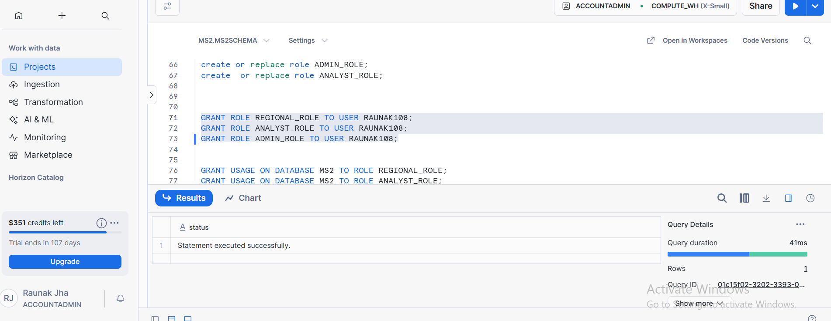

TASK 3 :
MASKING POLICY CREATION AND APPLICATION
NUMBER BASED (SALES COLUMN)
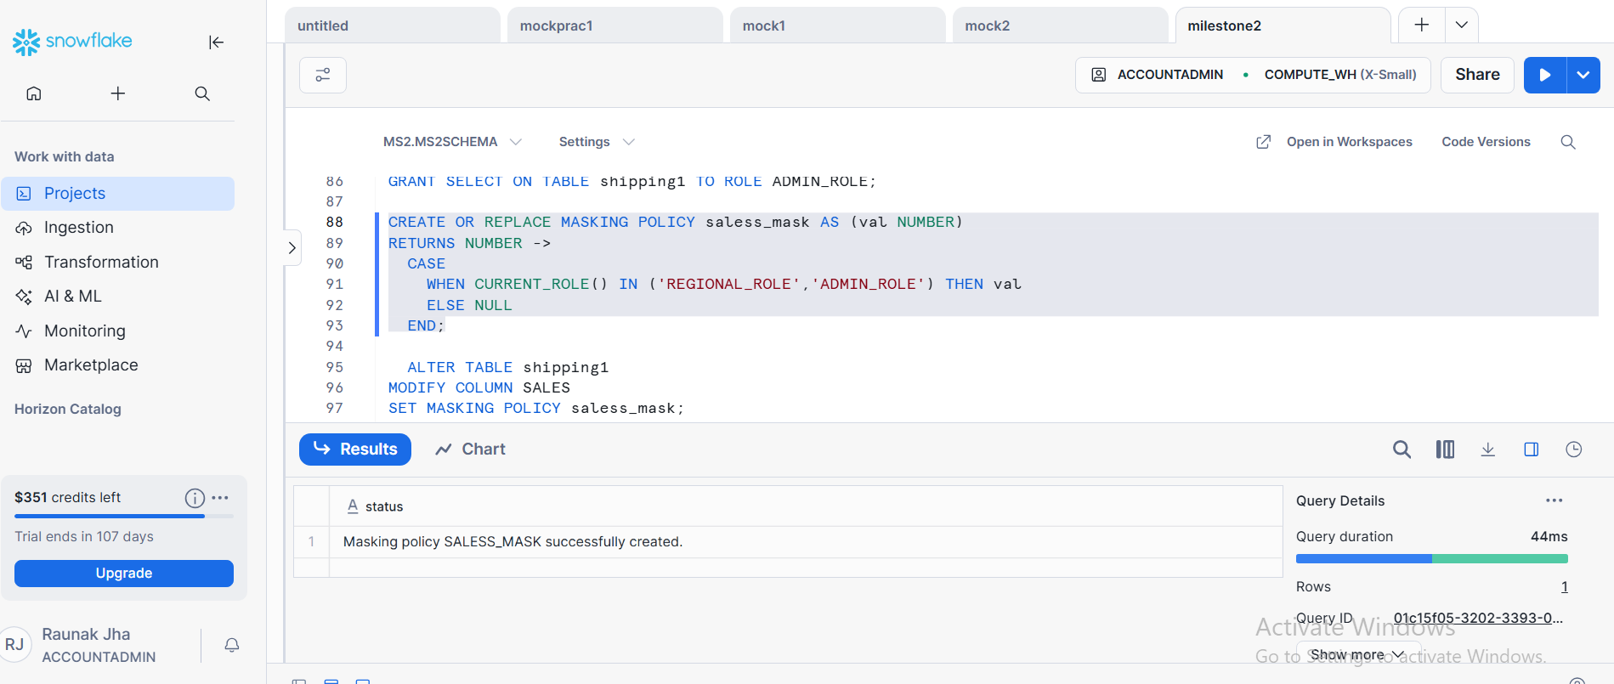

APPLICATION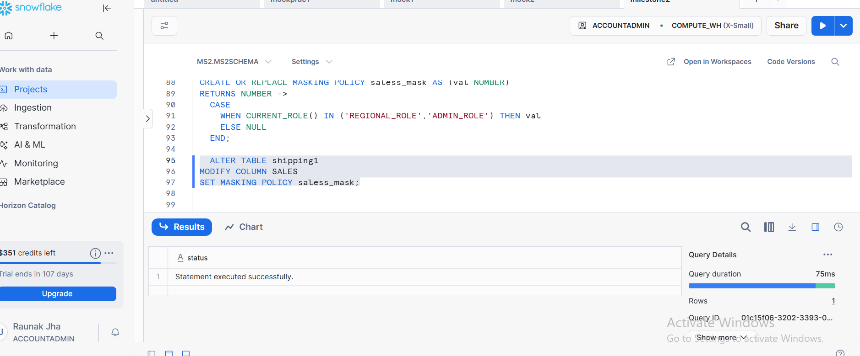

STRING BASED (CUSTOMER NAME)
STRING MASKING CREATION COLUMN BASED
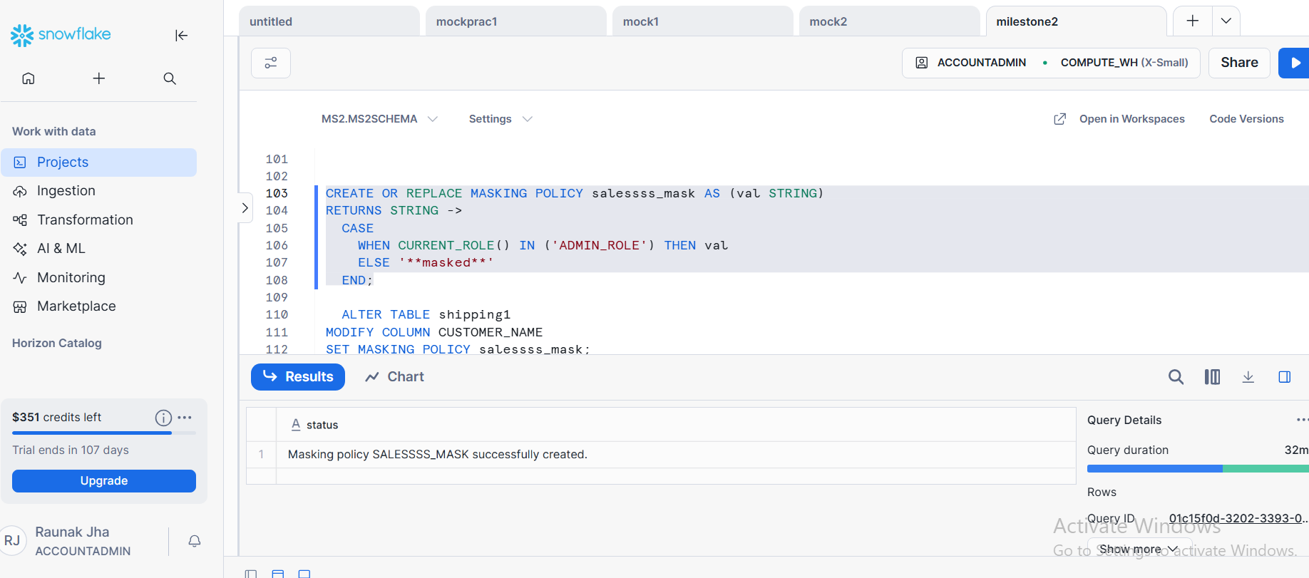

APPLICATION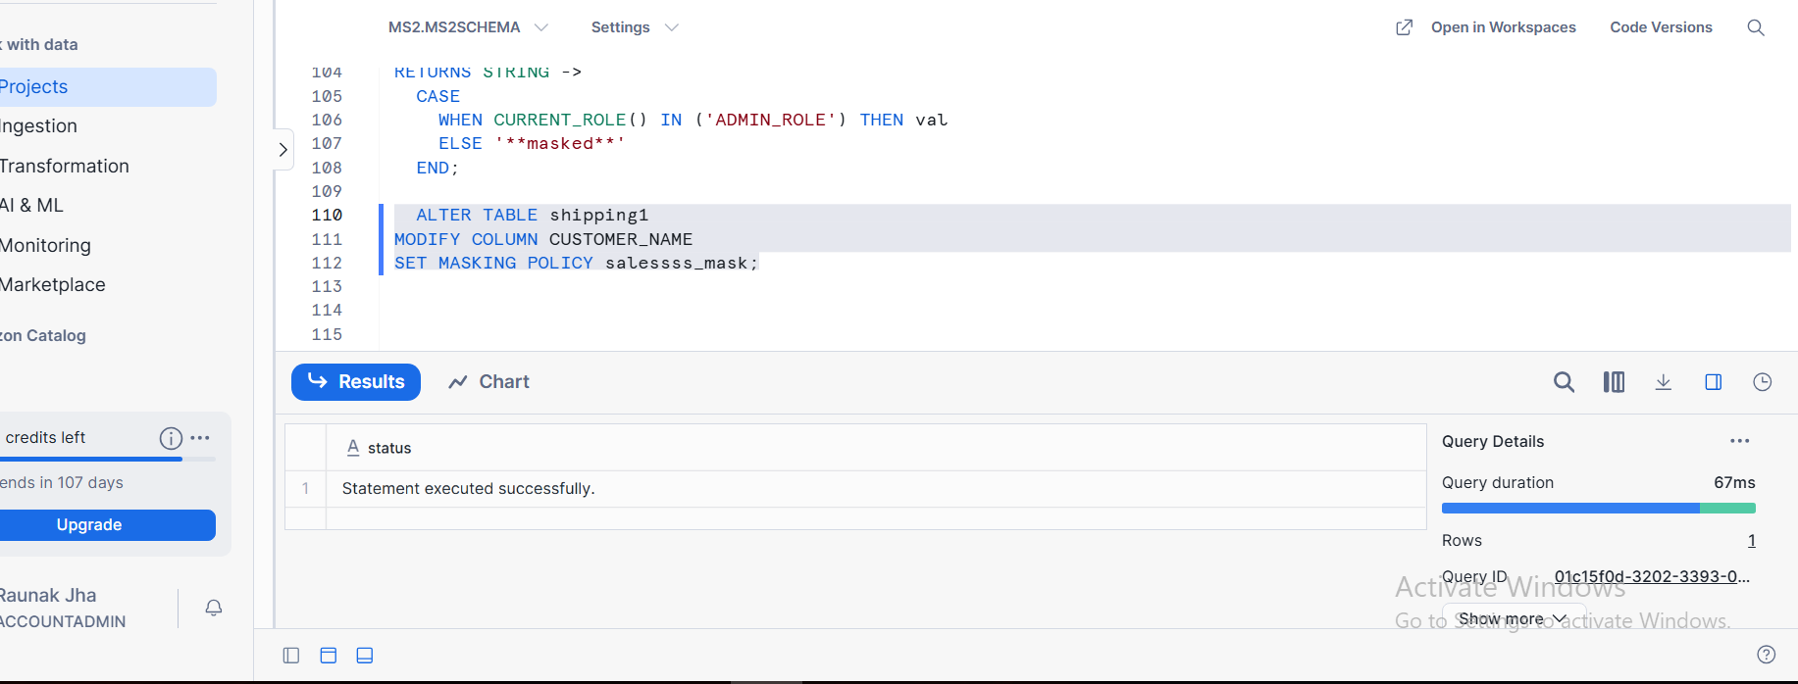

TASK 4:
ROW ACCESS POLICY CREATION AND ASSIGNMENT
ROW ACCESS POLICY CREATION
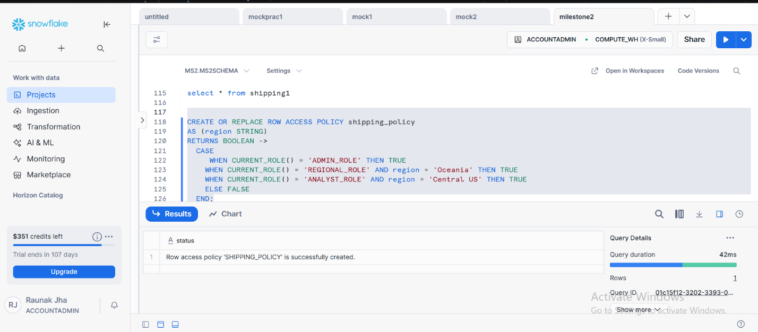

ASSIGNMENT
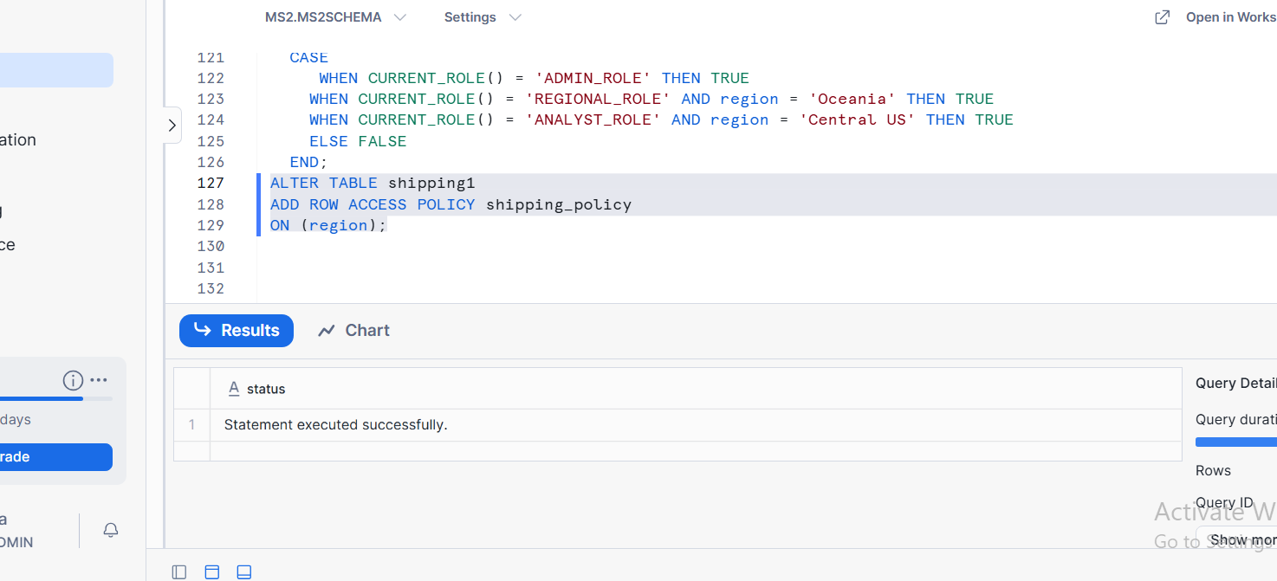

TASK 5:
OUPUT OF COLUMN BASED MASKING STRING AND NUMBER
SALES COLUMN MASED FOR ANALYST ROLE
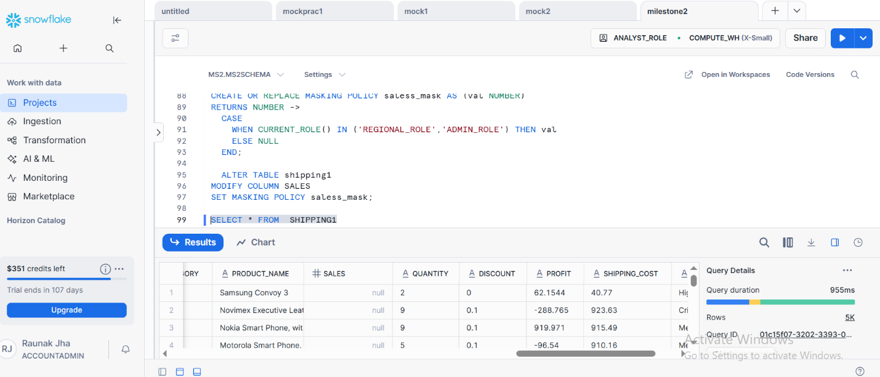
CUSTOMER NAME MASKED FOR NON-ADMIN ROLES

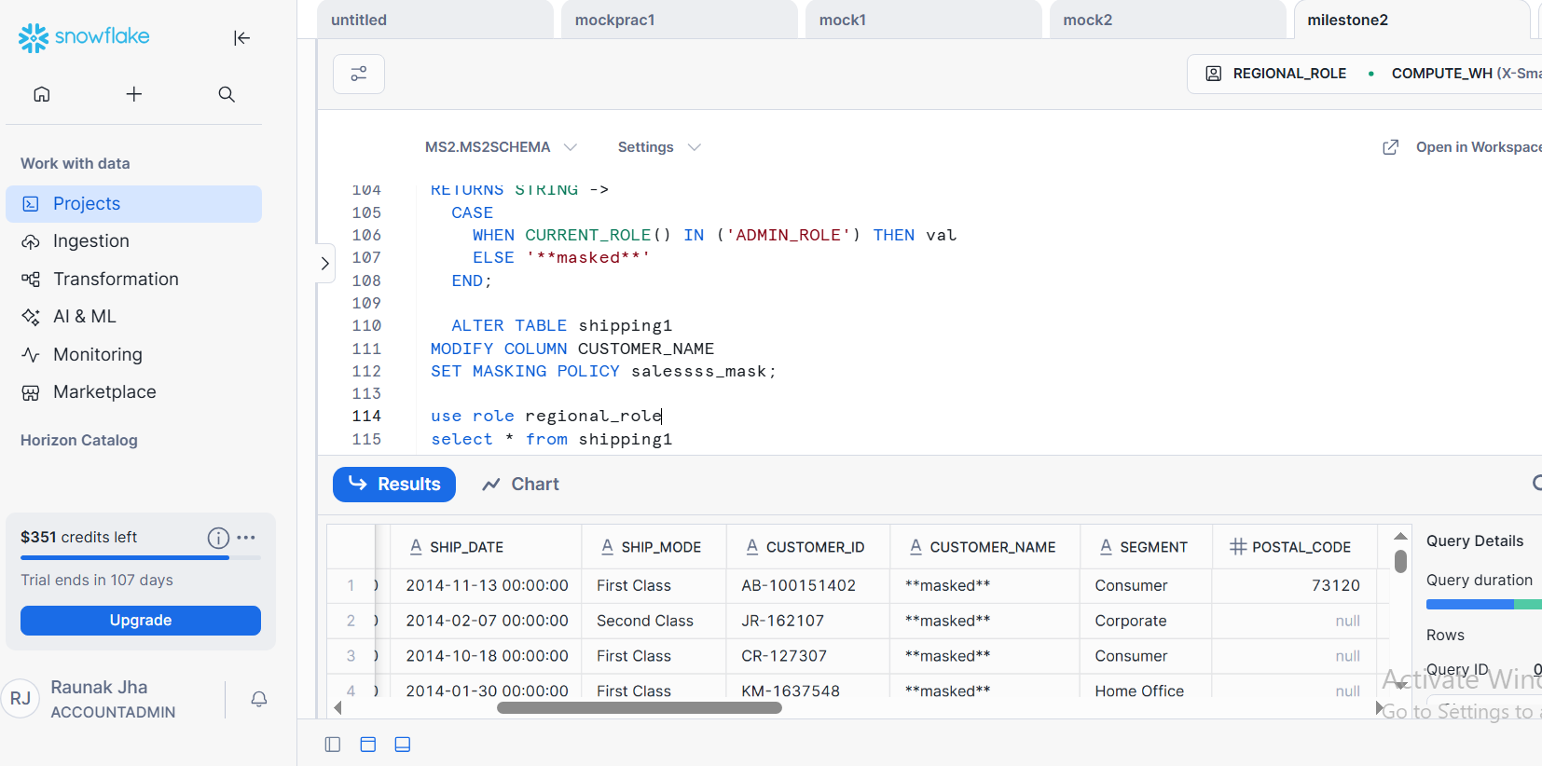

ROW LEVEL RESTRCTION SPECIFIC ROW VISIBILITY(REGIONAL ROLE)
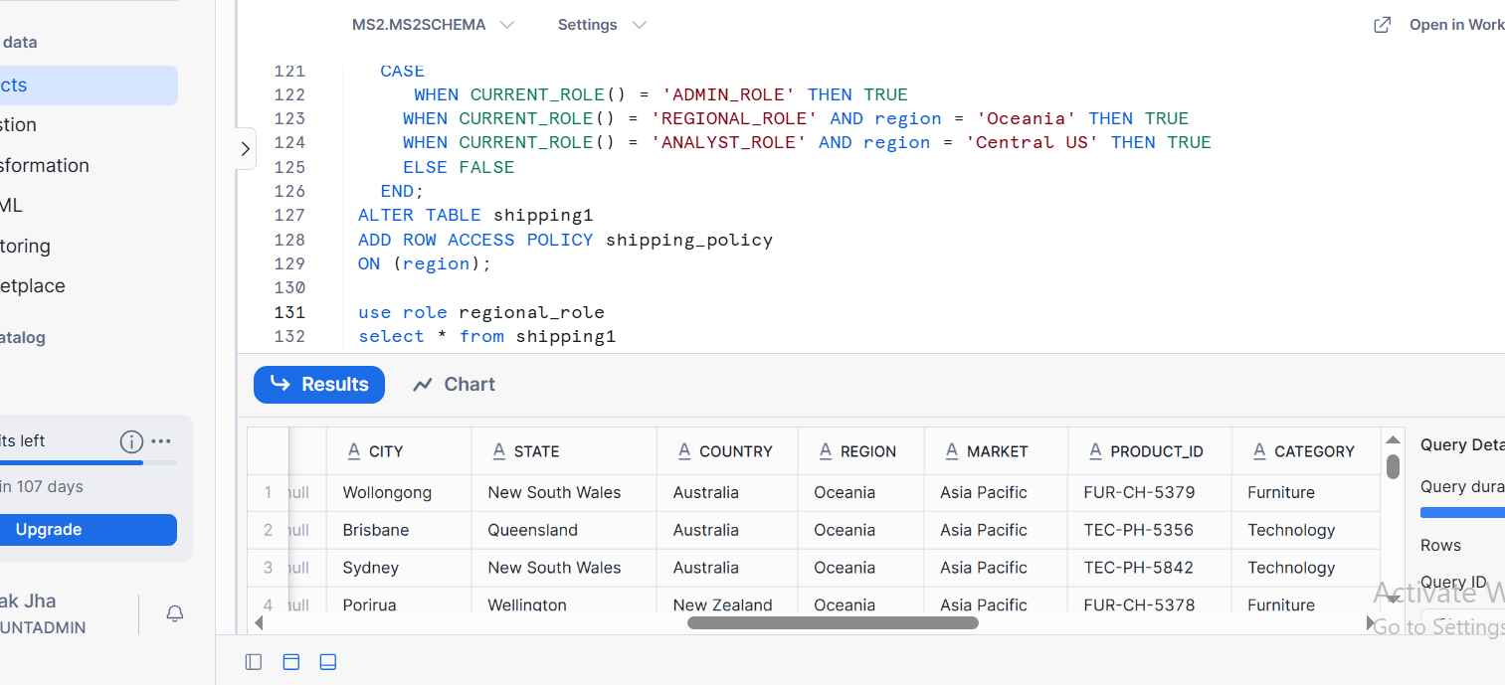

Q3 : SNOWFLAKE TABLE TYPES, DATA RETENTION, VALIDATION, TABLE STAGE LOAD, AND SECURE DATA SHARING
TASK 1 : PERMANENT TABLE CREATION
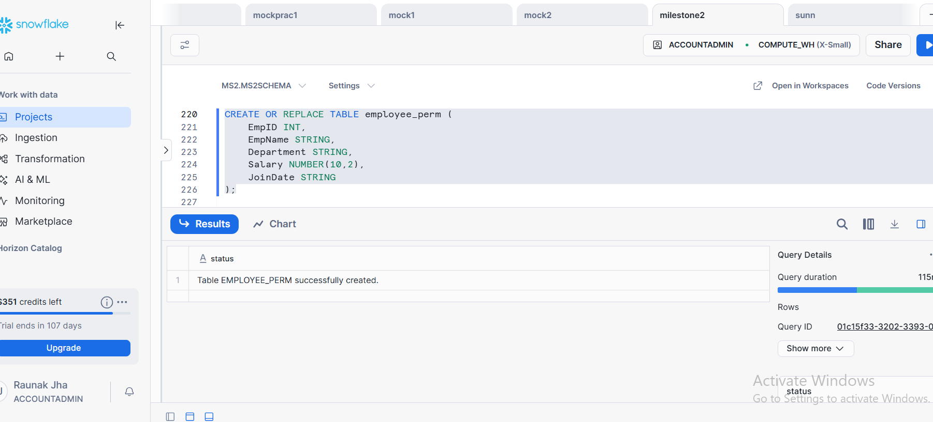

TEMPORARY TABLE CREATION
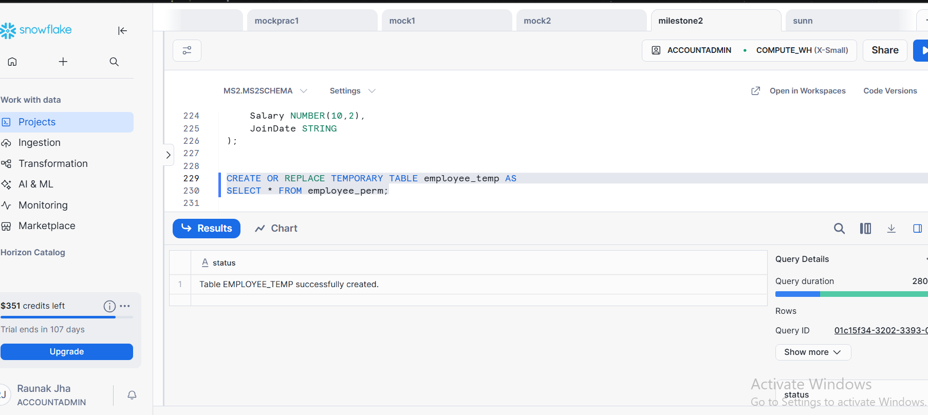

TRANSIENT TABLE CREATION
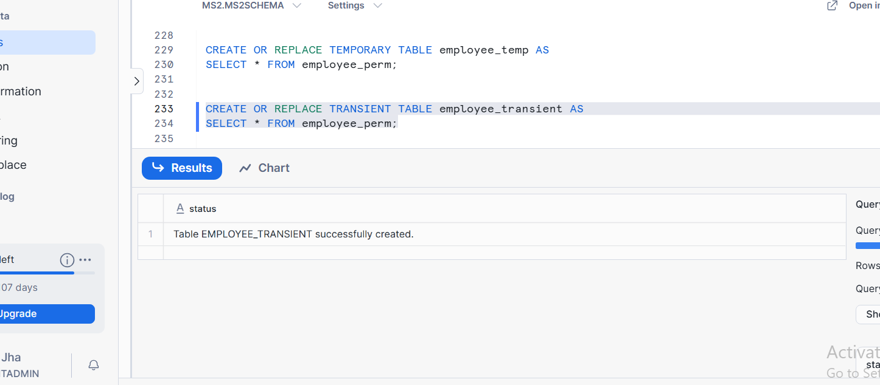

TASK 2:
LOADING DATA USING TABLE STAGE
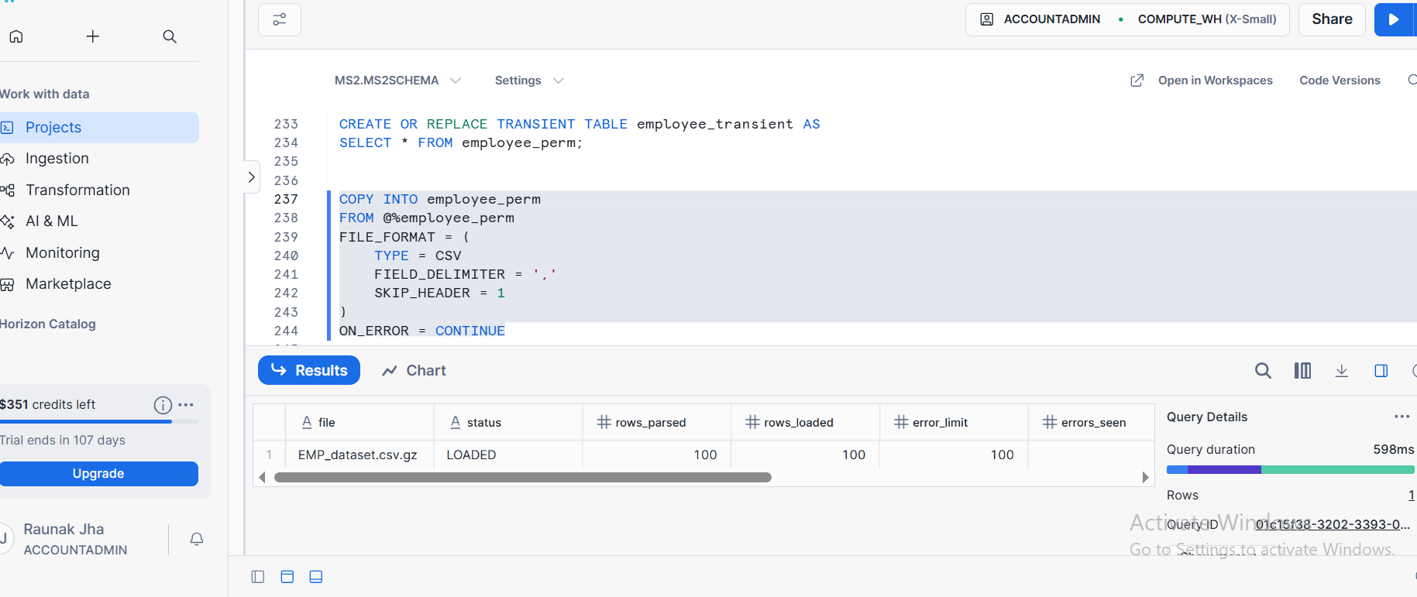

TASK 3 : DATA RETENTION PERIOD OF ALL TABLES
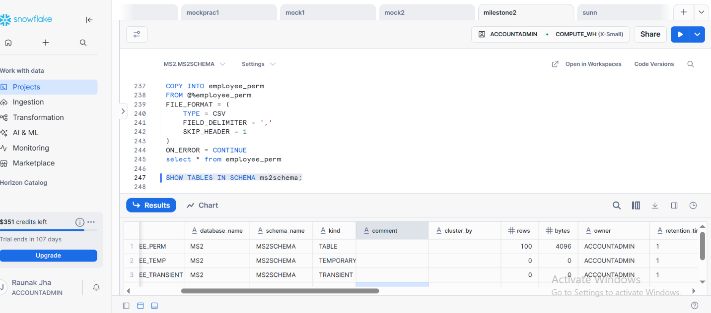

TASK 4 : SQL USED FOR SECURE SHARE CREATION AND GRANTS
SECURE SHARE CREATION
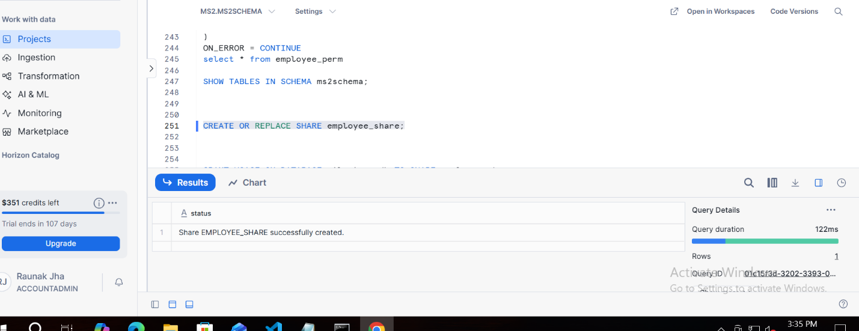

GRANTS
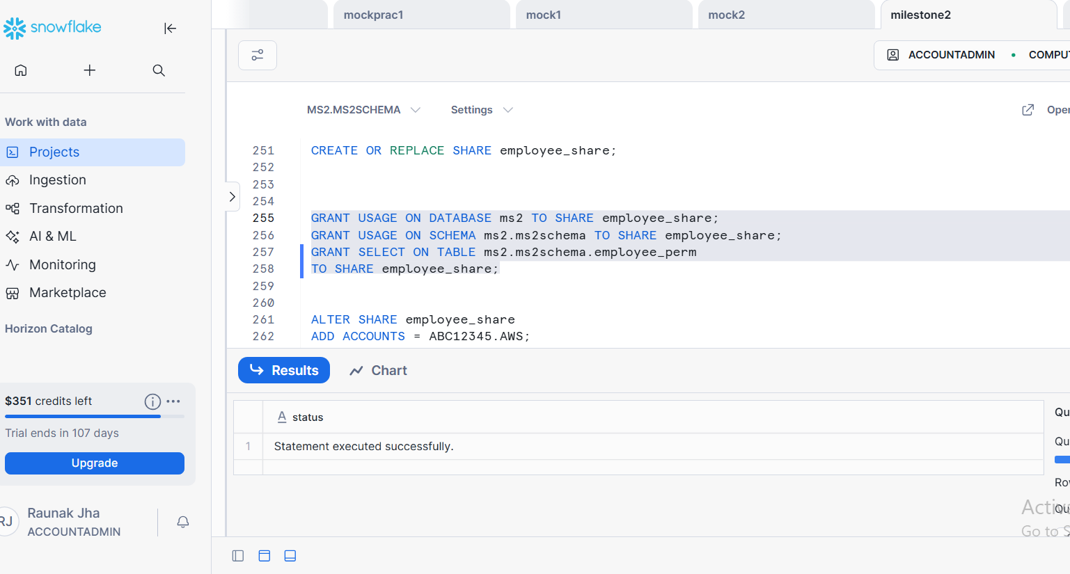

TASK 5:
OUPUT SHOWING SHARE IS ACTIVE ( SHOW SHARES)
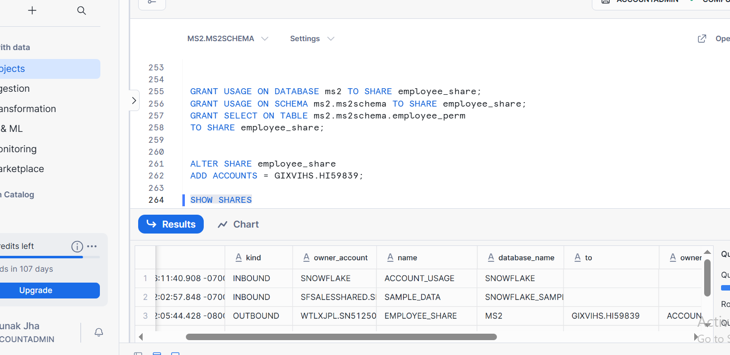

Q4 : SNOWFLAKE USER STAGE DATA LOAD, MATERIALIZED VIEW CREATION, AND DARA UNLOADING
TASK 1:
SQL USED FOR TABEL CREATION

TASK2 DATA LOADING FROM USER STAGE
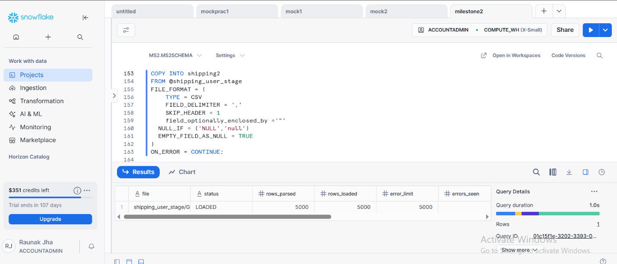

TASK 3 : MATERIALIZED VIEW CREATION
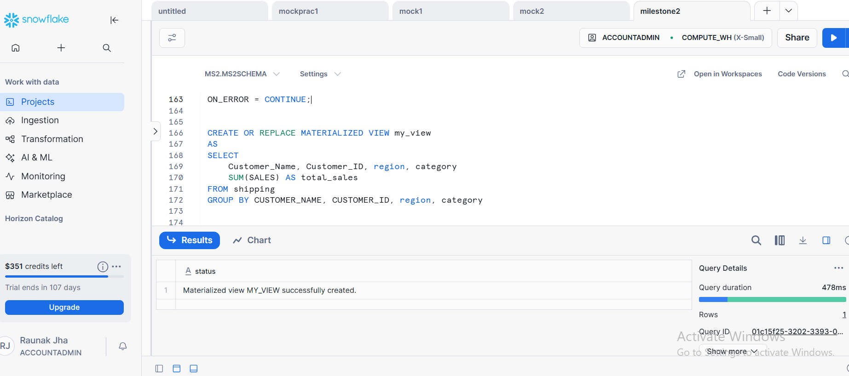

TASK 4 : SQL USED FOR UNLOADING THE DATA
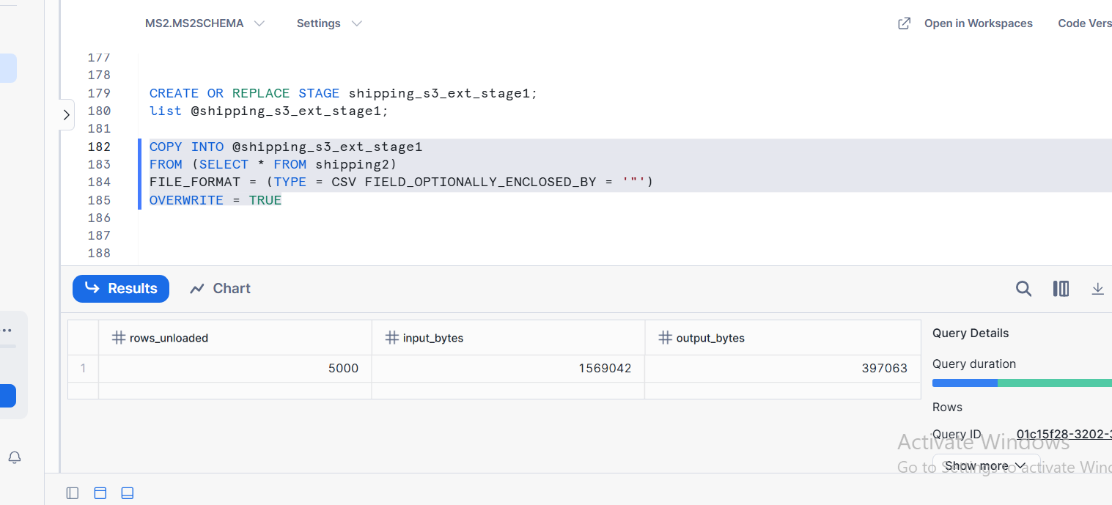

TASK 5: QUERY OUTPUT VALIDATING DATA LOADED AND MATERIALIZED VIEW RESULTS
OUPUT VALIDATING LOADED DATA
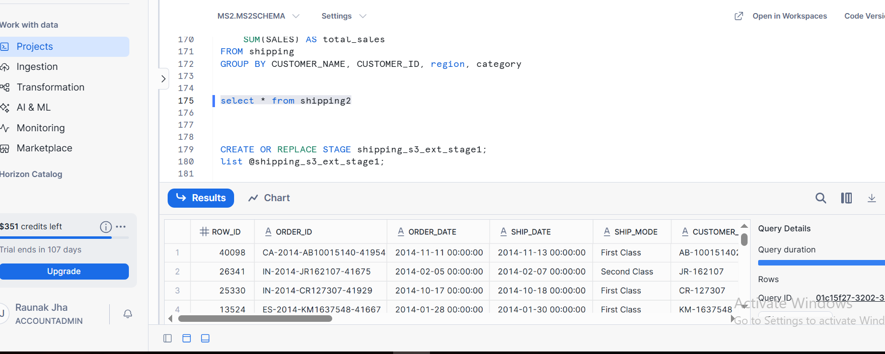

MATERIALIZED VIEW RESULTS
