Name : Raunak Jha
Question Name: SNOWFLAKE DATA LOADING AND UNLOADING USING EXTERNAL STAGE(AWS S3)
1(A) External Stage Creation
Description:
Here is the screenshot of the external stage creation where we specified the URI to provide the access at the location in the s3 bucket after that we have defined the storage integration and the format of the file and the output is as follows 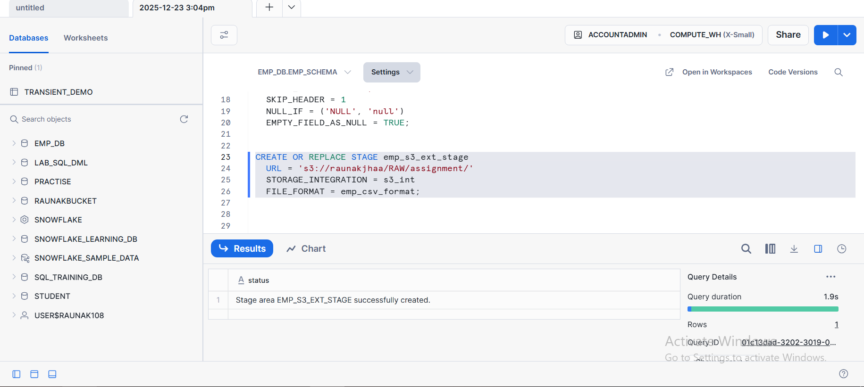

1(B) SUCCESFUL DATA LOAD INTO THE TABLE
DESCRIPTION :
Here WE HAVE DESCRIBE THE DATA LOADING INTO THE TABLE FROM THE EXTERNAL STORAGE TO THE EMPLOYEE TABLE USING THE COPY INTO COMMAND AS FOLLOWS
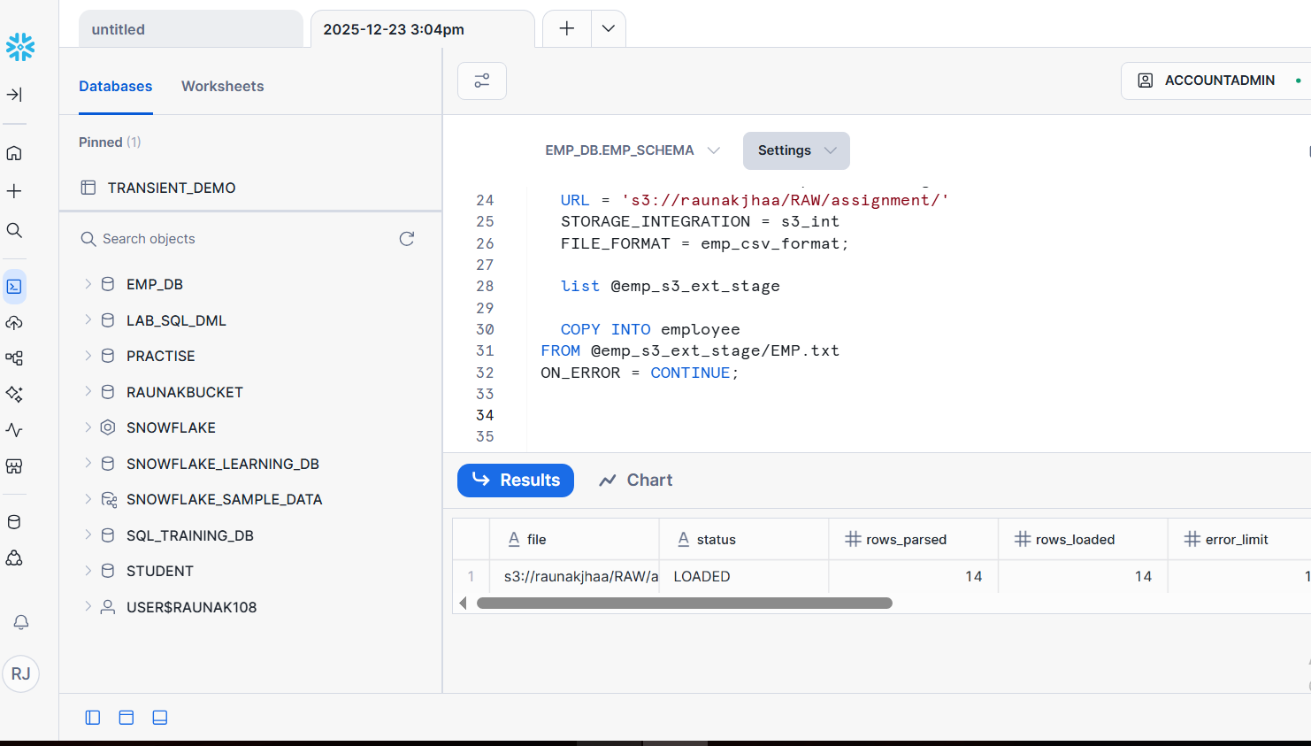

1(C) Query output validating loaded data
Description: Here in the task we have displayed the data which is loaded into the table to show that all things are working correctly and the data is successfully loaded.
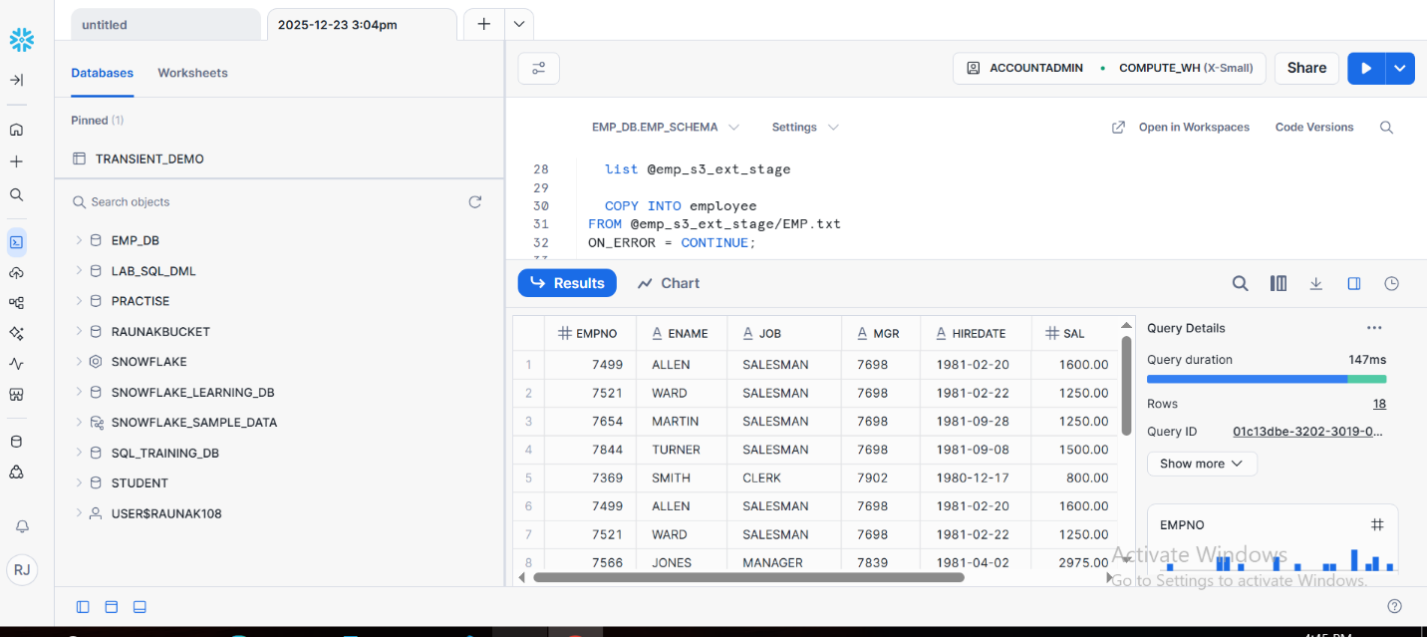
1(D) UNLOAD OPERATION OUTPUT
Description:
Here we have create a new stage and from the table we have unloaded the data using the copy into which is showing that the data is unloaded as per description
