Name – Raunak Jha
Question 1 : Title: Configure the cortex search service & amp; cortexSEarch_Preview
For semantic document retrieval
TASK 1 : CREATE/TABLE/INSERT statements execution
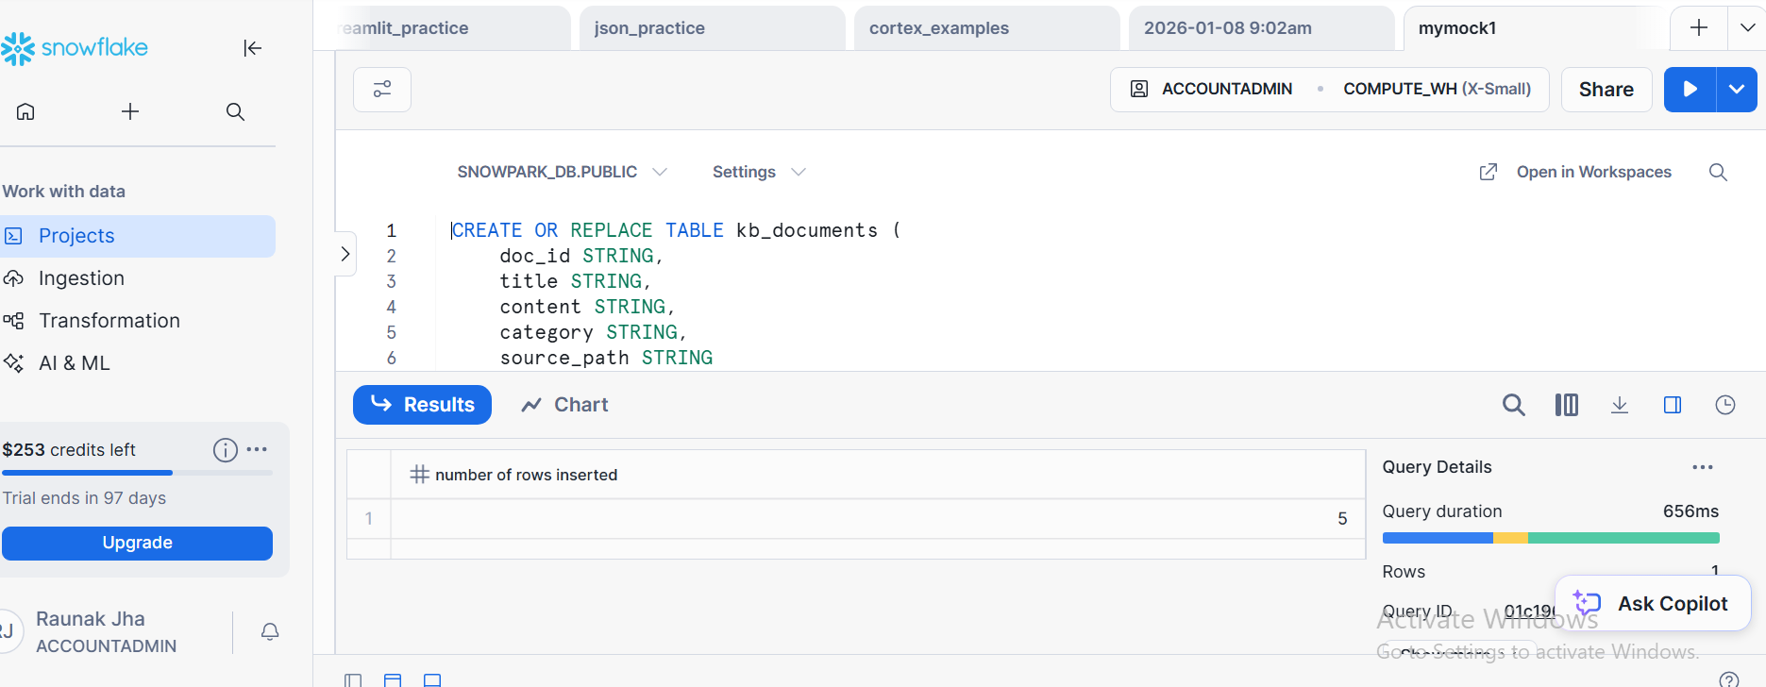

TASK 2: CORETEX SEARCH SERVICE PREVIEW CONFIGURATION CREATION SCREENSHOT
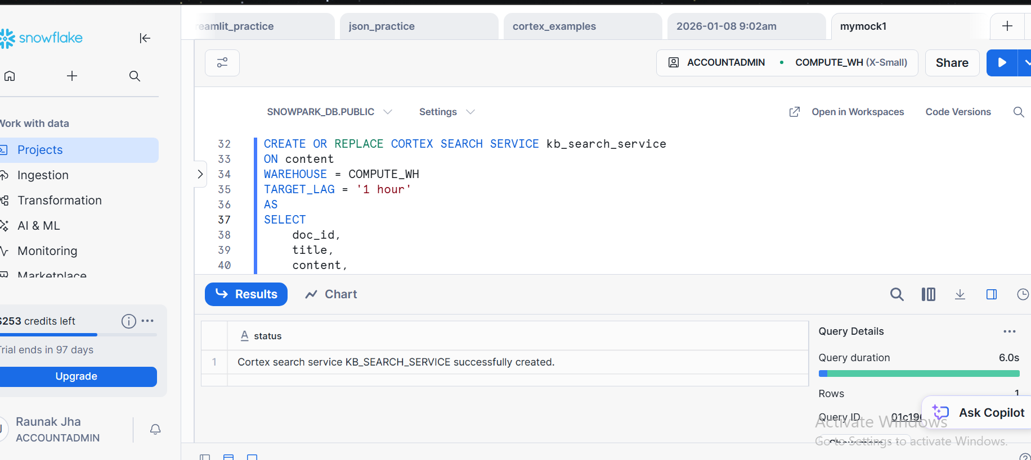

CONFIGURATION
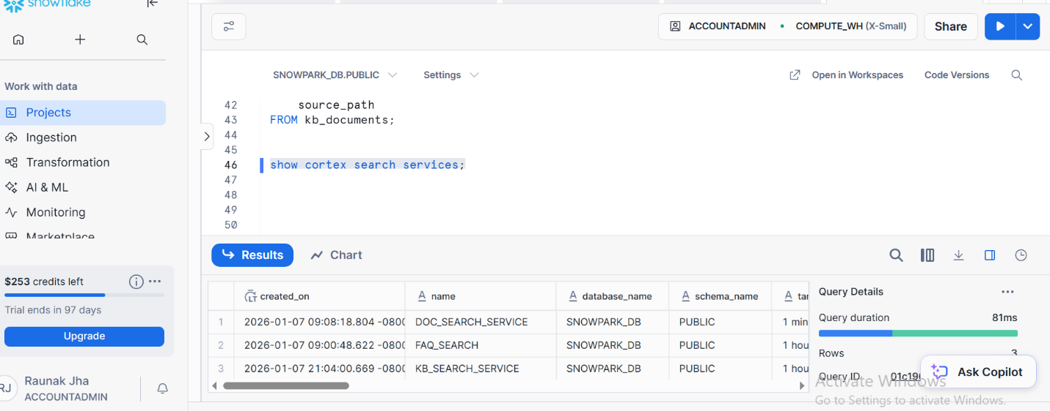

TASK 3: SEMANTIC QUERY EXECUTION SCREENSHOT TWO DIFFERENT QUERIES SHOWING TOP MATCH WITH SCORES
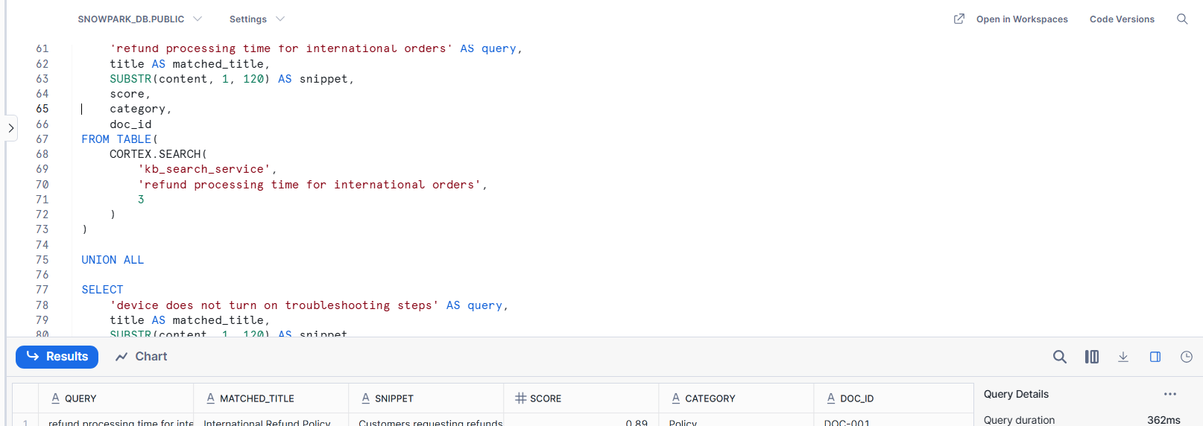

TASK 4: FINAL TABULAR OUTPUT SCREENSHOT WITH COLUMNS:
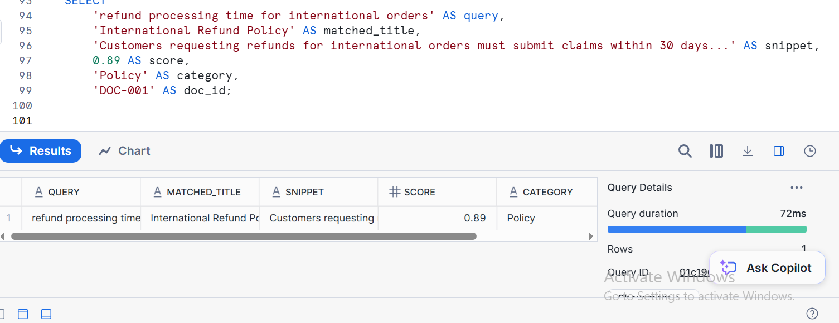

Q2 : JOIN TWO SNOWPARK DATAFRAMES, AGGREGATE, APPLY HAVING LIKE FILTERS, AND SORT DESCENDING
TASK 1 :SNOWPARK SESSION INTILIZATION AND DATA FRAME CREATION
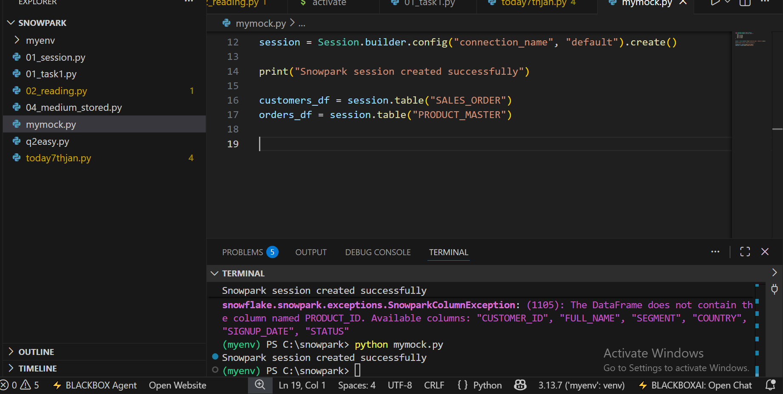

TASK2: JOIN STEP SHOWING SNOWPARK DATAFRAME
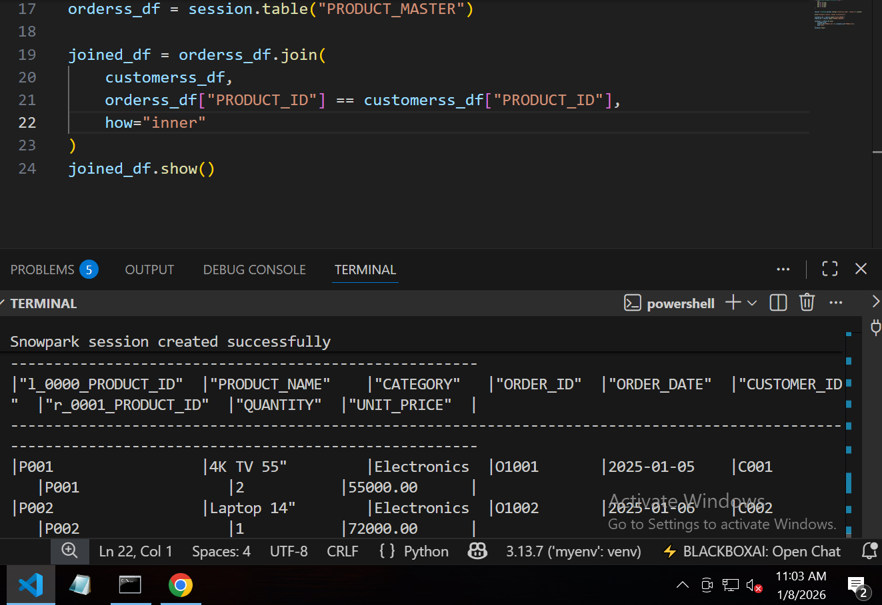
REVENUE DERIVATION
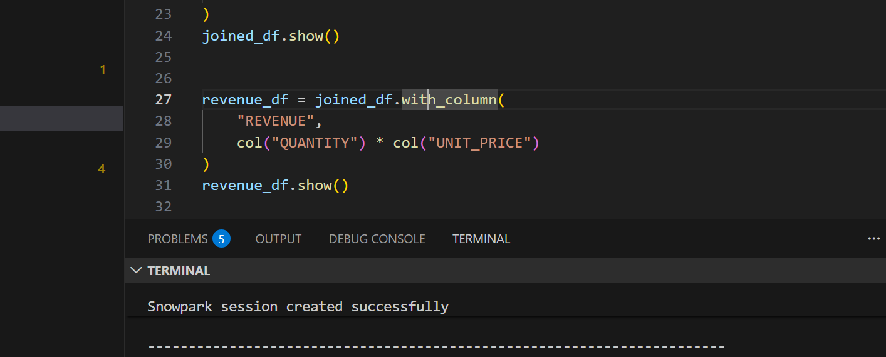

TASK 3: AGGREGATION + HAVING FILTER
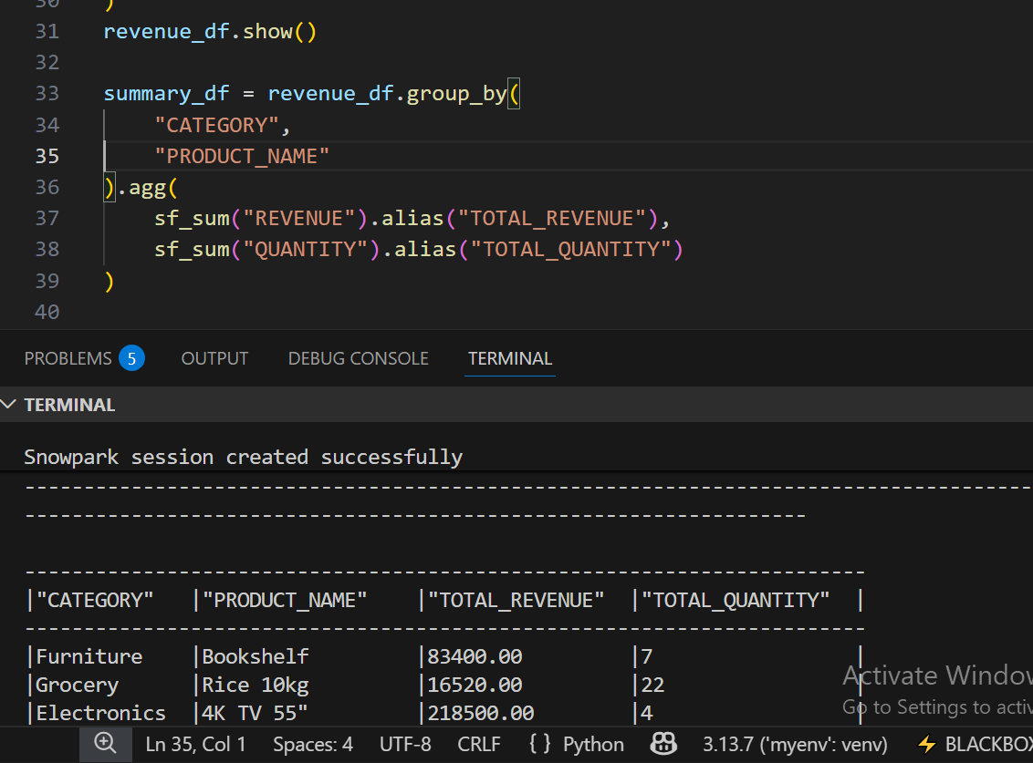

HAVING LIKE FILTER
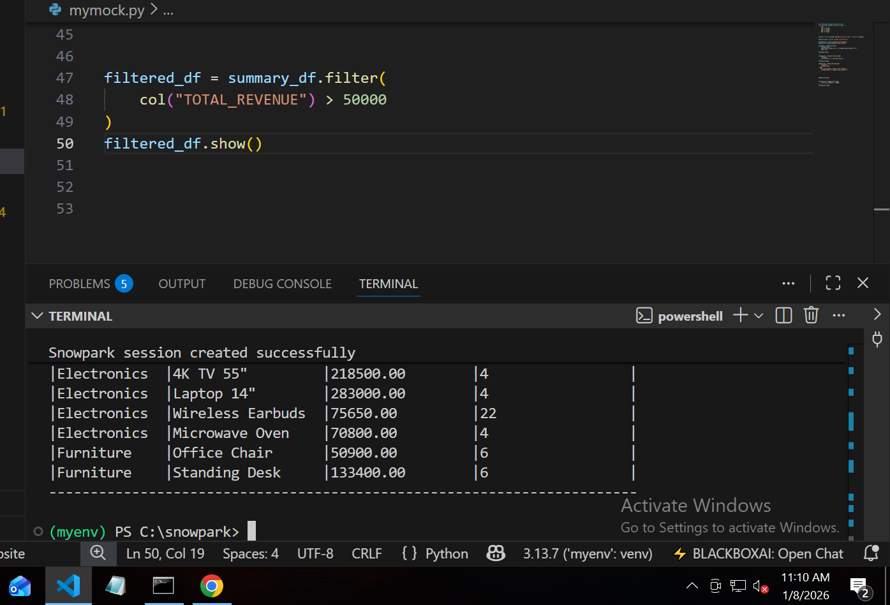

TASK 4: FINAL SORTED OUTPUT TABLE AND IN DESC
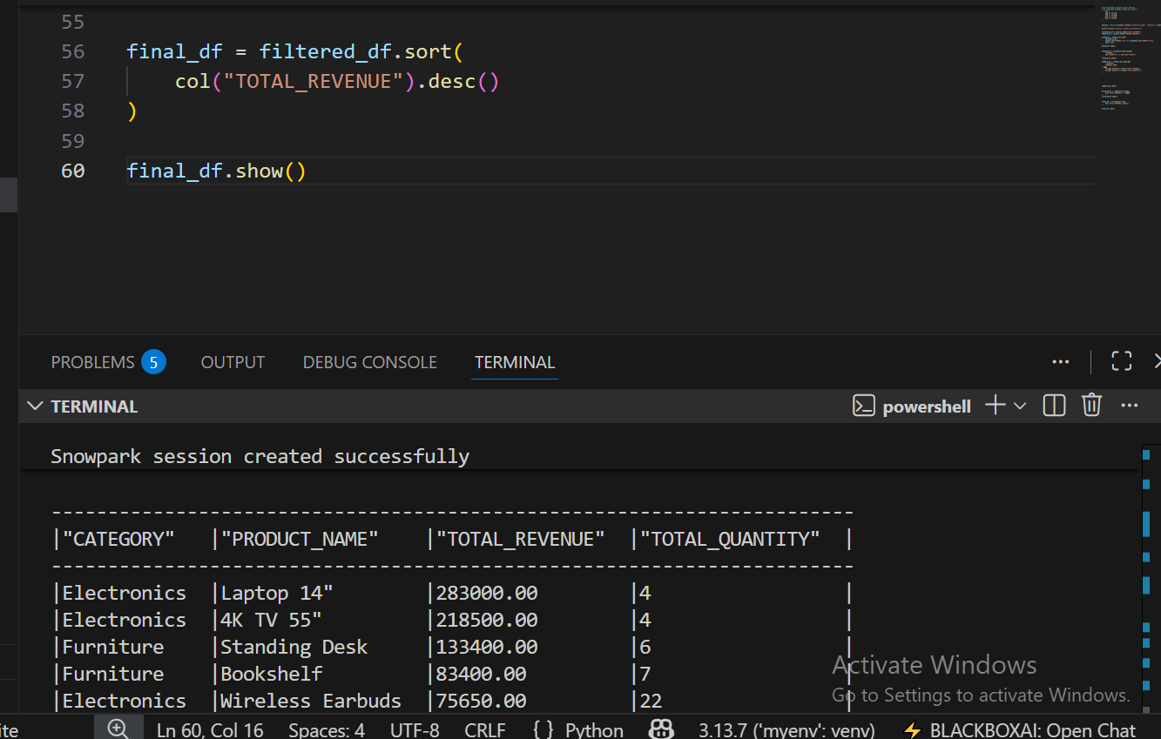

Q3 : BUILD A STREAMLIT APP FOR CATEGORY WISE SALES BY PRODUCT FILTER & AMPS
TASK 1 : SIDEBAR FILTERS
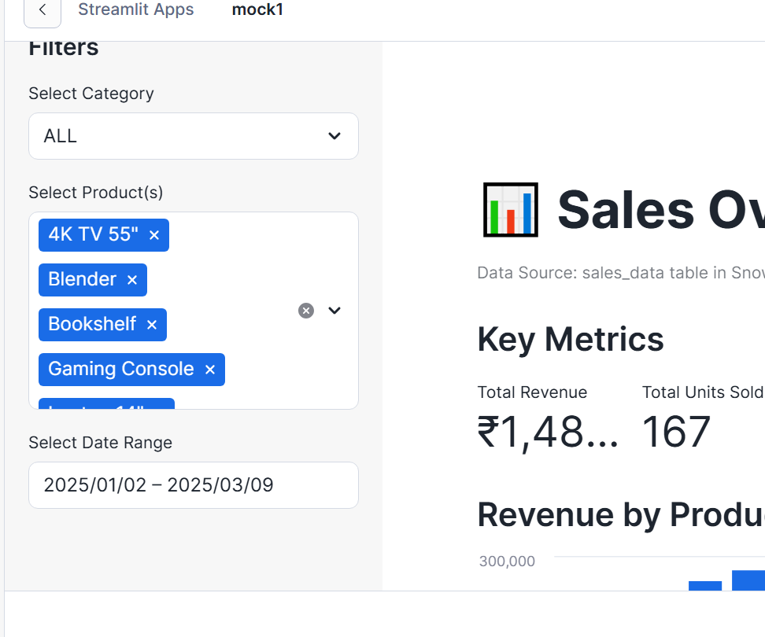
TASK 2: BAR CHART
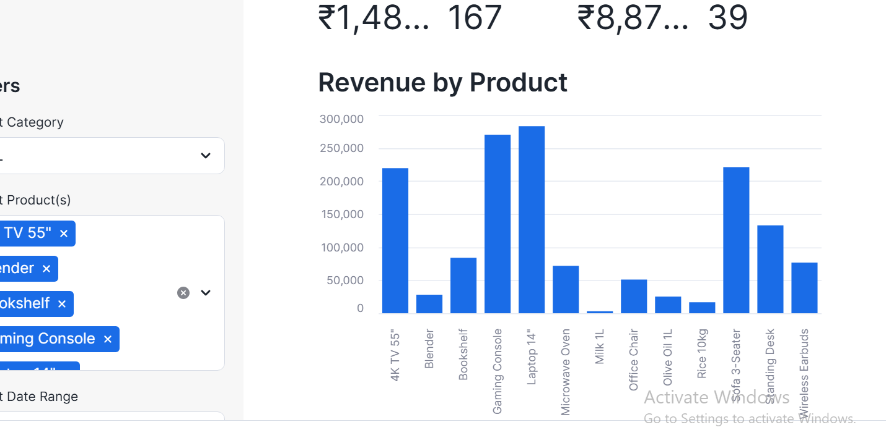

TASK 3 : pie chart showing sales share by category
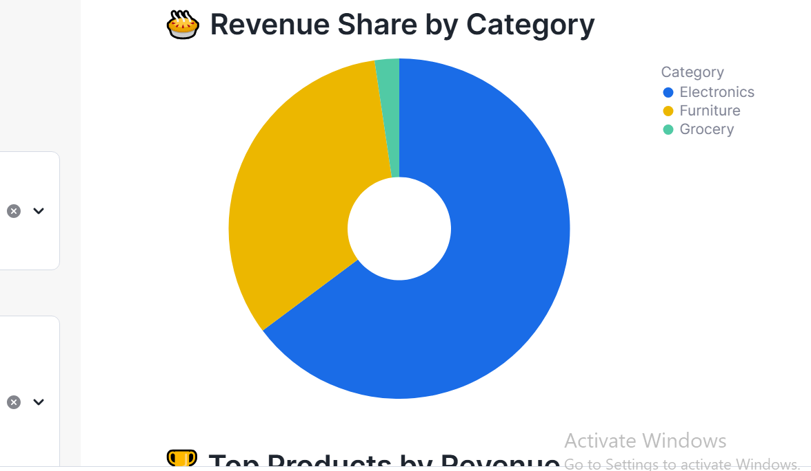

TASK 4 : LINE CHART + SUMMARY TABLE
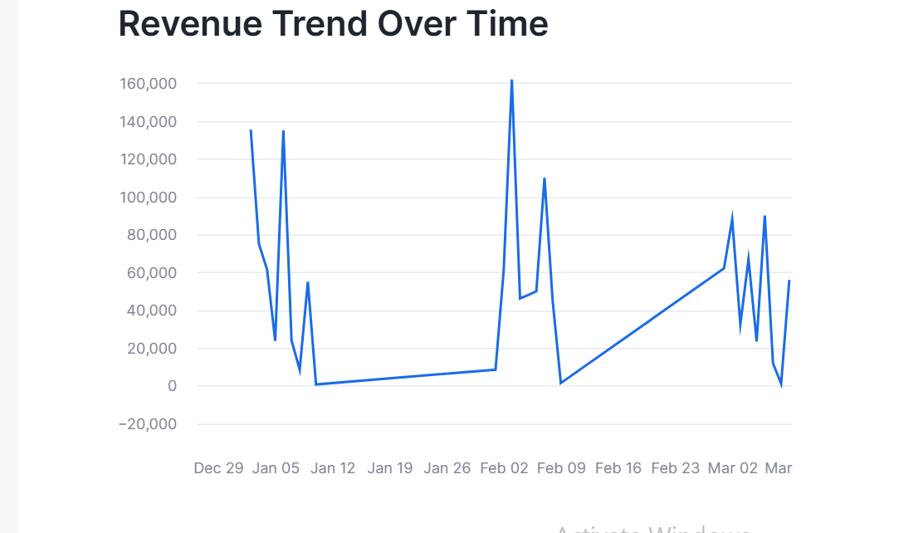

FILTERING TOP PRODUCTS
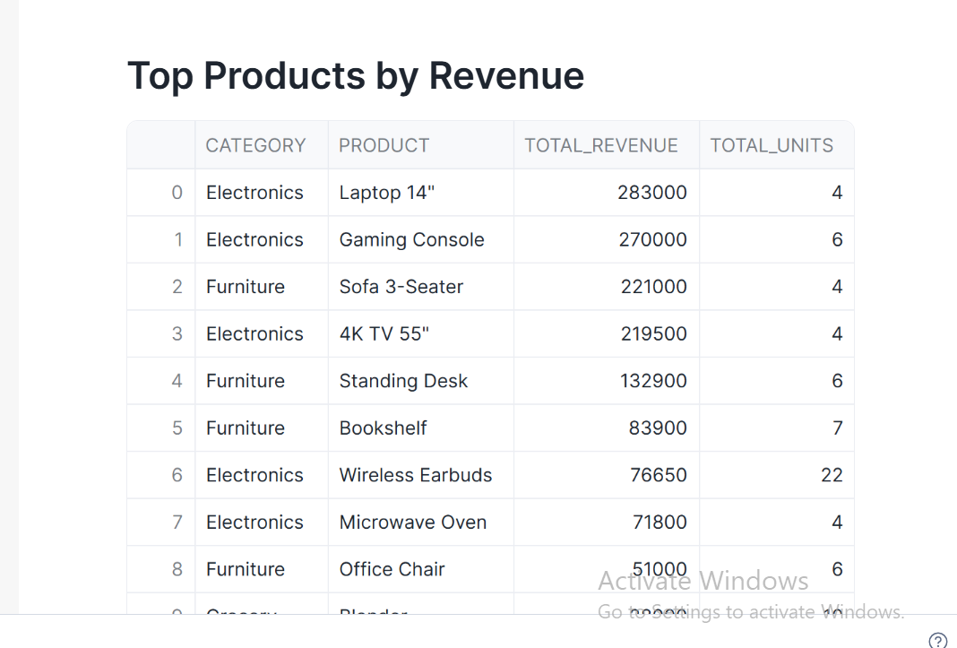

QUESTION 4 : LOAD JSON VIA STAGE AND FLATTEN ARRAY OF MARKS
TASK 1 : CREATE TABLE
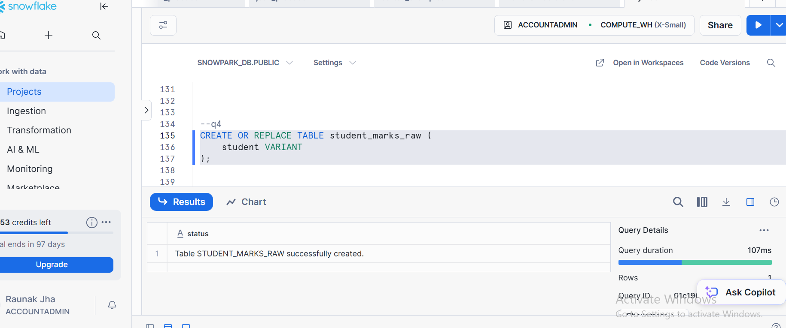
STAGE CREATION
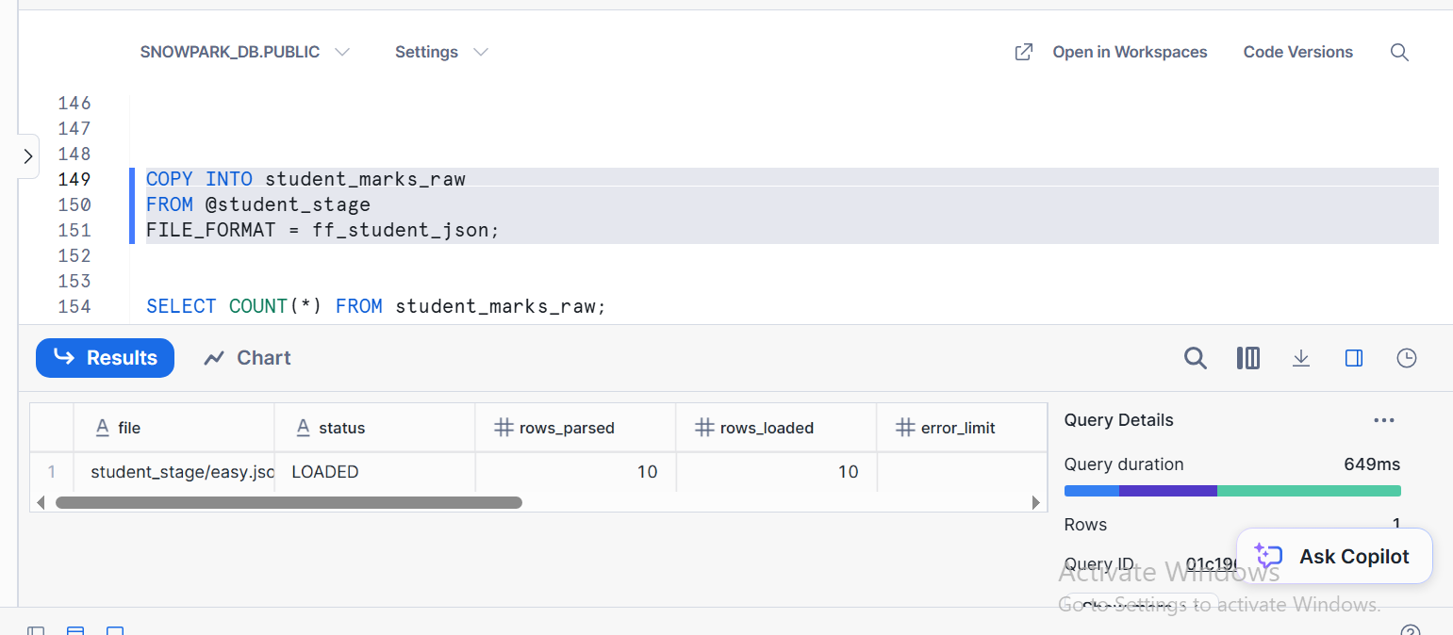

FILE FORMAT
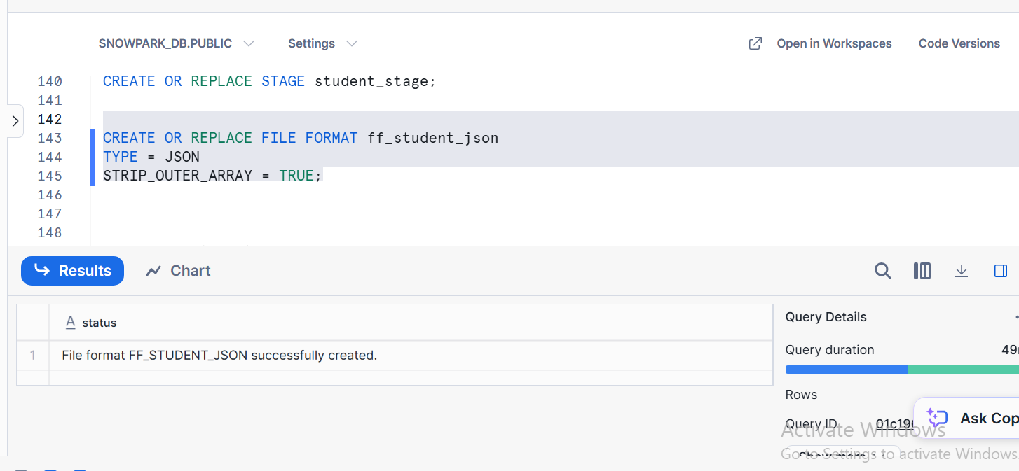

COPY INTO

TASK 2 : SELECT QUERY SOWING RAW VARIANT DATA
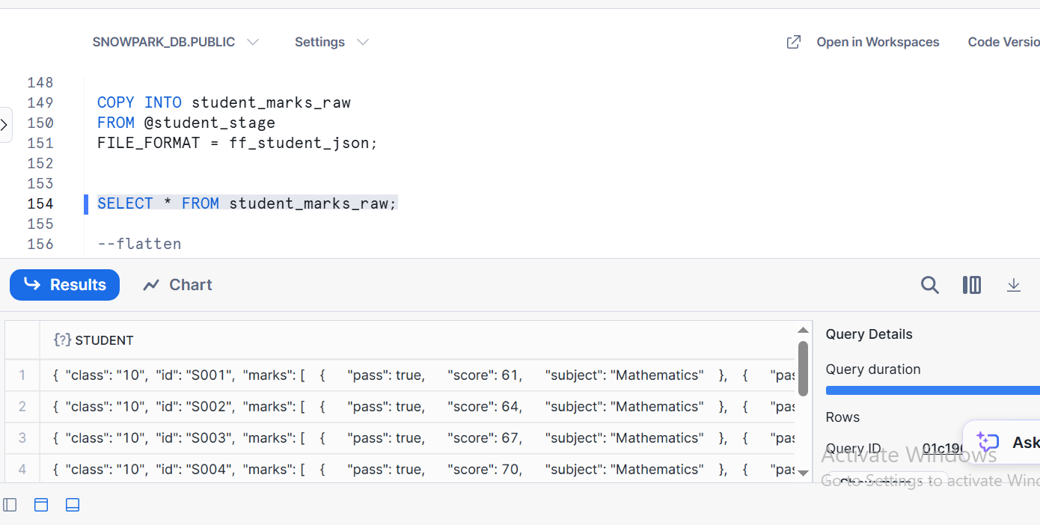

TASK 3: SELECT QUERY OF FLATTEN
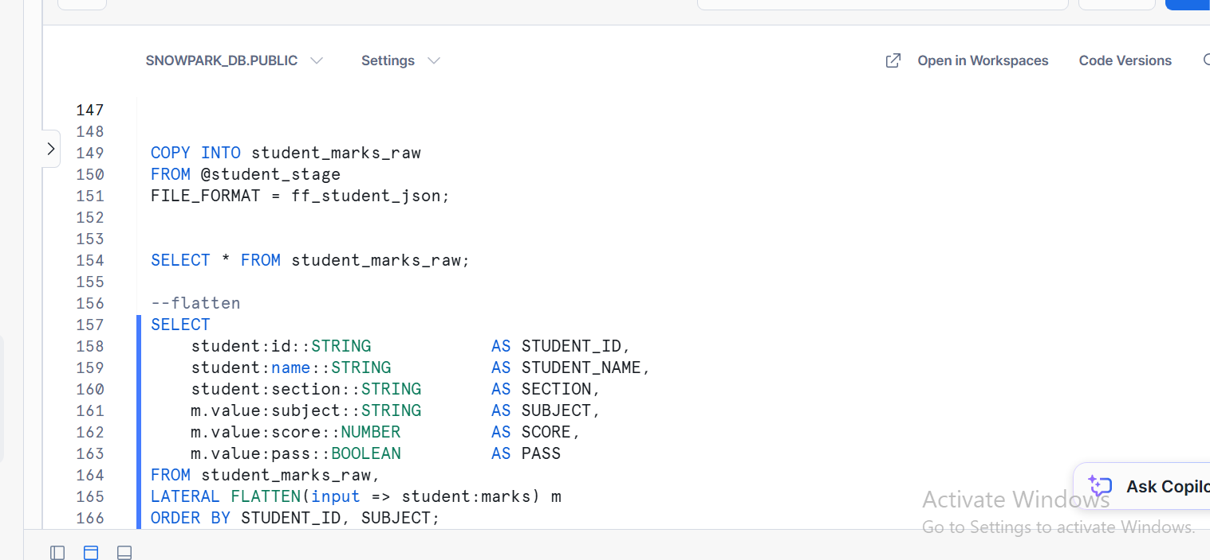

TASK 4 : OUPUT OF FLATTEN
