Name – Raunak Jha
Question 1: Build a Streamlit app for city wise orders by fulfillment type
TASK 1: APP RUNNING WITH SIDE BAR FILTERS OF CITY, FULFILLMENT TYPE, DATE RANGE
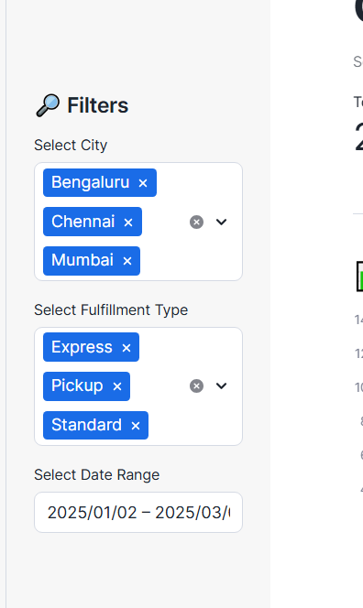

TASK 2: BAR CHART SHOWING CITY ORDERS BY FULLFILLMENT TYPE
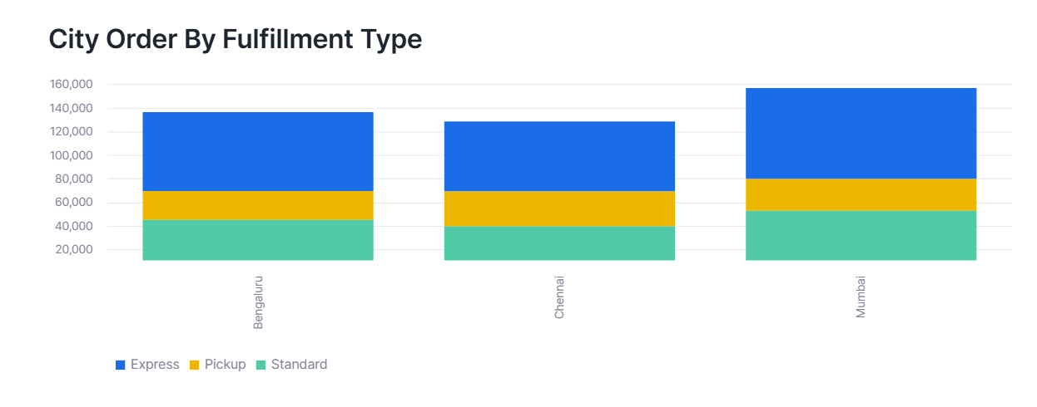
TASK 3: PIE CHART SHOWING ORDER VALUE SHARE BY CITY
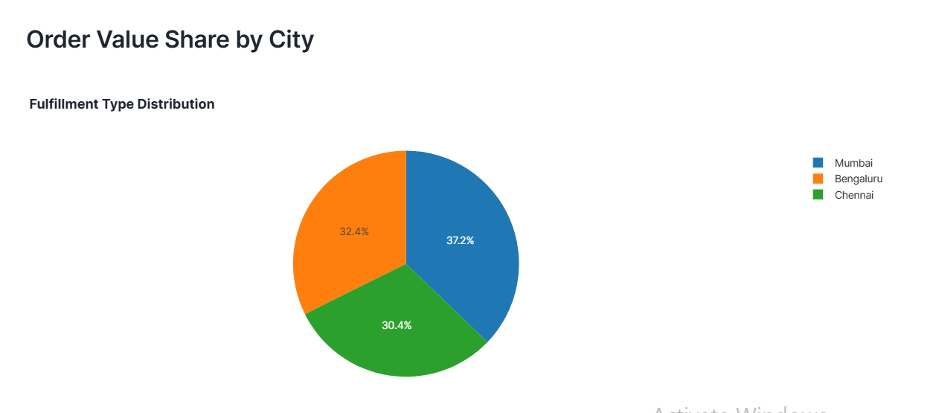

TASK 4: LINE CHART + SUMMARY TABLE
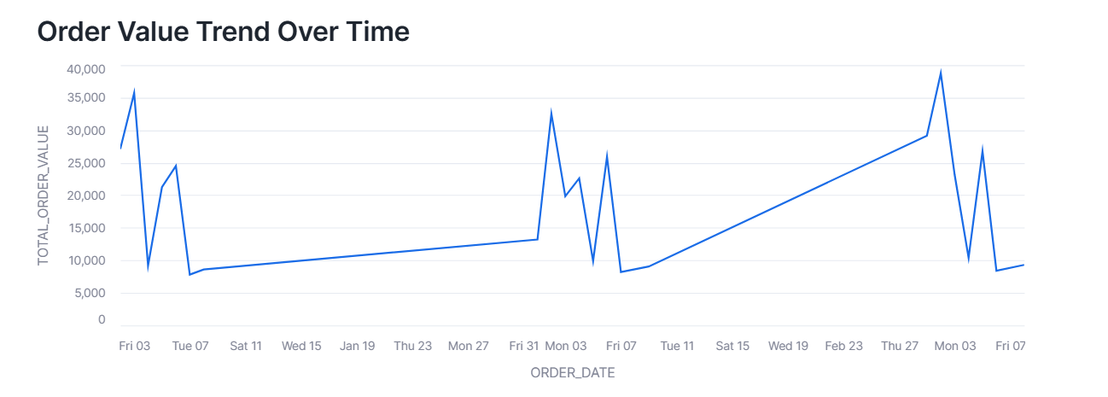

SUMMARY TABLE
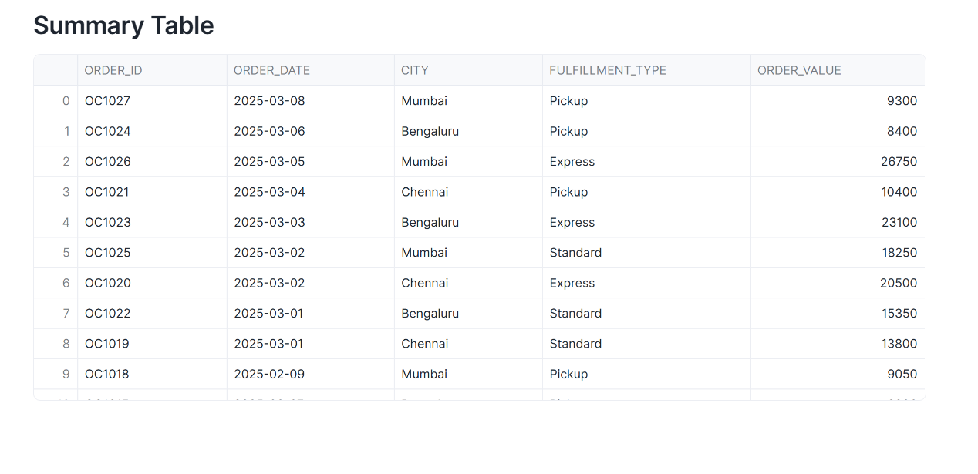

QUESTION 2 : JOIN TWO SNOWPARK DATAFRAMES, AGGREGATE, APPLY HAVING LIKE FILTERS AND SORT DESCENDING
TASK 1: SNOWPARK SESSION INTIALIZATION AND DATA FRAME CREATION
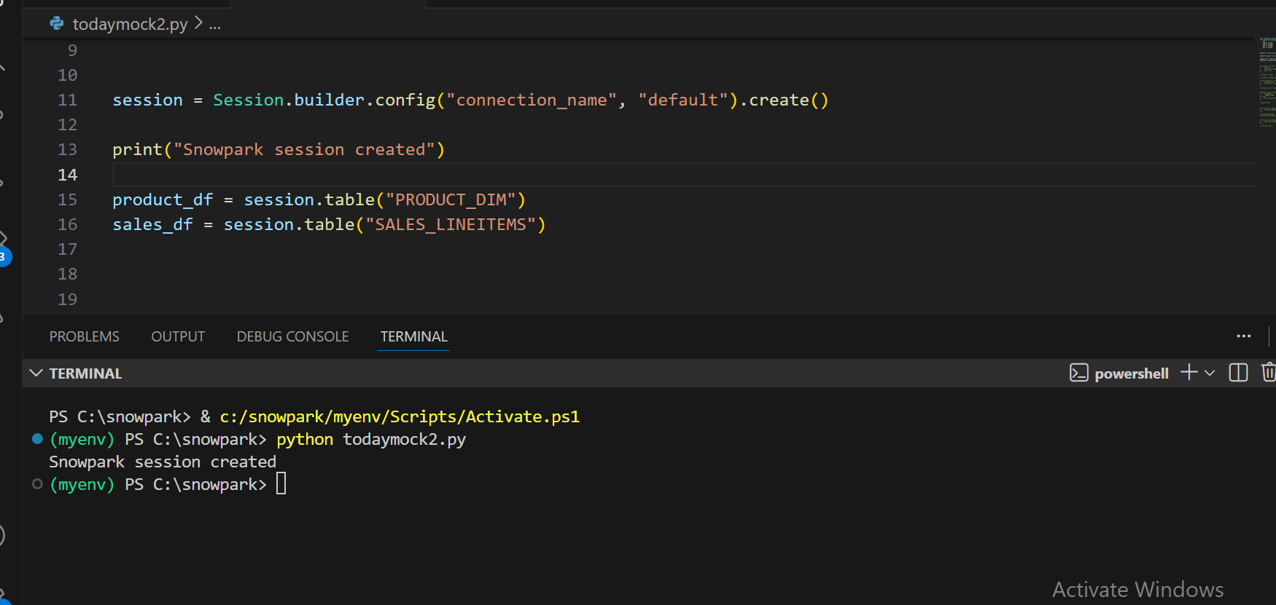

TASK 2: JOIN STEP AND REVENUE DERIVATION
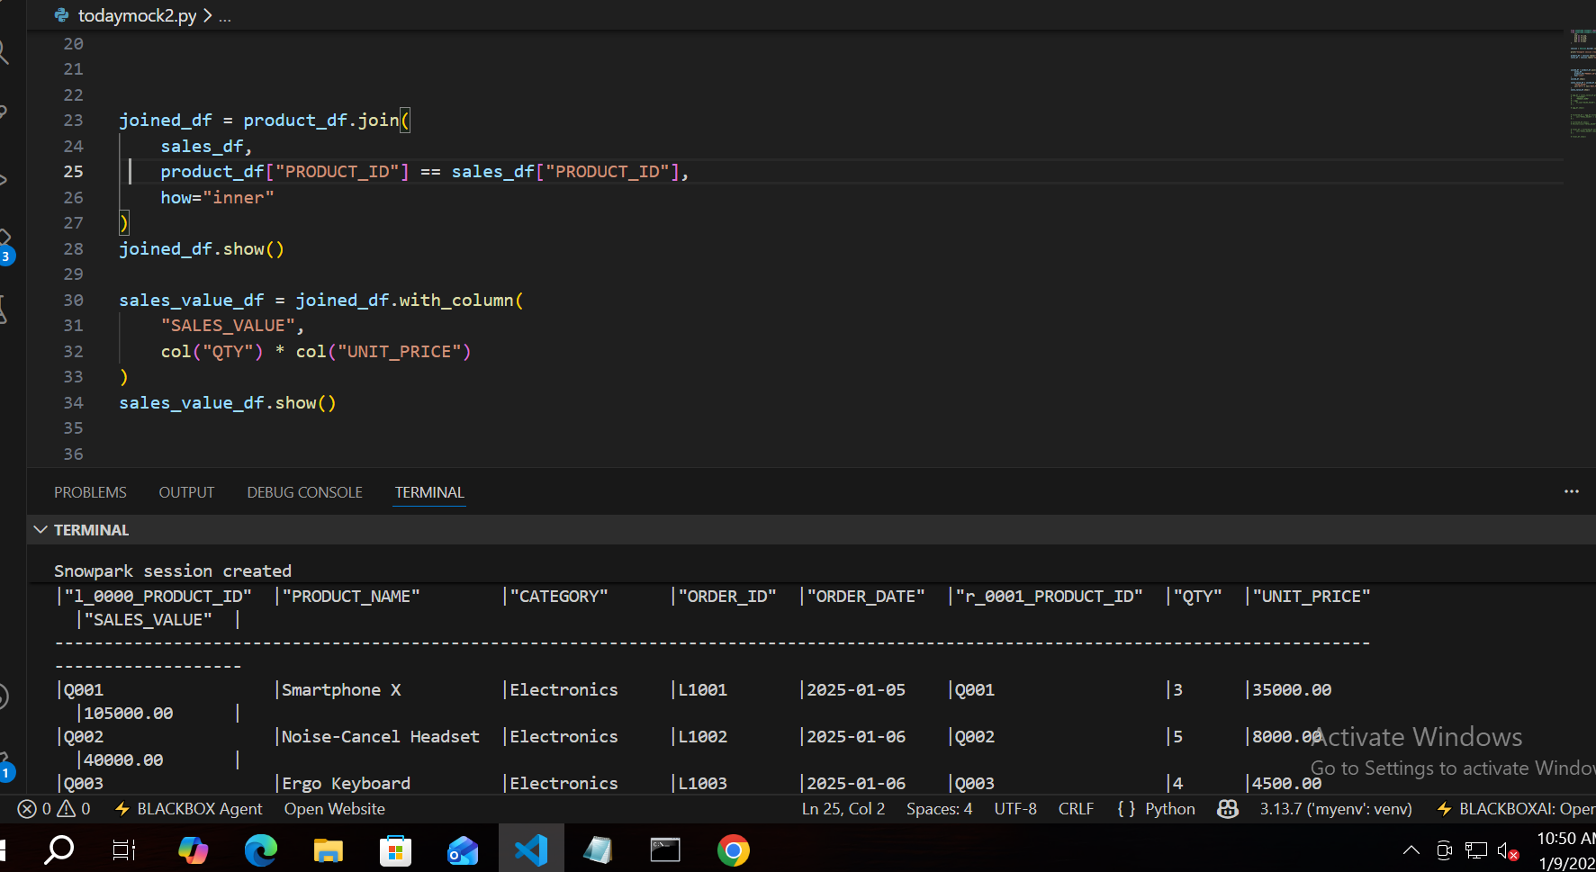

TASK 3: AGGREGATE + HAVING FILTER
AGGREGATION
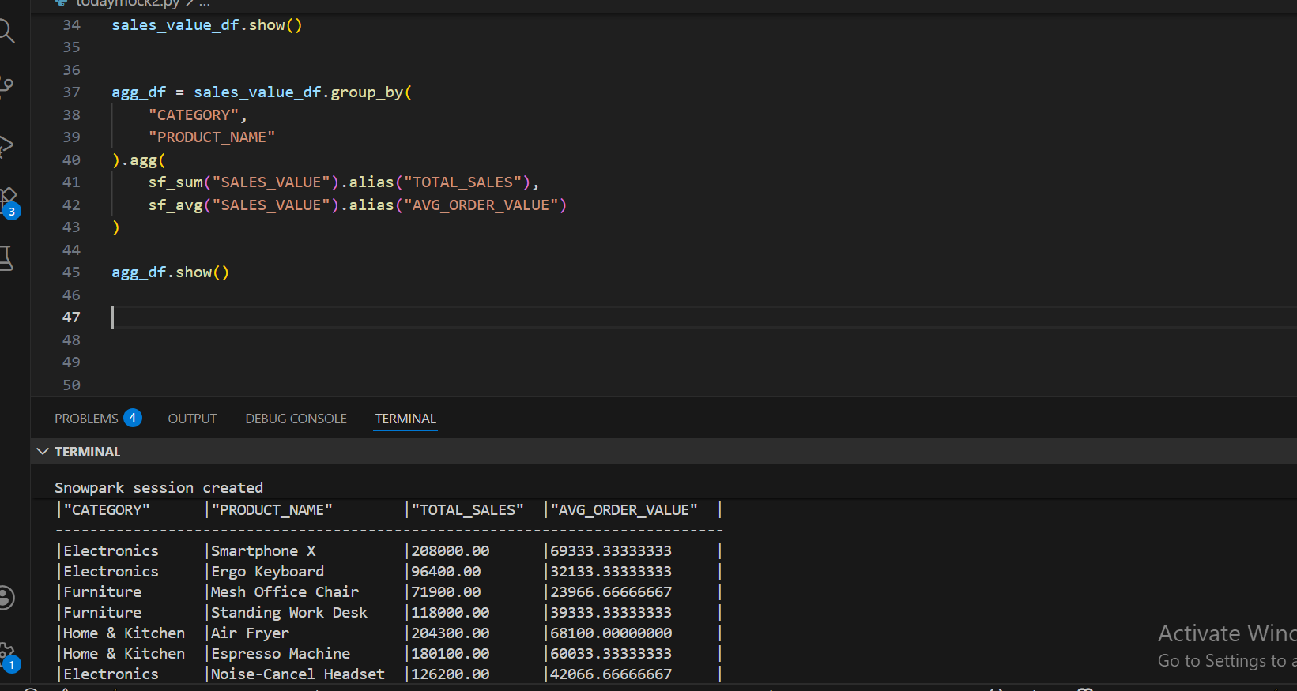

HAVING LIKE FILTER
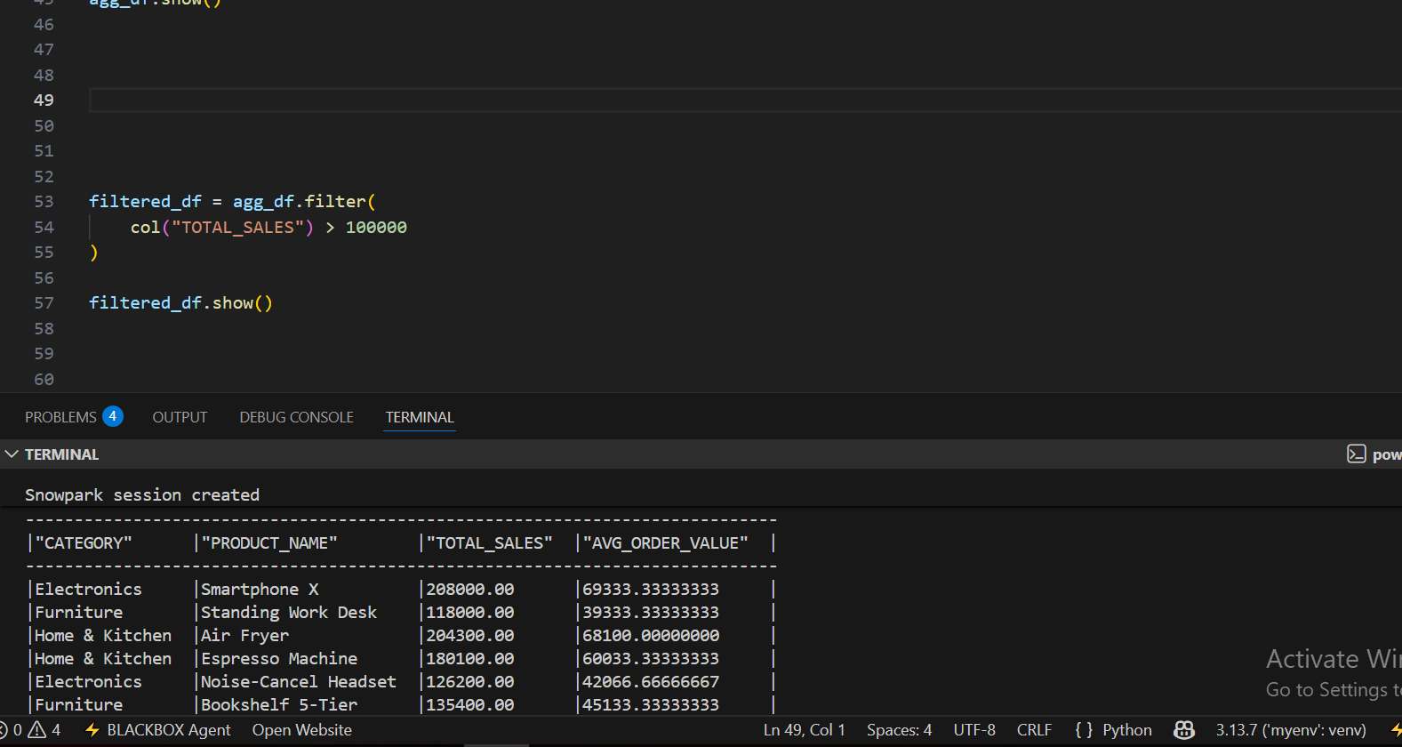

TASK 4 : FINAL SORTED OUPUT TABLE
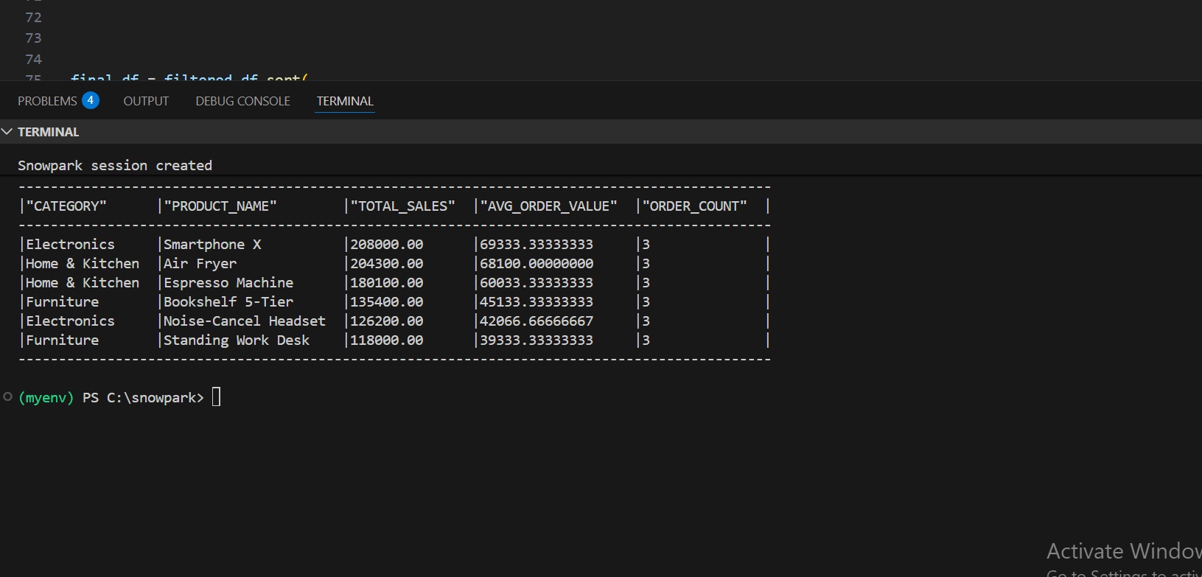

QUESTION 3: CONFIGURE THE CORTEX SEARCH SERVICE & CORTEX SEARCH PREVIEW FOR SEMANTIC DOCUMENT RETRIEVAL
TASK 1 : CREATE AND INSERTION EXECUTION
CREATE TABLE EXECUTION
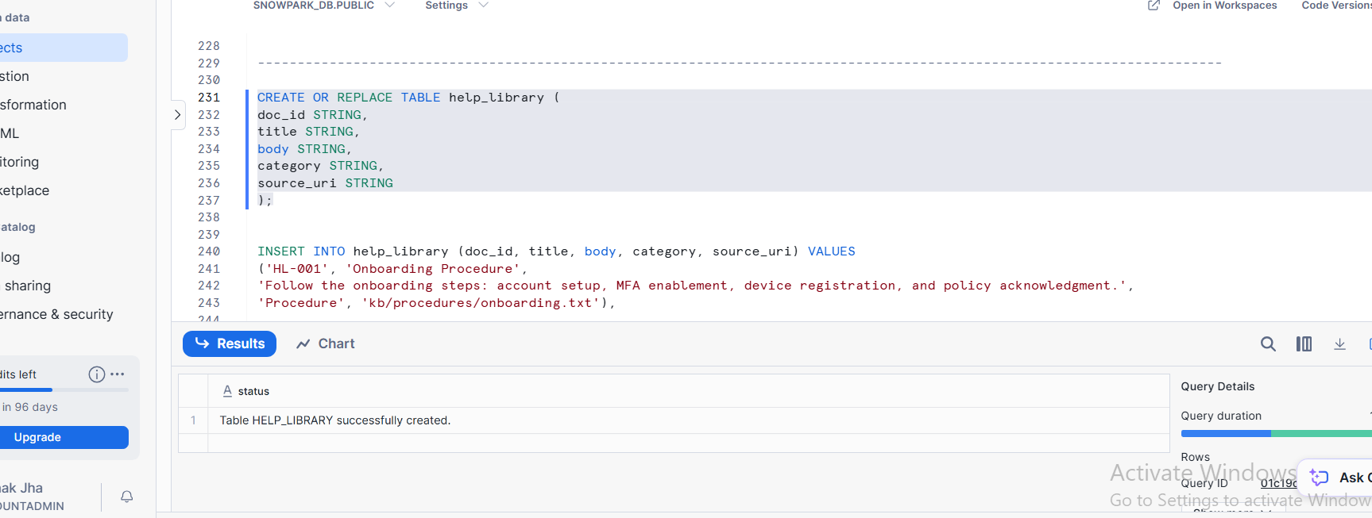

INSERT EXECUTION
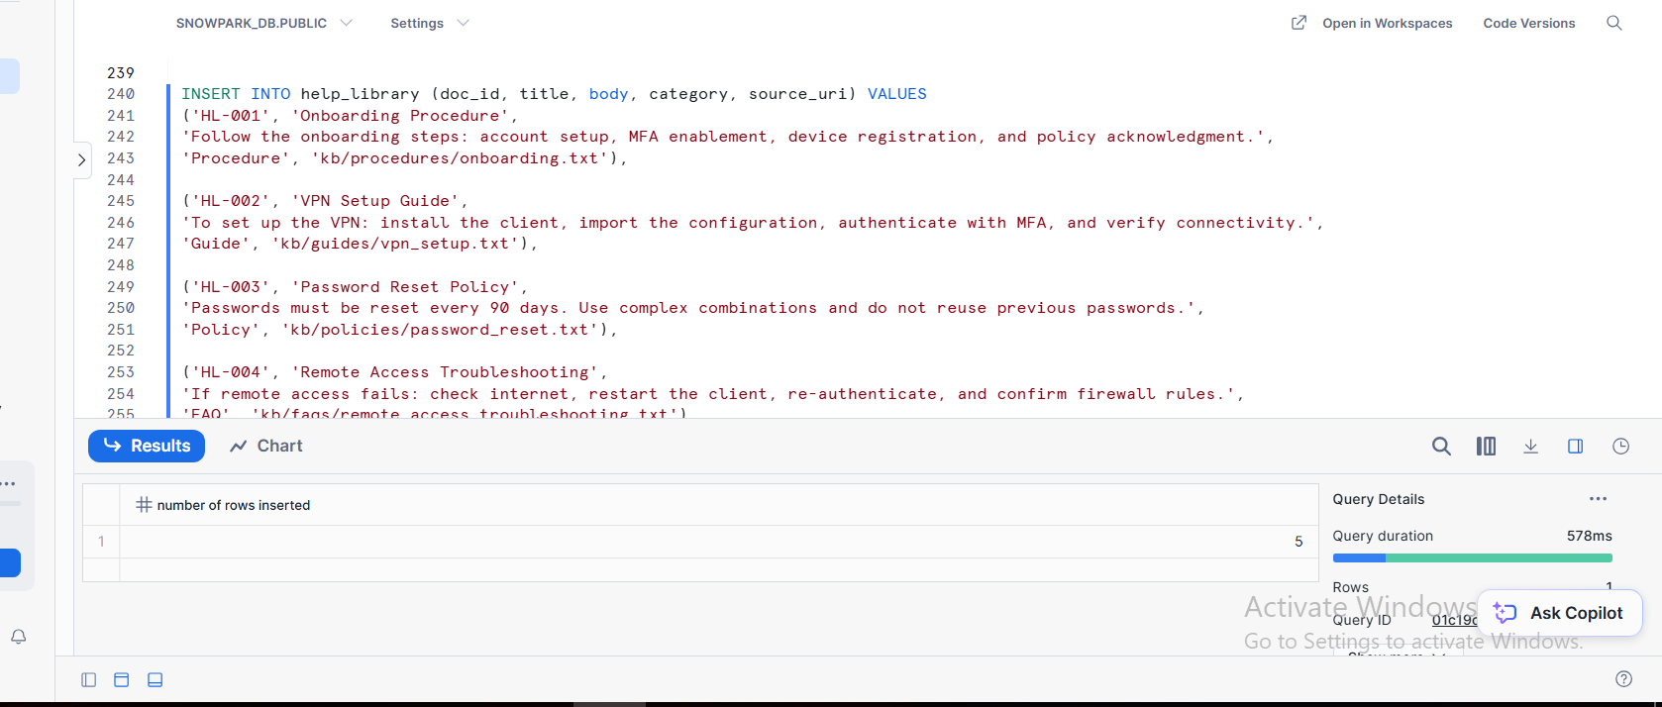

TASK 2 : CORTEX SEARCH PREVIW CONFIGURATION CREATION
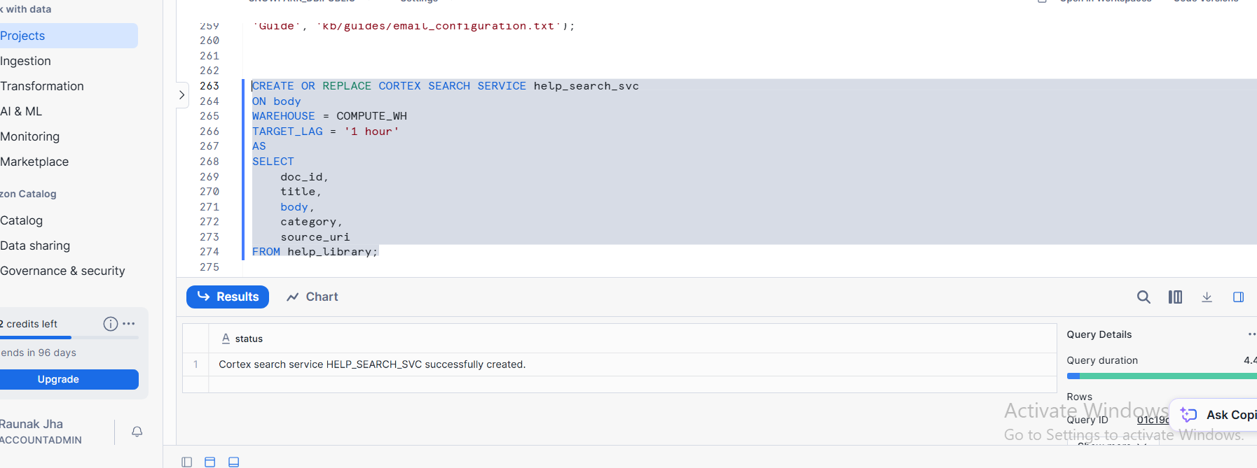

TASK 3 : SEMNATIC QUERY EXECUTION SCREENSHOT(TWO QUERIES)
QUERY 1
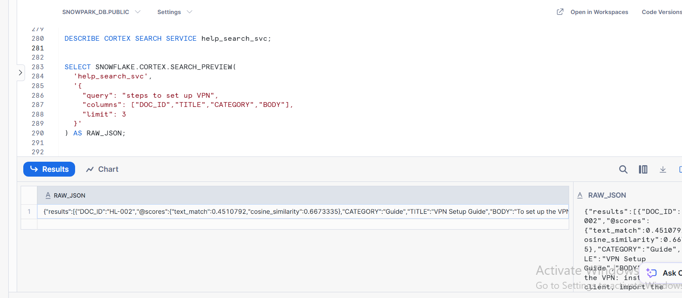
QUERY 2
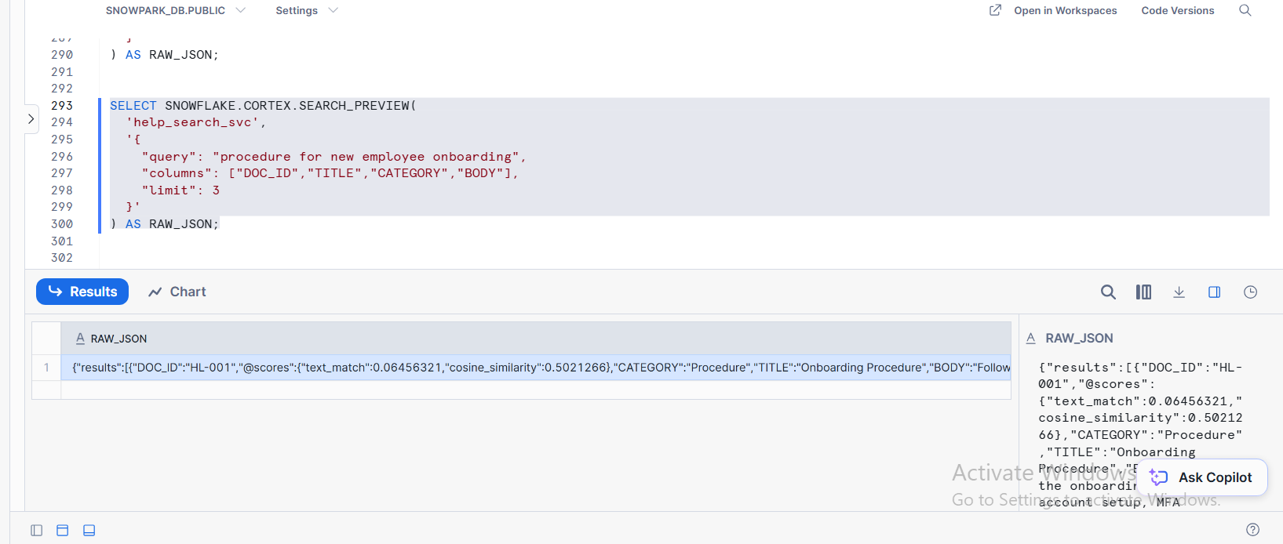

TASK 4 : FINAL TABULAR OUTPUT WITH COLUMNS
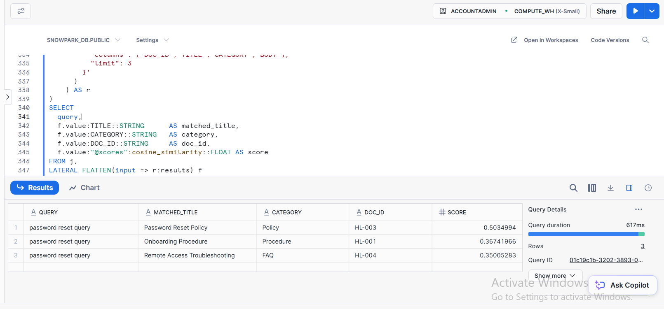

QUESTION 4 : LOAD JSON VIA STAGE AND FLATTEN ARRAY OF SESSIONS
TASK 1 : CREATE TABLE/ CREATE STAGE/ CREATE FILE FORMAT/ COPY INTO STATEMENTS
CREATE TABLE
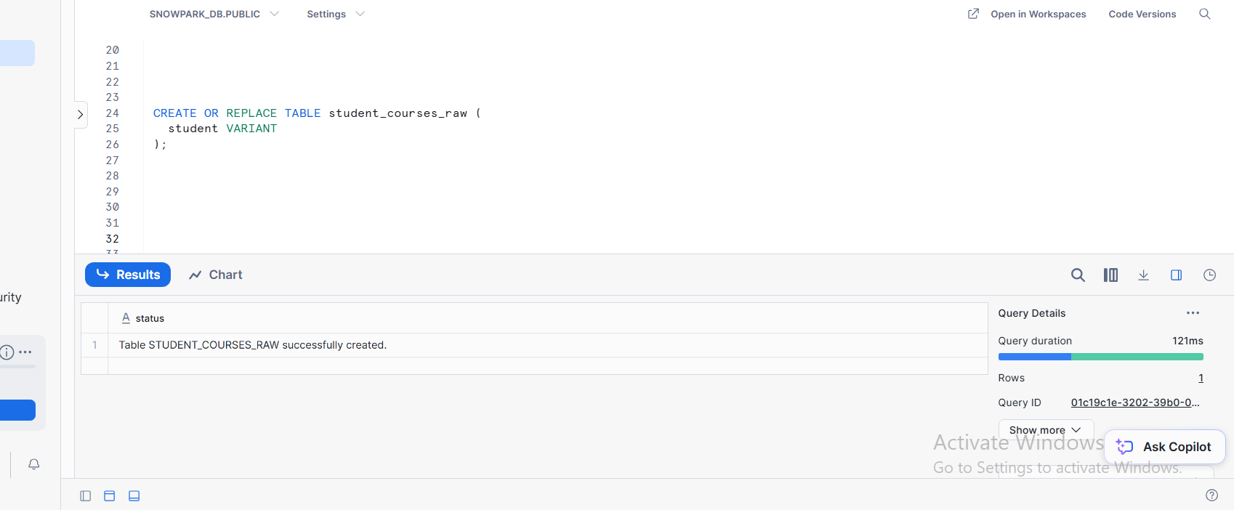

CREATE STAGE
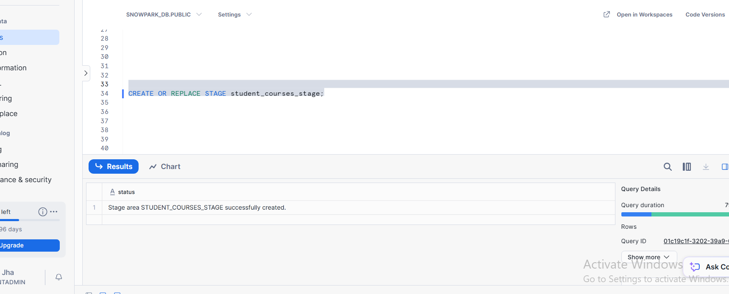

CREATE FILE FORMAT

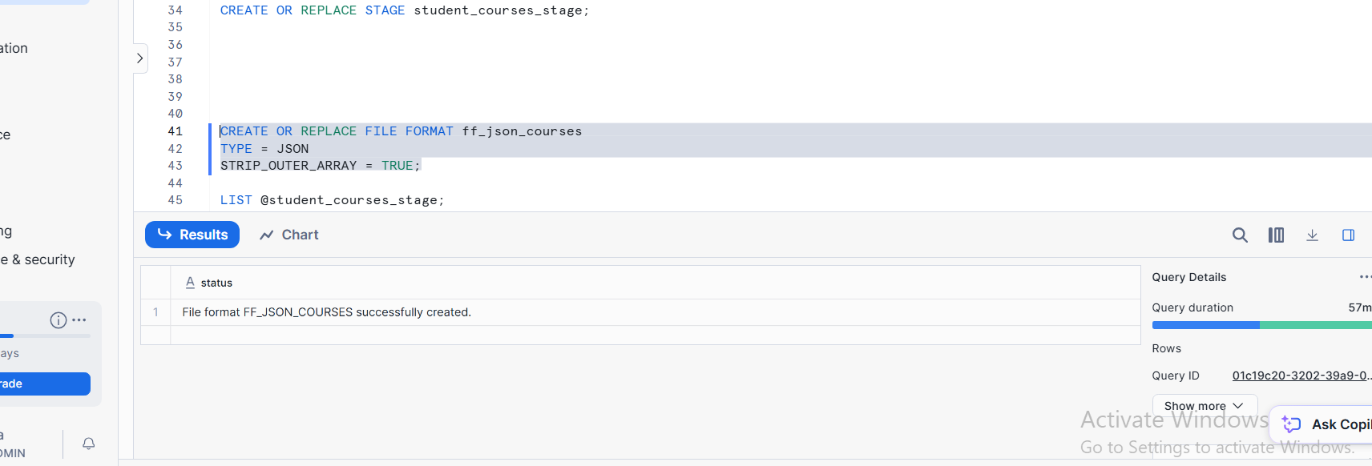

COPY INTO STATEMENT
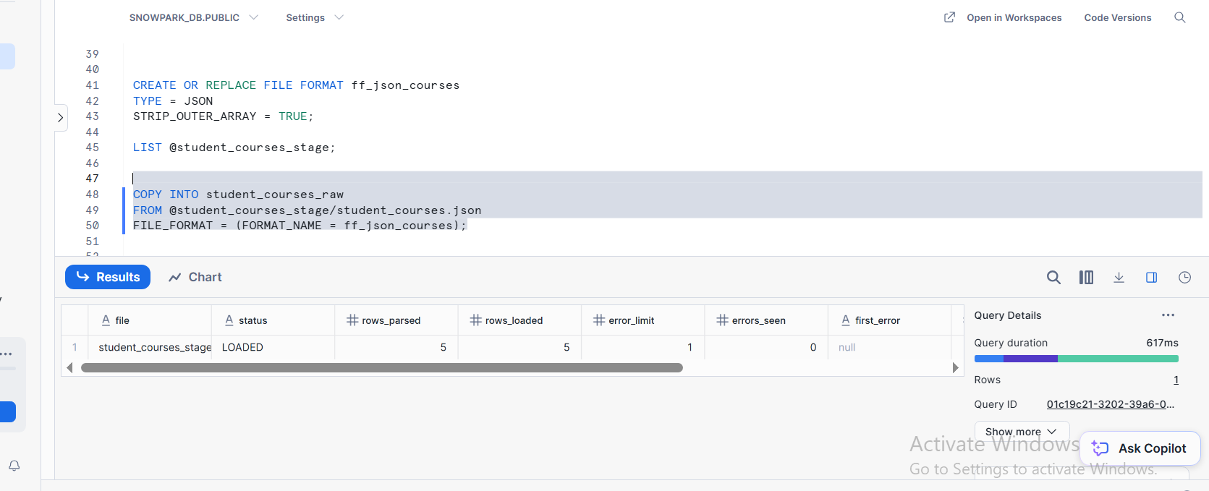

TASK 2 : SELECT QUERY SHOWING RAW VARIANT DATA
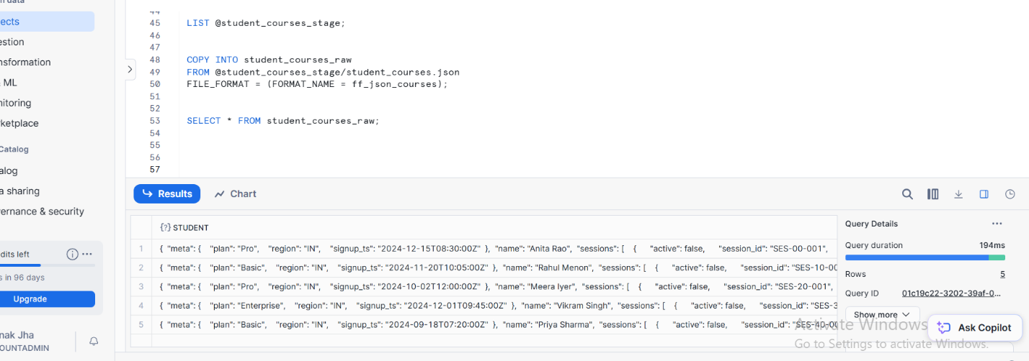
TASK 3 : SELECT QUERY OF LATERAL FLATTEN ON ARRAYS
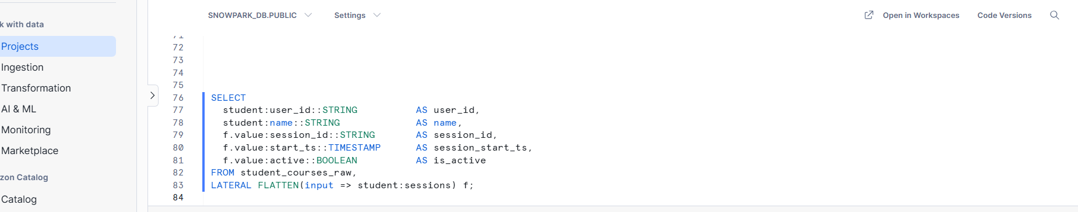

TASK 4 : FINAL OUTPUT DISPLAYING FLATTEND COLUMNS
