INSTITUTE OF ENGINEERING & MANAGEMENT

Department of Computer Science & Engineering Design Lab

Code: CS891

**SYSTEM REQUIREMENTS SPECIFICATION**

**For**

**PG WORLD**

**Version 1.0 Prepared by Team TerminalSix**

**12/03/2016**

**Revision History**

|  |  |  |  |
| --- | --- | --- | --- |
| **Name** | **Date** | **Reason For Changes** | **Version** |
| TerminalSix.SRS | 12/03/2016 | Changes based on review | 0.91 |
|  |  |  |  |
|  |  |  |  |

**Validation**

|  |  |  |  |
| --- | --- | --- | --- |
| **Approver Name** | **Title** | **Signature** | **Date** |
|  |  |  |  |
|  |  |  |  |
|  |  |  |  |
|  |  |  |  |

**Contents**

1. Product Description 1
   1. Purpose. 1
   2. Scope 1
   3. Stakeholders and Users 1
   4. Assumptions 2
   5. Constraints 2
2. Functional Requirements 3
   1. Configure College 3
   2. Registration 6
   3. Login… 7
   4. Manage Profile 8
   5. Search PG 9
   6. View PG details 12
   7. Post PG review 13
   8. Authenticate student 14
3. Interface Requirements 15
   1. User Interfaces 15
4. Use Case Model 22
   1. Use Case Diagram 22
   2. Use Case Description 22
5. Glossary 29
6. References 31

# ProductDescription

## Purpose

This document describes the requirements and specifications for a web based portal, which aims to provide an online meeting place for House owners and students. Students, especially those coming from different states find the process of looking for PGs quite cumbersome. The situation is no different for students who are coming from different districts. In most cases, students hear of PGs by word of mouth or via brokers or middlemen. As a result, there is frequent complain from students about not getting cheaper accommodation, due to brokerage activities. This portal aims to simplify the aforesaidproblems.

## Scope

The web portal will have three classes of users – House owners and Students. Independent house owners will be able to build an online profile, filling in necessary details which they would normally use to advertise themselves offline. The System will allow them a fair chance of being visible based only on their filled in information and not any advertising skills.

Students can search for PGs, filling in all the necessary criteria they desire. The System will provide them search results matching all their criteria, which they would find very difficult to find offline, purely by word of mouth. They can also read reviews and ratings of various students.

The System will provide all these functionalities to the users free of cost, with no hidden costs involved.

## Stakeholders andUsers

The following Stakeholders have been identified:

* + 1. House owners (TentativeUser)
    2. Students looking for PGs (TentativeUser)
    3. Team Terminal Six (Developers andOwners)

1

## Assumptions

1. Students and House-owners registered in the portal are genuine innature.
2. The various parameters used while searching are sufficient to find optimal matches as actually required by thestudent.
3. The student should be honest about his rating and views about thePG.

## Constraints

1. A student’s search for PG near a college is limited to the availability of such accommodations in the nearby area.

2

# FunctionalRequirements

* 1. **ConfigureCollege**

**Description:** Admin will add all the college names for which service will provided. A particular college name will be added to the system with all the details of that. The address of the college will be added to the system with the accurate latitude and longitude. The college will be displayed in the Google Map API.

* + 1. In the configure college form admin will provide all the details of a college in particular text box fields. The fields are as follows:
       1. Name: This field will be a simple text box for entering the college name.
       2. City: This field will be a simple text box for entering the name of the city where the college is situated.
    2. Admin will then click on the “calculate Latt /Lang” button for calculating the latitude and longitude of the college. The Geocoding feature of Google Maps API outputs the latitudes and longitudes of the requested query.
    3. Admin will then click on the “Add College” button for adding the college name in the college name list.
    4. Then the newly added college name will be added to the list.

## Registration

**Description:** Actors can register themselves with the system. This registration provides the actor with their own user account, by virtue of which they can navigate/use the different functionalities of the system. The Registration use case can be divided into two sub categories: Home owner and Student Registration.

* + 1. The first part of the registration page will be same for both the Home owner and the student, requesting basic details and they are distinguished by a final option.
    2. The registration form fields will be as follows:
       1. The common section of the registration page consists of:
          1. Name: This field will be a simple text box for name.
          2. Email Address: This field will be a simple text box for email. System must ensure that the email entered is of valid format. Also Email is a unique field in the database, so one email can have only one account.
          3. Contact Number: This field will be a simple text box for Contact Number. System must ensure that only valid Number formats (10-digit without special characters) is entered.
          4. Password: This field will be password type box. This is used to enter the password for the user.
          5. The distinction between the landowner and the student is done based on the radio button, having options student and land owner.
    3. Finally, the “Next” Button will submit all the data to System server. Server will validate all the data as mentioned above, and return a positive or negative acknowledgement.
    4. If acknowledgement is positive, the actor is taken to another page for filling of other mandatory details related him/her, in order to complete the registration process. The fields are as follows:
       1. For the Student’s details:
          1. Name: Text field containing the name entered in the previous step.
          2. E-mail: Text field containing the e-mail entered in the previous step, with duevalidation, as done previously.
          3. Contact No. Number field containing the phone number previouslyentered.
          4. Gender: Drop down box, containing options Male, Female,Other.
          5. Date of Birth: This field will be a date selection widget for selection of date ofbirth.

System must ensure that the date of birth cannot be after the current System date.

* + - * 1. College Name: A drop down box from which the student can select his/her college name.
        2. Permanent Address: A text field to enter the permanent address of the student.

* + - * 1. Submit button: To finalise the details and submit to the server. The system, at this point validates the mandatory fields and proceeds to the student’s homepage. If any errors are found, the student is prompted to make due corrections before proceeding.
      1. For Home owner’sdetails:
         1. Address Line 1 & 2: Text field toenter address
         2. City: Text field to enter cityname.
         3. Pin code: Numeric field to enter pin code, with validation for Indian pin code format.
         4. PG for: Radio buttons to select whether the PG is for male or female students.
         5. List with entries for number of beds available in 1bed, 2 bed and 3 bed room categories with their respective prices indicated.
         6. Other facilities: Check boxes to select which of the facilities are provided at the PG (Wi-Fi, Food, TV,AC).
         7. Submit Button: To finalise the details and submit to the server. The system at this point validates the mandatory fields and proceeds to the houseowner’s homepage. If any errors are found,

the house owner is prompted to make due corrections before proceeding.

**2.2.3** If acknowledgement is negative, the actor is redirected to the homepage with an error message.

* 1. **Login**

**Description**: An actor has to login to the site to avail its full functionalities, after creating and account during registration.

* + 1. The login page contains the following fields:
       1. E-mail: This is a text field, for entering the e-mail id of the user, against which the account is created.
       2. Password: This is a password field for entering the password, as stored during registering.
    2. After entering the fields, the actor clicks on “Log In” button. At this point, the system checks for the validity of the e-mail and password combination from its database.

If a match is found, the server starts a new session, and the actor is taken to his/her homepage with access level according to his account.

But if no such match is found, the actor is notified about the same and is prompted to enter correct credentials.

## ManageProfile

**Description:** House owner and student are the actor here. House owner can add the PG name, address of the PG , the facilities will be provided to this form.

When this details will be added then the new PG details will be successfully added to the list.

Student can update his/her previously given details in this form.

* + 1. **Houseowner**

**2.4.2.1** House owner will add the PG details in the add PGdetails

form by giving all the values in the form. The fields that are to be filled by the House owner are as follows;

* + - * 1. Address line1: This is a simple text box where the address of the PG will be added. This is a Mandatory field which House owner has tofill.
        2. Address Line2: This is a simple text box where the address of the PG can be added if the address is too longto fill in the address line1. But this is not a mandatoryfield.
        3. City: This is a simple text box where House ownerwill enter the City name where the PG is situated. This is a mandatory field which House owner must has tofill.
        4. State: This is a simple text box where Houseowner will enter the state name where the PG issituated.
        5. Pin code: This is a simple text box where Houseowner will enter the pin code of the location where the PG is situated. This is a mandatory field which House owner has to fill. This field can be fill with numbers and the must have to be of 6 digits. If House owner enters anything apart from the number or if the number is less than 6 digit then a pop up message will be displayed that “Pin code isinvalid”.
        6. NO. of available occupancy: This is a simple text field which has to be filled by the house owner. This field can be filled up only by the numbers. If house owner enters apart from numbers a popup message will be displayed whichwill show “Invalidinput”.
        7. Price: This is a simple text field which has to be filled by the House owner. This text filled is mandatory field. This field can be filled up only by numbers. If House owner enters apart from numbers in this field then a pop up will be displayed as “Invalid input”.
        8. Facilities: Here four check boxes are displayed like Food, TV, AC and Wi-Fi. House owner can select any number of check boxes which he/she will provide for the PG.
        9. E-mail: This field is a text field by which Houseowner can update his/her previously provided e-mail id. This field is e-mail address sensitive so it should contain one“@”.
        10. Password: This is a text field through which House owner can update his/her password for his/her account which is previously given.
        11. Contact Number: This is a text field through which House owner can up update his/her contact number which is previously given by them. This field is number sensitive only. If House owner enters apart from number it will show an error pop up message as “Invalid input”.
      1. House owner submits all the details by clicking on the button “Submit”.
      2. If all the mandatory fields are not filled in the form then an error message will be generated which will be shown in a pop up window as “Please fill all the * marked fields”.
      3. If all the mandatory fields are correctly entered then an acknowledgement will come as successfully submitted.
      4. Also system acknowledges that the changes made are successfully updated in the database.

## SearchPG

**Description:** System allows students to fill in their requirements. According to these parameters the system searches its database for all possible PG and returns as aresult.

* + 1. User fills in their requirements according to thesecriteria.
       1. College name: User can select any college from the drop down menu. Example options- Jadavpur/ IEM/ TechoIndia/Heritage/….etc.
       2. Facilities: The user can select whatever facilities required. The provided options are-Food,Wi-Fi,TV,AC .If user needs any one of these facilities he can just select the checkbox for that option. All are unchecked initially.
       3. Number of Occupancy: User can provide the number of peoples with whom he wants to share his room, as to be comfortable. Default value to this is1.
       4. Number of Beds: User needs to provide number of beds required. Default value to this is0.
       5. Budget: User sets the maximum price per bed which he can afford using a slider. This helps our system show results of PG according to the need of the user. Default value to it is 1000Rs/bed.
    2. Then user hits the search button. On clicking this all data are sent to the search process, initiated at backend. The search algorithm will match all of the specified requirements mentioned before.
    3. System returns the result to the same page in a well formatted form. The result is collection of latitudes, longitudes in order to represent all the different PG in the map around that university, with a zoomed in view of the map showing the nearest once.
    4. The markers are color coded, according to the college from which majority of students come from, so that he/she can choose those which have students from his/her college.
    5. On hovering on the marker, PGID and number of students from that college are shown in an infobox.
    6. Then the student can click any of these markers to get that particular PG details. This is only applicable for registered student.
  1. **View PG Details and Review**

**Description:** Students are able to see PG details as well as provide review according to their experiences.

* + 1. PG Details: User is able to see details about the PG he has selected from the map. Following criteria is followed for showing details.
       1. Address Line: This provides the address of the PG ,where it is located.
       2. City: The city where the PG exists is shown.
       3. Pin code: Shows the pin code for the address.
       4. Facility: Shows all the facilities available in that PG using check box.
       5. PG for: This shows whether its girls PG or boys PG.
    2. PG Reviews: This shows all the reviews posted about that PG. This helps other user to decide whether that PG would be suitable for them, with all its currently available facilities. Authenticated or nor both are able to see the

reviews of other students.

* 1. **Post PGreviews**

**Description:** The system will allow students to rate a PG, on a scale from 1 -5, with 1 star as “very poor” to 5 star as “excellent”, along with a detailed review based on the general living experience and level of satisfaction.

* + 1. The process of review and rating will be as follows:
       1. Student visits the respective PG details page.
       2. Student rates with a rating from 1 to 5 stars, with each bearing the following values
          - 1 star: VeryPoor
          - 2 star:Poor
          - 3 star:Average
          - 4 star: VeryGood
          - 5 star:Excellent
       3. The student also writes a review and then clicks “Post”Button.
       4. The student is cross examined with the AuthenticateStudent database of that particular PG by the system, to verify that he indeed availed accommodation at that place.
       5. If the student is a registered current/ ex-resident of that PG, the rating is added to the rating records of thePG.
       6. The rating is displayed on that PG details page, alongwith the review, and contributes to the overall rating of thePG.
    2. The underlying assumptions are:
       1. A student should be willing to help other students looking for rooms in the same area by providing a rating and a review of thePG.
       2. The student should be honest about his rating and views about his/her PG.
  1. **AuthenticateStudents**

**Description:** House owner gives the details of students who are present inhabitants in his PG, so that he can post reviews which are verified. This prevents any unauthorised reviews on the part of the students who did not live at that particular PG.

* + 1. The page contains the followingfields:
       1. E-mail: This is a text field, where the e-mail id of the student who joins the PG is to be entered. This acts as the unique identifier of each student, and has general e-mail formatvalidation.
       2. PG number: This is a text field where the unique PG id of the given PG is to be entered.
    2. The control flow of the above authentication process is as follows:
       1. House owner clicks student verification button.
       2. That will bring a student verification page.
       3. House owner enters student’s email and PGid.
       4. House owner clicks add button.
       5. Entered data is added to database successfully and system confirms by giving a message.

# InterfaceRequirements

## 3.1 UserInterfaces

The various proof of concept screenshots are shown below:

### Home Page

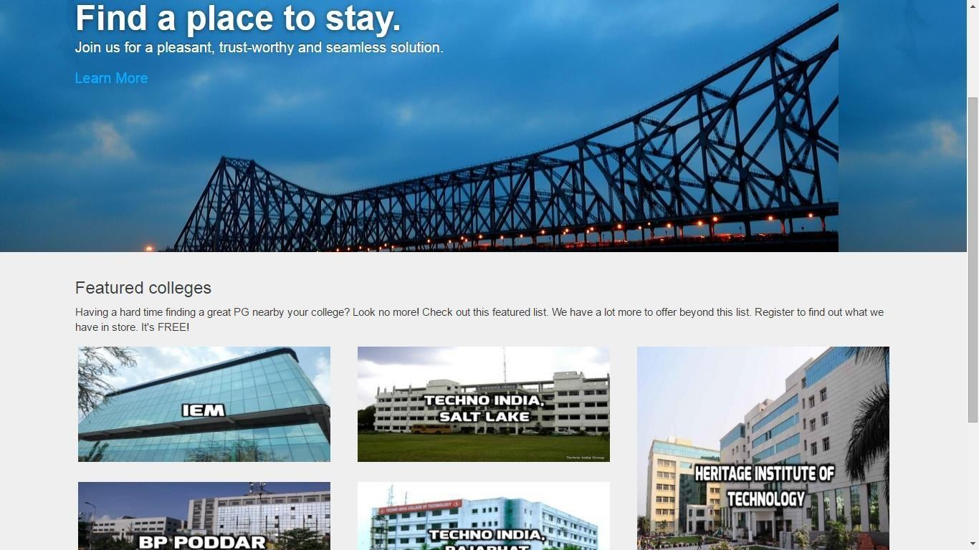

### Configure Colleges Page

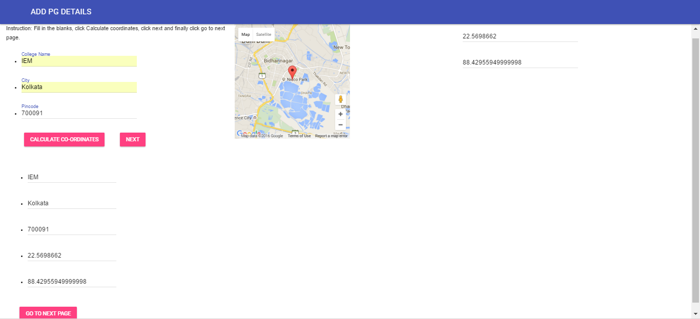

### Registration Form

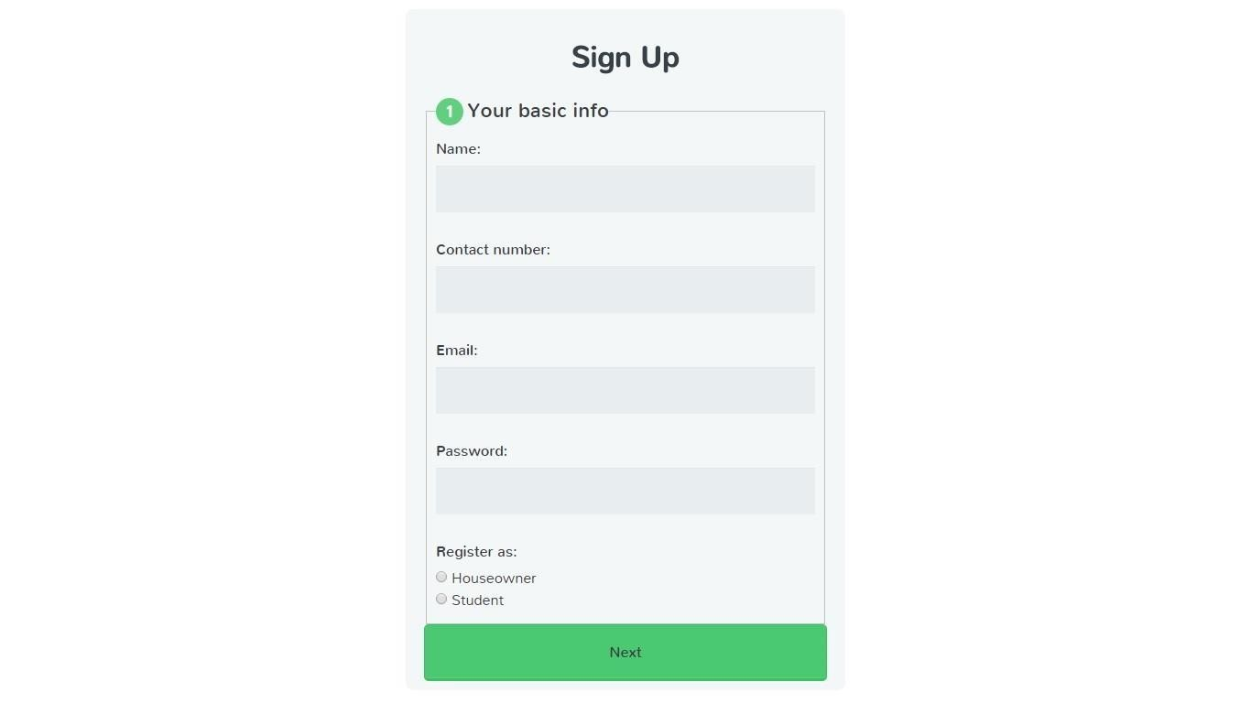

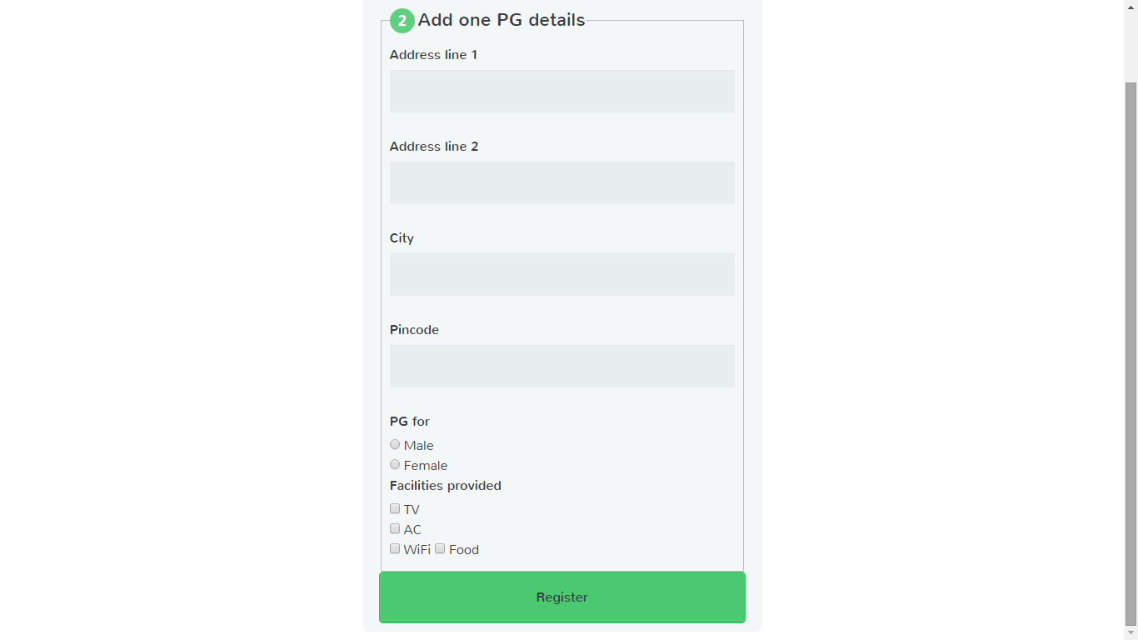

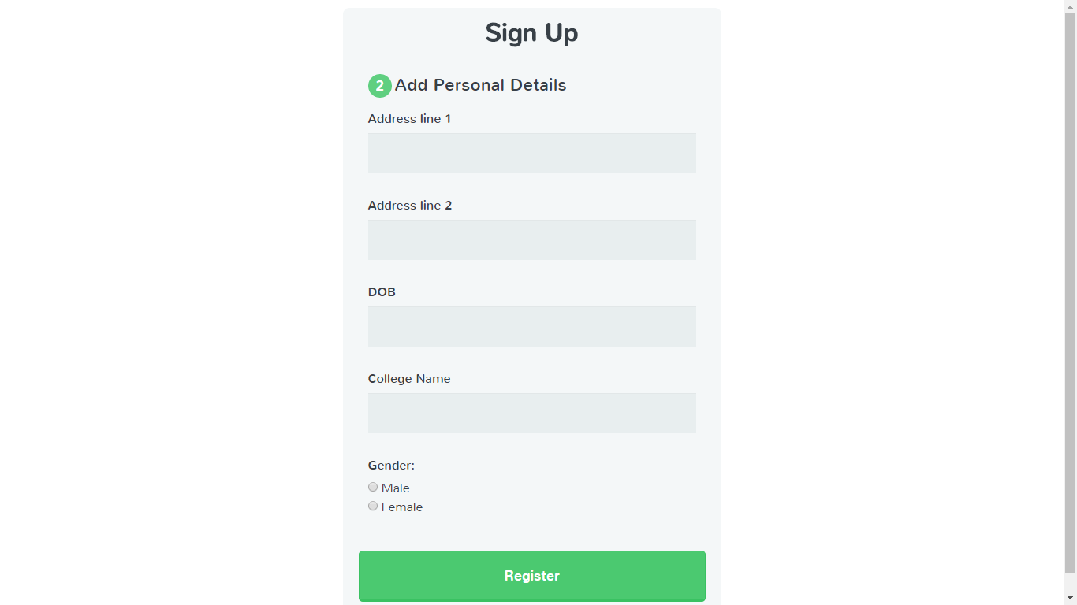

### Manage Profile: House owner

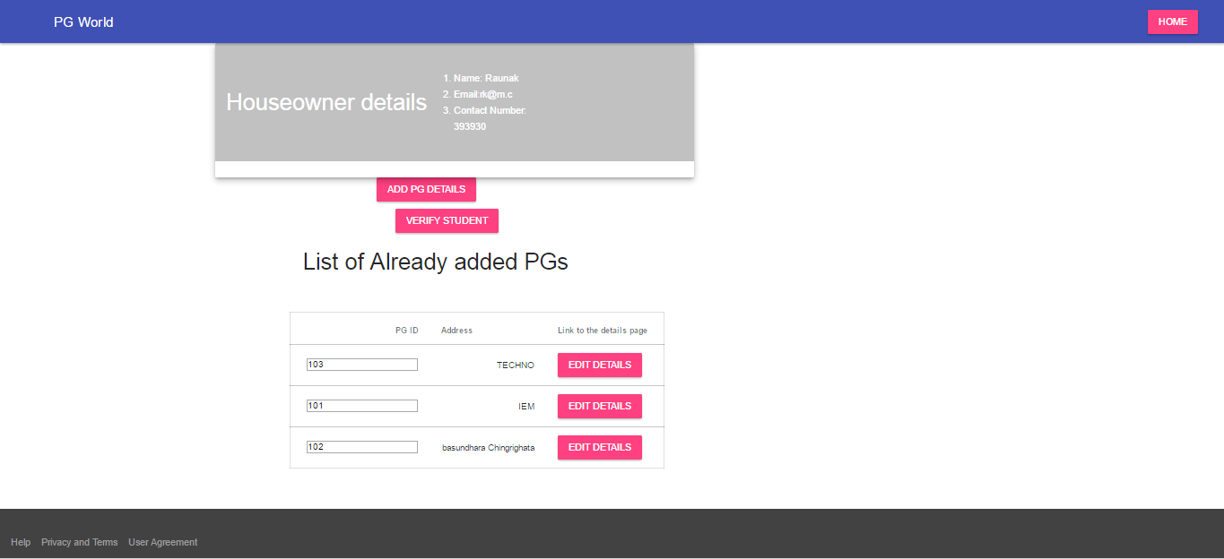

### Search PG:

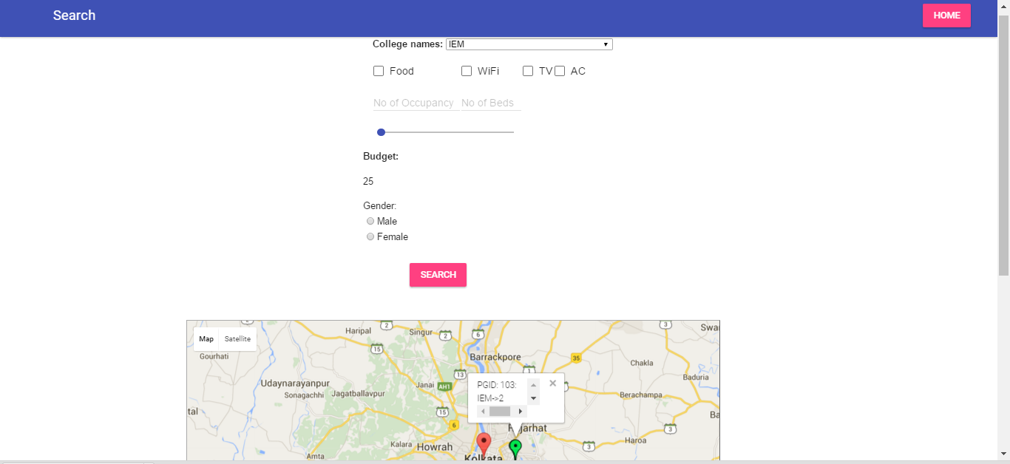

### Student Verification:

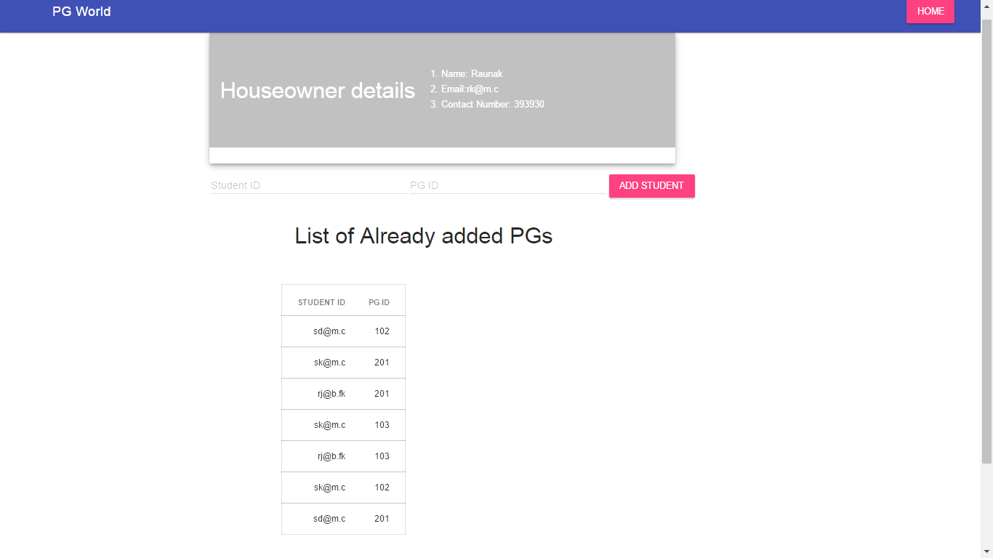

**PG Details:**

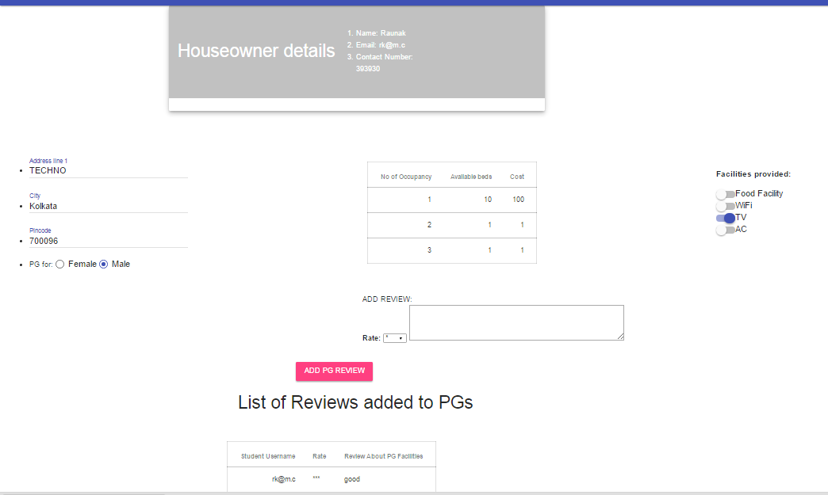

1. ***Use CaseModel***

## Use CaseDiagram

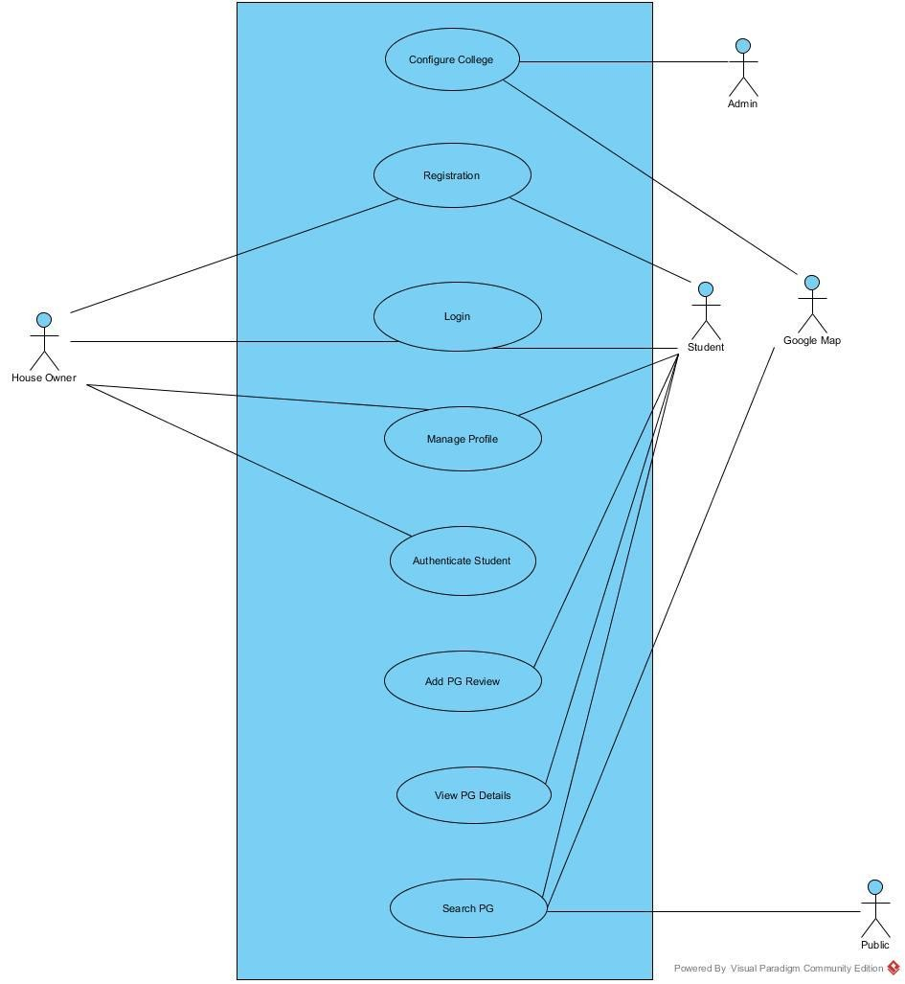

## Use CaseDescription:

|  |  |  |  |
| --- | --- | --- | --- |
| Use Case ID: | 1 | | |
| Use Case Name: | ConfigureCollege | | |
| Created By: | Shamik Kundu | Last Updated By: | Shashwat Majumdar |
| Date Created: | 10/3/2016 | Date Last Updated: | 10/03/2016 |

|  |  |
| --- | --- |
| Actor: | Admin |
| Description: | Admin adds all the colleges for which service will be provided |
| Preconditions: | A particular college is required to be added to the system. |
| Post conditions: |  |
| Priority: | Very High |
| Frequency of Use: | Very less |
| Flow of Events: | 1. Admin enters name and the city of the colleges for which service will be provided, into the Configure college page, and clicks   “Calculate Latt/ Lang”.   1. The Geocoding feature of Google Maps API outputs the latitudes and longitudes of the requestedquery 2. Admin clicks “Add College”button. 3. Search list is updated with the new entry, and is displayed in the listbelow |
| Alternative Flows: |  |
| Exceptions: |  |
| Includes: |  |
| Special Requirements: |  |
| Assumptions: |  |
| Notes and Issues: |  |
|  |  |

|  |  |  |  |
| --- | --- | --- | --- |
| Use Case ID: | 2 | | |
| Use Case Name: | Registration | | |
| Created By: | Shailesh Kumar | Last Updated By: | Shailesh Kumar |
| Date Created: | 09-03-2016 | Date Last Updated: | 09-03-2016 |

|  |  |
| --- | --- |
| Actor: | Student, House Owner |
| Description: | Actor can register to the system to gain access unlock more functionalities in the website. |
| Preconditions: | Actor must be at the home page. |
| Post conditions: |  |
| Priority: | High. |
| Frequency of Use: | Less. |
| Flow of Events: | 1. Actor clicks on registerbutton. 2. System opens up registrationpage. 3. Actor enters his name, e-mail id, contact number, password and selects whether he/she wants to register as a student ora house owner and clicks the ‘register’button. 4. Based on actor’s selection of student/house-owner option, a new page is provided by the system, to collectfurther   details.  House owner:   * 1. House owner is asked to fill the details of at leastone   PG  to complete registration process.   * 1. House owner fills in required details for a PG (Address line 1, address line 2, city, state, pin code, no of available occupancy in the PG, price of each occupancy, various facilitiesavailable).   Student:  5.1 Student is asked to fill some more details namely gender, dob, college, and permanent address to complete the registration process.  6. System checks whether any mandatory field is missing, stores the data in database and acknowledges that registration is |
| Alternative Flows: | 1. Actor enters any data in wrongformat. 2. System finds out the error and generates an errormessage. 3. Actor corrects the error and resubmits theform. |
| Exceptions: |  |
| Includes: |  |
| Special Requirements: |  |
| Assumptions: |  |
| Notes and Issues: |  |

|  |  |  |  |
| --- | --- | --- | --- |
| Use Case ID: | 3 | | |
| Use Case Name: | Login | | |
| Created By: | ShashwatMajumdar | Last Updated By: | ShashwatMajumdar |
| Date Created: | 9/3/2016 | Date Last Updated: | 9/3/2016 |

|  |  |
| --- | --- |
| Actor: | House owner, Student |
| Description: | Allows registered users of the system to login |
| Preconditions: | Actor is already registered to the system. |
| Post conditions: |  |
| Priority: | High |
| Frequency of Use: | High |
| Flow of Events: | 1. Actor clicks the login button on thescreen. 2. System prompts for username andpassword. 3. The actor enters the requiredinformation. 4. The system validates the username and password andlogs   the actor into the system and is taken to his respective homepage. |
| Alternative Flows: | 1. The actor enters wrong username-passwordcombination 2. The system asks to enter the correct username and password. |
| Exceptions: |  |
| Includes: |  |
| Special Requirements: |  |
| Assumptions: |  |
| Notes and Issues: |  |

|  |  |  |  |
| --- | --- | --- | --- |
| Use Case ID: | 4 | | |
| Use Case Name: | Manage Profile | | |
| Created By: | Shamik Kundu | Last Updated By: | Shamik Kundu |
| Date Created: | 4/3/2016 | Date Last Updated: | 4/3/2016 |

|  |  |
| --- | --- |
| Actor: | House owner |
| Description: | Actor makes changes or adds new information to his/her profile. |
| Preconditions: | 1. Actor is already loggedin. 2. Actor selects Manage Profile option from dropdown menu,. |
| Post conditions: |  |
| Priority: | High |
| Frequency of Use: | Less than moderate |
| Flow of Events: | House-owner:   1. House owner adds a new PG by adding the required fields (Address line 1, address line 2, city, state, description, images, pin code, no. of available occupancy in the PG, price of each occupancy, various facilities available). He/she can also update the details of an already registered PG. 2. Changes in the profile are stored in thedatabase. 3. System acknowledges that the changes made are successful. |
| Alternative Flows: | 1. System finds some of the newly entered data are in incorrect format. System reloads the same page againand shows a message stating the mistake made byactor. 2. Actor makes proper changes and presssubmit. 3. System checks for any mistake and updates the database if no errors arefound. 4. System acknowledges that the changes made are successful. |

|  |  |
| --- | --- |
| Exceptions: |  |
| Includes: |  |
| Special Requirements: |  |
| Assumptions: |  |
| Notes and Issues: |  |

|  |  |  |  |
| --- | --- | --- | --- |
| Use Case ID: | 5 | | |
| Use Case Name: | SearchPG | | |
| Created By: | Raunak Kumar | Last Updated By: | Raunak Kumar |
| Date Created: | 04-03-2016 | Date Last Updated: | 09-03-2016 |

|  |  |
| --- | --- |
| Actor: | Public, Student, Google map API |
| Description: | Student can search for PGs near a college and can also apply various conditions to filter the search result. |
| Preconditions: | Actor must be in home page. |
| Post conditions: |  |
| Priority: | High. |
| Frequency of Use: | High |
| Flow of Events: | Public :   1. Public is in Homepage. 2. Public clicks any of the featured college displayed in homepage to see the nearby PGs of that college. No details of the PG is available to public, and is asked to login to avail more features. Also, no custom search is allowed for public actor.   Student:   1. Student enters the college name in searchbox. 2. Student fills in the facilities required (food, Wi-Fi, AC, TV), number of occupancy, number of beds required andbudget. 3. Student clicks searchbutton. 4. All possible PGs within a certain radius of the college are retrieved from database and shown in the map, with color coding, based on the college from which majority of students belong. 5. Hovering on a marker will display an info window, PG name and number of students stayingthere. 6. Student can zoom in or zoom out in order to see less ormore number ofPGs. 7. Student clicks on individual PG (indicated by a location marker). |
| Alternative Flows: | 1. Actor enters a college name which is not presentin database. 2. System generates a message stating that the results ofthe search query is currentlyunavailable. 3. System redirects the user tohomepage. |
| Exceptions: |  |
| Includes: |  |

|  |  |
| --- | --- |
| Special Requirements: |  |
| Assumptions: |  |
| Notes and Issues: |  |

|  |  |  |  |
| --- | --- | --- | --- |
| Use Case ID: | 6 | | |
| Use Case Name: | ViewPGDetails | | |
| Created By: | Raunak Kumar | Last Updated By: | Raunak Kumar |
| Date Created: | 04-03-2016 | Date Last Updated: | 09-03-2016 |

|  |  |
| --- | --- |
| Actor: | Student |
| Description: | Student can get in-depth details about a particular PG such as reviews by inhabitants of the PG, images of the PG and the facilities available in surrounding area. |
| Preconditions: | 1. Student has loggedin. 2. Student clicks a particular PG marker in the map according to his/her searchquery. |
| Post conditions: |  |
| Priority: | High |
| Frequency of Use: | High |
| Flow of Events: | 1. Student reads thedetails. 2. Student gets information about various facilities available in nearbyarea. 3. Student views various images of thePG. 4. Student reads the reviews and ratings of thePG. |
| Alternative Flows: |  |
| Exceptions: |  |
| Includes: |  |
| Special Requirements: |  |
| Assumptions: |  |
| Notes and Issues: |  |

|  |  |  |  |
| --- | --- | --- | --- |
| Use Case ID: | 7 | | |
| Use Case Name: | PostPGReview | | |
| Created By: | Soudip Paul | Last Updated By: | Soudip Paul |
| Date Created: | 09-03-2016 | Date Last Updated: | 12-03-2016 |

|  |  |
| --- | --- |
| Actor: | Student |
| Description: | Student can post his/her review stating all the positive and negative points of the PG |
| Preconditions: | . Actor must be logged in as student. |
| Post conditions: | . |
| Priority: | Medium |
| Frequency of Use: | Less |
| Flow of Events: | 1. Student goes to the details page of a specificPG. 2. Student gives a rating of 1 – 5 stars, and writes a review, and clicks the “Post”button. 3. System checks AuthenticateStudent database to check whether the actor is indeed an inhabitant of the saidPG. 4. If verified, system posts the review against his name on the PG detailspage. 5. The overall rating is recalculated based on the all ratings obtained sofar. |
| Alternative Flows: | 1. System finds out the actor is not an inhabitant of the PG he wants to write a reviewon. 2. System generates a message stating that Writing review is only possible only for the inhabitant of thePG. |
| Exceptions: |  |
| Includes: |  |
| Special Requirements: |  |
| Assumptions: |  |
| Notes and Issues: |  |

|  |  |  |  |
| --- | --- | --- | --- |
| Use Case ID: | 8 | | |
| Use Case Name: | AuthenticateStudent | | |
| Created By: | SoubhikSingha Roy | LastUpdatedBy: | SoubhikSingha Roy |
| Date Created: | 09-03-2016 | Date LastUpdated: | 09-03-2016 |

|  |  |
| --- | --- |
| Actor: | House Owner |
| Description: | House owner authenticates that a student is indeed an inhabitant of his/her PG. |
| Preconditions: | 1. House owner must loggedin. 2. House owner must open student verifypage. |
| Postconditions: |  |
| Priority: | High. |
| Frequency of Use: | Less frequent. |
| Flow of Events: | 1. House owner clicks Student verification button to open up student verifypage. 2. House owner adds Student email, name andPGID. 3. House owner Clicks addbutton. 4. System stores the data in database and generates a message stating the operation issuccessful. |
| Alternative Flows: |  |
| Exceptions: |  |
| Includes: |  |
| Special Requirements: |  |
| Assumptions: |  |
| Notes and Issues: |  |
|  |  |

1. **Glossary**

**House Owner:** Any person who rents his/her apartment for the paying guest facility.

**Student:** Any college student registered in the system who can avail the services of the portal finding PGs

**Public:** Any unregistered user who is not logged in, and can check parts of the portal.

**Google Maps API**: Application program interface by Google that provides the maps and geo location features to the system.

**Configure College**: Admin adds all the colleges for which services will be provided.

**Registration**: Actor can register to the system to gain access unlock more functionalities in the website.

**Login**: Allows registered users of the system to login

**Manage Profile**: Actor makes changes or adds new information to his/her profile.

**SearchPG**: Student can search for PGs near a college and can also apply various conditions to filter the search result.

**ViewPGDetails**: Student can get in-depth details about a particular PG such as reviews by inhabitants of the PG, images of the PG and the facilities available in surrounding area.

**PostPGReview** : Student can post his/her review stating all the positive and negative points of the PG.

**AuthenticateStudent**: House owner authenticates that a student is indeed an inhabitant of his/her PG.

# References

Provide a list of all documents and other sources of information referenced in the SRS and utilized in developing the SRS. Include for each the document number, title, date and author.

|  |  |  |  |
| --- | --- | --- | --- |
| **Document No.** | **Document Title** | **Date** | **Author** |
|  |  |  |  |
|  |  |  |  |
|  |  |  |  |
|  |  |  |  |
|  |  |  |  |
|  |  |  |  |