INTERNSHIP REPORT
Of
Research and Evaluation of Chat Technologies and GFX Design Tools at Espotz
Submitted
To
School of Computer Science and Engineering
IILM University, Greater Noida, U.P.
In partial fulfilment of the requirement of degree of
B.Tech CSE

By
Roll Number of Student: 2410030569
Name of Student: SINGH RAUNAK SURENDRA
Batch: 2024-2028

CANDIDATE'S DECLARATION
I, Singh Raunak Surendra, do hereby declare that the internship report titled “Research and Evaluation of Chat Technologies and GFX Design Tools at Espotz” has been completed by me to fulfil the requirement for the award of the degree of Bachelor of Technology in CSE. All the references have been quoted and I have not taken as such any material from any other source. I affirm to you that this report is my own and has not been submitted to any other institute for any degree/diploma requirement and further I shall be solely responsible for any kind of copyright violation in this regard.

Signature
Student Name: Singh Raunak Surendra
Roll No.: 2410030569

ACKNOWLEDGEMENT
I am using this opportunity to express my gratitude to everyone who supported me throughout the Internship Program at Espotz. I am thankful for their aspiring guidance, invaluably constructive criticism and friendly advice during this work. I am sincerely grateful to my senior developer at Espotz for continuous mentorship on evaluating technologies and structuring research work, which shaped much of my professional growth during this internship. I would also like to thank the entire engineering team at Espotz for their support and collaboration throughout my tenure.
I would also like to thank the faculty of the School of Computer Science and Engineering, IILM University, Greater Noida, for their support and encouragement throughout this internship period.
I express my gratitude to my parents for their blessings.

Signature
Student Name: Singh Raunak Surendra
Roll No.: 2410030569

INTERNSHIP COMPLETION CERTIFICATE

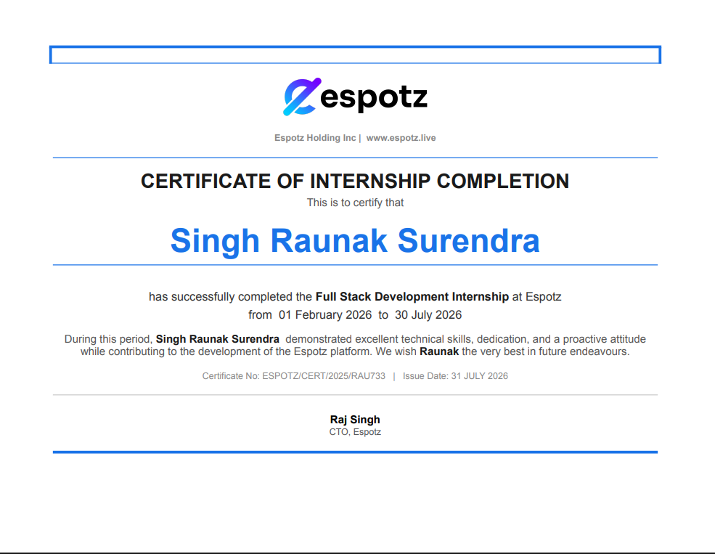

TABLE OF CONTENT
Chapter No. | Chapter Name | Page Nos.
 | Cover Page
1. | Candidate's Declaration
2. | Acknowledgement
3. | Internship Completion Certificate
4. | Project Description
 | 4.1 Introduction
 | 4.2 Organization Profile
 | 4.3 Problem Statement
 | 4.4 Project Objectives
 | 4.5 Scope of the Project
 | 4.6 Technologies and Tools Used
 | 4.7 System Architecture
 | 4.8 Methodology
 | 4.9 Expected Outcomes
 | 4.10 Certificates of completion and communication proof
5. | Bibliography/References

4. PROJECT DESCRIPTION

4.1 Introduction
This report presents the work carried out during my internship as a Software Engineer Intern at Espotz, a competitive esports tournament platform. Espotz enables organizers to run large-scale online tournaments (with an initial focus on Valorant), covering bracket management, match scheduling, live standings, and post-match promotional graphics. During this internship, I worked within the frontend and platform engineering team on research-driven evaluation work across two areas: identifying and comparing candidate technologies for an in-tournament player chat system, and identifying and comparing candidate tools and approaches for designing GFX (graphics) templates used by Espotz's automated tournament graphics pipeline. In both areas, my work involved surveying multiple available tools, evaluating them against Espotz's specific constraints, and building small proof-of-concept prototypes to validate the most promising options before recommending a direction to the team.
The internship gave me practical exposure to technology evaluation as a discipline in its own right — defining evaluation criteria, testing real tools hands-on rather than relying on documentation alone, and communicating trade-offs clearly enough for the team to make an informed decision, rather than simply picking the first workable option.

4.2 Organization Profile
Espotz is a competitive esports tournament platform that provides infrastructure for organizing, running, and promoting online gaming tournaments. The platform's initial focus has been on Valorant, a popular tactical shooter title with an active competitive scene. Espotz's product surface includes tournament creation and management tools for organizers, player and team registration and onboarding, real-time match results and bracket progression, and automated generation of promotional graphics for standings, match results, and playoff brackets to be shared on social media.
The engineering organization is structured around a monorepo containing multiple backend services and a frontend web application, allowing coordinated development across the platform's various concerns — API, real-time communication, background processing, and graphics rendering.

4.3 Problem Statement
Players participating in an Espotz tournament previously had no in-product way to communicate with one another during a tournament — for coordination around match timing, lobby readiness, or general communication — without relying on external tools such as Discord. Before any chat feature could be built, the team needed a clear, evidence-based answer to a foundational question: which real-time messaging technology would best fit Espotz's scale, latency, and cost constraints, out of the many available options (self-hosted WebSocket solutions, managed real-time services, and third-party chat SDKs)? Choosing incorrectly at this stage would be costly to reverse later.
Similarly, Espotz's automated GFX generation pipeline needed a growing library of well-designed, on-brand visual templates, and the team needed to evaluate which design and templating tools/approaches would let designers and engineers collaborate efficiently — balancing design flexibility, ease of handoff into the existing React-based rendering pipeline, and speed of iteration.

4.4 Project Objectives
- Research and identify candidate technologies for a real-time in-tournament chat system, covering self-hosted, managed, and SDK-based approaches.
- Define clear evaluation criteria (latency, scalability, cost, ease of integration with the existing Nx monorepo) to compare chat technology candidates objectively.
- Build small proof-of-concept prototypes for the most promising chat technology candidates to validate real-world behaviour beyond documentation claims.
- Research and compare GFX/design tools and templating approaches suitable for Espotz's existing React-based graphics rendering pipeline.
- Prototype sample GFX templates using the leading candidate tools/approaches to assess design flexibility and integration effort.
- Present findings and a recommended direction for both chat technology and GFX tooling to the engineering team.

4.5 Scope of the Project
The scope of the work covered two research-and-evaluation tracks within the Espotz platform:
- Chat Technology Research: Surveying and comparing multiple real-time messaging tools and approaches for an in-tournament player chat system, and building small proof-of-concept prototypes with the strongest candidates to validate their behaviour under realistic conditions.
- GFX Tooling Research: Surveying and comparing multiple design and templating tools/approaches for producing GFX templates compatible with Espotz's existing graphics pipeline, with sample prototype templates built to test each approach.
The scope did not extend to the full production implementation of either the chat system or a finalized template library; the work focused on research, comparative evaluation, and proof-of-concept validation to inform the team's eventual build decisions.

4.6 Technologies and Tools Used
- Chat technology candidates researched: self-hosted WebSocket-based solutions (e.g. Socket.IO), managed real-time messaging services, and third-party chat SDKs
- GFX/design tool candidates researched: design and prototyping tools (e.g. Figma), and React-component-based templating approaches consistent with Espotz's existing GFX pipeline
- Frontend (for prototypes): React, TypeScript, Vite
- Monorepo tooling: Nx (espotz-backend, espotz-webapp)
- UI/Design system: Radix UI, and Espotz's existing themeable card design system
- Version control: Git, with rebase-based branch synchronization workflow (git rebase origin/branch-name and git push --force-with-lease)

4.7 System Architecture
For the chat research track, the evaluation was structured around candidate architectures rather than a single fixed design: a self-hosted WebSocket approach (giving full control but requiring the team to manage scaling and reliability), a managed real-time messaging service (trading some control for reduced operational overhead), and third-party chat SDKs (fastest to integrate but with the least customization). For each promising candidate, a minimal proof-of-concept was built — a small tournament-room-scoped chat prototype — to observe real message latency, connection handling, and integration friction with Espotz's existing Nx monorepo structure, rather than relying solely on vendor documentation or marketing claims.
For the GFX tooling research track, the evaluation centered on how well each candidate tool or approach could plug into Espotz's existing render-then-export pipeline, where React components styled with CSS are converted into exportable PNG graphics. Sample templates were prototyped using the leading candidates to test how easily a design could be translated into a production-ready, themeable React component consistent with Espotz's existing card-based visual language, without requiring a parallel or incompatible styling system.

4.8 Methodology
For both research tracks, the methodology followed a consistent structure: first, a broad survey of available tools/approaches was conducted to build a shortlist; second, clear evaluation criteria were defined upfront (for chat: latency, scalability, cost, and integration effort; for GFX tooling: design flexibility, hand-off ease, and rendering-pipeline compatibility); third, small proof-of-concept prototypes were built for the strongest candidates in each shortlist, since documentation and marketing material alone were judged insufficient to make a reliable recommendation; and finally, findings were synthesized into a comparison to support a team decision, rather than presenting a single unexamined pick.
This proof-of-concept-driven approach meant that even though the work was primarily research-oriented, each candidate technology was tested hands-on within a scaled-down but realistic version of the actual problem (a working chat room prototype; a working sample GFX template rendered through the existing pipeline), which surfaced practical integration issues that a purely theoretical comparison would have missed.

4.9 Expected Outcomes
- A clear, criteria-based comparison of candidate real-time chat technologies, backed by hands-on proof-of-concept testing rather than documentation alone.
- A recommended chat technology direction for Espotz's future in-tournament chat feature, with trade-offs clearly documented for the team.
- A clear, criteria-based comparison of candidate GFX/design tooling approaches, validated with working sample templates.
- A recommended GFX tooling direction that fits cleanly into Espotz's existing React-based rendering pipeline.
- Practical experience in structured technology evaluation — defining criteria, building proof-of-concept prototypes, and communicating trade-offs to guide real engineering decisions.

4.10 Certificates of Completion and Other Communication Mail Proof
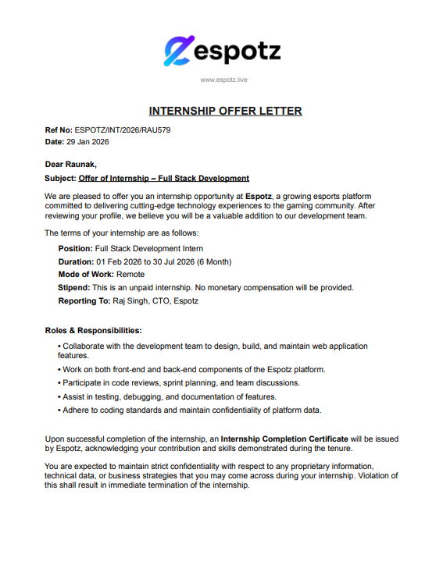

5. BIBLIOGRAPHY/REFERENCES
1. React Documentation. Available at: https://react.dev
2. TypeScript Documentation. Available at: https://www.typescriptlang.org/docs
3. Nx Documentation — Smart Monorepos. Available at: https://nx.dev
4. Radix UI Documentation. Available at: https://www.radix-ui.com
5. Socket.IO Documentation. Available at: https://socket.io/docs
6. Figma — Design Tool Documentation. Available at: https://www.figma.com
7. Nx Documentation — Smart Monorepos. Available at: https://nx.dev
8. Espotz Platform — Internal Engineering Documentation (Espotz, 2026).

