Analysis Tasks

Basic Statistics tasks

* Which store has maximum sales

Solution



* Which store has maximum standard deviation i.e., the sales vary a lot. Also, find out the coefficient of mean to standard deviation



* Which store/s has good quarterly growth rate in Q3’2012

* Some holidays have a negative impact on sales. Find out holidays which have higher sales than the mean sales in non-holiday season for all stores together

* Provide a monthly and semester view of sales in units and give insights

Statistical Model

For Store 1 – Build  prediction models to forecast demand

* Linear Regression – Utilize variables like date and restructure dates as 1 for 5 Feb 2010 (starting from the earliest date in order). Hypothesize if CPI, unemployment, and fuel price have any impact on sales.
* Change dates into days by creating new variable.

For training data

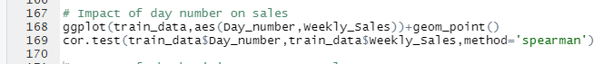

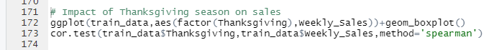

Based on training dataset, Weekly Sales of Store 1 has correlation with factors like CPI, Fuel Price, year, Temperature, Thanksgiving Season, Super Bowl Season and Day Number. Since, probability of these features being uncorrelated with Weekly_Sales<0.05, we can reject the Null Hypothesis which states that they are not correlated with Weekly_Sales.

However, Unemployment column has p-value >0.05 and therefore we cannot reject Null Hypothesis for Unemployment column for Training Dataset and do not include it in Linear Regaression Model

Now, Variance Inflation Factor (VIF) is calculated to check for Multi-colinearity.

Features with greatest VIF are removed one by one and VIF is recomputed till all remaining features have VIF<10

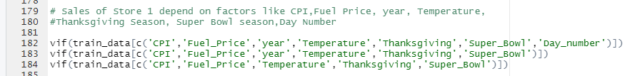

After feature reduction using VIF, the remaining Features are CPI, Fuel_Price, Temperature, Thanksgiving, Super_Bowl

Now, we perform Linear Regression and remove features with p-val>0.05, till essential features for Linear Regression model having p-value<0.05 are remaining

Final Linear Regression Model

CPI🡪 Prevailing consumer price index

Temperature🡪Temperature on the day of sale

Thanksgiving🡪 This value is ‘1’ if Thanksgiving holiday lies during the week of sale. Otherwise, it is ‘0’

Predicted Weekly Sales 🡪 Prediction of Weekly Sales

Training Data has R^2 value of 0.248 and Adjusted R^2 value of 0.227

Performance on Test Dataset

Test Data has R^2 value of 0.359