**Steps that will help in the completion of the project:**

1. Import the data from all available Excel files

2. Data transformation:

* Make sure the **City** column names are corrected

**For example:**

“Sí£o Paulo” should be corrected to “São Paulo”

* Ensure the city name isn't ambiguous

**For example:**

“Cedar Rapids/Iowa City” should be corrected to “Cedar Rapids”

“ÛÁstanbul” should be corrected to “Istanbul”

3. Remove any columns that aren't being used

4. Create two columns to display the **Restaurant Name** and **Restaurant Address**

5. Make a separate table for the list of the cuisines that each restaurant serves

Restaurants serving more than one cuisine have each cuisine served by the restaurant listed in a separate row

6. As it's a dimension table, the **Country-Code** table must only include unique and non-blank values

**Steps to use DAX in the project:**

1) Add a **Rating color** column in an appropriate table with the data rows in the format given below

|  |  |
| --- | --- |
| **Aggregate rating** | **Rating color** |
| Above 4.5 | Dark Green |
| 4 to 4.4 | Green |



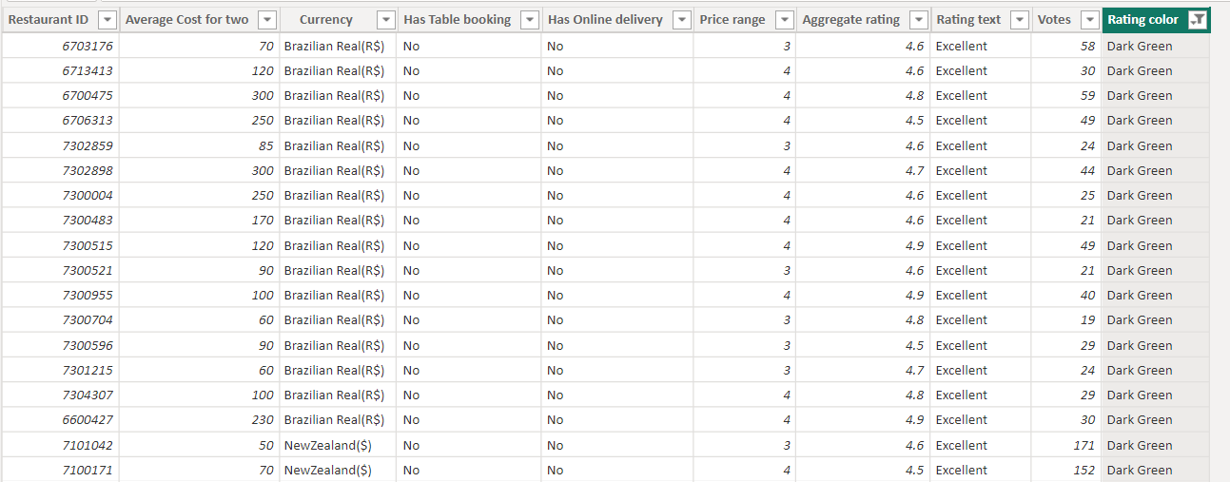

2) Create the following measures in the appropriate tables

a. Restaurant count

b. Average cost

c. Average rating

d. Cuisine count



3) Create a new column in the **Country Code** table and name it “**Continent”** and create the values using the below-mentioned convention

**Note**: The mapping is continent - country, for example ''Africa – South Africa''



VISUALIZATION

Filters across all pages are in sync

