DATA STRUCTURES AND ALGORITHMS
CASE STUDY REPORT
Ride-Sharing Capacity Management System
A C-based solution for ride booking, passenger allocation, waiting lists and route-wise capacity checking

Student Name | HARDIK DUBEY [70562500028]  NETIK SHARMA[70562500070]  RAUNIKA GULATI[70562500094]
Course / Subject | Data Structures and Algorithms
Semester | Semester III
Programming Language | C
Academic Year | 2026-27

Submitted as part of the DSA case study project

Table of Contents
1. Introduction 3
2. Problem Statement 4
3. Objectives 5
4. Real-World Application 6
5. DSA Concepts Used 7
6. System Design 8
6.1 Data Model 8
6.2 Program Modules 8
7. Menu Structure 9
8. Algorithms 10
8.1 Ride / Passenger Search 10
8.2 Waiting Queue 10
8.3 Capacity Checking Algorithm 10
8.4 Booking Decision 11
9. C Implementation 12
9.1 Structure Definitions 12
9.2 Important Functions 12
9.3 CSV Loading 12
9.4 Memory Management 13
10. Sample Input / Output 14
10.1 Main Menu 14
10.2 Example - Ride Capacity 14
10.3 Example - Full Capacity 14
10.4 Example - Occupancy by Stop 14
11. Time & Space Complexity 15
12. Test Cases 16
13. Advantages 17
14. Limitations 18
15. Future Scope 19
16. Conclusion 20
Appendix A - Code Reference Map 21

1. Introduction
The Ride-Sharing Capacity Management System is a command-line C program designed around a simple practical problem: several passengers may want seats on the same vehicle, but the vehicle should never be overloaded on any part of its route. The program keeps ride records, passenger records and a waiting list, and it checks whether a new booking can be accepted by looking at the overlap between passenger routes.
The implementation uses basic data structures that are part of a typical DSA syllabus. Rides are stored in an array, passengers are maintained in a linked list, and waiting passengers are handled through a queue. Capacity is checked using a route-event array and a running total across stops. This makes the project a useful example of how data structures are connected to a real scheduling problem.
The program also includes practical operations such as adding rides, adding passengers, booking and cancelling rides, completing a passenger trip, viewing the waiting queue, and checking occupancy. The main menu is kept simple so that the flow of the system can be followed directly during execution.

2. Problem Statement
Given multiple passengers with pickup and drop points, ensure that the vehicle never exceeds its maximum seating capacity at any point during the journey.
To design and implement a Ride-Sharing Capacity Management System in C that efficiently manages ride bookings, passenger allocation, waiting lists, cancellations and record searching while ensuring that vehicle capacity is never exceeded at any point along the route using appropriate data structures and algorithms.
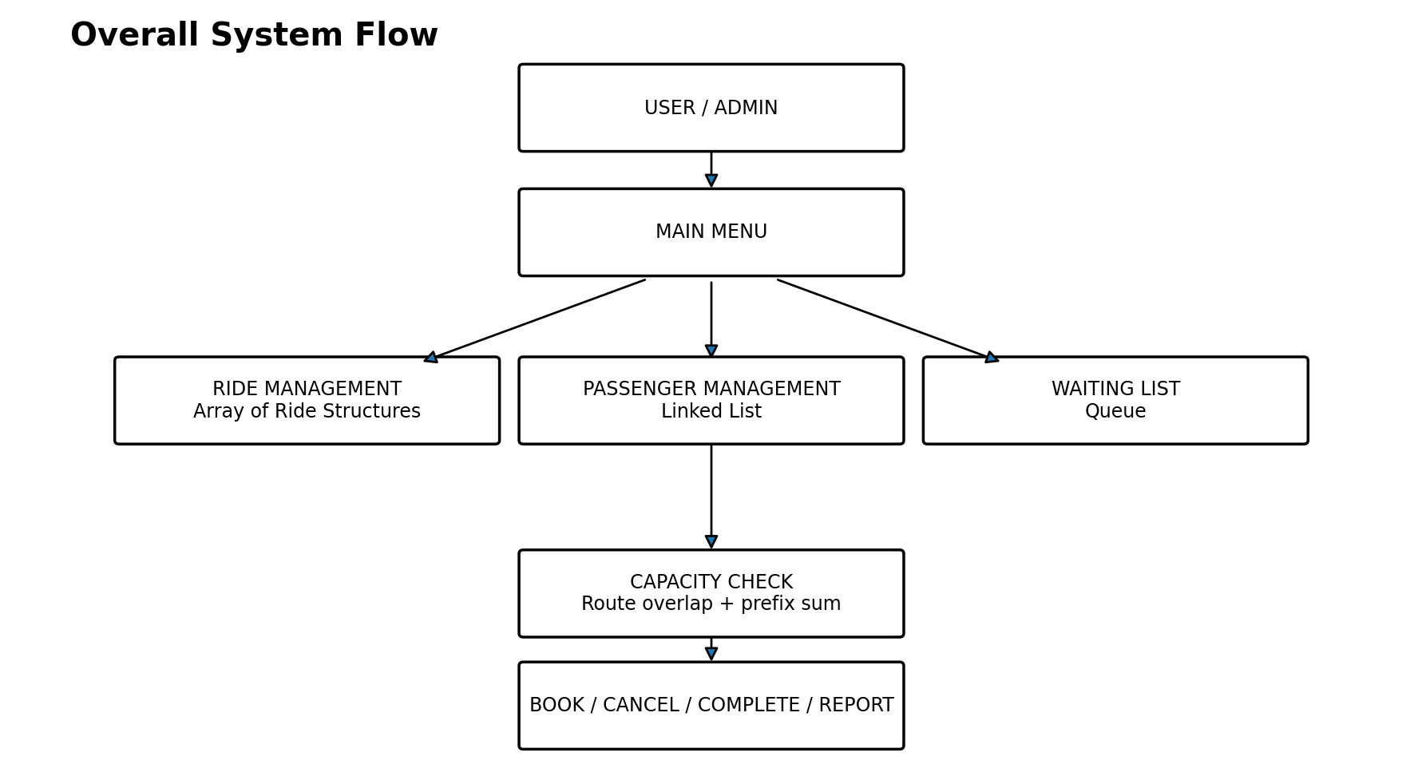
Figure 1. Overall working flow of the proposed system.

3. Objectives
- Manage multiple rides with driver, vehicle, source, destination, capacity, seats and fare details.
- Maintain passenger records dynamically instead of using a fixed-size passenger array.
- Provide a FIFO waiting list when a passenger cannot be booked immediately.
- Check the maximum occupancy over the full route instead of checking only total passengers.
- Allow booking cancellation and attempt to serve the next suitable waiting passenger.
- Provide simple searching through ride IDs and passenger IDs.
- Use a modular C implementation with separate functions for each major operation.

4. Real-World Application
The same basic idea can be used in many transport situations where people share a vehicle for part of a route. The project is smaller than a commercial ride-sharing platform, but the core capacity problem is similar: a passenger may board at one stop and leave at another, so the vehicle load changes during the trip.
Application | How the idea fits
Shared cabs | Accept bookings while keeping route-wise seat usage within the vehicle limit.
Campus or office shuttles | Maintain passenger records and a waiting queue during peak hours.
Event transport | Allocate seats for attendees travelling between selected pickup and drop points.
Carpool services | Reject or queue a booking if the route overlap would cross the allowed capacity.
In this case study, the stop list is represented by 15 predefined stops such as Indore Railway Station, Bhawarkua, Palasia, Vijay Nagar, Rajwada and Bengali Square. These stops give a concrete route on which the capacity calculation can be demonstrated.

5. DSA Concepts Used
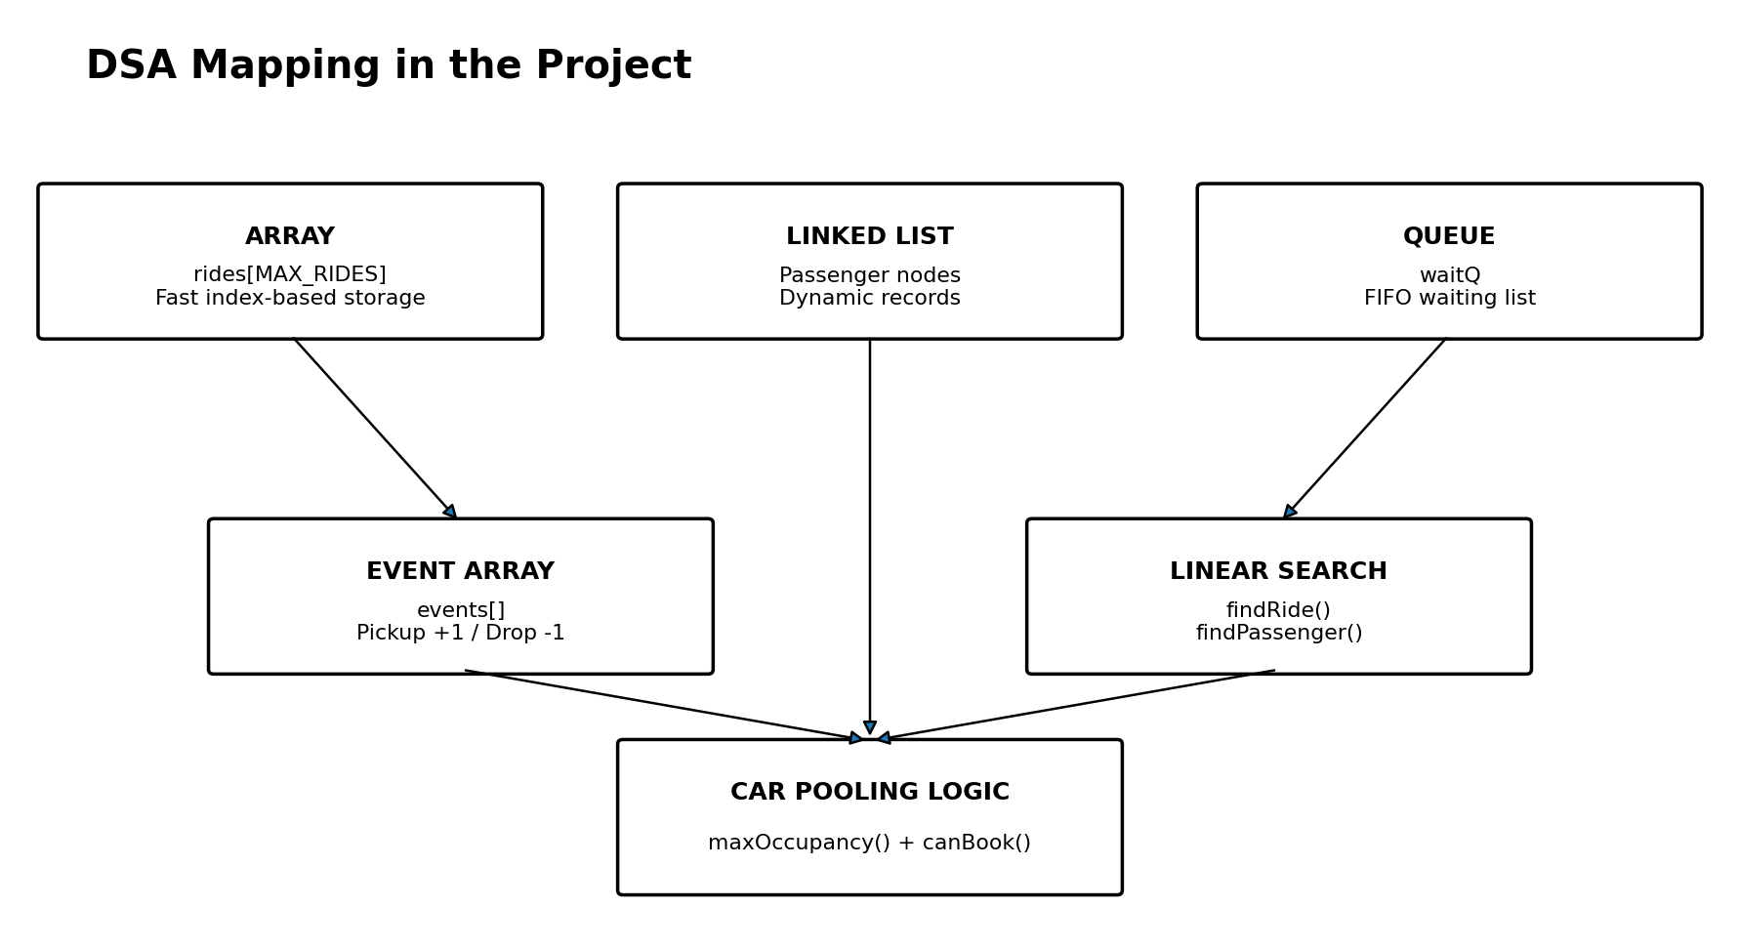
Figure 2. Data structures and core logic used in the implementation.
Concept | Where it is used | Purpose
Array | rides[] and stopList[][] | Stores a fixed maximum number of rides and route stops.
Linked List | struct Passenger | Stores passenger records dynamically; each node points to the next passenger.
Queue | waitQ | Maintains waiting passengers in FIFO order.
Event Array + Prefix Sum | events[] in maxOccupancy() and showOccupancy() | Tracks boarding and drop-off changes across the route.
Linear Search | findRide(), findPassenger(), stopIndex() | Finds a matching record or stop by scanning the available entries.
The project therefore stays within simple, explainable DSA concepts. There is no need for advanced structures such as trees or graphs to solve the main capacity problem in this version.

6. System Design

6.1 Data Model
The program uses three main structures: Ride, Passenger and Queue.
Structure | Important fields
Ride | id, driver, vehicle, source, destination, capacity, seats, fare
Passenger | id, name, phone, rideId, pickup, drop, status, next
Queue | data[MAX_QUEUE], front, rear

6.2 Program Modules
- Ride Management - add and display rides.
- Passenger Management - add, display and complete passenger records.
- Booking and Cancellation - validate a ride, check capacity, book or cancel a passenger.
- Waiting List - enqueue waiting passengers and try to serve the next suitable passenger.
- Capacity Management - show ride capacity, occupancy at every stop, and booking feasibility.
- Input and Database Loading - read passenger records from the configured CSV file.
The source code initializes five sample rides and a list of 15 route stops. The passenger records are loaded from a CSV file named passengers.csv. The program stores passengers as linked-list nodes and places passengers marked as Waiting into the queue when the database is loaded.

7. Menu Structure
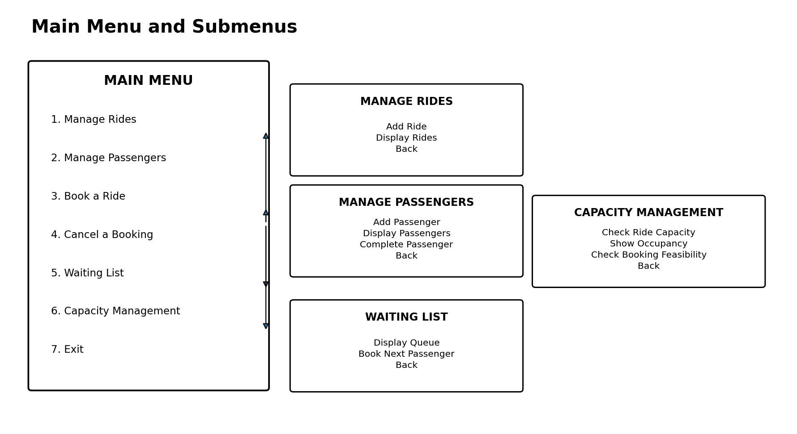
Figure 3. Main menu and submenu organization.
Main option | Main purpose
1. Manage Rides | Add a ride or display all rides.
2. Manage Passengers | Add, display or complete passenger records.
3. Book a Ride | Attempt a booking after checking route-wise capacity.
4. Cancel a Booking | Cancel a booked passenger and try to serve a waiting passenger.
5. Waiting List | View the queue or try to book the next suitable waiting passenger.
6. Capacity Management | Check ride capacity, stop-wise occupancy or booking feasibility.
7. Exit | Free dynamically allocated passenger nodes and end the program.

8. Algorithms

8.1 Ride / Passenger Search
The program searches the rides array by ride ID and the passenger linked list by passenger ID. Both are simple linear searches. They are easy to understand and are suitable for the small data size used in this case study.
findRide(id):
for each ride in rides[]
if ride.id == id
return address of that ride
return NULL
findPassenger(id):
temp = head
while temp is not NULL
if temp.id == id
return temp
temp = temp.next
return NULL

8.2 Waiting Queue
The waiting list follows FIFO order. Enqueue adds a passenger at the rear. Dequeue removes the passenger from the front. The servePassenger() function temporarily rotates the queue while checking which waiting passenger belongs to the selected ride and can now fit.
ENQUEUE(id):
if queue is full -> stop
rear = rear + 1
queue[rear] = id
DEQUEUE():
if front > rear -> return -1
id = queue[front]
front = front + 1
if queue becomes empty -> reset front and rear
return id

8.3 Capacity Checking Algorithm
This is the main algorithm of the project. Instead of simply counting all booked passengers, the program considers where every passenger boards and leaves. For each booked passenger, one event is added at the pickup stop and one negative event is added at the drop stop. A running sum across the route gives the number of passengers inside the vehicle at each point.
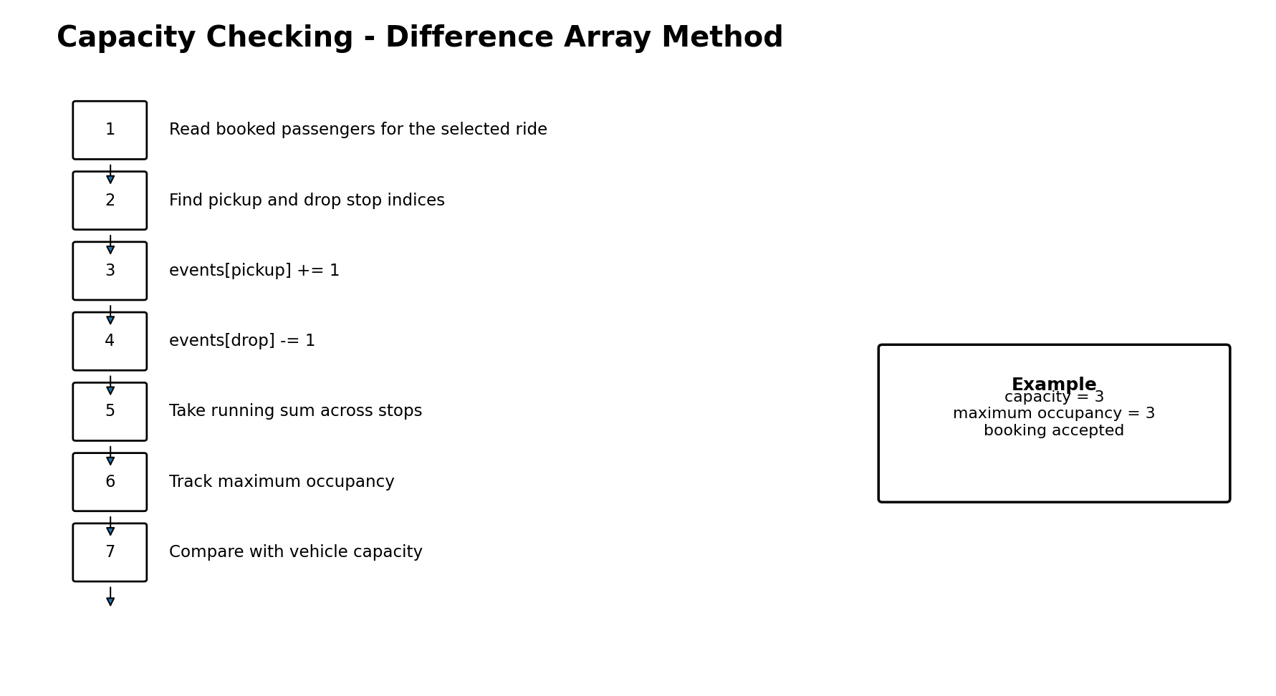
Figure 4. Route-wise capacity check using pickup and drop events.
maxOccupancy(rideId, extra):
create events[] initialized to zero
scan all passengers
consider only Booked passengers for rideId
start = pickup stop index
end = drop stop index
events[start]++
events[end]--
if extra is given
add its start and end events too
current = 0
maximum = 0
for each stop
current += events[stop]
maximum = max(maximum, current)
return maximum

8.4 Booking Decision
canBook(passenger, rideId):
find ride
validate pickup and drop stops
maximum = maxOccupancy(rideId, passenger)
if maximum <= ride.capacity
return 1
else
return 0
This means a booking is accepted only when the maximum occupancy after adding that passenger remains within the vehicle capacity. The same logic is used by both booking and capacity-feasibility checks.

9. C Implementation
The implementation is written as a menu-driven C program. The code starts by initializing the waiting queue, loading the predefined rides, loading passengers from the CSV file, and updating available seats. Control then remains in the main menu until the user selects Exit.

9.1 Structure Definitions
struct Ride {
int id;
char driver[40];
char vehicle[20];
char source[40];
char destination[40];
int capacity;
int seats;
float fare;
};
struct Passenger {
int id;
char name[40];
char phone[15];
int rideId;
char pickup[40];
char drop[40];
char status[15];
struct Passenger *next;
};

9.2 Important Functions
Function | Role in the project
loadRides() | Loads five predefined ride records.
loadPassengers() | Reads passenger rows from passengers.csv and builds the linked list.
addPassengerNode() | Creates a passenger node using dynamic memory.
bookRide() | Validates passenger and ride details, then checks capacity.
cancelBooking() | Marks a booking cancelled, updates seats and calls servePassenger().
servePassenger() | Checks waiting passengers and moves a suitable passenger into Booked status.
showOccupancy() | Prints occupancy at each stop and the maximum value found.
maxOccupancy() | Core route-overlap calculation used by booking checks.
canBook() | Returns whether the proposed passenger fits within capacity.

9.3 CSV Loading
Passenger records are loaded with fopen(), fgets() and sscanf(). The first line is skipped as the CSV header. Each valid row is converted into a linked-list node. Passengers whose status is “Waiting” are also inserted into the waiting queue. The current code uses a configured local file path for passengers.csv, so that path must exist on the machine where the program is run.
file = fopen(FILE_PATH, "r");
if (file == NULL)
print database-not-found message;
while (fgets(line, sizeof(line), file) != NULL)
if (sscanf(...) == 7)
addPassengerNode(...);

9.4 Memory Management
Passenger nodes are created using malloc(). Before the program exits, freePassengers() walks through the linked list and releases every allocated node using free(). This avoids leaving dynamically allocated passenger records in memory after the program ends.

10. Sample Input / Output
The following examples are representative runs based on the rides and stops built into the supplied program. Exact passenger names and IDs depend on the passengers.csv file used with the project.

10.1 Main Menu
================================================
RIDE-SHARING CAPACITY MANAGEMENT SYSTEM
================================================
1. Manage Rides
2. Manage Passengers
3. Book a Ride
4. Cancel a Booking
5. Waiting List
6. Capacity Management
7. Exit
================================================
Enter choice:

10.2 Example - Ride Capacity
Ride ID: 101
Ride Capacity: 3
Maximum Occupancy After Booking: 2
Booking can be accepted.
Ride 101 is initialized with a capacity of 3. The output depends on the passenger records currently booked on that ride, so the exact maximum occupancy changes with the dataset.

10.3 Example - Full Capacity
Ride Capacity: 3
Maximum Occupancy After Booking: 4
Booking cannot be accepted.
1. Add to Waiting Queue
2. Cancel
Choice: 1
Passenger added to waiting queue.

10.4 Example - Occupancy by Stop
Stop No. Stop Occupancy
----------------------------------------------------
1 Indore Railway Station 1
2 Navlakha 2
3 Bapat Square 2
...
Maximum Occupancy: 2
Vehicle Capacity : 3
Available Seats : 1

11. Time & Space Complexity
Let R be the number of rides, P the number of passenger records, S the number of route stops (15 in this implementation), and W the number of waiting passengers.
Operation | Time Complexity | Reason
findRide() | O(R) | Scans the rides array.
findPassenger() | O(P) | Traverses the linked list.
stopIndex() | O(S) | Scans the fixed stop list.
maxOccupancy() | O(P + S) | Scans passengers, then scans the event array.
canBook() | O(P + S) | Uses maxOccupancy() after validating stops.
showOccupancy() | O(P + S) | Builds events and then prints every stop.
enqueue() / dequeue() | O(1) | Adds/removes a queue element using front/rear indices.
servePassenger() | O(W(P + S)) worst case | May inspect every waiting ID and call the booking check.
Space usage is O(R + P + W + S). The ride array and queue have fixed limits, passenger storage grows dynamically with the number of records, and the event array has only MAX_STOPS + 1 elements.

12. Test Cases
Test Case | Input / Situation | Expected Result | Observed / Logic in Code
TC-01 | Start program with valid passengers.csv | Passenger database loads and waiting passengers enter queue. | Handled by loadPassengers().
TC-02 | Book passenger when maximum occupancy is within capacity | Booking status becomes Booked and available seats are updated. | Handled by bookRide() and canBook().
TC-03 | Try booking when route-wise occupancy exceeds capacity | Booking is rejected; user may place passenger into waiting queue. | Handled by bookRide().
TC-04 | Cancel an existing booked passenger | Status becomes Cancelled; seats are recalculated; next suitable waiting passenger is considered. | Handled by cancelBooking() and servePassenger().
TC-05 | Check stop-wise occupancy | Program prints occupancy at all 15 stops and the maximum value. | Handled by showOccupancy().
TC-06 | Use an invalid pickup or drop stop | Input is rejected and the passenger is not inserted. | Handled in addPassenger().
TC-07 | Try completing a waiting passenger | Program refuses because the passenger has not been booked. | Handled by completePassenger().
TC-08 | Exit program | Linked-list passenger nodes are freed and program ends. | Handled by freePassengers() in main().

13. Advantages
- The capacity calculation checks route overlap, not just the total number of passengers.
- Linked-list storage allows passenger records to be added dynamically.
- The waiting list follows FIFO order, which is easy to explain and fair for normal queue handling.
- The program is modular, with separate functions for rides, passengers, booking, waiting list and capacity management.
- The interface is simple enough to demonstrate each DSA operation during a viva or lab evaluation.
- The program releases allocated passenger memory before exiting.

14. Limitations
- The current stop list is fixed at 15 stops and is not editable from the menu.
- The waiting queue uses a fixed array size of 30 entries.
- The maximum number of rides is limited to 20 by MAX_RIDES.
- The passenger database depends on the local passengers.csv file and a configured file path.
- The queue implementation uses a simple array and resets when it becomes empty; it is not a circular queue.
- The system is single-user and command-line based, with no login or multi-user control.
- There is no permanent storage for changes made to rides or passenger status beyond the current run; the CSV acts as the initial passenger source.

15. Future Scope
- Use a circular queue so the waiting-list array can reuse freed positions without resetting indices.
- Save updated ride and passenger information back to a data file so that changes persist between program runs.
- Allow administrators to add, delete and edit route stops.
- Add date/time information and support multiple trips for the same vehicle.
- Provide a graphical interface or web interface while keeping the same DSA logic in the backend.
- Add summary reports such as total bookings, cancellations, waiting passengers and average occupancy.
- Introduce stronger input validation for phone numbers, duplicate IDs, capacities and route order.

16. Conclusion
The Ride-Sharing Capacity Management System demonstrates how a real transport problem can be converted into a manageable DSA problem. The ride array keeps the basic vehicle information, the linked list stores passenger records, and the queue handles passengers who cannot be booked immediately. The most important part is the route-wise capacity check, where pickup and drop events are converted into a running occupancy value for every stop.
The project is intentionally built with simple C concepts so that each part can be explained clearly: structures hold records, pointers connect passenger nodes, front and rear manage the waiting queue, and functions break the program into smaller tasks. The final system can therefore be used as a practical example of arrays, linked lists, queues, searching and a car-pooling style capacity algorithm working together in one application.
Manage rides -> manage passengers -> check capacity -> book or queue -> cancel / complete -> maintain safe occupancy

Appendix A - Code Reference Map
Source area | Function / item | Purpose
Definitions | struct Ride, struct Passenger, struct Queue | Data representation.
Data setup | loadRides(), stopList[][] | Initial ride and route data.
Input | loadPassengers(), readLine() | CSV loading and safe line input.
Records | addPassengerNode(), findPassenger(), findRide() | Create and search records.
Booking | bookRide(), canBook(), maxOccupancy() | Capacity-safe booking.
Cancellation | cancelBooking(), servePassenger() | Free a seat and consider waiting passenger.
Queue | initQueue(), enqueue(), dequeue(), showQueue() | FIFO waiting list.
Capacity | showRideCapacity(), showOccupancy(), checkBooking() | Capacity and route occupancy display.
Memory | freePassengers() | Release linked-list nodes before exit.
Control | main() | Initializes data and handles the menu loop.
Prepared from the supplied project source file: dsa_casestudy(1).c. The report intentionally follows the section order shown in the case-study overview and uses simple wording suitable for a college submission.

