package mongodb;

import com.mongodb.client.MongoClient;
import com.mongodb.client.MongoClients;
import com.mongodb.client.MongoDatabase;

public class MongoDBConnection {

public static void main(String[] args) {

String connectionString = "mongodb://localhost:27017";

try (MongoClient mongoClient = MongoClients.create(connectionString)) {

MongoDatabase database = mongoClient.getDatabase("vit");

System.out.println("Connected successfully to MongoDB!");
System.out.println("Database Name: " + database.getName());

} catch (Exception e) {
e.printStackTrace();
}
}
}

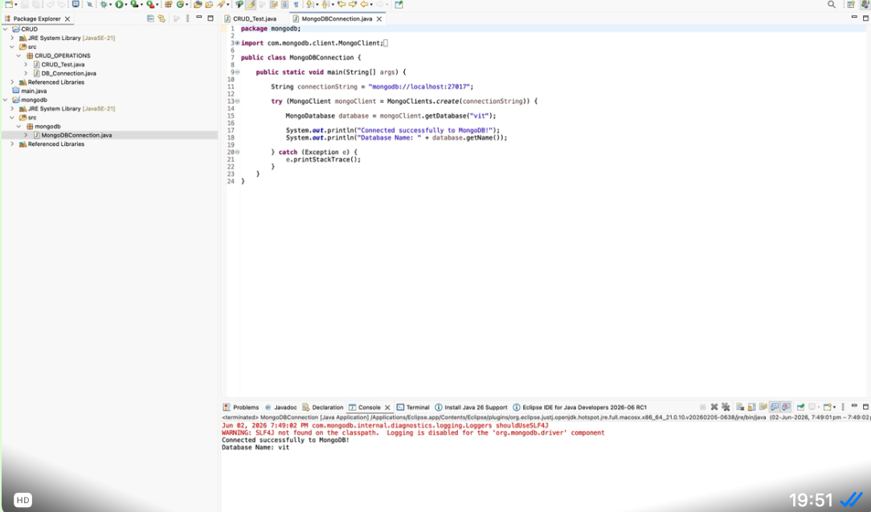

CRUD_Test.java
package CRUD_OPERATIONS;

import java.sql.Connection;
import java.sql.PreparedStatement;
import java.sql.ResultSet;

public class CRUD_Test {

public static void main(String[] args) {

CRUD_Test objTest = new CRUD_Test();

// insert data
objTest.create_data("1", "shubham", "shubham@gmail.com");
objTest.create_data("2", "rahul", "rahul@gmail.com");

// read data
objTest.read_data();

// update data
objTest.update_data("2", "22", "priya", "priya@gmail.com");

// delete data
objTest.delete_data("1");

// read data again
objTest.read_data();
}

public void create_data(String sl_no, String name, String email) {

DB_Connection obj_DB_Connection = new DB_Connection();

try {
Connection connection = obj_DB_Connection.get_connection();

String query = "INSERT INTO `user` (sl_no, name, email) VALUES (?, ?, ?)";

PreparedStatement ps = connection.prepareStatement(query);

ps.setString(1, sl_no);
ps.setString(2, name);
ps.setString(3, email);

ps.executeUpdate();

System.out.println("Data inserted successfully");

ps.close();
connection.close();

} catch (Exception e) {
e.printStackTrace();
}
}

public void read_data() {

DB_Connection obj_DB_Connection = new DB_Connection();

try {
Connection connection = obj_DB_Connection.get_connection();

String query = "SELECT * FROM `user`";

PreparedStatement ps = connection.prepareStatement(query);

ResultSet rs = ps.executeQuery();

while (rs.next()) {
System.out.println("Sl no - " + rs.getString("sl_no"));
System.out.println("Name - " + rs.getString("name"));
System.out.println("Email - " + rs.getString("email"));
System.out.println("--------------------");
}

rs.close();
ps.close();
connection.close();

} catch (Exception e) {
e.printStackTrace();
}
}

public void update_data(String sl_no, String new_sl_no, String name, String email) {

DB_Connection obj_DB_Connection = new DB_Connection();

try {
Connection connection = obj_DB_Connection.get_connection();

String query = "UPDATE `user` SET sl_no = ?, name = ?, email = ? WHERE sl_no = ?";

PreparedStatement ps = connection.prepareStatement(query);

ps.setString(1, new_sl_no);
ps.setString(2, name);
ps.setString(3, email);
ps.setString(4, sl_no);

ps.executeUpdate();

System.out.println("Data updated successfully");

ps.close();
connection.close();

} catch (Exception e) {
e.printStackTrace();
}
}

public void delete_data(String sl_no) {

DB_Connection obj_DB_Connection = new DB_Connection();

try {
Connection connection = obj_DB_Connection.get_connection();

String query = "DELETE FROM `user` WHERE sl_no = ?";

PreparedStatement ps = connection.prepareStatement(query);

ps.setString(1, sl_no);

ps.executeUpdate();

System.out.println("Data deleted successfully");

ps.close();
connection.close();

} catch (Exception e) {
e.printStackTrace();
}
}
}
CRUD_Connection
package CRUD_OPERATIONS;

import java.sql.Connection;
import java.sql.DriverManager;

public class DB_Connection {

public Connection get_connection() {

Connection connection = null;

try {
Class.forName("com.mysql.cj.jdbc.Driver");

connection = DriverManager.getConnection(
"jdbc:mysql://localhost:3306/crud",
"root",
"your_mysql_password"

);

} catch (Exception e) {
e.printStackTrace();
}

return connection;
}
}

Mysql workbench
CREATE TABLE user (
sl_no INT(5) AUTO_INCREMENT PRIMARY KEY,
name VARCHAR(100) NOT NULL,
email VARCHAR(100) NOT NULL UNIQUE
)
ENGINE = InnoDB
DEFAULT CHARSET = latin1
COLLATE = latin1_swedish_ci;

INSERT INTO user (name, email)
VALUES
('Shubham Sharma', 'shubham@gmail.com'),
('Rahul Verma', 'rahul@gmail.com'),
('Priya Singh', 'priya@gmail.com');

SELECT * FROM user;

