Student Name: RAUNIT SINGH ID: 1000030627 Major: B-Tech

Instructions
- There are 2 questions in this assignment.
- Email/paper/other modes of submissions will not be accepted.
- Upload a word version of this document.
- Submit the assignment by the due date and time.

Due Date: 11:50 am, August 2026.

Submitting this Assignment

You will submit (upload) this assignment in LMS. Name this document as NGLA1_AJPODD2025_John_Doe.doc in case your name is John Doe, and this non-graded lab assignment is no. 1 of course whose acronym is AJP, and offered in ODD 2025. Paste your code after each question, paste the screenshot of output, save and upload the document.

Grading Scheme: This assignment has 0 Marks. However, students must submit the complete assignment by the due date and time.

Question 1: Write a C programs to print your name on console.
ans.
#include<stdio.h>
void main()
{
printf("RAUNIT SINGH\t1000030627");
printf("\nMy name is RAUNIT SINGH");
}
OUTPUT:

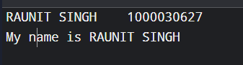

Question 2: Write a C program to print student data in the following manner:

Student ID | Student Name | Branch
101 | Aman | CSE
102 | Baman | CSE
103 | Raman | IT

Ans.
#include<stdio.h>
void main()
{
printf("RAUNIT SINGH\t1000030627");
printf("\nStudent ID\tStudent Name\tBranch");
printf("\n101\t\t\tAman\t\t\tCSE");
printf("\n102\t\t\tBaman\t\t\tCSE");
printf("\n103\t\t\tRaman\t\t\tIT");
}

OUTPUT:

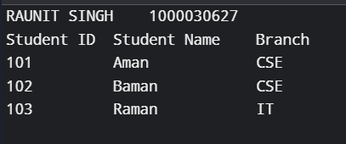

Question 3: Write a C program to demonstrate the programming environment in C. Explain each basic entity required to build a program including the compilation and run process.
Ans.
#include <stdio.h>

int main(void)
{
int x = 5, y = 10, sum;
printf("RAUNIT SINGH\t1000030627\n");
sum = x + y;

printf("\nHello, World!\n");
printf("Sum of %d and %d is %d\n", x, y, sum);

return 0;
}

OUTPUT:
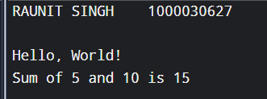

BASIC ENTITIES USED IN THE PROGRAM:

1. #include <stdio.h>
- This is a preprocessor directive.
- It tells the preprocessor to include the Standard Input Output header file.
- This header file contains the declaration of functions like printf(), which we use for displaying output.

2. int main(void)
- This is the main function, and every C program must have exactly one.
- It is the entry point of the program, meaning execution always starts from here.
- "int" means this function will return an integer value to the operating system.
- "void" means this function does not take any input parameters.

3. { } (Curly Braces)
- These mark the beginning and end of the main function's body.
- All statements of the function are written inside these braces.

4. int x = 5, y = 10, sum;
- This is a variable declaration statement.
- "int" is a data type used to store whole numbers.
- x, y, and sum are variable names (identifiers) used to store data in memory.
- x is initialized with 5 and y is initialized with 10, while sum is declared without a value.

5. sum = x + y;
- This is an assignment statement.
- It adds the values of x and y and stores the result in the variable sum.
- The "=" sign is the assignment operator.

6. printf("Hello, World!\n");
- This is a function call to printf(), a built-in library function.
- It is used to print output on the screen.
- "\n" is an escape sequence that moves the cursor to a new line.

7. printf("Sum of %d and %d is %d\n", x, y, sum);
- This is also a call to printf(), used to print the values of variables along with text.
- %d is a format specifier used to print integer values.
- The values of x, y, and sum are passed and displayed in place of %d.

8. return 0;
- This statement ends the main function.
- It sends the value 0 back to the operating system.
- 0 indicates that the program executed successfully without any errors.

9. ; (Semicolon)
- Used at the end of every statement in C.
- It tells the compiler that the statement has ended.

COMPILATION PROCESS:

1. Preprocessing
- All lines starting with # (like #include) are processed.
- The preprocessor adds the actual code of the header files into the program.
- Comments are removed.
- Output of this stage is an expanded C file.

2. Compilation
- The compiler takes the expanded code and converts it into assembly language.
- Assembly language is a low-level language, closer to machine understanding but still somewhat readable by humans.

3. Assembling
- The assembler converts the assembly code into machine code (binary - 0s and 1s).
- This creates an object file.
- This file is not runnable yet, as it does not contain code for built-in functions like printf().

4. Linking
- The linker connects the object file with the required library files (like the code for printf()).
- After linking, we get an executable file, which the computer can run.

5. Execution
- The executable file is run.
- The operating system loads it into memory, and the program starts executing from the main() function.

In short:
Source Code -> Preprocessing -> Compilation -> Assembling -> Linking -> Executable -> Run

RUN PROCESS:

1. Writing the Program
- The source code is written in a text editor and saved with a .c extension, for example hello.c

2. Compiling the Program
- The following command is used to compile the program:
gcc hello.c -o hello
- This command internally performs preprocessing, compilation, assembling, and linking, and creates an executable file named hello

3. Running the Executable
- The following command is used to run the program:
./hello
- The operating system loads the executable file into memory and execution begins from the main() function

4. Output is Displayed
- The program executes line by line and displays the result on the screen:
Hello, World!
Sum of 5 and 10 is 15

In short:
Write hello.c -> Compile using gcc hello.c -o hello -> Run using ./hello -> Output is displayed

Question 4: Write a C program to demonstrate the use of printf() and scanf() statements to read and print values of variables of different data types.

ans.
#include <stdio.h>

int main()
{
int a;
float b;
char c;
double d;
printf("RAUNIT SINGH\t1000030627\n\n");
printf("Enter an integer value: ");
scanf("%d", &a);

printf("Enter a float value: ");
scanf("%f", &b);

printf("Enter a character: ");
scanf(" %c", &c);

printf("Enter a double value: ");
scanf("%lf", &d);

printf("\nYou entered:\n");
printf("Integer value: %d\n", a);
printf("Float value: %.2f\n", b);
printf("Character value: %c\n", c);
printf("Double value: %.2lf\n", d);

return 0;
}

OUTPUT:
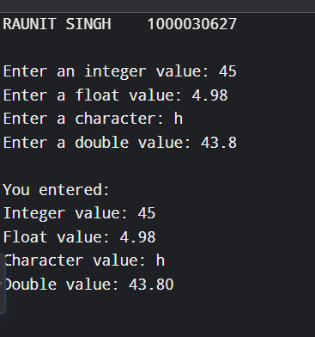

Question 5: Write a C program to demonstrate the use of assignment operator.
Ans.
#include <stdio.h>

int main()
{

printf("RAUNIT SINGH\t100003006267\n");
int a, b, c;

a = 10;
b = 20;

c = a + b;
printf("Simple assignment: c = a + b = %d\n", c);

c += a;
printf("c += a -> c = %d\n", c);

c -= b;
printf("c -= b -> c = %d\n", c);

return 0;
}

OUTPUT:
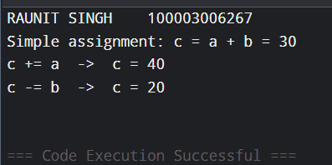

Question 6: Write a C program to displays the size of every data type.
Ans.
#include <stdio.h>

int main(void)
{
printf("RAUNIT SINGH\t1000030627\n\n");
printf("Size of int: %zu bytes\n", sizeof(int));
printf("Size of float: %zu bytes\n", sizeof(float));
printf("Size of double: %zu bytes\n", sizeof(double));
printf("Size of char: %zu bytes\n", sizeof(char));

return 0;
}

OUTPUT:
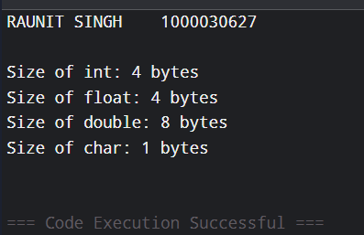

Question 7: Write a C program to demonstrate the programming environment in C. Explain
each basic entity required to build a program, including the compilation and run process.
Ans. Same as Question 3.

Question 8: Write a C program to convert a floating-point number into the corresponding integer and vice versa.
Ans.
#include <stdio.h>

int main()
{
int a, i;
float b, f;

printf("RAUNIT SINGH\t1000030627");

printf("\nEnter the float value to be converted into integer: ");
scanf("%f", &b);

printf("\nEnter the integer value to be converted into float: ");
scanf("%d", &a);

i = (int)b;
printf("\nFloat %.2f converted to Integer = %d", b, i);

f = (float)a;
printf("\nInteger %d converted to Float = %.2f", a, f);

return 0;
}

OUTPUT:
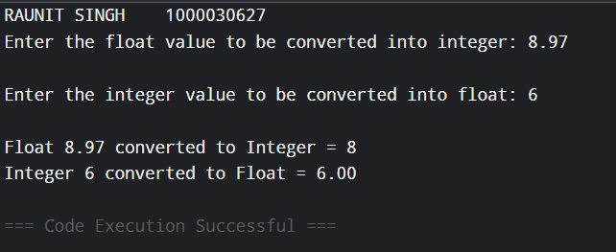

Question 9: Write a C program to convert degrees Fahrenheit into degrees Celsius.
Ans.
#include <stdio.h>

int main(void)
{
float fahrenheit, celsius;
printf("RAUNIT SINGH\t1000030627\n\n");
printf("Enter temperature in Fahrenheit: ");
scanf("%f", &fahrenheit);

celsius = (fahrenheit - 32) * 5 / 9;

printf("Temperature in Celsius = %.2f\n", celsius);

return 0;
}

OUTPUT:
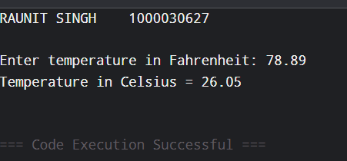

Question 10: Write a C program to print the ASCII value of a character.
Ans.
#include <stdio.h>

int main()
{
char ch;
printf("RAUNIT SINGH\t1000030627\n\n");
printf("Enter a character: ");
scanf("%c", &ch);

printf("ASCII value of %c = %d\n", ch, ch);

return 0;
}

OUTPUT;
