Student Name: ID: Major:

Instructions
- There are ___ questions in this assignment.
- Email/paper/other modes of submissions will not be accepted.
- Upload a word version of this document.
- Submit the assignment by the due date and time.

Due Date: ___ pm, August 2026.

Submitting this Assignment

You will submit (upload) this assignment in MS Teams. Name this document as NGLA1_AJPODD2024_John_Doe.doc in case your name is John Doe, and this non-graded lab assignment is no. 1 of course whose acronym is AJP, and offered in ODD 2024. Paste your code after each question, paste the screenshot of output, save and upload the document.

Grading Scheme: This assignment has 0 Marks. However, students must submit the complete assignment by the due date and time.

1.Write a program to find area of rectangle.
Ans.
#include <stdio.h>

int main()
{
float l,b;
printf("RAUNIT SINGH\t1000030627\n");
printf("Enter the value of length and braedth of the rectangle: ");
scanf("%f%f",&l,&b);
printf("The area of the rectangle of breadth %f and breadth %f is %0.2f",l,b,l*b);
return 0;
}

OUTPUT

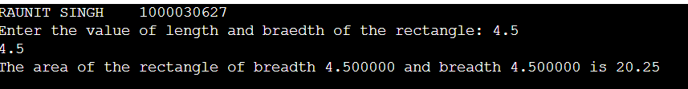

2.Write a program to find area of a circle.
Ans.
#include <stdio.h>

int main()
{
float r;
printf("RAUNIT SINGH\t1000030627\n");
printf("Enter the value of radius of circle: ");
scanf("%f",&r);
printf("The area of the circle of radius %f is %0.2f",r,3.14*r*r);
return 0;
}

OUTPUT :
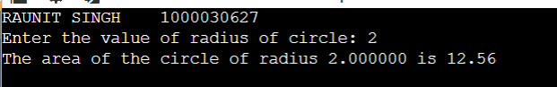

3.Write a program to find area of a triangle.
Ans.
#include <stdio.h>

int main()
{
float b,h;
printf("RAUNIT SINGH\t1000030627\n");
printf("Enter the value of base and height: ");
scanf("%f%f",&b,&h);
printf("The area of the circle of base %f and height %f is %0.2f",b,h,0.5*b*h);
return 0;
}

OUTPUT

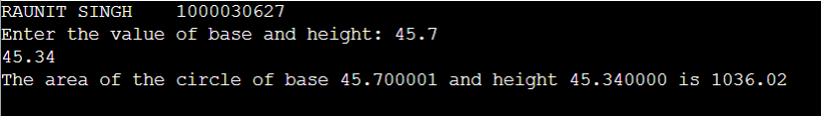

4.Write a program to find area of a triangle using Heron’s formula.
Ans.
#include <stdio.h>
#include <math.h>

int main()
{
float a, b, c, s, area;
printf("RAUNIT SINGH\t1000030627\n");
printf("Enter side 1: ");
scanf("%f", &a);
printf("Enter side 2: ");
scanf("%f", &b);
printf("Enter side 3: ");
scanf("%f", &c);

s = (a + b + c) / 2;
area = sqrt(s * (s - a) * (s - b) * (s - c));

printf("Area of the triangle = %.2f\n", area);

return 0;
}

OUTPUT
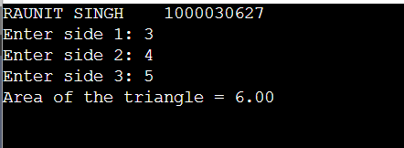

5.Write a program to find area of a right-angle triangle using Pythagoras
Theorem
Ans.
#include <stdio.h>
#include <math.h>

int main()
{
float base, hypotenuse, height, area;
printf("RAUNIT SINGH\t1000030627\n");

printf("Enter base: ");
scanf("%f", &base);
printf("Enter hypotenuse: ");
scanf("%f", &hypotenuse);

height = sqrt((hypotenuse * hypotenuse) -( base * base));

area = 0.5 * base * height;

printf("Height = %.2f\n", height);
printf("Area of the triangle = %.2f\n", area);

return 0;
}

OUTPUT

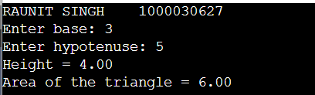

6.Write a program to find perimeter of rectangle.
Ans.
#include <stdio.h>

int main()
{
float l, b, perimeter;
printf("RAUNIT SINGH\t1000030627\n");
printf("Enter length: ");
scanf("%f", &l);
printf("Enter breadth: ");
scanf("%f", &b);

perimeter = 2 * (l +b);

printf("Perimeter of the rectangle = %.2f\n", perimeter);

return 0;
}

OUTPUT

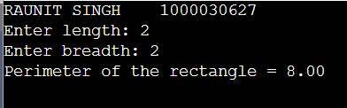

7.Write a program to find circumference of circle.
Ans.
#include <stdio.h>
int main()
{
float r, circumference;
const float PI = 3.14159;

printf("RAUNIT SINGH\t1000030627\n");
printf("Enter radius: ");
scanf("%f", &r);

circumference = 2 * PI * r;

printf("Circumference of the circle = %.2f\n", circumference);

return 0;
}

OUTPUT

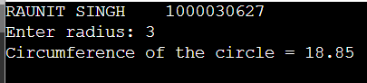

8.Write a C program to illustrate the use of unary prefix/ postfix increment and decrement operators.
Ans.
#include <stdio.h>

int main()
{
int a = 5, b = 5, c = 5, d = 5;

printf("RAUNIT SINGH\t1000030627\n");
printf("Initial values: a=%d, b=%d, c=%d, d=%d\n\n", a, b, c, d);

printf("Postfix Increment (a++):\n");
printf("a++ = %d\n", a++);
printf("Now a = %d\n\n", a);

printf("Prefix Increment (++b):\n");
printf("++b = %d\n", ++b);
printf("Now b = %d\n\n", b);

printf("Postfix Decrement (c--):\n");
printf("c-- = %d\n", c--);
printf("Now c = %d\n\n", c);

printf("Prefix Decrement (--d):\n");
printf("--d = %d\n", --d);
printf("Now d = %d\n", d);

return 0;
}

OUTPUT

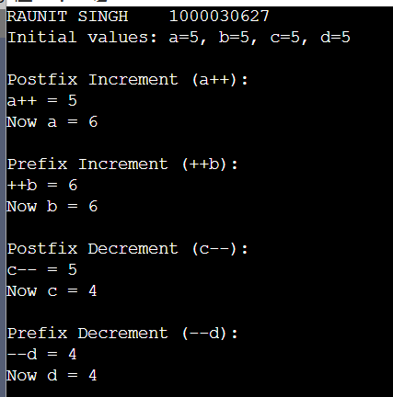

9.Write a C program to find the largest of two numbers using ternary operator.
Ans.
#include <stdio.h>

int main()
{
int a, b, largest;

printf("RAUNIT SINGH\t1000030627\n");
printf("Enter first number: ");
scanf("%d", &a);
printf("Enter second number: ");
scanf("%d", &b);

largest = (a > b) ? a : b;

printf("Largest number = %d\n", largest);

return 0;
}
OUTPUT
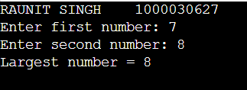

10.Write a C program to print the ASCII value of a character.
Ans.
#include <stdio.h>

int main()
{
char ch;

printf("RAUNIT SINGH\t1000030627\n");
printf("Enter a character: ");
scanf("%c", &ch);

printf("ASCII value of %c = %d\n", ch, ch);

return 0;
}

OUTPUT
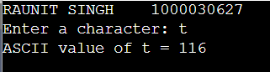

11.Write a C program to read a character in upper case and then print in lower case.
Ans.
#include <stdio.h>

int main()
{
char ch;

printf("RAUNIT SINGH\t1000030627\n");
printf("Enter an uppercase character: ");
scanf("%c", &ch);

ch = ch + 32;

printf("Lowercase character = %c\n", ch);

return 0;
}

OUTPUT
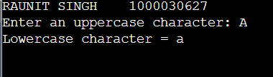

12.Write a C program to convert degrees Fahrenheit onto degree Celsius.
Ans.
#include <stdio.h>

int main()
{
float fahrenheit, celsius;

printf("RAUNIT SINGH\t1000030627\n");
printf("Enter temperature in Fahrenheit: ");
scanf("%f", &fahrenheit);

celsius = (fahrenheit - 32) * 5 / 9;

printf("Temperature in Celsius = %.2f\n", celsius);

return 0;
}

OUTPUT
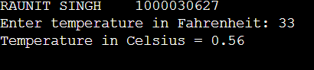

13.Write a C program to convert a floating-point number into the corresponding integer and vice versa.
Ans.
#include <stdio.h>

int main()
{
float f;
int i;

printf("RAUNIT SINGH\t2000030627\n");
printf("Enter a floating-point number: ");
scanf("%f", &f);
i = (int)f;
printf("Integer value = %d\n\n", i);

printf("Enter an integer: ");
scanf("%d", &i);
f = (float)i;
printf("Floating-point value = %.2f\n", f);

return 0;
}

OUTPUT:
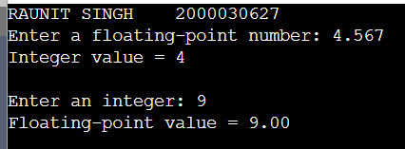

14.Write the C programs to demonstrate the use of the following operators:
i. Arithmetic Operators
ii. Relational Operators
iii. Logical Operators
iv. Shorthand Assignment
v. Unary Operators
vi. Conditional Operators
vii. Bitwise Operators
viii. Comma Operator
Ans.
#include <stdio.h>

int main()
{
int a = 12, b = 5;

printf("RAUNIT SINGH\t1000030627\n");
printf("---- Arithmetic Operators ----\n");
printf("a + b = %d\n", a + b);
printf("a - b = %d\n", a - b);
printf("a * b = %d\n", a * b);
printf("a / b = %d\n", a / b);
printf("a %% b = %d\n\n", a % b);

printf("---- Relational Operators ----\n");
printf("a > b = %d\n", a > b);
printf("a < b = %d\n", a < b);
printf("a == b = %d\n", a == b);
printf("a != b = %d\n\n", a != b);

printf("---- Logical Operators ----\n");
printf("(a > b) && (a > 0) = %d\n", (a > b) && (a > 0));
printf("(a < b) || (a > 0) = %d\n", (a < b) || (a > 0));
printf("!(a > b) = %d\n\n", !(a > b));

printf("---- Shorthand Assignment Operators ----\n");
int x = 10;
x += 5; printf("x += 5 -> x = %d\n", x);
x -= 3; printf("x -= 3 -> x = %d\n", x);
x *= 2; printf("x *= 2 -> x = %d\n", x);
x /= 4; printf("x /= 4 -> x = %d\n", x);
x %= 3; printf("x %%= 3 -> x = %d\n\n", x);

printf("---- Unary Operators ----\n");
int p = 5;
printf("p++ = %d\n", p++);
printf("After p++, p = %d\n", p);
printf("++p = %d\n", ++p);
printf("-p = %d\n\n", -p);

printf("---- Conditional Operator ----\n");
int max = (a > b) ? a : b;
printf("Largest of a and b = %d\n\n", max);

printf("---- Bitwise Operators ----\n");
printf("a & b = %d\n", a & b);
printf("a | b = %d\n", a | b);
printf("a ^ b = %d\n", a ^ b);
printf("~a = %d\n", ~a);
printf("a << 1 = %d\n", a << 1);
printf("a >> 1 = %d\n\n", a >> 1);

printf("---- Comma Operator ----\n");
int m, n;
m = (n = 10, n + 5);
printf("n = %d, m = %d\n", n, m);

return 0;
}

OUTPUT:
