Student Name: RAUNIT SINGH ID: 1000030627 Major: B-Tech CSE

Instructions
- There are ___ questions in this assignment.
- Email/paper/other modes of submissions will not be accepted.
- Upload a word version of this document.
- Submit the assignment by the due date and time.

Due Date: ___ pm, September 2026.

Submitting this Assignment

You will submit (upload) this assignment in MS Teams. Name this document as NGLA1_AJPODD2026_John_Doe.doc in case your name is John Doe, and this non-graded lab assignment is no. 1 of course whose acronym is AJP, and offered in ODD 2026. Paste your code after each question, paste the screenshot of output, save and upload the document.

Grading Scheme: This assignment has 0 Marks. However, students must submit the complete assignment by the due date and time.

1.Write a C program to show the use of logical operators.
Ans.
#include <stdio.h>

void main()
{
int a = 12, b = 5;

printf("RAUNIT SINGH\t1000030627\n");
printf("(a > b) && (a > 0) = %d\n", (a > b) && (a > 0));
printf("(a < b) || (a > 0) = %d\n", (a < b) || (a > 0));
printf("!(a > b) = %d\n\n", !(a > b));
}

OUTPUT
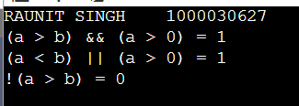

2.Write a C program to show whether a person is eligible to vote.
Ans.
#include <stdio.h>
void main()
{
int a,b;
printf("RAUNIT SINGH\t1000030627\n");
printf("Enter the age of person1:");
scanf("%d",&a);
printf("Enter the age of person2:");
scanf("%d",&b);
if (a>=18)
printf("The person1 is eligible to vote\n");
else
printf("The person1 is not eligible to vote\n");
if (a<=18)
printf("The person2 is eligible to vote\n");
else
printf("The person2 is not eligible to vote\n");
}

OUTPUT
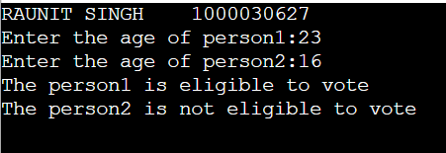

3.Write a C program to show the use of isalpha(), isdigit(), isprint() and isspace() functions with if.
Ans.
#include <stdio.h>
#include <ctype.h>

void main()
{
char ch1 = 'A';
char ch2 = '5';

printf("RAUNIT SINGH\t1000030627\n");
printf("Character 1: '%c'\n", ch1);

if (isalpha(ch1))
printf("isalpha: Yes\n");
else
printf("isalpha: No\n");

if (isdigit(ch1))
printf("isdigit: Yes\n");
else
printf("isdigit: No\n");

if (isprint(ch1))
printf("isprint: Yes\n");
else
printf("isprint: No\n");

if (isspace(ch1))
printf("isspace: Yes\n");
else
printf("isspace: No\n");

printf("\nCharacter 2: '%c'\n", ch2);

if (isalpha(ch2))
printf("isalpha: Yes\n");
else
printf("isalpha: No\n");

if (isdigit(ch2))
printf("isdigit: Yes\n");
else
printf("isdigit: No\n");

if (isprint(ch2))
printf("isprint: Yes\n");
else
printf("isprint: No\n");

if (isspace(ch2))
printf("isspace: Yes\n");
else
printf("isspace: No\n");

}
OUTPUT
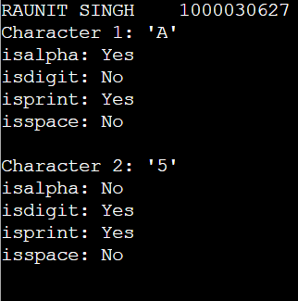
4.Write a C program to enter number from 1 to 7 and display the corresponding day of the week using switch case statement.
Ans.
#include <stdio.h>
#include <ctype.h>

void main()
{
int day;

printf("RAUNIT SINGH\t1000030627\n");
printf("Enter a number (1-7): ");
scanf("%d", &day);

switch (day) {
case 1:
printf("Monday\n");
break;
case 2:
printf("Tuesday\n");
break;
case 3:
printf("Wednesday\n");
break;
case 4:
printf("Thursday\n");
break;
case 5:
printf("Friday\n");
break;
case 6:
printf("Saturday\n");
break;
case 7:
printf("Sunday\n");
break;
default:
printf("Invalid input! Please enter a number between 1 and 7.\n");
}

}

OUTPUT

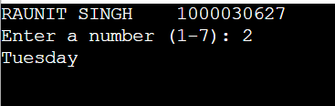

5.Write a C program to print 20 horizontal asterisks (*) using while loop.
Ans.
#include <stdio.h>

void main()
{
int a = 0;

printf("RAUNIT SINGH\t100030627\n");
while (a < 20)
{
printf("*");
a++;
}
}

OUTPUT


6.Write a C program to calculate the sum of numbers from m to n using while loop.
Ans.
#include <stdio.h>

void main()
{
int m, n, sum = 0;

printf("RAUNIT SINGH\t1000030627\n");
printf("Enter the value of m: ");
scanf("%d", &m);

printf("Enter the value of n: ");
scanf("%d", &n);

int i = m;
while (i <= n)
{
sum += i;
i++;
}

printf("Sum of numbers from %d to %d = %d\n", m, n, sum);

}
OUTPUT
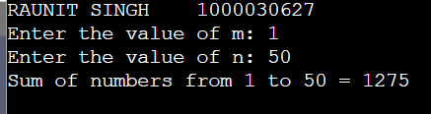

7.Write a C program to display the square and cube of first n natural numbers using do-while loop.
Ans.
#include <stdio.h>

void main()
{
int n, i = 1;

printf("RAUNIT SINGH\t1000030627\n\n");
printf("Enter the value of n: ");
scanf("%d", &n);

printf("Number\tSquare\tCube\n");

do
{
printf("%d\t%d\t%d\n", i, i * i, i * i * i);
i++;
} while (i <= n);
}
OUTPUT
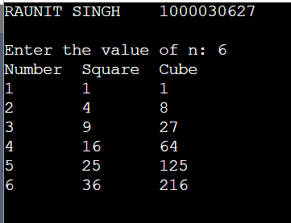

8.Write the C programs to print following patterns using for loop:
(i)
**********
**********
**********
**********
**********
Ans.
#include <stdio.h>

void main()
{
int i, j, rows = 5, cols = 10;

printf("RAUNIT SINGH\t1000030627\n\n");
for (i = 1; i <= rows; i++)
{
for (j = 1; j <= cols; j++)
{
printf("*");
}
printf("\n");
}
}
OUTPUT
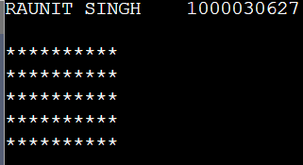

(ii)
*
**
***
****
*****
Ans.
#include <stdio.h>

void main()
{
int i, j, rows = 5;

printf("RAUNIT SINGH\t1000030627\n\n");
for (i = 1; i <= rows; i++)
{
for (j = 1; j <= i; j++)
{
printf("*");
}
printf("\n");
}

}
OUTPUT
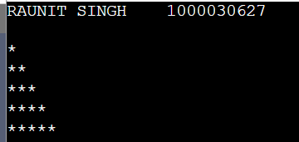

(iii)
1
12
123
1234
12345
Ans.
#include <stdio.h>

void main()
{
int i, j, rows = 5;

printf("RAUNIT SINGH\t1000030627\n\n");
for (i = 1; i <= rows; i++)
{
for (j = 1; j <= rows - i; j++)
{
printf(" ");
}
for (j = 1; j <= i; j++)
{
printf("%d", j);
}
printf("\n");
}
}

OUTPUT
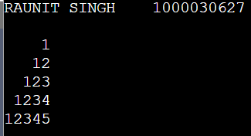

(iv)

1
121
12321
1234321
123454321

Ans.
#include <stdio.h>

void main() {
int i, j, rows = 5;

printf("RAUNIT SINGH\t1000030627\n\n");
for (i = 1; i <= rows; i++)
{
for (j = 1; j <= rows - i; j++)
{
printf(" ");
}
for (j = 1; j <= i; j++)
{
printf("%d", j);
}
for (j = i - 1; j >= 1; j--)
{
printf("%d", j);
}
printf("\n");
}
}
OUTPUT
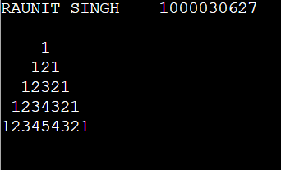

9. Write a program in C using for loop to calculate the factorial of a number.
Ans.
#include <stdio.h>

void main()
{
int n;
unsigned long long factorial = 1;

printf("RAUNIT SINGH\t1000030627\n\n");
printf("Enter a positive integer: ");
scanf("%d", &n);

if (n < 0)
{
printf("Error! Factorial of a negative number doesn't exist.\n");
}
else
{
for (int i = 1; i <= n; i++)
{
factorial *= i;
}
printf("Factorial of %d = %llu\n", n, factorial);
}
}
OUTPUT
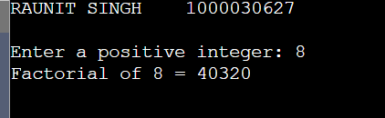

10. Write a program in C to print the reverse of a number.
Ans.
#include <stdio.h>

void main()
{
int num, reversed = 0, digit;

printf("RAUNIT SINGH\t1000030627\n\n");
printf("Enter a number: ");
scanf("%d", &num);

while (num != 0)
{
digit = num % 10;
reversed = reversed * 10 + digit;
num = num / 10;
}

printf("Reversed number: %d\n", reversed);
}
OUTPUT
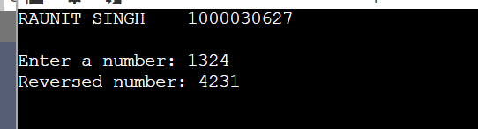

11. Write a program in C to classify a number as prime or composite.
Ans.
#include <stdio.h>

void main()
{
int num, i, isPrime = 1;

printf("RAUNIT SINGH\t1000030627\n");
printf("Enter a number: ");
scanf("%d", &num);

for (i = 2; i < num; i++)
{
if (num % i == 0)
{
isPrime = 0;
break;
}
}

if (num < 2)
{
isPrime = 0;
}

if (isPrime)
{
printf("%d is Prime\n", num);
}
else
{
printf("%d is Composite\n", num);
}
}

OUTPUT
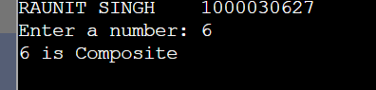

12. Write the programs to demonstrate the use of break, continue and goto statements.
Ans.
#include <stdio.h>
void main()
{
int i;

printf("RAUNIT SINGH\t1000030627\n");

printf("Demonstration of break statement:\n");
printf("Loop will terminate when i = 5\n\n");

for (i = 1; i <= 10; i++)
{
if (i == 5)
{
break;
}
printf("i = %d\n", i);
}

printf("\nLoop terminated. Value of i = %d\n", i);

printf("Demonstration of continue statement:\n");
printf("Printing numbers from 1 to 10, skipping multiples of 3\n\n");

for (i = 1; i <= 10; i++)
{
if (i % 3 == 0)
{
continue;
}
printf("i = %d\n", i);
}

i = 1;
printf("Demonstration of goto statement:\n\n");

start:
if (i <= 5)
{
printf("i = %d\n", i);
i++;
goto start;
}

printf("\nLoop ended using goto. Final value of i = %d\n", i);

}
OUTPUT
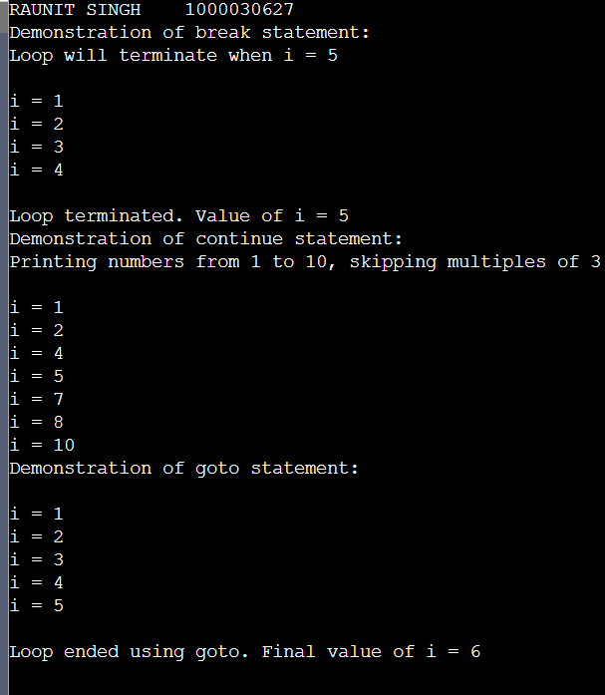

13. Write a C program to find the greatest of three numbers using && and if-else-if.
Ans.
#include <stdio.h>

void main()
{
int a, b, c;

printf("RAUNIT SINGH\t1000030627\n");
printf("Enter three numbers: ");
scanf("%d %d %d", &a, &b, &c);

if (a >= b && a >= c)
{
printf("%d is the greatest\n", a);
}
else if (b >= a && b >= c)
{
printf("%d is the greatest\n", b);
}
else
{
printf("%d is the greatest\n", c);
}
}
OUTPUT
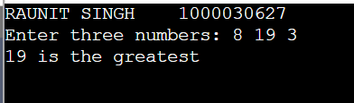

14. Write a C program to show the use of isalpha(), isdigit(), isprint() and isspace() functions with if.
Ans.
#include <stdio.h>
#include <ctype.h>

void main()
{
char ch1 = 'A';
char ch2 = '5';

printf("RAUNIT SINGH\t1000030627\n");
printf("Character 1: '%c'\n", ch1);

if (isalpha(ch1))
printf("isalpha: Yes\n");
else
printf("isalpha: No\n");

if (isdigit(ch1))
printf("isdigit: Yes\n");
else
printf("isdigit: No\n");

if (isprint(ch1))
printf("isprint: Yes\n");
else
printf("isprint: No\n");

if (isspace(ch1))
printf("isspace: Yes\n");
else
printf("isspace: No\n");

printf("\nCharacter 2: '%c'\n", ch2);

if (isalpha(ch2))
printf("isalpha: Yes\n");
else
printf("isalpha: No\n");

if (isdigit(ch2))
printf("isdigit: Yes\n");
else
printf("isdigit: No\n");

if (isprint(ch2))
printf("isprint: Yes\n");
else
printf("isprint: No\n");

if (isspace(ch2))
printf("isspace: Yes\n");
else
printf("isspace: No\n");
}

OUTPUT
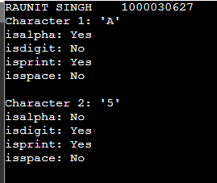

15. Write a C program to enter numbers from 1 to 7 and display the corresponding day of the week using a switch case statement.
Ans.
#include <stdio.h>
#include <ctype.h>

void main()
{
int day;

printf("RAUNIT SINGH\t1000030627\n");
printf("Enter a number (1-7): ");
scanf("%d", &day);

switch (day) {
case 1:
printf("Monday\n");
break;
case 2:
printf("Tuesday\n");
break;
case 3:
printf("Wednesday\n");
break;
case 4:
printf("Thursday\n");
break;
case 5:
printf("Friday\n");
break;
case 6:
printf("Saturday\n");
break;
case 7:
printf("Sunday\n");
break;
default:
printf("Invalid input! Please enter a number between 1 and 7.\n");
}

}
OUTPUT
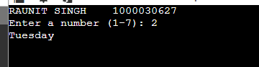

16. Write a C program to calculate the sum of numbers from m to n using a while loop.
Ans.
#include <stdio.h>

void main()
{
int m, n, sum = 0;

printf("RAUNIT SINGH\t1000030627\n");
printf("Enter the value of m: ");
scanf("%d", &m);

printf("Enter the value of n: ");
scanf("%d", &n);

int i = m;
while (i <= n)
{
sum += i;
i++;
}

printf("Sum of numbers from %d to %d = %d\n", m, n, sum);
}
OUTPUT
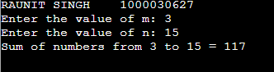

17. Write a C program to display the square and cube of first n natural numbers using the do-while loop.
Ans.
#include <stdio.h>

void main()
{
int n, i = 1;

printf("RAUNIT SINGH\t1000030627\n\n");
printf("Enter the value of n: ");
scanf("%d", &n);

printf("Number\tSquare\tCube\n");

do
{
printf("%d\t%d\t%d\n", i, i * i, i * i * i);
i++;
} while (i <= n);
}
OUTPUT
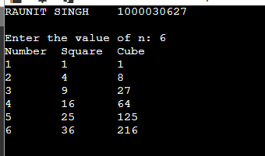

18. Write the C programs to print the following patterns using the for loop:
(i)
*
**
***
****
*****
Ans.
#include <stdio.h>

void main()
{
int i, j, rows;

printf("RAUNIT SINGH\t1000030627\n\n");
printf("Enter the no of rows you want:");
scanf("%d",&rows);
for (i = 1; i <= rows; i++)
{
for (j = 1; j <= i; j++)
{
printf("*");
}
printf("\n");
}
}
OUTPUT
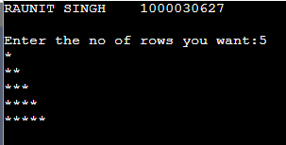

(ii)
1
12
123
1234
12345
Ans.
#include <stdio.h>
void main()
{
int i, j, n;

printf("RAUNIT SINGH\t1000030627\n");
printf("Enter the number of rows you want:");
scanf("%d",&n);

for(i = 1; i <= n; i++)
{
for(j = 1; j <= n-i; j++)
{
printf(" ");
}
for(j = 1; j <= i; j++)
{
printf("%d", j);
}
printf("\n");
}
}

OUTPUT
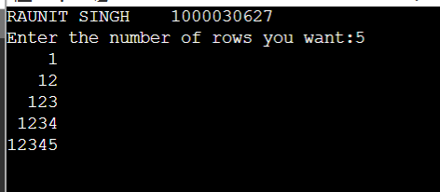

19. Write the programs to demonstrate the use of break, continue, and goto statements.
Ans.
#include <stdio.h>
void main()
{
int i;

printf("RAUNIT SINGH\t1000030627\n");

printf("Demonstration of break statement:\n");
printf("Loop will terminate when i = 5\n\n");

for (i = 1; i <= 10; i++)
{
if (i == 5)
{
break;
}
printf("i = %d\n", i);
}

printf("\nLoop terminated. Value of i = %d\n", i);

printf("Demonstration of continue statement:\n");
printf("Printing numbers from 1 to 10, skipping multiples of 3\n\n");

for (i = 1; i <= 10; i++)
{
if (i % 3 == 0)
{
continue;
}
printf("i = %d\n", i);
}

i = 1;
printf("Demonstration of goto statement:\n\n");

start:
if (i <= 5)
{
printf("i = %d\n", i);
i++;
goto start;
}

printf("\nLoop ended using goto. Final value of i = %d\n", i);

}
OUTPUT
