Student Name: RAUNIT SINGH ID:1000030627 Major: B-Tech CSE

Instructions
- There are ___ questions in this assignment.
- Email/paper/other modes of submissions will not be accepted.
- Upload a word version of this document.
- Submit the assignment by the due date and time.

Due Date: ___ pm, September 2026.

Submitting this Assignment

You will submit (upload) this assignment in MS Teams. Name this document NGLA4_AJPODD2026_John_Doe.doc if your name is John Doe. This is a non-graded lab assignment no. 1 of the course AJP, and it is offered in ODD 2024. Paste your code after each question, paste the screenshot of the output, save, and upload the document.

Grading Scheme: This assignment has 0 Marks. However, students must submit the complete assignment by the due date and time.

1. Write a C program to enter numbers from 1 to 7 and display the corresponding day of the week using a switch case statement.
Ans.
#include <stdio.h>
void main()
{
printf("Raunit Singh\t1000030627\n");
int n;
printf("Entre your choice between (1-7):");
scanf("%d", &n);

switch(n)
{
case 1 :
printf("Monday");
break;

case 2 :
printf("Tuesday");
break;

case 3 :
printf("Wednesday");
break;

case 4 :
printf("Thursday");
break;

case 5 :
printf("Friday");
break;

case 6 :
printf("Saturday");
break;

case 7 :
printf("Sunday");
break;

default :
printf("INVALID INPUT\nEnter a valid input");

}

}

OUTPUT

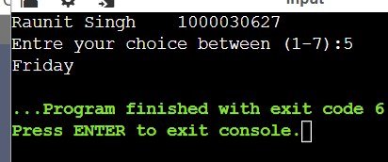

2. Write a C program to calculate the sum of numbers from m to n using a while loop.
Ans.
#include <stdio.h>

int main()
{
printf("Raunit Singh\t1000030627\n");

int m, n, sum = 0;

printf("Enter the starting number (m): ");
scanf("%d", &m);
printf("Enter the ending number (n): ");
scanf("%d", &n);

if (m > n)
{
printf("Error!!! - m should be less than or equal to n.\n");
return 1;
}

int i = m;

while (i <= n)
{
sum += i;
i++;
}

printf("The sum of numbers from %d to %d is: %d\n", m, n, sum);

return 0;
}

OUTPUT:
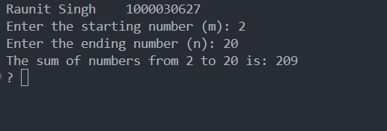

3. Write a C program to display the square and cube of the first n natural numbers using the do-while loop.
Ans.
#include <stdio.h>

#include <stdio.h>

int main()
{
printf("Raunit Singh\t1000030627\n");

int n, i = 1;

printf("Enter the number of natural numbers (n): ");
scanf("%d", &n);

if (n <= 0)
{
printf("Please enter a positive integer greater than 0.\n");
}

printf("\n%-10s %-10s %-10s\n", "Number", "Square", "Cube");

do
{
printf("%-10d %-10d %-10d\n", i, i * i, i * i * i);
i++;
} while (i <= n);

return 0;
}
OUTPUT:
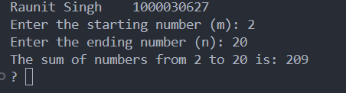

4. Write the C programs to print the following patterns using the for loop:
(i)
*
**
***
****
*****
Ans.
#include <stdio.h>

int main()
{
printf("Raunit Singh\t1000030627\n");
int i, n, j;

printf("Enter the number of rows you want:");
scanf("%d", &n);

for (i = 1; i <= n; i++) {
for (j = 1; j <= i; j++) {
printf("*");
}
printf(" \n");
}
return 0;
}

OUTPUT:
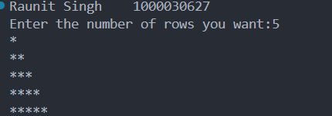

(ii)
1
12
123
1234
12345
Ans.
#include <stdio.h>
int main()
{
printf("Raunit Singh\t1000030627\n");
int i, j, n;
printf("Enter the number of rows you want :");
scanf("%d", &n);

for (i = 1; i <= n; i++)
{
for (j = 1; j <= n - i; j++)
{
printf(" ");
}
for (j = 1; j <= i; j++)
{
printf("%d", j);
}
printf("\n");
}
return 0;
}
OUTPUT:
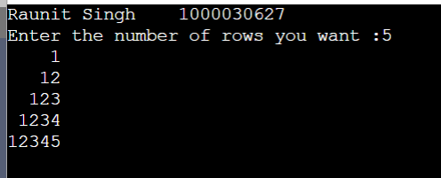
5. Write C programs to demonstrate the use of break, continue, and goto statements.
Ans.
#include <stdio.h>
void main()
{
int i;

printf("RAUNIT SINGH\t1000030627\n");

printf("Demonstration of break statement:\n");
printf("Loop will terminate when i = 5\n\n");

for (i = 1; i <= 10; i++)
{
if (i == 5)
{
break;
}
printf("i = %d\n", i);
}

printf("\nLoop terminated. Value of i = %d\n", i);

printf("Demonstration of continue statement:\n");
printf("Printing numbers from 1 to 10, skipping multiples of 3\n\n");

for (i = 1; i <= 10; i++)
{
if (i % 3 == 0)
{
continue;
}
printf("i = %d\n", i);
}

i = 1;
printf("Demonstration of goto statement:\n\n");

start:
if (i <= 5)
{
printf("i = %d\n", i);
i++;
goto start;
}

printf("\nLoop ended using goto. Final value of i = %d\n", i);

}

OUTPUT:
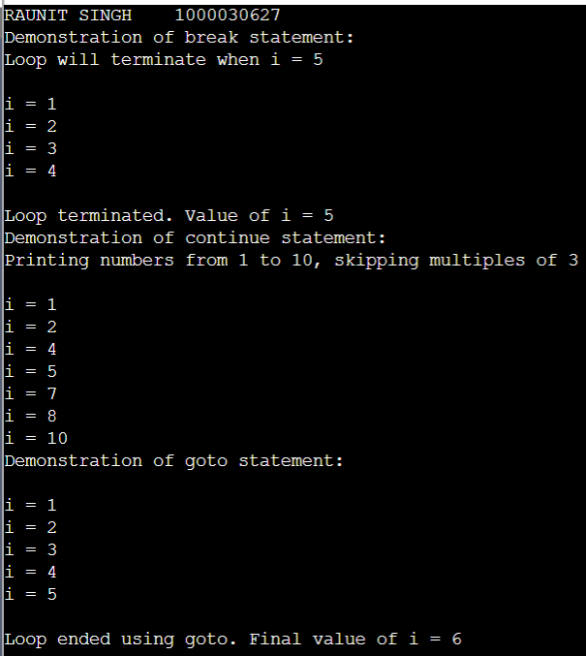

6. Develop a program to calculate the sum of n array elements in C.
Ans.
#include <stdio.h>

int main()
{
printf("Raunit Singh\t1000030627\n");

int n, i, sum = 0;

printf("Enter number of elements: ");
scanf("%d", &n);

int arr[n];

printf("Enter %d numbers:\n", n);
for(i = 0; i < n; i++)
{
scanf("%d", &arr[i]);
sum += arr[i];
}

printf("Sum = %d\n", sum);

return 0;
}
OUTPUT:
