BIMAYA
Online Insurance Made Easy
Project Documentation
What Bimaya Is, Who It's For, and How It Works

Version: | 1.0
Prepared by: | Aman Rauniyar
Date: | September 2026
Audience: | General — no technical background required

Table of Contents

1. What Is Bimaya?
Bimaya is a digital insurance marketplace built for Nepal. It's a platform where anyone can go online, compare insurance policies from multiple companies side by side, and buy the one that fits them best — without visiting an agent's office or filling out paperwork by hand.
Think of it as bringing insurance shopping online the way people already shop for flights or hotels: browse options, compare prices and coverage, and buy — all from a phone or a computer.

2. Why Bimaya Exists

2.1 The Problem
- There is no single place in Nepal where someone can compare insurance policies across different companies
- Most people don't fully understand their insurance options, because information is scattered and often only available through agents
- Buying insurance today is slow and paper-heavy — physical forms, in-person visits, manual follow-ups
- Insurance companies themselves have limited digital reach to find new customers

2.2 The Opportunity
Nepal's insurance penetration is still low compared to many other countries, and the market is shifting toward digital services as smartphone and internet use grows. Bimaya is positioned to be one of the first true multi-provider insurance marketplaces in Nepal — comparable to how Policybazaar works in India, adapted for the Nepali market and its two major payment gateways, eSewa and Khalti.

3. Who Bimaya Is For
Who | Description | What they get from Bimaya
Customer | Anyone in Nepal looking to buy Life, Health, Vehicle, or Travel insurance | Compare policies from multiple companies, buy online, manage policies, file claims — without visiting an agent
Insurance Provider | An insurance company wanting to sell policies digitally | Reach new customers, publish and manage a policy catalog, handle claims from one dashboard
Administrator | The Bimaya team, operating the platform | Approve providers and policies, verify KYC, keep the marketplace trustworthy

4. Platforms
Bimaya is built across three coordinated platforms, all connected to one shared system, so information is always consistent no matter where someone accesses it:
- Web Application — used by Customers, Insurance Providers, and Administrators
- Mobile Application (Android & iOS) — used by Customers, planned after the web platform is stable
- Admin Panel — used internally by the Bimaya team to approve providers and policies and keep the platform trustworthy
Why this matters: Because everything runs on one shared system, a customer's purchase, a provider's new policy, or an admin's approval is instantly reflected everywhere — there's no delay or inconsistency between platforms.

5. Complete Feature List

5.1 For Customers
Feature | What it does
Registration & Login | Sign up with a phone number or email, verify with a one-time code (OTP), log in securely
Browse & Discover | Explore insurance policies by category: Life, Health, Vehicle, Travel
Search & Filter | Narrow down policies by premium price, coverage amount, provider, or duration
Compare Policies | View multiple policies side by side to see which one offers the best value
Buy a Policy | Select a policy, provide personal and nominee details, upload ID/KYC documents, and pay online
Online Payment | Pay securely using eSewa or Khalti, Nepal's leading digital payment services
Instant Confirmation | Receive a policy number and digital receipt immediately after payment succeeds
Manage Policies | View active and expired policies, download policy documents, get renewal reminders
File a Claim | Submit a claim with supporting documents and track its status until resolved

5.2 For Insurance Providers
Feature | What it does
Company Registration | Register the company and submit KYC documents for verification
Profile Management | Maintain company information and branding
Create & Manage Policies | Add new policies, set premiums, coverage, terms, and optional add-ons
Policy Approval Workflow | Every new or edited policy is reviewed by an Admin before it becomes visible to customers
View Customer Activity | See who has purchased which policies and track leads
Handle Claims | Review incoming claims from customers, update their status, and communicate directly
Sales Dashboard | See views, purchases, and claim activity for the company's policies

5.3 For Administrators
Feature | What it does
Platform Dashboard | See overall statistics: users, policies, transactions, and revenue
Approve Providers | Review and verify new insurance companies before they can operate on Bimaya
Approve Policies | Review every individual policy before it appears to customers
Verify KYC | Check identity and company documents submitted by customers and providers
Manage Users & Providers | Oversee all accounts on the platform
Generate Reports | Produce sales, commission, and provider performance reports

6. How It Works — Customer Journey
Here's exactly what a customer experiences from first visiting Bimaya to owning an active policy:
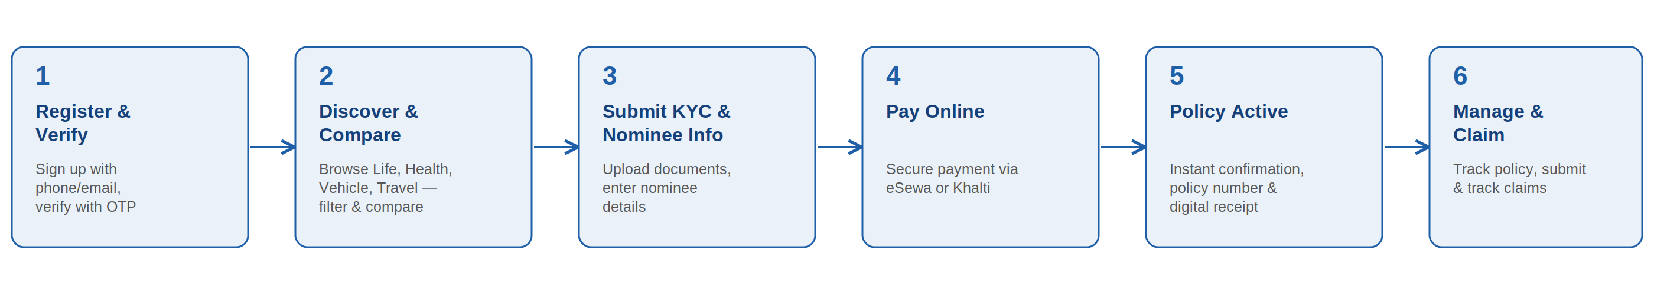
- Register & Verify — the customer signs up and confirms their phone/email with a one-time code
- Discover & Compare — they browse policies by category and compare options side by side
- Submit KYC & Nominee Info — once they choose a policy, they upload identity documents and enter nominee details
- Pay Online — they complete payment securely through eSewa or Khalti
- Policy Active — the moment payment succeeds, the policy activates automatically with a policy number and digital receipt
- Manage & Claim — from here, they can view their policy any time, get renewal reminders, and file a claim if something happens

7. How It Works — Provider Journey
Here's how an insurance company gets its products listed and sold on Bimaya:
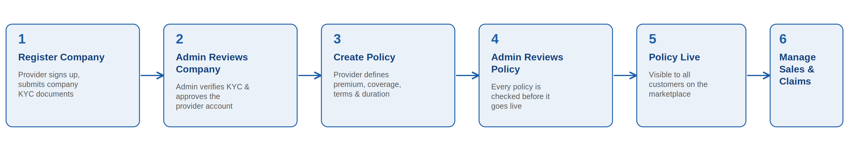
- Register Company — the provider signs up and submits company registration and KYC documents
- Admin Reviews Company — a Bimaya administrator verifies the company before it's allowed to operate on the platform
- Create Policy — once approved, the provider adds policies with pricing, coverage, and terms
- Admin Reviews Policy — every individual policy is checked by an Admin before it can be seen by customers
- Policy Live — approved policies appear on the public marketplace, visible to every customer
- Manage Sales & Claims — the provider tracks purchases and handles any claims that come in
Why the double approval?: Both the company and each individual policy need separate Admin approval. This two-layer check is what keeps the marketplace trustworthy — a bad actor can't slip in by getting the company approved once and then listing anything afterward.

8. How It Works — Admin Oversight
Administrators sit behind the scenes, making sure nothing reaches a customer without being checked first:
- Every new provider company must be manually approved before it can list any policies
- Every individual policy must be manually approved before it appears publicly — including if a provider edits an already-approved policy, which sends it back for re-approval
- Identity documents (KYC) from both customers and providers are reviewed and verified
- Admins can see platform-wide statistics and generate reports on sales, commissions, and provider performance

9. What Makes Bimaya Different
- Multi-provider comparison — most insurance companies in Nepal only offer their own products through their own app; Bimaya lets customers compare across companies in one place
- Fully digital, paperless process — from browsing to buying to claiming, no physical paperwork is required
- Built-in trust and safety — the two-layer Admin approval process means only vetted providers and reviewed policies ever reach customers
- Local payment integration — built specifically around eSewa and Khalti, the payment services Nepali customers already use daily

10. Where Things Stand Today
Bimaya is being built in phases, each one adding a complete, working piece of the product rather than many half-finished features at once:

Phase 0 — Foundation (Complete)
- Account registration & login, provider onboarding, policy catalog with search/compare, and the approval workflow connecting customers, providers, and admins

Phase 1 — Transact (Complete)
- Customers can now complete a real purchase: choose a policy, pay through eSewa or Khalti, and receive an active policy with a policy number — end to end

Phase 2 — Support & Trust (Upcoming)
- Claims submission and tracking, automatic notifications (email/SMS/push), and a full Admin analytics dashboard

Phase 3 — Scale (Future)
- Native mobile apps for Android and iOS, AI-based policy recommendations, chatbot support, and multi-language (Nepali/English) support

11. The Long-Term Vision
Bimaya aims to become the trusted starting point for anyone in Nepal thinking about insurance — the same way people now default to comparison platforms when booking travel or shopping online. For insurance providers, Bimaya offers a new digital distribution channel to reach customers they couldn't easily reach before. And for the broader goal of financial inclusion in Nepal, a platform like this can meaningfully increase how many people actually have insurance coverage, by making the buying process simple enough that people don't put it off.

