E.V.S
ACTIVITY-5

NAME – Raunak Singh
BATCH – B58
SAP – 590025098
SUBMITTED TO – Mrs. SILVI RAWAT

GROUP MEMBERS -:
KRRISH MADHWAL
MAYANK PUNIA
ARIHANT AHLAWAT
RAUNAK SINGH
PIYUSH KAMBOJ
ARSHVEER JOHAR
KABIR VINAY KAUSHIK
OBJECTIVE

Through creative initiatives such as flash mobs, street plays, and public awareness drives, students will engage with the community to highlight pressing environmental issues and inspire collective action for sustainability.

INTRODUCTION

Environmental issues such as climate change, pollution, deforestation, and resource depletion are growing concerns worldwide. Addressing these challenges requires active participation from society. Students can play a vital role by engaging communities through creative and impactful initiatives that promote awareness and action.

Creative Initiatives

Activities such as flash mobs and street plays (nukkad natak) are powerful tools to spread awareness. Flash mobs attract public attention instantly, while street plays effectively communicate environmental problems and their solutions in a relatable manner.

1.Flash Mobs
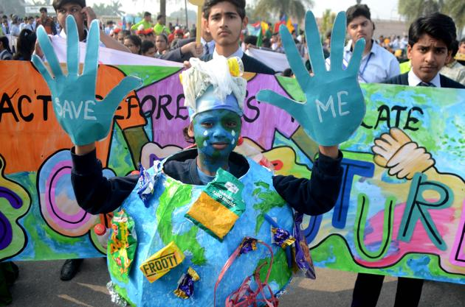

A flash mob is a sudden group performance in a public place where people gather, perform a planned act like dance or drama, and then disperse quickly. It is used to attract attention and spread messages in an engaging way. In environmental campaigns, flash mobs help raise awareness about issues like pollution and sustainability.

2.Street Play
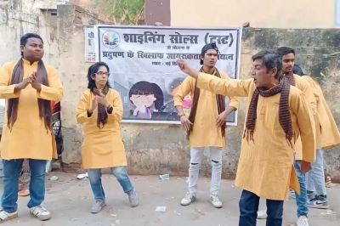

A street play is a live performance conducted in public places to spread awareness on social issues. It uses simple dialogue, acting, and emotions to communicate messages effectively. In environmental campaigns, street plays highlight problems like pollution and encourage people to adopt sustainable practices.

3. Tree Plantation Drive
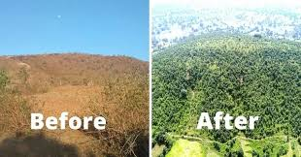

A tree plantation drive is an activity where people come together to plant trees in public or open areas to promote greenery. It helps improve air quality, reduce pollution, and maintain ecological balance. Such drives encourage community participation and raise awareness about environmental conservation.

4. Cleanliness Campaign
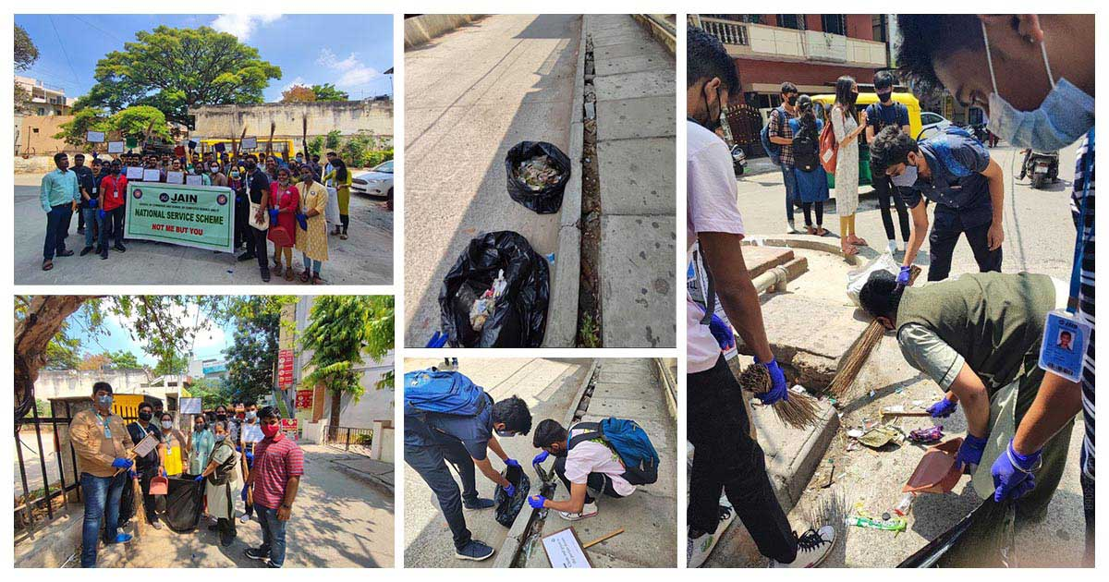

A cleanliness campaign is an organized activity where people work together to clean public places like streets, parks, and rivers. It helps reduce pollution, promote hygiene, and create a healthier environment. Such campaigns encourage individuals to maintain cleanliness and adopt responsible waste disposal habits.
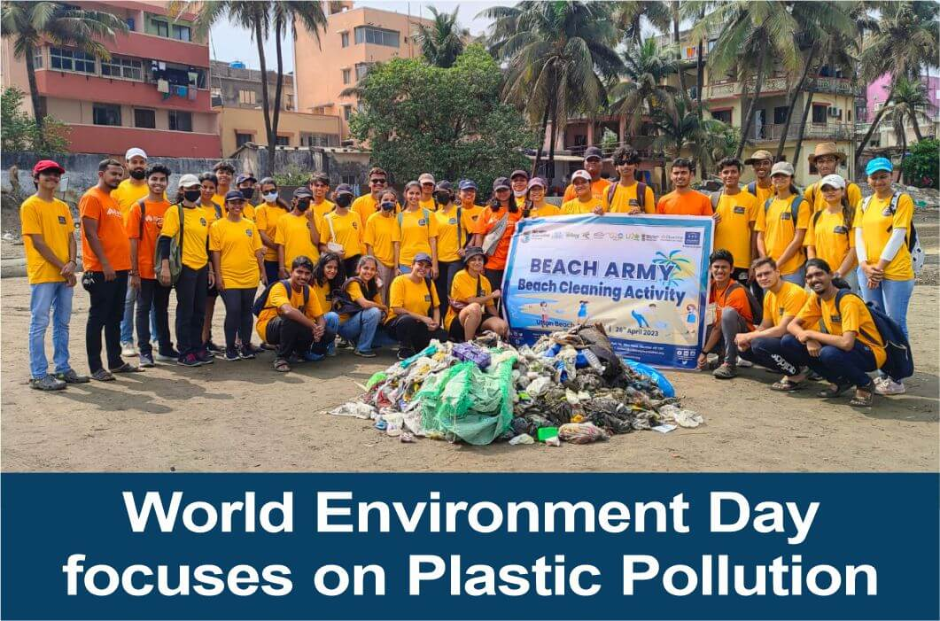

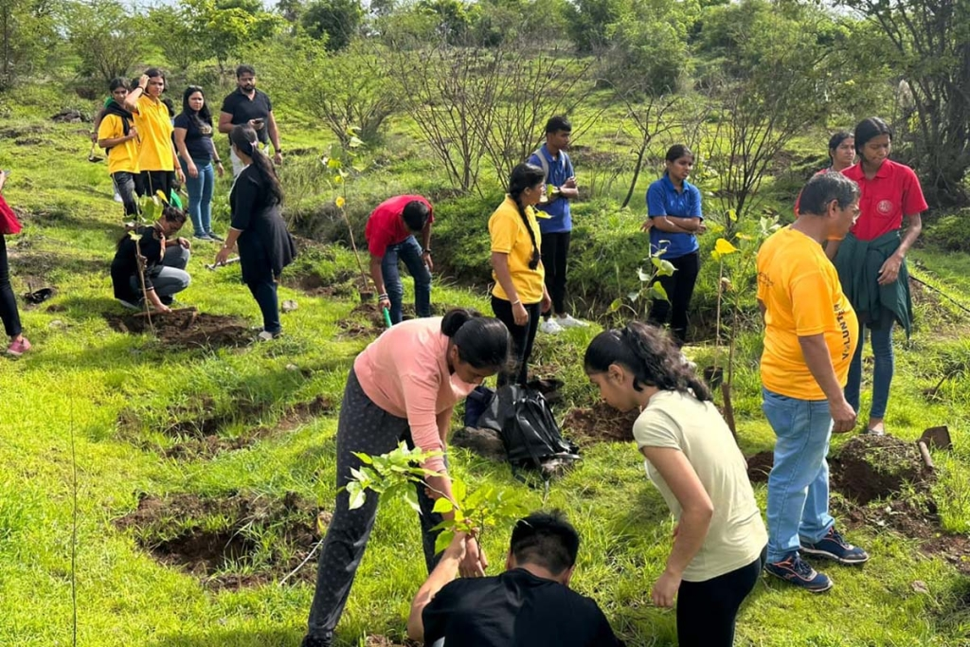

Public Awareness Drives

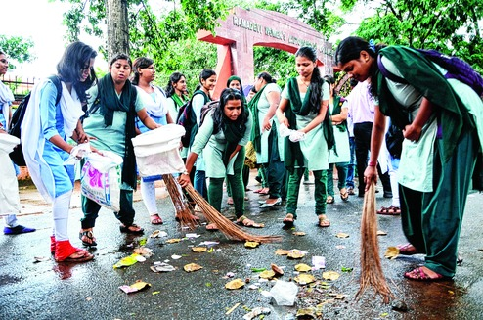
Students can organize rallies, poster campaigns, tree plantation drives, and cleanliness programs. Social media platforms can also be used to spread awareness and encourage eco-friendly habits like reducing plastic usage and conserving water.

Community Impact

Such initiatives inspire people to reflect on their actions and adopt sustainable practices. Increased awareness leads to collective efforts toward environmental protection.


Role of Students

Students act as change-makers by leading initiatives and motivating others. These activities also help develop leadership, teamwork, and communication skills.
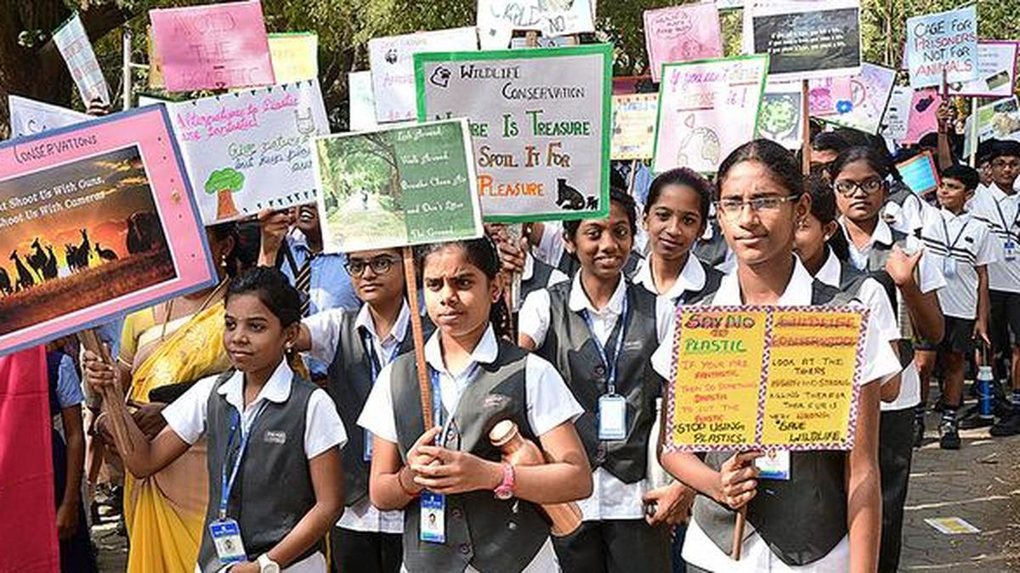

Conclusion

Creative community engagement is an effective way to promote sustainability. By combining awareness with action, students can help build a greener and healthier future.

