1.0 Inventory

1.0.1 MASTERS

- GROUP MASTER

- SUB GROUP MASTER

- STORE MASTER

- ITEM MASTER

1.0.1.1 Group Master:

Purpose:

The main purpose of this master is to create a new Item Category for Grouping Items based on the Item Characteristics. .

How to Start:

Masters -> Group Master

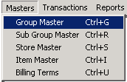

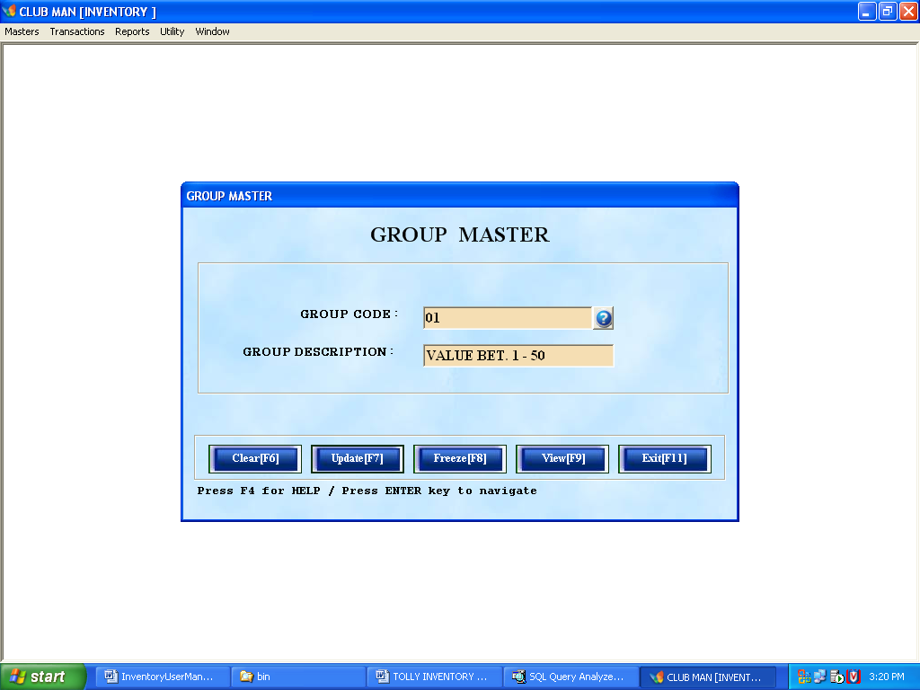

How to Fill:

- Use Enter key [↵ ] for navigation
- Enter Group code
- Enter Group description (full name of that particular GROUP).
- To Save
  - Navigate through the form using Enter key [↵] until Add Button is highlighted
  - Or directly click Add button 
  - Or press [F7] key from key board
- To Update
  - Fetch back your data by either using the Lookup Button or directly entering the Group code.
  - Caption of Add button  automatically changes to update [F7] after fetch back
  - Now make modifications in description only
  - Navigate through the form using enter key until Update button is highlighted
  - Or directly click Update button
  - Or press [F7] key from key board

(Note: Group code modification is not allowed)

- To Freeze
  - Fetch back your data by either using the Lookup Button or pressing [F4] key or by entering predefined code.
  - Freeze button gets automatically unlocked after fetch back
  - Navigate through the form using enter key until Freeze is highlighted
  - Or directly click Update button

- To Clear
  - Hit [F6] key from key board
  - Or click Clear Button 

8. To Exit
a. Hit [F11] key from key board
b. Or click Exit Button 

Remarks:

Item Group Master is used to define a new Item Group or to amend / avert an existing Item Group, view and print the entire Item Group available in the master.

1.0.1.2. Subgroup Master:

Purpose:

The purpose of this master is to define different sub group for the particular group. The SUB GROUP is defined with 3 combinations i.e. group/menu code, group/menu description, short name.

How to Start:

Masters -> Sub Group Master

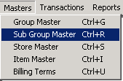

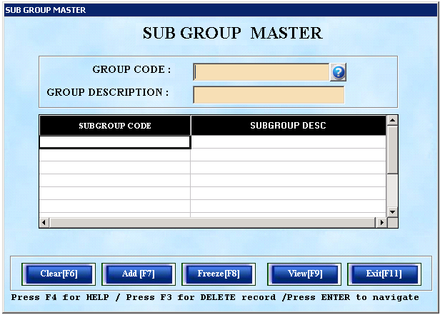

How to Fill:

1. Use Enter key [↵ ] for navigation through out the form.
2. Enter the group/menu code (unique in nature).
- Specify the group description (full name of that particular group).
- Enter various subgroup code and description under that particular group.
- To Save
  - Navigate through the form using Enter key [↵] until Add is highlighted
  - Or directly click Add button
  - Or hit [F7] key for key board
- To Update
  - Fetch back your data by either clicking Lookup Button or directly predefined code.
  - Caption of Add button automatically change to update [F7] after fetch back
  - Now make modification in description only
  - Navigate through the form using enter key until Update is highlighted
  - Or directly click Update button
  - Or hit [F7] key from key board

(Note: Group code modification is not allowed)

- To Freeze
  - Fetch back your data by either clicking Lookup Button or pressing [F4] key or directly predefined code.
  - Freeze button automatically unlocked after fetch back
  - Navigate through the form using enter key until Freeze is highlighted
  - Or directly click Update button

- To Clear
  - Hit [F6] key from key board
  - Or click Clear Button

9. To Exit
a. Hit [F11] key from key board
b. Or click Exit Button

Remarks:

Item sub Group Master is used to define a new Item sub Group or to amend / avert an existing Item Group, view and print the entire Item sub Group available in the master.
1.0.1.3 Store Master:

Purpose:

The main purpose of this master is to define a new store to the Store Master

How to Start:

Masters -> Store Master

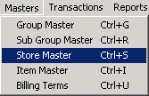

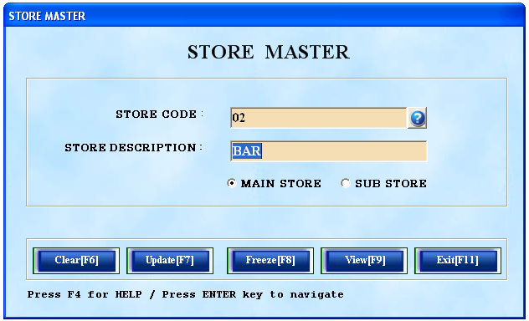

How to Fill:

1. Use Enter key [↵ ] for navigation through out the form.
2. Enter the Store code (unique in nature).
- Specify the Store description.
- Specify whether it a sub store or main store by selecting respective option button
- To Save
  - Navigate through the form using Enter key [↵] until Add is highlighted
  - Or directly click Add button
  - Or hit [F7] key for key board
- To Update
  - Fetch back your data by either clicking Lookup Button or directly predefined code.
  - Caption of Add button automatically change to update [F7] after fetch back
  - Now make modification in description only
  - Navigate through the form using enter key until Update is highlighted
  - Or directly click Update button
  - Or hit [F7] key from key board

(Note: Store code modification is not allowed)

- To Freeze
  - Fetch back your data by either clicking Lookup Button or pressing [F4] key or directly predefined code.
  - Freeze button automatically unlocked after fetch back
  - Navigate through the form using enter key until Freeze is highlighted
  - Or directly click Update button

- To Clear
  - Hit [F6] key from key board
  - Or click Clear Button

9. To Exit
a. Hit [F11] key from key board
b. Or click Exit Button

Remarks:

Store Location Master is used to define a new Store or to amend / avert an existing store, view and print all the stores available in the store master.

1.0.1.4. Item Master:

Purpose:

The main purpose of this master is to define the Inventory Items.

How to Start:

Masters -> Item Master

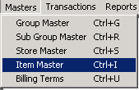

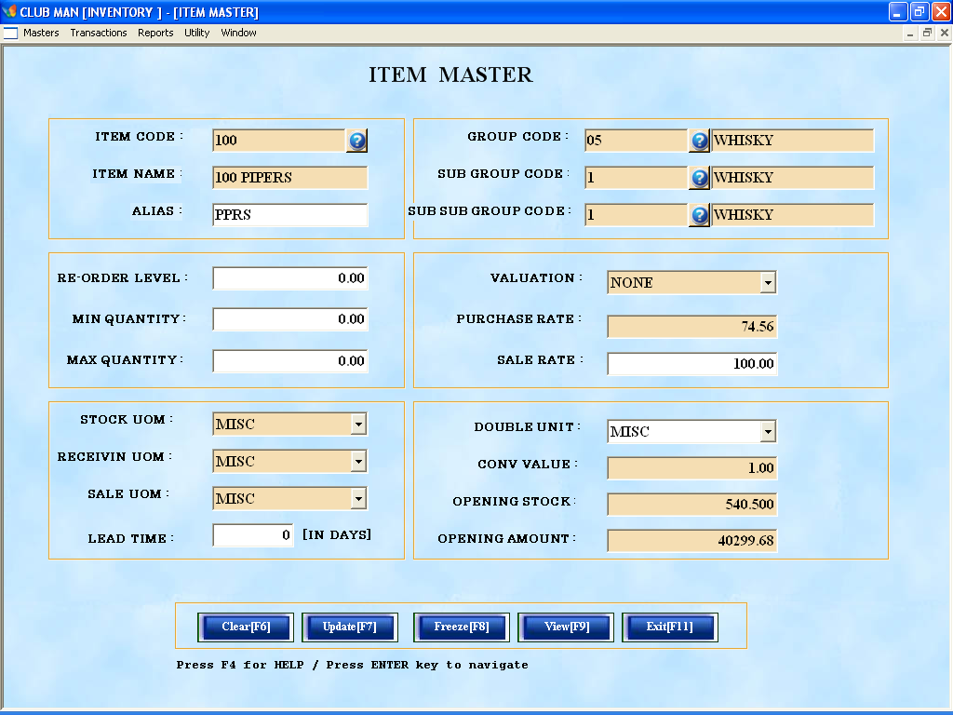

How to Fill:

1. Use Enter key [↵ ] for navigation through out the form.
2. Enter the item code (Unique in nature).
3. Enter the item description.
4. Enter short name for that item.
5. Enter User defined Group code using Lookup Button or pressing [F4] key or directly predefined code.
6. Enter User defined Subgroup code using Lookup Button or pressing [F4] key or directly predefined code.
7. Enter User defined Sub Subgroup code using Lookup Button or pressing [F4] key or directly predefined code.
8. Enter Reorder level for that item.
9. Enter Max quantity for that item.
10. Enter Min quantity for that item.
11. Choose Stock Valuation for that item.
12. Enter Purchase Rate for that item.
13. Enter Sale Rate for that item.
14. Choose Stock UOM in which stock is maintained for that item.
15. Choose Receive UOM in which item is being received.
16. Choose Sale UOM in which item is being sale.
17. Enter Lead Time in no. of day.
18. Choose Double UOM or smallest UOM for that item.
19. Enter the relationship between Stock UOM and Double UOM.
20. Enter Opening Stock for that item (Modification is not allowed).
21. Enter Opening Value for that item.
22. To Save
  - Navigate through the form using Enter key [↵] until Add is highlighted
  - Or directly click Add button
  - Or hit [F7] key for key board
- To Update
  - Fetch back your data by either clicking Lookup Button or directly predefined code.
  - Caption of Add button automatically change to update [F7] after fetch back
  - Now make modification in description only
  - Navigate through the form using enter key until Update is highlighted
  - Or directly click Update button
  - Or hit [F7] key from key board

(Note: Item code modification is not allowed)

- To Freeze
  - Fetch back your data by either clicking Lookup Button or pressing [F4] key or directly predefined code.
  - Freeze button automatically unlocked after fetch back
  - Navigate through the form using enter key until Freeze is highlighted
  - Or directly click Update button

- To Clear
  - Hit [F6] key from key board
  - Or click Clear Button

26. To Exit
a. Hit [F11] key from key board
b. Or click Exit Button

Remarks:

Item Master is used to define a new Item or to amend / avert an existing Item, view and print the entire Item available in the master.

1.0.2. TRANSACTIONS

  - GRN CUM PURCHASE BILL

  - STOCK ISSUE

  - STOCK TRANSFER / RETURN

  - STOCK ADJUSTMENT

  - STOCK INDENT

  - ACCOUNT POSTING INVENTORY

1.0.2.1. GRN cum Purchase Bill:

Purpose:

The purpose of this screen is to make entries of the Goods received against the order placed as a receipt for that order.

How to Start:

Transaction -> GRN cum Purchase Bill

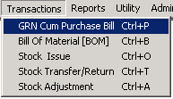

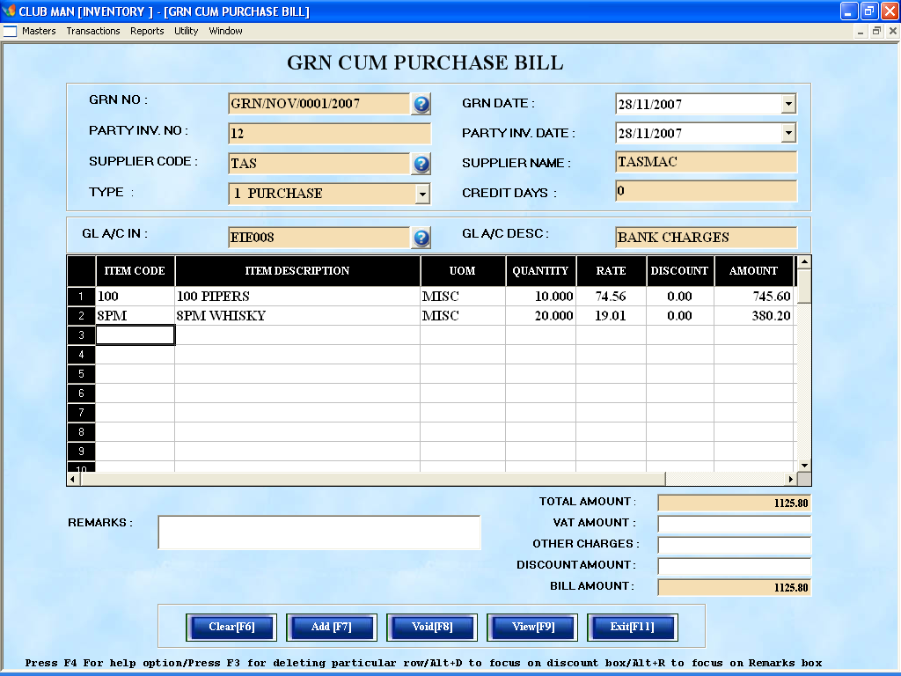

How to Fill:

1. Use Enter key [↵ ] for navigation through out the form.
2. GRN NO. is a auto generating field.
3. Enter the GRN date.
4. Enter Party Inv. No or Chelan no which will be in manual purchase bill.
5. Enter Party Inv. Date.
6. Enter User defined Supplier code using Lookup Button or pressing [F4] key or directly predefined code.
7. Choose Type which is meant for billing terms.
8. Enter GL account code to which the amount of this Bill is going to be debited.
9. The Items Menu can be accessed from Item code [F4]. This is a search menu and can also be accessed by typing the item code in item code field or typing item description in item description fields.
10. Enter No of quantity received in Quantity fields.
11. Enter Total VAT amount
12. Enter Surchase amount (if any)
13. To Save
  - Navigate through the form using Enter key [↵] until Add is highlighted
  - Or directly click Add button
  - Or hit [F7] key for key board
14. to Update
  - Fetch back your data by either clicking Lookup Button or directly predefined code.
  - Caption of Add button automatically change to update [F7] after fetch back
  - Now make modification in description only
  - Navigate through the form using enter key until Update is highlighted
  - Or directly click Update button
  - Or hit [F7] key from key board

(Note: GRN NO. modification is not allowed)

- To Void
  - Fetch back your data by either clicking Lookup Button or pressing [F4] key or directly predefined code.
  - Freeze button automatically unlocked after fetch back
  - Navigate through the form using enter key until Freeze is highlighted
  - Or directly click Update button

- To Clear
  - Hit [F6] key from key board
  - Or click Clear Button

17. to Exit
a. Hit [F11] key from key board
b. Or click Exit Button

Remarks:

- Goods Receipt Note is generated for the suppliers to the Business Center.

- The GRN entry affects the stock status for the Business center and is accountable and all entries are reflected in the purchase ledger.

NOTE:

GRN Entry will be a reference to the Item purchases and cannot be modified or deleted after the purchase modalities are over.

1.0.2.2. Issues to Stores

Purpose:

The purpose of this screen is to document the stock issued to the running stores from main store. Any Issues made through this module is reflected in the running store stock ledger as receipt and the same is deducted from the base store stock ledger.

How to Start:

Transaction -> Stock Issue

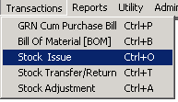

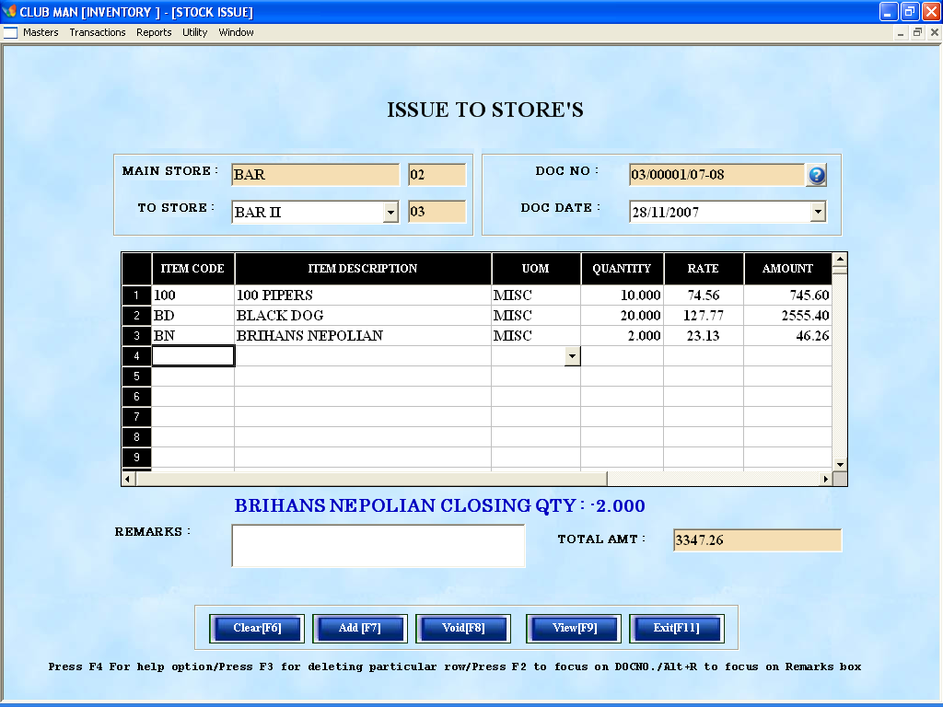

How to Fill:

1. Use Enter key [↵ ] for navigation through out the form.
2. Choose To Store where item will be transfer from Main store.
3. Doc No is an auto generating field.
4. Enter Doc date.
5. The Items Menu can be accessed from Item code [F4]. This is a search menu and can also be accessed by typing the item code in item code field or typing item description in item description fields.
6. Enter No of quantity Issued in Quantity fields.
7. To Save
  - Navigate through the form using Enter key [↵] until Add is highlighted
  - Or directly click Add button
  - Or hit [F7] key for key board
8. To Update
  - Fetch back your data by either clicking Lookup Button or directly predefined code.
  - Caption of Add button automatically change to update [F7] after fetch back
  - Now make modification in description only
  - Navigate through the form using enter key until Update is highlighted
  - Or directly click Update button
  - Or hit [F7] key from key board

(Note: DOC NO. modification is not allowed)

- To Void
  - Fetch back your data by either clicking Lookup Button or pressing [F4] key or directly predefined code.
  - Freeze button automatically unlocked after fetch back
  - Navigate through the form using enter key until Freeze is highlighted
  - Or directly click Update button

10. To Clear
  - Hit [F6] key from key board
  - Or click Clear Button

11. To Exit
a. Hit [F11] key from key board
b. Or click Exit Button

Remarks:

- This screen is used for making entries for the stock Issues. These entries affect the stock status for the Business center and are accountable and all entries are reflected in the stock ledger.

1.0.2.3. Stock Return

Purpose:

The purpose of this screen is to document the stock transferred from one store to another store, one POS to another POS, store to POS, POS to store etc. Any Transfer made through this module is reflected in the receiving store stock ledger as receipt and issuing store stock ledger as Issue.

How to Start:

Transaction -> Stock Transfer/Return

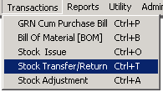

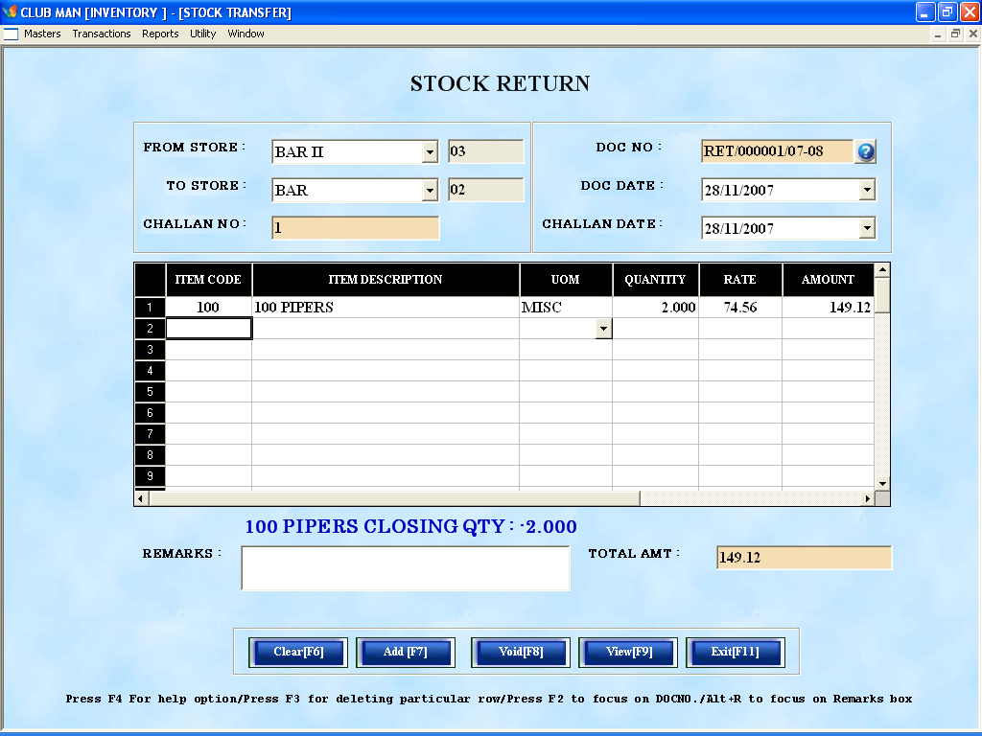

How to Fill:

1. Use Enter key [↵ ] for navigation through out the form.
2. Choose From Store Location.
3. Choose To Store Location.
4. Doc No is an auto generating field.
5. Enter Doc date.
6. The Items Menu can be accessed from Item code [F4]. This is a search menu and can also be accessed by typing the item code in item code field or typing item description in item description fields.
7. Enter No of quantity Issued in Quantity fields.
8. To Save
  - Navigate through the form using Enter key [↵] until Add is highlighted
  - Or directly click Add button
  - Or hit [F7] key for key board
9. To Update
  - Fetch back your data by either clicking Lookup Button or directly predefined code.
  - Caption of Add button automatically change to update [F7] after fetch back
  - Now make modification in description only
  - Navigate through the form using enter key until Update is highlighted
  - Or directly click Update button
  - Or hit [F7] key from key board

(Note: DOC NO. modification is not allowed)

- To Void
  - Fetch back your data by either clicking Lookup Button or pressing [F4] key or directly predefined code.
  - Freeze button automatically unlocked after fetch back
  - Navigate through the form using enter key until Freeze is highlighted
  - Or directly click Update button

11. To Clear
  - Hit [F6] key from key board
  - Or click Clear Button

12. To Exit
a. Hit [F11] key from key board
b. Or click Exit Button

Remarks:

This screen is used for making entries for the stock Transfers. These entries affect the stock status for the Business center and are accountable and all entries are reflected in the stock ledger.

1.0.2.4. Stock Adjustment

Purpose:

The purpose of this module is to adjust the stock of a particular item in accordance to the available physical quantity.

How to Start:

Transaction -> Stock Adjustment

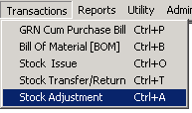

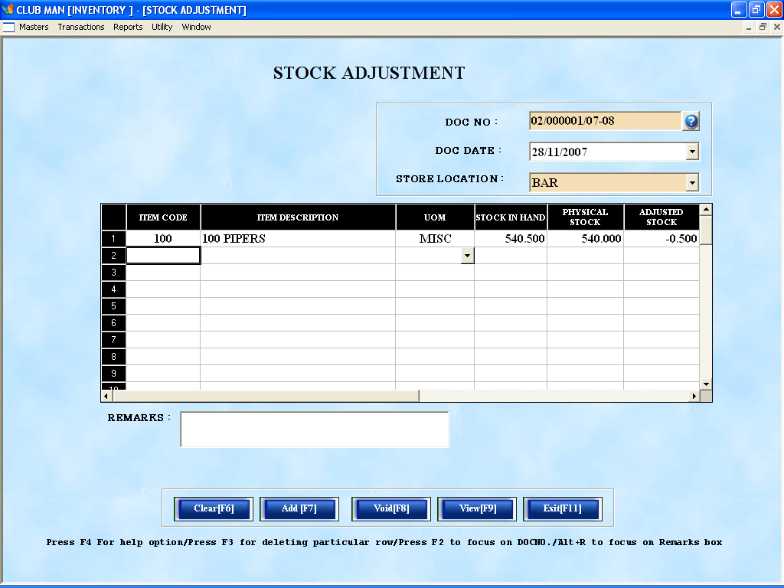

How to Fill:

1. Use Enter key [↵ ] for navigation through out the form.
2. Choose Store Name where that club needs to adjust the stock.
3. Doc No is an auto generating field.
4. Enter Doc date.
5. The Items Menu can be accessed from Item code [F4]. This is a search menu and can also be accessed by typing the item code in item code field or typing item description in item description fields.
6. Enter at present physical stock.
7. To Save
  - Navigate through the form using Enter key [↵] until Add is highlighted
  - Or directly click Add button
  - Or hit [F7] key for key board
8. To Update
  - Fetch back your data by either clicking Lookup Button or directly predefined code.
  - Caption of Add button automatically change to update [F7] after fetch back
  - Now make modification in description only
  - Navigate through the form using enter key until Update is highlighted
  - Or directly click Update button
  - Or hit [F7] key from key board

(Note: DOC NO. modification is not allowed)

- To Void
  - Fetch back your data by either clicking Lookup Button or pressing [F4] key or directly predefined code.
  - Freeze button automatically unlocked after fetch back
  - Navigate through the form using enter key until Freeze is highlighted
  - Or directly click Update button

10. To Clear
  - Hit [F6] key from key board
  - Or click Clear Button

11. To Exit
a. Hit [F11] key from key board
b. Or click Exit Button

1.0.3. REPORTS

- ISSUE REGISTER

- ISSUE DETAILS

- STOCK LEDGER

- ISSUE SUMMARY

- STOCK SUMMARY

- PURCHASE REGISTER

- STOCK TRANSFER REGISTER

- STOCK RETURN REGISTER

- STOCK ADJUSTMENT REGISTER

- EXCEPTION REPORT

- INDENT WISE REPORT

- PENDING REGISTER REPORT

- CONSOLIDATED SUMMARY

- VAT INPUT TAX REPORT

- ABC REPORT ANALYSIS

- ROL SUMMARY

- STCOK VS MONTHLY ISSUE

1.0.3.1. Issue Register

Purpose:

The purpose of this report is to generate store wise Issue register for the Items issued from the Main store.

How to Start: Reports -> Issue Register

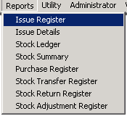

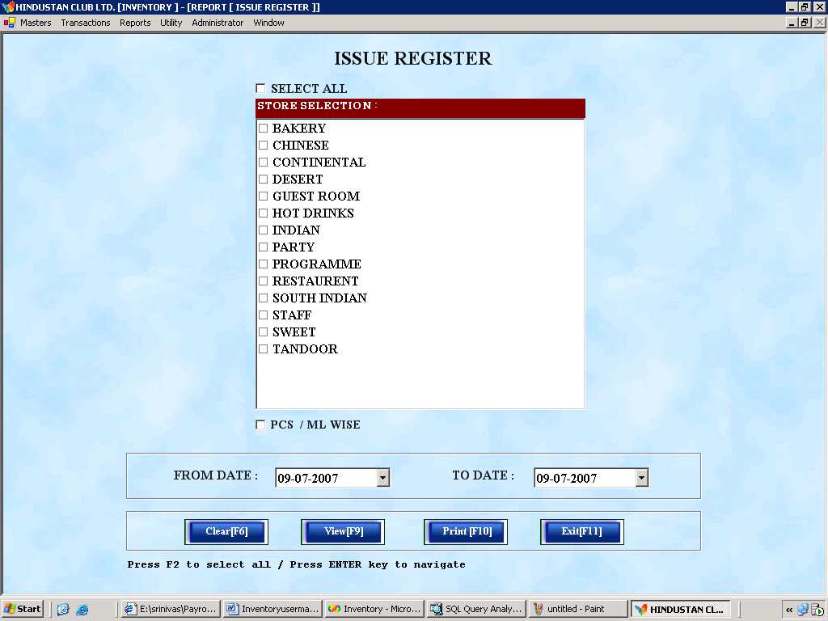

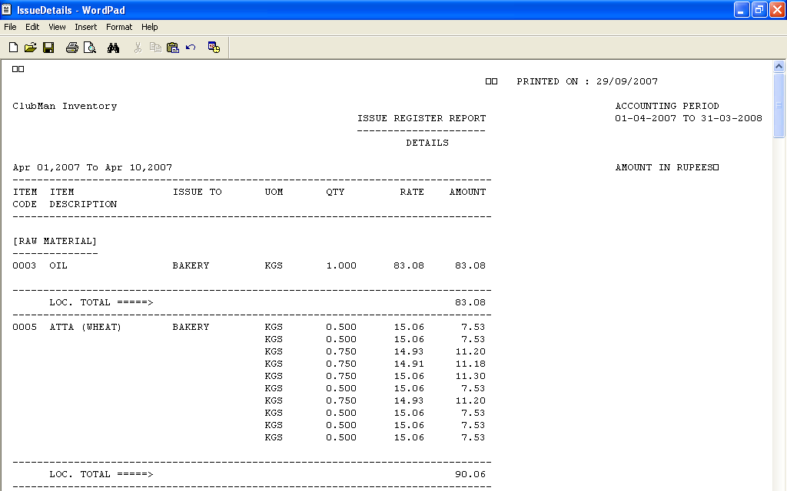

Sample Issue Register

How to Fill:

1. Select Store Location from given list check box (user can select multiple check box)
- Enter From date and to date.
- To view:
  - Hit [F9] key
  - Hit [Alt + v] key
  - Click [View button] 
- To Print:
  - Hit [F10] key
  - Hit [Alt + p] key
  - Click [Print button] 
- To clear
  - Hit [F6] key
  - Hit [Alt + c] key
  - Click [Clear Button]
- To exit:
  - Hit [F11] key
  - Hit [Alt + e] key
  - Click [Clear Button]
Remarks:

This report is used to generate store wise Item Issue details from Main store. This report can be days specific or store specific. The user may select any Store any time period for viewing the Issue details from main store to that particular store in that time period.

1.0.3.2. Issue Details

Purpose:

The purpose of this report is to generate store wise Issue details of Items from Main store.
How to Start:

Reports -> Issue Details

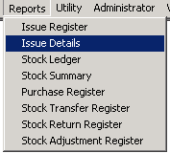

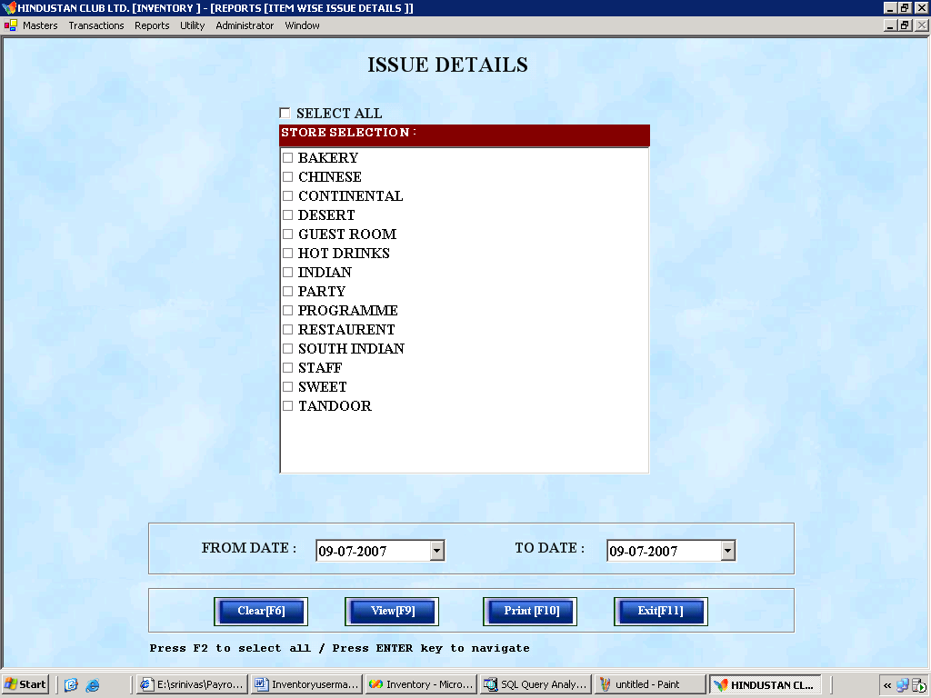

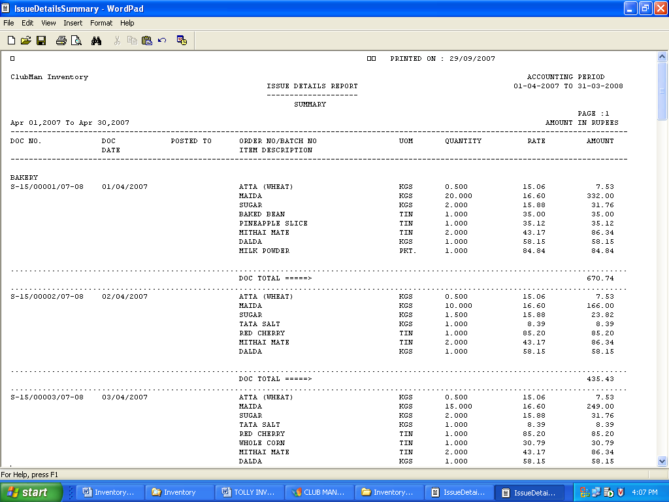
Sample Issue Details Report
How to Fill:

1. Select Store Location from given list check box (user can select multiple check box)
- Enter From date and To date.
- To view:
  - Hit [F9] key
  - Hit [Alt + v] key
  - Click [View button]
- To Print:
  - Hit [F10] key
  - Hit [Alt + p] key
  - Click [Print button]
- To clear
  - Hit [F6] key
  - Hit [Alt + c] key
  - Click [Clear Button]
- To exit:
  - Hit [F11] key
  - Hit [Alt + e] key
  - Click [Clear Button]

Remarks:

This report is used to generate store wise Item Issue details from Main store. This report can be days specific or store specific. The user may select any Store any time period for viewing the Issue details from main store to that particular store in that time period.
1.0.3.3. Main Stock Ledger

Purpose:

The purpose of this report is to generate the Stock ledger report with Opening quantity, Receive Quantity, Issue Quantity, Damage Quantity, Closing Quantity of a particular Item in a particular Store.

How to Start:

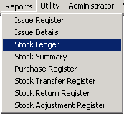

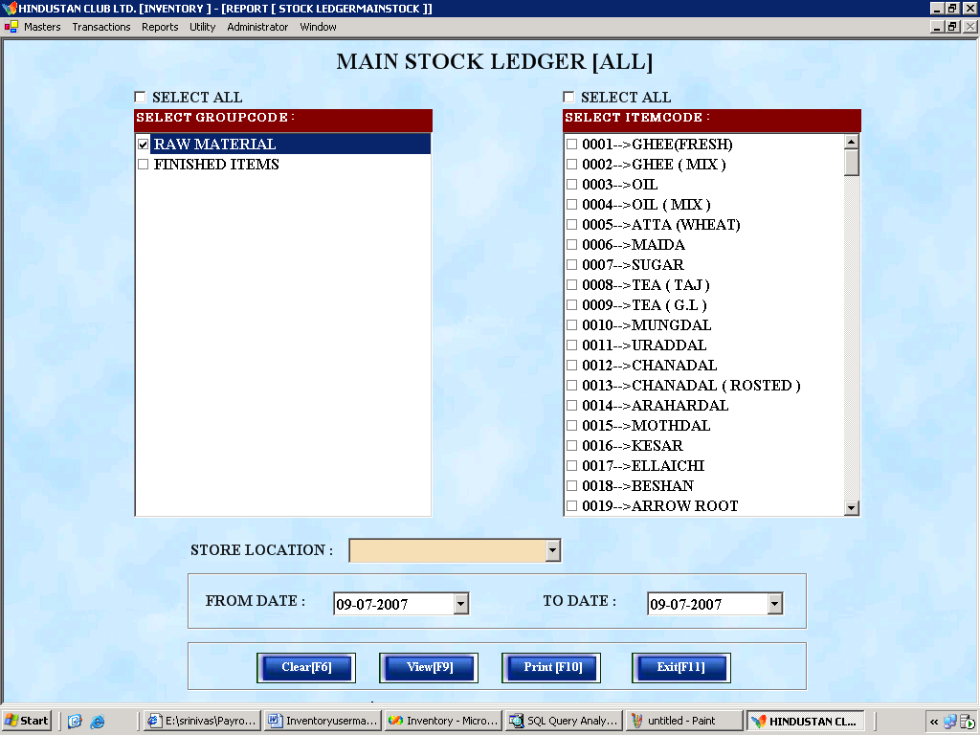

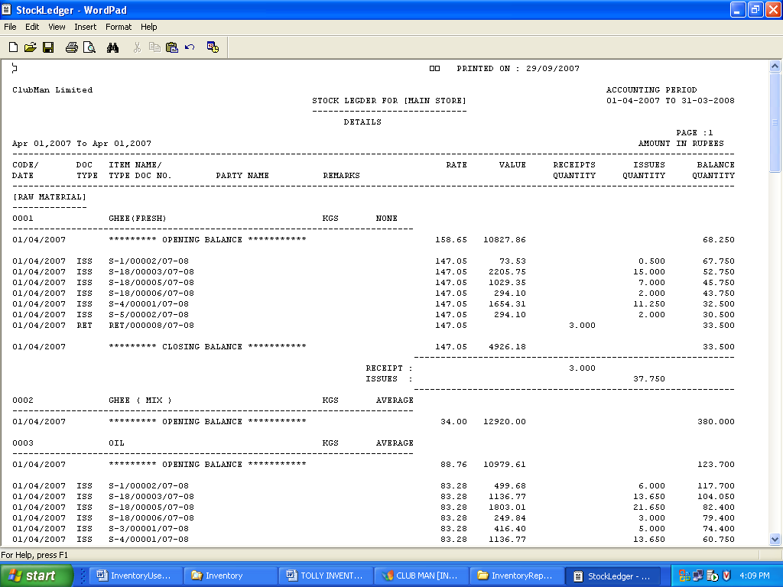
Sample Stock Ledger Report

How to Fill:

1. Select Group description from given list check box (user can select multiple check box)
- Select Item code from given list check box (user can select multiple check box).
- Choose the store location.
- To view:
  - Hit [F9] key
  - Hit [Alt + v] key
  - Click [View button]
- To Print:
  - Hit [F10] key
  - Hit [Alt + p] key
  - Click [Print button]
- To clear
  - Hit [F6] key
  - Hit [Alt + c] key
  - Click [Clear Button]
- To exit:
  - Hit [F11] key
  - Hit [Alt + e] key
c. Click [Clear Button]
Remarks:

This report is Mains tore specific, Item Category Specific and Item Specific. User may select any Item category and any Item to view the stock ledger of the particular Item.

1.0.3.4. Issue Summary

Purpose:

The purpose of this report is to generate store wise Issue details of Items from Main store.
How to Start:

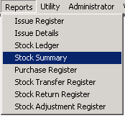

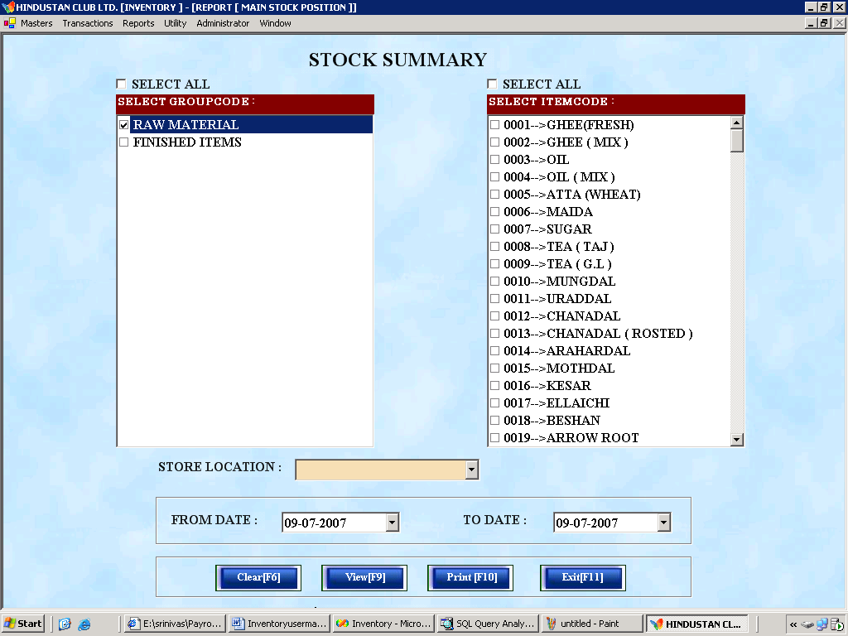

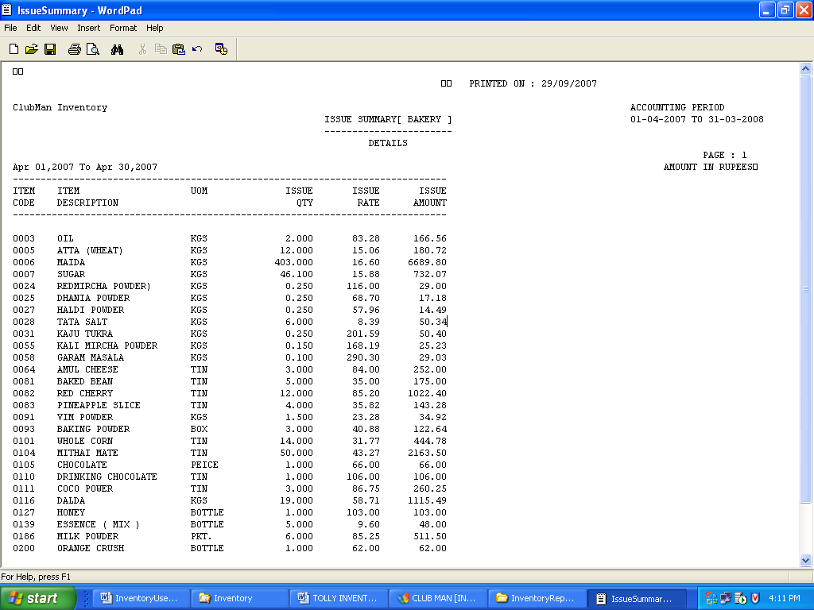

Sample Issue Summary Report
How to Fill

1. Select Group description from given list check box (user can select multiple check box)
- Select Item code from given list check box (user can select multiple check box).
- Choose the store location.
- To view:
  - Hit [F9] key
  - Hit [Alt + v] key
  - Click [View button]
- To Print:
  - Hit [F10] key
  - Hit [Alt + p] key
  - Click [Print button]
- To clear
  - Hit [F6] key
  - Hit [Alt + c] key
  - Click [Clear Button]
- To exit:
  - Hit [F11] key
  - Hit [Alt + e] key
c. Click [Clear Button]
Remarks

This report is used to generate store wise Item Issue details from Main store. This report can be days specific or store specific. The user may select any Store any time period for viewing the Issue details from main store to that particular store in that time period.

1.0.3.5. Purchase Register

Purpose:

This report is used to get the vendor wise purchase detail for all the purchases of the business center.

How to Start:
Reports -> Purchase Register

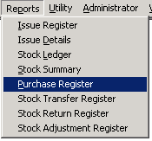

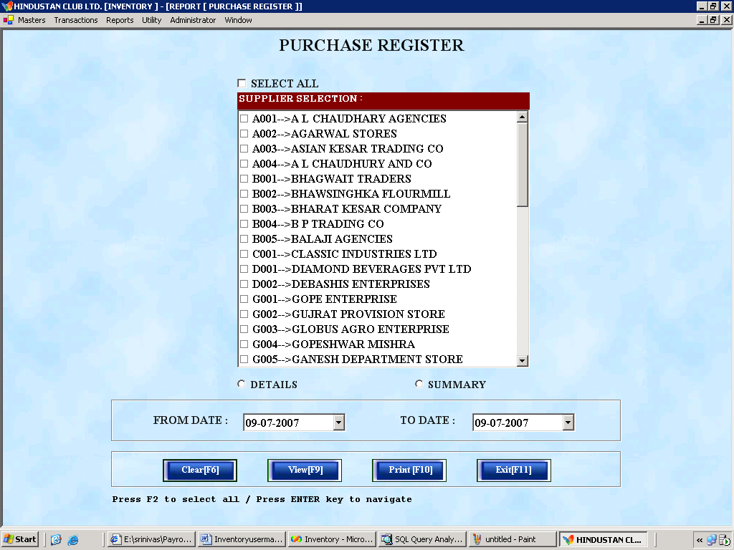

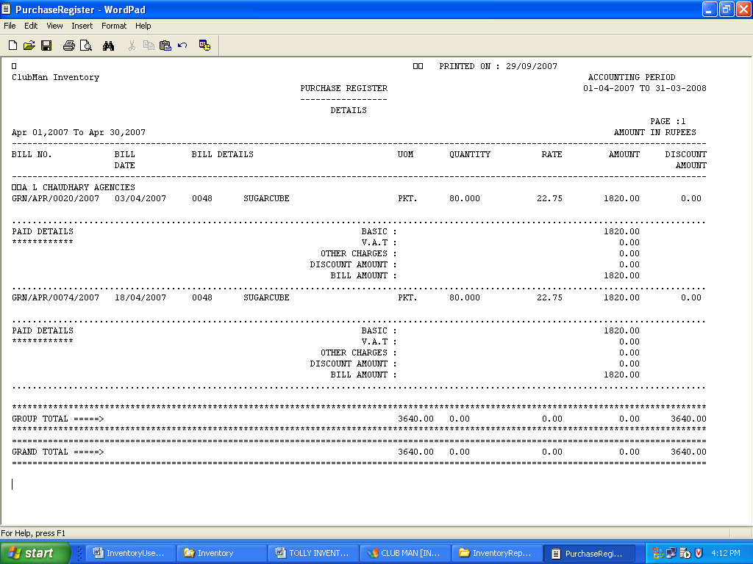
Sample Purchase Register Report
How to Fill:

- Select Supplier Name from given list check box (user can select multiple check box)
- Select either Detail/Summary option button.
- Enter From date and To date.
- To view:
  - Hit [F9] key
  - Hit [Alt + v] key
  - Click [View button]
- To Print:
  - Hit [F10] key
  - Hit [Alt + p] key
  - Click [Print button]
- To clear
  - Hit [F6] key
  - Hit [Alt + c] key
  - Click [Clear Button]
- To exit:
  - Hit [F11] key
  - Hit [Alt + e] key
  - Click [Clear Button]
Remarks:

This report is used to generate vendor wise purchase details of all the Items. This report can be day’s specific and vendor specific.

1.0.3.6. Stock Transfer Register

Purpose:

The purpose of this report is to generate store wise Stock Transfer register for the Items Transferred from one sub store to another sub store.
How to Start:
Reports -> Stock Transfer Register

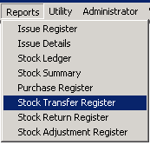

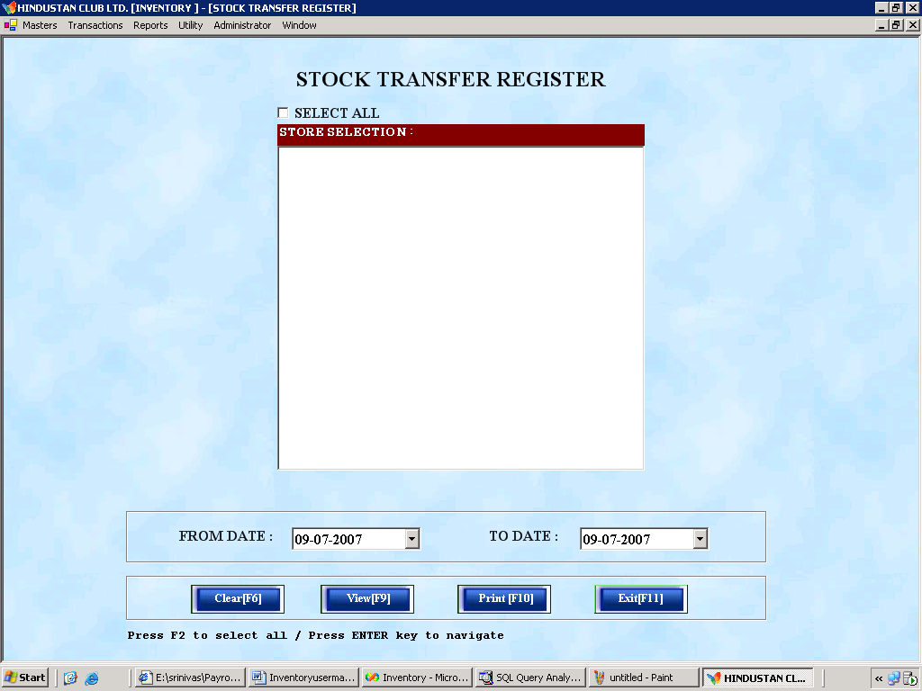

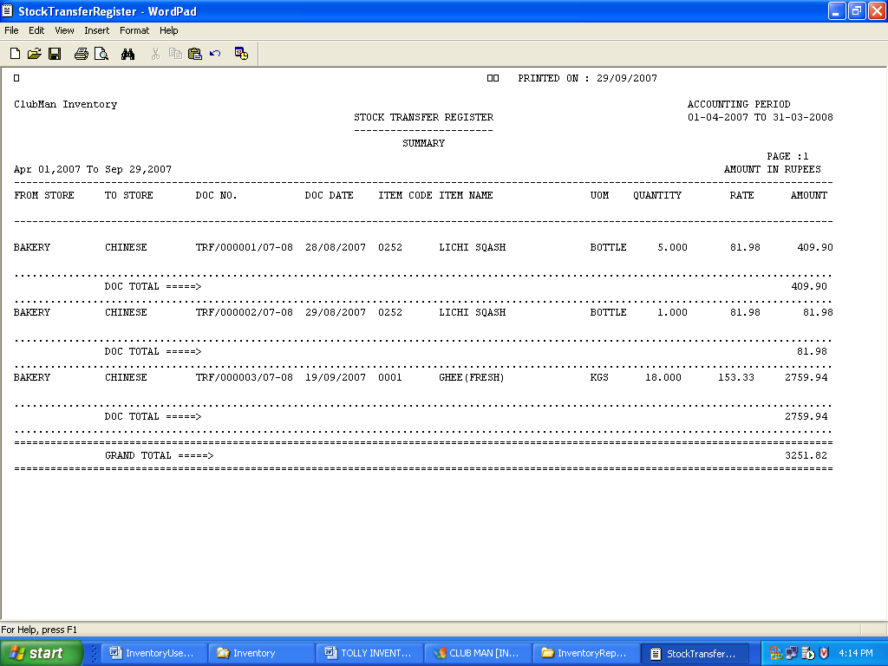

Sample Stock Transfer Register
How to Fill:

1. Select Store Location from given list check box (user can select multiple check box)
- Enter From date and To date.
- To view:
  - Hit [F9] key
  - Hit [Alt + v] key
  - Click [View button]
- To Print:
  - Hit [F10] key
  - Hit [Alt + p] key
  - Click [Print button]
- To clear
  - Hit [F6] key
  - Hit [Alt + c] key
  - Click [Clear Button]
- To exit:
  - Hit [F11] key
  - Hit [Alt + e] key
Click [Clear Button]

Remarks:

This report is used to generate store wise Item Transfer details from one store to another store. This report can be days specific or store specific. The user may select any Store any time period for viewing the Transfer details.

1.0.3.7. Stock Return Register

Purpose:

The purpose of this report is to generate store wise Stock Return register for the Items Returned from the sub store to the Main Store.

How to Start:

Reports -> Stock Return Register
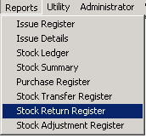

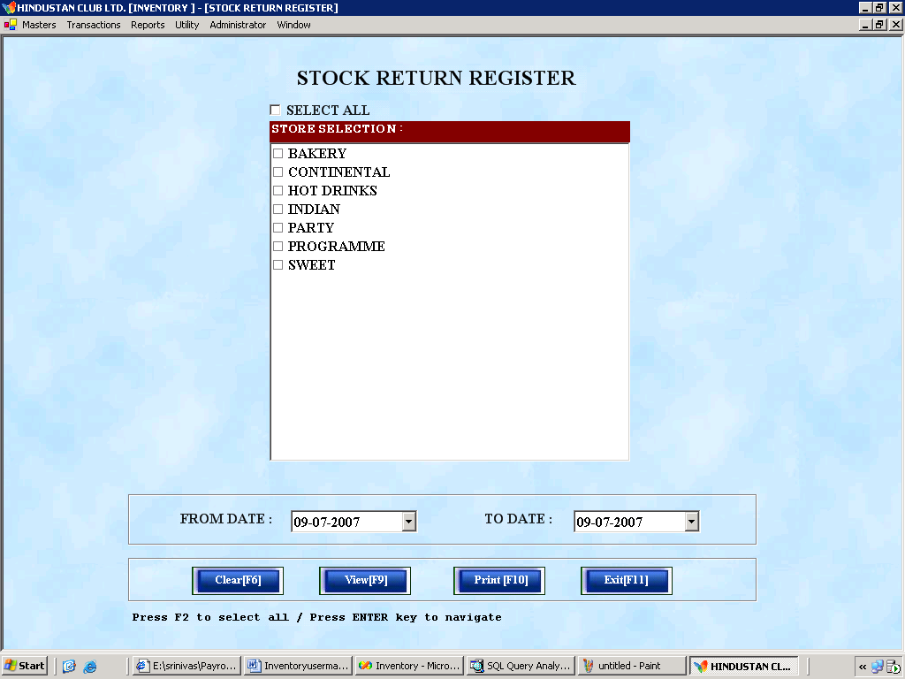

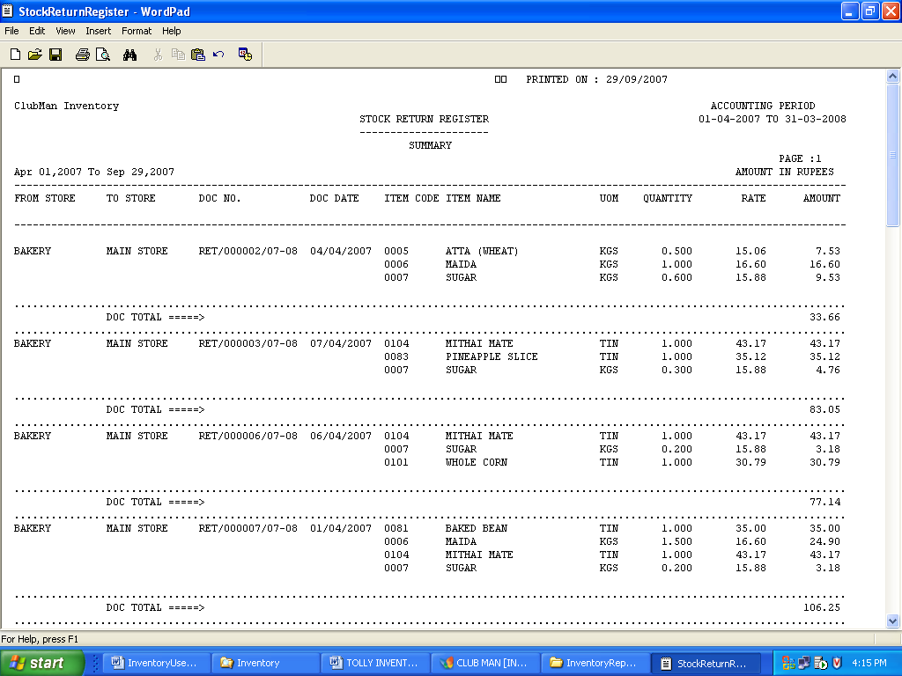
Stock Return Register
How to Start

1. Select Store Location from given list check box (user can select multiple check box)
- Enter From date and To date.
- To view:
  - Hit [F9] key
  - Hit [Alt + v] key
  - Click [View button]
- To Print:
  - Hit [F10] key
  - Hit [Alt + p] key
  - Click [Print button]
- To clear
  - Hit [F6] key
  - Hit [Alt + c] key
  - Click [Clear Button]
- To exit:
  - Hit [F11] key
  - Hit [Alt + e] key
  - Click [Clear Button]

Remarks:

This report is used to generate store wise Item Return details from a sub store to the Main store. This report can be days specific or store specific. The user may select any Store any time period for viewing the Return details.
1.0.3.8. Stock Adjustment Register

Purpose:

The purpose of this report is to generate store wise Stock Adjustment register for the particular sub store or the Main Store.

How to Start:

Reports -> Stock Adjustment Register

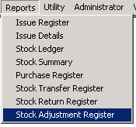

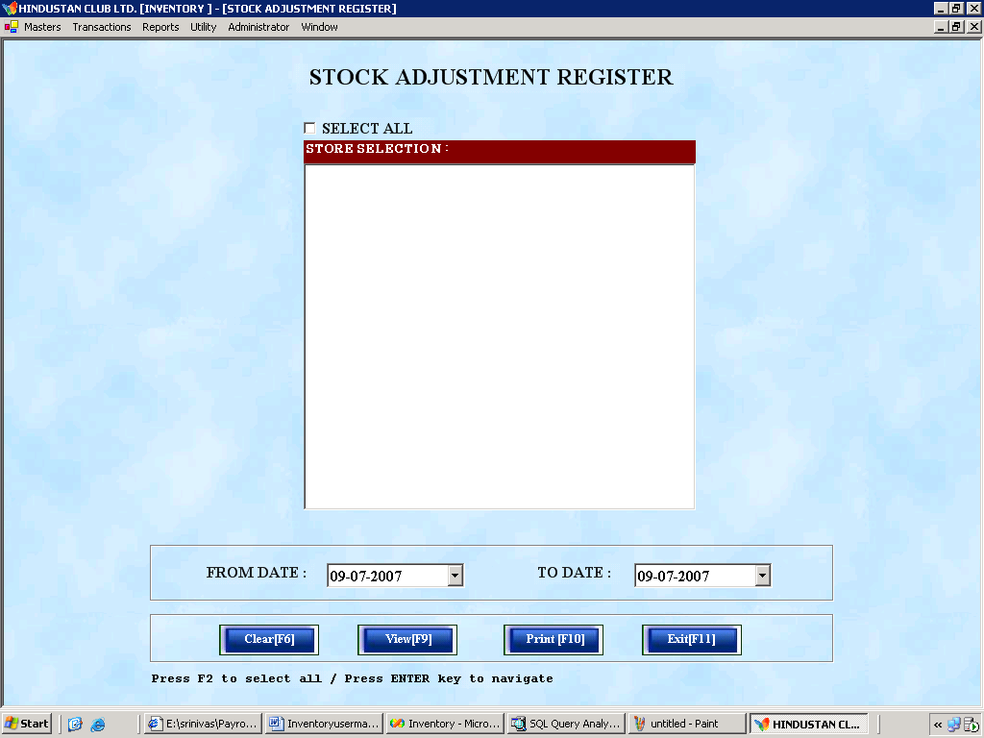

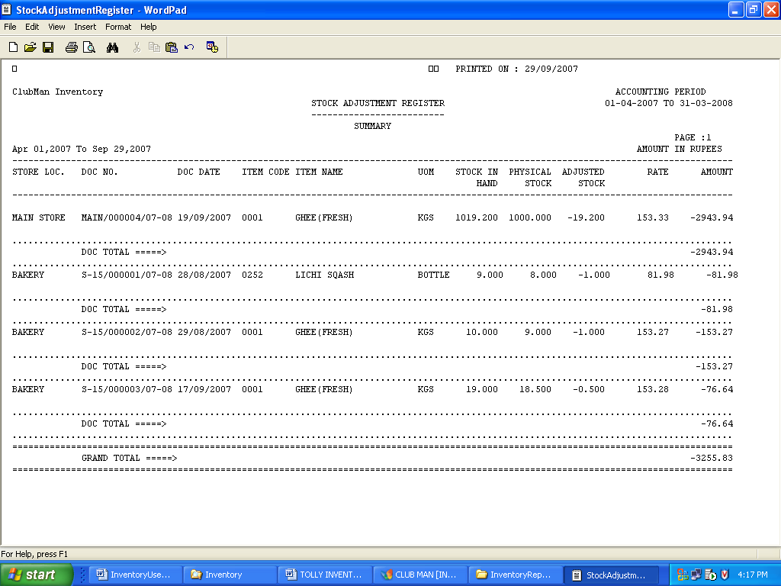

Sample Stock Adjustment Register
How to Fill

1. Select Store Location from given list check box (user can select multiple check box)
- Enter From date and To date.
- To view:
  - Hit [F9] key
  - Hit [Alt + v] key
  - Click [View button]
- To Print:
  - Hit [F10] key
  - Hit [Alt + p] key
  - Click [Print button]
- To clear
  - Hit [F6] key
  - Hit [Alt + c] key
  - Click [Clear Button]
- To exit:
  - Hit [F11] key
  - Hit [Alt + e] key
c. Click [Clear Button]

Important Notes:

Note 1: This report is used to generate store wise Item Adjustment details of the Items adjusted in a Particular sub store or Main store. This report can be days specific or store specific. The user may select any Store any time period for viewing the Adjustment details.

Note 2: Recommended Item Codifications:

I.Main Groups(First Two digits 01 to 05):
1.Grocessary Items
Which include Rice,Wheat,Atta,Sugar,Dal etc.,
2.Tinned or Bottled Items:
(all tinned& Bottled items which are straight away countable are included)
3. Spices Items
4.Dry-Fruit items
5.Other Items
(Items do not figure in 1-4 & are miscellaneous in nature)

II.Sub-Group Items(3rd & 4th digits):

Within each main group, items are classified in the following sub-group Categories:
- Primary
- Secondary
- Miscellaneous

Example: Under GROCESSARIES main or Primary category -Group,Items like Wheat,Atta,Rice,Sugar etc.,, (which are major part of any recipe of the current menu) can be classified; where as the other items which constitutes lesser than 30% but more than 5%, can be classified as SECONDARY or SECOND category items(Examples:Sugar,Corn Powder, Vanaspathi,Oil,Ghee tec., may fall under this category;The rest of the items like Salt,Ajina Moto and Coco Powder etc.,(which forms less than 5%) could be classified as Miscellaneous Category.

III.Sub-subgroups (Priority numbers within the group, 5th & 6th digits):

Within the particular sub-group, the sequential priority numbers based on usage of the item are determined to form these two digits.

Example:Under Grocessary-Primary item namely RICE, there could be more than one variety & they are codified with numbers like 01(Basmati),02(Idly Rice) & 03(Chaval Rice) .

IV.Running Item Numbers(Codes):

All the existing item names may be sorted in Alphabetical order & the list is already existing at the main Store.Currently for each alphabet 3-7 items are seen.
DataBase software(DBS) provides FOUR digit codification for each item.
Therefore, Users can start the items codes with 01 (for the first item)with the increment of 10 to reach the next item code, till all items are included.
That is, the first Item code starting with ‘A’ may be codified as 01 & the next one be with 11 & so on till 3001 to arrive at the 300th item. This way, any new items also may be inserted accordingly in future with a provision for around 9000+ item codes.

Note 3: Deduction for Inventory Control of Work In Progress and Finished Goods:
For Inventory control of Work In Progress and Finished Goods, the Item code should start with either ‘W’ or ‘F’ depending upon the categories (Work in progress and Finished goods).By assigning appropriate code like ’W’ or ‘F’ , the same programs can be used to arrive at the related reports of Work in Progress and Finished goods items.
Therefore, the operional aprt of the doc also woruld remain ame for WIP and finished goods parts of Inventory control.

Note 4: The Bar Inventory is also included as part of Finished Goods Inventory; however the process of Raw Material Inventory is followed for Bar Inventory item too with a distinguished and Unique Item codes.

