AGENTIC CONTENT FACTORY
Beginner → Advanced Implementation Playbook

WHAT • WHY • HOW • RESULT • FAILURES • TESTING • LEARNING
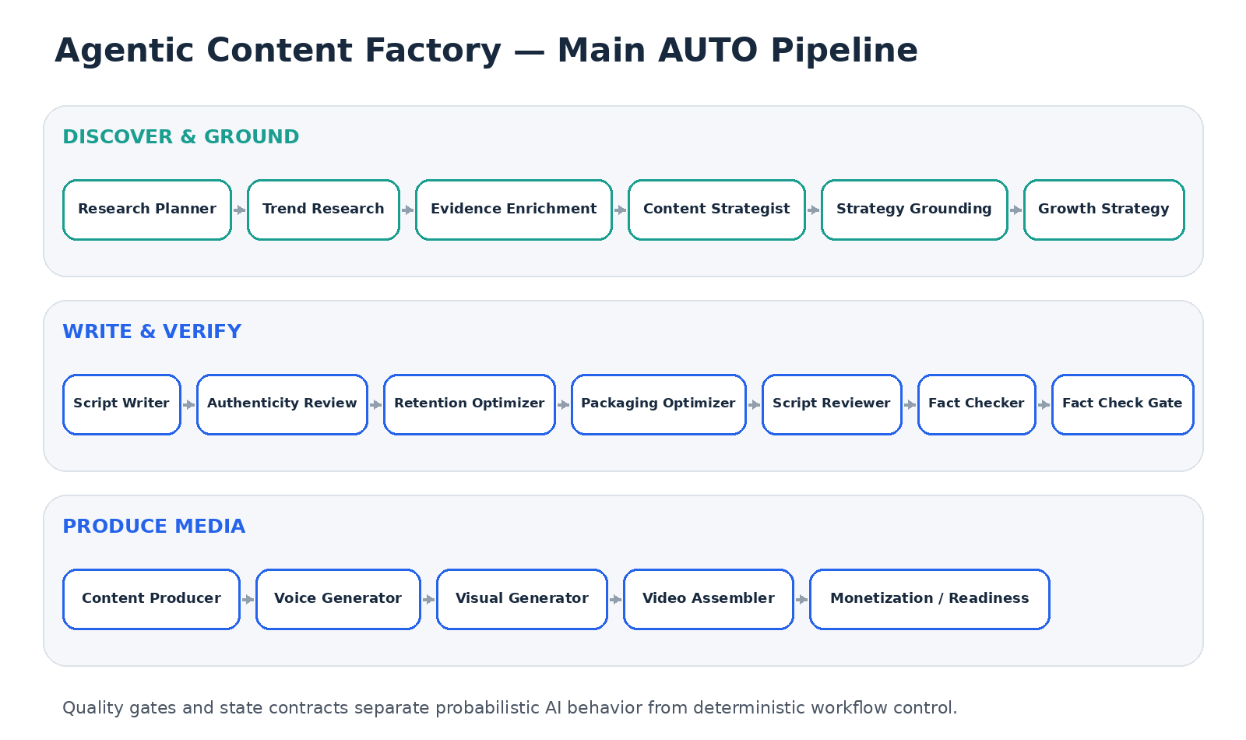

Project: github.com/raushan-raj-ai-engineer/agentic-content-factory
Local-first multi-agent AI content production • Python • Ollama • llama3.2 • Pydantic • Piper • FFmpeg
Learner edition • August 2026

0. How to Use This Playbook
This document is written for someone who may know Python and automation but is new to Agentic AI. It explains the system as an engineering workflow rather than treating the LLM as magic.
If you are… | Start here | Goal
New to AI agents | Chapters 1–6 | Understand agents, state, orchestration and structured output
Python/SDET learner | Chapters 7–20 | Follow the actual AUTO pipeline stage by stage
Media/GenAI learner | Chapters 21–25 | Understand voice, visuals, FFmpeg and experimental video paths
Interview candidate | Chapters 26–31 | Learn failure stories, testing, debugging and trade-offs
Core reading pattern: for every component ask four questions — What problem is it solving? Why is an LLM needed or not needed? What contract does it consume/produce? What happens when it fails?

Playbook map
Chapters 1–16 | Chapters 17–31
1. Project mental model | 17. Fact Checker and Fact Gate
2. Local-first architecture | 18. Content Production Plan
3. Repository map | 19. Voice Generation
4. Agent + state fundamentals | 20. Visual Generation
5. Configuration and model selection | 21. Video Assembly
6. Structured outputs and contracts | 22. Monetization / Readiness
7. Main orchestration workflow | 23. Performance, logs and artifacts
8. Research Planner | 24. Cartoon pipeline
9. Trend Research | 25. Local video experiments
10. Evidence Enrichment | 26. Real failures and fixes
11. Content Strategy | 27. Testing strategy for Agentic AI
12. Strategy Grounding | 28. Debugging runbook
13. Growth Strategy and approvals | 29. Hands-on learner labs
14. Script Writer | 30. Productionization roadmap
15. Authenticity / Retention / Packaging | 31. Glossary + revision sheet
16. Script Review

1. Project Mental Model — What Are We Actually Building?
The project is not “one AI that makes a video.” It is a pipeline where deterministic Python orchestration coordinates multiple specialized AI-assisted and non-AI components.
trend signal → evidence → strategy → script → review → fact gate → production plan → voice → visuals → video → readiness

What is an agent here?
An agent is a focused software component with one responsibility and a defined input/output contract. Some agents call an LLM; others apply deterministic rules, orchestration or media processing.
Concept | Beginner explanation | Project example
Agent | A worker with one job | Script Writer writes narration; Fact Checker evaluates claims
Orchestrator | The manager deciding order | workflow.py executes agents and checks gates
State | Shared job folder passed between workers | topic, evidence, strategy, script, fact result, media artifacts
Gate | A rule deciding continue/stop/repair | Fact Check Gate blocks unresolved material issues
Provider | Concrete implementation behind an interface | Ollama for local LLM, Piper for TTS
Artifact | A saved result from a run | audio segments, images, MP4, reports, logs
The most important idea: probabilistic AI is surrounded by deterministic software controls. This is where SDET-quality engineering becomes central.

2. Why a Local-First Architecture?
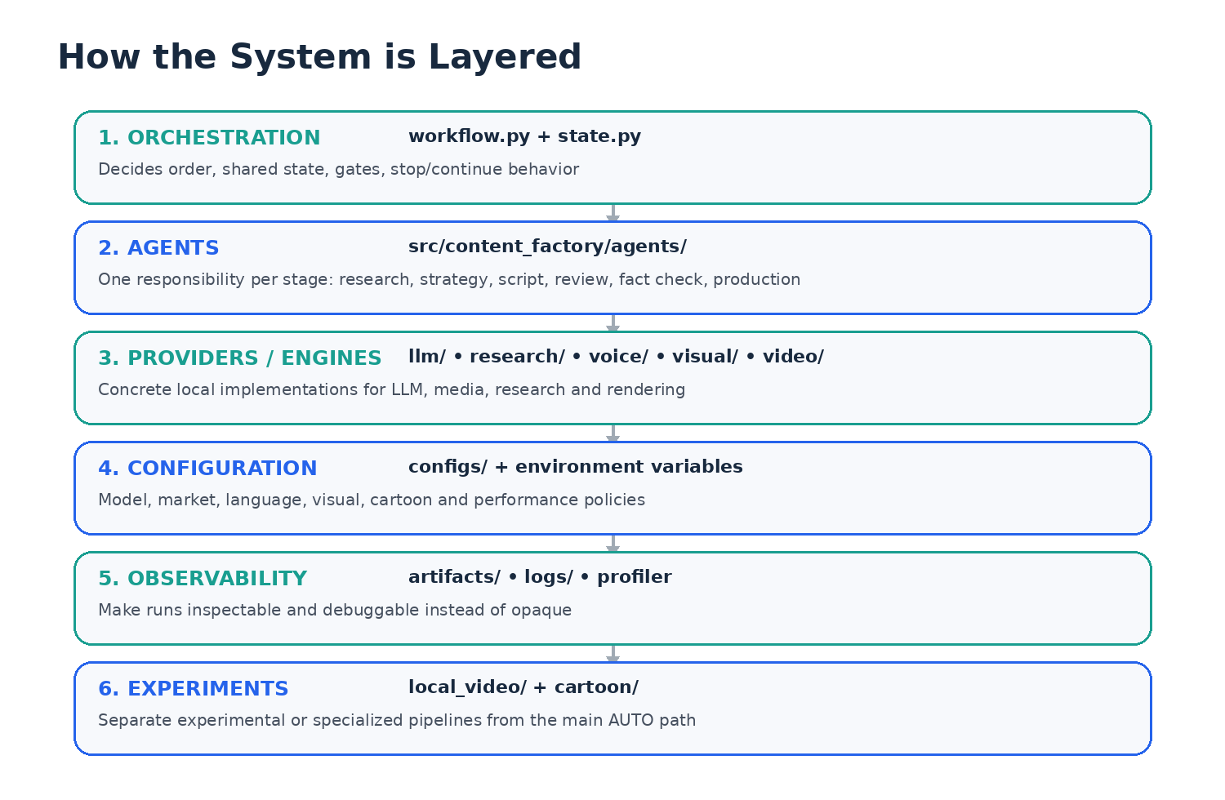
The project was intentionally developed on an Apple M2 machine with 8 GB unified memory. This constraint made architecture decisions visible: model size, timeout behavior, memory release and bounded generation all became engineering concerns.
Choice | Why it was chosen | Trade-off
Ollama + llama3.2 | Run reasoning locally, low recurring API cost, learn runtime behavior | Slower than hosted large models; constrained by local RAM
Python | Strong AI ecosystem and automation fit | Requires careful async/process/resource handling
Piper / macOS voices | Local narration | Quality/voice variety lower than premium cloud TTS
FFmpeg | Reliable deterministic media assembly | Command/filter complexity
Separate experimental video lab | Protect stable main path from heavy experiments | More code paths to maintain
Local-first does not mean “everything must run locally forever.” It means the architecture can operate locally and later route expensive work to a stronger worker without rewriting the whole system.

3. Repository Map — Where Should a New Learner Look?
agentic-content-factory/
├── configs/ # model, market, language, cartoon & quality configuration
├── docs/ # development history and architecture notes
├── scripts/ # setup, diagnostics, reports and tests
├── src/content_factory/
│ ├── agents/ # workflow stages
│ ├── orchestration/ # shared state + workflow ordering
│ ├── llm/ # local LLM abstraction/provider
│ ├── research/ # trend/research sources and scoring
│ ├── voice/ # narration generation
│ ├── visual/ # semantic routing and visual generation
│ ├── video/ # video assembly
│ ├── monetization/ # readiness heuristics
│ ├── cartoon/ # separate cartoon pipeline
│ ├── local_video/ # experimental local motion/video backends
│ └── performance/ # timing/profiling
├── tests/
├── run_auto.sh
├── run_cartoon.sh
└── run_own_video.sh
Folder/File | Role
run_auto.sh | Entry point for the main real-trends workflow
run_cartoon.sh | Entry point for cartoon/story workflow
run_own_video.sh | Entry point for experimental local video pipeline
src/content_factory/orchestration/workflow.py | Coordinates stages
src/content_factory/orchestration/state.py | Defines/holds shared workflow state
src/content_factory/agents/ | Main specialized agents
configs/local.yaml | Local model/runtime settings
docs/DEVELOPMENT_NOTES.md | Evolution, failures, patch history, constraints
scripts/ | Operational checks and regression helpers

4. Agent + Shared State Fundamentals
A beginner often imagines agents chatting freely. This project is closer to an orchestrated state machine: each stage receives shared state, adds or validates a result, and returns control to the workflow.
state = WorkflowState(topic=..., evidence=...)
state = await content_strategist.execute(state)
state = await script_writer.execute(state)
state = await fact_checker.execute(state)
# gates inspect fields on state before allowing downstream production
The exact implementation may differ by class/method name, but the engineering pattern is stable: state is the contract between stages.
Why shared state helps | Example
Traceability | You can see which stage produced script/fact/production data
No hidden coupling | Downstream stages read explicit fields instead of global variables
Gate decisions | Fact gate can inspect a stored FactCheckResult
Debugging | A failure can be localized to the transition that produced invalid/missing state
Real bug learned from this design: a valid local fact-check result existed in a variable, but it had not been assigned into shared state. The next guard therefore behaved as if no result existed. Agentic systems still fail from ordinary state-management bugs.

5. Configuration and Model Selection
Configuration separates code from environment-specific decisions. The project uses files such as configs/local.yaml and environment variables to choose local model/runtime behavior.
# conceptual precedence
terminal environment override
↓
project .env / config default
↓
local.yaml fallback / validated settings
Current practical local text model: llama3.2. It was selected because it is more realistic for an 8 GB M2 than larger local models.
Configuration concern | Why configurable
LLM model | Switch model without editing agent logic
Timeouts | Different hardware/providers have different latency
Language/market | Research and content behavior vary by region
Visual policies | Quality treatment can evolve independently
Voice model paths | Large local models are installed outside Git
Performance flags | Allow experiments without destabilizing production defaults
Do not hard-code a model name deep inside every agent. Centralized model selection is a maintainability and testing decision, not only convenience.

6. Structured Outputs and Pydantic-style Contracts
Free-form LLM text is difficult to automate. Downstream code needs known fields, types and validation. The project therefore uses structured models/contracts around important LLM outputs.
class TicketLikeResult(BaseModel):
decision: str
confidence: float
reasons: list[str]
raw = response.message.content
if raw is None:
raise RuntimeError("LLM returned no content")
result = TicketLikeResult.model_validate_json(raw)
This pattern is the same reason the project validates structured strategy/script/fact outputs: downstream automation should not parse arbitrary prose when a typed contract is available.
Problem | Structured-output benefit
Missing keys | Validation fails early
Wrong types | Caught before downstream code
Unexpected prose | Schema requirement reduces parser ambiguity
None content | Explicit guard avoids type/runtime error
Testability | Fixtures can instantiate/validate the same models without LLM calls
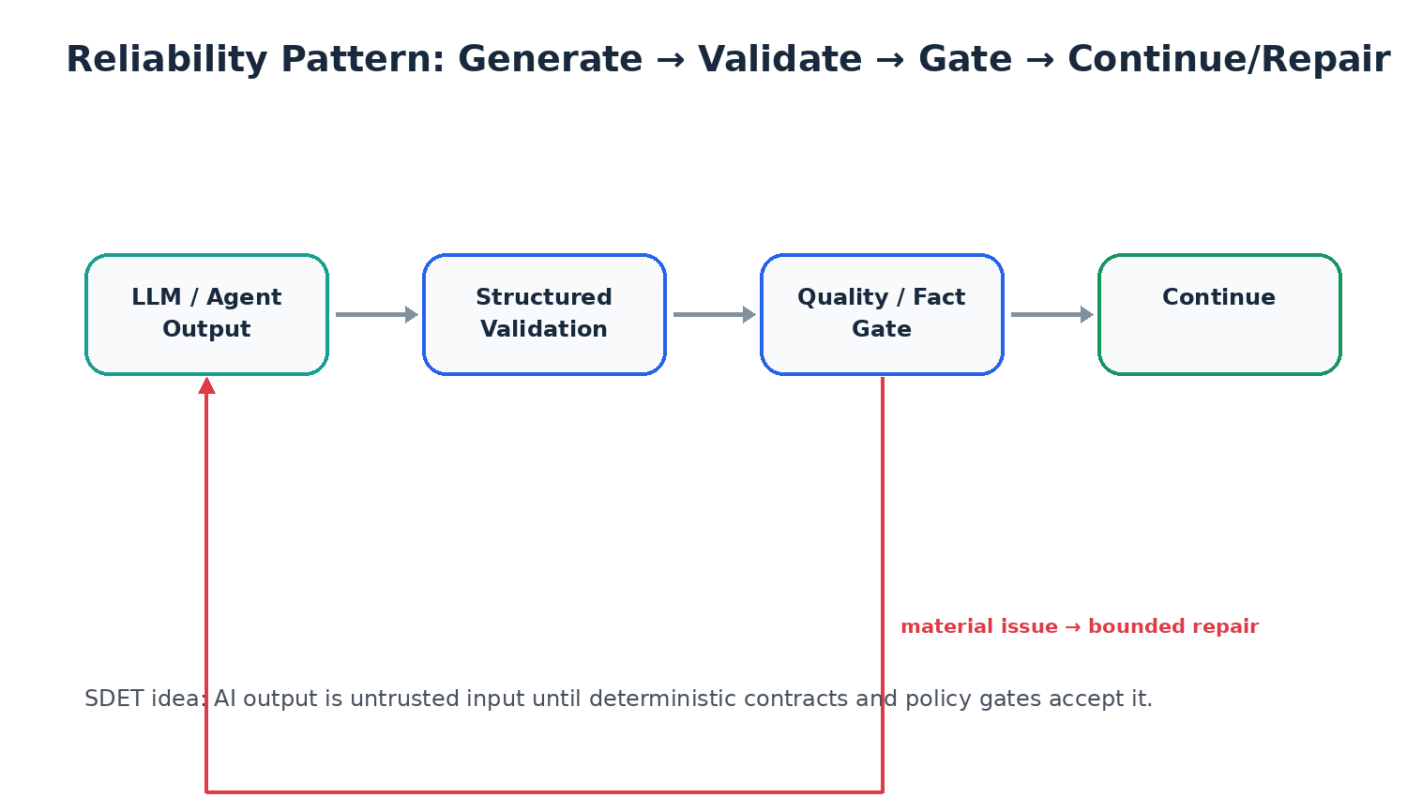

7. Main Orchestration Workflow
Primary implementation area: src/content_factory/orchestration/workflow.py + main.py

What it does
The orchestrator executes the end-to-end AUTO workflow in a defined order and records stage success/failure.

Why it exists
Without orchestration, every component would need to know which component comes next. Central ordering keeps responsibilities separate and enables gates, timing, cleanup and recovery.

How it works
1. Initialize configuration and run state.
2. Run discovery/research stages.
3. Build and ground strategy.
4. Run script/review/fact stages.
5. Stop or continue based on approval gates.
6. Generate production plan, voice, visuals and video.
7. Run readiness checks and finalize artifacts.
8. Release heavy local model resources when appropriate.

Inputs and outputs
Input | Output
CLI/configuration + initial workflow state | Updated state + artifacts + final status

Result / value produced
A run has a visible lifecycle instead of hidden calls scattered across the codebase.

Common failure modes
- An agent raises an exception.
- A required state field is missing.
- A gate blocks the run.
- A local model hangs or times out.
- Media stage fails after text stages succeeded.

What a learner should understand
Be able to explain why orchestration is deterministic even when some internal agents are probabilistic.

8. Research Planner
Primary implementation area: src/content_factory/agents/research_planner.py

What it does
Decides what information should be researched before the system commits to a content angle.

Why it exists
A content system that writes before planning research is more likely to anchor on a weak or generic topic.

How it works
1. Read the selected market/topic context.
2. Identify the research questions/signals needed.
3. Build a plan for external/current sources.
4. Store the plan in workflow state for downstream research.

Inputs and outputs
Input | Output
Market/topic candidates + configuration | Research plan

Result / value produced
Research becomes intentional and traceable instead of arbitrary browsing.

Common failure modes
- Research plan too broad.
- Plan asks for unavailable data.
- Plan is not aligned with target market/language.

What a learner should understand
Planning and execution are separate concerns. This mirrors test planning before test execution.

9. Trend Research
Primary implementation area: src/content_factory/agents/trend_researcher.py + src/content_factory/research/

What it does
Collects, scores and ranks topic signals from multiple public sources such as Google Trends, Google News, YouTube and Hacker News.

Why it exists
One source can be noisy or unavailable. Multiple sources reduce dependence on a single signal and create evidence for trend selection.

How it works
1. Load candidate markets/languages.
2. Query available research providers.
3. Normalize/clean returned topic signals.
4. Reject weak or generic candidates.
5. Score relevance/freshness/opportunity.
6. Rank and select the strongest candidate.
7. Record timeouts/source failures without hiding them.

Inputs and outputs
Input | Output
Research plan + providers | Ranked trend candidates + selected topic

Result / value produced
The script pipeline starts from a current, selected topic rather than a hard-coded prompt.

Common failure modes
- A source times out (observed in real runs).
- Source returns no usable items.
- Candidates are duplicates/low quality.
- Language/market mismatch.

What a learner should understand
External research is inherently flaky. Design source adapters so one failure degrades the evidence set instead of crashing everything unnecessarily.

10. Evidence Enrichment
Primary implementation area: src/content_factory/agents/evidence_enricher.py

What it does
Adds supporting evidence/context to the chosen topic before strategy and script generation.

Why it exists
Trend popularity is not the same as factual evidence. Writing needs source-backed facts and uncertainty boundaries.

How it works
1. Read selected topic and initial research.
2. Extract/support key claims with evidence.
3. Capture what is known vs uncertain.
4. Store enriched evidence for strategy/script/fact stages.

Inputs and outputs
Input | Output
Selected topic + research signals | Evidence bundle

Result / value produced
Later agents can ground their outputs in a shared factual context.

Common failure modes
- Insufficient evidence.
- Conflicting source information.
- Evidence is current but not relevant to the intended angle.

What a learner should understand
Do not “solve” thin evidence by asking the LLM to invent more detail. Evidence limits should influence strategy and duration.

11. Content Strategist
Primary implementation area: src/content_factory/agents/content_strategist.py

What it does
Converts research/evidence into a content angle, audience framing and initial duration/structure.

Why it exists
Raw facts do not automatically become a coherent story. Strategy decides what the video is actually about and for whom.

How it works
1. Read topic + evidence.
2. Choose a useful angle.
3. Estimate structure/duration.
4. Define target audience/language/tone.
5. Produce structured strategy for grounding.

Inputs and outputs
Input | Output
Topic + evidence + market | Content strategy

Result / value produced
The Script Writer receives a clear brief rather than unstructured research notes.

Common failure modes
- Strategy drifts away from the actual topic.
- Duration is unrealistic for available evidence.
- Unsupported angle is introduced.

What a learner should understand
Strategy is creative but must remain evidence-constrained.

12. Strategy Grounding
Primary implementation area: src/content_factory/agents/strategy_grounding.py

What it does
Checks and corrects strategy drift before expensive script generation.

Why it exists
LLMs can produce attractive but unsupported angles. A grounding layer keeps the story tied to known evidence and topic identity.

How it works
1. Compare strategy terms with evidence/topic.
2. Remove or soften unsupported claims.
3. Recalculate/adjust duration based on evidence density.
4. Preserve the selected topic identity.
5. Return corrected strategy.

Inputs and outputs
Input | Output
Proposed strategy + evidence | Grounded strategy

Result / value produced
Observed runs showed duration correction such as 8m → 7m when evidence did not support the original plan.

Common failure modes
- Over-correction makes content too generic.
- Grounding misses subtle unsupported causal claims.
- Evidence bundle itself is weak.

What a learner should understand
Grounding is a pre-generation quality gate: prevent bad instructions rather than only repairing bad output later.

13. Growth Strategy and Approval Gates
Primary implementation area: growth_strategy.py + growth_readiness.py + human/approval.py + approval gate agents

What it does
Adds packaging/growth considerations and controls whether the workflow is ready to invest in script/media generation.

Why it exists
Expensive downstream work should not start if strategy is obviously weak, unsafe or incomplete.

How it works
1. Assess topic/strategy opportunity.
2. Create growth/packaging considerations.
3. Run automated readiness checks.
4. Optionally require human approval depending on workflow mode.
5. Continue only when required conditions are satisfied.

Inputs and outputs
Input | Output
Grounded strategy + research context | Growth plan + approval state

Result / value produced
Bad early-stage ideas can be stopped before consuming LLM/media compute.

Common failure modes
- Gate too strict and blocks useful content.
- Gate too permissive and lets unsupported strategy through.
- Human approval mode stalls unattended automation.

What a learner should understand
Gates are equivalent to quality checkpoints in CI/CD: fail early before downstream cost increases.

14. Script Writer — The Most Important LLM Stage
Primary implementation area: src/content_factory/agents/script_writer.py + script_writer_chunked.py

What it does
Generates spoken narration and structured script data from the grounded strategy and evidence.

Why it exists
This is the point where research becomes audience-facing content, so hallucination control, language consistency and duration realism matter most.

How it works
1. Compute target narration length using a words-per-minute assumption (historically ~165 WPM).
2. Build a prompt containing topic, strategy, evidence and constraints.
3. Request structured script output from the local LLM.
4. Validate the schema.
5. Count actual narration words.
6. Reconcile claimed duration with actual narration length.
7. For long output, prefer bounded/chunked generation instead of one giant call.
8. Merge chunks while preserving continuity and evidence limits.

Inputs and outputs
Input | Output
Grounded strategy + evidence + target language/duration | Structured YouTubeScript + actual word count/duration metadata

Result / value produced
Observed behavior included 825 words being reconciled from 8 minutes to about 6 minutes; another weak 319-word result was reconciled to about 2 minutes rather than pretending it was 7 minutes.

Common failure modes
- Single full-script call can hang for 600 seconds on local hardware.
- LLM may return too few words.
- LLM can add unsupported facts to fill length.
- Structured JSON may be invalid or empty.
- Chunks can lose continuity if poorly prompted.

What a learner should understand
Never hide output-length failure with metadata. Measure the actual result and make the system honest about it.

Why increasing the timeout was the wrong long-term fix
The local LLM layer once enforced a minimum timeout of 600 seconds. That converted a slow generation problem into a ten-minute workflow stall. The better architecture is bounded work: smaller generation units, per-call timeout, compact rescue/fallback, and no second giant full-script rewrite.
Bad reliability pattern:
one huge prompt → wait 600s → maybe fail
Better pattern:
chunk 1 (bounded)
chunk 2 (bounded)
chunk 3 (bounded)
chunk 4 (bounded)
merge → validate → reconcile duration

15. Authenticity, Retention and Packaging
Primary implementation area: authenticity_review.py + retention_optimizer.py + packaging_optimizer.py

What it does
Reviews the draft for generic/template behavior, improves the hook/retention structure, and creates title/thumbnail packaging variants.

Why it exists
A factually correct script can still be boring, generic or poorly packaged. These stages optimize communication without changing evidence boundaries.

How it works
1. Authenticity review identifies overly generic/template text.
2. Retention optimizer improves the opening and pacing selectively.
3. Packaging optimizer proposes multiple title/thumbnail combinations.
4. Reject package angles that are unsupported by the script/evidence.

Inputs and outputs
Input | Output
Draft script + strategy/evidence | Refined script + package candidates

Result / value produced
Runtime logs have shown multiple A/B package candidates ready for downstream use.

Common failure modes
- Optimizer rewrites too much and introduces facts.
- Clickbait package exceeds evidence.
- Multiple optimization passes create style drift.

What a learner should understand
Optimization agents should have a narrow edit scope. “Improve everything” is a dangerous prompt in a grounded pipeline.

16. Script Reviewer
Primary implementation area: src/content_factory/agents/script_reviewer.py

What it does
Performs a structured quality review before the dedicated fact-check stage.

Why it exists
Separating general writing quality from factual verification keeps each evaluation focused.

How it works
1. Inspect structure, coherence, language and production suitability.
2. Identify material quality problems.
3. Store review result/feedback.
4. Allow repair or approval based on policy.

Inputs and outputs
Input | Output
Refined script | Review result / feedback

Result / value produced
Fact Checker receives a script that has already passed general quality checks.

Common failure modes
- Reviewer and writer share same blind spot.
- Feedback is subjective/non-actionable.
- Reviewer becomes a second writer and causes churn.

What a learner should understand
Use evaluators to produce decisions and actionable issues, not uncontrolled rewrites.

17. Fact Checker and Fact Check Gate
Primary implementation area: src/content_factory/agents/fact_checker.py + fact_check_gate.py

What it does
Checks material claims against the available evidence and decides whether the script is safe to continue.

Why it exists
LLMs can produce plausible but unsupported statements. A dedicated factual gate protects downstream media generation from amplifying them.

How it works
1. Run the first fact-check evaluation.
2. Persist the result into shared state.
3. If zero material issues: approve and skip repair.
4. If issues exist: repair once using evidence constraints.
5. Re-check the repaired script.
6. Gate either PASS or BLOCK based on remaining material issues.

Inputs and outputs
Input | Output
Script + evidence | FactCheckResult + approval/block status

Result / value produced
The intended clean path is: 0 issues → PASS → repair skipped. The issue path is bounded: issues → one repair → recheck → PASS/BLOCK.

Common failure modes
- Bug: zero issues incorrectly triggered repair.
- Bug: local result existed but was not assigned to state, causing “0 issues without FactCheckResult”.
- Repair can introduce new unsupported claims.
- Fact checker itself can hallucinate issues.

What a learner should understand
The safest repair loop is bounded. Infinite “self-healing” is not reliability—it is uncontrolled mutation.

Control-flow lesson from the real bug
if len(issues) == 0:
state.fact_check = first_result
state.fact_check.approved = True
# repair MUST be skipped
else:
repaired_script = repair_once(...)
second_result = recheck(repaired_script)
state.fact_check = second_result
Interview-quality insight: AI reliability failures are often ordinary software bugs around AI outputs—state assignment, branching, null handling, retries and timeout policy.

18. Content Production Plan
Primary implementation area: src/content_factory/agents/content_producer.py

What it does
Translates the approved script into a structured scene/media plan that downstream voice and visual systems can execute.

Why it exists
The media engines should not receive a giant paragraph and guess everything. They need explicit scene semantics, timing and visual intent.

How it works
1. Split approved narration into production units/scenes.
2. Associate voice segments with scene timing.
3. Define visual subject, composition, treatment and avoidance instructions.
4. Create metadata such as thumbnail/description/tags where appropriate.
5. Persist a production plan.

Inputs and outputs
Input | Output
Approved script + packaging | Production plan with scene/media instructions

Result / value produced
Downstream generators receive deterministic structure even if they use generative providers internally.

Common failure modes
- Too many scenes increase runtime.
- Too few scenes create repetitive visuals.
- Scene descriptions do not match narration semantics.
- Production plan requests assets unavailable locally.

What a learner should understand
The production plan is an adapter between language models and media engines. It converts intent into executable instructions.

19. Voice Generation
Primary implementation area: src/content_factory/agents/voice_generator.py + src/content_factory/voice/ + Piper/local voices

What it does
Generates narration audio segments that correspond to the approved production plan.

Why it exists
Audio timing drives final video timing. Local TTS also supports the project’s local-first constraint.

How it works
1. Choose a voice profile/provider.
2. Generate audio for each narration segment.
3. Validate that expected audio files exist and are readable.
4. Capture durations for synchronization.
5. Store audio artifact paths in state/plan.

Inputs and outputs
Input | Output
Production plan voice segments | Audio files + duration metadata

Result / value produced
The video assembler gets deterministic audio assets rather than synthesizing during final encoding.

Common failure modes
- Missing local .onnx voice model.
- TTS process fails or produces empty audio.
- Voice speed/duration creates scene timing mismatch.
- Language/voice does not match target market.

What a learner should understand
Large voice model binaries should be installed locally, not committed to Git. Reproducibility should come from setup scripts and documented model names.

Why Piper?
Piper is lightweight enough for local TTS and avoids per-request cloud cost. macOS voices provide an additional local fallback. The trade-off is that premium cloud systems may provide more natural emotional delivery.

20. Visual Generation and Semantic Routing
Primary implementation area: src/content_factory/agents/visual_generator.py + src/content_factory/visual/

What it does
Creates or composes scene visuals based on the production plan. The visual layer contains semantic routing, quality logic and multiple composition paths.

Why it exists
A single generic image prompt per scene tends to create repetitive slideshow output. The visual engine needs to choose treatments based on scene meaning.

How it works
1. Read each scene’s semantic intent.
2. Route it to an appropriate visual treatment/provider.
3. Generate/compose the visual asset.
4. Apply quality checks and fallback behavior.
5. Track treatment diversity across the full video.

Inputs and outputs
Input | Output
Production scenes + visual policies | Scene images/visual assets + routing/quality metadata

Result / value produced
The project’s Premium Visual Engine V4 targets 1080p production and uses varied editorial treatments instead of one repeated template.

Common failure modes
- Same background/layout repeats.
- Generated image does not match narration.
- Provider unavailable.
- Image quality is poor or text is malformed.
- Plan claims diversity but renderer ignores treatment markers.

What a learner should understand
Visual diversity must be validated on the final output, not only inferred from different prompt strings.

Editorial treatment diversity
- opening_context
- evidence_board
- timeline
- comparison_split
- headline_context
- key_points
- what_to_watch
- closing_synthesis
These labels are useful only if they materially change the rendered scene. A metadata marker that the renderer ignores does not create real visual diversity.

21. Video Assembly with FFmpeg
Primary implementation area: src/content_factory/agents/video_assembler.py + src/content_factory/video/local.py

What it does
Combines audio, visuals, timing and motion into the final encoded MP4.

Why it exists
Final assembly is a deterministic media-processing problem; a reliable tool like FFmpeg is better suited than asking an LLM to manipulate media.

How it works
1. Read scene/audio artifact paths and timing.
2. Create visual clips/motion treatment.
3. Synchronize visuals with narration durations.
4. Concatenate/composite segments.
5. Encode the final file with the chosen quality profile.
6. Validate that the output file exists and has plausible media properties.

Inputs and outputs
Input | Output
Audio + visual scene artifacts + timing | Final MP4

Result / value produced
Current quality target in the project: 1080p30, H.264, CRF17, BT.709, motion-aware output.

Common failure modes
- FFmpeg command/filter failure.
- Audio/video duration mismatch.
- Missing asset path.
- Codec/container incompatibility.
- Final video technically valid but visually repetitive.

What a learner should understand
Keep semantic generation separate from deterministic rendering: the LLM decides what; FFmpeg decides how bytes become a playable video.

22. Monetization / Upload Readiness Heuristics
Primary implementation area: src/content_factory/agents/monetization_safety.py + src/content_factory/monetization/readiness.py

What it does
Runs internal heuristics to flag repetitive/template-like output and other upload-readiness risks.

Why it exists
A technically valid MP4 may still be low-quality or overly repetitive. The readiness layer adds a final quality/risk perspective.

How it works
1. Inspect narration/scene counts.
2. Measure scene/treatment diversity.
3. Evaluate repetitive treatment risk.
4. Check disclosure/review flags where relevant.
5. Return upload-ready/review-required status.

Inputs and outputs
Input | Output
Final/near-final production state | Readiness risk/status

Result / value produced
It can prevent the pipeline from silently treating every generated video as publishable.

Common failure modes
- Fixed word threshold can unfairly penalize short legitimate videos.
- Plan-level diversity can disagree with actual rendered diversity.
- Heuristics may not match external platform review.

What a learner should understand
Internal readiness is a guardrail, not a guarantee of monetization or platform approval. Final human review remains important.

23. Performance, Logs, Artifacts and Model Memory Release
Observability is a first-class requirement. The pipeline reports stage timing such as “[PERF] Script Writer Agent: 600.1s (failed)” so bottlenecks are visible.
Mechanism | Purpose | Learner lesson
performance/profiler.py | Measure stage latency | Optimize based on evidence, not guesses
logs/ | Persist diagnostic output | A failed run should be explainable later
artifacts/<topic>/<run-id>/ | Keep run outputs together | Reproducible analysis and visual review
model_memory_release.py | Release local model resources before media-heavy stages | Unified memory is shared on Apple Silicon
scripts/show_* | Operational reports | Observability can be productized into helper commands
Heavy generated/runtime assets are intentionally ignored by Git: .venv/, .visual-venv/, .local-video-engine/, artifacts/, logs/, large model checkpoints and downloaded Piper .onnx files.
A local AI project needs operational engineering: memory, disk, caches and generated assets are part of system design.

24. Separate Cartoon Pipeline
The cartoon pipeline is intentionally separated from the main real-trends AUTO pipeline. It has different concepts: recurring characters, poses, story beats, scene dynamics, action worlds and character performance.
Area | Files / concepts
Entry point | run_cartoon.sh
Core package | src/content_factory/cartoon/
Characters | characters.py + configs/cartoon_characters.json
Story | story_planner.py
Scene dynamics | scene_dynamics.py
Performance | performance_director_v16.py
Routing | router.py + cartoon_routes.json
Visual quality | quality_reset_v17.py + cartoon_visual_quality.json
Monetization | cartoon/monetization.py + cartoon_monetization.json
Large character sprite PNG collections were removed from Git tracking to keep the repository lightweight. They remain local/runtime assets and should eventually be reproducibly installed or generated by setup tooling.
The cartoon workflow taught a second kind of multimodal challenge: even if a script is good, static front-facing characters, repeated backgrounds and poor gaze/turn-taking can make the video feel artificial.
Keep specialized pipelines separate when their domain model is materially different. Reusing “one universal pipeline” can create worse abstractions.

25. Local Video Experiment Pipeline
The local_video package is an experimental area for exploring true/local motion and video generation without destabilizing the main AUTO workflow.
Backend/Tool | Role | Status / lesson
Stable Video Diffusion (SVD) | Image-to-video style motion backend | Experimental code path; heavy for limited hardware
AnimateDiff / AnimateDiff-Lightning | Diffusion-based animation/motion | Experimental; model/cache footprint is large
LTX-style backend | Alternative motion/video path | Experimental
MuseTalk | Lip-sync backend path | Experimental integration area
Piper | Local voice in video pipeline | Practical local component
MLX | Apple Silicon model execution experiments | Useful, but not all models fit 8 GB

Wan2.1 proof and why it was stopped
A Wan2.1-T2V-1.3B MLX proof was attempted with 4-bit quantization and very small output settings. The pipeline still needed large components, including a roughly 11.4 GB text encoder, and macOS terminated the process under memory pressure (“zsh: killed”).
This was not treated as a failure to hide. It produced an architectural conclusion: full local text-to-video diffusion is not practical on the target 8 GB M2, so the stable path should use lighter image generation + controlled motion/animation, or later offload heavy video inference to stronger compute.
Engineering maturity means knowing when NOT to integrate a model.

26. Real Failures → Root Cause → Fix → Result
Failure | Root cause | Fix / design response | Result / lesson
Script Writer waited 600s | Whole long structured call + local LLM minimum timeout forced to 600s | Move toward bounded/chunked calls; reduce global timeout ceiling; disable giant full-script rewrite | Failure becomes bounded and diagnosable
Fact checker repaired 0-issue script | Incorrect branch logic | 0 issues → PASS and skip repair | Avoid mutating clean output
“0 issues without FactCheckResult” | Result existed locally but was not persisted to workflow state | Assign validated result before guard/gate | State propagation is part of correctness
319 words labelled as long video | Metadata duration not reconciled with actual narration | Count words and recompute realistic duration | System reports honest duration
Repetitive visuals | Different prompts but same visual treatment/layout | Semantic routing + explicit treatment diversity + final video review | Move from prompt variation to material scene variation
Wan2.1 process killed | Model/text encoder exceeded 8 GB unified memory practicality | Do not integrate; use lighter motion or stronger remote/self-hosted GPU | Hardware constraint becomes architectural input
Git push wrote 9.18 GiB | Local virtual envs, model caches, .onnx/checkpoints and sprites were tracked/history-packed | Ignore/untrack large runtime assets, rebuild clean history, garbage collect | Repository pack reduced to ~100 MiB and pushed successfully
Patch introduced SyntaxError | Text insertion occurred at unsafe statement boundary | Transactional patching: transform in memory, parse/compile, backup, then commit | Failed patches can stop safely without corrupting source

Failure story template for learners
1. Symptom: What did the log/output show?
2. Scope: Which agent/stage failed?
3. Root cause: AI limitation, code bug, state bug, timeout, hardware, or media issue?
4. Fix: Smallest architecture/code change that removes the cause.
5. Guard: What test/log/gate prevents recurrence?
6. Result: What measurable behavior improved?

27. Testing Strategy for an Agentic AI System
Traditional unit testing is still necessary, but AI systems add non-deterministic outputs. The right approach is layered testing.
Layer | What to test | Example
Unit tests | Deterministic helpers/contracts | word counting, duration reconciliation, config precedence
Schema tests | Structured output models | valid/invalid JSON, missing fields, None content
Agent tests | One stage with mocked LLM/provider | Fact Checker zero-issue path skips repair
Contract tests | State hand-offs | script_writer populates state.script before reviewer
Integration tests | Multiple stages | research → strategy → script with fake providers
Golden/fixture tests | Known input against expected invariants | no unsupported keywords; language preserved
Property/invariant tests | Rules that must always hold | 0 issues must never trigger repair
Failure-injection tests | Timeouts/provider errors | research source timeout does not corrupt state
Media validation | File/duration/codec checks | final MP4 exists, audio duration plausible
Human quality review | Subjective final media quality | scene matches narration; no repetitive slideshow feel

What NOT to assert
Do not write brittle tests that require the LLM to return the exact same wording every run. Test invariants, contracts, factual boundaries, structure and decision rules instead.

High-value test examples
def test_zero_fact_issues_skip_repair():
first = FactCheckResult(issues=[])
# assert approved and repair call count == 0
def test_duration_comes_from_actual_words():
# 330 words at ~165 WPM should be near 2 minutes, not 7
def test_none_llm_content_fails_cleanly():
# clear error before Pydantic JSON validation
def test_large_local_assets_are_gitignored():
# optional repo hygiene test/check in CI
SDET advantage: AI quality is not “prompt engineering only.” It is contracts, invariants, negative paths, observability, controlled retries and reproducible fixtures.

28. Debugging Runbook — How a New Learner Should Investigate Failures
1. Read the LAST successful stage and FIRST failed stage in the logs. Do not debug the entire pipeline.
2. Confirm the input state for the failed stage: required fields present? correct language/topic? evidence available?
3. Classify the failure: deterministic code exception, schema validation, provider timeout, bad AI content, missing file/model, memory pressure, or media encoding.
4. If LLM-related, capture prompt size/target output, timeout and raw response availability before changing prompts.
5. If state-related, verify the local result was assigned to shared state before the next gate.
6. If media-related, verify each input artifact exists before debugging FFmpeg.
7. If hardware-related, inspect model size/cache and whether heavy models were released before the next stage.
8. Add a regression test or invariant after the root cause is fixed.
9. Re-run the smallest possible stage/test first; only then run the full workflow.
Log pattern | Likely direction
ReadTimeout / 600s | Bound generation / timeout architecture; do not just wait longer
model_validate_json + None | Provider returned no content; guard before validation
missing FactCheckResult | State assignment/contract problem
zsh: killed | OS memory pressure; model does not fit practical hardware budget
FFmpeg nonzero exit | Inspect input files, filter graph and codec
Git pack measured in GiB | Large runtime assets/history were tracked

29. Hands-On Learner Labs
These labs turn the codebase into a learning curriculum. Complete them in order and write down the observed input/output for each stage.

Lab 1 — Trace one AUTO run
Task: Run ./run_auto.sh and create a timeline of every [START], [PERF], [FACT], [VISUAL], [VIDEO] log line.
Learning result: Understand orchestration and observability.

Lab 2 — Mock the LLM
Task: Replace/patch the LLM provider in a test with a deterministic JSON response.
Learning result: Separate agent logic from model randomness.

Lab 3 — Break the schema
Task: Return missing/wrong fields and observe validation failure.
Learning result: Understand structured output contracts.

Lab 4 — Fact checker clean path
Task: Feed a script/evidence fixture with no issues and assert repair is never called.
Learning result: Learn invariant testing.

Lab 5 — Fact checker issue path
Task: Inject one unsupported claim, repair once, then re-check.
Learning result: Learn bounded self-repair.

Lab 6 — Duration reconciliation
Task: Test 165, 330, 825 and 990 narration words.
Learning result: See how WPM converts content length to video duration.

Lab 7 — Provider timeout
Task: Force a short research/LLM timeout.
Learning result: Practice graceful failure and logs.

Lab 8 — Scene treatment diversity
Task: Build a production plan with repeated vs varied treatment markers and compare readiness behavior.
Learning result: Understand heuristics vs actual rendered quality.

Lab 9 — FFmpeg proof
Task: Assemble two still scenes + one audio track into a tiny MP4.
Learning result: Understand deterministic media assembly separately from AI.

Lab 10 — Git hygiene
Task: Run git count-objects -vH and inspect ignored model/cache directories.
Learning result: Learn why ML artifacts require repository strategy.

Lab 11 — Local hardware experiment
Task: Observe RAM/model behavior with a small model and document the practical ceiling.
Learning result: Treat hardware as a design constraint.

Lab 12 — Add one new agent
Task: Create a simple deterministic “PolicyCheckAgent” that reads state and outputs a structured result.
Learning result: Practice agent contract + orchestration integration.

30. How This Would Evolve Toward Production
Current local-first design | Production evolution
Single local machine | Containerized services/workers with explicit resource classes
Ollama local inference | Provider router: local model + hosted model + self-hosted GPU
Local filesystem artifacts | Object storage with run IDs and metadata
Console/file logs | Structured logs + traces + metrics + dashboards
Simple retries/repairs | Retry budgets, circuit breakers, idempotency and dead-letter recovery
Manual final video review | Automated media metrics plus required human approval for publish
Heuristic AI evaluation | Evaluation dataset, regression suite, LLM-as-judge only where validated
Local config files | Environment/secret management + versioned policy configuration
One-machine workflow | Queue-based orchestration with checkpoint/resume
Experimental backends in repo | Feature flags and capability-aware worker routing

Why a GPU worker is a better next step than forcing M2 8 GB
Heavy video diffusion is a different resource class from text orchestration. A production architecture should route expensive media inference to a machine designed for it, while keeping the orchestration and quality logic hardware-agnostic.
A strong architecture lets you change the model/provider without rewriting the quality gates and workflow semantics.

31. Glossary + Final Revision Sheet
Term | Meaning in this project
Agent | Focused workflow component with a clear responsibility
Orchestration | Deterministic ordering and control of agents
Workflow state | Structured shared data passed between stages
Structured output | LLM response validated against a schema/model
Grounding | Constraining output to available evidence/context
Hallucination | Unsupported/invented model output
Gate | Decision point that can pass, block or trigger bounded repair
Fallback | Alternative behavior when a provider/feature is unavailable
Retry | Repeat the same operation after a transient failure
Repair | Change an invalid output then re-evaluate it
Idempotency | Repeated execution does not cause uncontrolled duplicate effects
Observability | Logs, timings, artifacts and state that explain system behavior
TTS | Text-to-speech narration generation
Diffusion model | Generative model family commonly used for images/video
MLX | Apple Silicon-focused machine learning framework
FFmpeg | Deterministic audio/video processing toolkit
Pydantic | Python validation/data modelling used for typed contracts
Ollama | Local LLM runtime/API
Piper | Lightweight local text-to-speech engine

One-page mental model
- Research tells the system what is happening now.
- Evidence tells the system what it is allowed to claim.
- Strategy tells the system what story to tell.
- Grounding removes unsupported strategy drift.
- Script Writer turns the grounded strategy into spoken narration.
- Review agents improve quality without owning factual truth.
- Fact Checker + gate protect against unsupported material claims.
- Content Producer turns language into executable media instructions.
- Voice/visual providers generate assets; FFmpeg assembles the final video.
- Readiness heuristics flag repetitive/template risk but do not guarantee platform approval.
- Logs/state/contracts make the system debuggable.
- Hardware limits, model timeouts and disk/Git hygiene are part of AI engineering.
Best learner takeaway: The LLM is only one component. The real system is the orchestration, contracts, evidence, gates, retries, observability, media engines and failure handling around it.

Appendix A — Important Source Files to Read in Order
Order | File | Read it to understand
1 | src/content_factory/orchestration/state.py | Understand shared workflow data
2 | src/content_factory/orchestration/workflow.py | Understand stage ordering
3 | src/content_factory/agents/base.py | Understand the agent abstraction
4 | src/content_factory/llm/base.py + llm/local.py | Understand Ollama boundary and timeout behavior
5 | src/content_factory/agents/research_planner.py | Research intent
6 | src/content_factory/agents/trend_researcher.py + research/ | External research
7 | src/content_factory/agents/content_strategist.py | Strategy creation
8 | src/content_factory/agents/strategy_grounding.py | Evidence constraint
9 | src/content_factory/agents/script_writer.py | Core generation
10 | src/content_factory/agents/script_writer_chunked.py | Bounded long-generation design
11 | src/content_factory/agents/fact_checker.py + fact_check_gate.py | Factual quality control
12 | src/content_factory/agents/content_producer.py | Script-to-production transformation
13 | src/content_factory/voice/ | TTS abstraction/implementation
14 | src/content_factory/visual/ | Semantic visual system
15 | src/content_factory/video/ | Final media assembly
16 | src/content_factory/monetization/readiness.py | Readiness heuristics
17 | src/content_factory/performance/profiler.py | Timing/observability
18 | src/content_factory/cartoon/ | Specialized cartoon workflow
19 | src/content_factory/local_video/ | Experimental video-generation backends
20 | docs/DEVELOPMENT_NOTES.md | Read failure history after understanding architecture

Appendix B — Tool / Technology Matrix
Technology | Used for | Why | Important limitation
Python | Orchestration, agents, validation, providers | AI ecosystem + automation fit | Resource/process discipline still required
Ollama | Local LLM API/runtime | Local inference and provider abstraction | Latency and memory constrained by hardware
llama3.2 | Default local reasoning model | Practical fit for 8 GB M2 | Less capable than larger models; long outputs need bounds
Pydantic-style models | Typed structured contracts | Fail fast on invalid AI output | Schema cannot guarantee factual correctness
Piper | Local TTS | Offline/lightweight | Voice quality/model installation constraints
macOS voices | TTS fallback/alternative | Already available locally | Voice consistency/quality varies
FFmpeg | Media assembly/encoding | Deterministic and mature | Filter graphs can be complex
MLX | Apple Silicon model experiments | Native Apple acceleration | Model still must fit unified memory
MFlux / local visual tooling | Image generation path | Apple/local visual experimentation | Quality/speed depends on model/hardware
SVD | Experimental image-to-video | Motion experimentation | Heavy for target hardware
AnimateDiff | Experimental motion | Generative animation option | Large caches/runtime footprint
LTX-style backend | Experimental video motion | Alternative backend architecture | Not the stable default
MuseTalk | Lip-sync experiment | Talking-character synchronization path | Experimental integration
pytest | Automated tests | Regression and contract checks | LLM exact-output assertions are brittle
Git/GitHub | Source/version control | Reproducibility and portfolio | Large models/caches must be excluded
Shell scripts | Entry points/setup/diagnostics | Simple operator workflow | Need portability/error handling

Appendix C — Practical Commands
# Main pipeline
./run_auto.sh
# Cartoon pipeline
./run_cartoon.sh
# Experimental local video pipeline
./run_own_video.sh
# Repository health
git status
git count-objects -vH
# Useful diagnostics (examples in scripts/)
./scripts/check_visual_engine.sh
./scripts/check_visual_provider_integrity.sh
./scripts/show_performance_report.sh
./scripts/show_monetization_report.sh
./scripts/show_voices.sh
Exact local setup can change as the project evolves. Prefer the repository README and scripts over copying old commands from notes.

Final Note for New Learners
Do not try to understand the whole system by starting with the most complex video model. Start with state + orchestration + one simple agent. Then trace one run. Then learn structured outputs and gates. Only after the text pipeline makes sense should you study voice, visuals and video.
The project’s strongest teaching value is that it exposes the gap between an AI demo and an engineered AI workflow. Every major challenge—timeouts, hallucinations, state bugs, duration mismatch, repetitive visuals, memory limits and repository bloat—was solved or reframed with ordinary software-engineering discipline around probabilistic components.
Build AI like you build automation: observable inputs, explicit contracts, controlled side effects, negative-path tests, bounded retries and honest failure states.

