
DISCLAIMER

Copyright 2017, Airworthiness Certification Services, Inc. (ACS) in partnership with the Avionics Certification Academy.

All rights reserved.

These Templates are perpetually licensed for a single company, for the site and/or project team who initially purchased. The purchaser can use the Templates, or any customized variant of them, on as many projects as desired. The Templates may not be shared outside of the purchasing company with the exception of interactions with customers and program auditors. The Purchaser agrees to these terms as part of the sale. If a worldwide Corporate License is desired, which provides unlimited access for all sites and project teams within a company, contact info@avionics-certification-academy.com for details and a quote.

This Template is proprietary to ACS. and should not be distributed or copied in its original format without written permission. It is to be used solely as the basis of documentation for the purchaser of this template. Also, it should not be viewed as FAA opinion or regulatory guidance and presents only opinion and interpretation of FAA information by ACS.

All references to DO-178C and/or DO-254 material are copyrighted by and used with permission from:
RTCA, Inc.
1150 18th Street NW, Suite 910
Washington, DC 20036
(202) 833-9339
www.rtca.org

ACS hereby disclaims all warranties and conditions with respect to these Templates, either express, implied or statutory, including, but not limited to, the implied warranties and/or conditions of merchantability, of satisfactory quality, of fitness for a particular purpose, of accuracy, or quiet enjoyment, and non-infringement of third party rights. ACS does not warranty against interference with clients enjoyment of the Templates, that the functions contained in the Templates will meet the client’s requirements, that the Templates will be error-free or that defects in the templates will be corrected.
No oral or written information or advice given by ACS or by an ACS authorized representative shall create a warranty should the Templates prove defective, client assumes the entire cost of all necessary servicing, repair or correction.

Downloading and using these templates signifies you have read and accepted these conditions.

Please direct all questions or concerns to:
Airworthiness Certification Services
25327 SE Mirrormont Blvd Issaquah WA 98027
Phone: 206-226-6561, email: info@airworthinesscert.com

NOTE: YOU MAY REMOVE THIS PAGE FROM YOUR TEMPLATES AFTER READING THIS DISCLAIMER

Software Configuration Management Plan
for the
<Program Name>
Document No: <Doc Number>
Revision: -

__________________________________________________ |  |  | ___________
<Name>, Program Manager |  | Date
__________________________________________________ |  | ___________
<Name>, Technical Project Lead |  | Date
__________________________________________________ |  | ___________
<Name>, Engineer |  | Date
__________________________________________________ |  | ___________
<Name>, Software Configuration Management Lead |  | Date
__________________________________________________ |  | ___________
<Name>, Quality Engineer |  | Date

Notice
This document and the information contained herein are the property of <Company Name>. Any reproduction, disclosure or use thereof is prohibited except as authorized in writing by <Company Name>. Recipient accepts the responsibility for maintaining the confidentiality of the contents of this document.

REVISIONS
Rev. | Reason/Description | Requested/ Changed By | Date

Table of Contents

Section Page
1.0 INTRODUCTION 5
1.1 Purpose 5
1.2 Scope 5
1.3 Acronyms and Abbreviations 6
1.4 Applicable Documents 7
1.4.1 External Documents 7
1.4.2 Internal Documents 7
2.0 ENVIRONMENT 8
2.1 Software Configuration Management Objectives 8
2.2 Organizational Responsibilities and Interfaces 9
2.3 Tools and Methods 11
2.3.1 Item Master 11
2.3.2 Bill of Material (BOM) 11
2.3.3 Visual Source Safe (VSS) 11
2.3.4 Problem Reporting Management System 13
2.3.5 Change Order System 14
3.0 ACTIVITIES 15
3.1 Configuration Identification 15
3.1.1 Assignment and Construction of software document numbers 16
3.2 Baselines and Traceability 18
3.2.1 Functional Baseline 18
3.2.2 Allocated Baseline 18
3.2.3 Development Baseline 19
3.2.3.1 Pre-Release Software Identification and Tracking 21
3.2.4 Product Baseline 22
3.2.4.1 Software Configuration Index 22
3.2.4.2 Software Environment Configuration Index 22
3.2.5 Requirements Traceability 23
3.3 Problem Reporting 24
3.3.1 Summary of Problem Reporting Methods 24
3.3.2 Problem Reporting Overview 25
3.4 Problem Report Initiation 27
3.4.1 Hardware or Software Bug Report 27
3.4.2 Corrective Action Request 27
3.4.3 Preventive Action Request 27
3.5 Problem Report Investigation 28
3.5.1 Critical 28
3.5.2 High 28
3.5.3 Medium 28
3.5.4 Low 28
3.6 Problem Report Assignment 29
3.7 Corrective Action Implementation 29
3.8 Corrective Action Verification 29
3.9 Problem Report Closure 29
3.10 Open Problem Reports 30
3.10.1 Acceptable Open Problem Report Types 30
3.10.2 Unacceptable Open Problem Report Type 30
3.11 Change Control 31
3.11.1 Relationship Between Problem Reports and Change Orders 31
3.12 Engineering Change Order Process Flow 32
3.12.1 Propose Change(s) 33
3.12.2 Perform Change Impact Analysis 33
3.12.3 Develop an Implementation Strategy 34
3.12.4 Implement Changes 35
3.12.5 Verify Changes 35
3.12.5.1 Inspect, Review, or Analyze Changes 35
3.12.5.2 Perform Regression Testing 35
3.12.5.3 Perform Other Verification 36
3.12.6 Finalize Change Impact Analysis 36
3.12.7 Report and Analyze Problems 36
3.12.8 Address Problems 37
3.12.9 Fix Problems, As Required 37
3.12.10 Release Hardware & Software 37
3.12.11 Certification Authority Change Notification 37
3.12.11.1 Major and Minor Modifications 37
3.13 Change Review 39
3.14 Configuration Status Accounting 39
3.14.1 Material Control System (Item Master) 39
3.14.2 Status Accounting System (Visual Source Safe) 40
3.14.3 Bill of Material (BOM) System 41
3.14.4 Software Configuration Index 41
3.14.5 Software Environment Configuration Index 41
3.15 Archive, Retrieval, and Release 41
3.7.1 Archive and Retrieval Process 41
3.15.1 Software and Document Release 42
3.16 Software Load Control 43
3.17 Software Life Cycle Environment Controls 43
3.18 Software Lifecycle Data Controls 44
3.18.1 Control Categories Associated with Lifecycle Data 45
3.19 Transition Criteria 45
3.19.1 SCM transition criteria for Plans and Standards Release 45
3.19.1.1 SCM Transition criteria for control of the Plans and Standards 45
3.19.2 SCM Transition criteria for establishment of the Functional Baseline 45
3.19.2.1 SCM Transition criteria for control of the Functional Baseline 46
3.19.3 SCM Transition criteria for establishment of the Allocated Baseline 46
3.19.3.1 SCM Transition criteria for control of the Allocated Baseline 46
3.19.4 Transition criteria for establishment of the Development Baseline 46
3.19.4.1 SCM Transition criteria for control of the Development Baseline 46
3.19.5 Transition criteria for establishment of the Product Baseline 46
3.19.5.1 SCM Transition criteria for control of the Product Baseline 47
4.0 SOFTWARE CM DATA 48
4.1 SCM Records 49
5.0 SUPPLIER CONTROL 55

INTRODUCTION

Purpose
The purpose of this Software Configuration Management Plan is to establish the Software Configuration Management (SCM) related policies and methods to be adopted and implemented during Lifecycle development of the program. This plan specifically addresses SCM methods related to identification, change control, change review, status accounting, and baseline development and review of program documentation and Computer Software Configuration Items (CSCIs). In addition, this plan establishes and provides the basis for a uniform and concise SCM policy during the Planning, Requirements, Design, Code, Integration, Verification, and Certification phases of the Program, including the integral SQA process.
Starting with the System Requirements Document and extending through design and test documentation, the functional and allocated configurations of the development will be protected from uncoordinated and unauthorized changes. This protection will be provided by formal SCM operations including document identification, release, and change control procedures. This process does not stop when the product is accepted. The process continues throughout the service life of the equipment.

Scope
This Software SCM Plan applies to activities scheduled to be performed on the <Program Name>. When approved by the program team, the plan is to be fully implemented during the development of the program. This document presents the plan by which software artifacts associated with this project will be identified, configured, controlled, archived, and tracked. This Software Configuration Management Plan complies with the documentation requirements of RTCA/DO-178C, Section 11.4.

Acronyms and Abbreviations
<PROJ> <Add Project Acronyms in Alphabetical Order>
RAMS Reviews and Analysis Management System
CAMS Coverage Analysis Management System
CC1 DO-178C Control Category 1
CC2 DO-178C Control Category 2
CI Configuration Item
CM Configuration Management
COTS Commercial off the Shelf
CPU Central Processing Unit
CSC Computer Software Component
CSCI Computer Software Configuration Item
CSU Computer Software Unit
DER Designated Engineering Representative
DRMS Document Review Management System
FAA Federal Aviation Administration
FHA Functional Hazard Assessment
HWCI Hardware Configuration Item
IVT Independent Verification Testing
MC/DC Modified Condition/Decision Coverage
MISRA Motor Industries Software Reliability Association
MLCP Master Load Control Procedure
PEMS Project Event Management System
PRMS Problem Reporting Management System
PRB Problem Report Board
PSAC Plan for Software Aspects of Certification
PSSA Preliminary System Safety Assessment
PVCS Serena PVCS Version Control Software
QA Quality Assurance
RTCA Radio Technical Commission for Aeronautics
RTMS Requirements Traceability Management System
SAS Status Accounting System
SCI Software Configuration Index
SCM Software Configuration Management
SCMP Software Configuration Management Plan
SCS Software Coding Standard
SDD Software Design Description
SDS Software Design Standard
SDP Software Development Plan
SECI Software Environment Configuration Index
SQA Software Quality Assurance
SQAP Software Quality Assurance Plan
SQE Software Quality Engineer
SRS Software Requirements Standard
SSA System Safety Assessment
SVC&P Software Verification Cases and Procedures
SVCP Software Verification Cases and Procedures
SVP Software Verification Plan
SWRD Software Requirements Document
VR Verification Results
VSS Visual Source Safe

Applicable Documents
The following documents are listed for reference only. Each document is applicable to this plan only to the extent specified herein.

External Documents
RTCA/DO-178C Software Considerations in Airborne Systems and Equipment Certification
FAA Order 8110.4C Type Certification
FAA Order 8110.49 FAA, Software Approval Guidelines
AC 20-115B Advisory Circular, RTCA Inc., Document DO-178C, Software Considerations in Airborne Systems and Equipment Certification
<Spec Number> <Customer Specification>
<Spec Number> <Regulatory Specification>

Internal Documents

<Ref Doc> Plan for Software Aspects of Certification (Ref. DO-178C, 11.1)
<Ref Doc> Software Development Plan (Ref. DO-178C, 11.2)
<Ref Doc> Software Verification Plan (Ref. DO-178C, 11.3)
<Ref Doc> Software Configuration Management Plan (Ref. DO-178C, 11.4)
<Ref Doc> Software Quality Assurance Plan (Ref. DO-178C, 11.5)
<Ref Doc> Software Design Standards (Ref. DO-178C, 11.7)
<Ref Doc> Software Code Standards (Ref. DO-178C, 11.8)
<Ref Doc> Software Requirements Document (Ref. DO-178C, 11.9)
<Ref Doc> Software Design Description (Ref. DO-178C, 11.10)
<Ref Doc> Build Procedure for Source Code (Ref. DO-178C, 11.11)
<Ref Doc> Load Control for Executable Object Code (Ref. DO-178C, 11.12)
<Ref Doc> Software Verification Cases and Procedures (Ref. DO-178C, 11.13)
<Ref Doc> Software Verification Results (Ref. DO-178C, 11.14)
<Ref Doc> Software Environment Configuration Index (Ref. DO-178C, 11.15)
<Ref Doc> Software Configuration Index (Ref. DO-178C, 11.16)
<Ref Doc> Software Accomplishment Summary (Ref. DO-178C, 11.20)

ENVIRONMENT
This project will utilize a centralized approach to directing and monitoring the company's routine use of Configuration Management techniques and practices.

Software Configuration Management Objectives
The following SCM Objectives will be satisfied and Activities performed during the project.

Table A-8 Software Configuration Management Process
 | Objective | Ref | Verification Evidence Cross-Reference
1 | Configuration items are identified. | 7.2.1  ABCD | Qualtech Compliance Management System(s)  Document Review Management System  Reviews and Analysis Management System  Documents Checklist(s)  Software Configuration Management Plan  Software Configuration Index  Review Checklist(s)  Software Planning Review  Software Conformity Review
2 | Baselines and traceability are established. | 7.2.2  ABCD | Qualtech Compliance Management System(s)  Document Review Management System  Reviews and Analysis Management System  Documents Checklist(s)  Software Configuration Management Plan  Software Configuration Index  Review Checklist(s)  Software Planning Review  Software Critical Design Review  Software Verification Review  Software Conformity Review
3 | Problem reporting, change control, change review, and configuration status accounting are established. | 7.2.3  7.2.4  7.2.5  7.2.6  ABCD | Qualtech Compliance Management System(s)  Problem Reporting System  Document Review Management System  Reviews and Analysis Management System  Documents Checklist(s)  Software Configuration Management Plan  Review Checklist(s)  Software Planning Review
4 | Archive, retrieval, and release are established. | 7.2.7  ABCD | Qualtech Compliance Management System(s)  Document Review Management System  Reviews and Analysis Management System  Documents Checklist(s)  Software Configuration Management Plan  Review Checklist(s)  Software Planning Review
5 | Software load control is established. | 7.2.8  ABCD | Qualtech Compliance Management System(s)  Document Review Management System  Reviews and Analysis Management System  Documents Checklist(s)  Software Configuration Management Plan  Software Verification Cases & Procedures  Review Checklist(s)  Software Verification Review
6 | Software life cycle environment control is established. | 7.2.9  ABCD | Qualtech Compliance Management System(s)  Document Review Management System  Reviews and Analysis Management System  Documents Checklist(s)  Software Configuration Management Plan  Software Environment Configuration Index  Review Checklist(s)  Software Verification Review

Organizational Responsibilities and Interfaces
Management for the Program will be performed by a team consisting of selected representatives from Program Management, Software Engineering, Software Configuration Management (SCM), and Software Quality Assurance (SQA) organizations. Team member responsibilities are detailed in the Software Verification Plan.

Software Configuration Management Activities
Create and Maintain Software Configuration Management Plan
Create and Maintain Software Lifecycle Environment Configuration Index
Create and Maintain Software Configuration Index
Release Plan for Software Aspects of Certification
Release Software Development Plan
Release Software Verification Plan
Release Software Configuration Management Plan
Release Software Quality Assurance Plan
Release Software Requirements Standards
Release Software Design Standards
Release Software Code Standards
Release System Requirements Document
Release Software Requirements Document
Release Software Design Description
Establish Software Library
Release Low Level Software Verification Cases and Procedures
Release Low Level Verification Results
Release Source Code
Release Software Verification Cases and Procedures
Release Software Verification Results
Release Structural Coverage Analysis Results
Release Software Lifecycle Environment Configuration Index
Release Software Configuration Index
Release Software Accomplishment Summary

Tools and Methods
The following sections describe the configuration management tools that will be used to maintain SCM records for the project. The tools are grouped into three categories:
- Configuration Identification Tools
  - Software Item Master
  - System Bill Of Materials
- Configuration Change Control Tools
  - Engineering Change Notification System
- Configuration Status Accounting Tools
  - Visual Source Safe (VSS)
  - Problem Reporting Management System (PRMS)

Item Master
The Item Master is used to assign unique numbers to hardware, software, and documentation.

Bill of Material (BOM)
The BOM System is used to generate the parent / child relationship between elements.

Visual Source Safe (VSS)
Microsoft Visual SourceSafe CMS will be used to control specific planning, development, verification, and certification work products until transitioning to the Applicant configuration-control environment after the successful completion of the Test Readiness Review.
During development, all software planning, design, test, source code, assembly instructions, build files, and configuration files will be maintained under version control in the CMS. The CMS automatically records modifications made to the source code set, noting the date and time. The system retains all intermediate versions of the source code back to the original implementation. Each file checked into the CMS will have a version number that is initialized to 1. This version number will be incremented by 1 each time the file is revised (by first checking out the file, revising the file, and then checking the file back into CMS). The information tracked by the CMS allows the engineering team to identify the specific version of each file that is required to build an executable configuration. CMS has facilities for restricting or completely eliminating modifications to controlled items, which will be used to control configurations. This mechanism, combined with a regular backup routinely administered by systems administration staff, ensures the ability to retrieve and build any given software configuration.
The CMS environment will reside on an internal server and will be accessible to a network of PC-compatible workstations. Access control will be managed by user name and password, and will provide access to the network areas associated with the CMS.

Sample Screen Shot: Visual SourceSafe
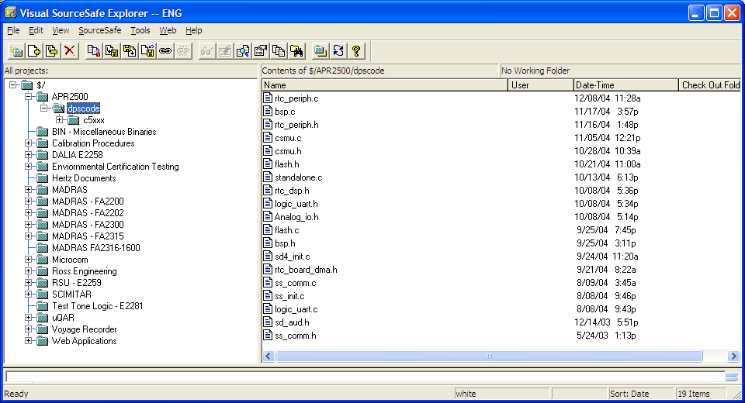

Problem Reporting Management System
The Problem Reporting Management System generates a unique database record for each problem report / improvement request. A PR can be created by anyone. Automatic email notification of PR adds modifications and closures. Safety related PR's are flagged. Status updates and assignments are restricted / secure.

Sample Screen Shot: PRMS
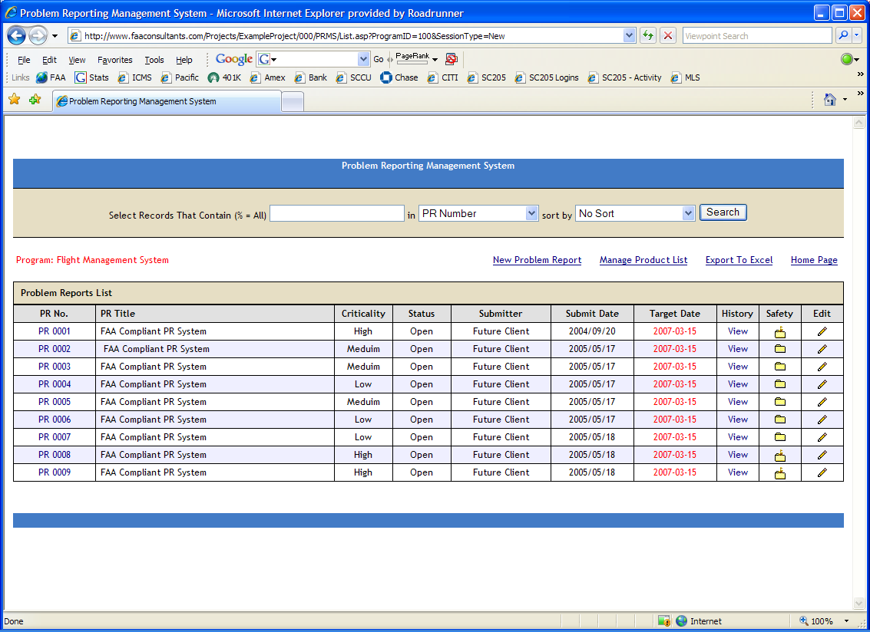

Sample Screen Shot: Problem Reporting Management System Detail

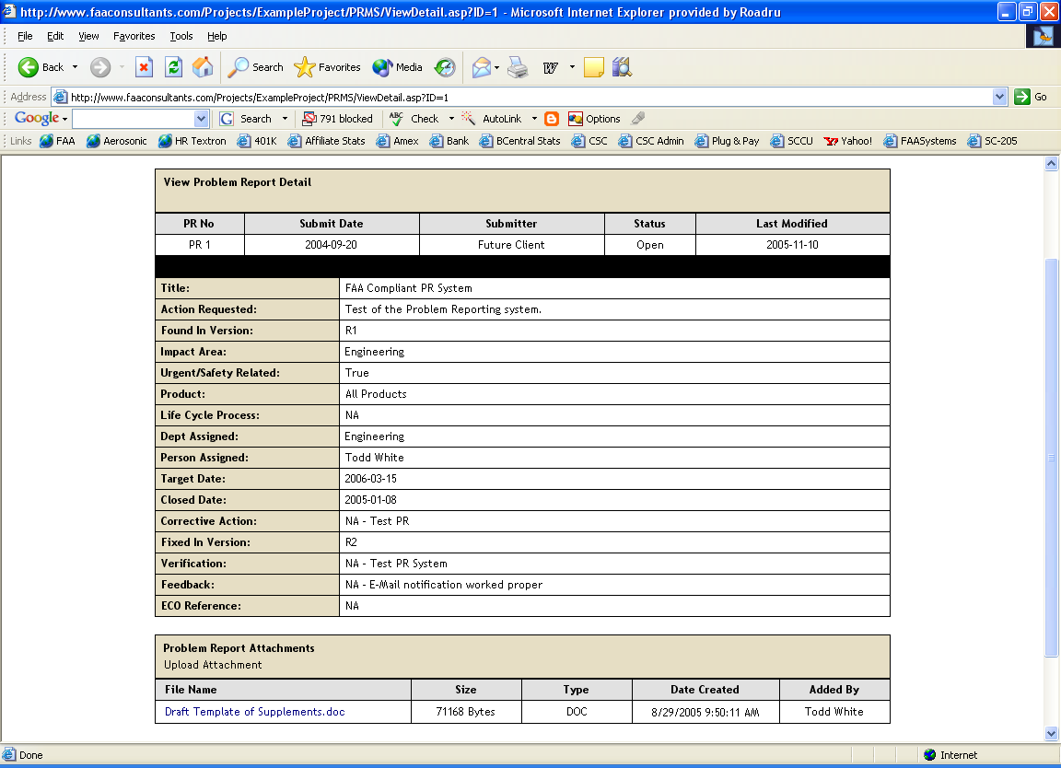

Change Order System
The Change Order System is the formal change approval, effectivity, and tracking system.

ACTIVITIES

Configuration Identification
Every hardware, software, and documentation configuration item has a unique identification number. In addition, every high-level, low-level, and derived requirement will have a unique identification number. With the exception of requirement numbers, identification numbers will be generated from and stored in the Item Master. Unique requirement numbers are generated by the RTMS tool. Revisions of documents will be maintained with sequential revision letters in the Status Accounting System; the first baseline version of a document will be a Rev. -, the second Rev A, and so on.
Source code and build files will be uniquely identified by name. CSCI's will be uniquely identified by both name and software part number. Note that the primary version number increments each time a new software version are introduced into production. This software part number is displayed on the Unit nameplate along with the Mod Status and RTCA/DO-178C Level. The Software Quality Engineer (SQE) verification baseline, referred to in this document as the Preliminary Product Baseline, will be identified with a unique internal version number and a checksum. Once SQE verification testing passes, that internal revision and checksum will be associated with the primary version (i.e., -01, -02, etc.) in the Visual Source Safe Label. Therefore, a unique identifier will exist for each artifact and component of the software system configuration, as well as for the software system configuration as a whole.
The information elements are incorporated into the system progressively as they are generated or as they are subjected to internal control as a result of a design freeze of approved baselines. A change of the primary version number (resulting from an approved software modification) creates a new software part number (i.e., PartNumber-01 to PartNumber-02). This new software part number is associated with a top level Model Number (i.e., TopLevelNumber-01) using the Bill of Material System. Details of the numbering schema and their hierarchical relationships are recorded in the Software Configuration Index Document.
Commercial-Off-The-Shelf (COTS) software, being composed of third party software, has a limited span of control. The commercial aspect of this software limits this control to assurance of the correct level of the commercial package being provided in support of the system. COTS Software is not used on this program. Note also that internally developed Reusable Software is not used on this program.
The software developed specifically in support of a program is designated and controlled as Unique Software. The Software Configuration Index (SCI) will identify, by use of the identification numbering, each Computer Software Unit (CSU) and Computer Software Component (CSC). The software contained in the CSCI represents the body of code being developed for and used by the program.
During verification testing, SCM assures that all files are properly identified and constructs the SCI, which describes the software that constitutes the CSCI. The software is bit-for-bit compared to assure that the proper files are controlled. Difference utilities provided by Visual SourceSafe are used, with the differences verified by the developers and QA. Checksums are also used for objects. Formal test builds are accomplished using controlled software.

Assignment and Construction of software document numbers

XXX-X XXXX-XX
| | | |
| | | |________Production Release Identifier
| | |______________Next Sequential Number
| |_________________Product Line Code
|_____________________Identification Prefix

The following generic codes (first, second, & third digits) are used to uniquely identify hardware and software design control documents.

Software Lifecycle Data

800 System Requirements Document
801 Plan for Software Aspects of Certification
802 Software Development Plan
803 Software Verification Plan
804 Software Configuration Management Plan
805 Software Quality Assurance Plan
806 Software Requirements Standards
807 Software Design Standards
808 Software Code Standards
810 Software Requirements Document
811 Software Design Document
820 Software Low Level Verification Cases and Procedures
822 Software System Verification Cases and Procedures & Results
822 Software System Verification Cases and Procedures & Results
823 Structural Coverage Analysis Results
830 Software Life Cycle Environment Configuration Index
831 Software Configuration Index
832 Software Accomplishment Summary

Software Packages

840 CSCI Package (Production Library Disk)
851 CSCI Package Images (Production Library Disk)
852 CSCI Binaries
854 Library Package
855 Web Site Sources

Miscellaneous Software Packages

882 Customer Purchased/Vendor Property Software Package
883 Customer Purchased/Vendor CD Rom Software Package

Product Line Code

The Product Line Code (fourth digit).

Next Sequential Number

The next sequential number (fifth, sixth, seventh, & eight digits) are obtained from the Engineering Release Notebook, which represents an allocation of numbers from the drawing number assignment record. Separate books are kept and maintained for various product lines and/or departments.

Production Release Identifier

The ninth and tenth digits shall be used for specifying the Production Release. For example:

00 = Initial Production Release
01 = Production Release
02 = Production Release

The first release of the product will begin with 00 as its initial production release.

Within Visual Source Safe a "Label" is applied to the software project. This label will reference Internal Release (I.R.) for baseline builds or "Release" (Rel) for production releases. A note will be applied with the Released label referencing the part number version and the revision level of the software.

Baselines and Traceability
Baselines are established at key transition points (identified below) and maintained in the Status Accounting System to ensure their integrity. Once a baseline is established, it is subject to formal CC1 change control procedures as defined later in this plan. Configuration Management procedures ensure that new baselines are traceable to the baselines from which the new baselines were derived.
Corresponding to certain Transition Reviews, the four baselines are used to effectively identify the system configuration throughout the software life cycle. The baselines are:
- Functional Baseline (Requirements Transition)
- Allocated Baseline (Detailed Design / Critical Design Transition)
- Development Baseline (Test Readiness Transition)
- Product Baseline (Conformity)
These baselines and the method used to ensure traceability between baselines are defined in the following sections.

Functional Baseline
This is the initial baseline build standard for the system, defined by the marketing requirements, where functions are specified in a descriptive manner and qualified by performance parameters. This is the starting point for establishing the engineering requirements level documentation and requirements traceability. The functional baseline is established at the end of the Requirements Process.
Step1: Review and Sign Life Cycle Documents
Step2: Check Documents into Visual Source Safe
Step3: Update Configuration Index Document
Step4: Check Configuration Index Document into Visual Source Safe
Step5: Create Visual Source Safe Label
The following configuration items are included in the functional baseline:
- Software Planning Documents
- (preliminary) Software Configuration Index
- Marketing requirements

Allocated Baseline
This is the documentation baseline used to define both the hardware and software configuration items. Documents identified in the allocated baseline have been “allocated” from system requirements defined in the Functional Baseline or are part of a higher-level configuration item. The allocated baseline is established at the end of the Design Process.
Step1: Review and Software Requirements and Design Documents
Step2: Release Documents into Status Accounting System
Step3: Create Preliminary Configuration Index Document
Step4: Create Visual Source Safe Label
The following configuration items are included in the allocated baseline:
- Software Planning Documents
- Software Requirements Specification
- Software Design Description
- (preliminary) Software Configuration Index

Development Baseline
The Development Baseline is a baseline used to perform design verification testing or to identify and baseline a red-label unit. The following diagram describes this process:

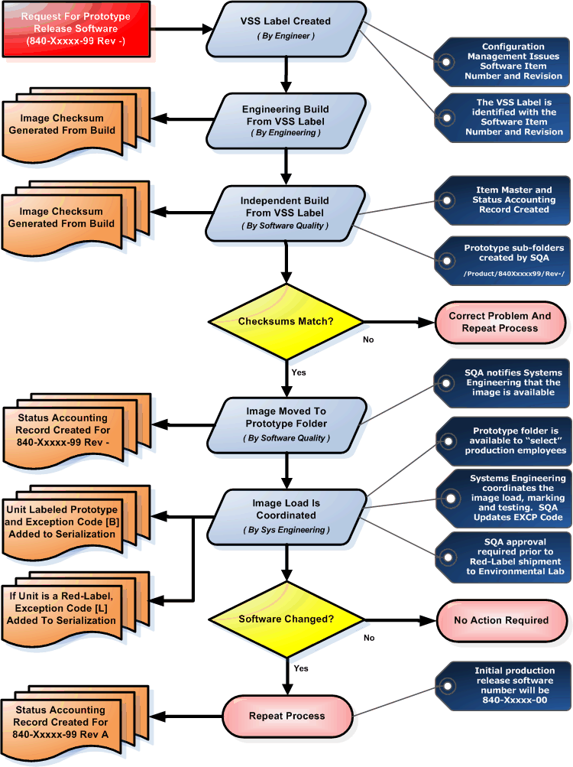

The following configuration items are included in the development baseline:
- Software Planning Documents
- Software Requirements Specification
- Software Design Description
- Source Code (including any COTS software)
- (preliminary) Executable Object Code
- (preliminary) Software Configuration Index

Pre-Release Software Identification and Tracking
Prior to formal release, software will be identified with a -99 designator. This provides the ability to create an Item Number for the software and track revision status in the Status Accounting System. The first production release will contain a -00 designator.
Once a unit is identified as pre-release, and prior to the pre-release software being installed, the Director of Systems Engineering will contact Software Quality, who will mark the serialization Exception Code of that unit with [ B ], identifying it as pre-production. This status is checked prior to shipment. A status of [ B ] ensures that the unit will not be shipped. In addition to the Exception Code designation, a note will be placed in the record indicating that the unit was delivered, and is being controlled by, Systems Engineering.
The Preliminary Product baseline also describes the detailed requirements of the approved Software Design Description (SDD) in a manner that can be used to begin software design. The approved SDD, authentication of supporting data will be accomplished. These include, but are not limited to, the assignment of the CSCI requirements to specific lower level CSCs; the overall information flow between software units, the methods by which each unit gains control, and the sequencing of units relative to each other; the detailed design characteristics of all interfaces, including their data source destination, and interface names and relationships; detailed characteristics of the database structure, including all files, records, fields and items; and access rules, such as how file sharing will be controlled, procedures for data recovery/regeneration from a system failure, rules for data manipulation, rules for maintaining file integrity, rules for usage reporting, and rules for governing the types and depth of access are defined within this baseline.
Under internal Engineering/CM control, this baseline evolves throughout the development cycle and represents the definition of the hardware and software at any stage of the development. As stated, the preliminary product baseline may be established at several points during the Coding Process. As such, this baseline represents an ongoing process as opposed to a static event.
Step1: Review and Sign Life Cycle Documents
Step2: Release Documents into Status Accounting System
Step3: Check Source Code into Visual Source Safe
Step4: Create Preliminary Configuration Index Document
Step5: Create Visual Source Safe Label
A Preliminary Product Baseline is always established prior to initiation of regression testing. This baseline represents the Engineering produced and integrated configuration of both the hardware and software. This baseline is otherwise known as the Quality Test Baseline.

Product Baseline
The Product Baseline is established upon successful completion of the QA Conformity Review. The Product Baseline is a final accumulation of requirements, design, and test documents, including completed Hardware Configuration Item (HWCI) and CSCI test reports. The Product Baseline is represented by the Plan for Software Aspects of Certification, Software Configuration Index Document and the Software Accomplishment Summary. This baseline is re-established each time a new release is implemented.
Step1: Update All Impacted Documents and Traceability
Step2: Check Source Code into Visual Source Safe
Step3: Review, Update, and Sign Life Cycle Documents
Step4: Update Software Verification Cases and Procedures with New Test Cases
Step5: Update Configuration Index Document
Step6: Create / Update Software Accomplishment Summary
Step7: Release Configuration Index Document and Software Accomplishment Summary
Step8: Create Visual Source Safe Label
Step9: Generate and Process New Software Release (Changing Dash Configuration)
Step10: Submit Formal Letter
Step11: Generate and Process Engineering Change Order
Step12: Update Technical Manuals and Issue Field Service Bulletin
The product baseline includes all configuration items identified in this SCMP.

Software Configuration Index
The Software Configuration Index will be prepared as a separate document for each software product or family of software products. The Software Configuration Index identifies the configuration of the software product. This document will include references to other software Lifecycle data to provide a complete view of the software configuration.

Software Environment Configuration Index
The Software Environment Configuration Index will be prepared as a separate document, associated with the Software Configuration Index. The Software Environment Configuration Index identifies the configuration of the software lifecycle environment, including both development and verification tools. This data will be included in the SCI document.

Requirements Traceability
Requirements traceability is maintained through the use of a Web based, on-line Requirements Traceability Management System (RTMS). See Section 2.3 of this document for sample screen shots of this system. The requirements traceability matrix is contained in the Software Requirements Document. Derived requirements are traced as necessary for decomposition (derived requirements, by definition, do not always trace upwards). All software requirements must be associated with one or more test cases. All test cases must be associated with one or more test procedures. Many-to-many relationships will be supported throughout. SCM coordinates changes to requirements, ensuring that new, changed, and/or deleted requirements flow back into the appropriate Lifecycle process.

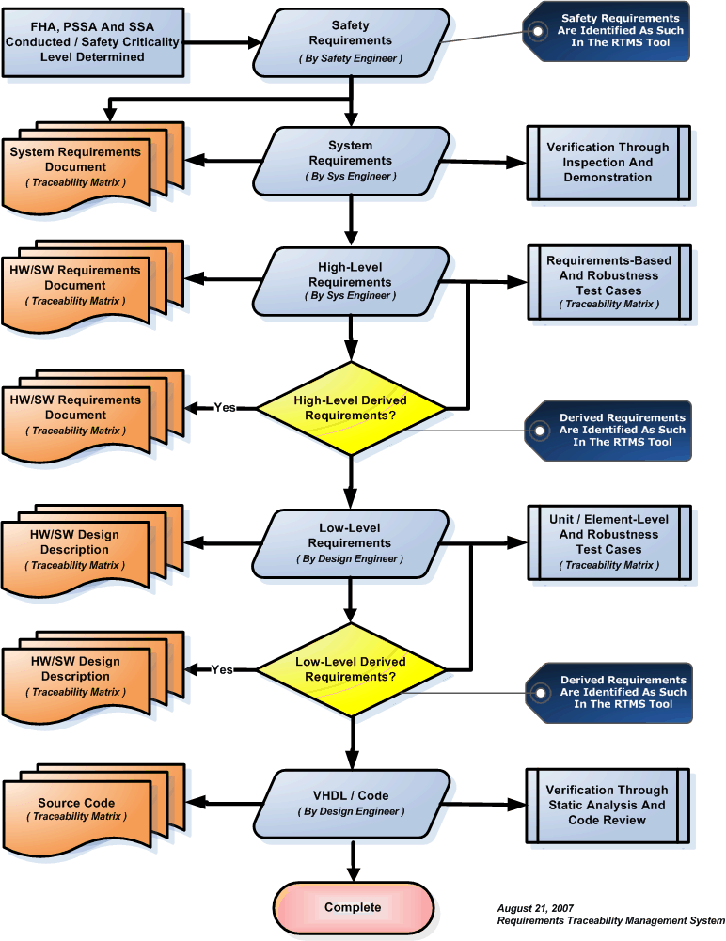

Problem Reporting

Summary of Problem Reporting Methods
Throughout the planning and development lifecycle, document comments, document redlines, action items, problem reports and corrective and preventive action requests will be generated and managed to closure and placed under CC2 control. Each of these methods forms part of the overall problem reporting process.

Finding Type | Doc  Comment | Doc  Redline | Action  Item | Problem  Report | Corrective Action | SQA Closure
CC1 Document Finding |  |  |  |  |  | Yes
CC2 Document Finding |  |  |  |  |  | No
Transition Review Finding |  |  |  |  |  | Yes
Peer Review Finding |  |  |  |  |  | No
SQA Process Finding Not requiring root-cause analysis |  |  |  |  |  | Yes
SQA Process Finding requiring root-cause analysis |  |  |  |  |  | Yes
Product bugs and Product Findings (following test baseline) |  |  |  |  |  | Yes

Problem Reporting Overview
Problem Reports written against the Software Documents are traced back to that document and are in the form of document review comments. These comments are recorded and tracked in the Document Review Management System and managed by the Project Engineer through closure. Comments provided by the Certification Authority are added to the Document Review Management System and managed to closure. On-going change control and change authorization is provided through the Configuration Management Process. The specific methods for document problem reporting are contained in the Software Configuration Management Plan.

Problem Reports related to software process transition objectives and process non-compliances, including the objectives and/or activities, are in the form of action items. These action items are recorded and tracked in the Reviews and Analysis Management System. The action items are traced to the specific transition phase affected by the problem report and managed by the Project Engineer through closure. Action Items provided by the Certification Authority are in the form of coordination correspondence (i.e., Engineering Coordination Memos) and are added to the Reviews and Analysis Management System and managed to closure. The specific methods for transition output and process deficiency problem reporting are contained in the Software Configuration Management Plan.

Problem Reports related to the software product are traced back to the software file and version. These Problem Reports are recorded and tracked in the Problem Reporting Management System and managed by the Project Engineer through closure. Comments provided by the Certification Authority are added to the Document Review Management System and managed to closure. On-going change control and change authorization is provided through the Configuration Management Process. The specific methods for document problem reporting are contained in the Software Configuration Management Plan.

The purpose of the problem reporting system is to provide a tool for anyone to report problems, deficiencies, non-compliances, or to recommend enhancements to the product. In addition, the reporting system provides a tool to track and record corrective or other action taken to implement the request. A Web-based, on-line Problem Reporting Management System (PRMS) is used for this effort. The PRMS is a relational database with a simple Web Interface. The system has two primary interfaces: a user interface and an implementer interface. The user interface is available to everyone on the team, and is used to initiate a PR (requesting action). The implementation interface access is limited to Authorized Administrators (users granted access by the QCMS administrator), and is used to document the PR investigation and resolution.

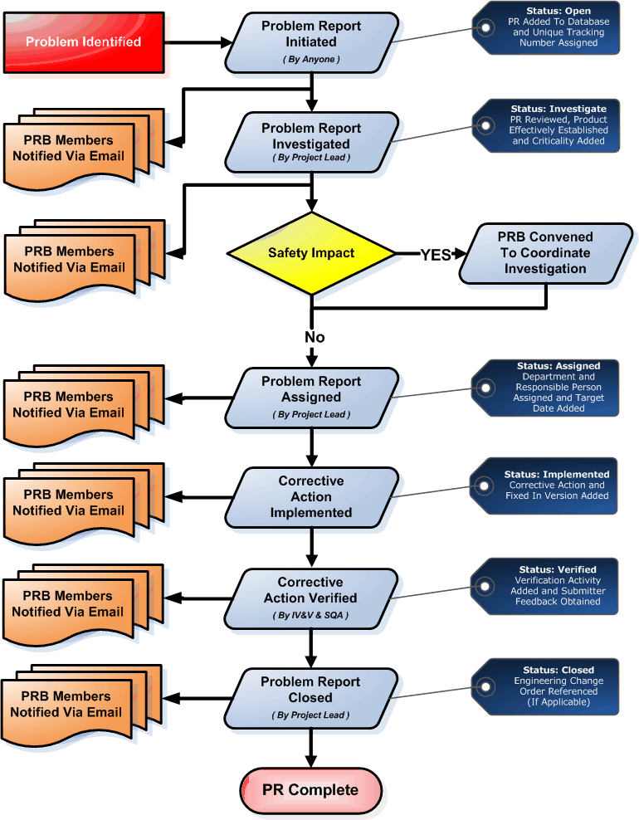

Problem Report Initiation
Problem reports are initiated from many sources. Some come from the product and process development teams. Some come from internal or external verification teams. Some come from customers. Once a Problem Report has been initiated, it is assigned a unique tracking and a status of Open. There are three types of Problem Reports:

Hardware or Software Bug Report
The purpose of a Bug Report is to report a product-specific non-conformity in the hardware or software. Bug reports are typically the result of formal and informal verification activities.

Corrective Action Request
The purpose of a Corrective Action Request is to eliminate the cause of an existing non-conformity, defect or other undesirable situation in order to prevent a recurrence.

Preventive Action Request
The purpose of a Preventive Action Request is to eliminate the cause of a potential non-conformity, defect or other undesirable situation in order to prevent a first occurrence.

Problem Report Investigation
In the Investigation process, the Problem Report is reviewed by the PRB for Product and Process impacts and assigned a Criticality Level. The investigation result will be a set of suggested actions to resolve the problem or possibly a problem report dismissal/rejection.

Critical
Subject does not function or critical aspects of the subject are not stable.
Customer, Manufacturing, Testing or Development process stopped.
Other conditions that are considered Critical severity:
- Management directive

High
Subject functions. However, invoking certain functions may cause error codes and/or require subject to be re-set before functioning. Other conditions that are considered high severity:
- Reliability is degraded
- High rejection rate in production

Medium
Subject functions and is fairly stable; a workaround exists for the problem. There may also be performance issues or missing non-critical functionality with otherwise stable operation. Other conditions that are considered medium severity:
- Rework or assembly issues

Low
Subject is useable and stable. Minor application and design issues.

Problem Report Assignment
The PR-Board (PRB) assigns the Problem to a specific department and individual for resolution, based on the suggested problem solution. The PR-Board also assigns a Target Completion Date. The QCMS tool provides Email notifications of PR assignments; and also provides mechanisms to list the Problem Reports by assigned individual, by originating individual or by status PR (open/resolved).

Corrective Action Implementation
During the implementation process, detailed analysis and testing is executed to evaluate, document and implement the precise changes selected to resolve the reported problem. If the implementation is targeted for a known product release, it is identified at this time. If the proposed change effects a production released product a Change Order must also be generated and approved by the Software Configuration Control Board (SCCB) to authorize changes to production baseline.

Corrective Action Verification
Following the implementation activities, an independent person or group is assigned to verify the implementation. (Note: independence is not required for this activity, but will be obtained, except where exceptions are justified.) The results of the verification activity are recorded in the Problem Report. This process will also include an interview with the Problem Report submitter to acquire feedback on the actual implementation.

Problem Report Closure
Once the PR is implemented and verified, it is closed according to the release level of the target:
- For PRs that affects a production released product configuration, the PR is listed on Engineering Change Notice (Release) Form. And, the PR lists the target Change Order.
- PRs that do not affect a production released product are closed within the PR record itself.
The Change Order is the tool used to authorize a change to affected areas (that is, Production Control, Manufacturing, and Quality Assurance). An Change Order is issued to authorize the changes indicated by a PR, so Change Orders may be considered subordinate change documents to PRs. Software changes are not fully closed until a change review is performed. The Change Order also records the effectivity of the change.

Open Problem Reports
Open Problem Reports against the Software Requirements are acceptable and may be proposed at certification if they do not affect safety. A tabulation of the Open Problem Reports is recorded in the Software Accomplishment Summary.

Acceptable Open Problem Report Types

Type 0: a problem whose consequence impacts safety.

Type 1: a problem whose consequence is a possible failure – under certain conditions- of the system; having no safety impact on the aircraft (this needs to be confirmed by the aircraft manufacturer). If agreed between aircraft manufacturer and supplier, this type should be divided into two sub-types:

- Type 1A: failure with a “significant” functional consequence; the meaning of “significant” should be defined in the context of the related system in agreement between aircraft manufacturer and equipment supplier (for instance “cockpit effect”).

- Type1B: failure with no “significant” functional consequence.

Type2: a fault which does not result in a failure (i.e.: no system functional consequence, fault not detectable by the crew in foreseeable operating conditions).

Type3: a problem which is not type 0, 1 or 2, but a deviation to the rules (plans or development standards, applicable CRI’s). If agreed between aircraft manufacturer and supplier, this type should be divided into two sub-types:

- Type 3A: a “significant” deviation whose effects could be to lower the assurance that the software or the CDD behaves as intended and has no unintended behavior

- Type3B: a non-“significant" deviation to the methodology (plans) that does not affect the assurance obtained.

Type 4: a problem which affects documentation only. Type 4 problem reports are used to record document issues that do not affect compliance to regulations, process, or requirements.

Unacceptable Open Problem Report Type

Unacceptable open problem reports include a problem whose consequence is a possible failure (under certain conditions) of the system with a safety impact. These Problem Reports are Classified Type 0.

Change Control
Formal changes are initiated from one or more approved Problem Reports and/or from other external sources. The objective of change control is to provide for recording, evaluation, resolution, and approval of changes throughout the product Lifecycle. For this program, change control will preserve the integrity of the configuration items and baselines by providing protection against unauthorized changes. All changes to items under configuration control are recorded, approved, and tracked.

Relationship Between Problem Reports and Change Orders

The following diagram illustrates the relationship between the Problem Reporting System formal change control process.

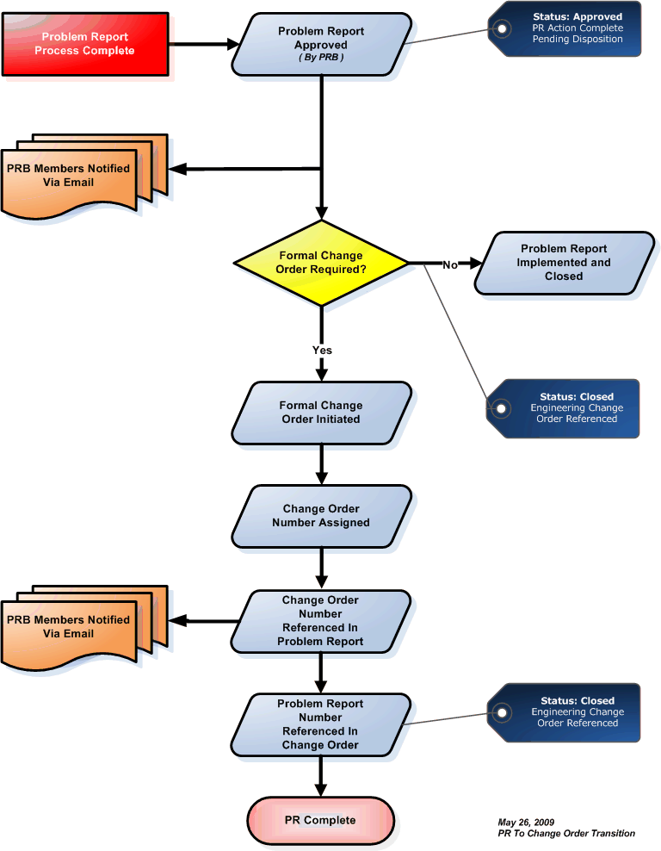

Engineering Change Order Process Flow

The following diagram illustrates the change control process. The steps illustrated on the diagram are detailed below.

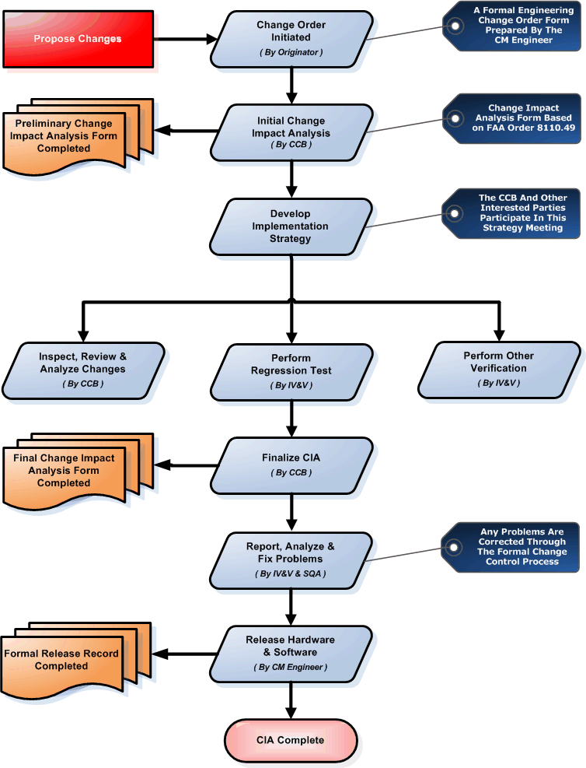

Propose Change(s)
The first step of the change process is to identify the proposed change(s). The proposed changes may be written to request replacement of obsolete parts, fix bugs found in the design, add new features, or to modify existing features.

Perform Change Impact Analysis
All changes (both hardware and software) scheduled to be integrated into the Product Baseline are reviewed by the Configuration Control Board to determine if they are technically possible, financially feasible, and/or necessary to meet customer requirements. Each change is initially assessed to determine whether it will be implemented, deferred, or closed with no action. Considerations for technical feasibility, safety, cost, and customer satisfaction weigh heavy in the decision. Initial change impact analysis is used as a vehicle to help with this assessment. Each change is analyzed to determine the potential impact. There are many components of the change impact analysis. Some of the analysis can be done roughly to initially determine the feasibility of the change, but should be repeated after the software change is implemented to assure the original performance, safety, and resource constraints have not been compromised.
The change impact analysis process addresses the items below. The items fall roughly into two categories: performance-related analysis and safety-related analysis.
The following items are related to the overall performance characteristics of the system:
- Traceability analysis to identify the requirements, design elements, code, test cases, and procedures that may be either directly or indirectly affected by the change. Forward traceability of changes identifies design components affected by the change. Backward traceability helps determine other design features and requirements that may be inadvertently affected by the change. Overall, the requirements traceability helps determine the impact of change on the software project.
- Memory margin analysis to assure that the memory allocation requirements are not altered, the original memory map is maintained, and adequate memory margins are maintained.
- Timing margin analysis to assure that the original timing requirements, central processing unit (CPU), task scheduling requirements, system resource contention characteristics, and interface timing requirements are met and adequate timing margins are maintained.
- Data flow analysis to identify any adverse affects due to changes in data flow and coupling between and within components. In order to perform the data flow analysis, each variable and interface affected by the change should be analyzed to assure that the original initialization of that variable is still valid, that the change was made consistently, and that the change does not affect any other usage of that data element. This can be a costly and difficult process, if large global sections are used.
- Control flow analysis to identify any adverse effects due to changes to the control flow and coupling of components. Task scheduling, execution flow, prioritization, and interrupt structure are examples of the items that should be considered.
- Input/output analysis to assure that the changes have not adversely impacted the input and output requirements of the product. Things such as bus loading, memory access, throughput, hardware input, and output device interfaces should be considered.
- Development environment and process analyses to identify any change(s) that may adversely impact the software product (e.g., compiler options or versions and optimization change; linker, assembler, and loader instructions or options change; or software tool change).
- Operational characteristics analysis, such as evaluation of changes to displays and symbols, performance parameters, gains, filters, limits, data validation, interrupt and exception handling, and fault mitigation to assure that there are no adverse affects.
- Certification Maintenance Requirements (CMR) analysis to determine whether new or changed CMRs are necessitated by the software change. During the original certification of an aviation product, CMRs are identified. For example, the brakes may need to be inspected after 100 landings. If a change to software affects a CMR, it should be addressed during the change process.
- Partitioning analysis to assure that the changes do not impact any protective mechanisms incorporated in the design. If architectural means are employed as part of the partitioning scheme, the change must not affect those strategies. For example, data should not be passed from a less critical partition to a more critical partition.
The change impact analysis also assesses whether the change could adversely affect safe operation of the system or product. The following areas are reviewed to determine if there is an adverse impact on safety or operation and are addressed during this process:

- Safety-related information is changed.
- Operational or procedural characteristics are changed in a manner that could adversely affect flight safety as a result of the software change.
- New functions or features are added to the existing system functions that could adversely impact flight safety or could affect the basis for the original certification approval.
- Processors, interfaces, and other hardware components of the operational environment are changed in such a way that safety or the software could be adversely affected. An international Certification Authorities Software Team (CAST) paper entitled, “Guidance for Assuring the Software Aspects of Certification when Replacing Obsolete Electronic Parts Used in Airborne Systems and Equipment,” provides additional guidance for assessing hardware changes that could affect software.
- Software life cycle data (e.g., requirements, design, code, architecture, or test cases/procedures) is significantly changed in such a way that it could adversely affect safety. This analysis is facilitated when safety-related software requirements are identified and a safety assessment is maintained.
Change impact analysis will document software life cycle data (e.g., requirements, design, architecture, source and object code, test cases and procedures) affected by the change and verification activities (e.g., reviews analyses, inspections, tests) needed to assure that no adverse affects on the system are introduced during the change.

Develop an Implementation Strategy
Once software changes to be implemented into a previously developed baseline are identified, an implementation strategy is developed and executed. The implementation strategy specifies the change process, software life cycle data to be updated, activities to be implemented, resources needed, schedules to be applied, etc.
All software modifications are handled like “mini-developments”. Plans are established for development, software quality assurance, software configuration management, and verification/testing. Once the plans are established, the changes are implemented following those plans.
The implementation strategy also describes the verification activities that will be needed to verify the changes and to verify that there are no adverse effects on the system. The change impact analysis addresses how changes which could adversely affect performance or safe operation of the system or aircraft will be verified, such that the changed and unchanged software will continue to satisfy their requirements for safe operation. These verification activities may include reviews, analyses, regression testing, requirements-based testing, bench testing, etc., including re-evaluation of existing analyses, re-execution of existing tests, and new test procedures and cases (for added functionality or previously deficient testing).
Additionally, the implementation strategy describes the resources needed to perform and assure the changes, the schedule for changes and verification activities, the software life cycle data to be updated, and any other programmatic details needed for success.

Implement Changes
The implementation of software changes follows the documented plans. During the actual implementation of changes, there may be additional issues identified. These might require modification to the change impact analysis or plans.
As stated above, changes will be grouped and scheduled as multiple software changes. To assure correctness of each change, each change is verified both individually and as a part of the overall system.

Verify Changes
Once the changes have been implemented, they are verified. Verification includes reviews, inspections, walkthroughs, analyses, and tests of software. The verification process is divided into three tasks. These tasks are detailed below:

Inspect, Review, or Analyze Changes
This task includes many of the non-testing aspects of the verification process (i.e., reviews, analyses, inspections, and walkthroughs). In this task, the software life cycle data (e.g., requirements, design, architecture, code, test cases, and procedures) are reviewed for accuracy and consistency.

Perform Regression Testing
Regression testing is another aspect of the verification process that is addressed when software changes. Software progresses through several versions before one is ready for release. Regression testing is performed on each version of software. Any specific change can (a) fix only the problem that was reported, (b) fail to fix the problem, (c) fix the problem but adversely affect some other function or aspect that was previously working, or (d) fail to fix the problem and adversely affect something else. Since it is not always possible to re-run every test on every version of software, analysis is used to determine which tests should be run on the interim versions. The following “types” of tests are performed during the regression testing process:

- Bug verification tests – executed to verify that the fix for a bug addresses the problem and doesn’t introduce additional problems.
- Build acceptance tests – tests executed to make sure that a build is ready to go to the test team.
- Regression test run with a regression test suite – running regressions tests that have been automated.
- Regression test run for closed bugs – rerunning the regression tests even after the bugs have been “fixed”. Includes robustness tests.
- Regression test run without a test suite – manually running regression tests. Includes robustness tests.
It is standard practice that the most important tests are run first in order to quickly validate operation and assess risks. In some cases, regression testing may be run in parallel with other development activities. Generally, a test that has passed twice should be considered as regressed, unless the code has been frequently changed. A test that has failed once should not be re-executed unless the developer informs the test team that the defect has been fixed.
For tests that have already passed once, the second execution is reserved for the final regression pass, unless frequent changes to the code indicate otherwise. In every case, the change impact analysis must lead to a set of regression tests that are unique to the set of changes being proposed. All of these identified regression tests are run on the final version of the software prior to release.

Perform Other Verification
In addition to the inspections, reviews, analyses, and regression testing, other types of verification activities are performed. Some of these activities are performed at the software level, some at the system level, and some at the integrated system level. For example, requirements-based tests, acceptance tests, bench tests, structural coverage analysis, etc. may need to be performed. These additional verification activities will vary, depending on the extent of the change and the function(s) affected. In all cases, these tests are planned after the change impact analysis is performed and agreed upon.

Finalize Change Impact Analysis
Early in the change process, it is impossible to fully evaluate the impact of the software changes. Therefore, once the changes have been implemented and verified, the change impact analysis is finalized. This review is performed by scheduling a Configuration Control Board meeting.
Updates to the change impact analysis are fed back into the change control process where appropriate.

Report and Analyze Problems
Each problem discovered during the previous steps is documented in a formal Engineering Change Order. The Engineering Change Order includes a place to identify affected documents, problem analyses, and proposed resolution.

Address Problems
All problems documented in an action request are addressed in some manner. The problem can be fixed or determined to have no safety, performance, or operational affects. It is unacceptable to finish a project with open action requests.

Fix Problems, As Required
As mentioned above, all problems are fixed and go through the change control and verification processes.

Release Hardware & Software
Once the necessary changes have been implemented, problems have been addressed, software has been re-verified, and documentation has been updated, the software is ready for production release.

Certification Authority Change Notification

Major and Minor Modifications
Notification of change to the FAA is an essential part of the change control process. The determination of Major or Minor change results from the Change Impact Analysis process. Guidance for the Change Impact Analysis process is found in FAA Order 8110.49, Chapter 11.
Major Modification
<Example Paragraph for TSOA products>
Per FAR Section 21.619, any design change by the manufacturer that is extensive enough to require a substantially complete investigation to determine compliance with a TSO is a major change. Before making such a change, the manufacturer will assign a new type or model designation to the article and apply for an authorization.
<Example Paragraph for Non-TSOA products>
Per FAR Section 21.93, any design change by the manufacturer that is extensive enough to have an “appreciable effect on the weight, balance, structural strength, reliability, operational characteristics, or other characteristics affecting the airworthiness of the product” is a major change. Before making such a change, the manufacturer will assign a new type or model designation to the article and apply for an authorization.
See Minor Changes for the Change Impact Analysis and change notification process. Note that the process for a Major modification is identical to the process for a Minor Modification with the exception that the FAA Atlanta Aircraft Certification Office (Certification Authority) has approval authority over Major changes.
Minor Modification
<Example Paragraph for TSOA products>
Per FAR Section 21.619, a manufacturer of an article under an authorization issued under this part may make minor design changes (any change other than a major change) without further approval by the FAA Administrator. In this case, the changed article keeps the original model number (part numbers may be used to identify minor changes) and the manufacturer will forward minor change approval notice to the Certification Authority.
<Example Paragraph for Non-TSOA products>
Per FAR Section 21.93, a manufacturer of an article under an authorization issued under this part may make minor design changes (any change other than a major change) without further approval by the FAA Administrator. In this case, the changed article keeps the original model number (part numbers may be used to identify minor changes) and the manufacturer will forward to the Certification Authority.
The Software Quality Engineer is responsible for:
- Completion of the Request for Software Modification.
- Completion of the Change Impact Analysis Checklist.
The Vice President of Engineering and the Director of Quality Assurance are responsible for:
- Review the Request for Software Modification.
- Review Justification for Software Modification.
- Determine Concurrence of Software Modification.
The SQE performs and validates the software modification as described on the Change Order. The following analysis is performed prior to final determination of modification type. See Section 3.4.2 for a complete Change Impact Analysis description.
- Analysis performed to ensure requirements remains completely and accurately implemented and fully verified.
- Analysis performed to ensure memory allocation requirements are maintained.
- Analysis performed to ensure the timing requirements, CPU task scheduling requirements, system resource contention characteristics, or interface-timing requirements are maintained.
- Analysis performed to identify changes to flow and coupling.
- Analysis performed to ensure that the change(s) have not impacted the I/O (bus loading) requirements established for the product.
- Analysis performed to identify software requirements; software architecture and safety-related software requirements impacted by the change.
- Analysis performed to identify the software components impacted by the change.
- Analysis performed to identify change(s) that may adversely impact the software product (i.e. compiler options and optimization, tool qualification).
- Identify documentation requiring changes other than code.
- Identify change(s) that may affect operation characteristics (i.e. gain, filter and limit changes, sensed data validation, and fault annunciation).
- Identify all feature(s) or function(s) that are being added.
- Identify specific test procedures and cases that will be needed to be re-executed to verify the changes, new test procedures and cases (for added functionality or previously deficient testing), and that there are no adverse effects (regression testing).
- Identify any other areas of analysis that are appropriate and not mentioned above.
The Program Manager officially notifies the Certification Authority of the Software Modifications by submitting a formal letter. Note that prior to the letter being sent, it is typical that initial contact is established with the customer and/or Certification Authority, whether in person or by telephone, to inform them that a modification is being proposed.
The minimal submittal package consists of the Plan for Software Aspects of Certification, Software Configuration Index, and Software Accomplishment Summary. The software modification letter and associated technical documentation is archived and maintained for the product life. In addition, the Change Impact Analysis Report is provided, justifying the modification level proposed.

Change Review
The objective of change review is to ensure that problems and changes are assessed, and either approved or disapproved. Approved changes are implemented and feedback is provided to affect processes through problem reporting and change control methods defined during the product planning process. For this program, change review activity includes confirmation that affected CIs are identified, assessment of the impact on critical requirements is accomplished, assessment of problems or other proposed changes is accomplished, and that decisions for action taken and feedback of problem report or change impacts are recorded.
Change review is accomplished either within Engineering or, for changes impacting products and product releases, a Configuration Control Board (CCB) is convened to review proposed changes. Each review includes, but is not limited to, the evaluation of technical approach, necessary schedule changes, impacts to other program's activities, and alternatives. Actions are assigned as necessary and problems resolved in an orderly and timely manner. For CCB activity, the agendas and minutes are recorded and maintained by the QA Organization.

Configuration Status Accounting
The objective of Status Accounting is to provide data for the configuration management of the Lifecycle process with respect to configuration identification, baseline development and release, problem and enhancement reporting, and change control. This activity includes, but is not limited to, reporting on configuration item identification, baseline identification, problem and enhancement implementation status, change history, and release status.
Configuration Management Status Accounting and the SCI are the recording activities of CM. It is concerned with relating fully approved changes to drawings, specifications, and other baselined documentation. During the configuration identification process, the CSUs are accounted for using naming conventions established by Software Engineering, in conjunction with procedures identified in the Software Development Plan. Several systems are used to accomplish status accounting. Specific systems used during the status accounting process are as follows:

Material Control System (Item Master)
The purpose of the Item Master is to record the unique identity of each configuration item and maintain pertinent information relating to each unique identity. See Section 2.3 of this document for sample screen shots of this system.

Item Number | Description | Rev | Rev Date
123456 | Some item | C | 01-01-2011
123457 | Some other item | A | 02-02-2011

Status Accounting System (Visual Source Safe )
The purpose of the Status Accounting System is to record and report the as-designed revision and change status of each configuration item and its associated technical documentation. Both the Status Accounting System and Visual Source Safe are used for this task. See Section 2.3 of this document for sample screen shots of these systems.

Item Number | Rev | Rev Date | Change Source
123456 | - | 01-01-2011 | New Release
123456 | A | 02-02-2011 | DCN 13579
123456 | B | 03-03-2011 | DCN 26897

Bill of Material (BOM) System
The purpose of the BOM is to generate and maintain hierarchical lists that fully identify High-Level CIs and Low-Level CIs (See Section 4.2 of this document). The BOM lists all assemblies and subassemblies, including components/piece parts required to build the product. In addition, the BOM is used to link impact documents (documents that are likely to change when its associated assembly or subassembly changes) to their associated assemblies. Once a BOM is approved, it is released into the Status Accounting System and controlled by SCM.

Software Configuration Index
The Software Configuration Index (SCI) identifies the baselined configuration of the software.
For this program, the SCI will identify the:
- Software product
- Executable object code
- Each source code component
- Software Lifecycle data
- Archive and release media
- Reference to instructions for building the executable object code (including instructions and data used for compiling and linking and the procedures to recover the software for regeneration, testing, or modification)
- Reference to the Lifecycle Environmental Configuration Index
- Data integrity checks for the executable object code, if applicable.

Software Environment Configuration Index
QA will prepare a Software Environment Configuration Index (SECI). The SECI identifies the configuration of the software Lifecycle environment. The index identifies the software Lifecycle environment hardware and software operating system. The SECI identifies the software development tools and Automated Test Equipment (ATE) tools. The SECI identifies any qualified tools and their associated qualification data. For this program, the SCI and SECI will be separate documents.

Archive, Retrieval, and Release
The objective of the archive and retrieval activity is to ensure that the product's Lifecycle data can be retrieved in case of the need to duplicate, regenerate, retest, or modify the product. The objective of the release activity is to ensure that only authorized product CIs are used, especially for manufacturing, in addition to being archived and retrievable.

Archive and Retrieval Process
Standard backup archive and retrieval processes will be followed during development. These procedures will ensure that all of the Software Life Cycle Data is archived to a tape or CD using Microsoft Backup for Windows NT archival system. At a minimum, archival will be done weekly and after each release. To ensure that the archival data is complete and accurate the following will be performed.
- Two copies of each release archival will be created.
- Each tape or CD will be verified, at creation, as valid and password protected. The final release will be installed, for verification purposes, on a machine that has been formatted and Windows NT installed.
- One tape or CD will be stored on the premises in a secure location.
- One tape or CD will be stored off-site in a secure location.
- The archival tapes will be regenerated every four years, by Alternative Avionics, to ensure the integrity of the media and data.
Each tape or CD will have a label with the following information:
- Date Created
- Version number of the of the release (if applicable)
- Description of what is on the tape or CD.
The archive process will archive the following software life cycle data:
- Software Plans & Standards
- Software Requirements Document
- Software Design Document
- Traceability data
- Software Verification Cases and Procedures
- Review Records
- Source Code
- Build Procedures
- Load-Control Procedures
- PRS Database
- CMS Database
- Executable Code as applicable
- Log of what is on the tape or CD. For final release, an installable or bootable version of the operating system and all development and verification tools, defined in the SECI, must be included.

Software and Document Release
All software is identified and formally released prior to use for manufacture. Once the release is authorized (independent build by SCM, complete verification testing and approval by SQA), the software is formally "Labeled" in the automated version control tool, Visual SourceSafe. This Label is associated with the build checksum(s) and represents the release baseline of the Executable Object Code.
Visual SourceSafe is a version control system for team development of software applications. This version control systems tracks and stores changes to all software files so developers can review a file's history, return to earlier versions of a file, and develop programs concurrently. Visual SourceSafe does this using reverse delta technology, and stores only the changes to a file, not each complete version of the file itself.
One Visual SourceSafe Project will be established for this program. A project is a collection of files stored in the Visual SourceSafe tool. Organizing code in a Visual SourceSafe Project is similar to organizing files in directories. The manner in which the project is set up and the subprojects beneath it mirrors the directory structure of an operating system. With Visual SourceSafe, one file can simultaneously exist in many projects. This tool also maintains multiple versions of a file, including a record of the changes to the file from version to version. Version control addresses team coordination making sure, by default, that only one person at a time is modifying a file, to prevent accidental replacement of another user's changes.
As with software, all approved documents are identified by unique numbers and formally released into the Status Accounting System before use for development or manufacture.

Software Load Control
The objective of load control is to ensure that the executable object code is loaded into the airborne system or equipment with appropriate safeguards. Software load control refers to the process by which data and programmed instructions are transferred from a master memory device into the airborne system or equipment. Load control procedures are followed during QA Verification and Regression testing (See System Verification Cases and Procedures document). Load control is performed using the verified load control procedures throughout the life of the system.

Software Life Cycle Environment Controls
The objective of software life cycle environment control is to ensure that the tools used to produce and verify the software are identified, controlled, and are retrievable. The software life cycle environment tools are initially defined in the Software Development Plan and Software Verification Plan. The list is then finalized in the Software Life Cycle Environment Configuration Index (SECI) prior to formal certification testing.
The tools identified in the SECI are subject to the appropriate SCM controls. The tools used to develop and control the software/firmware is COTS, provided by carefully selected vendors. As such, the software, along with its build environment, is formally released.
Development and verification tool versions are verified during creation and review of the SECI. Verification tool versions are further verified during the test setup review during formal verification.
Hardware platforms required to run specific tools will be preserved as necessary as a component of the SECI preparation and review process.

Software Lifecycle Data Controls
Lifecycle data is assigned one of two Control Categories. Control Category 1 (CC1) and Control Category 2 (CC2). These control categories are related to the configuration management controls placed on the lifecycle data. The following matrix defines the set of process objectives assigned to each Control category.

SCM Process Objective | - Reference | CC1 | CC2
Configuration Identification | 7.2.1
Baselines | 7.2.2a, b, c, d, e
Traceability | 7.2.2f, g
Problem Reporting | 7.2.3
Change Control – integrity and identification | 7.2.4a, b
Change Control - tracking | 7.2.4c, d, e
Change Review | 7.2.5
Configuration Status Accounting | 7.2.6
Retrieval | 7.2.7a
Protection against Unauthorized Changes | 7.2.7b(1)
Media Selection, Refreshing, Duplication | 7.2.7b(2), (3), (4), c
Release | 7.2.7d
Data Retention | 7.2.7e

All of the SCM process objectives described in this document and listed in the table apply to CC1 data. Because the process criticality of CC2 documents is lower, CC2 documents are allowed to be handled with slightly less stringent controls. Specifically CC2 documents are not required to meet the Baselines, Problem Reporting, Change Control – tracking, Change Review, Configuration Status Accounting, Media Selection, Refreshing, Duplication and Release objectives. However, with the advent of universal electronic lifecycle document storage, and Version Control Systems the cost of establishing baselines, configuration status accounting, media Maintenance and release are significantly reduced, such that it is easier to include CC2 documents in these systems than to exclude them. And this is how this SCM plan has been defined.
Within this project, the differences CC2 vs. CC1 document handling are:
- Problem Reports must be generated before Product Released CC1 documents are modified.
- A Change Order (authorization) must be generated and approved before Product Released CC1 documents are modified.
- All CC1 documents will be individually signature approved by SQA, Engineering and Management. The SCMP also requires a signature from SCM management due to its configuration management specific content.
- SQA Auditing of baselines and configuration status accounting may be limit to CC1 items.
- Change control tracking and review may be limited to CC1 items.

Control Categories Associated with Lifecycle Data
Applicable Control Categories are identified with their associated lifecycle data in Section 5.

Transition Criteria
Software Configuration Management is an integral process. It begins during the Planning process and continues throughout the software life cycle. Putting work products under configuration control too early or too late in a process can result in unnecessary costs: too early and the cost of change control can become excessive, too late and the uncontrolled changes can lead to rework. At the very least, controls must be placed on work products prior to review or test to establish review and test baselines. The following lists the minimum transition criteria for establishing and controlling the baselines:

SCM transition criteria for Plans and Standards Release

- Planning documents have been reviewed and approved
- Standards have been reviewed and approved
- Signature authority has signed each document
- Review evidence is under CC2 control

SCM Transition criteria for control of the Plans and Standards

- Changes have been recorded (in problem reports for CC1 changes)
- Changes have been authorized and verified

SCM Transition criteria for establishment of the Functional Baseline

- Software requirements documents have been reviewed and approved
- Signature authority has signed each document
- Review evidence is under CC2 control

SCM Transition criteria for control of the Functional Baseline

- Changes have been recorded (in problem reports for CC1 changes)
- Changes have been authorized and verified

SCM Transition criteria for establishment of the Allocated Baseline

- Software design documents have been reviewed and approved
- Signature authority has signed each document
- Review evidence is under CC2 control

SCM Transition criteria for control of the Allocated Baseline

- Changes have been recorded (in problem reports for CC1 changes)
- Changes have been authorized and verified

Transition criteria for establishment of the Development Baseline

- Source Code and EOC has been reviewed and approved
- Review evidence is under CC2 control

SCM Transition criteria for control of the Development Baseline

- Changes have been recorded (in problem reports for CC1 changes)
- Changes have been authorized and verified

Transition criteria for establishment of the Product Baseline

- Baseline documents have been reviewed and approved
- Signature authority has signed each document
- Review evidence is under CC2 control

SCM Transition criteria for control of the Product Baseline

- Changes have been recorded (in problem reports for CC1 changes)
- Changes have been authorized and verified

SOFTWARE CM DATA
SCM data consists of the software life cycle data produced by the SCM process. This includes, but may not be limited to, SCM Records, the Software Configuration Index and Software Environment Configuration Index. Documents are verified and release authorization is obtained using the Document Review Management System, as described below.

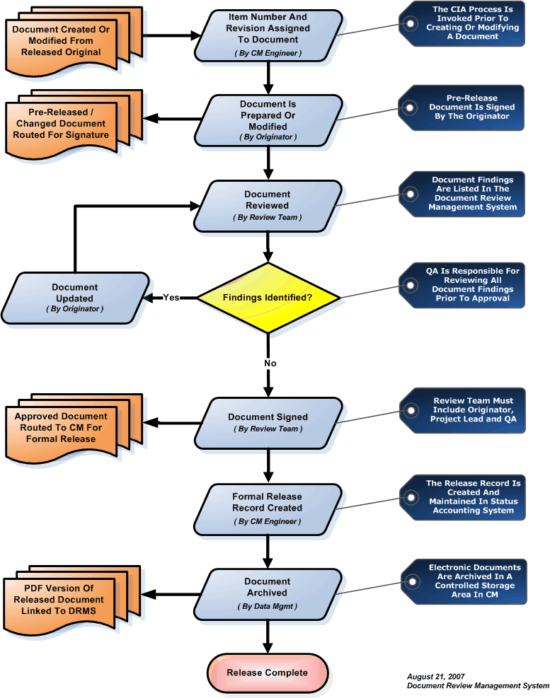

SCM Records
The following table details the SCM data associated with the software development effort.

Data Description | 178B Ref | Abbr. | Control Category | Availability
Plan for Software Aspects of Certification | 11.1 | PSAC | CC1 | Submit to FAA
Plan for Software Aspects of Certification | A liaison document, the PSAC will describe the proposed development methods to the certification authority for agreement, and defines the means of compliance with DO-178C.
Software Development Plan | 11.2 | SDP | CC2 | On File in CM
Software Development Plan | Defines the software Lifecycle and software development environment.
Software Verification Plan | 11.3 | SVP | CC2 | On File in CM
Software Verification Plan | Defines the means by which the software verification process objectives will be satisfied.
Software Configuration Management Plan | 11.4 | SCMP | CC2 | On File in CM
Software Configuration Management Plan | This document, which defines the means by which the software configuration management process objectives will be satisfied.
Software Quality Assurance Plan | 11.5 | SQAP | CC2 | On File in CM
Software Quality Assurance Plan | Defines the means by which the software quality assurance process objectives will be satisfied.
Software Requirements Standards | 11.6 | SRS | CC2 | On File in CM
Software Requirements Standards | Defines the methods, rules, and tools to be used to develop the high-level requirements.

Data Description | 178B Ref | Abbr. | Control Category | Availability
Software Design Standards | 11.7 | SDS | CC2 | On File in CM
Software Design Standards | Defines the methods, rules, and tools to be used to develop the software architecture and low-level requirements.
Software Code Standards | 11.8 | SCS | CC2 | On File in CM
Software Code Standards | Defines the programming languages, methods, rules, and tools to be used to code the software.
Software Requirements Specification | 11.9 | SRS | CC1 | On File in CM
Software Requirements Specification | Defines the system requirements allocated to software: the high-level software requirements. In addition, describes derived high-level software requirements necessary to describe a complete and coherent software system.
Traceability Matrix | 11.21 | TM | CC2 | On File in CM
Traceability Matrix | Defines the traceability among the system level requirements, the high-level software requirements, the code, and the test cases and procedures. This data will be stored within a Microsoft Access database.
Software Design Description | 11.10 | SDD | CC2 | On File in CM
Software Design Description | Defines the software architecture and the low-level requirements that satisfy the high-level software requirements.
Source Code | 11.11 | N/A | CC1 | On File in CM
Source Code | The CMS database that controls the source and builds files. Production release baselines will be stored on archive media, which is identified by the SCI.

Data Description | 178B Ref | Abbr. | Control Category | Availability
Executable Object Code | 11.12 | N/A | CC1 | On File in CM
Executable Object Code | The executable object code image that will be used in the production environment. The production release baseline will be stored on archive media, which is identified by the SCI.
Development Environment | 11.11 | N/A | CC1 | On File in CM
Development Environment | An archive with the development environment. The SECI will list the storage location, file compression technique (if used), filenames, size, and last update of the development environment used to generate the executable image. This environment will include the associated operating system and registry files.
Verification Environment | 11.11 | N/A | CC1 | On File in CM
Verification Environment | An archive with the verification environment. The SECI will list the storage location, file compression technique (if used), filenames, size, and last update of the verification environment used to verify the software configuration. This environment will include the associated operating system and registry files.
Software Build Procedures | 11.11 | N/A | CC1 | On File in CM
Software Build Procedures | Describes or automates the process of compiling and linking the software.
Load Control Procedure | 11.11 | MLCP | CC1 | On File in CM
Load Control Procedure | Describes the procedure used to load the primary executable software onto the target hardware.

Data Description | 178B Ref | Abbr. | Control Category | Availability

Data Description | 178B Ref | Abbr. | Control Category | Availability
Software Verification Cases and Procedures | 11.13 | SVC&P | CC2 | On File in CM
Software Verification Cases and Procedures | Details how the software process activities are implemented. Includes the test environment setup, test cases and procedures, and analyses performed in verifying the software configuration.
Software Coverage Analysis Report | 6.4.4.2 | N/A | CC2 | On File in CM
Software Coverage Analysis Report | Documents the software structural coverage analyses performed.
Software Verification Results | 11.14 | SVR | CC2 | On File in CM
Software Verification Results | Documents the results of the verification activities, including test results, analyses results, and review results.
Software Configuration Index | 11.16 | SCI | CC1 | Submit to FAA
Software Configuration Index | Identifies the configuration of the software product. This document will include references to other software Lifecycle data to provide a complete view of the software configuration.
Software Environment Configuration Index | 11.15 | SECI | CC1 | On File in CM
Software Environment Configuration Index | Identifies the configuration of the software Lifecycle environment, including both development and verification tools. This data will be included in the SCI document.
Software Problem Reports | 11.17 | N/A | CC2 | On File in CM
Software Problem Reports | Describes issues or errors in the software and/or documentation, including details of the investigation and corrective actions taken.
Software Configuration Management Records | 11.18 | N/A | CC2 | On File in CM
Software Configuration Management Records | Describes the outputs of the software configuration management process, including change history reports, archive records, and release records.
Software Quality Assurance Records | 11.19 | N/A | CC2 | On File in CM
Software Quality Assurance Records | Documents the software quality assurance activities, including audit reports.

Data Description | 178B Ref | Abbr. | Control Category | Availability
Software Conformity Review | 8.3 | N/A | CC2 | On File in CM
Software Conformity Review | Will document the results of the Software Conformity Review, using the Software Conformity Review Form.
Software Accomplishment Summary | 11.20 | SAS | CC1 | Submit to FAA
Software Accomplishment Summary | Describes the software system and the activities performed in verifying it. Typically includes reference to the PSAC and deviations made.
Parameter Data Item File | 11.22 | PDIF | CC1 | On File in CM
Parameter Data Item File | Configuration or other data file used to influence operation of the software, if packaged separately from the

SUPPLIER CONTROL
Current and future vendor / subcontractors will be subjected to equivalent criteria in SQA monitoring, Configuration Control rigor, software development, and verification requirements, and safety analysis as utilized internally. These requirements are flowed down to the vendor / subcontractor in the form of a Statement of Work (SOW) via a purchase order. SQE is tasked with assuring that the vendor / subcontractor complies with the SOW via reviews of deliverable documentation and witnessing of testing.

