
DISCLAIMER

Copyright 2017, Airworthiness Certification Services, Inc. (ACS) in partnership with the Avionics Certification Academy.

All rights reserved.

These Templates are perpetually licensed for a single company, for the site and/or project team who initially purchased. The purchaser can use the Templates, or any customized variant of them, on as many projects as desired. The Templates may not be shared outside of the purchasing company with the exception of interactions with customers and program auditors. The Purchaser agrees to these terms as part of the sale. If a worldwide Corporate License is desired, which provides unlimited access for all sites and project teams within a company, contact info@avionics-certification-academy.com for details and a quote.

This Template is proprietary to ACS. and should not be distributed or copied in its original format without written permission. It is to be used solely as the basis of documentation for the purchaser of this template. Also, it should not be viewed as FAA opinion or regulatory guidance and presents only opinion and interpretation of FAA information by ACS.

All references to DO-178C and/or DO-254 material are copyrighted by and used with permission from:
RTCA, Inc.
1150 18th Street NW, Suite 910
Washington, DC 20036
(202) 833-9339
www.rtca.org

ACS hereby disclaims all warranties and conditions with respect to these Templates, either express, implied or statutory, including, but not limited to, the implied warranties and/or conditions of merchantability, of satisfactory quality, of fitness for a particular purpose, of accuracy, or quiet enjoyment, and non-infringement of third party rights. ACS does not warranty against interference with clients enjoyment of the Templates, that the functions contained in the Templates will meet the client’s requirements, that the Templates will be error-free or that defects in the templates will be corrected.
No oral or written information or advice given by ACS or by an ACS authorized representative shall create a warranty should the Templates prove defective, client assumes the entire cost of all necessary servicing, repair or correction.

Downloading and using these templates signifies you have read and accepted these conditions.

Please direct all questions or concerns to:
Airworthiness Certification Services
25327 SE Mirrormont Blvd Issaquah WA 98027
Phone: 206-226-6561, email: info@airworthinesscert.com

NOTE: YOU MAY REMOVE THIS PAGE FROM YOUR TEMPLATES AFTER READING THIS DISCLAIMER

Software Quality Assurance Plan
for the
<Program Name>
Document No: <Doc Number>
Revision: -

__________________________________________________ |  |  | ___________
<Name>, Program Manager |  | Date
__________________________________________________ |  | ___________
<Name>, Technical Project Lead |  | Date
__________________________________________________ |  | ___________
<Name>, Engineer |  | Date
__________________________________________________ |  | ___________
<Name>, Quality Engineer |  | Date

Notice
This document and the information contained herein are the property of <Company Name>. Any reproduction, disclosure or use thereof is prohibited except as authorized in writing by <Company Name>. Recipient accepts the responsibility for maintaining the confidentiality of the contents of this document.

REVISIONS
Rev. | Reason/Description | Requested/ Changed By | Date

Table of Contents

Section Page
1.0 INTRODUCTION 5
1.1 Purpose 5
1.2 Scope 5
1.3 Acronyms and Abbreviations 6
1.4 Applicable Documents 7
1.4.1 External Documents 7
1.4.2 Internal Documents 7
2.0 ENVIRONMENT 8
2.1 Scope 8
2.2 Software Quality Assurance Objectives 8
2.3 Organizational Responsibilities and Interfaces 12
2.4 Standards 12
2.5 Tools 12
2.5.1 Reviews and Analysis Management System 13
2.5.1.1 Meeting and Action Item Checklist 13
2.5.2 Document Review Management System 18
2.5.2.1 Document Review Checklist 18
2.6 Methods 22
3.0 AUTHORITY 23
3.1 SQA Independence 23
3.2 SQA Authorization 24
4.0 ACTIVITIES 25
4.1 Detailed QA Approach and Activities 25
4.2 Methods and Techniques 26
4.3 Product Life Cycle Development Planning 27
4.3.1 Traceability of Requirements to Design and Test 27
4.3.2 Requirements, Design and Coding Standards 27
4.3.3 Traceability of Reviews and Analysis Results 27
4.3.4 Processing Resources and Resource Capacity 27
4.3.5 Interface Control Process 27
4.4 Documentation Reviews 28
4.5 Project Reviews 28
4.5.1 Review and Sampling Methods 28
4.5.1.1 Reviews 28
4.5.1.2 Sampling 28
4.5.2 Recording of Findings, Observations and Action Items 30
4.5.2.1 Finding 30
4.5.2.2 Observation 30
4.5.2.3 Action 30
4.5.2.4 Recommendation 30
4.6 Software Quality Assurance Surveillance Reviews 31
4.6.1 Software Planning SOI Pre-Review 31
4.6.2 Software Development SOI Pre-Review 31
4.6.3 Software Verification SOI Pre-Review 31
4.6.4 Final Certification SOI Pre-Review 31
4.7 Corrective and Preventive Action 33
4.7.1 Methods and Techniques 35
4.8 Approach and Activities 36
4.9 Conformity Review 37
5.0 TRANSITION CRITERIA 38
5.1.1 SQA Transition Criteria During the Planning Process 38
5.1.2 SQA Transition Criteria During the Software Development Processes 38
5.1.3 SQA Transition Criteria During the Software Verification Process 38
5.1.4 SQA Transition Criteria During the Software Configuration Management Process 38
5.1.5 SQA Transition Criteria During the Certification Liaison Process 39
5.2 Program Review Transition Process Flow 40
6.0 TIMING 41
7.0 SQA RECORDS 42
7.1 Document Review Management System 42
7.1.1 Document Review Checklist 42
7.1.2 Document Review Action Item Sub-System 43
7.2 Meeting and Reviews and Analysis Management System 43
7.2.1 Meeting and Action Item Checklists 43
7.2.2 Meeting and Action Item Sub-System 44
7.3 FAA Stage of Involvement Audit Checklists 45
8.0 SUPPLIER CONTROL 47
8.1.1 Supplier Identification and Roles 48
8.1.1.1 Acme Consultants, Inc. 48
8.1.1.2 Supplier Competence Questionnaire Example 50
8.1.1.3 Supplier Management Plan 52
APPENDIX A: Software Quality Assurance PROCESS Checklists 54
APPENDIX B: Software Quality Assurance DOCUMENT Checklists 56

INTRODUCTION

Purpose
This plan describes the Software Lifecycle Process associated with Software Quality Assurance to be implemented on the program.

Scope
This plan will be used to direct Software Quality Assurance objectives, activities and the production of lifecycle data associated with the Program. In addition, it will be used by the customer and the certification authority to determine if the Software Lifecycle Process is commensurate with the rigor required for the level of software being developed. Once approved, it is implemented during the development and product lifecycle of the deliverable software. This Software Quality Assurance Plan complies with the documentation requirements of RTCA/DO-178C, Section 11.5.

Acronyms and Abbreviations
<PROJ> <Add Project Acronyms in Alphabetical Order>
RAMS Reviews and Analysis Management System
CAMS Coverage Analysis Management System
CC1 DO-178C Control Category 1
CC2 DO-178C Control Category 2
CI Configuration Item
CM Configuration Management
COTS Commercial off the Shelf
CPU Central Processing Unit
CSC Computer Software Component
CSCI Computer Software Configuration Item
CSU Computer Software Unit
DER Designated Engineering Representative
DRMS Document Review Management System
FAA Federal Aviation Administration
FHA Functional Hazard Assessment
QCMS Integrated Certification Management System
IVT Independent Verification Testing
MC/DC Modified Condition/Decision Coverage
MISRA Motor Industries Software Reliability Association
MLCP Master Load Control Procedure
PEMS Project Event Management System
PRMS Problem Reporting Management System
PSAC Plan for Software Aspects of Certification
PSSA Preliminary System Safety Assessment
PVCS Serena PVCS Version Control Software
QA Quality Assurance
RTCA Radio Technical Commission for Aeronautics
RTMS Requirements Traceability Management System
SAS Status Accounting System
SCI Software Configuration Index
SCM Software Configuration Management
SCMP Software Configuration Management Plan
SCS Software Coding Standard
SDD Software Design Description
SDS Software Design Standard
SDP Software Development Plan
SECI Software Environment Configuration Index
SQA Software Quality Assurance
SQAP Software Quality Assurance Plan
SQE Software Quality Engineer
SRS Software Requirements Standard
SSA System Safety Assessment
SVC&P Software Verification Cases and Procedures
SVCP Software Verification Cases and Procedures
SVP Software Verification Plan
SWRD Software Requirements Document
VR Verification Results
VSS Visual Source Safe

Applicable Documents
The following documents are listed for reference only. Each document is applicable to this plan only to the extent specified herein.

External Documents
RTCA/DO-178C Software Considerations in Airborne Systems and Equipment Certification
FAA Order 8110.4C Type Certification
FAA Order 8110.49 FAA, Software Approval Guidelines
AC 20-115B Advisory Circular, RTCA Inc., Document DO-178C, Software Considerations in Airborne Systems and Equipment Certification
<Spec Number> <Customer Specification>
<Spec Number> <Regulatory Specification>

Internal Documents

<Ref Doc> Plan for Software Aspects of Certification (Ref. DO-178C, 11.1)
<Ref Doc> Software Development Plan (Ref. DO-178C, 11.2)
<Ref Doc> Software Verification Plan (Ref. DO-178C, 11.3)
<Ref Doc> Software Configuration Management Plan (Ref. DO-178C, 11.4)
<Ref Doc> Software Quality Assurance Plan (Ref. DO-178C, 11.5)
<Ref Doc> Software Design Standards (Ref. DO-178C, 11.7)
<Ref Doc> Software Code Standards (Ref. DO-178C, 11.8)
<Ref Doc> Software Requirements Document (Ref. DO-178C, 11.9)
<Ref Doc> Software Design Description (Ref. DO-178C, 11.10)
<Ref Doc> Build Procedure for Source Code (Ref. DO-178C, 11.11)
<Ref Doc> Load Control for Executable Object Code (Ref. DO-178C, 11.12)
<Ref Doc> Software Verification Cases and Procedures (Ref. DO-178C, 11.13)
<Ref Doc> Software Verification Results (Ref. DO-178C, 11.14)
<Ref Doc> Software Environment Configuration Index (Ref. DO-178C, 11.15)
<Ref Doc> Software Configuration Index (Ref. DO-178C, 11.16)
<Ref Doc> Software Accomplishment Summary (Ref. DO-178C, 11.20)

ENVIRONMENT

Scope
The function of SQA is to assess the software lifecycle processes and their outputs to obtain assurance that the objectives are satisfied, the deficiencies are detected, evaluated, tracked, and resolved, and that the software product and software lifecycle data conform to the certification requirements. Software Quality Engineers (SQE's) are responsible for conducting independent reviews, audits, evaluations, the tracking of reported problems through resolution, and the monitoring of the software lifecycle process. They interface primarily with the Software Engineering and the Verification Engineering groups, and support Project Management, Certification Liaison, Software Change Control Board, and Certification Authority reviews. The SQE also interfaces with the Configuration Management Department to assure archival and reproducibility of the project software.
Software Quality Assurance records are recorded and maintained by the SQA department until the end of the Software Lifecycle at which time they are archived, configuration identified, and placed into CM control. They include completed checklists from evaluations performed and reports on design reviews, documentation reviews, and audits. SQA records are available for customer and Certification Authority review.

Software Quality Assurance Objectives
The following SQA Objectives will be satisfied during the project.

Table A-9 Software Quality Assurance Process

 | Objective | Ref | Verification Evidence Cross-Reference
1 | Assurance is obtained that software plans and standards are developed and reviewed for compliance with this document and for consistency. | 8.1a  ABC | Documents Review Checklist(s)  Software Quality Assurance Plan  Review Checklist(s)  Software QA Planning Review  Software QA Development Review  Software QA Verification Review  Software QA Final Review  SCM Records  QA Records
2 | Assurance is obtained that software life cycle processes comply with approved software plans. | 8.1b  ABCD | Documents Review Checklist(s)  Software Quality Assurance Plan  Transition Review Checklist(s)  All Transition Review Checklists  Review Checklist(s)  Software QA Planning Review  Software QA Development Review  Software QA Verification Review  Software QA Final Review  SCM Records  QA Records
3 | Assurance is obtained that software life cycle processes comply with approved software standards. | 8.1b  ABC | Documents Review Checklist(s)  Software Quality Assurance Plan  Review Checklist(s)  Software QA Planning Review  Software QA Development Review  Software QA Verification Review  Software QA Final Review  SCM Records  QA Records
4 | Assurance is obtained that transition criteria for the software life cycle processes are satisfied. | 8.1c  ABC | Documents Review Checklist(s)  Software Quality Assurance Plan  Review Checklist(s)  Software Planning Review  Software Requirements Review  Software Preliminary Design Review  Software Critical Design Review  Software Code Review  Software Integration Review  Software Verification Review  Software Conformity Review  SCM Records  QA Records
5 | Assurance is obtained that software conformity review is conducted. | 8.1d  ABCD | Documents Review Checklist(s)  Software Quality Assurance Plan  Review Checklist(s)  Software Conformity Review  SCM Records  QA Records

Software Quality Assurance Activities

Software Quality Assurance Plan
Complete Plan for Software Aspects of Certification Checklist
Complete Software Development Plan Checklist
Complete Software Verification Plan Checklist
Complete Software Configuration Management Plan Checklist
Complete Software Quality Assurance Plan Checklist
Complete Software Requirements Standards Checklist
Complete Software Design Standards Checklist
Complete Software Code Standards Checklist
Complete Software Planning Review Checklist
Complete Software Requirements Review Checklist
Complete Preliminary Design Review Checklist
Complete Critical Design Review Checklist
Complete Code Review Checklist
Complete Integration Review Checklist
Complete System Verification Review Checklist
Complete Software Lifecycle Environment Configuration Index Checklist
Complete Software Configuration Index Checklist
Complete Software Accomplishment Summary Checklist
Transition Criteria Verification (Planning Review Checklists)
Transition Criteria Verification (Requirements Review Checklists)
Transition Criteria Verification (Design Review Checklists)
Transition Criteria Verification (Code Review Checklists)
Transition Criteria Verification (Integration Review Checklists)
Software Conformity Review

Organizational Responsibilities and Interfaces
Management for the Program will be performed by a team consisting of selected representatives from Program Management, Software Engineering, Software Configuration Management (SCM), and Software Quality Assurance (SQA) organizations. Team member responsibilities are detailed in the Software Verification Plan.

Standards
Standards for SQA are established in this Software Quality Assurance Plan. Artifacts from SQA reviews become Process Assurance Records.

Tools
The project will use the Web-based Qualtech Compliance Management System as the primary tool to record and store QA Records. The system includes multiple integrated tools including the Reviews and Analysis Management System and Document Review Management System.

Reviews and Analysis Management System
The Reviews and Analysis Management System generates a unique database record for each meeting, automatically create checklists addressing DO-178C objectives, create a list of required documents, create an attendees list, and an action item sub-system for recording and managing action items. The Reviews and Analysis Management System contains the following features:
- Unique Database Record For Each Meeting
- Auto-Generates Checklist Based on DO-178C Guidance Applicable The Meeting
- All Level Specific Objectives, Activities and Lifecycle Data are Listed in the Checklists
- All DO-178C Artifacts Identified As Inputs To Applicable Meetings
- Auto-Generates Attendee List
- Auto-Generates Action Item Subsystem
- Email Notification of Major Events

Meeting and Action Item Checklist
The following checklists will be used and maintained online during the project lifecycle:
- Software Planning Transition Review Checklist
- Software Requirements Transition Review Checklist
- Software Preliminary Design Transition Review Checklist
- Software Critical Design Transition Review Checklist
- Software Code Transition Review Checklist
- Software Integration Transition Review Checklist
- System Verification Results Transition Review Checklist
- Software Conformity Review Checklist

Sample Screen Shot: Main Reviews and Analysis Management System Page
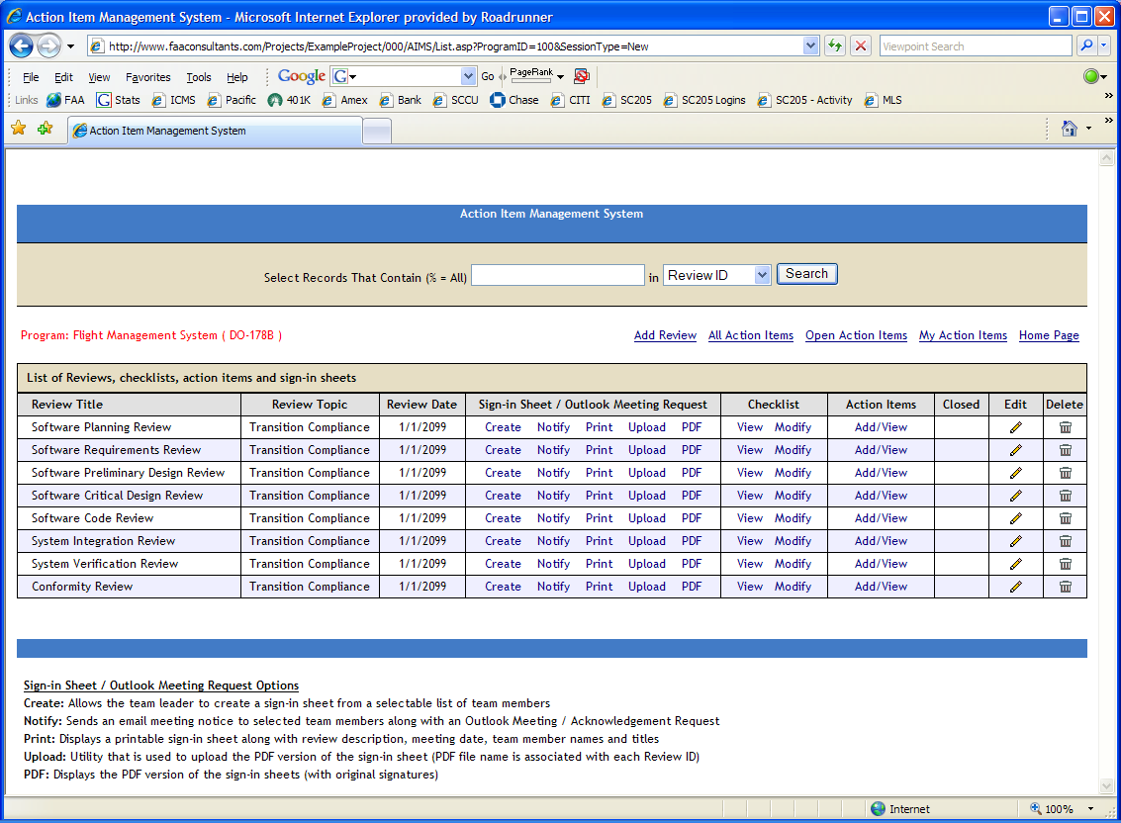
Sample Screen Shot: Planning Review Checklist
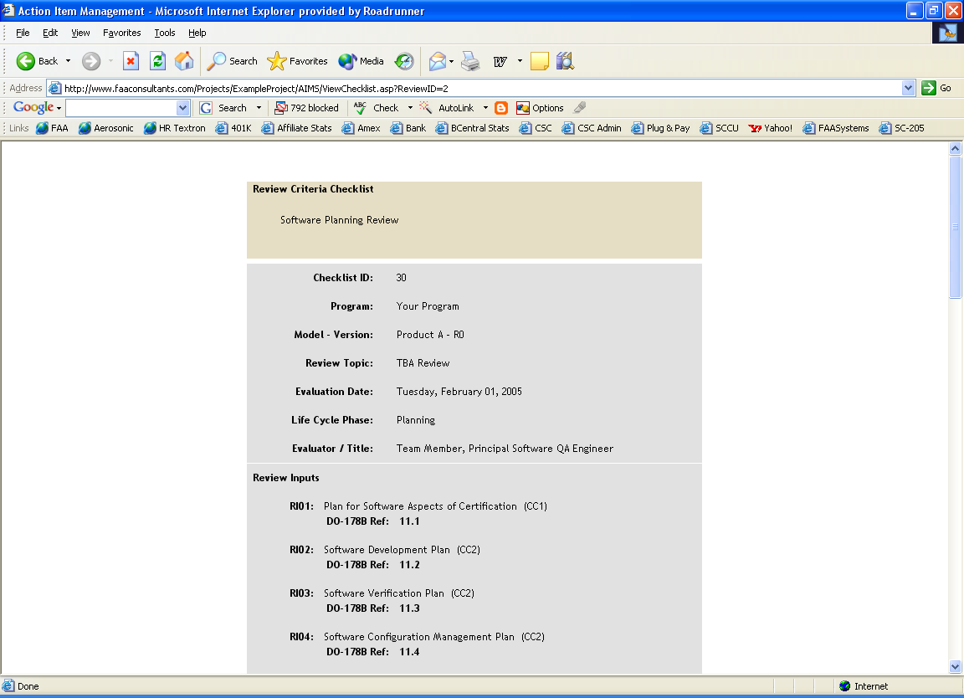
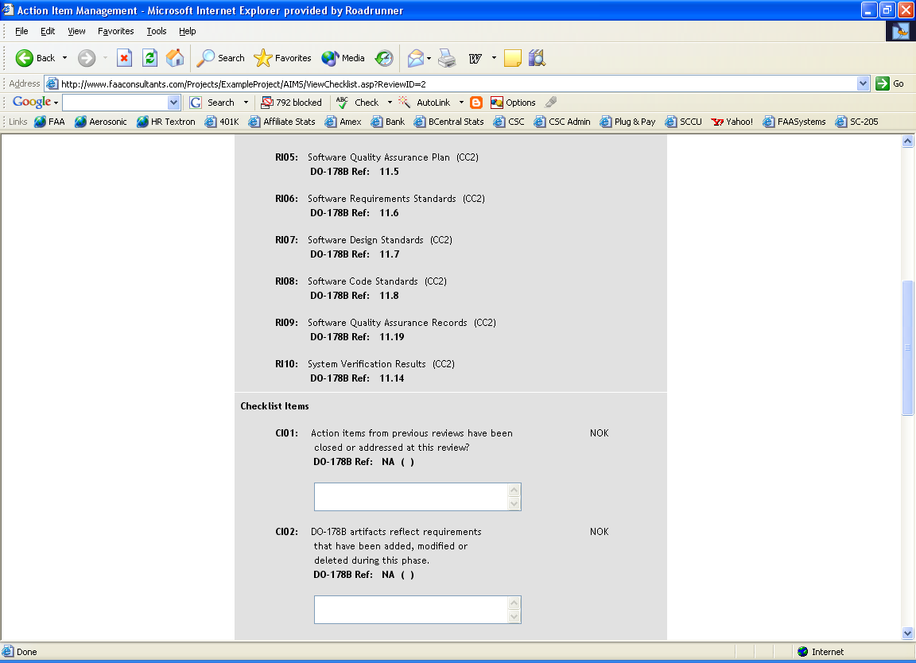

Sample Screen Shot: Action Item Sub-System

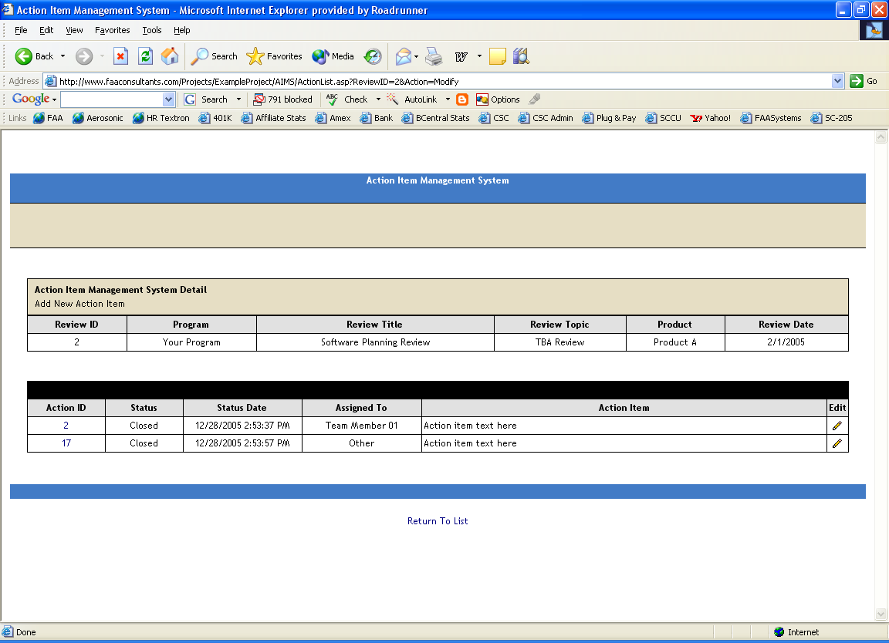

Sample Screen Shot: Meeting Attendee List / Sign-in Sheet

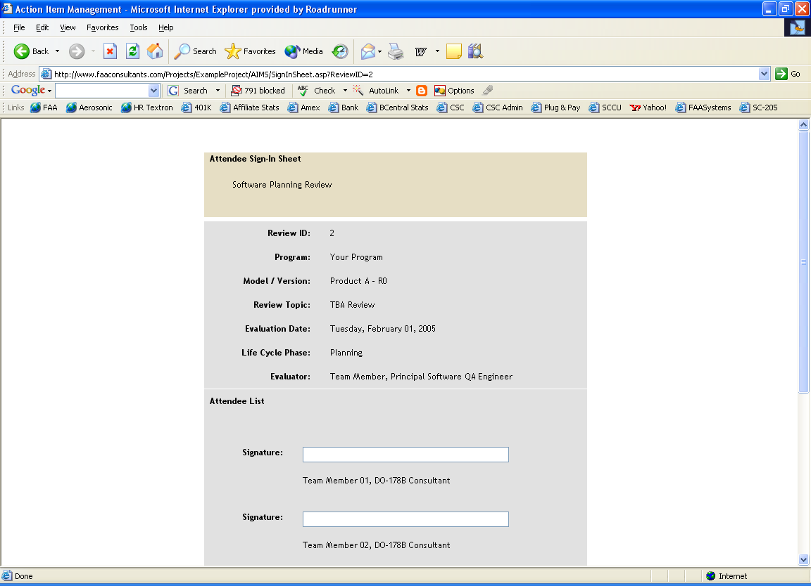

Document Review Management System
The Document Review Management System generates a unique database record for each lifecycle document, automatically generates a checklist addressing applicable DO-178C objectives, creates an action item sub-system for recording and managing inputs from individuals reviewing the document, and provides email notification of changes. The Document Review Management System contains the following features:

- Unique Database Record for Each Document
- Hyperlinks To Each Program Document
- Auto-Generates Review Checklist Based on DO-178C Section 11 Guidance
- Auto-Generates Action Item Subsystem
- Auto-Generates Document Templates
- Email Notification of Major Events

Document Review Checklist
The following checklists will be used and maintained online during the project lifecycle:

- Plan for Software Aspects of Certification Checklist
- Software Development Plan Checklist
- Software Verification Plan Checklist
- Software Quality Assurance Plan Checklist
- Software Configuration Management Plan Checklist
- Software Requirements Standards Checklist
- Software Design Standards Checklist
- Software Code Standards Checklist
- Software Requirements Document Checklist
- Software Design Description Checklist
- Software Verification Cases and Procedures Checklist
- Software Verification Results Checklist
- Software Lifecycle Environment Configuration Index Checklist
- Software Configuration Index Checklist
- Software Accomplishment Summary Checklist
Sample Screen Shot: Main Document Review Management System Page

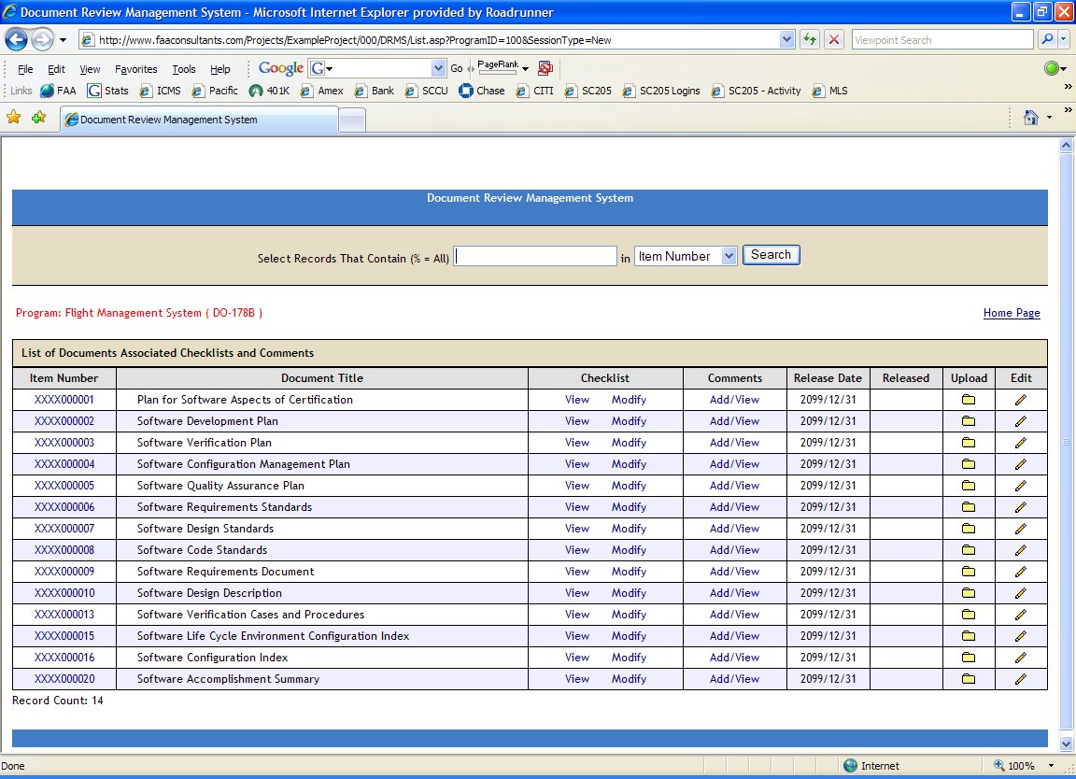

Sample Screen Shot: Document Review Checklist

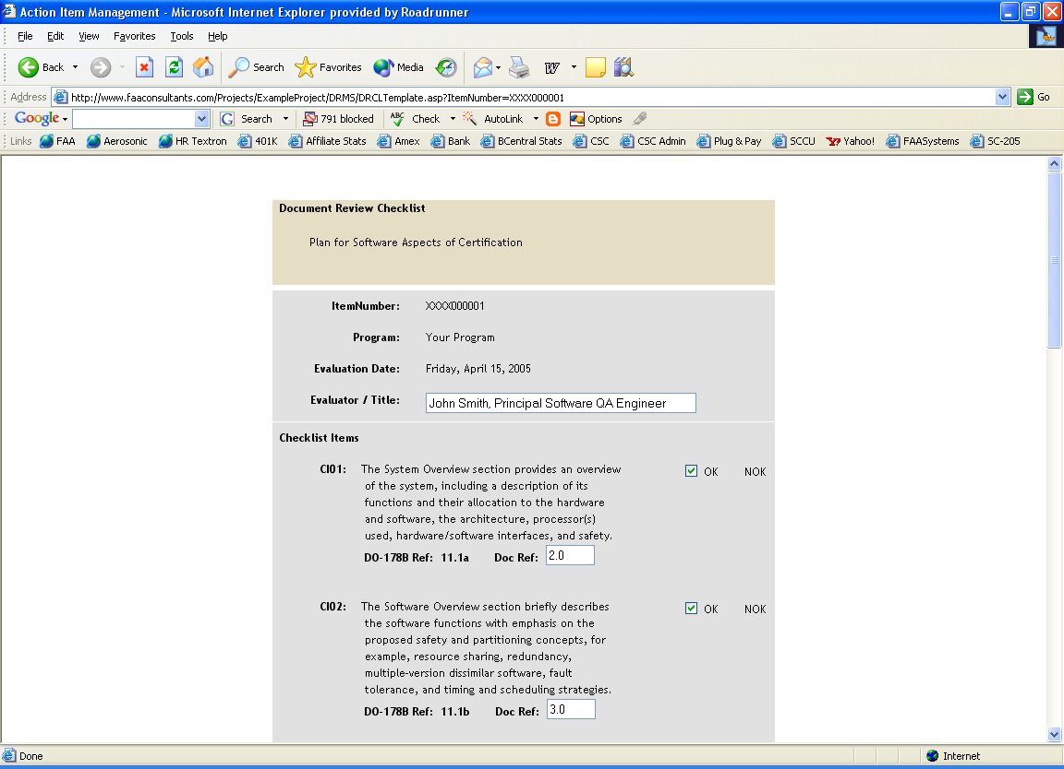

Sample Screen Shot: Action Item Sub-System

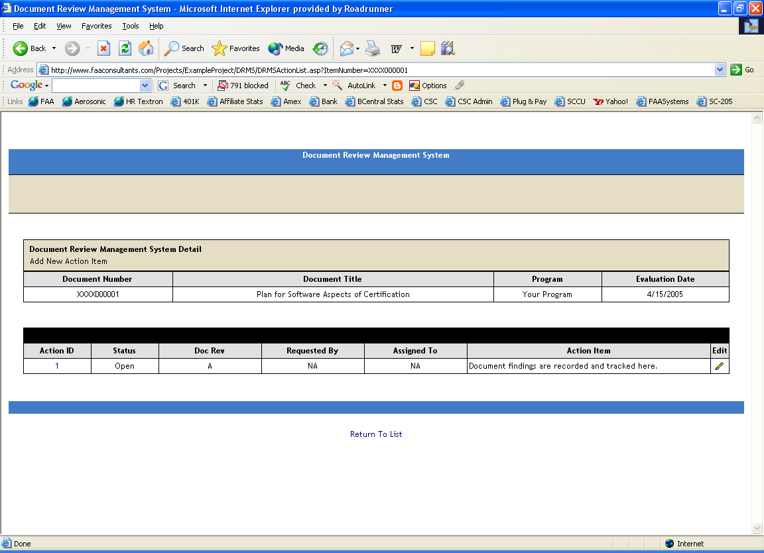

Methods
SQE uses both audit and review methods in their oversight activities. An audit verifies that work was performed according to a plan—and that all work planned was performed. The quality of the work products is not the focus of an audit; rather, adherence to the approved processes is emphasized. Audits may be limited to an element of a sampling of the data to be audited, or may include every element.
The review process, in contrast to the audit process, is the verification that the work is correct, feasible, and accurate. The SQE review process is applied to the planning and process support documentation (standards, templates, and forms)—as well as the FAA liaison documentation, Plan for Software Aspect of Certification (PSAC), Software Configuration Index (SCI), and Software Accomplishment Summary (SAS).
The preparation and review of the planning documents ensures that plans do not conflict, that the planning data describes a reasonable and feasible means of compliance to RTCA/DO-178C, and that the plans represent a process that can be verified through audits and reviews. In addition to the planning documents, the SQE reviews other project documentation such as the Software Requirements Document and Software Design Description. In all cases, a document review checklist is prepared (See Document Review Management System in Section 6 of this document). In addition, SQE participates in the review process to ensure that the reviews associated with the processes are performed as identified in the SVP.
Reviews involve a qualitative examination of work products to ensure compliance with standards, necessary functionality, and so forth. SQE will take part in formal reviews of work products according to the process described in the Software Verification Plan. Issues found during reviews will be tracked with the Reviews and Analysis Management System (See Reviews and Analysis Management System in Section 6 of the document).
An audit is an examination of work products and records to ensure adherence to the planned processes, methods, and standards. If sampling is performed in an audit, the sample size and strategy will be documented in the Audit report. Non-compliance issues found during audits will be tracked with the Corrective and Preventive Action System. All audits will be documented.

AUTHORITY
The Software Quality Assurance Engineer has the authority to review and audit the development process to ensure conformance to the planning, requirements, design, and test documents for the program. In order to deliver the final product, it is incumbent upon the Program Team to comply with the development process as defined in the project planning documents and standards. SQA has been assigned approval authority for airborne equipment, software, and related documentation by the highest level of management.

SQA Independence
The SQA role is an oversight role for the entire project. As such, SQA does not perform any of the development or verification activities. In addition, the SQA reporting structure is independent of Engineering, Manufacturing, and Project Management. A direct reporting channel to Senior Management ensures independent quality assurance. SQA has the authority to stop the certification effort. In addition, SQA can suspend activity on any lifecycle data to ensure that safe and correct foundations are used for ongoing development.

<There should be a customized discussion of the actual organization here…>

The following chart shows that the Quality Assurance Organization is independent from Engineering. It also demonstrates that the verification and test activities are performed independently by someone other than the development engineer.

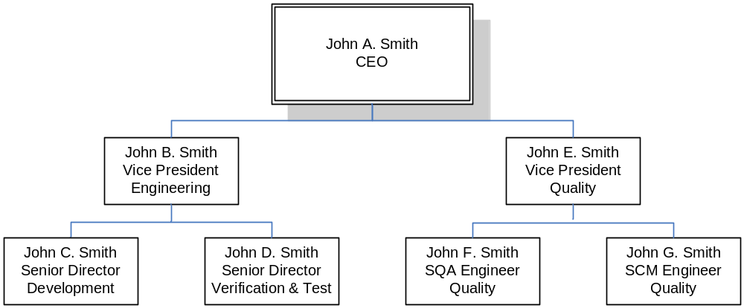

SQA Authorization
The SQA group is authorized to audit all processes and data related to planned activities—as well as the review and approval authority for the plans. In this capacity, SQA will:
- Perform audits of the planned development and verification activities.
- Participate in formal reviews of requirements, design, code, verification cases and procedures as necessary to ensure compliance to plans.
- Review and approve project plans, development documentation, verification documentation, and certification liaison documentation.
- Audit the configuration and change control mechanisms and artifacts.
- Participate in the Certification Liaison activities to ensure full visibility into the planned and ongoing development activities.
- Document deviations from planned activities and track them to ultimate resolution.
- Participate in Software Configuration Control Board (SCCB).
- Perform a Software Conformity Review.

ACTIVITIES

The program team actively participates in the QA Program, which is a planned and systematic approach to the evaluation of the quality of and adherence to product standards, processes, and procedures. QA includes the process of assuring that standards and procedures are established and are followed throughout the product life cycle. Compliance with agreed-upon standards and procedures is evaluated through process monitoring, product evaluation, and audits. Product development and control processes include quality assurance approval points, where an SQE evaluation of the product shall be done.

The QA Process is part of the overall life cycle development process and is initiated during the Planning Process. The QA process continues throughout the development and verification processes. QA Records are generated as a result of transition reviews between these processes. These records are maintained in QCMS in the form of transition criteria checklists. Action Items from the transition reviews are also generated and maintained in QCMS. These action items are defined as items that do not meet the planned schedule and do not produce a deviation of any product from its requirements or standards.

Detailed QA Approach and Activities

The SQE will conduct independent oversight of the overall program efforts to ensure that the program team is carrying out a development program that meets documented requirements. The SQE and SQE are assigned this oversight responsibility. As part of the oversight role, The SQE reviews and approves documents and perform surveillance of approved processes.

During the Planning Process, the SQE is involved in review of management and development plans to ensure that the processes, procedures and standards identified in the plans are appropriate, clear, specific, and can be audited. At the end of this process, SQE ensures that the transition criteria, as defined in the plans, are complete and accurate. This evaluation is performed at the Planning Review. Objective evidence of compliance is maintained in the QCMS.

During the Requirements Process, the SQE ensures that the plans and standards are being followed. This is done by active surveillance throughout the requirements process. At the end of this process, SQE ensures that the transition criteria, as defined in the plans, are complete and accurate. This evaluation is performed at the Requirements Review. Objective evidence of compliance is maintained in the QCMS.

During the Design Process, the SQE ensures that the plans and standards are being followed. This is done by active surveillance throughout the design process. At the end of this process, SQE ensures that the transition criteria, as defined in the plans, are complete and accurate. This evaluation is performed at the Preliminary Design Review and Critical Design Reviews. Objective evidence of compliance is maintained in the QCMS.

During the Coding Process, the SQE ensures ensure that the plans and standards are being followed. This is done by active surveillance throughout the coding process. At the end of this process, SQE ensures that the transition criteria, as defined in the plans, are complete and accurate. This evaluation is performed at the Software Code Review. Objective evidence of compliance is maintained in the QCMS.

During the Integration Process, the SQE ensures that the plans and standards are being followed. This is done by active surveillance throughout the Integration Process. At the end of this process, SQE ensures that the transition criteria, as defined in the plans, are complete and accurate. This evaluation is performed at the System Integration Review. Objective evidence of compliance is maintained in the QCMS.

During Software Testing, the SQE ensures that the plans and standards are being followed. This is done by active surveillance throughout the Testing Process. At the end of this process, SQE ensures that the transition criteria, as defined in the plans, are complete and accurate. This evaluation is performed at the Software Verification Review. Objective evidence of compliance is maintained in the QCMS.

During Conformity, the SQE ensures that a compliant baseline, including all objective evidence of compliance, has been produced and is available. At the end of this activity, SQE ensures that the criteria, as defined in the plans, are complete and accurate. An audit of Configuration Management activities and data is required for completion of the conformity assurance. This evaluation is performed at the Software Conformity Review. Objective evidence of compliance is maintained in the QCMS.

Methods and Techniques

The SQE will use checklists generated from the Document Review Management System and Reviews and Analysis Management System, which correspond to the team members’ approved standards to verify compliance with documented standards and procedures.

Product Life Cycle Development Planning

Traceability of Requirements to Design and Test

SQE reviews requirements traceability throughout development and software testing. All requirements shall be identified and traceable to the product components and test cases. These matrixes are included in the appropriate design and test documents. These matrices are generated and maintained in the QCMS and included in the appropriate documents.

Requirements, Design and Coding Standards
The program team uses the following standards as guidance to implement the requirements, design, coding and verification aspects of the Program. During the Requirements Review, Critical Design Review and Code Review, the SQE and/or SQE will confirm that the guidelines are being followed. Objective evidence of compliance is generated and maintained in the QCMS.

- Software Requirements Standards
- Software Design Standards
- Software Coding Standards

Traceability of Reviews and Analysis Results

SQA will verify that reviews and analysis results are traceable to the artifacts that they verify. This will be facilitated by applying a unique ID to each review activity via the Reviews and Analysis Management System. The attendees, review criteria and related action items will be will be traceable to each other based in this ID. In addition, a review folder which contains the review artifacts is maintained using the same ID, ensuring complete traceability and archiving. A final review of all verification evidence and related traceability will be conducted as part of the Software Conformity Reviews.

Processing Resources and Resource Capacity

The SQE verifies that the program team has analyzed the processing resource requirements and that the appropriate resources are being allocated. The SQE will also work with the program team to monitor the utilization of processing resources.

Interface Control Process

The Program Manager will coordinate hardware and software interfaces. The applicable interface documents and diagrams will be developed and released.

Documentation Reviews

The SQE reviews all documentation to ensure completeness, accuracy and consistency with other project documentation and for conformance to internal standards and requirements of RTCA/DO-178C where applicable.

Records of these reviews are generated and maintained in the Document Review Management System, in the QCMS.

Project Reviews

The SQE coordinates, evaluates, and/or participates in project reviews. Review checklists will be evaluated by SQE and the Program Manager during each review. These checklists provide the list of materials to be reviewed and the transition criteria to be fulfilled prior to closing the specified lifecycle phase. When appropriate, records of these reviews can be generated and maintained in the Reviews and Analysis Management System, in the QCMS.

Review and Sampling Methods

Reviews
Reviews are the act of inspecting or examining software life cycle data, software project progress and records, and other evidence produced with the intent of finding compliance with DO-178C objectives. Review is an encompassing term and may consist of a combination of reading, interviewing project personnel, witnessing activities, sampling data, and participating in presentations. A review may be conducted at one’s own desk, at an applicant’s facility, or at an applicant’s supplier’s facility.

Sampling
Sampling is the process of selecting a representative set of software life cycle data for inspection or analysis to attempt to determine the compliance of all the software life cycle data developed up to that point in time in the project. Sampling is the primary means of assessing the compliance of the software processes and data. Examples of sampling may include any or all of the following:

- An inspection of the traceability from system requirements to software requirements to software design to code and from software requirements and design to test cases and procedures to test results.

- A review of any analyses used to determine the system safety classification and the software level or of any reviews or analyses used to meet any DO-178C objective (e.g., timing analysis or code review). This review assures that system safety assessment inputs to the software lifecycle are addressed.

- An examination of the code coverage of multiple samples of code modules.

- An examination of multiple samples of software quality assurance records and configuration management records.

Recording of Findings, Observations and Action Items

Finding
Finds are the identification of a failure to show compliance with one or more of the objectives of DO-178C.

Observation
Observations are the identification of a potential software life cycle process improvement.

Action
An action is the description of the activity to be performed by the applicant/supplier in order to resolve a finding or any other deficiency detected by the auditor. By default, actions should be completed and closed before approval.

Recommendation
A recommendation is the description of the activity to be performed by the applicant/supplier in order to resolve an observation identified by the auditor. Implementation of recommendations is not mandatory prior to approval.

Software Quality Assurance Surveillance Reviews

In support of the stages of involvement audits, the SQE coordinates, evaluates, and/or participates in surveillance reviews. The reviews begin early in the software life cycle. Early Process Assurance involvement reduces the risk that the system, software, and planning decisions will not satisfy DO-178C objectives. Early involvement requires timely communication between Process Assurance and the certification authority about planning decisions that may affect the software product and processes. This means that regular contact with the certification authorities should be established. This contact should provide gradually increasing confidence in the software life cycle processes and in the resultant product to both the applicant and the certification authorities. The four types of reviews conducted by Process Assurance in support of the certification authority reviews are described as follows:

Software Planning SOI Pre-Review

A software planning SOI pre-review review is conducted when the initial software planning process is complete (i.e. when the most of the plans and standards are completed and reviewed). This pre-review is an internal review designed to assure the project is prepared for the formal Planning SOI Review conducted by the certification authority or their designee. The current FAA Job Aid is used to perform this review. The FAA Job Aid is available from the FAA website.

Software Development SOI Pre-Review

A software development SOI pre-review is conducted when at least 75% of the software development data (i.e. requirements, design, and code) are complete and reviewed. This pre-review is an internal review designed to assure the project is prepared for the formal Development SOI Review conducted by the certification authority or their designee. The current FAA Job Aid is used to perform this review. The FAA Job Aid is available from the FAA website.

Software Verification SOI Pre-Review

A software verification SOI pre-review is conducted when at least 75% of the software verification and testing data are complete and reviewed. This pre-review is an internal review designed to assure the project is prepared for the formal Verification SOI Review conducted by the certification authority or their designee. The current FAA Job Aid is used to perform this review. The FAA Job Aid is available from the FAA website.

Final Certification SOI Pre-Review

A final certification SOI pre-review is conducted after the final software build is completed, the software verification is completed, a preliminary software conformity review has been conducted, and the application(s) is ready for formal system certification approval. This pre-review is an internal review designed to assure the project is prepared for the formal Final Certification SOI Review conducted by the certification authority or their designee. The current FAA Job Aid is used to perform this review. The FAA Job Aid is available from the FAA website.

Corrective and Preventive Action
The Corrective and Preventive Action System (CPAS) is the program’s Non-conformance Reporting and Corrective Action System. The CPAS will provide for the recording of non-conformances, the evaluation of impact and establishing of priority, the tracking and reporting of status and the closure after testing. A non-conformance is defined as a deviation of any product from its requirements or standards. Non-conformance reports will be filed against any product in any phase of the lifecycle after a product is first approved or baselined by its developer and released for wider use.

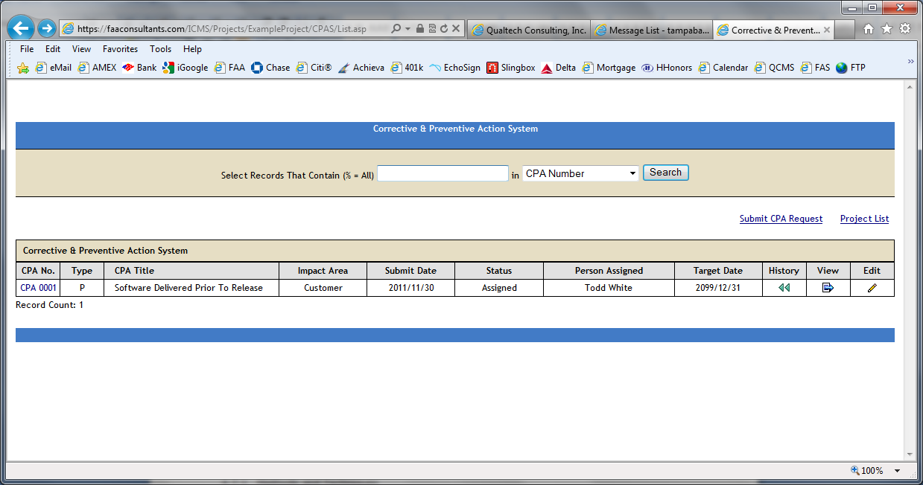

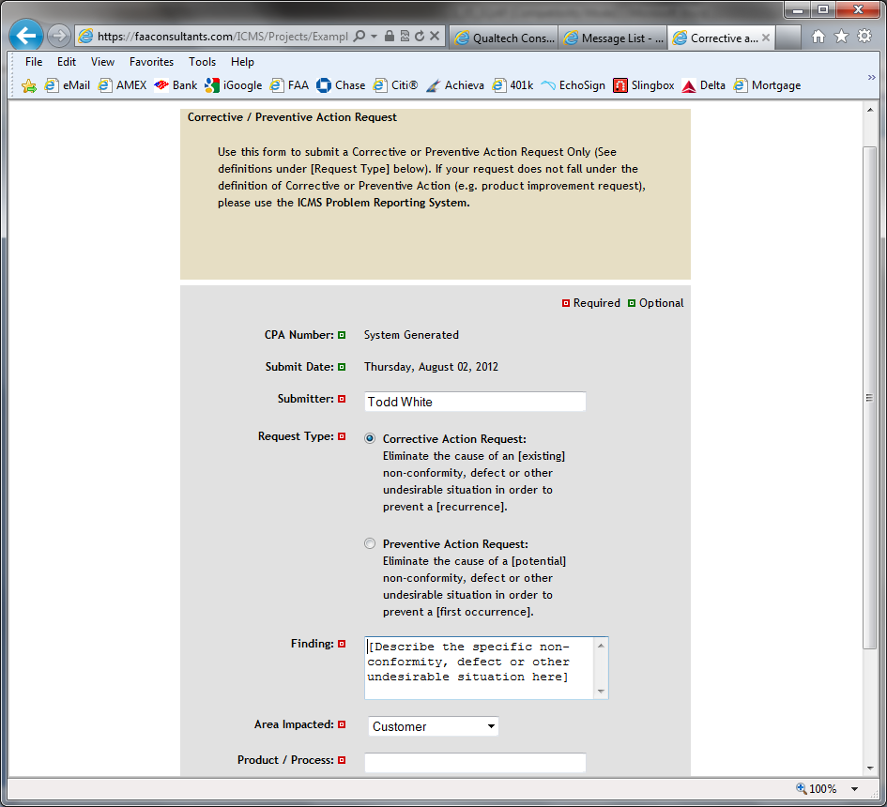

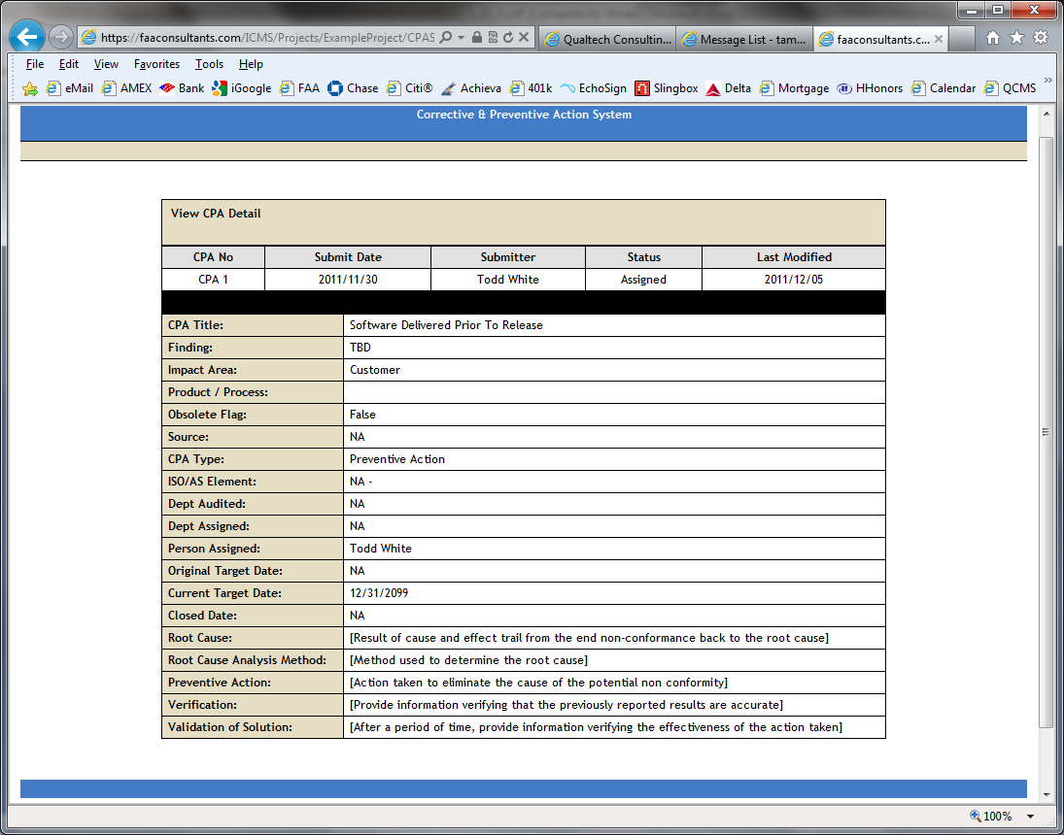

Methods and Techniques
The CPAS will be used to provide management reports containing enhancement, error and correction status, the number of enhancements/errors found per product, and the criticality of open problems. This data enables the impact of non-conformances to be evaluated so that the use of resources may be prioritized.
Non-conformance reports will be evaluated for criticality and level of importance. In addition, each non-conformance report will be evaluated to identify those that contain requirements changes disguised as non-conformances. Factors to be considered in the criticality and level of importance will include:
- The impact of not correcting the non-conformance.
- The resources required for correcting the non-conformance.
- The impact on other baselined items if the non-conformance is corrected.
If the decision is made to correct a non-conformance, there will be procedures to control the corrective action process. Such procedures will include follow up to ensure the non-conformance has been documented and corrected in the appropriate product version, and to assure that adequate testing, including regression testing, is accomplished.

Approach and Activities
Various automated forms will be used to generate the non-conformance reports. Each form will contain the date and the time of detection of the non-conformance; error identification (report number and title); reporting individual, and individual responsible for corrective action; criticality of the non-conformance, proposed fix for the non-conformance; identifier of the unit of code, data, or documentation in which corrective action must be taken; lifecycle phase in which the non-conformance was introduced; lifecycle phase in which the non-conformance was detected; final resolution; date and/or version of the configuration item in which the correction will be included, and date on which the non-conformance is closed.
Non-conformance report closure is verified as part of the software conformity review (see 4.9). The process for opening, evaluating, resolving, and closing of non-conformance reports is evaluated as part of software development process audits.

Conformity Review
The software conformity review is conducted by SQE to assure the following:
- The software lifecycle process is complete.
- The software lifecycle data is complete.
- The project object code modules are controlled and can be regenerated from a controlled computer environment.
The review consists of the following steps, the results of which will be recorded in the software verification results and the audit of these results will be recorded in the SQA Records.
At a minimum, the Conformity Review will determine that:
- Planned software lifecycle process activities for certification credit, including the generation of software lifecycle data, have been completed and records of their completion are retained.
  - This includes a Configuration Management process and data audit for evidence of compliance to the Software Configuration Management Plan.
- Software lifecycle data developed from specific system requirements, safety-related requirements, or software requirements are traceable to those requirements.
- Software lifecycle data complies with software plans and standards, and is controlled in accordance with the SCMP.
  - This includes evaluation of the Software Lifecycle Environment Configuration Index (SECI) for compliance to the environment identified in the software plans, and that the environment identified in the SECI was used in the development and verification of the software.
- Problem reports that comply with the SCMP have been evaluated and their status has been recorded.
- Software requirement deviations are recorded and approved.
- The Executable Object Code can be regenerated from the archived Source Code.
- The approved software can be loaded successfully through the use of released instructions.
- Problem reports deferred from a previous software conformity review are re-evaluated to determine their status.
- If certification credit is sought for the use of previously developed software, the current software product baseline is traceable to the previous baseline and the approved changes to that baseline.
If certification credit is sought for the use of previously developed software, the current software product baseline is traceable to the previous baseline and the approved changes to that baseline.

TRANSITION CRITERIA
The transition criterion for entering the SQA process is the development of the software plans and standards. The SQA process continues throughout the entire software life cycle process. Entering the Software Quality Assurance Process need not wait until all the predecessor activities for all verification activities are completely finished, instead a specific oversight activity may begin once all the predecessor activities for that activity are mature.
The SQA process performs oversight of the software development, verification, and integral processes throughout the development life cycle, from the planning process through the post-certification load control process, including all of the integral processes. The criteria for activating the SQA process during Planning, Development, Verification, Configuration Management and Certification Liaison Processes include:

SQA Transition Criteria During the Planning Process
- Planning process inputs are complete and compliant with DO-178C
- Planning process outputs are compliant with the plans
- Planning process activities have been performed
- Planning process transition criteria have been satisfied
- Deviations from the planning process have been identified

SQA Transition Criteria During the Software Development Processes
- Development process inputs are complete and compliant with the plans
- Development process outputs are compliant with the plans and standards
- Development process activities have been performed
- Development process transition criteria have been satisfied
- Deviations from the development process have been identified

SQA Transition Criteria During the Software Verification Process
- Verification process inputs are complete and compliant with the plans
- Verification process outputs are compliant with the plans
- Verification process activities have been performed
- Verification process transition criteria have been satisfied
- Deviations from the development process have been identified

SQA Transition Criteria During the Software Configuration Management Process
- SCM process inputs are complete and compliant with the plans
- SCM process outputs are compliant with the plans
- SCM process activities have been performed
- SCM process transition criteria have been satisfied
- Deviations from the development process have been identified

SQA Transition Criteria During the Certification Liaison Process
- Planning process is mature enough for SOI #1 – Planning Review
- Development process is mature enough for SOI #2 – Development Review
- Verification process is mature enough for SOI #3 – Verification Review
- All objectives, activities and lifecycle data are complete – Conformity Review
- All objectives, activities and lifecycle data are complete SOI #4 – Final Review

Errors/deficiencies discovered during the SQA oversight process have been fed back into the appropriate processes.

Program Review Transition Process Flow
Review checklists will be evaluated by QA and the Program Manager during each review. These checklists provide the list of materials to be reviewed and the criteria to be fulfilled prior to closing the specified lifecycle phase. The following process flow describes the program review process, with emphasis on transition criteria evaluation and authorization to proceed.

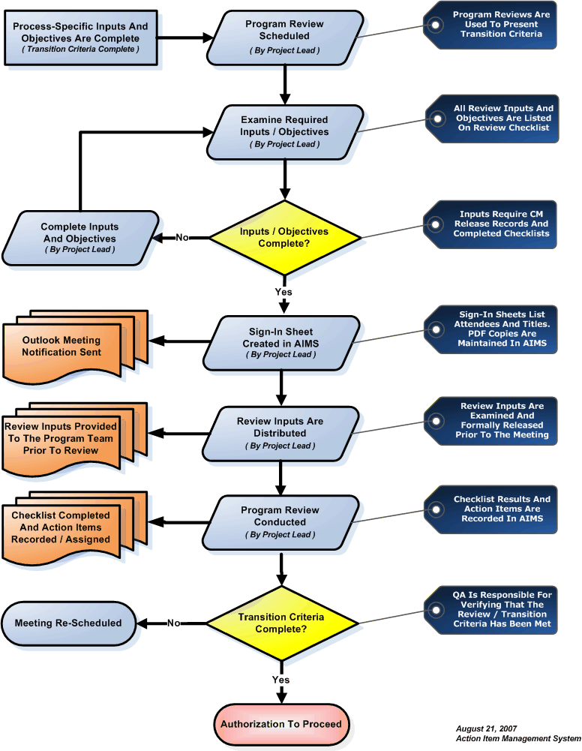

TIMING
The timing of the SQE process activities in relation to the activities of the software lifecycle is predicated on the software engineering and software verification groups’ development and verification schedule. This is critical to the successful completion of the elements of the software lifecycle. While software planning, development, and verification may overlap at times, each step must be completed in the order presented. The SQE review of each software lifecycle element will occur when the element is complete.

SQA RECORDS
The SQA Records generated during the software lifecycle are comprised of three basic types: Reviews, Evaluations, and Audits. Reviews are designed to verify conformance of a product or document to specific procedures and procedural standards. Evaluations are performed to determine if the use of a specific procedure or procedural standard fulfills its intended purpose and meets specified criteria. Audits are designed to verify that evidence is available to prove that the required activities have been completed and were deemed acceptable. In order to provide objective evidence of these reviews, evaluations, and audits, SQA will use the Document Review Management System and Meeting and Reviews and Analysis Management System.

Document Review Management System
The Document Review Management System generates a unique database record for each lifecycle document; automatically generates a checklist addressing applicable objectives, including references to DO-178C; creates an action item sub-system for recording and managing inputs from individuals reviewing the document, and provides email notification of changes.

Document Review Checklist
The following checklists will be used and maintained online during the project lifecycle:
- Plan for Software Aspects of Certification Checklist
- Software Development Plan Checklist
- Software Verification Plan Checklist
- Software Quality Assurance Plan Checklist
- Software Requirements Standards Checklist
- Software Design Standards Checklist
- Software Code Standards Checklist
- Software Requirements Document Checklist
- Software Design Description Checklist
- Software Verification Cases and Procedures Checklist
- Software Lifecycle Environment Configuration Index Checklist
- Software Configuration Index Checklist
- Software Accomplishment Summary Checklist

Document Review Action Item Sub-System
Action items will be recorded and managed in the Document Review Action Item Sub-System.
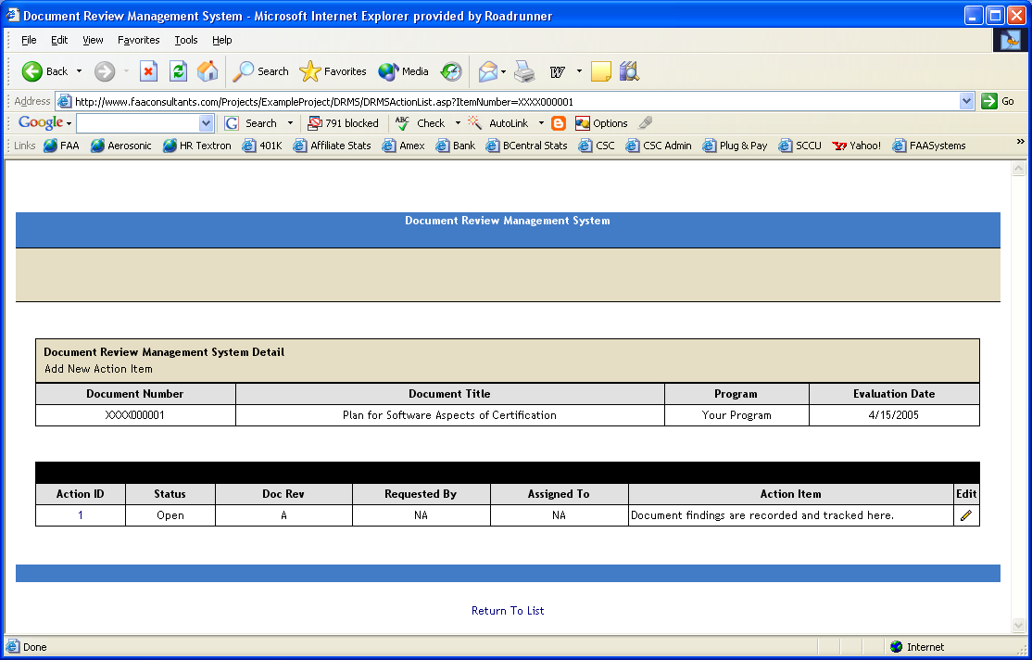

Meeting and Reviews and Analysis Management System
The Meeting and Reviews and Analysis Management System generates a unique database record for each meeting; automatically creates checklists addressing DO-178C objective; creates a list of required documents; creates an attendees list and an action item sub-system for recording and managing action items.

Meeting and Action Item Checklists
The following checklists will be used and maintained online during the project lifecycle:
- Software Planning Review Checklist
- Software Requirements Review Checklist
- Software Preliminary Design Review Checklist
- Software Critical Design Review Checklist
- Software Code Review Checklist
- System Integration Review Checklist
- System Verification Review Checklist
- Software Conformity Review Checklist

Meeting and Action Item Sub-System
Action items will be recorded and managed in the Meeting and Action Item Sub-System.

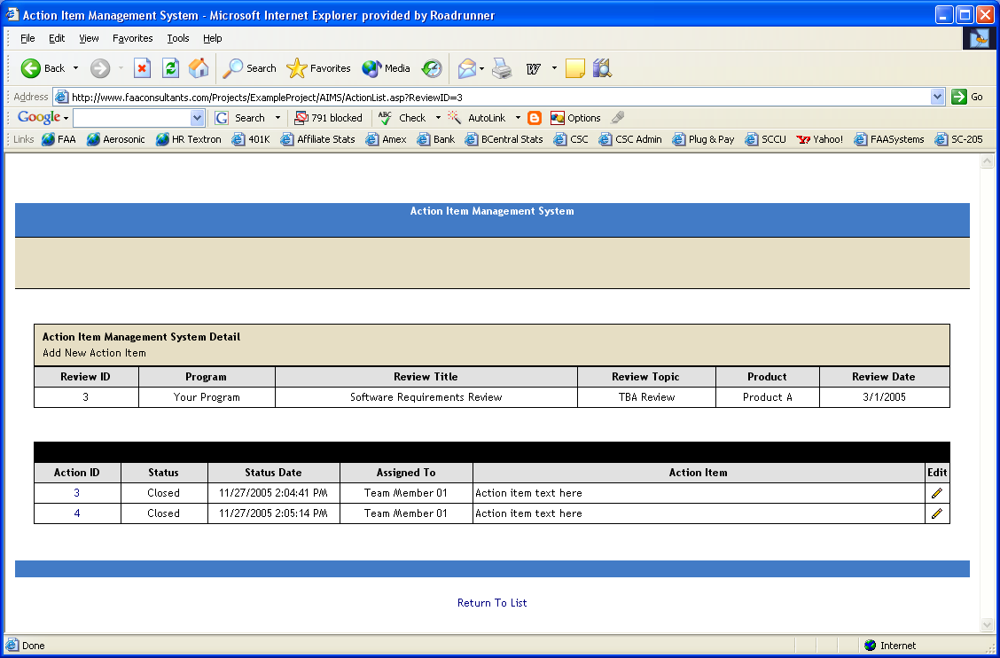

FAA Stage of Involvement Audit Checklists
The following checklists will be used and maintained online during the project lifecycle:
- FAA Stage of Involvement #1 Checklist
- FAA Stage of Involvement #2 Checklist
- FAA Stage of Involvement #3 Checklist
- FAA Stage of Involvement #4 Checklist

The current FAA Job Aid is used for Stage of Involvement Audits. The FAA Job Aid is available from the FAA website.
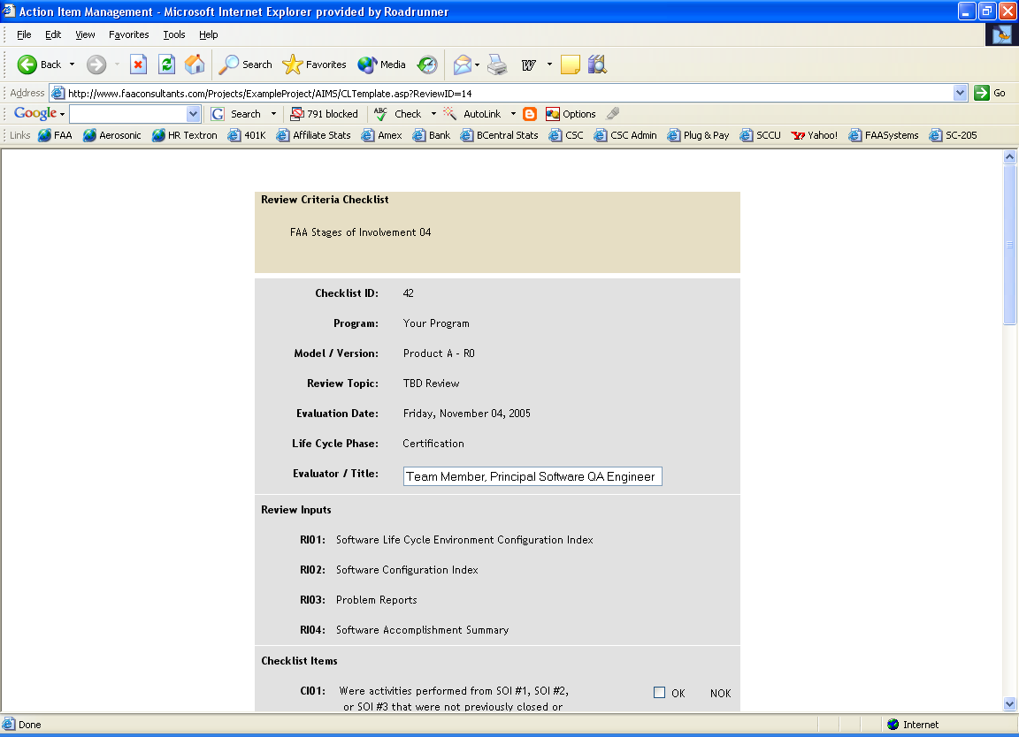

7.4 Project Metrics

The SQE will use metrics as management and quality indicators. To support this use, the program team will support establishment and implementation of a metrics program which will enhance their capabilities to manage and direct the development process and facilitate the growth of product quality.

Metric data will be collected that support the quantitative evaluation and analysis of trends for the entire lifecycle development process and the products that it generates. Metrics to be collected include, but are not limited to:

- Problem Reports
- Various Code Complexity Metrics
- Source lines of code estimates
- Percent memory, CPU, and I/O utilization

The collection, reporting, and analysis of metrics will be automated to the fullest extent practicable. Metrics may be provided using either raw data or in graphical form.

SUPPLIER CONTROL

General supplier control and oversight is detailed in the company Supplier Control Plan. This section identifies the proposed suppliers and introduces the objectives, activities and lifecycle data that will be satisfied, performed and provided by the supplier. As the applicant, it is our responsibility to ensure that all suppliers and sub-tier suppliers will comply with all regulations, policy, guidance, agreements, and standards that apply to this certification program. The applicable publications include, but are not limited to:

- Title 14 of the Code of Federal Regulations (14 CFR);

- Advisory circulars;

- FAA orders and notices;

- Issue papers;

- Special conditions;

- Delegated organization authorization procedures, airworthiness representative procedures, designated engineering representative (DER) procedures, partnership for safety plans, memoranda of agreement;

- Standards for system, hardware, and software development (including requirements, design, and coding standards);

- Quality assurance plans, procedures, and processes;

- Configuration management plans, procedures, and processes;

- System supplier standards, plans, procedures and processes; and

- Process for software change impact analysis.

Details of supplier control, including configuration management and problem reporting are documented in the Software Configuration Management Plan. Details of the development and verification activities, environment and lifecycle data oversight are detailed in the Software Development Plan and Software Verification Plan.

Supplier Identification and Roles

Acme Consultants, Inc.

General Information

Company Name: | Acme Consultants, Inc.
Company Address: | 1213 Main
Country: | USA
Telephone: | 941-999-9999
Fax: | 941-888-8888
E-mail address: | Jim.Thomas@acme.com
Web URL: | Acme.com
Contact (Name / Title): | Jim Thomas, Program Manager
Division or subsidiary of: | Worldwide Engineering Services, Inc.
Number of employees: | 125
Years of experience with supplier: | 4
Quality Certifications: | ISO 9001, AS 9100, CMMI Level III

Software Quality System

SQA Plan or Procedures in place?
Who is responsible for SQA?
Is SQA independent of engineering?
Internal auditing system?
Corrective action process?

Software Configuration Management System

SCM Plan or Procedures in place?
Configuration identification?
Configuration change control?
Problem reporting process?
Change impact analysis process?
Notice of Change Process?

COTS Software Products Being Provided by Supplier

Product 1 | Usage:
Product 2 | Usage:
Product 3 | Usage:

Non-COTS Software Products Being Provided by Supplier

Product 1 | Usage:
Product 2 | Usage:
Product 3 | Usage:

Objectives Being Satisfied by Supplier

Planning:
Requirements:
Design:
Coding:
Integration:
Verification (Reviews):
Verification (Analysis):
Verification (Test):
Configuration Management:
Quality Assurance:
Certification Liaison:

Activities Being Performed by Supplier

Planning:
Requirements:
Design:
Coding:
Integration:
Verification (Reviews):
Verification (Analysis):
Verification (Test):
Configuration Management:
Quality Assurance:
Certification Liaison:

Lifecycle Data Being Produced / Provided by Supplier

Planning:
Requirements:
Design:
Coding:
Integration:
Verification (Reviews):
Verification (Analysis):
Verification (Test):
Configuration Management:
Quality Assurance:
Certification Liaison:

Supplier Competence Questionnaire Example

The supplier's planning documents, such as certification plans and Plans for Software Aspects of Certification (PSACs), should describe how the applicant will gain visibility into their suppliers' and sub-tier suppliers' activities. This includes commercial off-the-shelf software component suppliers and vendors. The supplier should submit these plans to the applicant for review and approval, preferably early in the program. The supplier should avoid making changes to the plans late in the program. If late changes are unavoidable, the applicant must allow adequate time for review and consideration. The following list some general questions of interest asked of our prospective suppliers.

Question Posed To Supplier | Expected Supplier Response | Comply
What is the Certification Basis? | xx.1301 – Intended Function  xx.1309 – Safety  Issue Papers & CRI’s
Which development process will be used to develop the product? | V Model
When do you perform the Planning, Requirements, Design and Integration Transition Reviews? | Following completion of ALL Objectives, Activities and Lifecycle Data for that Process.
When do you perform the CM, QA, Verification and Validation Transition Reviews? | Prior to entering these Processes.
What establishes the number of peer reviews you perform for each process? | At least one peer review is performed for each major function in the design. If there are five major functions, there will be six peer reviews for requirements, design, code, test case preparation. Five to cover the major functions and the last one to cover the interface between major functions.
What evidence is required for demonstrating that the analysis activity has been achieved? | - The artifact that was reviewed (List of Requirements)  - The criteria for the review (Peer Review Checklist)  - Who reviewed the artifact (Sign-In Sheet)  - The effectiveness of the review (Action Item List)
Do you have a Software Requirements Standard? What does it cover? | See DO-178C Section 11
Do you have a Software Architectural Standard? What does it cover? | See DO-178C Section 11
Do you have a Software Design Standard? What does it cover? | See DO-178C Section 11
Do you have a Software Coding Standard? What does it cover? | See DO-178C Section 11
Do you have a Software Validation Standard? What does it cover? | See DO-178C Section 11
Do you have a Software Verification Standard? What does it cover? | See DO-178C Section 11
Do you have Quality Assurance Plans, Procedures and Processes? How do they interface with the customer’s Quality Assurance Plans, Procedures and Processes? | Detailed process that includes clear interfaces with the customer.
Do you have Configuration Management Plans, Procedures and Processes? How do they interface with the customer’s Configuration Management Plans, Procedures and Processes? | Detailed process that includes clear interfaces with the customer.
Do you have System Safety Procedures and Processes? How do they interface with the customer’s System Safety Procedures and Processes? | Detailed process that includes clear interfaces with the customer.
Once you exit a Process and obtain transition criteria credit (i.e., Requirements Process), how do you record changes to process artifacts from that Process going forward and re-establish the integrity of that baseline? How are those changes verified? | Prepare a PR, have it authorized (by the customer) and perform a Change Impact Analysis. Based on that analysis, perform re-verification which may include reviews, analysis and test.

Supplier Management Plan

Process Assurance will address the following concerns in a supplier management plan or other suitable planning documents. Certification Specialists and/or DER’s review the plan(s) and ensure that the following areas are addressed to their satisfaction:

1. Visibility into compliance with regulations, policy, plans, standards, and agreements:

The plan will address how we will ensure that all applicable regulations, policy, plans, standards, Issue Papers, CRIs, and memoranda of agreement are conveyed to, coordinated with, and complied with by prime and sub-tier suppliers.

2. Integration management: The plan will address how the system components will be integrated, and who will be responsible for validating and verifying the software and the integrated system. The plan will address:

(a) How requirements will be implemented, managed, and validated; including safety requirements, derived requirements, and changes to requirements;

(b) How the design will be controlled and approved;

(c) How the integration test environment will be controlled;

(d) How the software build and release process will be controlled (reconcile any differences between the supplier's and the applicant's release strategies);

(e) What product assurance activities that support the certification requirements will be conducted and who will be conducting them; and

(f) The applicant's strategy for integrating and verifying the system, including requirements-based testing and coverage analysis.

3. Tasks and responsibilities: The plan will identify who the responsible are and what their responsibilities are, who the focal points are, and how their activities will be coordinated and communicated. It will identify who will approve or recommend approval of software life cycle data.

4. Problem reporting and resolution: The plan will establish a system to track problem reports. It will describe how problems will be reported between us and all levels of suppliers. The problem reporting system will ensure that problems are resolved, and that reports and the resulting changes are recorded in a configuration management system. The plan will describe how the responsible group(s) will oversee problem reporting.

5. Integration verification activity: The plan will identify who will be responsible for ensuring that all integration verification activities between all levels of suppliers comply with applicable guidance. It will describe how the responsible group(s) will oversee the verification process.

6. Configuration management: The plan will describe the procedures and tools to aid configuration management of all software life cycle data. It will describe how configuration control will be maintained across all sub-tier suppliers, including those in foreign locations, and how the persons responsible for certification will oversee configuration management.

7. Compliance substantiation and data retention: The plan will describe how we will ensure that all supplier and sub-tier supplier compliance findings are substantiated and retained for the program. The plan will address, at minimum, the following certification data:

(a) Evidence that compliance has been demonstrated;
(b) Verification and validation data; and
(c) Software life cycle data.

APPENDIX A: Software Quality Assurance PROCESS Checklists

See FAA Job Aids Attached.

APPENDIX B: Software Quality Assurance DOCUMENT Checklists

PSAC Checklist Items | RTCA DO178B Reference | Yes/No | Comments
1. Does the PSAC identify the author, version number and other identification information? | 8.2(b)  8.2(d1)  11.1
2. An overview of the system, including a description of its functions and their allocation to the hardware and software, the architecture, processor(s) used, hardware/software interfaces, and safety features is contained in the plan. | 8.2(b)  8.2(d1)  11.1(a)
3. A software overview describes the software functions and emphasizes the proposed safety and partitioning concepts. | 8.2(b)  8.2(d1)  11.1(b)
4. A summary of the certification basis, including the means of compliance, is contained in the document. | 8.2(b)  8.2(d1)  11.1(c)
5. The software level is stated. | 8.2(b)  8.2(d1)  11.1(c)
6. The software life cycle to be used and a summary of each software life cycle and its processes are defined. | 8.2(b)  8.2(d1)  11.1(d)
7. How the objectives of each software life cycle process will be satisfied is explained along with a definition of the organizations involved. | 8.2(b)  8.2(d1)  11.1(d)
8. The software life cycle data that will be produced and controlled by the software life cycle processes is defined. The form of the data and the means by which software life cycle data will be made available to the certification authority is also defined. | 8.2(b)  8.2(d1)  11.1(e)
9. The means, by which visibility of the activities of the software lifecycle can be provided, is described in the document. | 8.2(b)  8.2(d1)  11.1(f)
10. Specific features or additional considerations that may affect the certification process are described. | 8.2(b)  8.2(d1)  11.1(g)

SDP Checklist Items | RTCA  DO178B Reference | Yes/No | Comments
1. Does the software development plan identify the author, version number and other identification information? | 8.2(b)  11.2
2. Does the software development plan identify the Software Requirements Standards, Software Design Standards, and Software Code Standards for the program? Are references made to the standards for previously developed software, including COTS software, if those standards are different? | 8.2(b)  11.2
3. Are the software life cycle processes described and do they include transition criteria. | 8.2(b)  11.2(b)
4. Has the software development environment been described and does it include: | 8.2(b)  11.2(c)
5. The chosen requirements development method and tools to be used. | 8.2(b)  11.2(c1)
6. The chosen design methods and tools to be used. | 8.2(b)  11.2(c2)
7. The programming languages, coding tools, compilers, linkage editors and loaders to be used. | 8.2(b)  11.2(c3)
8. The hardware platform for the tools to be used. | 8.2(b)  11.2(c4)

SVP Checklist Items | RTCA  DO178B Reference | Yes/No | Comments
1. Does the software verification plan identify the author, version number and other identification information? | 8.2(b)
2. The organizational responsibilities for the verification activities are detailed. | 8.2(b)  11.3(a)
3. The data interfaces to the other life cycle processes are detailed. | 8.2(b)  11.3(a)
Independence
4. A description of the methods for establishing verification independence is included. | 8.2(b)  11.3(b)
Verification Methods
5. A description is included of:
6. Review methods including checklists | 8.2(b)  11.3(c1)
7. Analysis methods including traceability and coverage analysis. | 8.2(b)  11.3(c2)
8. Testing methods, including guidelines that establish the test case selection process, the test procedures to be used, and the test data to be produced. | 8.2(b)  11.3(c3)
Verification Environment
9. The verification plan describes the equipment used for testing, the testing and analysis tools, and the guidelines for applying these tools and hardware test equipment. | 8.2(b)  11.3(d)
Transition Criteria
10. The transition criteria for entering the software verification process are detailed. | 8.2(b)  11.3(e)
Partitioning Considerations
11. If partitioning is used, the methods used to verify the integrity of the partitioning. | 8.2(b)  11.3(f)
Compiler Assumptions
12. A description is included of the assumptions made by the applicant about the correctness of the compiler, linkage editor or loader. | 8.2(b)  11.3(g)
Re-Verification Guidelines
13. For software modification, a description of the methods for identifying the affected areas of the software and the changed parts of the Executable Object Code. | 8.2(b)  11.3(h)
Previously Developed Software
14. For previously developed software, if the initial compliance baseline for the verification process does not comply with this document, a description of the methods to satisfy the objectives of DO-178C. | 8.2(b)  11.3(i)
Multiple Version Dissimilar Software
15. If multiple-version dissimilar software is used, a description of the software verification process activities is included. | 8.2(b)  11.3(j)

SCMP Checklist Items | RTCA  DO178B Reference | Yes/No | Comments
Environment
1. A description of the SCM environment to be used is detailed, including procedures, tools, methods, standards, organizational responsibilities, and interfaces. | 8.2(b)  11.4(a)
Activities
2. Configuration Identification: the plan details items to be identified, when they will be identified, the identification methods for software life cycle data, and the relationship of software identification and airborne system or equipment identification. | 8.2(b)  11.4(b1)
3. Baselines and Traceability: The plan details the means of establishing baselines, what baselines will be established, when these baselines will be established, the software library controls, and the configuration item and baseline traceability. | 8.2(b)  11.4(b2)
4. Problem Reporting: The plan includes content and identification of problem reports for the software product and software life cycle processes, when they will be written, the method of closing problem reports, and the relationship to the change control activity. | 8.2(b)  11.4(b3)
5. Change Control: The plan identifies configuration items and baselines to be controlled when they will be controlled, the problem/change control activities that control them, pre-certification controls, and the means of preserving the integrity of baselines and configuration items | 8.2(b)  11.4(b4)
6. Change Review: The plan details the method of handling feedback from and to the software life cycle processes; the methods of assessing and prioritizing problems, approving changes, and handling their resolution or change implementation; and the relationship of these methods to the problem reporting and change control activities. | 8.2(b)  11.4(b5)
7. Configuration Status Accounting: The plan details the data to be recorded to enable reporting configuration management status, definition of where that data will be kept, how it will be retrieved for reporting, and when it will be available. | 8.2(b)  11.4(b6)
8. Archive, Retrieval, and Release: The integrity controls, the release method and authority, and data retention. | 8.2(b)  11.4(b7)
9. Software Load Control: The plan details the software load control safeguards and records. | 8.2(b)  11.4(b8)
10. Software Life Cycle Environment Controls: The plan details the controls for the tools used to develop, build, verify and load the software. This includes control of tools to be qualified. | 8.2(b)  11.4(b9)
11. Software Life Cycle Data Controls: Controls associated with Control Category 1 and Control Category 2 data. | 8.2(b)  11.4(b10)
Transition Criteria
12. The plan details the transition criteria for entering the SCM process. | 8.2(b)  11.4(c)
SCM Data
13. The definition of the software life cycle data produced by the SCM process is included, including SCM records, the software configuration index, and the Software Life Cycle Environment Configuration Index (both of which are contained in the version description document). | 8.2(b)  11.4(d)
Supplier Control
14. The plan includes the means of applying SCM process requirements to sub-tier suppliers. | 8.2(b)  11.4(e)

SQAP Checklist Items | RTCA  DO178B  Reference | Yes/No | Comments
Detail
1. Does the software quality assurance plan identify the author, version number and other identification information? | 8.2(b)  8.2(d1)  11.5
2. Is a description of the SQA environment, including scope, organizational responsibilities and interfaces, standards, procedures, tools and methods, is identified? | 8.2(b)  8.2(d1)  11.5(a)
3. Is a statement of the SQA authority, responsibility, and independence, including the approval authority for software products, included in the document? | 8.2(b)  8.2(d1)  11.5(b)
4. The SQA activities that are to be performed for each software life cycle process and throughout the software life cycle are described? | 8.2(b)  8.2(d1)  11.5(c)
5. SQA methods are described? | 8.2(b)  8.2(d1)  11.5(c1)
6. Activities related to the problem reporting, tracking and corrective action system are described? | 8.2(b)  8.2(d1)  11.5(c2)
7. Is the software conformity review described? | 8.2(b)  8.2(d1)  11.5(c3)
8. The transition criteria for entering the SQA process are defined? | 8.2(b)  8.2(d1)  11.5(d)
9. The timing of the SQA process activities in relation to the activities of the software life cycle processes is defined? | 8.2(b)  8.2(d1)  11.5(e)
10. The records to be produced by the SQA process are defined? | 8.2(b)  8.2(d1)  11.5(f)
11. The means of ensuring that sub-tier suppliers' processes and outputs comply with the SQA Plan is described. | 8.2(b)  8.2(d1)  11.5(g)

SRS Checklist Items | RTCA  DO178B  Reference | Yes/No | Comments
Detail
1. Does the software requirements standards identify the author, version number and other identification information? | 8.2(b)  8.2(d1)  11.6
2. The methods to be used for developing software requirements? | 11.6(a)
3. Notation to be used to express requirements? | 11.6(b)
4. Constraints on the use of the requirements development tools? | 1.6(c)
5. The method to be used to provide derived requirements to the system process? | 11.6(d)

SDS Checklist Items | RTCA  DO178B  Reference | Yes/No | Comments
Detail
1. Does the software design standard identify the author, version number and other identification information? | 8.2(b)  8.2(d1)  11.6
2. Design description methods to be used? | 11.7(a)
3. Naming conventions to be used? | 11.7(b)
4. Conditions imposed on permitted design methods? | 11.7(c)
5. Constraints on the use of design tools? | 11.7(d)
6. Constraints on design? | 11.7(e)
7. Complexity restrictions? | 11.7(f)

SCS Checklist Items | RTCA  DO178B  Reference | Yes/No | Comments
Detail
1. Does the software coding standard identify the author, version number and other identification information? | 8.2(b)  8.2(d1)  11.6
2. Programming language(s) to be used and/or defined subset(s). | 11.8(a)
3. Source code presentation standards? | 11.8(b)
4. Naming conventions for components, etc? | 11.8(c)
5. Conditions and constraints imposed on permitted coding conventions? | 11.8(d)
6. Constraints on the use of coding tools? | 11.8(e)

SRD Checklist Items | RTCA  DO178B  Reference |  | Yes/No |  | Comments
Does the Software Requirements Data Include:
1. Description of the allocation of system requirements to software? |  | 11.9(a)
2. Functional and operational requirements under each mode of operation? |  | 11.9(b)
3. Performance criteria? |  | 11.9(c)
4. Timing requirements and constraints? |  | 11.9(d)
5. Memory size constraints? |  | 11.9(e)
6. Hardware and software interfaces? |  | 11.9(f)
7. Failure detection and safety monitoring requirements? |  | 11.9(g)
8. Partitioning requirements allocated to software? |  | 11.9(h)

SDD Checklist Items | RTCA  DO178B  Reference | Yes/No | Comments
Detail
1. Do the software design documents identify the author, version number and other identification information? | 8.2(b,c)  11.10
Does the Design Description include:
2. A detailed description of how the software satisfies the specified high-level requirements, including algorithms, data structures, and how software requirements are allocated to processors and tasks. | 8.2(b,c)  11.10(a)
3. The description of the software architecture defining the software structure to implement the requirements. | 8.2(b,c)  11.10(b)
4. The input/output description (Software Interface Control Document) | 8.2(b,c)  11.10(c)
5. The data flow and control flow of the design. | 8.2(b,c)  11.10(d)
6. Resource limitations, the strategy for managing each resource and its limitations, the margins, and the method for measuring those margins. | 8.2(b,c)  11.10(e)
7. Scheduling procedures and inter-processor/inter-task communication mechanisms, including time-rigid sequencing, preemptive scheduling, Ada rendezvous, and interrupts. | 8.2(b,c)  11.10(f)
8. Design methods and details for their implementation, for example, software data loading, user-modifiable software, or multiple-version dissimilar software. | 8.2(b,c)  11.10(g)
9. Partitioning methods and means of preventing partitioning breaches. | 8.2(b,c)  11.10(h)
10. Descriptions of the software components, whether they are new or previously developed, and, if previously developed, reference to the baseline from which they were taken. | 8.2(b,c)  11.10(i)
11. Derived requirements resulting from the software design process. | 8.2(b,c)  11.10(j)
12. If the system contains deactivated code, a description of the means to ensure that the code cannot be enabled in the target computer. | 8.2(b,c)  11.10(k)
13. Rationalizations for those design decisions that are traceable to safety-related systems requirements. | 8.2(b,c)  11.10(l)

SVCP Checklist Items | RTCA  DO178B  Reference | Yes/No | Comments
Detail
1. Review and analysis procedures; Details which describes the scope and depth of the review or analysis methods to be used. | 8.2(h)  11.13(a)
2. Test Cases: The purpose of each test case, set of inputs, conditions, expected results to achieve the required coverage criteria, and the pass/fail criteria. | 8.2(h)  11.13(b)
3. Test Procedures: The step-by-step instructions for how each test case is to be set up and executed, how the test results are evaluated, and the test results to be used. | 8.2(h)  11.13(c)

SVR Checklist Items | RTCA  DO178B  Reference | Yes/No | Comments
Detail
1. For each review, analysis and test indicate each procedure that passed or failed during the activities and the final pass/fail results. | 11.14(a)
2. Identify the configuration item or software version reviewed, analyzed or tested. | 11.14(b)
3. Include the results of tests, reviews and analyses, including coverage analyses and traceability analyses. | 11.14(c)

SCI Checklist Items | RTCA  DO178B  Reference | Yes/No | Comments
The following are identified
1. The software product. | 11.16(a)
2. Executable Object Code. | 11.16(b)
3. Each Source Code component. | 11.16(c)
4. Previously developed software in the software product, if used. | 11.16(d)
5. Software life cycle data. | 11.16(e)
6. Archive and release media. | 11.16(f)
7. Instructions for building the Executable Object Code, including, for example, instructions and data for compiling and linking; and the procedures used to recover the software for regeneration, testing or modification. | 11.16(g)
8. Reference to the Software Life Cycle Environment Configuration Index, if is packaged separately. | 11.16(h)
9. Data integrity checks for the Executable Object Code, if used. | 11.16(i)

SECI Checklist Items | RTCA  DO178B  Reference | Yes/No | Comments
The following are identified
1. The software life cycle environment hardware and its operating system software. | 11.15(a)
2. The software development tools, such as compilers, linkage editors and loaders, and data integrity tools (such as tools that calculate and embed checksums or cyclical redundancy checks). | 11.15(b)
3. The test environment used to verify the software product, for example, the software verification tools. | 11.15(c)
4. The qualified tools and their associated tool qualification data. | 11.15(d)

SAS Review Checklist Items | RTCA  DO178B  Reference | Yes/No | Comments
General Format
1. Is the document under configuration control? | 7.2.1(d)
2. Is a revision history provided and accurate? | 7.2.1(a)
3. Does the title page include program name, document release date, document identification and revision level? | 7.2.1
4. Are the references in the table of contents completed and correct? | ---
5. Are terms and acronyms defined? | ---
6. Does the referenced document section include all documents referenced in the text? | ---
SAS Items
7. Does the SAS include a system overview including any differences from the PSAC, that includes: | 11.20(a)
8. A description of the system functions and their allocation to the hardware and software? | 11.20(a)
9. The system architecture? | 11.20(a)
10. Processor’s used? | 11.20(a)
11. Hardware/Software interfaces? | 11.20(a)
12. System safety features? | 11.20(a)
13. Does the SAS include a software overview including any differences from the PSAC? | 11.20(b)
14. Does the SAS include the software configuration and part number? | 11.20(h)
15. Are the certification levels to be achieved identified? | 11.20(c)
16. Are the differences between the PSAC certification considerations and the means for compliance used, defined and explained? | 11.20(c)
17. Are the following software characteristics defined including the means of measuring: | 11.20(d)
18. The executable object size? | 11.20(d)
19. The executable object timing? | 11.20(d)
20. The executable object memory margins? | 11.20(d)
21. The executable object resource limitations? | 11.20(d)
22. Does the SAS contain the software life cycles and the differences with the PSAC if applicable? | 11.20(e)
23. Does the SAS contain the software life cycle processes and the differences with the PSAC if applicable? | 11.20(e)
24. Does the SAS include a description of the software life cycle data created namely: | 11.20(f)
25. Relationship of the data to each other and to the other data defining the system? | 11.20(f)
26. The means by which this data will be made available to the certification authority? | 11.20(f)
27. Any differences between this data and that specified in the PSAC? | 11.20(f)
28. Does the SAS contain a summary of certification issues, if applicable, and does it reference applicable data items such as issue papers or special conditions? | 11.20(g)
29. Does the SAS identify the software changes made and future changes? | 11.20(i)
30. Does the SAS include the list of opened problem reports and the related functional limitations? | 11.20(j)
31. Does the SAS include the statement of compliance achieved and summary of the methods used to demonstrate the compliance? | 11.20(k)
32. Are any additional rulings and deviations from the software plans, standards and DO178B addressed? (e.g. alternate methods of compliance, tool qualification, previously developed software, option-selectable software, user-modifiable software, COTS software, field-loadable software, multiple-version dissimilar software, and product service history) | 11.20(k)
33. If software patches are used to resolve known deficiencies in the software development environment, is there justification for their use? | 11.20(g)  5.4.3(d3)

