
DISCLAIMER

Copyright 2017, Airworthiness Certification Services, Inc. (ACS) in partnership with the Avionics Certification Academy.

All rights reserved.

These Templates are perpetually licensed for a single company, for the site and/or project team who initially purchased. The purchaser can use the Templates, or any customized variant of them, on as many projects as desired. The Templates may not be shared outside of the purchasing company with the exception of interactions with customers and program auditors. The Purchaser agrees to these terms as part of the sale. If a worldwide Corporate License is desired, which provides unlimited access for all sites and project teams within a company, contact info@avionics-certification-academy.com for details and a quote.

This Template is proprietary to ACS. and should not be distributed or copied in its original format without written permission. It is to be used solely as the basis of documentation for the purchaser of this template. Also, it should not be viewed as FAA opinion or regulatory guidance and presents only opinion and interpretation of FAA information by ACS.

All references to DO-178C and/or DO-254 material are copyrighted by and used with permission from:
RTCA, Inc.
1150 18th Street NW, Suite 910
Washington, DC 20036
(202) 833-9339
www.rtca.org

ACS hereby disclaims all warranties and conditions with respect to these Templates, either express, implied or statutory, including, but not limited to, the implied warranties and/or conditions of merchantability, of satisfactory quality, of fitness for a particular purpose, of accuracy, or quiet enjoyment, and non-infringement of third party rights. ACS does not warranty against interference with clients enjoyment of the Templates, that the functions contained in the Templates will meet the client’s requirements, that the Templates will be error-free or that defects in the templates will be corrected.
No oral or written information or advice given by ACS or by an ACS authorized representative shall create a warranty should the Templates prove defective, client assumes the entire cost of all necessary servicing, repair or correction.

Downloading and using these templates signifies you have read and accepted these conditions.

Please direct all questions or concerns to:
Airworthiness Certification Services
25327 SE Mirrormont Blvd Issaquah WA 98027
Phone: 206-226-6561, email: info@airworthinesscert.com

NOTE: YOU MAY REMOVE THIS PAGE FROM YOUR TEMPLATES AFTER READING THIS DISCLAIMER


Software Requirements Standards
for the
<Program Name>
Document No: <Doc Number>
Revision: -

__________________________________________________ |  |  | ___________
<Name>, Program Manager |  | Date
__________________________________________________ |  | ___________
<Name>, Technical Project Lead |  | Date
__________________________________________________ |  | ___________
<Name>, Engineer |  | Date
__________________________________________________ |  | ___________
<Name>, Quality Engineer |  | Date

Notice
This document and the information contained herein are the property of <Company Name>. Any reproduction, disclosure or use thereof is prohibited except as authorized in writing by <Company Name>. Recipient accepts the responsibility for maintaining the confidentiality of the contents of this document.

REVISIONS
Rev. | Reason/Description | Requested/ Changed By | Date

Table of Contents

Section Page
1.0 INTRODUCTION 5
1.1 Purpose 5
1.2 Scope 5
1.3 Acronyms and Abbreviations 6
1.4 Applicable Documents 7
1.4.1 External Documents 7
1.4.2 Internal Documents 7
2.0 SOFTWARE REQUIREMENTS STANDARDS 8
2.1 Requirements Model 9
2.2 Characteristics of Software Requirements Data 15
2.2.1 Unambiguous 15
2.2.2 Complete 15
2.2.3 Verifiable 15
2.2.4 Consistent 15
2.2.5 Modifiable 16
2.2.6 Traceable 16
2.2.7 Unique 16
3.0 DEVELOPMENT METHODS 17
3.1 System Requirements 17
3.1.1 System Requirements Tool Output 18
3.1.2 Three Tier Requirements Model Example 18
3.2 High-Level Software Requirements 20
3.2.1 Boolean Requirements 21
3.2.2 Textual Case Format 21
3.2.3 Input Requirements 22
3.2.4 Functional Requirements 22
3.2.5 Output and Performance Requirements 22
3.2.6 Timing Requirements 22
3.2.7 Complex COTS Key Parameter Requirements 23
3.2.8 Robustness Requirements 24
3.2.8.1 Behavioral Hardware Requirements 25
3.2.8.2 Structural Software Requirements 25
3.2.9 High Level Software Requirement Review Criteria 26
3.2.10 High-Level Software Requirements Tool Output 27
3.3 Low-Level Software Requirements 28
3.3.1 Low-Level Software Requirements Tool Output 28
4.0 REQUIREMENTS NOTATION 31
4.1 System Requirement Notation 31
4.1.1 System Requirements Place Holder for Derived Requirements Not Traceable 31
4.1.2 System Requirements Identification 31
4.2 High-level Software Requirements Notation 32
4.3 Low-Level Software Requirements Notation 32
4.4 High-Level Derived Software Requirements Notation 33
4.5 Low-Level Derived Software Requirements Notation 33
4.6 Requirements Traceability 34
5.0 DERIVED SOFTWARE REQUIREMENTS 35
5.1 Output of Derived Software Requirements That Are Not Traceable 35
5.2 Output of Derived Software Requirements That Are Traceable 35
6.0 REQUIREMENTS DEVELOPMENT TOOLS 36
6.1 Requirements Traceability Management System 36
7.0 REQUIREMENTS TRACEABILITY MATRIX 37
7.1.1 Software Requirements to Code 37
7.1.2 Software Requirements To Test 38
7.1.3 Code To Software Requirements 39

INTRODUCTION

Purpose
This plan describes the Software Requirements Standards and has been prepared in accordance with the requirements of RTCA/DO-178C.

Scope
This standard will be used during the requirements definition process to define the methods, rules, and tools to be used to develop the high-level requirements for the Program. Once approved, it is implemented during the development and product life cycle of the deliverable airborne software. This Software Requirements Standards document complies with the documentation requirements of RTCA/DO-178C, Section 11.6.

Acronyms and Abbreviations

<PROJ> <Add Project Acronyms in Alphabetical Order>
RAMS Reviews and Analysis Management System
CAMS Coverage Analysis Management System
CC1 DO-178C Control Category 1
CC2 DO-178C Control Category 2
CI Configuration Item
CM Configuration Management
COTS Commercial off the Shelf
CPU Central Processing Unit
CSC Computer Software Component
CSCI Computer Software Configuration Item
CSU Computer Software Unit
DER Designated Engineering Representative
DRMS Document Review Management System
FAA Federal Aviation Administration
FHA Functional Hazard Assessment
IVT Independent Verification Testing
MC/DC Modified Condition Decision Coverage
MISRA Motor Industries Software Reliability Association
MLCP Master Load Control Procedure
PEMS Project Event Management System
PRMS Problem Reporting Management System
PSAC Plan for Software Aspects of Certification
PSSA Preliminary System Safety Assessment
PVCS Serena PVCS Version Control Software
QA Quality Assurance
RTCA Radio Technical Commission for Aeronautics
RTMS Requirements Traceability Management System
SAS Status Accounting System
SCI Software Configuration Index
SCM Software Configuration Management
SCMP Software Configuration Management Plan
SCS Software Coding Standard
SDD Software Design Description
SDS Software Design Standard
SDP Software Development Plan
SECI Software Environment Configuration Index
SQA Software Quality Assurance
SQAP Software Quality Assurance Plan
SQE Software Quality Engineer
SRS Software Requirements Standard
SSA System Safety Assessment
SVC&P Software Verification Cases and Procedures
SVCP Software Verification Cases and Procedures
SVP Software Verification Plan
SWRD Software Requirements Document
VR Verification Results
VSS Visual Source Safe

Applicable Documents
The following documents are listed for reference only. Each document is applicable to this plan only to the extent specified herein.

External Documents
RTCA/DO-178C Software Considerations in Airborne Systems and Equipment Certification
FAA Order 8110.4C Type Certification
FAA Order 8110.49 FAA, Software Approval Guidelines
AC 20-115B Advisory Circular, RTCA Inc., Document DO-178C, Software Considerations in Airborne Systems and Equipment Certification
<Spec Number> <Customer Specification>
<Spec Number> <Regulatory Specification>

Internal Documents

<Ref Doc> Plan for Software Aspects of Certification (Ref. DO-178C, 11.1)
<Ref Doc> Software Development Plan (Ref. DO-178C, 11.2)
<Ref Doc> Software Verification Plan (Ref. DO-178C, 11.3)
<Ref Doc> Software Configuration Management Plan (Ref. DO-178C, 11.4)
<Ref Doc> Software Quality Assurance Plan (Ref. DO-178C, 11.5)
<Ref Doc> Software Design Standards (Ref. DO-178C, 11.7)
<Ref Doc> Software Code Standards (Ref. DO-178C, 11.8)
<Ref Doc> Software Requirements Document (Ref. DO-178C, 11.9)
<Ref Doc> Software Design Description (Ref. DO-178C, 11.10)
<Ref Doc> Build Procedure for Source Code (Ref. DO-178C, 11.11)
<Ref Doc> Load Control for Executable Object Code (Ref. DO-178C, 11.12)
<Ref Doc> Software Verification Cases and Procedures (Ref. DO-178C, 11.13)
<Ref Doc> Software Verification Results (Ref. DO-178C, 11.14)
<Ref Doc> Software Environment Configuration Index (Ref. DO-178C, 11.15)
<Ref Doc> Software Configuration Index (Ref. DO-178C, 11.16)
<Ref Doc> Software Accomplishment Summary (Ref. DO-178C, 11.20)

SOFTWARE REQUIREMENTS STANDARDS

The purpose of the Software Requirements Standards is to define the methods, rules, and tools to be used to develop the high-level and low-level software requirements. This includes, but is not be limited to:
- The methods to be used for developing software requirements.
- Notations to be used to express requirements, such as data flow diagrams and formal specification languages.
- Constraints on the use of requirement development tools.
- The method to be used to provide derived requirements to the system process.

All System Requirements, including functional, safety, and interface requirements allocated to software are analyzed. The objective of this analysis is to:
- Ensure that system requirements allocated to software do not have ambiguities, inconsistencies, or undefined conditions. Clarification, if any, will be made from the requirement source and/or other system lifecycle processes.

High-Level Requirements include functional requirements, safety requirements, interface requirements, capability requirements, data element requirements, adaptation requirements, programming requirements, design constraints, human factor requirements, and algorithmic requirements.
The Software Requirements Document lists all high-level requirements, including requirements with safety implications. With the exception of derived requirements, all high-level Requirements are traceable to one or more System Requirements.
Low-level requirements, developed from the software high-level requirements, are traceable to high-level and derived high-level requirements, as described below.
Requirements with Mission Critical, Reliability, and Safety Performance Characteristics (MRSC) are identified.

Requirements Model
The following diagrams represent the standard requirements identification and decomposition model. This model will be used to decompose system requirements into lower level requirements, including bidirectional requirements and test traceability.

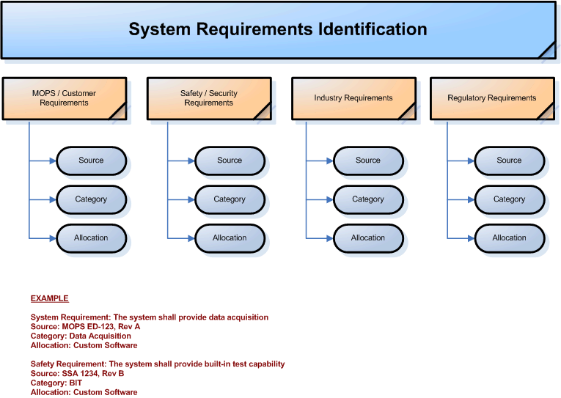
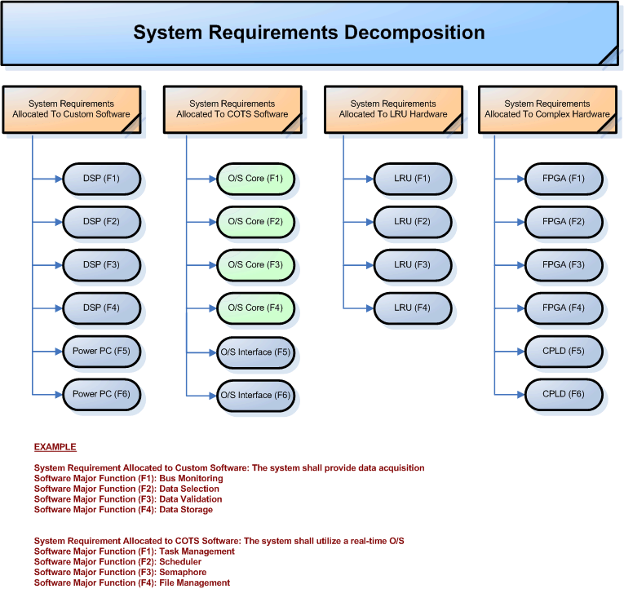
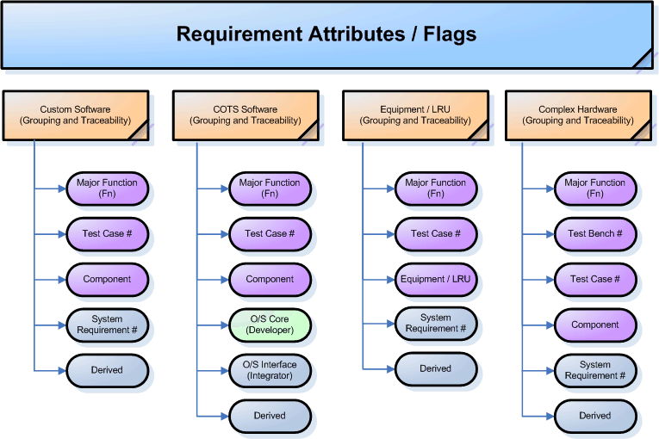
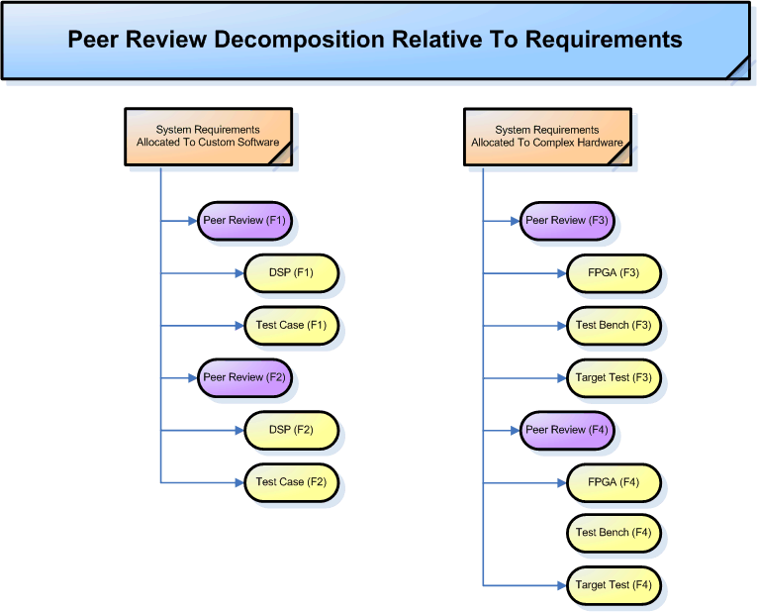
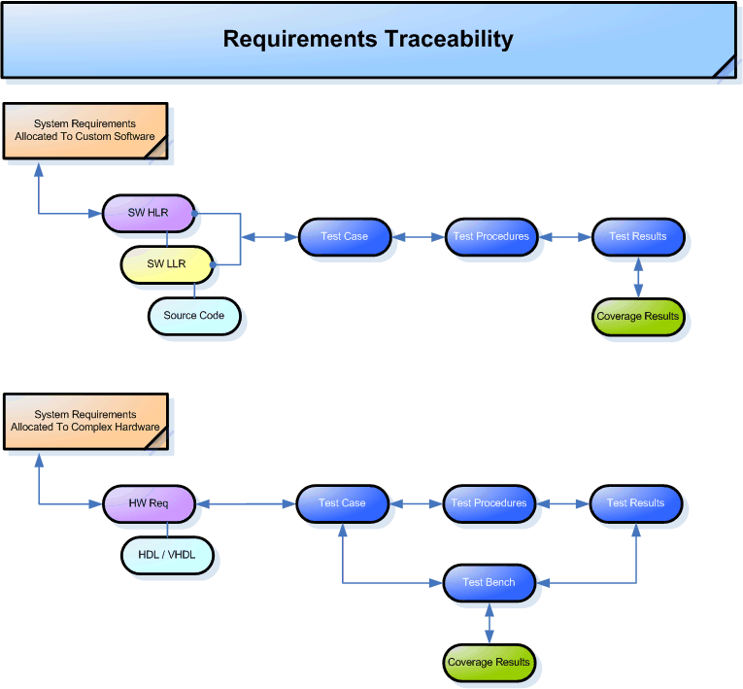

Requirements Definition / Traceability Flow

The following diagram shows the requirements definition and traceability process.

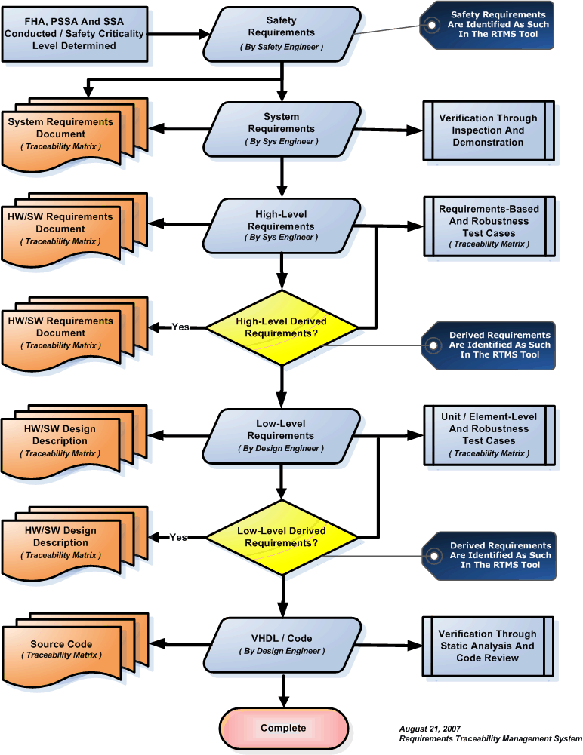

Characteristics of Software Requirements Data
The purpose of the software requirements data is to correctly define all the software requirements. Software requirements data does not describe design or verification details, except for required design constraints. The software requirements data shall limit the range of valid solutions but does not specify a particular design or architecture, thus providing the engineer with flexibility.
The software requirements data must be unambiguous, complete, verifiable, consistent, modifiable, traceable, and usable during the operational life of the software, and the requirements must be uniquely defined. In order to facilitate these characteristics, the project will store all requirements in the RTMS requirement tool. The software requirements data will be generated from the RTMS tool/database. Each of these characteristics is described in the following paragraphs.

Unambiguous
The software requirements data shall be unambiguous.
The software requirements data is unambiguous if every requirement stated has only one interpretation. This requires that each characteristic of the final product be described using a single unique term or phrase. Terminology with a recognized industry definition is used consistent with its established definitions, or a clear alternate definition is provided.

Complete
The software requirements data shall be complete.
Software requirements data is complete if it:
- Includes all significant requirements relating to functionality, performance, design constraints, and external interfaces.
- Contains full labeling and referencing of all its figures, tables, and diagrams, and defines all terms and units of measure.
- Conforms to these Software Requirements Standards.

Verifiable
The software requirements data shall be verifiable.
Software requirements data is verifiable if there is a finite, cost-effective method by which a person or machine can check that the software meets the requirements.

Consistent
The software requirements data shall be consistent.
Software requirements data is consistent if no pairs or sets of individual requirements are in conflict. Requirements in conflict might:
- Use different terms for the same object.
- Specify different characteristics for the same object.
- Specify illogical or impossible relationships between actions.

Modifiable
The software requirements data shall be modifiable.
Software requirements data is modifiable if its structure and style are such that any necessary changes can be made easily, completely, and consistently. This generally requires the software requirements data to have a coherent and easy-to-use organization, with a table of contents and an optional index. In addition, it shall not be redundant, i.e.; the same requirement shall not appear in more than one place, since this could lead to errors later if that requirement needs to be modified. The use of the RTMS tool allows requirements data to be easily modifiable, while maintaining traceability.

Traceable
The software requirements data shall be traceable.
Software requirements data is traceable if its corresponding requirements in the system specification are clear (backward traceability) and if it facilitates the referencing of each requirement in the design and verification data (forward traceability). Backward traceability depends on each requirement referencing its source in previous documents. Forward traceability depends on each requirement in the software requirements data having a unique name or reference number. RTMS accomplishes both forward and backward traceability.

Unique
The software requirements data shall be unique.
Software requirements data is unique if it is distinctively defined such that each requirement statement consists of a single requirement and a single reference tag number. RTMS only allows a single reference tag per requirement.

DEVELOPMENT METHODS
Structured methods will be used to perform requirements identification and traceability. These methods will result in the identification and traceability of System Level Requirements, High-level requirements, Low-Level Software Requirements, and Derived Software Requirements. Using this method, requirements will be written that are unambiguous, consistent, and verifiable.

System Requirements
System requirements allocated to software are high-level functions of the system and represent categories of high-level requirements (e, the system shall process ARINC 429 messages).
System requirements are not verifiable through Test or Analysis. Engineering is responsible for producing the System Requirements Document. This document is the starting point for requirement definition and traceability.
System requirements are categorized into the following types:

- Functional and operational requirements
- Interface requirements
- Performance requirements
- Safety-related requirements
- Security requirements
- Maintenance requirements

System requirements allocated to software will be used as the high-level architecture (categories or buckets of functionality) for developing software test cases and performing verification activities such as peer reviews. System requirements allocated to software are typically based on system states, modes of operation, tasks, etc. Examples of these “buckets” include:

The System SHALL support Data Acquisition
The System SHALL support Data Storage
The System SHALL support ARINC 429 Bus Processing
The System SHALL support IBIT and CBIT
The System SHALL support Health Monitoring

In this example, these system requirements allocated to software represent high-level architectural modularization and encapsulation of functionality. Each of these requirements would provide the basis for determining the number of peer reviews required for the project. For example, the team will hold at least one peer review for each group of high-level software requirements allocated to each “bucket” of functionality. A final peer review would be conducted to analyze the interfacing between these buckets of functionality.

System Requirements Tool Output
The RTMS tool will output each system requirement in a table format. The table will include the unique system requirement number, category, system requirement, source of the requirement, and will identify if the requirement is safety-related.

Three Tier Requirements Model Example
The following example was extracted from RTCA DO-248B and demonstrates the three tier requirements model that is required for compliance with DO-178C (May exclude Level D).

System Requirement

The FADEC shall detect and accommodate the low engine rotor speed (NL) signal for open and short circuit failures, and range failures per hardware dependent software requirements specification limitations.

This could lead to the following high-level software requirement:

Software High-Level Requirement

If the NL rotor speed is outside the range of 5% and 95% or if the NL rate of change is greater than 10% per second, then a fault shall be declared.

The underlying hardware or software may impose limitations in the numeric representation of the NL signal. To ensure adequate granularity exists in the variable associated with the NL variable, the following low-level requirement could be produced:

Software Low-Level Requirement (i.e., Design)

The resolution of NL shall be at least 0.01%

These various requirement levels could be verified as follows:

To verify the system-level requirement one would generate a high-level test that sets up an engine simulation to run at engine idle speed, open circuit the NL signal, short circuit the NL signal, and check that the fault is recorded or annunciated.

The range check verification occurs as a part of the test case

To verify the high-level requirement, one would set input values of the NL signal:

- Just outside, on, and inside its range limits, and
- Above, on, and inside its rate limits.

To verify the low-level requirement one could determine by test input values what the % increment is for a one (1) bit change in the NL signal and determine if it has adequate signal resolution for NL.

System Requirement Output Example

Unlike the example above, this example assumes that there were no system requirements allocated to software. In this case, system requirement “buckets” are developed to represent high level categories (or logical groupings) of high-level requirements.

Req No | System Requirement | Category | Source | Safety
001 | Derived requirements shall be identified, verified and justified. | Derived Requirements | RTCA | FALSE
002 | The system shall read ARINC 429 and select the airspeed label for airspeed data. | ARINC 429 | QRST-12345 | FALSE
003 | The system shall determine the correct state for the XYZ Inhibit Relay. | XYZ State | QRST-12345 | FALSE
004 | The system shall perform continuous functional monitoring to determine fault status. | Functional Monitoring | QRST-12345 | TRUE
005 | The system shall support a commanded XYZ Inhibit functional Built In Test sequence. | Commanded BIT | QRST-12345 | TRUE
006 | The system shall support a coverage analysis output from an SCI port. | Coverage Analysis | DO-178C | FALSE

High-Level Software Requirements
High-level software requirements are verifiable through test or analysis. They are used by the System Architect and Design Engineer to develop the architecture and detailed design and by the Test Engineering to develop requirements-based and robustness test cases.
High-level requirements are those requirements that are developed from analysis of the system requirements, safety-related requirements, and system architecture. High-level requirements are written as individually verifiable requirements. High-level requirements are tested at the “black-box” level.
Special focus will be given to high-level requirements, as they form the basis for the requirements-based normal-range and robustness testing that is used as the basis for determining the structural coverage of the source code.

High-level requirements will include, but not be limited to, the following:

- Functional and operational requirements for each state
- Functional and operational requirements under each mode of operation
- Functional and operational requirements for each state and mode transition
- Functional and operational requirements for each high-level condition and expression
- Performance and test criteria (e.g., precision, accuracy)
- Hardware and software interfaces (e.g., protocols)
- High-level software module interface (data and control coupling)
- Description of how Parameter Data Items are used by the software
- Description of the structure and attributes for each of the Parameter Data Item element and (when applicable) the value of each element.
- Timing requirements and constraints
- Memory size constraints
- Failure detection and health monitoring requirements

High-level requirements are identified with the following categories:

Boolean Requirements
Boolean requirements are the most predominant technique used during requirements definition. They are written in terms of conditional cause and effect expressions as follows:
If X is true and Y is false, A shall do B.
In this case, the requirements are laid out in table format so it is immediately clear whether or not something has been missed (requirements tracking shows you haven't missed implementing and testing your requirements but doesn't so clearly show missed requirements). Examples include:
X false, Y false => A shall do C ------- X false, Y true => A shall do D
X true, Y false => A shall do B -------- X true, Y true => A shall do E
In addition, requirements should be separated by preconditions and stimulus to account for static conditions (e.g. internal system state, external input states) that must exist for the requirement to even apply, followed by the specific stimulus (e.g. input or time-out) that requires the response to occur. The response is then the same 'subject shall action’.

Textual Case Format
Textual use case format for system and high level requirements is also used. The advantages include the ability to capture the purpose, key preconditions, the actors and then, as a set of statements like format A, the sequence of events. While this seems like a lot, it may just be 2 or 3 sentences.
By expanding a nominal case into alternate and exception cases, the development and verification engineer can check if all the values and interactions make sense and uncover any new requirements along the way.
Nominal Case Example:
The system does B when precondition X and Y input values are applied.
Precondition X=True, Y= False.
Verify: A does B
This is a simple example; however, the technique is also used with some of the complex interactions. In this case, the engineer write requirements in this form and capture a lot of information. This also tells a story which the verification engineer, responsible for developing the requirements-based normal and robustness test cases can understand.
Exception Case 1:
Precondition X !=True, Y= False.
Verify A does not do B, but better to say A does C which is usually not open-ended.
Exception Case 2:
Precondition X =True, Y!= False.
Verify Exception Condition is reached.

Input Requirements
Input requirements consist of a list or reference to the appropriate interface documents for all analog, discrete, and serial digital inputs to the system. List or reference the appropriate interface documents for all the inputs to the software from external interface devices. For all inputs, listed or referenced, state the voltage, current, and frequency. State the pre-processing requirements for all inputs. This covers de-bouncing for discrete inputs. Describe the algorithms to be used. Use logical notation and flow charts as necessary. Enter all this requirements data into RTMS.

Functional Requirements
Once the requirements for the inputs to the software are captured, the definition functional requirements may begin. The functional requirements describe in detail the functions to be performed by the system. Describe the designs that are used to meet the functional requirements. Describe the built-in test requirements. Enter all this requirements data into RTMS.

Output and Performance Requirements
Specify the output and performance requirements of the software. List or reference the appropriate interface document, discrete and serial digital outputs specifying their voltage, current, frequency, and the rate of update. Enter all this requirements data into RTMS.

Timing Requirements
The interactions between the software and associated devices are subject to timing constraints. List all of the setup/hold times and frequency constraints from data sheets. Enter the timing constraint data into RTMS.

In addition, requirements should be separated by preconditions and stimulus to account for static conditions (e.g. internal system state, external input states) that must exist for the requirement to even apply, followed by the specific stimulus (e.g. input or time-out) that requires the response to occur. The response is then the same 'subject shall action’.

Complex COTS Key Parameter Requirements

The use of complex Commercial Off-the-Shelf (COTS) components requires the identification and enumeration of device key parameters as part of the overall high level requirements definition. While these parameters may not be well known at the beginning of a given development activity, they will be identified as part of the detailed design process. As such, complex COTS key parameters must be added to the high level hardware requirements so that they can be included in the formal design verification process. The identification of these key parameters (or characteristics) also establishes a reference baseline for such devices in the event that replacement parts must be selected in the future. It is recognized that some of these parameters may overlap, or otherwise be captured, through the identification of Input, Functional, Output/Performance, or Timing requirements as described above.

Complex COTS key parameters may include, but are not limited to, items such as:

- Computational bandwidth
- Internal memory
- Built in timers
- External interrupts
- Built in I/O
- Bus types and speed
- Minimum clock rate
- Number of programmable cells/gates
- Package type

The identified key parameters should be related to the selected device characteristics necessary to satisfy the associated high level system requirements.

Robustness Requirements
Robustness requirements are documented during the requirements process. Robustness test cases are generated from the robustness requirements, ensuring that they are requirements-based. These requirements specify the expected response to abnormal conditions and inputs. The test cases resulting from these requirements are intended to reveal inadequacies in the software requirements, in which case the software requirements are then modified. This method ensures that a complete set of requirements exists that covers all abnormal conditions and inputs.
In addition, this activity is to promote the implementation of a robustness strategy early in the development process. This strategy has two benefits. First, by identifying the vulnerable areas of the design early, architectural mitigation can more easily be implemented during the conceptual and detail design process. Secondly, by including key individuals in the process of robustness requirements definition, it helps to ensure complete and creative robustness test cases. These individuals include, but may not be limited to, Requirements Engineering, Systems Engineering, Safety Engineering and Verification Engineering.
The following represent common types of robustness requirements:
- Exercising fault conditions individually, in sequence and in combination.
- Exercising (high, low, mid and outside) range requirements
- Exercising variables using equivalence class selection of invalid values.
- Exercising System initialization during abnormal conditions.
- Exercising possible failure modes of the incoming data, especially complex, digital data strings from an external system.
- Exercising For loops where the loop count is a computed value, requirements should be developed to account for out-of-range loop count values.
- Exercising protection mechanisms for exceeded frame times.
- For time-related functions, such as filters, integrators, and delays, exercising arithmetic overflow protection mechanisms.
- For state transitions, requirements should be developed to provoke transitions that are not allowed by the software requirements.

Behavioral Hardware Requirements

The highest level of abstraction is the behavioral level that describes a system in terms of what it does (or how it behaves) rather than in terms of its components and interconnection between them. A behavioral description is used to specify the relationship between the input and output signals. This is typically represented as a Boolean expression or a more abstract description such as the Register Transfer or Algorithmic level.

The following is an example of a good behavioral requirement that will result in logic that warns car passengers when the door is open or the seatbelt is not used whenever the car key is inserted in the ignition lock.
Using the correct Boolean requirement structure (If X is true and Y is false, A shall do B), the following requirement will result:
- Software Requirement 01: IF the Ignition is off THEN the warning indication shall not be asserted
- Software Requirement 02: IF the Ignition is on AND the Door is open THEN the warning indication shall be asserted
- Software Requirement 03: IF the Ignition is on AND the Seatbelt Indicator is off THEN the warning indication shall be asserted

In this case, the following logical expression would result:
- Warning = Ignition_on AND ( Door_open OR Seatbelt_off)

Structural Software Requirements

The structural level, on the other hand, describes a system as a collection of gates and components that are interconnected to perform a desired function. A structural description could be compared to a schematic of interconnected logic gates. It is a representation that is usually closer to the physical realization of a system. For the example above, the structural representation is shown in the following figure.

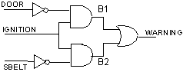

High Level Software Requirement Review Criteria
As the software requirements are expressed in text, the use of unambiguous words and correct language are essential. Pre-release reviews of the software Requirements Data shall use the following criteria:
- Watch for persuasive connectors such as certainly, therefore, or obviously, and ask why they are present.
- Ensure vague terms such as some, usually, or most are clarified. However, avoid the use of vague terms as a general rule.
- Look for statements containing always, every, never, or other terms that imply certainty and ask for proof.
- Ensure lists are complete. Eliminate use of phrases like etc., and so on, or such as.
- Beware of vague verbs such as handled, processed, or eliminated that can be interpreted in many ways.
- Always include units in stated ranges of variables.
- When a term is explicitly defined in one place, make sure that definition applies for other occurrences of the same term.
- If necessary, when a structure is described in words, draw a picture or a table to aid in understanding it.
- When a series of logical conditions are stated, consider the use of formal notation, logic and/or flow diagrams as a more effective way of expression.

High-Level Software Requirements Tool Output
The RTMS tool will output each high-level and derived software requirement in a table format (see example below). The table will include the unique high-level software requirement number, type, software requirement, source of the requirement, and will identify if the requirement is safety related. Once the requirements-based test cases are developed, they will be cross-referenced to each high-level requirement. This will be used as the basis for determining the extent of test coverage.

High-Level Requirement Output Example
004.0011 | The software shall monitor the ARINC 429 SSM bits 30 and 31 for valid airspeed data (both high is good, any other combination is a Fault)

004.0012 | The software shall monitor the XYZ input command

004.0013 | During "No Fault" operation, the software shall toggle the FLT_DRV pin at 1 kHz ± 0.1kHz.

004.0014 | If a "Fault" is detected, the software shall leave the FLT_DRV pin either in the high or the low state (not toggling)

004.0015 | Absense of valid ARINC airspeed data for greater than 1 second shall set the Fault condition

004.0016 | Return of valid ARINC airspeed data shall immediately Clear the Fault condition

004.0017 | The software shall set the Fault condition if a Latched Fault is detected

004.0018 | The software shall set a Latched Fault if the commanded Inhibit state does not match the measured Inhibit relay state (RLY_MON)

004.0019 | The software shall set a Latched Fault if the commanded Fault relay state does not match the measured Fault relay state (FAULT_MON)

004.0020 | The software shall write the Latched Fault status to Non-volitile memory on detection

004.0021 | The software shall clear the Latched Fault and write a No Fault status to Non-volitile memory on successful completion of the Pilot Initiated Test

Low-Level Software Requirements
Low-level software requirements are detailed implementation instructions directed at the Engineer responsible for writing the source code. They are verified through unit test and analysis.
Low-level requirements are typically documented in terms of low-level SHALL statements, function descriptions and pseudo code (least desirable). It is the responsibility of the software architect to define low-level requirements at a granularity that will be fully understood by the implementation engineer and engineers responsible for maintaining the source code. Where multiple implementation paths are available for a high-level requirement, the low-level requirement provides clarification by describing a specific implementation. A competent code developer should be able to implement the design using only the low-level requirements.
Each low-level requirement is individually identified and traced to its higher level requirement. Low-level requirements are tested at the “white-box” level.
If source code can be directly implemented without further information from the high-level requirement, then the high-level requirements may be considered low-level requirements and the guidelines for low-level requirements still apply. In this case, the high-level requirement is duplicated as a low-level requirement. This is required in order to facilitate a logical flow of requirement traceability data.

Low-Level Software Requirements Tool Output
The RTMS tool will output each low-level software requirement in a table format (see example below). The table will include the unique low-level software requirement number, type, software requirement, source of the requirement, and will identify if the requirement is safety related. Once the unit-level test cases are developed, they will be cross-referenced to each low-level requirement.
Low-Level Requirement Output Example

004.0011.0029 | The software shall examine bits 30 and 31 of the ARINC word (SSM bits) and indicate condition when either of or both bits are 0.

004.0011.0030 | The software shall ignore the ARINC word containing an invalid SSM.

004.0012.0031 | The software shall read the numeric representation of the analog XYZ Input Command signal.

004.0012.0032 | The software shall internally flag the valid state of the XYZ Input command, if the value is above 15 V.

004.0012.0033 | The software shall internally flag the invalid state of the XYZ Input command, if the value is below of equal to 15 V.

004.0013.0034 | The software shall configure the pin P1.3 as digital output.

004.0013.0035 | The software shall produce 1 kHz output with 5% to 95% duty cycle range on the FLT_DRV (P1.3) durng the No Fault operation.

004.0013.0035 | The software shall produce 1 kHz output with 5% to 95% duty cycle range on the FLT_DRV (P1.3) durng the No Fault operation.

004.0014.0036 | The software shall configure the pin P1.3 as digital output.

004.0014.0037 | The software shall set the FLT_DRV (P1.3) low during the Fault Detected operation.

004.0015.0038 | The software shall define an ARINC timeout counter of the 1 KHz cycles without the valid ARINC airspeed data present initialized to 0 at power up.

004.0015.0039 | The software shall increment the ARINC timeout counter by 1 each 1 KHz frame, during which the valid ARINC airspeed data was not present.

004.0015.0040 | The software shall set the Fault condition if the ARINC timeout counter exceeds 1000 (1 sec)

004.0016.0041 | The software shall clear the ARINC timeout counter to 0, and clear the Fault condition, if valid ARINC airspeed data is received.

004.0017.0042 | The software shall read the Saved Fault status from non-volitile memory at power up and set the Fault condition if a saved Latched Fault is present.

004.0017.0043 | The software shall OPEN the Fault Relay (set FLT_DRV low), if a Latched Fault is detected.

004.0018.0044 | The software shall set the Inhibit Relay Command as True if XYZ Input command is True AND XYZ Relay Command is TRUE

004.0018.0045 | The software shall monitor the Inhibit Relay Command and the monitor (RLY_MON) signals.

REQUIREMENTS NOTATION

System Requirement Notation

System Requirements Place Holder for Derived Requirements Not Traceable
DO-178C requires that derived requirements be identified and verified. Derived requirements may or may not be traceable to higher level requirements. If they are traceable, the notation “Derived” is placed in the Reference field. In order to facilitate requirements traceability of untraceable derived requirements, a requirement for derived requirements is created at the system level and is used as a “bucket” to hold untraceable derived requirements. This system level category will always be identified as system requirement 001.

System | HL Software | LL Software | Description
001 |  |  | Place Holder for Derived Requirements

System Requirements Identification

System level requirements are identified as incremental numbers between 002 and 999.

System | HL Software | LL Software | Description
002 |  |  | First System Level Requirement
.  .  . |  |  | Incremental Numbering
999 |  |  | Last System Level Requirement

High-level Software Requirements Notation
High-level requirements are identified as incremental numbers between 0002 and 9999.

System | HL Software | Description
002 | 0002 | First High Level Software Level Requirement
003 | 0003 | Second High Level Software Level Requirement
003 | 0004 | Third High Level Software Level Requirement
003 | 0005 | Forth High Level Software Level Requirement
003 | 0006 | Fifth High Level Software Level Requirement
004 | 0007 | Sixth High Level Software Level Requirement
004 | 0008 | Seventh High Level Software Level Requirement

Low-Level Software Requirements Notation
Low-level requirements are identified as one-up numbers between 0001 and 9999.

System | HL Software | LL Software | Description
002 | 0002 | 0001 | First Low Level Software Requirement
002 | 0002 | 0002 | Second Low Level Software Requirement
002 | 0003 | 0003 | Third Low Level Software Requirement
002 | 0004 | 0004 | Forth Low Level Software Requirement
003 | 0004 | 0005 | Fifth Low Level Software Requirement
003 | 0004 | 0006 | Sixth Low Level Software Requirement
006 | 0008 | 0007 | Seventh Low Level Software Requirement

High-Level Derived Software Requirements Notation
High-Level derived requirements are identified using the next available incremental reference number at the high-level tier, and by tracing to the system level derived requirement placeholder [001]. This is illustrated below.

System | HL Software | Description
001 | 0001 | Place holder for LL Derived Software Requirement
001 | 0004 | First Derived HL Software Requirement
001 | 0016 | Second Derived HL Software Requirement
001 | 0027 | Third Derived HL Software Requirement
001 | 0035 | Forth Derived HL Software Requirement

Low-Level Derived Software Requirements Notation
Low-Level derived requirements are identified using the next available incremental reference number at the low-level tier, and by tracing to the high-level derived requirement placeholder [0001]. This is illustrated below.

System | HL Software | LL Software | Description
001 | 0001 | 0001 | First Derived LL Software Requirement
001 | 0001 | 0021 | Second Derived LL Software Requirement
001 | 0001 | 0063 | Third Derived LL Software Requirement
001 | 0001 | 0104 | Forth Derived LL Software Requirement

Requirements Traceability

Trace data establishes the associations between life cycle data items contents. Trace data will be provided that demonstrates bi-directional associations between:

- System requirements allocated to software and high-level requirements.
- High-level requirements and low-level requirements.
- Low-level requirements and Source Code.
- Software Requirements and on-target test cases.
- Test cases and test procedures.
- Test procedures and test results.

The Trace Data between test procedures and test results is part of the Software Verification Results. The following will be provided as objective evidence of compliance:

- Trace data, showing the bi-directional association between system requirements allocated to software and high-level requirements, is developed to enable verification of the complete implementation of the system requirements allocated to software and give visibility to the derived high-level requirements.

- Trace data, showing the bi-directional association between the high-level requirements and low-level requirements, is developed to enable verification of the complete implementation of the high-level requirements and give visibility to the derived requirements and the architectural design decisions made during the software design process.

- Trace data, showing the bi-directional association between low-level requirements and Source Code, is developed to enable verification that no Source Code implements an undocumented function and verification of the complete implementation of the low-level requirements.

The following activities will be performed (still need to add the who, what, where and when information):

- The traceability between the software requirements and the test cases is verified during the requirements-based coverage analysis.

- The traceability between the software requirements and the test results is verified during the requirements-based coverage analysis.

- Completeness of the test coverage of software structure is demonstrated by the structural coverage analysis.

DERIVED SOFTWARE REQUIREMENTS
Derived requirements are additional requirements resulting from the software development processes, which may not be directly traceable to higher level requirements. In order to facilitate a logical flow of requirements traceability data, a system level-derived requirement placeholder may be established (if this type of untraceable derived requirement is anticipated). In this case, this would be recorded as the first system level requirement and is identified as 01.

Output of Derived Software Requirements That Are Not Traceable

01.001 | Category: | Functional & Operational
01.001 | Type: | Regulatory
Sys Requirement ( 01 )
Derived requirements shall be identified and verified.
HL HW Requirement
The Software shall do something testable.
Req Source: | System Requirements Document
Req Number: | SYS 01 |  | Paragraph: | 4.0
Safety Related: | False |  | Req Test Case:
Reference: | Customer Spec 5.12.3

Output of Derived Software Requirements That Are Traceable

03.056 | Category: | Functional & Operational
03.056 | Type: | Derived
<Same as above>

REQUIREMENTS DEVELOPMENT TOOLS

Requirements Traceability Management System
The Requirements Traceability Management System generates a unique database record for each requirement. Requirement definition is recorded from the System Level to the High-Level Software Requirements to the Low-Level Software Requirements to the Code to the Test Cases.
The system generates requirements-to-code, requirements-to-test and code-to-requirements Matrices. The system outputs tables are directly inserted into the System Requirements Document, Software Requirements Document, and Software Design Description.
Main Requirements Management System Interface

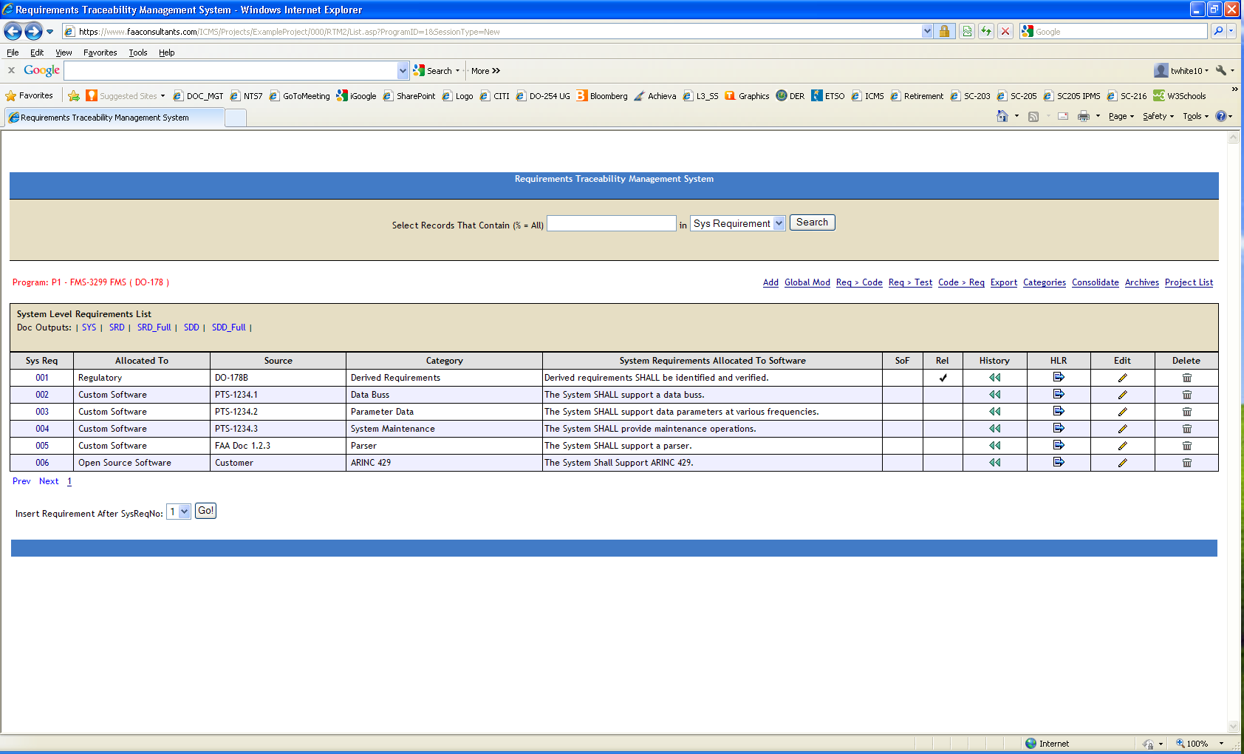

REQUIREMENTS TRACEABILITY MATRIX

Software Requirements to Code

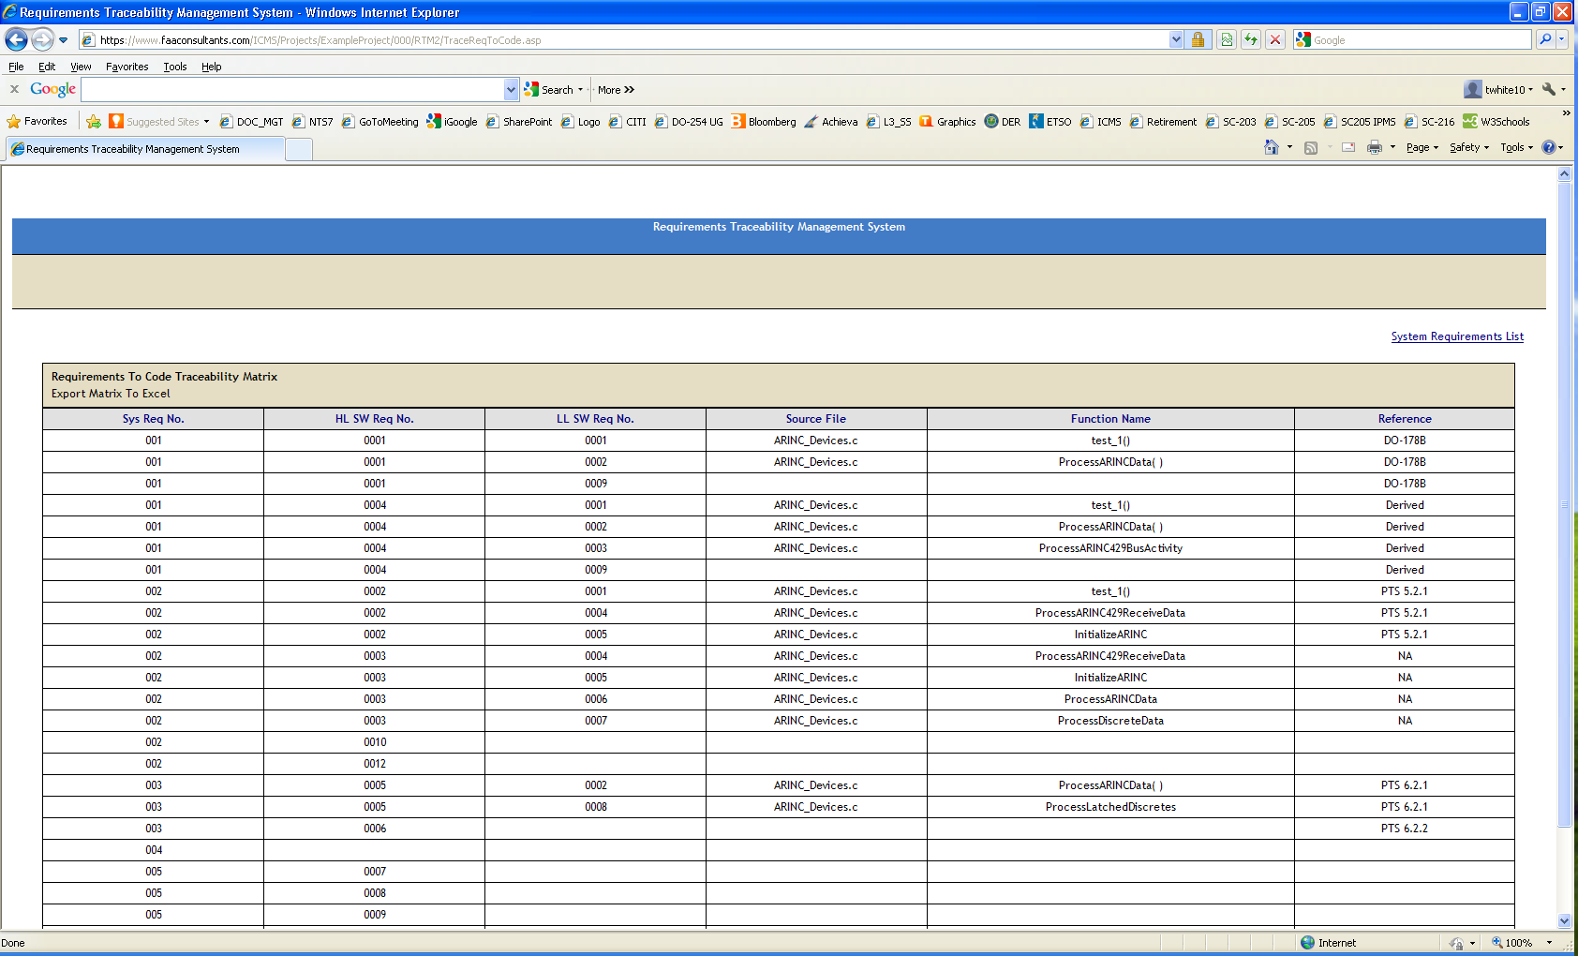

Software Requirements To Test

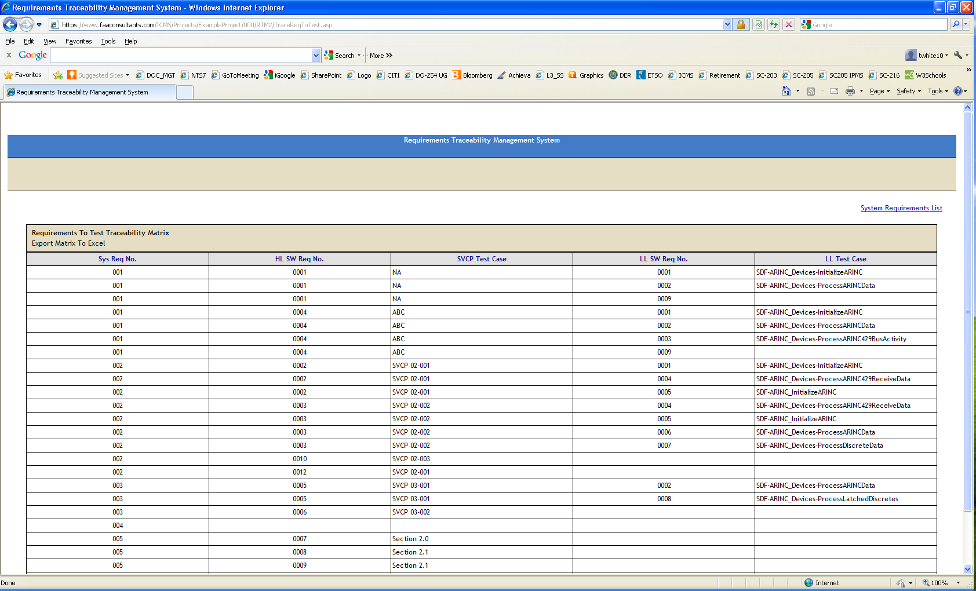

Code To Software Requirements

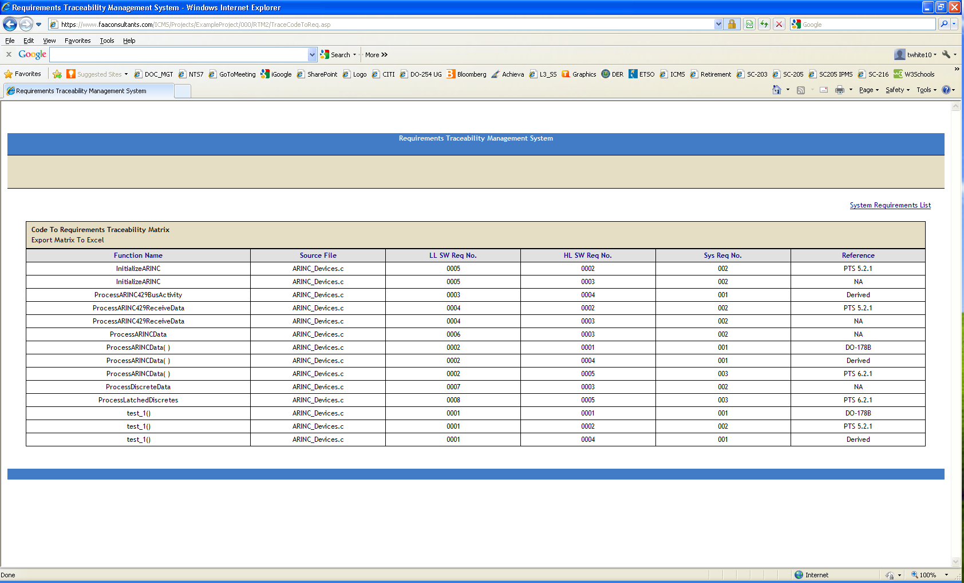
Detail Screen for High-Level Requirements

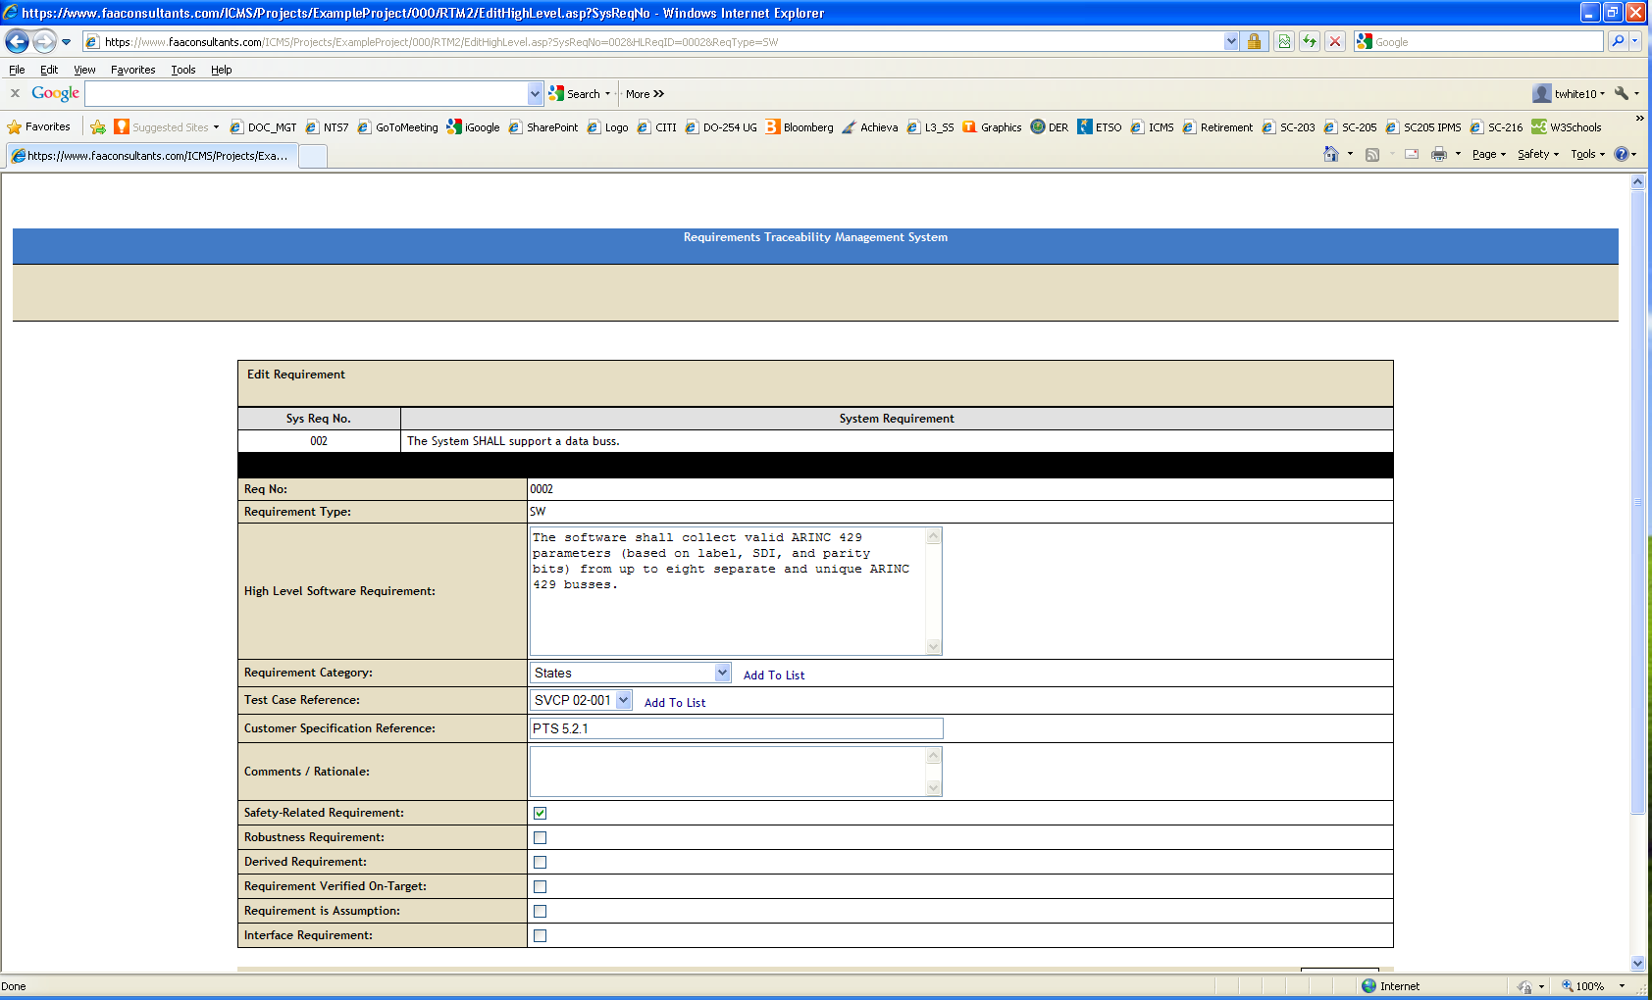

Detail Screen for Low-Level Requirements

