
DISCLAIMER

Copyright 2017, Airworthiness Certification Services, Inc. (ACS) in partnership with the Avionics Certification Academy.

All rights reserved.

These Templates are perpetually licensed for a single company, for the site and/or project team who initially purchased. The purchaser can use the Templates, or any customized variant of them, on as many projects as desired. The Templates may not be shared outside of the purchasing company with the exception of interactions with customers and program auditors. The Purchaser agrees to these terms as part of the sale. If a worldwide Corporate License is desired, which provides unlimited access for all sites and project teams within a company, contact info@avionics-certification-academy.com for details and a quote.

This Template is proprietary to ACS. and should not be distributed or copied in its original format without written permission. It is to be used solely as the basis of documentation for the purchaser of this template. Also, it should not be viewed as FAA opinion or regulatory guidance and presents only opinion and interpretation of FAA information by ACS.

All references to DO-178C and/or DO-254 material are copyrighted by and used with permission from:
RTCA, Inc.
1150 18th Street NW, Suite 910
Washington, DC 20036
(202) 833-9339
www.rtca.org

ACS hereby disclaims all warranties and conditions with respect to these Templates, either express, implied or statutory, including, but not limited to, the implied warranties and/or conditions of merchantability, of satisfactory quality, of fitness for a particular purpose, of accuracy, or quiet enjoyment, and non-infringement of third party rights. ACS does not warranty against interference with clients enjoyment of the Templates, that the functions contained in the Templates will meet the client’s requirements, that the Templates will be error-free or that defects in the templates will be corrected.
No oral or written information or advice given by ACS or by an ACS authorized representative shall create a warranty should the Templates prove defective, client assumes the entire cost of all necessary servicing, repair or correction.

Downloading and using these templates signifies you have read and accepted these conditions.

Please direct all questions or concerns to:
Airworthiness Certification Services
25327 SE Mirrormont Blvd Issaquah WA 98027
Phone: 206-226-6561, email: info@airworthinesscert.com

NOTE: YOU MAY REMOVE THIS PAGE FROM YOUR TEMPLATES AFTER READING THIS DISCLAIMER


Software Accomplishment Summary
for the
<Program Name>
Document No: <Doc Number>
Revision: -

__________________________________________________ |  |  | ___________
<Name>, Program Manager |  | Date
__________________________________________________ |  | ___________
<Name>, Technical Project Lead |  | Date
__________________________________________________ |  | ___________
<Name>, Engineer |  | Date
__________________________________________________ |  | ___________
<Name>, Quality Engineer |  | Date

Notice
This document and the information contained herein are the property of <Company Name>. Any reproduction, disclosure or use thereof is prohibited except as authorized in writing by <Company Name>. Recipient accepts the responsibility for maintaining the confidentiality of the contents of this document.

REVISIONS
Rev. | Reason/Description | Requested/ Changed By | Date

Table of Contents

Section Page
1.0 INTRODUCTION 7
1.1 Purpose 7
1.2 Scope 7
1.3 Definitions 7
1.4 Part Number and Nomenclature 8
1.5 Special Considerations Cross Reference 9
1.6 Team Members and Signature Authority 10
1.6.1 Independent Reporting Structure 11
1.6.1.1 Software Quality Assurance Independence 11
1.6.1.2 Verification Independence of DO-178C Objectives 12
1.6.2 Signature Authority 15
1.7 Organizational Responsibilities 15
1.8 Acronyms and Abbreviations 17
1.9 Applicable Documents 18
1.9.1 External Documents 18
1.9.2 Internal Documents 18
2.0 SYSTEM OVERVIEW 19
2.1 Mechanical Systems Top level Diagram 19
2.1.1 System Functions Allocated to Mechanical Hardware 19
2.2 Electrical Systems Top Level Block Diagram 20
2.2.1 System Functions Allocated to Electrical Hardware and Software 21
2.2.1.1 Data Acquisition Printed Circuit Board #1 21
2.2.1.2 Input / Output Printed Circuit Board #2 21
2.2.1.3 Monitor Printed Circuit Board #3 21
2.3 System Functional Description 22
2.3.1 System Failure Conditions 23
2.3.2 High-Level Hardware Functions and Contribution to Potential Failures 23
2.3.3 Safety and Partitioning 23
3.0 SOFTWARE OVERVIEW 24
3.1 Software Architectural Block Diagram 24
3.2 Processor #1 24
3.2.1 States and Modes 24
3.2.2 Tasks 24
3.3 Processor #2 24
3.3.1 States and Modes 24
3.3.2 Tasks 24
3.4 COTS Software Identification 24
3.4.1 Real Time Operating System 24
3.4.2 Board Support Package 24
3.4.3 Compiler Provided Libraries 24
3.5 Deactivated Code Partitioning 25
3.5.1 USB Interface Code 25
3.5.2 RS-232 Interface Code 25
3.5.3 Ethernet Interface Code 25
3.5.4 Boot Load Code Partitioning 25
3.6 Safety and Partitioning 26
3.6.1 Safety Monitoring 26
3.7 Resource Sharing <Example Text> 26
3.8 Redundancy 26
3.9 Fault Tolerance <Example Text> 26
3.10 Timing and Task Scheduling 26
3.10.1 Timing <Example Text> 26
3.10.2 Task Scheduling <Example Text> 27
4.0 CERTIFICATION CONSIDERATIONS 28
4.1 Certification Basis and Means of Compliance 28
4.2 Issue Papers and Certification Review Items (CRI) 28
4.3 Software Level Determination 29
4.4 Compliance Matrix 31
4.4.1 Software Conformity Objectives 58
5.0 SOFTWARE CHARACTERISTICS 65
5.1 Software Size 65
5.2 Timing 65
5.3 Memory Margins 65
5.3.1 Program Flash Usage 65
5.3.2 Processor RAM Usage 66
5.3.3 NVRAM Usage 66
5.3.4 Flash Usage 66
5.3.5 Processor Bandwidth Utilization 67
6.0 SOFTWARE LIFE CYCLE 68
6.1 Team Member Responsibilities 69
6.2 Relationship Between Processes and Activities 72
6.3 Interaction Among Processes 73
6.3.1 System Lifecycle Flow Diagram 73
6.3.2 Hardware and Software Lifecycle Flow Diagram 74
6.3.3 Software Incremental Development Lifecycle Flow Diagram 75
6.4 Means of Providing Feedback 76
6.4.1 Feedback to the System and Safety Process 76
6.4.2 Feedback to the Development and Integral Processes 77
6.5 Traceability of Reviews and Analysis Results 78
6.6 Summary of Problem Reporting Methods 79
6.7 Software Planning Process 80
6.7.1 Software Planning Process Objectives 80
6.7.2 Software Planning Process Deviations from the PSAC 80
6.8 Software Requirements Process 81
6.8.1 Software Requirements Process Objectives 81
6.8.2 Software Requirements Process Deviations from the PSAC 81
6.9 Software Design Process 82
6.9.1 Software Design Process Objectives 82
6.9.2 Software Design Process Deviations from the PSAC 82
6.10 Software Coding Process 83
6.10.1 Software Coding Process Objectives 83
6.10.2 Software Coding Process Deviations from the PSAC 83
6.11 Integration Process 84
6.11.1 Integration Process Objectives 84
6.11.2 Integration Process Deviations from the PSAC 84
6.12 Software Testing Process 85
6.12.1 Software Testing Process Objectives 85
6.12.2 Software Testing Process Deviations from the PSAC 85
7.0 SOFTWARE LIFE CYCLE DATA 86
7.1 Overview 86
7.2 Trace Data 86
7.2.1 Trace Data Objective Evidence of Compliance 87
7.3 Software Lifecycle Data to Be Produced and Controlled 88
7.4 Relationship of Lifecycle Data to Other Data Defining the System 90
7.5 Software Lifecycle Data to be Submitted to Certification Authority 91
7.6 Software Control Categories 92
7.7 Software Lifecycle Data DER Delegation 93
8.0 ADDITIONAL CONSIDERATIONS 94
8.1 Use of Previously Developed Software 94
8.2 Tool Qualification 97
8.2.1 Development Tools 97
8.2.1.1 Qualification of Development Tools 97
8.2.2 Qualified Verification Tools 98
8.2.2.1 Qualification of Verification Tools 98
8.3 Alternative Methods 98
9.0 SOFTWARE IDENTIFICATION 99
10.0 CHANGE HISTORY 100
11.0 SOFTWARE STATUS 101
12.0 COMPLIANCE STATEMENT 102

List of Figures

Figure 1-1 Organization Chart 11
Figure 2-1 System Level Block Diagram 20
Figure 2-2 System Functional Diagram 22
Figure 5-1 Relationship Between Processes and Activities 72
Figure 5-2 System Lifecycle Flow Diagram 73
Figure 5-3 Hardware and Software Lifecycle Diagram 74
Figure 5-4 Software Incremental Development Lifecycle Flow 75
Figure 5-5 System and Safety Process Feedback Flow Diagram 76
Figure 5-6 Lifecycle Process Feedback Flow Diagram 77

List of Tables

Table 1-1 Definitions 8
Table 1-2 Part Number and Nomenclature 8
Table 1-3 Team Members and Signature Authority 10
Table 2-1 System Failure Conditions 23
Table 4-1 List of Compliance Documents 28
Table 4-2 List of Issue Papers and CRI’s 28
Table 4-3 Design Assurance Levels 30
Table 4-13 Compliance Matrix – Certification Liaison Process 57
Table 4-14 Compliance Matrix - Software Conformity Process 64
Table 5-1 Software Size 65
Table 5-2 Executable object Code Size 65
Table 5-3 Program Flash Usage 65
Table 5-4 Processor RAM Usage 66
Table 5-5 NVRAM Usage 66
Table 5-6 Flash Usage 66
Table 5-7 Processor Bandwidth Utilization 67
Table 6-1 Team Member Responsibilities 71
Table 5-2 Summary of Problem Reporting Methods 79
Table 6-2 Software Planning Process Objectives 80
Table 6-3 Software Requirements Process Objectives 81
Table 6-4 Software Design Process Objectives 82
Table 6-5 Software Coding Process Objectives 83
Table 6-6 Integration Process Objectives 84
Table 6-7 Software Testing Process Objectives 85
Table 7-1 Lifecycle Data To be Produced 88
Table 7-2 Lifecycle Data To Certification Authority 91
Table 7-3 Software Control Categories 92
Table 7-4 Software DER Delegation 93
Table 8-1 Software Development Tools 97
Table 8-2 Software Verification Tools 98
Table 9-1 Software Identification 99
Table 11-1 Software Status – Open Problem Reports 101

INTRODUCTION

Purpose
This plan describes the Software Life Cycle Processes that have been implemented on the <Program Name> Program and has been prepared in accordance with the requirements of RTCA/DO-178C.
Differences between the Plan for Software Aspects of Certification and the Software Accomplishment Summary are identified in each section of the lifecycle process.

Scope
This document is to be used by the certification authority to determine if the completed Software Life Cycle Process is commensurate with the rigor required for the level of software being developed and complies with the approved plans. The processes described in this document have been implemented during the development and product life cycle of the deliverable airborne software. This Software Accomplishment Summary complies with the documentation requirements of RTCA/DO-178C, Section 11.20.

Definitions

Definition | Meaning
COTS IC | Any COTS digital or hybrid electronic device which does not execute software in a specific core. COTS ICs may be bus controllers, flip-flop, multiplexers, converters, memories… The hardware functions implemented within these components may be simple or complex. (See also definition of SEH below).
COTS Graphical Processor | Any COTS microcontroller specifically designed for graphical applications. COTS graphical processors for airborne systems are required to have built in mitigation against Hazardous and Misleading information(HMI).
COTS Microcontroller | Any IC which executes software in a specific core area (Central Processing Unit) and implements peripheral hardware elements such as, for example, input/output (I/O), bus controllers… Such a peripheral element may be considered simple (e.g. a UART, A/D, D/A) or complex (e.g. a bus controller). (See also definition of SEH below).
Highly complex COTS microcontroller | Any microcontroller where at least one of the statements below is true:  - more than one Central Processing Unit (CPU) is embedded and they use the same bus (which is not strictly separated or which uses the same single port memory)  - several complex interfaces are dependent on each other and exchange data  - several internal busses are integrated and are used in a dynamic way (for example, a dynamic bus switch matrix)
Integrated Circuit | A circuit (also IC, microcircuit, microchip, silicon chip, or chip) consisting of elements inseparably associated and formed in-situ on or within a single substrate to perform an electronic circuit function. Among the most advanced integrated circuits are the microprocessors or "cores", digital memory chips, ASICS and bus controllers. Integrated circuits can be classified into analog, digital and hybrid signal:  - Digital integrated circuits are typically microprocessors, DSPs, an micro controllers and work using binary mathematics to process "one" and "zero" signals.  - Analog ICs, such as sensors, power management circuits, and operational amplifiers, work by processing continuous signals. They perform functions like amplification, active filtering, demodulation, mixing, etc.  - Hybrid ICs can combine analog and digital circuits on a single chip to create functions such as A/D converters and D/A converters.  Digital and Hybrids ICs include ASIC, COTS ICs, highly complex, COTS Microcontroller, Microprocessor, COTS Microcontroller, COTS Graphical Processor, PLD, CEH, SEH.
Microprocessor | A single Central Processing Unit which executes software and does not contain any additional integrated peripheral hardware element such as a UART, A/D, D/A, bus controller, Time Processing Unit, Memory Management Unit, watchdog, etc.
Table 1-1 Definitions

Part Number and Nomenclature

Part Number | Nomenclature
Table 1-2 Part Number and Nomenclature

Special Considerations Cross Reference

Software Consideration | Applicable | Addressed In Doc / Section
General Processor, DSP, etc. | Y/N
COTS Graphical Processor (CGP) | Y/N
Product Service History | Y/N
Legacy System Software | Y/N
Previously Developed Software | Y/N
Field Loadable Software | Y/N
Option-Selectable Software | Y/N
User-Modifiable Software | Y/N
Safety Monitoring Software | Y/N
COTS Software | Y/N
Public Domain Software | Y/N
Parameter Data / Databases | Y/N
Operating System | Y/N
Compiler Provided Libraries | Y/N
Board Support Package | Y/N
Dead, Unreachable or Deactivated Code | Y/N
DAL Justification | Y/N
Derived / Safety Requirements | Y/N
Robustness Requirements / Testing | Y/N
Structural Coverage Analysis | Y/N
Data and Control Coupling Analysis | Y/N
Partitioning (Multi-DAL) | Y/N
Exhaustive Input Testing | Y/N
Development Tool Qualification | Y/N
Verification Tool Qualification | Y/N
Single Event Upset (SRAM) | Y/N
Formal Methods | Y/N
Model Based Development | Y/N
Object Oriented Technology | Y/N
Domestic / Off-Shore Supplier | Y/N
International Cert (EASA, TCCA, etc.) | Y/N
Open Problem Report Management | Y/N
Issue Papers / Certification Review Items | Y/N

Team Members and Signature Authority

Name | Title
Signature Authority / PRB & CCB Members:
John Smith | Systems Engineer
John Smith | Software Lead
John Smith | Independent Verification Engineer
John Smith | Software Quality Engineer
John Smith
Team Members:
John Smith | Systems Engineer
John Smith | Safety Engineer
John Smith | Software Design Engineer
John Smith | Configuration Management Specialist
John Smith
Peer Review Members:
John Smith | Systems Engineer
John Smith | Software Engineer
John Smith
Transition Review Team:
John Smith | Project Engineer
John Smith | Certification Manager
John Smith | Software Quality Engineer (SQA Records)
John Smith | Systems Engineer
John Smith | Safety Engineer
Table 1-3 Team Members and Signature Authority

Independent Reporting Structure

The following chart shows that the Quality Assurance Organization is independent from Engineering. It also demonstrates that the verification and test activities are performed independently by someone other than the development engineer.

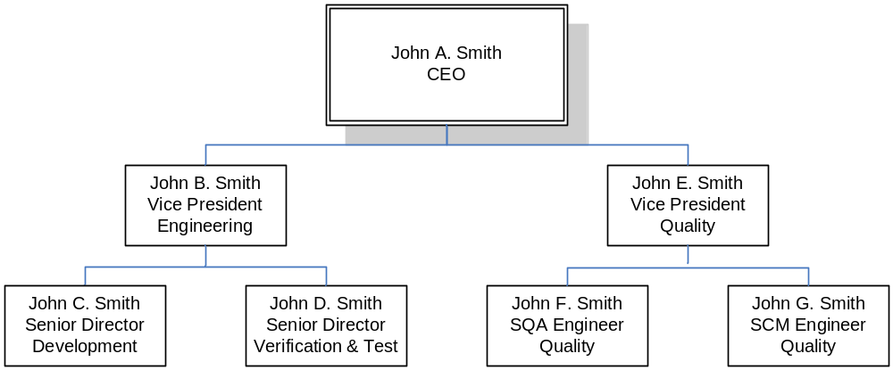
Figure 1-1 Organization Chart

Software Quality Assurance Independence
SQA assesses the software life cycle processes and their outputs to obtain assurance that objectives are satisfied, deficiencies are detected, evaluated, tracked, and resolved, and software product and software life cycle data conform to certification requirements. The SQA role is an oversight role for the entire project. As such, SQA does not perform any of the development or verification activities. In addition, the SQA reporting structure is independent of Engineering, Test, Manufacturing, and Project Management.

Verification Independence of DO-178C Objectives
The following matrix shows the DO-178C objectives that will be satisfied with independence. In addition, the item being verified and the role of the individual performing the verification is also shown.

Table | Objective | Verification Activity | Item Being Verified | Interpretation
A-3(1) | Software high-level requirements comply with system requirements. | Reviews and Analyses of the High-Level Requirements | High-level requirements | The reviews and analyses of the high-level requirements will be performed by a person(s) other than the developer of the high-level requirements.
A-3(2) | High-level requirements are accurate and consistent. | Reviews and Analyses of the High-Level Requirements | High-level requirements
A-3(7) | Algorithms are accurate. | Reviews and Analyses of the High-Level Requirements | High-level requirements
A-4(1) | Low-level requirements comply with high-level requirements. | Reviews and Analyses of the Low-Level Requirements | Low-level requirements | The reviews and analyses of the low-level requirements will be performed by a person(s) other than the developer of the low-level requirements.
A-4(2) | Low-level requirements are accurate and consistent. | Reviews and Analyses of the Low-Level Requirements | Low-level requirements
A-4(7) | Algorithms are accurate. | Reviews and Analyses of the Low-Level Requirements | Low-level requirements
A-4(8) | Software architecture is compatible with high-level requirements. | Reviews and Analyses of the Software Architecture | Software architecture | The reviews and analyses of the software architecture will be performed by a person(s) other than the developer of the software architecture.
A-4(9) | Software architecture is consistent. | Reviews and Analyses of the Software Architecture | Software architecture
A-4(13) | Software partitioning integrity is confirmed. | Reviews and Analyses of the Software Architecture | Software architecture
A-5(1) | Source Code complies with low-level requirements. | Reviews and Analyses of the Source Code | Source Code | The reviews and analyses of the Source Code will be performed by a person(s) other than the developer of the Source Code.
A-5(2) | Source Code complies with software architecture.
A-5(6) | Source Code is accurate and consistent.
A-6(3) | Executable Object Code complies with low-level requirements. | Requirements-Based Testing | Executable Object Code | The person(s) who created a set of low-level requirements-based test cases should not be the same person(s) who developed the associated Source Code from those low-level requirements. It follows that:  1. The same person(s) could develop the low-level requirements and the Source Code, provided another person(s) develops the test cases from those low-level requirements, or  2. The same person(s) could develop the low-level requirements and their associated test cases, provided another person(s) develops the Source Code.
A-6(4) | Executable Object Code is robust with low-level requirements. | Requirements-Based Testing | Executable Object Code
A-7(1) | Test procedures and expected results are correct. | Reviews and Analyses of the Test Procedures | Test procedures | The reviews and analyses of the test procedures will be performed by a person(s) other than the developer of the test procedures.
A-7(2) | Test results are correct and discrepancies explained. | Reviews and Analyses of the Test Results | Test results | The reviews and analyses of the test results will be performed by a person(s) other than the person(s) who performed the tests.
A-7(3) | Test coverage of high-level requirements is achieved. | Requirements-Based Test Coverage Analysis | Test cases | The requirements-based test coverage analysis will be performed by a person(s) other than the developer of the test cases.
A-7(4) | Test coverage of low-level requirements is achieved. | Requirements-Based Test Coverage Analysis | Test cases
A-7(5) | Test coverage of software structure (modified condition/decision) is achieved. | Structural Coverage Analysis | Test cases, test procedures, and/or test results | The exact independence required depends on how the structural coverage analysis is carried out. For example, if the structural coverage analysis is performed on the test cases, then the structural coverage analysis will be performed by a person(s) other than the developer of the test cases. Similarly, if the structural coverage analysis is performed on the test procedures and test results, then the structural coverage analysis will be performed by a person(s) other than the developer of the test procedures and test results.
A-7(6) | Test coverage of software structure (decision coverage) is achieved. | Structural Coverage Analysis | Test cases, test procedures, and/or test results
A-7(7) | Test coverage of software structure (statement coverage) is achieved. | Structural Coverage Analysis | Test cases, test procedures, and/or test results
A-7(8) | Test coverage of software structure (data coupling and control coupling) is achieved. | Structural Coverage Analysis | Test cases, test procedures, and/or test results

Signature Authority
“Signature Authority”, as used herein, is a project-level approval authority that is composed of the following members at minimum:
- Project Manager
- Software Lead
- Independent Verification Engineer
- Software Quality Engineer
Other team members may be required to sign specific documents in addition to this core group, depending on the content of the document. For example, a Configuration Management Specialist is required to sign the Software Configuration Management Plan to acknowledge acceptance of the CM processes defined therein.

Organizational Responsibilities

Project Role | Department | Responsibility
Project Engineer | Program Management | Manage all project activities, including planning, coordination of system life cycle processes, and scheduling of major milestones. Provides liaison with company management.
Software Lead | Software Engineering | Manage all aspects of software development including planning, technical direction, collection and analysis life cycle data, coordination of life cycle processes and scheduling of major milestones. Participate in the software release, change, and baseline process as a required member of the SCCB.
Systems Engineer | Systems Engineering | Develop high level requirements and the high level architecture in accordance with the DO-178B guidelines and engineering procedures.
Safety Engineer | Systems Engineering | Performs the System Safety Assessment (SSA) which determines and categorizes the failure conditions of the system and from that defines safety related requirements. Reviews all requirements changes. Approves derived requirements.
Software Engineer(s) | Software Engineering | Develop software standards, architecture, requirements, design, source code and executable code in accordance with software procedures and DO-178B guidelines. Conduct reviews and analysis of life cycle data. Implement changes during verification testing as required.
Independent Verification Engineer(s) | System/Software/Test Engineering | Conduct independent verification including test development, reviews, analysis, and performing tests in accordance with the Software Verification Plan (SVP).
Software Quality Engineer | Software Quality Assurance | Assure that the software life cycle processes produce software that conforms to its requirements by ensuring that project activities are performed in compliance with the SQAP. Conduct Product Reviews, Process Reviews, and Audits throughout the software development life cycle in accordance with checklists provided in Appendix A of the SQAP.
Configuration Management Specialist | Configuration Management | Provide configuration management of all project life cycle data in accordance to the Software Configuration Management Plan. Assure that changes in hardware, software, documentation, and delivered products conform to the Configuration Item (CI) baseline(s). Ensures the integrity of configuration identification of released products. The CM manager or designee is the chair for the SCCB.
Certification Manager | Program Management/ Project Technical Lead | Ensure that the software development and life cycle data meet customer requirements and DO-178B and guidelines

Acronyms and Abbreviations

RAMS Reviews and Analysis Management System
CAMS Coverage Analysis Management System
CC1 DO-178C Control Category 1
CC2 DO-178C Control Category 2
CI Configuration Item
CM Configuration Management
COTS Commercial off the Shelf
CPU Central Processing Unit
CSC Computer Software Component
CSCI Computer Software Configuration Item
CSU Computer Software Unit
DER Designated Engineering Representative
DRMS Document Review Management System
FAA Federal Aviation Administration
FHA Functional Hazard Assessment
IVT Independent Verification Testing
MC/DC Modified Condition/Decision Coverage
MISRA Motor Industries Software Reliability Association
MLCP Master Load Control Procedure
PEMS Project Event Management System
PRMS Problem Reporting Management System
PSAC Plan for Software Aspects of Certification
PSSA Preliminary System Safety Assessment
PVCS Serena PVCS Version Control Software
QA Quality Assurance
RTCA Radio Technical Commission for Aeronautics
RTMS Requirements Traceability Management System
SAS Status Accounting System
SCI Software Configuration Index
SCM Software Configuration Management
SCMP Software Configuration Management Plan
SCS Software Coding Standard
SDD Software Design Description
SDS Software Design Standard
SDP Software Development Plan
SECI Software Environment Configuration Index
SQA Software Quality Assurance
SQAP Software Quality Assurance Plan
SQE Software Quality Engineer
SRS Software Requirements Standard
SSA System Safety Assessment
SVC&P Software Verification Cases and Procedures
SVCP Software Verification Cases and Procedures
SVP Software Verification Plan
SWRD Software Requirements Document
VR Verification Results
VSS Visual Source Safe

Applicable Documents
The following documents are listed for reference only. Each document is applicable to this plan only to the extent specified herein.

External Documents
RTCA/DO-178C Software Considerations in Airborne Systems and Equipment Certification
FAA Order 8110.4C Type Certification
FAA Order 8110.49 FAA, Software Approval Guidelines
AC 20-115B Advisory Circular, RTCA Inc., Document DO-178C, Software Considerations in Airborne Systems and Equipment Certification

Internal Documents

<Ref Doc> Plan for Software Aspects of Certification (Ref. DO-178C, 11.1)
<Ref Doc> Software Development Plan (Ref. DO-178C, 11.2)
<Ref Doc> Software Verification Plan (Ref. DO-178C, 11.3)
<Ref Doc> Software Configuration Management Plan (Ref. DO-178C, 11.4)
<Ref Doc> Software Quality Assurance Plan (Ref. DO-178C, 11.5)
<Ref Doc> Software Requirements Standards (Ref. DO-178C, 11.6)
<Ref Doc> Software Design Standards (Ref. DO-178C, 11.7)
<Ref Doc> Software Code Standards (Ref. DO-178C, 11.8)
<Ref Doc> Software Requirements Document (Ref. DO-178C, 11.9)
<Ref Doc> Software Design Description (Ref. DO-178C, 11.10)
<Ref Doc> Build Procedure for Source Code (Ref. DO-178C, 11.11)
<Ref Doc> Load Control for Executable Object Code (Ref. DO-178C, 11.12)
<Ref Doc> Software Verification Cases and Procedures (Ref. DO-178C, 11.13)
<Ref Doc> Software Verification Results (Ref. DO-178C, 11.14)
<Ref Doc> Software Environment Configuration Index (Ref. DO-178C, 11.15)
<Ref Doc> Software Configuration Index (Ref. DO-178C, 11.16)
<Ref Doc> Software Accomplishment Summary (Ref. DO-178C, 11.20)

SYSTEM OVERVIEW
This section provides an overview of the system, including a description of the mechanical enclosure and interfaces, electrical functions and their allocation to hardware and software, the architecture, processor(s) used hardware / software interfaces and safety features.

<Example Text>
The Avionics Passenger Counter is a module that will keep track of how many passengers are currently in the aircraft/cabin. The current number of passengers in the cabin will be displayed on a display panel in real-time. The system will have a keypad entry so that the flight attendant can enter a passenger headcount correction/adjustment. The passenger headcount and any fault status information collected will be transmitted via ARINC 429 via the PIC processor and ARINC 429 I/O FPGA.

Mechanical Systems Top level Diagram

System Functions Allocated to Mechanical Hardware

Electrical Systems Top Level Block Diagram
<This is a diagram of equipment showing a high-level interconnect of black boxes with emphasis on identifying the Printed Circuit Boards (PCB) at the LRU Level.>

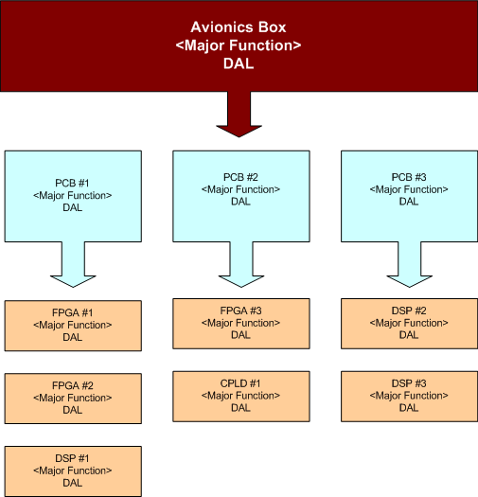

Figure 2-2 System Level Block Diagram

System Functions Allocated to Electrical Hardware and Software

Data Acquisition Printed Circuit Board #1
The Data Acquisition PCB has four primary functions. They include…

Device | Primary Functions | COTS
FPGA #2 | <Primary function implemented in this device> | N
FPGA #2 | <Primary function implemented in this device> | N
DSP #1 | <Primary function implemented in this device> | N
XYZ #1 | <Primary function implemented in this device> | Y

Input / Output Printed Circuit Board #2
The Input / Output PCB have five primary functions. They include…

Device | Primary Functions | COTS
CPLD #1 | <Primary function implemented in this device> | N
FPGA #1 | <Primary function implemented in this device> | N
XYZ #1 | <Primary function implemented in this device> | Y
XYZ #2 | <Primary function implemented in this device> | Y
XYZ #3 | <Primary function implemented in this device> | Y

Monitor Printed Circuit Board #3
The Monitor PCB has four primary functions. They include…

Device | Primary Functions | COTS
DSP #1 | <Primary function implemented in this device> | N
DSP #2 | <Primary function implemented in this device> | N
XYZ #1 | <Primary function implemented in this device> | Y
XYZ #2 | <Primary function implemented in this device> | Y

System Functional Description
<Example Text>
The passenger headcount function is performed by counting the number of entries and exits. The module uses an Entry/Exit-Sensor to detect passengers’ movements in and out of the cabin. The number of passengers in the cabin is tracked by an up/down counter in an FPGA. The passenger load is displayed in real-time on the display panel. The keypad entry can asynchronously load the counter thereby adjusting/correcting the passenger load on the display/system.

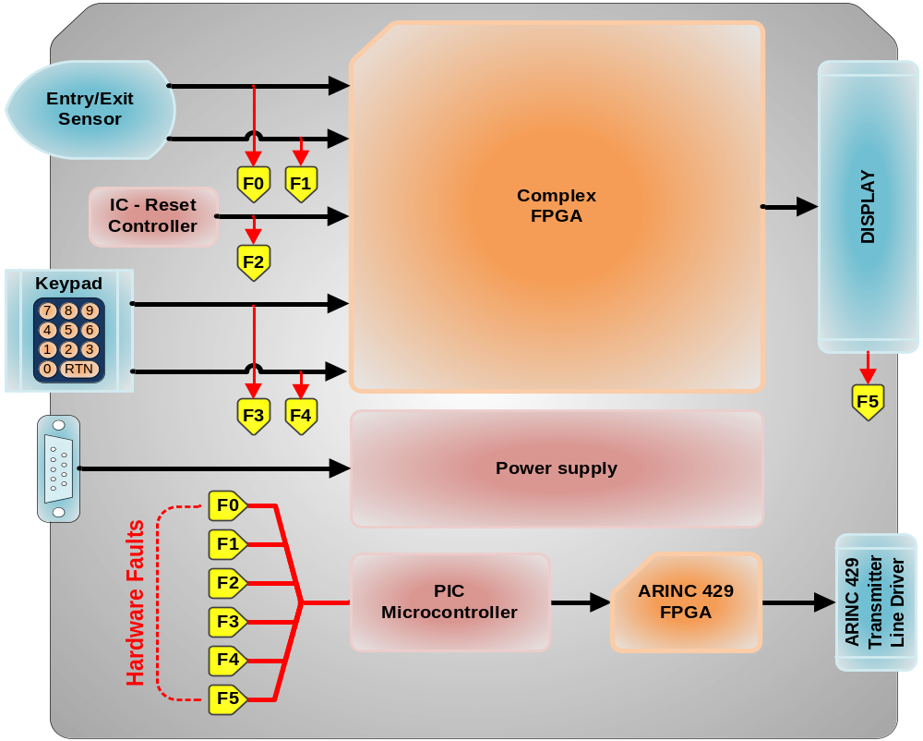
Figure 2-3 System Functional Diagram

System Failure Conditions

High-Level Hardware Functions and Contribution to Potential Failures

No | Function | Example of Potential Failure | DAL
01 | Provision of secure and timely data flow to and from applications and Input / output devices, e.g. sensors and actuators | Transmission of deploy command to landing gear in flight | A
02 | Controlled access to processing facilities | Omission in schedule of fuel system pumping control partition | B
03 | Provision of secure data storage and memory management | Corruption of fuel system execution code by lower integrity partition | B
04 | Provision of consistent execution state | Incorrect or inconsistent flight data is loaded into system | B
05 | Provision of health monitoring and failure management | Fuel system partition shut down when no error has occurred | A
06 | General provision of computing capability | Total loss of IMA platform | A
Table 2-4 System Failure Conditions

Safety and Partitioning
The system is composed of diagnostics and other fail-safe mechanisms used to ensure that failures of the system are detected and that the system goes to a safe state if it's unable to perform a safety function.

SOFTWARE OVERVIEW
This section describes the software functions with emphasis on the proposed safety and partitioning concepts.

Software Architectural Block Diagram
<Identifies each processor and the tasks to be performed within each>

Processor #1

States and Modes

Tasks

Processor #2

States and Modes

Tasks

COTS Software Identification

Real Time Operating System
<Describe the use of an RTOS, including qualification information>

Board Support Package
<Describe the use of a BSP, including qualification information>

Compiler Provided Libraries
<Describe the use of Libraries, including qualification information>

Deactivated Code Partitioning
How is the operational software protected from the activation of this code?

USB Interface Code

RS-232 Interface Code

Ethernet Interface Code

Boot Load Code Partitioning
The Boot Load Code is partitioned from the operational software and, if activated during flight, the crew will see a fault indication. Anomalous behavior of the Boot Load software, as shown by the system safety assessment, would cause or contribute to a failure of system function with no effect on aircraft operational capability or pilot workload. Software whose anomalous behavior would cause or contribute to a failure of the system function with no effect on aircraft operational capability or pilot workload is identified as Level E.

Safety and Partitioning
The system is composed of diagnostics and other fail-safe mechanisms used to ensure that failures of the system are detected and that the system goes to a safe state if it's unable to perform a safety function.

Safety Monitoring

The following safety monitoring rules and techniques will be used:
- Safety monitoring software will be assigned the software level associated with the most severe failure condition category for the monitored function.
- Assessment of the system fault coverage of a monitor will be used to ensure that the monitor's design and implementation are such that the faults which it is intended to detect will be detected under all necessary conditions.
- The monitor and protective mechanism will not be rendered inoperative by the same failure that causes the failure condition.

Resource Sharing <Example Text>
The system is based on Superloop architecture. As such, resource sharing is managed to prevent deadlocks. For example, if the analog board suffers a critical failure with the Dual-Port RAM and locked, in this event, the board would automatically be shipped. This results in no data from the analog board; however, the balance of the system is fully operational.

Redundancy
<Information Here If Applicable>

Fault Tolerance <Example Text>
The software will be designed so that it will continue to operate, possibly at a reduced level, rather than failing completely, when some part of the system fails. During this condition, a visible fault indication will be present.

Timing and Task Scheduling

Timing <Example Text>
The development team understands that numerous types of problems can arise when the software misses its timing constraints. Two types of constraints are recognized: hard timing requirements and soft timing requirements. A hard timing requirement denotes that if a constraint is missed, the program is in error; a late result is just as bad as a wrong result. A soft timing requirement indicates a constraint that the program should obtain on average, or one in which the value of the result degrades with time; occasionally missing a deadline is not considered an error.
The following timing-related problems that will be addressed in the system architecture:
- Priority inversion
- Schedulability and processor utilization
- Interrupt and event response times

It is recognized that such problems may go undetected by verification testing alone, since they only occur under specific timing conditions. As such, code review analysis is combined with testing to aid in uncovering these problems.

Task Scheduling <Example Text>
Scheduling is handled as a function of the Superloop architecture. Critical events are handled by hardware interrupts. Timers handle non-critical events.

CERTIFICATION CONSIDERATIONS

Certification Basis and Means of Compliance

The certification basis for the software is Title 14 CFR 2x.1301 and 14 CFR 2x.1309. RTCA/DO-178C has been selected as the means of compliance. The objectives will be satisfied during the lifecycle development and integral processes. The Quality Assurance Engineer will compile applicable artifacts and submit them to the Certification Authority. Verification objectives are satisfied through a combination of reviews and analysis, the development of test cases and procedures, and the subsequent execution of those test procedures. Reviews and analysis provide an assessment of the accuracy, completeness, and verifiability of the requirements, architecture, and design implementation.
The product will be developed in compliance with the following:

Reference / Issue | Description
FAA TSO- | TSO, Description
FAA Order 8110.4C | Type Certification
Table 4-5 List of Compliance Documents

Issue Papers and Certification Review Items (CRI)

Document Number | Title
Issue Paper SE-3.3 | Guidance for Conducting Change Impact Analysis
Issue Paper SE-3.5 | Use of Commercial Off The Shelf Software in Aircraft Avionics Systems
CRI F-10 | Management of Open Problem Reports (Software and CEH)
Table 4-6 List of Issue Papers and CRI’s

Software Level Determination
Software Level determination was based on the Functional Hazard Assessment (FHA), Preliminary System Safety Assessment (PSSA) and System Safety Assessment (SSA).
OR –
Software Level determination is based on aircraft installation requirements. These requirements are provided by our customers. The failure condition of the equipment has been determined to be <Failure Condition>.

<Level A>
This failure condition would prevent continued safe flight and landing. The applicable Failure Condition Category is Catastrophic. Software whose anomalous behavior would cause or contribute to a failure of system function resulting in a catastrophic failure condition for the aircraft is identified as Level A.
<Level B>
This failure conditions would reduce the capability of the aircraft or the ability of the crew to cope with adverse operating conditions to the extent that there would be a large reduction in safety margins or functional capabilities; physical distress or higher work load such that the flight crew would not be relied on to perform their tasks accurately or completely or adverse effects on occupants including serious or potentially fatal injuries to a small number of occupants. The applicable Failure Condition Category is Hazardous/Severe-Major. Software whose anomalous behavior would cause or contribute to a failure of system function resulting in a Hazardous/Severe-Major failure condition for the aircraft is identified as Level B.
<Level C>
This failure condition would reduce the capability of the aircraft or the ability of the crew to cope with adverse operating conditions to the extent that it would be a significant reduction in safety margins or functional capabilities and a significant increase in crew workload. The applicable Failure Condition Category is Major. Software whose anomalous behavior would cause or contribute to a failure of the system function resulting in a Major failure condition for the aircraft is identified as Level C.
<Level D>
This failure would not significantly reduce aircraft safety and would involve crew actions that are well within their capabilities. The applicable Failure Condition Category is Minor. Software whose anomalous behavior would cause or contribute to a failure of the system function resulting in a Minor failure condition for the aircraft is identified as Level D.

DO-178C Objectives By Design Assurance Level

Level | Failure Condition | DO-178C Objectives | Objectives Satisfied With Independence
A | Catastrophic | 66 | 25
B | Hazardous | 65 | 14
C | Major | 57 | 2
D | Minor | 28 | 2
E | No Effect | NA | NA
Table 4-7 Design Assurance Levels

Compliance Matrix
This section identifies the DO-178C objectives Annex Table A1 – A10 that apply to this program. The artifacts referenced in the table will be generated during the software development lifecycle and will provide evidence of compliance to pertinent objectives. Each artifact will be under configuration control. The letters (A, B, C, D) under the heading “Ref” represent the applicable DO-178C criticality levels of that objective. Documents will be reviewed for compliance to RTCA/DO-178C by the Software DER assigned to the program.

Table A-1 Software Planning Process

 | Objective | Ref | Verification Evidence Cross-Reference
1 | The activities of the software life cycle processes are defined. | 4.1a  ABCD | Documents Review Checklist(s)  Plan for Software Aspects of Certification  Software Development Plan  Software Verification Plan  Software Configuration Management Plan  Software Quality Assurance Plan  Peer Review Checklist(s)  Software Planning Peer Review  Transition Review Checklist(s)  Software Planning Transition Review  SCM Records  SQA Records
2 | The software life cycle(s), including the inter-relationships between the processes, their sequencing, feedback mechanisms, and transition criteria, is defined. | 4.1b  ABC | Documents Review Checklist(s)  Plan for Software Aspects of Certification  Peer Review Checklist(s)  Software Planning Peer Review  Transition Review Checklist(s)  Software Planning Transition Review  SCM Records  QA Records
3 | Software life cycle environment is selected and defined. | 4.1c  ABC | Documents Review Checklist(s)  Software Lifecycle Environment Config Index  Peer Review Checklist(s)  Software Planning Peer Review  Transition Review Checklist(s)  Software Planning Transition Review  SCM Records  QA Records
4 | Additional considerations are addressed. | 4.1d  ABCD | Documents Review Checklist(s)  Plan for Software Aspects of Certification  Peer Review Checklist(s)  Software Planning Peer Review  Transition Review Checklist(s)  Software Planning Transition Review  SCM Records  QA Records
5 | Software development standards are defined. | 4.1e  ABC | Documents Review Checklist(s)  Software Requirements Standards  Software Design Standards  Software Coding Standards  Peer Review Checklist(s)  Software Planning Peer Review  Transition Review Checklist(s)  Software Planning Transition Review  SCM Records  QA Records
6 | Software plans comply with this document. | 4.1f  ABC | Documents Review Checklist(s)  Plan for Software Aspects of Certification  Software Development Plan  Software Verification Plan  Software Configuration Management Plan  Software Quality Assurance Plan  Peer Review Checklist(s)  Software Planning Peer Review  Transition Review Checklist(s)  Software Planning Transition Review  SCM Records  QA Records
7 | Development and revision of software plans are coordinated. | 4.1g  ABC | Documents Review Checklist(s)  Plan for Software Aspects of Certification  Software Development Plan  Software Verification Plan  Software Configuration Management Plan  Software Quality Assurance Plan  Peer Review Checklist(s)  Software Planning Peer Review  Transition Review Checklist(s)  Software Planning Transition Review  SCM Records  QA Records

Table A-2 Software Development Processes

 | Objective | Ref | Verification Evidence Cross-Reference
1 | High-level requirements are developed. | 5.1.1a  ABCD | Documents Review Checklist(s)  Software Requirements Document  Peer Review Checklist(s)  Software Requirements Peer Review  Transition Review Checklist(s)  Software Requirements Transition Review  SCM Records  QA Records  Trace Data
2 | Derived high-level requirements are defined and provided to the system processes, including the system safety assessment process. | 5.1.1b  ABCD | Documents Review Checklist(s)  Software Requirements Document  Peer Review Checklist(s)  Software Requirements Peer Review  Transition Review Checklist(s)  Software Requirements Transition Review  SCM Records  QA Records
3 | Software architecture is developed. | 5.2.1a  ABCD | Documents Review Checklist(s)  Software Design Description  Peer Review Checklist(s)  Design Peer Review  Transition Review Checklist(s)  Preliminary Design Transition Review  SCM Records  QA Records
4 | Low-level requirements are developed. | 5.2.1a  ABC | Documents Review Checklist(s)  Software Design Description  Peer Review Checklist(s)  Design Peer Review  Transition Review Checklist(s)  Design Transition Review  SCM Records  QA Records  Trace Data
5 | Derived low-level requirements are defined and provided to the system processes, including the system safety assessment process. | 5.2.1b  ABC | Documents Review Checklist(s)  Software Design Description  Peer Review Checklist(s)  Design Peer Review  Transition Review Checklist(s)  Critical Design Transition Review  SCM Records  SQA Records
6 | Source Code is developed. | 5.3.1a  ABC | Documents Review Checklist(s)  NA  Peer Review Checklist(s)  Software Code Peer Review  Transition Review Checklist(s)  Software Code Transition Review  SCM Records  SQA Records  Trace Data
7 | Executable Object Code and Parameter Data Item Files, if any, are produced and loaded in the target computer. | 5.4.1a  ABCD | Documents Review Checklist(s)  NA  Peer Review Checklist(s)  Integration Peer Review  Test Results Peer Review  Transition Review Checklist(s)  Integration Transition Review  SCM Records  SQA Records

Table A-3 Verification of Outputs of Software Requirements Process

 | Objective | Ref | Verification Evidence Cross-Reference
1 | High-level requirements comply with system requirements. | 6.3.1a  ABCD | Documents Review Checklist(s)  Software Requirements Document  Peer Review Checklist(s)  Software Requirements Peer Review  Transition Review Checklist(s)  Software Requirements Transition Review  SCM Records  QA Records
2 | High-level requirements are accurate and consistent. | 6.3.1b  ABCD | Documents Review Checklist(s)  Software Requirements Document  Peer Review Checklist(s)  Software Requirements Peer Review  Transition Review Checklist(s)  Software Requirements Transition Review  SCM Records  QA Records
3 | High-level requirements are compatible with target computer. | 6.3.1c  AB | Documents Review Checklist(s)  Software Requirements Document  Peer Review Checklist(s)  Software Requirements Peer Review  Test Results Peer Review  Transition Review Checklist(s)  Software Requirements Transition Review  SCM Records  QA Records
4 | High-level requirements are verifiable. | 6.3.1d  ABC | Documents Review Checklist(s)  Software Requirements Document  Peer Review Checklist(s)  Software Requirements Peer Review  Transition Review Checklist(s)  Software Requirements Transition Review  SCM Records  QA Records
5 | High-level requirements conform to standards. | 6.3.1e  ABC | Documents Review Checklist(s)  Software Requirements Document  Peer Review Checklist(s)  Software Requirements Peer Review  Transition Review Checklist(s)  Software Requirements Transition Review  SCM Records  QA Records
6 | High-level requirements are traceable to system requirements. | 6.3.1f  ABCD | Documents Review Checklist(s)  Software Requirements Document  Peer Review Checklist(s)  Software Requirements Peer Review  Transition Review Checklist(s)  Software Requirements Transition Review  SCM Records  QA Records
7 | Algorithms are accurate. | 6.3.1g  ABC | Documents Review Checklist(s)  Software Requirements Document  Peer Review Checklist(s)  Software Requirements Peer Review  Transition Review Checklist(s)  Software Requirements Transition Review  SCM Records  QA Records

Table A-4 Verification of Outputs of Software Design Process

 | Objective | Ref | Verification Evidence Cross-Reference
1 | Low-level requirements comply with high-level requirements. | 6.3.2a  ABC | Documents Review Checklist(s)  Software Design Description  Peer Review Checklist(s)  Design Peer Review  Transition Review Checklist(s)  Critical Design Transition Review  SCM Records  SQA Records
2 | Low-level requirements are accurate and consistent. | 6.3.2b  ABC | Documents Review Checklist(s)  Software Design Description  Peer Review Checklist(s)  Design Peer Review  Transition Review Checklist(s)  Critical Design Transition Review  SCM Records  SQA Records
3 | Low-level requirements are compatible with target computer. | 6.3.2c  AB | Documents Review Checklist(s)  Software Design Description  Peer Review Checklist(s)  Design Peer Review  Test Results Peer Review  Transition Review Checklist(s)  Critical Design Transition Review  SCM Records  SQA Records
4 | Low-level requirements are verifiable. | 6.3.2d  AB | Documents Review Checklist(s)  Software Design Description  Peer Review Checklist(s)  Design Peer Review  Transition Review Checklist(s)  Critical Design Transition Review  SCM Records  SQA Records
5 | Low-level requirements conform to standards. | 6.3.2e  ABC | Documents Review Checklist(s)  Software Design Description  Peer Review Checklist(s)  Design Peer Review  Transition Review Checklist(s)  Critical Design Transition Review  SCM Records  SQA Records
6 | Low-level requirements are traceable to high-level requirements. | 6.3.2f  ABC | Documents Review Checklist(s)  Software Design Description  Peer Review Checklist(s)  Design Peer Review  Transition Review Checklist(s)  Critical Design Transition Review  SCM Records  SQA Records
7 | Algorithms are accurate. | 6.3.2g  ABC | Documents Review Checklist(s)  Software Design Description  Peer Review Checklist(s)  Design Peer Review  Transition Review Checklist(s)  Critical Design Transition Review  SCM Records  SQA Records
8 | Software architecture is compatible with high-level requirements. | 6.3.3a  ABC | Documents Review Checklist(s)  Software Design Description  Peer Review Checklist(s)  Design Peer Review  Transition Review Checklist(s)  Critical Design Transition Review  SCM Records  SQA Records
9 | Software architecture is consistent. | 6.3.3b  ABC | Documents Review Checklist(s)  Software Design Description  Peer Review Checklist(s)  Design Peer Review  Transition Review Checklist(s)  Critical Design Transition Review  SCM Records  SQA Records
10 | Software architecture is compatible with target computer. | 6.3.3c  AB | Documents Review Checklist(s)  Software Design Description  Peer Review Checklist(s)  Design Peer Review  Test Results Peer Review  Transition Review Checklist(s)  Critical Design Transition Review  SCM Records  SQA Records
11 | Software architecture is verifiable. | 6.3.3d  AB | Documents Review Checklist(s)  Software Design Description  Peer Review Checklist(s)  Design Peer Review  Transition Review Checklist(s)  Critical Design Transition Review  SCM Records  SQA Records
12 | Software architecture conforms to standards. | 6.3.3e  ABC | Documents Review Checklist(s)  Software Design Description  Peer Review Checklist(s)  Design Peer Review  Transition Review Checklist(s)  Critical Design Transition Review  SCM Records  SQA Records
13 | Software partitioning integrity is Confirmed. | 6.3.3f  ABCD | Documents Review Checklist(s)  Software Design Description  Peer Review Checklist(s)  Design Peer Review  Test Results Peer Review  Transition Review Checklist(s)  Critical Design Transition Review  SCM Records  SQA Records

Table A-5 Verification of Outputs of Coding & Integration Process

 | Objective | Ref | Verification Evidence Cross-Reference
1 | Source Code complies with low-level requirements. | 6.3.4a  ABC | Documents Review Checklist(s)  NA  Peer Review Checklist(s)  Software Code Peer Review  Transition Review Checklist(s)  Software Code Transition Review  SCM Records  SQA Records
2 | Source Code complies with software architecture. | 6.3.4b  ABC | Documents Review Checklist(s)  NA  Peer Review Checklist(s)  Software Code Peer Review  Transition Review Checklist(s)  Software Code Transition Review  SCM Records  SQA Records
3 | Source Code is verifiable. | 6.3.4c  AB | Documents Review Checklist(s)  NA  Peer Review Checklist(s)  Software Code Peer Review  Transition Review Checklist(s)  Software Code Transition Review  SCM Records  SQA Records
4 | Source Code conforms to standards. | 6.3.4d  ABC | Documents Review Checklist(s)  NA  Peer Review Checklist(s)  Software Code Peer Review  Transition Review Checklist(s)  Software Code Transition Review  SCM Records  SQA Records
5 | Source Code is traceable to low-level requirements. | 6.3.4e  ABC | Documents Review Checklist(s)  NA  Peer Review Checklist(s)  Software Code Peer Review  Transition Review Checklist(s)  Software Code Transition Review  SCM Records  SQA Records
6 | Source Code is accurate and consistent. | 6.3.4f  ABC | Documents Review Checklist(s)  NA  Peer Review Checklist(s)  Software Code Peer Review  Transition Review Checklist(s)  Software Code Transition Review  SCM Records  SQA Records
7 | Output of software integration process is complete and correct. | 6.3.5a  ABC | Documents Review Checklist(s)  NA  Peer Review Checklist(s)  Integration Peer Review  Transition Review Checklist(s)  Integration Transition Review  SCM Records  SQA Records
8 | Parameter Data Item File is correct and complete | 6.6a  ABCD | Documents Review Checklist(s)  NA  Peer Review Checklist(s)  Integration Peer Review  Transition Review Checklist(s)  Integration Transition Review  SCM Records  SQA Records
9 | Verification of Parameter Data Item File is achieved. | 6.6b  ABC | Documents Review Checklist(s)  NA  Peer Review Checklist(s)  Integration Peer Review  Transition Review Checklist(s)  Integration Transition Review  SCM Records  SQA Records

Table A-6 Testing of Outputs of Integration Process

 | Objective | Ref | Verification Evidence Cross-Reference
1 | Executable Object Code complies with high-level requirements. | 6.4a  ABCD | Documents Review Checklist(s)  Software Verification Results  Peer Review Checklist(s)  Test Results Peer Review  Transition Review Checklist(s)  Software Verification Transition Review  SCM Records  SQA Records  Trace Data
2 | Executable Object Code is robust with high-level requirements. | 6.4b  ABCD | Documents Review Checklist(s)  Software Verification Results  Peer Review Checklist(s)  Test Results Peer Review  Transition Review Checklist(s)  Software Verification Transition Review  SCM Records  SQA Records  Trace Data
3 | Executable Object Code complies with low-level requirements. | 6.4c  ABC | Documents Review Checklist(s)  Software Verification Results  Peer Review Checklist(s)  Test Results Peer Review  Transition Review Checklist(s)  Software Verification Transition Review  SCM Records  SQA Records  Trace Data
4 | Executable Object Code is robust with low-level requirements. | 6.4d  ABC | Documents Review Checklist(s)  Software Verification Results  Peer Review Checklist(s)  Test Results Peer Review  Transition Review Checklist(s)  Software Verification Transition Review  SCM Records  SQA Records  Trace Data
5 | Executable Object Code is compatible with target computer. | 6.4e  ABCD | Documents Review Checklist(s)  Software Verification Results  Peer Review Checklist(s)  Test Results Peer Review  Transition Review Checklist(s)  Software Verification Transition Review  SCM Records  SQA Records

Table A-7 Verification of Verification Process Results

 | Objective | Ref | Verification Evidence Cross-Reference
1 | Test procedures are correct. | 6.4.5b  ABC | Documents Review Checklist(s)  Software Test Cases and Procedures Review  Peer Review Checklist(s)  Test Procedures Peer Review  Transition Review Checklist(s)  Integration Transition Review  SCM Records  SQA Records
2 | Test results are correct and discrepancies explained. | 6.4.5c  ABC | Documents Review Checklist(s)  Software Verification Results  Peer Review Checklist(s)  Test Results Peer Review  Transition Review Checklist(s)  Software Verification Transition Review  SCM Records  SQA Records
3 | Test coverage of high-level requirements is achieved. | 6.4.4a  ABCD | Documents Review Checklist(s)  Software Test Cases and Procedures Review  Peer Review Checklist(s)  Test Procedures Peer Review  Transition Review Checklist(s)  Integration Transition Review  SCM Records  SQA Records
4 | Test coverage of low-level requirements is achieved. | 6.4.4b  ABC | Documents Review Checklist(s)  Software Test Cases and Procedures Review  Peer Review Checklist(s)  Test Procedures Peer Review  Transition Review Checklist(s)  Integration Transition Review  SCM Records  SQA Records
5 | Test coverage of software structure (modified condition/decision) is achieved. | 6.4.4c  A | Documents Review Checklist(s)  Software Verification Results  Peer Review Checklist(s)  Test Results Peer Review  Transition Review Checklist(s)  Software Verification Transition Review  SCM Records  SQA Records
6 | Test coverage of software structure (decision coverage) is achieved. | 6.4.4c  AB | Documents Review Checklist(s)  Software Verification Results  Peer Review Checklist(s)  Test Results Peer Review  Transition Review Checklist(s)  Software Verification Transition Review  SCM Records  SQA Records
7 | Test coverage of software structure (statement coverage) is achieved. | 6.4.4c  ABC | Documents Review Checklist(s)  Software Verification Results  Peer Review Checklist(s)  Test Results Peer Review  Transition Review Checklist(s)  Software Verification Transition Review  SCM Records  SQA Records
8 | Test coverage of software structure (data coupling and control coupling) is achieved. | 6.4.4d  ABC | Documents Review Checklist(s)  Software Verification Results  Peer Review Checklist(s)  Test Results Peer Review  Transition Review Checklist(s)  Software Verification Transition Review  SCM Records  SQA Records
9 | Verification of additional code, that cannot be traced to Source Code, is achieved. | 6.4.4c  A | Documents Review Checklist(s)  Software Verification Results  Peer Review Checklist(s)  Test Results Peer Review  Transition Review Checklist(s)  Software Verification Transition Review  SCM Records  SQA Records

Table A-8 Software Configuration Management Process

 | Objective | Ref | Verification Evidence Cross-Reference
1 | Configuration items are identified. | 7.1a  ABCD | Documents Review Checklist(s)  Software Configuration Management Plan  Software Configuration Index  Transition Review Checklist(s)  Software Planning Review  Software Conformity Review  SCM Records  SQA Records
2 | Baselines and traceability are established. | 7.1b  ABCD | Documents Checklist(s)  Software Configuration Management Plan  Software Configuration Index  Transition Review Checklist(s)  Software Planning Review (CBL)  Software Requirements Review (FBL)  Software Critical Design Review (ABL)  Software Verification Review (DBL)  Software Conformity Review (PBL)  SCM Records  SQA Records
3 | Problem reporting, change control, change review, and configuration status accounting are established. | 7.1c  7.1d  7.1e  7.1f  ABCD | Document Review Checklist(s)  Software Configuration Management Plan  Transition Review Checklist(s)  Software Planning Review  Software Conformity Review  SCM Records  SQA Records
4 | Archive, retrieval, and release are established. | 7.1g  ABCD | Document Review Checklist(s)  Software Configuration Management Plan  Software Configuration Index  Transition Review Checklist(s)  Software Planning Review  Software Conformity Review  SCM Records  SQA Records
5 | Software load control is established. | 7.1h  ABCD | Document Review Checklist(s)  Software Configuration Management Plan  Transition Review Checklist(s)  Software Planning Review  Software Integration Review  Software Conformity Review  SCM Records  SQA Records
6 | Software life cycle environment control is established. | 7.1i  ABCD | Document Review Checklist(s)  Software Configuration Management Plan  Software Lifecycle Environment Index  Transition Review Checklist(s)  Software Planning Review  Software Conformity Review  SCM Records  SQA Records

Table A-9 Software Quality Assurance Process

 | Objective | Ref | Verification Evidence Cross-Reference
1 | Assurance is obtained that software plans and standards are developed and reviewed for compliance with this document and for consistency. | 8.1a  ABC | Documents Review Checklist(s)  Software Quality Assurance Plan  Review Checklist(s)  Software QA Planning Review  Software QA Development Review  Software QA Verification Review  Software QA Final Review  SCM Records  SQA Records
2 | Assurance is obtained that software life cycle processes comply with approved software plans. | 8.1b  ABCD | Documents Review Checklist(s)  Software Quality Assurance Plan  Transition Review Checklist(s)  All Transition Review Checklists  Review Checklist(s)  Software QA Planning Review  Software QA Development Review  Software QA Verification Review  Software QA Final Review  SCM Records  SQA Records
3 | Assurance is obtained that software life cycle processes comply with approved software standards. | 8.1b  ABC | Documents Review Checklist(s)  Software Quality Assurance Plan  Review Checklist(s)  Software QA Planning Review  Software QA Development Review  Software QA Verification Review  Software QA Final Review  SCM Records  SQA Records
4 | Assurance is obtained that transition criteria for the software life cycle processes are satisfied. | 8.1c  ABC | Documents Review Checklist(s)  Software Quality Assurance Plan  Review Checklist(s)  Software Planning Review  Software Requirements Review  Software Preliminary Design Review  Software Critical Design Review  Software Code Review  Software Integration Review  Software Verification Review  Software Conformity Review  SCM Records  SQA Records
5 | Assurance is obtained that software conformity review is conducted. | 8.1d  ABCD | Documents Review Checklist(s)  Software Quality Assurance Plan  Review Checklist(s)  Software Conformity Review  SCM Records  SQA Records

Table A-10 Certification Liaison Process

 | Objective | Ref | Verification Evidence Cross-Reference
1 | Communication and understanding between the applicant and the certification authority is established. | 9a  ABCD | Documents Review Checklist(s)  Plan for Software Aspects of Certification  Certification Review Checklist(s)  Software Planning Review (SOI 1)
2 | The means of compliance is proposed and agreement with the Plan for Software Aspects of Certification is obtained. | 9b  ABCD | Documents Review Checklist(s)  Plan for Software Aspects of Certification  Certification Review Checklist(s)  Software Planning Review (SOI 1)
3 | Compliance substantiation is provided. | 9c  ABCD | Documents Review Checklist(s)  Software Configuration Index  Software Accomplishment Summary  Certification Review Checklist(s)  Software Planning Review (SOI 1)  Software Development Review (SOI 2)  Software Verification Review (SOI 3)  Software Final Review (SOI 4)
Table 4-8 Compliance Matrix – Certification Liaison Process

Software Conformity Objectives
A Software Conformity Review will be conducted in compliance with 8110.49 and 8110.4C objectives, as detailed below.

FAA Order 8110.49 Software Conformity Process

 | Objective | Method of Compliance
1 | The planning documents address which processes the software conformity applies to (i.e., TC, STC, ATC, ASTC, and TSO authorization projects)? | Qualtech Compliance Management System(s)  Document Review Management System  Reviews and Analysis Management System  Documents Checklist(s)  Software Conformity Plan  Plan for Software Aspects of Certification  Software Configuration Index  Software Environment Configuration index  Software Accomplishment Summary  Review Checklist(s)  Software Conformity Review
2 | The planning documents properly state the purpose of the software conformity (i.e., to determine compliance with 14 CFR § 21.33(b) and that the product and components conform to approved type design)? | Qualtech Compliance Management System(s)  Document Review Management System  Reviews and Analysis Management System  Documents Checklist(s)  Software Conformity Plan  Plan for Software Aspects of Certification  Software Configuration Index  Software Environment Configuration index  Software Accomplishment Summary  Review Checklist(s)  Software Conformity Review
3 | The planning documents reference all required type design data (Software Requirements Data,  Design Description, Source Code, Executable Object Code, Software Configuration Index, and the Software Accomplishment Summary)? | Qualtech Compliance Management System(s)  Document Review Management System  Reviews and Analysis Management System  Documents Checklist(s)  Software Conformity Plan  Plan for Software Aspects of Certification  Software Configuration Index  Software Environment Configuration index  Software Accomplishment Summary  Review Checklist(s)  Software Conformity Review
4 | The planning documents address the applicability of both software part conformity inspection and software installation conformity inspection? | Qualtech Compliance Management System(s)  Document Review Management System  Reviews and Analysis Management System  Documents Checklist(s)  Software Conformity Plan  Plan for Software Aspects of Certification  Software Configuration Index  Software Environment Configuration index  Software Accomplishment Summary  Review Checklist(s)  Software Conformity Review
5 | The planning documents state that conformity of the test article, test setup, test procedures used, and the validity of the test results are established for each test conducted for certification credit?  Test for certification credit is defined as system certification test conducted under an FAA-approved test plan for the purpose of showing compliance to the regulations. | Qualtech Compliance Management System(s)  Document Review Management System  Reviews and Analysis Management System  Documents Checklist(s)  Software Conformity Plan  Plan for Software Aspects of Certification  Software Configuration Index  Software Environment Configuration index  Software Accomplishment Summary  Review Checklist(s)  Software Conformity Review
Software Part Conformity Inspection
6 | The planning documents identify the specific FAA-Approved test plan to be used and states that the test plan must be FAA approved before conducting an official ground or flight test?  Examples of tests conducted to satisfy FAA certification credit are RTCA/DO-160D environmental qualification tests, system functional tests, systems integration tests, aircraft ground functional tests, and aircraft Type Inspection Authorization Tests (TIA) flight tests. | Qualtech Compliance Management System(s)  Document Review Management System  Reviews and Analysis Management System  Documents Checklist(s)  Software Conformity Plan  Plan for Software Aspects of Certification  Software Configuration Index  Software Environment Configuration index  Software Accomplishment Summary  Review Checklist(s)  Software Conformity Review
7 | The planning documents state the method used to ensure that the software baseline complies with its type design and released software plans (i.e., by conducting FAA desk and/or on-site reviews or establish that the software DER (if delegated) has approved the baseline software by submitting a FAA Form 8110-3, “Statement of Compliance with the Federal Aviation Regulations.”? | Qualtech Compliance Management System(s)  Document Review Management System  Reviews and Analysis Management System  Documents Checklist(s)  Software Conformity Plan  Plan for Software Aspects of Certification  Software Configuration Index  Software Environment Configuration index  Software Accomplishment Summary  Review Checklist(s)  Software Conformity Review
8 | The planning documents states that the DER must indicate in Form 8110-3 that the “purpose of Form 8110-3 is to approve the software baseline for the purposes of conducting FAA testing for certification credit.”? | Qualtech Compliance Management System(s)  Document Review Management System  Reviews and Analysis Management System  Documents Checklist(s)  Software Conformity Plan  Plan for Software Aspects of Certification  Software Configuration Index  Software Environment Configuration index  Software Accomplishment Summary  Review Checklist(s)  Software Conformity Review
9 | The planning documents address the use (or non-use) of special purpose software (i.e., software used for environmental qualification testing)?  If special purpose software is used, The planning documents should state the method used to verify, validate, and control the configuration of the special purpose test software. It should also indicate that the test software is included as part of the test setup conformity conducted before the qualification testing. | Qualtech Compliance Management System(s)  Document Review Management System  Reviews and Analysis Management System  Documents Checklist(s)  Software Conformity Plan  Plan for Software Aspects of Certification  Software Configuration Index  Software Environment Configuration index  Software Accomplishment Summary  Review Checklist(s)  Software Conformity Review
10 | The planning documents state the method(s) used to verify that the test configuration of the software complies with its software test baseline? | Qualtech Compliance Management System(s)  Document Review Management System  Reviews and Analysis Management System  Documents Checklist(s)  Software Conformity Plan  Plan for Software Aspects of Certification  Software Configuration Index  Software Environment Configuration index  Software Accomplishment Summary  Review Checklist(s)  Software Conformity Review
11 | The planning documents state the method(s) used to verify that all software artifacts associated with the test baseline are properly identified, under configuration control, and reflect the current state of the software under test? | Qualtech Compliance Management System(s)  Document Review Management System  Reviews and Analysis Management System  Documents Checklist(s)  Software Conformity Plan  Plan for Software Aspects of Certification  Software Configuration Index  Software Environment Configuration index  Software Accomplishment Summary  Review Checklist(s)  Software Conformity Review
12 | The planning documents state the method(s) used to verify that any software development tools or software verification tools that require qualification have been qualified? | Qualtech Compliance Management System(s)  Document Review Management System  Reviews and Analysis Management System  Documents Checklist(s)  Software Conformity Plan  Plan for Software Aspects of Certification  Software Configuration Index  Software Environment Configuration index  Software Accomplishment Summary  Review Checklist(s)  Software Conformity Review
13 | The planning documents discuss the process of initiating a FAA Form 8120-10, Request for Conformity, and submitting it to the MIDO? | Qualtech Compliance Management System(s)  Document Review Management System  Reviews and Analysis Management System  Documents Checklist(s)  Software Conformity Plan  Plan for Software Aspects of Certification  Software Configuration Index  Software Environment Configuration index  Software Accomplishment Summary  Review Checklist(s)  Software Conformity Review
14 | The planning documents state the method(s) used to verify that the proper build and load file(s) was/were removed from the software configuration management (SCM) library? | Qualtech Compliance Management System(s)  Document Review Management System  Reviews and Analysis Management System  Documents Checklist(s)  Software Conformity Plan  Plan for Software Aspects of Certification  Software Configuration Index  Software Environment Configuration index  Software Accomplishment Summary  Review Checklist(s)  Software Conformity Review
15 | The planning documents state the method(s) used to verify that approved build and load instructions are followed during the software build and load process? | Qualtech Compliance Management System(s)  Document Review Management System  Reviews and Analysis Management System  Documents Checklist(s)  Software Conformity Plan  Plan for Software Aspects of Certification  Software Configuration Index  Software Environment Configuration index  Software Accomplishment Summary  Review Checklist(s)  Software Conformity Review
16 | The planning documents state the method(s) used to verify that any data integrity checks and software part numbers (including version numbers) are verified in the Line Replacement Unit? | Qualtech Compliance Management System(s)  Document Review Management System  Reviews and Analysis Management System  Documents Checklist(s)  Software Conformity Plan  Plan for Software Aspects of Certification  Software Configuration Index  Software Environment Configuration index  Software Accomplishment Summary  Review Checklist(s)  Software Conformity Review
17 | The planning documents state the method(s) used to verify that the test setup conforms to the test setup configuration identified in the approved engineering test plan? | Qualtech Compliance Management System(s)  Document Review Management System  Reviews and Analysis Management System  Documents Checklist(s)  Software Conformity Plan  Plan for Software Aspects of Certification  Software Configuration Index  Software Environment Configuration index  Software Accomplishment Summary  Review Checklist(s)  Software Conformity Review
18 | The planning documents state the method(s) used to verify that procedures used for retention, archive and retrieval of the software life cycle data is compliant with the approved SCM plan? | Qualtech Compliance Management System(s)  Document Review Management System  Reviews and Analysis Management System  Documents Checklist(s)  Software Conformity Plan  Plan for Software Aspects of Certification  Software Configuration Index  Software Environment Configuration index  Software Accomplishment Summary  Review Checklist(s)  Software Conformity Review
19 | The planning documents state the software part conformity inspection must be successfully conducted before requesting a software installation conformity inspection? | Qualtech Compliance Management System(s)  Document Review Management System  Reviews and Analysis Management System  Documents Checklist(s)  Software Conformity Plan  Plan for Software Aspects of Certification  Software Configuration Index  Software Environment Configuration index  Software Accomplishment Summary  Review Checklist(s)  Software Conformity Review
Table 4-9 Compliance Matrix - Software Conformity Process

SOFTWARE CHARACTERISTICS

Software Size
The lines of code count was measured by using the program CodeCnt. The assembly code is counted separately from the C language code. The results are as follows:

Processor | Lines of Assembler | Lines of C Code | Total Lines of Code
TBD | 5,000 | 25,000 | 30,000
Table 5-10 Software Size
The Executable Object Code was measured by <describe here>. The results are as follows:

Processor | Program Space | EOC Size
TBD | 5,000 | 25,000
Table 5-11 Executable object Code Size

Timing
Timing limitations are dictated by ...
<document the timing margin or explain how it was calculated and measured >

Memory Margins
Memory Margins are described below for program Flash usage, Processor RAM usage, NVRAM usage, and CSMU Flash usage.

Program Flash Usage
The Program Flash Usage was measured by <describe here>. The results are as follows:

Processor | Space Available | Space Usage | Percent Usage
TBD | xx Kwords | xx Kwords | xx%
Table 5-12 Program Flash Usage

Processor RAM Usage
Available RAM space is xx Kwords (16 bits each) for the processor. RAM space is directly allocated for inter-task communication buffers and stack space usage. The following table identifies RAM space, allocation, usage and available margin for the TBD Processor.

Processor | Total Physical RAM  Size Available | Allocated RAM Size | Allocated RAM Used | Allocated  RAM Available  Margin | Unallocated RAM (unused)
TBD | xx Kwords | xx Kwords | xx% | xx% | xx Kwords
Table 5-13 Processor RAM Usage

NVRAM Usage
NVRAM usage is divided between the configuration and memory position index storage and the fault history log. The configuration and flash memory indices storage requires less than 2% of the memory.

Devices | Space Available | Space Usage | Percentage Usage
1 | xx Kwords | xx Kwords | xx%
Table 5-14 NVRAM Usage

Flash Usage
The following table identifies the Flash memory capacity for each model. The memory is housed in the CSMU for protected storage of recorded data. Due to the continuous, endless loop recording nature of this memory, it is by design, 100 percent utilized.

Part Number | 128 Mbit Devices | Total Memory | TBD
TBD | 4 | 32 Mwords | TBD
Table 5-15 Flash Usage

Processor Bandwidth Utilization
Processor utilization includes one wait state that is inserted for each external program/data memory access. Processor bandwidth is measured using a combination of analysis and code instrumentation. In the case of the TBD processor, idle task execution time resulting from the embedded kernel task scheduling is used to determine how much bandwidth is utilized by operational tasks as compared to the idle task.

Processor | Bandwidth | Usage | Percent Usage
TBD | 10.0 Mips | 7.0 Mips | 70%
Table 5-16 Processor Bandwidth Utilization
Mips: Millions of instructions per second

SOFTWARE LIFE CYCLE

This section describes the software lifecycle with emphasis on the deviations that have been taken from the original design lifecycle, as described in the Plan for Software Aspects of Certification, with regard to the procedures, methods and standards that were applied and processes and activities that were performed to meet the software development objectives.

The software Lifecycle includes the following processes:
- Software Planning Process.
- Software Development Processes
  - Software Requirements Process.
  - Software Design Process.
  - Software Coding Process.
  - Integration Process.
  - Software Testing Process.

Integrated into and integral to each of the Planning and Development Processes are the:
- Software Verification Process.
- Software Configuration Management Process.
- Software Quality Assurance Process.
- Certification Liaison Process.

Team Member Responsibilities

Systems Engineering & Software Engineering

Plan for Software Aspects of Certification
Software Verification Plan
Software Requirements Standards
Analysis of System Requirements (Complete Requirements Peer Review Checklists)
Software Requirements Document
Software Accomplishment Summary
Complete System Requirements Document Checklist
Complete Software Requirements Document Checklist
Complete Software Verification Cases and Procedures
Complete Software Verification Results
Structural Coverage Analysis Results

Software Configuration Management

Software Configuration Management Plan
Software Lifecycle Environment Configuration Index
Software Configuration Index
Release Plan for Software Aspects of Certification
Release Software Development Plan
Release Software Verification Plan
Release Software Configuration Management Plan
Release Software Quality Assurance Plan
Release Software Requirements Standards
Release Software Design Standards
Release Software Code Standards
Release System Requirements Document
Release Software Requirements Document
Release Software Design Description
Establish Software Library
Release Low Level Software Verification Cases and Procedures
Release Low Level Verification Results
Release Source Code
Release Software Verification Cases and Procedures
Release Software Verification Results
Release Structural Coverage Analysis Results
Release Software Lifecycle Environment Configuration Index
Release Software Configuration Index
Release Software Accomplishment Summary

Software Engineering & Independent Verification Engineers

Software Development Plan
Software Design Standards
Software Code Standards
Software Design Description
Source Code
Analysis of Requirements (Complete Requirements Peer Review Checklists)
Analysis of Design (Complete Design Peer Review Checklists)
Analysis of Code (Complete Code Peer Review Checklists)
Analysis of Integration (Complete Integration Peer Review Checklists)
Analysis of Test Cases, Procedures and Results (Complete Test Peer Review Checklists)
Low Level Verification Cases and Procedures
Low Level Verification Results
Executable Object Code
Complete Software Design Description Checklist
Complete Low Level Software Verification Cases and Procedures Checklist
Complete Low Level Software Verification Results Checklist

Transition Review Team

Software Planning Review
Software Requirements Review
Software Preliminary Design Review
Software Critical Design Review
Software Code Review
System Integration Review
System Verification Review

Safety Engineering

Review & Approval of Derived Requirements
Functional Hazard Assessment
Preliminary System Safety Assessment
System Safety Assessment

Software Quality Assurance

Software Quality Assurance Plan
Complete Plan for Software Aspects of Certification Checklist
Complete Software Development Plan Checklist
Complete Software Verification Plan Checklist
Complete Software Configuration Management Plan Checklist
Complete Software Quality Assurance Plan Checklist
Complete Software Requirements Standards Checklist
Complete Software Design Standards Checklist
Complete Software Code Standards Checklist
Complete Software Requirements Document Review Checklist
Complete Software Design Document Review Checklist
Complete Software Verification Cases and Procedures Document Review Checklist
Complete Software Verification Results Review Checklist
Complete Software Lifecycle Environment Configuration Index Checklist
Complete Software Configuration Index Checklist
Complete Software Accomplishment Summary Checklist
Transition Criteria Verification (Planning Review Checklists)
Transition Criteria Verification (Requirements Review Checklists)
Transition Criteria Verification (Preliminary Design Review Checklists)
Transition Criteria Verification (Critical Design Review Checklists)
Transition Criteria Verification (Code Review Checklists)
Transition Criteria Verification (Integration Review Checklists)
Transition Criteria Verification (Verification Review Checklists)
Software Conformity Review
Perform Surveillance and Pre-SOI Audits

FAA Software DER

Plan for Software Aspects of Certification Approval
Stages of Involvement Audit #1 Audit (Planning Review)
Stages of Involvement Audit #2 Audit (Design Review)
Stages of Involvement Audit #3 Audit (Verification Review)
Stages of Involvement Audit #4 Audit (Final Review)
Software Configuration Index Approval
Software Accomplishment Summary Approval
Complete FAA Form 8110-3

Table 6-17 Team Member Responsibilities

Relationship Between Processes and Activities
The following diagram illustrates the relationship between the Software Planning Process, Software Development Processes, Software Testing Process and the integral processes. Activities that will be performed during each of these processes are summarized in this document and detailed in the Software Development Plan, Software Verification Plan, Software Configuration Management Plan and Software Quality Assurance plan.

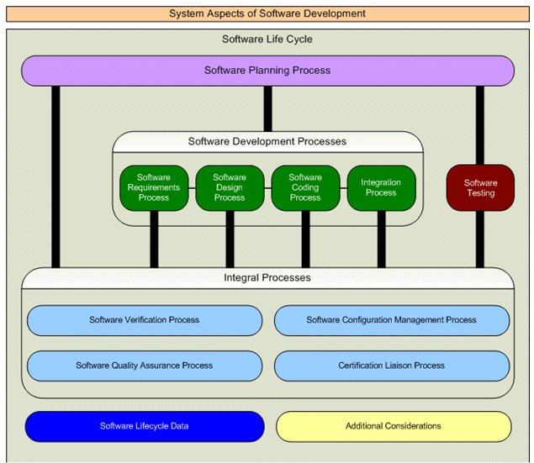
Figure 6-4 Relationship Between Processes and Activities

The diagram in the following section details the relationship between the hardware and software processes. It also includes the relationships of the related integral processes.

Interaction Among Processes

Each process and the interaction between the processes will be iterative. Each process has established transition criteria to enter the process and transition criteria to exit the process. These criteria are summarized in this Plan and detailed in the Software Development Plan, Software Verification Plan, Software Configuration Management Plan and Software Quality Assurance Plan. In order to maintain visibility into the results of previous iterations, processes may be re-entered. The following diagram illustrates the core interaction among each of the processes.

System Lifecycle Flow Diagram

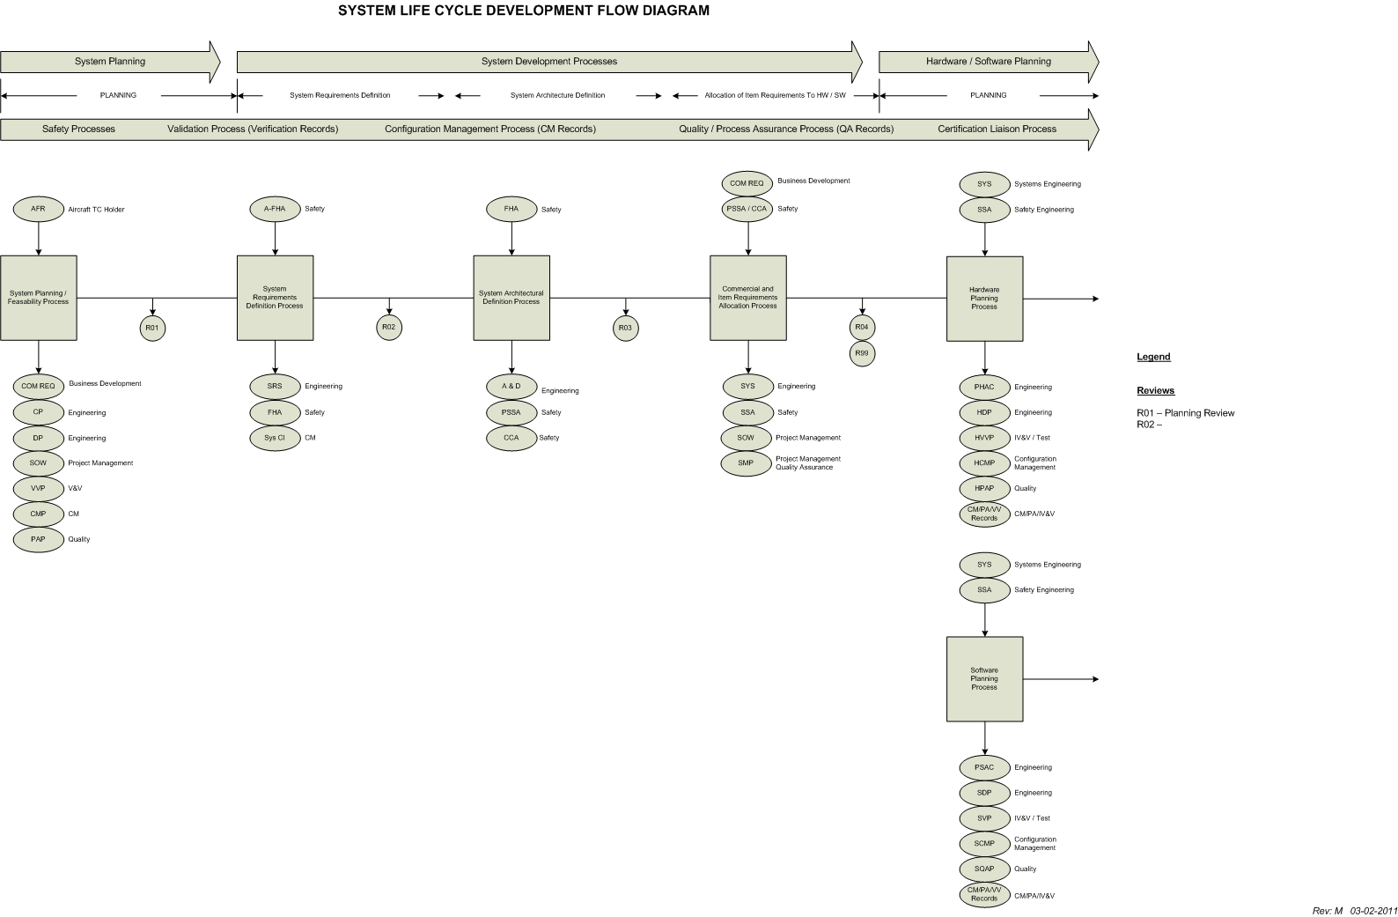

Figure 6-5 System Lifecycle Flow Diagram

Hardware and Software Lifecycle Flow Diagram

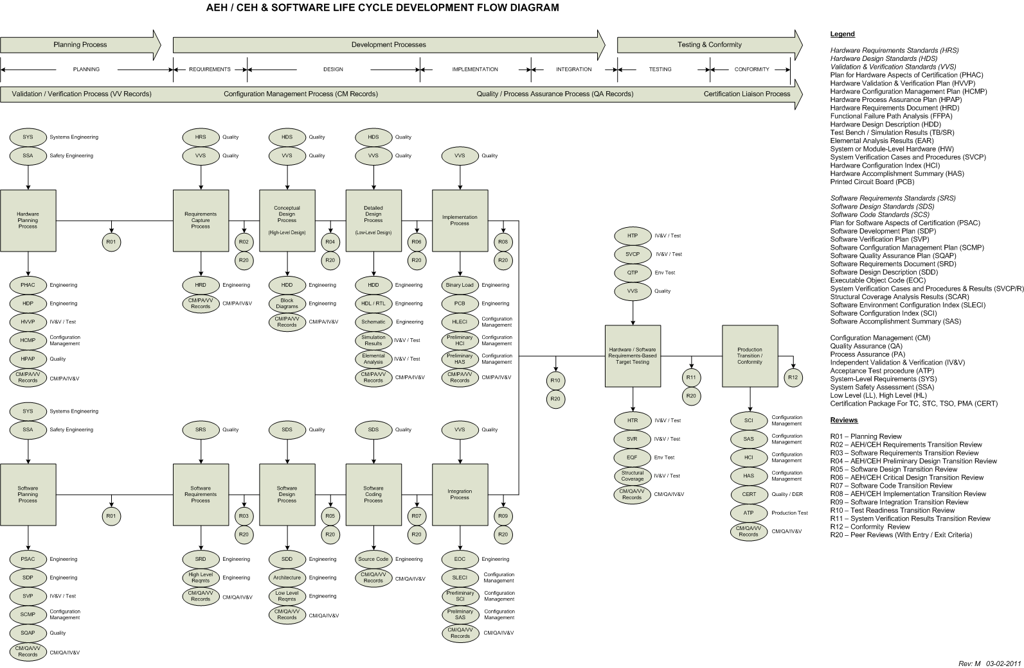

Figure 6-6 Hardware and Software Lifecycle Diagram

Software Incremental Development Lifecycle Flow Diagram

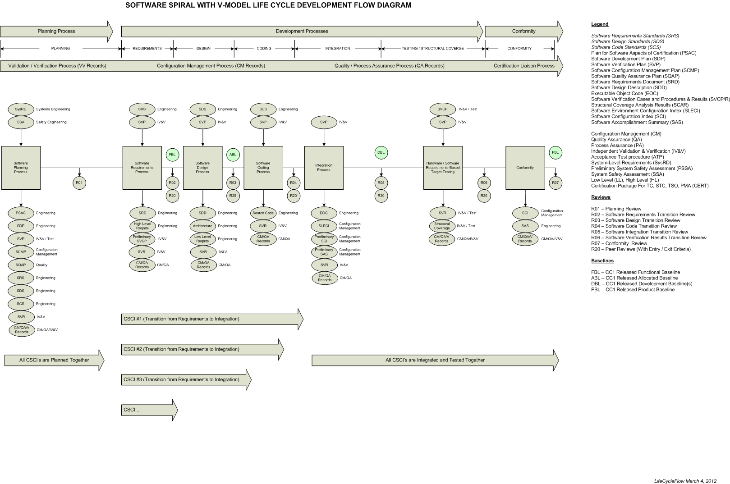

Figure 6-7 Software Incremental Development Lifecycle Flow

Means of Providing Feedback

Feedback to the System and Safety Process
The following diagram illustrates the feedback loop between the System and Software Development Processes. System requirements allocated to software have been validated as part of the System and Safety Processes. When derived requirements are produced during the software development process, they have not been validated, so they are provided to the System Process to determine if there is any impact on the system safety assessment and system requirements. This assessment is performed in a peer review, which includes representatives from System / Safety. The peer review will be recorded and resulting evidence maintained in the Reviews and Analysis Management System.

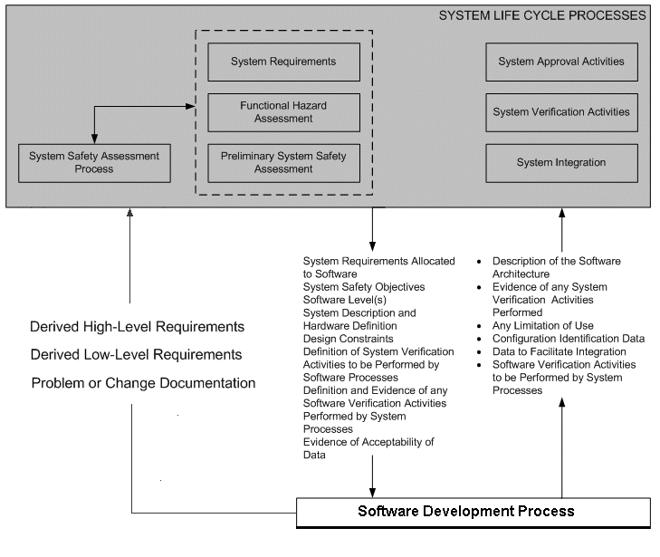
Figure 6-8 System and Safety Process Feedback Flow Diagram

Feedback to the Development and Integral Processes
When processes are entered, transition criteria for entering that process have been pre-established and reviewed / verified as transition criteria for exiting the previous process. When a process needs to be re-entered, the feedback mechanism for doing so is the same as the verifying the pre-established transition criteria for entering that process. For example, during the Design Process, the proposed implementation of a safe system included the need for a monitor. The monitor was not identified during the Requirements Process. In this case, the feedback mechanism is a Peer Review (with pre-established entry and exit criteria documented in the review checklist), where the new requirements are identified and recorded. The peer review may or may not result in action items. If it does, the action items also become a feedback mechanism.
Following the feedback process, activities of the process that was re-entered are carried out.

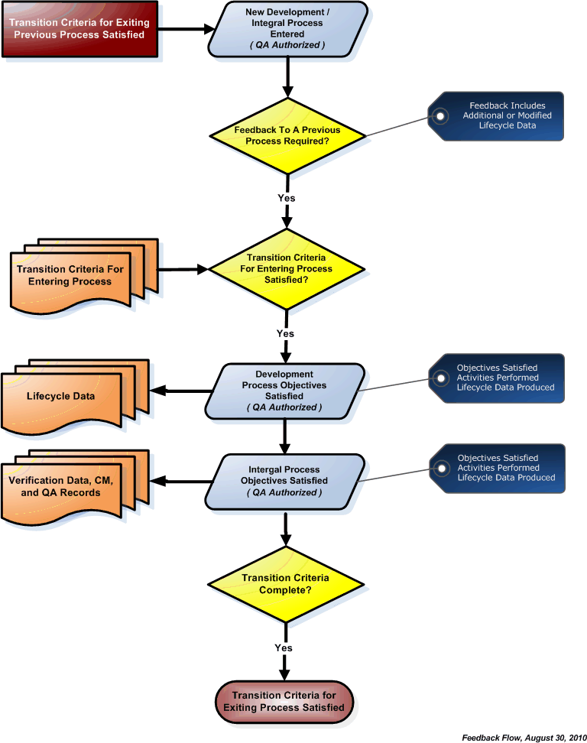
Figure 6-9 Lifecycle Process Feedback Flow Diagram

Traceability of Reviews and Analysis Results

Traceability between review artifacts and review and analysis results will be facilitated by applying a unique ID (including the Project ID and Review ID) to each review activity via the Reviews and Analysis Management System. The review item, review sign-in sheet, review checklist and related action items will be will be traceable to each other based in this ID. In addition, a review folder which contains the review artifacts is maintained using the same ID, ensuring complete traceability and archiving. A final review of all verification evidence and related traceability will be conducted as part of the Software Conformity Reviews.

Review Artifacts | Unique ID  <Project> - <Review> | Item
Review Item (What was reviewed) | RI: 01-025 | -01, 02, 03, etc.
Review Sign-In Sheet (Who reviewed it) | SS: 01-025
Review Checklist (Review criteria) | RC: 01-025
Action Items (Review effectiveness) | AI: 01-025 | -01, 02, 03, etc.

Reviews and Analysis Management System

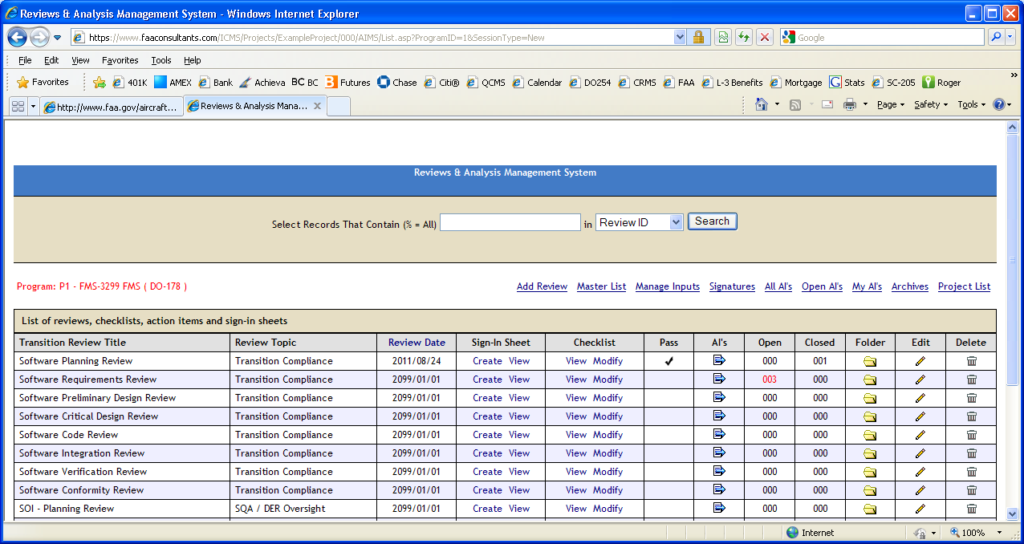

Summary of Problem Reporting Methods
Throughout the planning and development lifecycle, document comments, document redlines, action items, problem reports and corrective and preventive action requests will be generated and managed to closure and placed under CC2 control. Each of these methods forms part of the overall problem reporting process.

Finding Type | Doc  Comment | Doc  Redline | Action  Item | Problem  Report | Corrective Action | SQA Closure
CC1 Document Finding |  |  |  |  |  | Yes
CC2 Document Finding |  |  |  |  |  | No
Transition Review Finding |  |  |  |  |  | Yes
Peer Review Finding |  |  |  |  |  | No
SQA Process Finding Not requiring root-cause analysis |  |  |  |  |  | Yes
SQA Process Finding requiring root-cause analysis |  |  |  |  |  | Yes
Product bugs and Product Findings (following test baseline) |  |  |  |  |  | Yes
Table 6-18 Summary of Problem Reporting Methods

Software Planning Process
The Software Planning Process establishes the foundation for resource utilization and personnel assignments. During this process, the software development and integral activities are defined and additional considerations addressed.

Software Planning Process Objectives

DO-178C Objective | DO-178C Table Reference | DO-178C Paragraph Reference
The activities of the software life cycle processes are defined. | A-1.1 | 4.1a, 4.3
The software life cycle(s), including the inter-relationships between the processes, their sequencing, feedback mechanisms, and transition criteria, is defined. | A-1.2 | 4.1b, 4.3
Software life cycle environment is selected and defined. | A-1.3 | 4.1c
Additional considerations are addressed. | A-1.4 | 4.1d
Software development standards are defined. | A-1.5 | 4.1e
Software plans comply with this document. | A-1.6 | 4.1f, 4.6
Development and revision of software plans are coordinated. | A-1.7 | 4.1g, 4.6
Table 6-19 Software Planning Process Objectives

Software Planning Process Deviations from the PSAC
This section remains unchanged from the original PSAC and no deviations have been taken from the original design lifecycle approach.

Software Requirements Process
The Software Requirements Process produces high-level software requirements. High-level software requirements include functional, performance, interface and safety-related requirements. This process also produces high-level derived requirements that may or may not be directly traceable to system requirements. During this process, representatives from Business Development, Engineering, Program Management, and Quality meet to discuss the Business Development Requirements. Requirements are identified.
The system functional and interface requirements allocated to software will be analyzed for clarity, consistency, and completeness to ensure that the system requirements are understood. Any discrepancies or issues arising from this analysis are reported to the Project Engineer for clarification and resolution. The activities associated with the software requirements process produce a defined and traceable set of high-level requirements.

Software Requirements Process Objectives

DO-178C Objective | DO-178C Table Reference | DO-178C Paragraph Reference
High-level requirements are developed. | A-2.1 | 5.1.1a
Derived high-level requirements are defined and have been indicated to the System Safety Assessment Process. | A-2.2 | 5.1.1b
Table 6-20 Software Requirements Process Objectives

Software Requirements Process Deviations from the PSAC
This section remains unchanged from the original PSAC and no deviations have been taken from the original design lifecycle approach.

Software Design Process
During the Software Design Process, each software unit is further defined and partitioned into modules / routines and documented in the Software Design Description. This design activity includes establishing the calling sequences, assumptions, interaction with other routines, data and control interfaces, and limitations of each software unit. Documentation of the detailed design is presented at the Software Critical Design Review.

Software Design Process Objectives

DO-178C Objective | DO-178C Table Reference | DO-178C Paragraph Reference
The software architecture was developed from the high-level requirements. | A-2.3 | 5.2.1a
Low-level requirements are developed from high-level requirements. | A-2.4 | 5.2.1a
Derived low-level requirements are defined and have been provided to the System Safety Assessment Process. | A-2.5 | 5.2.1b
Table 6-21 Software Design Process Objectives

Software Design Process Deviations from the PSAC
This section remains unchanged from the original PSAC and no deviations have been taken from the original design lifecycle approach.

Software Coding Process
The Software Coding Process produces source code that is traceable, verifiable, and consistent and correctly implements the low-level requirements.

Software Coding Process Objectives

DO-178C Objective | DO-178C Table Reference | DO-178C Paragraph Reference
Source Code is developed that is traceable, verifiable, and consistent and correctly implements low-level requirements. | A-2.6 | 5.3.1a
Table 6-22 Software Coding Process Objectives

Software Coding Process Deviations from the PSAC

This section remains unchanged from the original PSAC and no deviations have been taken from the original design lifecycle approach.

Integration Process
Using the released source and object code, the development team builds the source code and object code into Executable Object Code and loads it into the target computer for hardware/software integration.

Integration Process Objectives

DO-178C Objective | DO-178C Table Reference | DO-178C Paragraph Reference
Executable Object Code and Parameter Data Item Files, if any, are produced and loaded in the target computer. | A-2.7 | 5.4.1a
Table 6-23 Integration Process Objectives

Integration Process Deviations from the PSAC

This section remains unchanged from the original PSAC and no deviations have been taken from the original design lifecycle approach.

Software Testing Process
The Software Testing Process produces Software Test Cases, Software Test Procedures and Software Test Results and utilizes three types of testing, including hardware/software integration testing, software integration testing and low-level testing. The Software Testing Process also produces Normal-Range Test Coverage Analysis Results and Structural Coverage Analysis Results.

Software Testing Process Objectives

DO-178C Objective | DO-178C Table Reference | DO-178C Paragraph Reference
Executable Object Code complies with high-level requirements. | A-6.1 | 6.4.2.1, 6.4.3
Executable Object Code is robust with high-level requirements. | A-6.2 | 6.4.2.2, 6.4.3
Executable Object Code complies with low-level requirements. | A-6.3 | 6.4.2.1, 6.4.3
Executable Object Code is robust with low-level requirements. | A-6.4 | 6.4.2.2, 6.4.3
Executable Object Code is compatible with target computer. | A-6.5 | 6.4.3a
Table 6-24 Software Testing Process Objectives

Software Testing Process Deviations from the PSAC

This section remains unchanged from the original PSAC and no deviations have been taken from the original design lifecycle approach.

SOFTWARE LIFE CYCLE DATA

Overview
This section describes the software design life cycle data that was produced during the software design life cycle for providing evidence of design assurance and compliance with certification requirements. The scope, amount, and detail of the life cycle data needed by the certification authorities as design assurance evidence will vary depending on a number of factors. These factors include the applicable certification authority requirements for the airborne system, the assigned design assurance levels and the complexity of the software.
The design life cycle data produced for this project will be:
- Unambiguous. Information/data is written in terms that allow only a single interpretation.
- Complete. Information/data includes necessary and relevant requirements and descriptive material, labeled figures, and defined terms and units of measure.
- Verifiable. Information / data can be checked for correctness by a person or a tool.
- Consistent. Information / data contain no conflicts.
- Modifiable. Information/data is structured and changes can be made completely, consistently and correctly while retaining the structure.
- Traceable. Information / data origin can be determined.

Trace Data
Trace data establishes the associations between life cycle data items contents. Trace data will be provided that demonstrates bi-directional associations between:
a. System requirements allocated high-level software requirements.
b. High-level requirements and low-level requirements.
c. Low-level requirements and Source Code.
d. Software Requirements and test cases.
e. Test cases and test procedures.
f. Test procedures and test results.

Trace Data between test procedures and results is part of the Software Verification Results.

Trace Data Objective Evidence of Compliance
Trace data, showing the bi-directional association between system requirements allocated to software and high-level requirements, is developed to enable verification of the complete implementation of the system requirements allocated to software and give visibility to the derived high-level requirements.
Trace data, showing the bi-directional association between the high-level requirements and low-level requirements, is developed to enable verification of the complete implementation of the high-level requirements and give visibility to the derived requirements and the architectural design decisions made during the software design process.
Trace data, showing the bi-directional association between low-level requirements and Source Code, is developed to enable verification that no Source Code implements an undocumented function and verification of the complete implementation of the low-level requirements.
The traceability between the software requirements and the test cases is accomplished by the requirements-based coverage analysis.
The traceability between the code structure and the test cases is accomplished by the structural coverage analysis.
High-level requirements and traceability to those high-level requirements will be verified.
The results of the traceability analyses and requirements-based and structural coverage analyses should show that each software requirement is traceable to the code that implements it and to the review, analysis, and/or test case that verifies it.
If the code tested is not identical to the airborne software, those differences will be specified and justified.
When it is not possible to verify specific software requirements by exercising the software in a realistic test environment, other means will be provided and their justification for satisfying the software verification process objectives defined in the Software Verification Plan or Software Verification Results.
Deficiencies and errors discovered during the software verification process will be reported to the software development processes for clarification and correction.

Software Lifecycle Data to Be Produced and Controlled
Software Life Cycle Data consists of the data or artifacts produced during life cycle development of the product. These artifacts are identified below:

Document Title | See SCI for Rev Data
Plan for Software Aspects of Certification
Plan for Software Aspects of Certification | A primary liaison document, the PSAC describes the proposed development methods to the certification authority for agreement and defines the Method of Compliance with DO-178C.
Software Development Plan
Software Development Plan | Defines the software life-cycle and software development environment.
Software Verification Plan
Software Verification Plan | Defines the means by which the software verification process objectives were satisfied.
Software Configuration Management Plan
Software Configuration Management Plan | Defines the means by which the software configuration management process objectives were satisfied.
Software Quality Assurance Plan
Software Quality Assurance Plan | Defines the means by which the software quality assurance process objectives were satisfied.
Software Requirements Standards
Software Requirements Standards | Defines the methods, rules, and tools to be used to develop the high-level requirements.
Table 7-25 Lifecycle Data To be Produced

Document Title | See SCI for  Rev Data
Software Design Standards
Software Design Standards | Defines the methods, rules, and tools to be used to develop the software architecture and low-level requirements.
Software Code Standards
Software Code Standards | Defines the programming languages, methods, rules, and tools to be used to code the software.
Software Requirements Document
Software Requirements Document | Defines the system requirements allocated to software: the high-level software requirements. In addition, describes derived high-level software requirements necessary to describe a complete and coherent software system.
Software Design Description
Software Design Description | Defines the software architecture and the low-level requirements that satisfy the high-level software requirements.
Source Code
Source Code | Code written source language(s) compiled in accordance with the Software Build Procedures (see below) to produce object code.
Software Build and Load Control Procedure
Software Build and Load Control Procedure | Describes the process of compiling and linking the software. Load control describes the procedure used to load the primary executable software onto the target hardware.
Executable Object Code
Executable Object Code | A form of Source Code that is directly usable by the central processing unit of the target computer. This is the software that is loaded into the system using the load procedures (see above).
Software Verification Cases and Procedures and verification Results
 | Details how the software process activities were implemented. Includes the test environment setup, test cases and procedures, and analyses performed in verifying the software configuration. Verification results documents the results of the verification activities, including test results, analyses results, and review results.
Software Configuration Index

Software Configuration Index | Identifies the configuration of the software product. This document will include references to other software life-cycle data to provide a complete view of the software configuration.
Software Environment Configuration Index
Software Environment Configuration Index | Identifies the configuration of the software life-cycle environment, including both development and verification tools. This data were included in the SCI document.
Software Accomplishment Summary
Software Accomplishment Summary | Describes the software system and the activities performed in verifying it.

Relationship of Lifecycle Data to Other Data Defining the System
Configuration Management Records and Quality Assurance Records combine with the Lifecycle Data to form a complete system design data package. The following records are included:
- Planning Requirements, Design and Verification Data
- Review Checklists from reviews identified in the Software QA Plan.
- Review Checklists from document reviews identified in the Software QA Plan.
- SQA audit results as identified in the Software QA Plan.
- Project metrics as identified in the Software QA Plan.
- Problem reports as identified in the Software Configuration Management Plan.
- Source Code
- Executable Object Code

Software Lifecycle Data to be Submitted to Certification Authority
Software Lifecycle Data will be provided to the Certification Authority in both hard copy format and on CD-ROM. The Software DER will review all lifecycle data and provide a signed Form 8110-3 recommending approval of the data. The following lifecycle data will be submitted:

Document Title | See SCI for Rev Data
Plan for Software Aspects of Certification
Plan for Software Aspects of Certification | A primary liaison document, the PSAC describes the proposed development methods to the certification authority for agreement and defines the Method of Compliance with DO-178C.
Software Configuration Index

Software Configuration Index | Identifies the configuration of the software product. This document will include references to other software life-cycle data to provide a complete view of the software configuration.
Software Accomplishment Summary
Software Accomplishment Summary | Describes the software system and the activities performed in verifying it.
Table 7-26 Lifecycle Data To Certification Authority

Software Control Categories

Software Life Cycle Data | Level A | Level B | Level C | Level D
Software Plans
Plan for Software Aspects of Certification | CC1 | CC1 | CC1 | CC1
Software Development Plan | CC1 | CC1 | CC2 | CC2
Software Verification Plan | CC1 | CC1 | CC2 | CC2
Software Configuration Management Plan | CC1 | CC1 | CC2 | CC2
Software Quality Assurance Plan | CC1 | CC1 | CC2 | CC2
Software Requirements Standards | CC1 | CC1 | CC2 | NA
Software Design Standards | CC1 | CC1 | CC2 | NA
Software Code Standards | CC1 | CC1 | CC2 | NA
Software Requirements Data | CC1 | CC1 | CC1 | CC1
Design Description | CC1 | CC1 | CC2 | CC2*
Source Code | CC1 | CC1 | CC1 | NA
Executable Object Code | CC1 | CC1 | CC1 | NA
Software Verification Cases and Procedures | CC1 | CC1 | CC2 | CC2
Software Verification Results | CC2 | CC2 | CC2 | CC2
Software Lifecycle Environment Configuration index | CC1 | CC1 | CC1 | CC2
Software Configuration Index | CC1 | CC1 | CC1 | CC1
Problem Reports | CC2 | CC2 | CC2 | CC2
Software Configuration Management Records | CC2 | CC2 | CC2 | CC2
Software Quality Assurance Records | CC2 | CC2 | CC2 | CC2
Software Accomplishment Summary | CC1 | CC1 | CC1 | CC1
Table 7-27 Software Control Categories
* Software Architecture Only

Software Lifecycle Data DER Delegation

FAA DER | Applicable Documents | Approve  (8110-3) | Recommend  Approval  (8110-3) | Review of Data
Todd White | Plan for Software Aspects of Certification |  | X
Todd White | Software Development Plan | X
Todd White | Software Verification Plan | X
Todd White | Software Configuration Management Plan | X
Todd White | Software Quality Assurance Plan | X
Todd White | Software Requirements Standards | X
Todd White | Software Design Standards | X
Todd White | Software Code Standards | X
Todd White | Software Requirements Data |  |  | X
Todd White | Software Design Data |  |  | X
Todd White | Software Traceability Data |  |  | X
Todd White | Software Review and Analysis Procedures. |  |  | X
Todd White | Software Review and Analysis Results | X
Todd White | System Verification Cases and Procedures | X
Todd White | Software Verification Results | X
Todd White | Software Configuration Management Records |  |  | X
Todd White | Software Quality Assurance Records |  |  | X
Todd White | Software Lifecycle Environment Configuration Index |  | X
Todd White | Software Configuration Index |  | X
Todd White | Software Accomplishment Summary |  | X
Todd White | Problem Reports |  |  | X
Table 7-28 Software DER Delegation

ADDITIONAL CONSIDERATIONS
This section of this SAS identifies additional considerations concerning the software aspects of certification in relation o the use of previously developed software, qualification of software tools, and alternative methods for achieving the objectives of the previous sections of this document.

Use of Previously Developed Software

The following evidence was provided in support of the PDS claim:

List of Certification Evidence

Certification Evidence | Document | Rev | Included in SAS
EASA Certification (AIRFRAFT)
DDP |  |  | Yes
Letter of Approval
FAA / Certification (AIRFRAFT)
Letter of FAA Approval |  |  | Yes

Certified Part Numbers → Part Numbers (Verify that they are the same)
Component | Rev | Aircraft 1 PN | Aircraft 2 PN | Aircraft 2 PN
PCB
Processor
DSP
PIC

DAL Verification (Verification that DAL is the same)
Component | Rev | Aircraft 1 PN | Aircraft 2 PN | Aircraft 2 PN
PCB |  | DAL C | DAL C | DAL C
Processor |  | DAL C | DAL C | DAL C
DSP |  | DAL C | DAL C | DAL C
PIC |  | DAL C | DAL C | DAL C

Open Problem Reports (Evidence that none are open)
PR ID | Title | Category | Safety
NA | None | NA | NA

Traceability Between Baseline Specification and Aircraft Installation Specification
Component Specification | Aircraft 1 PN | Aircraft 2 PN | Aircraft 2 PN
Requirements Reference | Yes | No | No
Requirements Reference | Yes | Yes | Yes
Requirements Reference | Yes | Yes | Yes

Unused Functions
Unused Functions | Aircraft 1 PN | Aircraft 2 PN | Aircraft 2 PN
Unused Function 1 | Yes | No | No
Unused Function 2 | Yes | Yes | Yes
Unused Function 3 | Yes | Yes | Yes

Unused Functions | Evidence of analysis showing that the unused function cannot jeopardize the application
Unused Function 1 | Although the requirement text is slightly different, the resulting implementation between all three aircraft is exactly the same.
Unused Function 2
Unused Function 3

Integration Test Strategy
Define integration test strategy and show evidence that testing was performed. Indicate that evidence will be provided to demonstrate that formal integration tests with the old component on the new target.

Integration Test Results
Integration Test Results | Old Target Reference | New Target Reference

SAS Updates To Support PDS Claim
SAS Section | Update Summary

Tool Qualification
Qualification of tools is required when processes of DO-178C are eliminated, reduced or automated by the use of a software tool without its output being verified. The objective of the tool qualification process is to ensure that the tool provides confidence at least equivalent to that of the process or processes eliminated, reduced or automated. This section lists all tools used to develop the software. Tools requiring qualification are identified and the appropriate qualification rationale provided.

Development Tools
Development tools that require qualification are those tools whose output is part of airborne software and can introduce errors. The following lists all development tools to be used on the program and identifies those tools that require qualification.

Tool Name | Tool Function | Qual  Required
NA | NA | NA
Table 8-29 Software Development Tools

Qualification of Development Tools
There were no development tools qualified for this project.

Qualified Verification Tools
Verification tools that require qualification are those tools that cannot introduce errors, but may fail to detect them. The following table lists all verification tools to be used on the program and identifies those tools that required qualification.

Tool Name | Tool Function | Qual  Required
PRMS | Problem Reporting Management System | No
RTMS | Requirements Traceability Management System | No
RAMS | Reviews and Analysis Management System | No
DRMS | Document Review Management System | No
CAMS | Coverage Analysis Management System | No
VSS | Software Version Control Management System | No
MS PowerPoint | Meetings and Presentations | No
MS Project | Project Schedules and Milestones | No
MS Visio | Flow Chart and Diagram Program | No
Table 8-30 Software Verification Tools

Qualification of Verification Tools
No verification tools were qualified on this program.

Alternative Methods
Alternative methods were not used on this program.

SOFTWARE IDENTIFICATION
The software core part number excludes the software version, which is represented by the last two digits of the software part number. The software part number legend is detailed in the Software Configuration Index.
This software release is applicable to the following software core part number and version:

Release | Part Number | Nomenclature | ECN
01 |  |  | Initial Release
01 |  |  | Initial Release
Table 9-31 Software Identification

CHANGE HISTORY
A complete change history can be found in the Software Configuration Index.

SOFTWARE STATUS
This section contains a list of problem reports unresolved at the time of submittal of the certification data.
Table 11-32 Software Status – Open Problem Reports
PR# | PR Title | Type | Safety

Acceptable Open Problem Report Types

Type 1: a problem whose consequence is a possible failure – under certain conditions- of the system; having no safety impact on the aircraft (this needs to be confirmed by the aircraft manufacturer). If agreed between aircraft manufacturer and supplier, this type should be divided into two sub-types:

- Type 1A: failure with a “significant” functional consequence; the meaning of “significant” should be defined in the context of the related system in agreement between aircraft manufacturer and equipment supplier (for instance “cockpit effect”).

- Type1B: failure with no “significant” functional consequence.

Type2: a fault which does not result in a failure (i.e.: no system functional consequence, fault not detectable by the crew in foreseeable operating conditions).

Type3: Any problem which is not type 0, 1 or 2, but a deviation to the rules (plans or development standards, applicable CRI’s). If agreed between aircraft manufacturer and supplier, this type should be divided into two sub-types:

- Type 3A: a “significant” deviation whose effects could be to lower the assurance that the software or the CDD behaves as intended and has no unintended behavior

- Type3B: a non-“significant" deviation to the methodology (plans) that does not affect the assurance obtained.

Unacceptable Open Problem Report Type

A problem whose consequence is a possible failure (under certain conditions) of the system with a safety impact.

COMPLIANCE STATEMENT
This document summarizes the software development methods used and has been prepared in accordance with RTCA/DO-178C. It demonstrates compliance with the criteria specified in the software plans.
<Summarize the results of the testing, indicating whether all tests passed, or if all discrepancies were explained.>
<Project Name> software complies with the development guidelines of RTCA/DO-178C using Level A/B/C/D criteria…

