
DISCLAIMER

Copyright 2017, Airworthiness Certification Services, Inc. (ACS) in partnership with the Avionics Certification Academy.

All rights reserved.

These Templates are perpetually licensed for a single company, for the site and/or project team who initially purchased. The purchaser can use the Templates, or any customized variant of them, on as many projects as desired. The Templates may not be shared outside of the purchasing company with the exception of interactions with customers and program auditors. The Purchaser agrees to these terms as part of the sale. If a worldwide Corporate License is desired, which provides unlimited access for all sites and project teams within a company, contact info@avionics-certification-academy.com for details and a quote.

This Template is proprietary to ACS. and should not be distributed or copied in its original format without written permission. It is to be used solely as the basis of documentation for the purchaser of this template. Also, it should not be viewed as FAA opinion or regulatory guidance and presents only opinion and interpretation of FAA information by ACS.

All references to DO-178C and/or DO-254 material are copyrighted by and used with permission from:
RTCA, Inc.
1150 18th Street NW, Suite 910
Washington, DC 20036
(202) 833-9339
www.rtca.org

ACS hereby disclaims all warranties and conditions with respect to these Templates, either express, implied or statutory, including, but not limited to, the implied warranties and/or conditions of merchantability, of satisfactory quality, of fitness for a particular purpose, of accuracy, or quiet enjoyment, and non-infringement of third party rights. ACS does not warranty against interference with clients enjoyment of the Templates, that the functions contained in the Templates will meet the client’s requirements, that the Templates will be error-free or that defects in the templates will be corrected.
No oral or written information or advice given by ACS or by an ACS authorized representative shall create a warranty should the Templates prove defective, client assumes the entire cost of all necessary servicing, repair or correction.

Downloading and using these templates signifies you have read and accepted these conditions.

Please direct all questions or concerns to:
Airworthiness Certification Services
25327 SE Mirrormont Blvd Issaquah WA 98027
Phone: 206-226-6561, email: info@airworthinesscert.com

NOTE: YOU MAY REMOVE THIS PAGE FROM YOUR TEMPLATES AFTER READING THIS DISCLAIMER


Validation and Verification Standards
for the
<Program Name>
Document No: <Doc Number>
Revision: -

__________________________________________________ |  |  | ___________
<Name>, Program Manager |  | Date
__________________________________________________ |  | ___________
<Name>, Technical Project Lead |  | Date
__________________________________________________ |  | ___________
<Name>, Engineer |  | Date
__________________________________________________ |  | ___________
<Name>, Quality Engineer |  | Date

Notice
This document and the information contained herein are the property of <Company Name>. Any reproduction, disclosure or use thereof is prohibited except as authorized in writing by <Company Name>. Recipient accepts the responsibility for maintaining the confidentiality of the contents of this document.

REVISIONS
Rev. | Reason/Description | Requested/ Changed By | Date

Table of Contents

Section Page
1.0 INTRODUCTION 5
1.1 Purpose 5
1.2 Scope 5
1.3 Acronyms and Abbreviations 6
1.4 Applicable Documents 7
1.4.1 External Documents 7
1.4.2 Internal Documents 7
2.0 VALIDATION Standards 8
2.1 Methods for Defining Requirements 8
2.1.1 Boolean Requirements 8
2.1.2 Textual Case Format 8
2.1.3 Input Requirements 9
2.1.4 Functional Requirements 9
2.1.5 Output and Performance Requirements 9
2.1.6 Timing Requirements 9
2.1.7 High Level Hardware Requirement Review Criteria 10
2.2 Validation Methods 11
2.2.1.1 Hardware Requirements Document Review 11
2.2.1.2 Hardware Requirements Review 12
2.2.1.3 Analysis of Hardware Requirements 13
2.2.1.4 System and Hardware Requirements Trace Analysis 13
2.3 Validation Data 14
2.4 Validation Environment 15
2.4.1.1 Problem Reporting Management System 15
2.4.1.2 Document Review Management System 16
2.4.1.3 Action Item Management System 17
2.4.1.4 Requirements Traceability Management System 18
3.0 Verification standards 19
3.1 Reviews 19
3.1.1 Hardware Requirements Review 19
3.1.2 Hardware Preliminary Design Review 19
3.1.3 Hardware Critical Design Review 19
3.1.4 Hardware Implementation Review 19
3.1.5 Hardware Verification Review 19
3.1.6 Production Transition Review 19
3.1.7 Hardware Conformity Review 19
3.2 Analysis 20
3.2.1 System/Safety Peer Review 20
3.2.2 Requirements Peer Review 20
3.2.3 Conceptual Design Peer Review 20
3.2.4 Detail Design Peer Review 20
3.2.5 Test Case Peer Review 20
3.2.6 Test procedure Peer Review 20
3.2.7 Test Results Peer Review (includes Coverage Results) 20
3.2.8 Production Transition Peer Review 20
3.2.9 HDL Simulation 20
3.3 Test 21
3.3.1 Functional Test 21
3.3.2 In-Circuit Test 21
3.3.3 Simulation and On-Target Testing 21
3.3.4 Structural Coverage Analysis 22
3.3.4.1 Statement Coverage 22
3.3.4.2 Branch Coverage 22
3.3.4.3 Condition and Expression Coverage 23
3.3.4.4 Directed and Focused Expression Coverage 23
3.3.4.5 Toggle Coverage 23
3.3.4.6 Triggering Coverage 23
3.3.4.7 Signal Tracing Coverage 24
3.4 Test Procedure Structure 25
3.5 Verification Environment 27
3.5.1.1 Problem Reporting Management System 27
3.5.1.2 Document Review Management System 28
3.5.1.3 Action Item Management System 29
3.5.1.4 Requirements Traceability Management System 30
3.5.1.5 Simulation and Testing Environment 31
3.5.1.5.1 Qualification of Verification Tools 31

INTRODUCTION

Purpose
This document contains the standards that will be observed in validating and verifying the hardware. Reviews will be used for both validating requirements and for validating the documents of the design life cycle. This standard has been prepared in accordance with the requirements of RTCA/DO-254.

Scope
This document contains standards to be observed in verifying the requirements. Tests or analysis will be conducted on the requirements that need to be verified. Requirements need to be verified if they are safety critical or are not covered by a higher level requirement that has already been tested (such as a system level test covering a high level requirement).

Acronyms and Abbreviations
<PROJ> <Add Project Acronyms in Alphabetical Order>
AIMS Action Item Management System
ALU Arithmetic Logic Unit
ARP Aerospace Recommended Practice
ASIC Application Specific Integrated Circuit
DRMS Document Review Management System
HAS Hardware Accomplishment Summary
HC1 Hardware Control Category 1
HC2 Hardware Control Category 2
COTS Commercial-Off-The-Shelf
EUROCAE European Organization for Civil Aviation Equipment
FAR Federal Aviation Regulations
FFP Functional Failure Path
FFPA Functional Failure Path Analysis
FHA Functional Hazard Assessment
F-FMEA Functional Failure Modes and Effects Analysis
FTA Fault Tree Analysis
HDL Hardware Description Language
JAR Joint Aviation Requirements
LRU Line Replaceable Unit
PHAC Plan for Hardware Aspects of Certification
PLD Programmable Logic Device
PSSA Preliminary System Safety Assessment
RTMS Requirements Traceability Management System
SAE Society of Automotive Engineers
SC Special Committee
SSA System Safety Assessment
WG Working Group

Applicable Documents
The following documents are listed for reference only. Each document is applicable to this plan only to the extent specified herein.

External Documents
RTCA/DO-254 Design Assurance for Airborne Electronic Hardware
FAA Order 8110.4C Type Certification
FAA Order 8110.105 FAA, Simple and Complex Electronic Hardware Approval Guidance
AC 20-152 Advisory Circular, RTCA Inc., Document DO-254, Design Assurance for Airborne Electronic Hardware
<Spec Number> <Customer Specification>
<Spec Number> <Regulatory Specification>

Internal Documents
<Ref Doc> Plan for Hardware Aspects of Certification (Ref. DO-254, 10.1.1)
<Ref Doc> Hardware Design Plan (Ref. DO-254, 10.1.2)
<Ref Doc> Hardware Verification Plan (Ref. DO-254, 10.1.4)
<Ref Doc> Hardware Configuration Management Plan (Ref. DO-254, 10.1.5)
<Ref Doc> Hardware Process Assurance Plan (Ref. DO-254, 10.1.6)
<Ref Doc> Hardware Requirements Standards (Ref. DO-254, 10.2.1)
<Ref Doc> Hardware Design Standards (Ref. DO-254, 10.2.2)
<Ref Doc> Validation and Verification Standards (Ref. DO-254, 10.2.3)
<Ref Doc> Hardware Requirements Document (Ref. DO-254, 10.3.1)
<Ref Doc> Hardware Design Data (Ref. DO-254, 10.3.2)
<Ref Doc> Hardware Test Procedures (Ref. DO-254, 10.4.4)
<Ref Doc> Hardware Lifecycle Environment Configuration Index (Ref. CAST 27)
<Ref Doc> Hardware Configuration Index (Ref. CAST 27)
<Ref Doc> Hardware Accomplishment Summary (Ref. DO-254, 10.9)

VALIDATION Standards
The validation standards define the rules, procedures, methods, criteria and tools used to validate the system and hardware requirements.

Methods for Defining Requirements

Boolean Requirements
Boolean requirements are the most predominant technique used during requirements definition. They are written in terms of conditional cause and effect expressions as follows:
If X is true and Y is false, A shall do B.
In this case, the requirements are laid out in table format so it is immediately clear whether or not something has been missed (requirements tracking shows you haven't missed implementing and testing your requirements but doesn't so clearly show missed requirements). Examples include:
X false, Y false => A shall do C ------- X false, Y true => A shall do D
X true, Y false => A shall do B -------- X true, Y true => A shall do E
In addition, requirements should be separated by preconditions and stimulus to account for static conditions (e.g. internal system state, external input states) that must exist for the requirement to even apply, followed by the specific stimulus (e.g. input or time-out) that requires the response to occur. The response is then the same 'subject shall action’.

Textual Case Format
Textual use case format for system and high level requirements is also used. The advantages include the ability to capture the purpose, key preconditions, the actors and then, as a set of statements like format A, the sequence of events. While this seems like a lot, it may just be 2 or 3 sentences.
By expanding a nominal case into alternate and exception cases, the development and verification engineer can check if all the values and interactions make sense and uncover any new requirements along the way.
Nominal Case Example:
The system does B when proper X and Y inputs are applied.
Precondition X=True, Y= False.
Verify: A does B
This is a simple example; however, the technique is also used with some of the complex interactions. In this case, the engineer write requirements in this form and capture a lot of information. This also tells a story which the verification engineer, responsible for developing the requirements-based normal and robustness test cases can understand.
Exception Case 1:
Precondition X !=True, Y= False.
Verify A does not do B, but better to say A does C which is usually not open-ended.
Exception Case 2:
Precondition X =True, Y!= False.
Verify Exception Condition is reached.

Input Requirements
Input requirements consist of a list or reference to the appropriate interface documents for all analog, discrete, and serial digital inputs to the system. List or reference the appropriate interface documents for all the inputs to the hardware from external interface devices. For all inputs, listed or referenced, state the voltage, current, and frequency. State the pre-processing requirements for all inputs. This covers de-bouncing for discrete inputs. Describe the algorithms to be used. Use logical notation and flow charts as necessary. Enter all this requirements data into RTMS.

Functional Requirements
Once the requirements for the inputs to the hardware are captured, the definition functional requirements may begin. The functional requirements describe in detail the functions to be performed by the system. Describe the designs that are used to meet the functional requirements. Describe the built-in test requirements. Enter all this requirements data into RTMS.

Output and Performance Requirements
Finally specify the output and performance requirements of the hardware. List or reference the appropriate interface document all discrete and serial digital outputs specifying their voltage, current, frequency, and the rate of update. Enter all this requirements data into RTMS.

Timing Requirements
The interactions between the hardware and associated devices are subject to timing constraints. List all of the setup/hold times and frequency constraints from data sheets. Enter the timing constraint data into RTMS.

High Level Hardware Requirement Review Criteria
As the hardware requirements are expressed in text, the use of unambiguous words and correct language are essential. Pre-release reviews of the hardware Requirements Data shall use the following criteria:
- Watch for persuasive connectors such as certainly, therefore, or obviously, and ask why they are present.
- Ensure vague terms such as some, usually, or most are clarified. However, avoid the use of vague terms as a general rule.
- Look for statements containing always, every, never, or other terms that imply certainty and ask for proof.
- Ensure lists are complete. Eliminate use of phrases like etc., and so on, or such as.
- Beware of vague verbs such as handled, processed, or eliminated that can be interpreted in many ways.
- Always include units in stated ranges of variables.
- When a term is explicitly defined in one place, make sure that definition applies for other occurrences of the same term.
- If necessary, when a structure is described in words, draw a picture or a table to aid in understanding it.
- When a series of logical conditions are stated, consider the use of formal notation, logic and/or flow diagrams as a more effective way of expression.

Validation Methods

During the Hardware Requirements Process, the Hardware Requirements and related traceability data are reviewed and analyzed by the signature authority based on the objectives identified in the Hardware Requirements Document Checklist and Hardware Requirements Review Checklist. The review checklists are contained in the Hardware Verification Plan.
The verification review comments for the Hardware Requirements Document is placed in the Document Review Management System and managed by the Project Engineer through closure. Upon acceptance, each team member signs the document, acknowledging acceptance. The document is then released and controlled through the SCM Process. The released document is provided to the Certification Authority for acceptance. Comments provided by the Certification Authority are added to the Document Review Management System and managed to closure. Re-verification of the Planning Documents occurs until final acceptance by the Certification Authority is reached. On-going change control and change authorization is provided through the SCM Process.
Upon final acceptance of the Hardware Requirements Documents by the development team and Certification Authority, a formal Hardware Requirements Review is conducted. The Requirements Review is used to demonstrate that all outstanding issues have been addressed to closure and that the established transition compliance criteria have been satisfied. Final transition criteria assurance and acceptance is obtained by Hardware Process Assurance, in conjunction with the Certification Authority.

Hardware Requirements Document Review
Review of the Hardware Requirements Document occurs when the document is mature enough to be reviewed. Once prepared, the Hardware Requirements Document is submitted to Hardware Configuration Management and entered into the document control system.
The Hardware Process Assurance Engineer coordinates the document review process using the Document Review Management System. Each reviewer ads his or her comments in the Document Review Management System. A cycle of comment incorporation and re-review occurs through Configuration Management until all comments are closed. The Project Lead is responsible or closing all document comments prior to formal release.
Once all comments have been closed, the Hardware Requirements Document is reviewed by the Hardware Process Assurance Engineer against the Document Review Checklist and a cross references from each section of the Hardware Requirements Document to the DO-254 Section 10 Objective to ensure that full compliance is achieved. Once complete the Hardware Process Assurance Engineer signs and dates the checklists, which is maintained by Hardware Configuration Management as HC2 compliance evidence. The Hardware Requirements Document is then signed and released.

Hardware Requirements Review
The Hardware Requirements Review follows the Hardware Requirements Definition Process. The Project Engineer conducts the Hardware Requirements Review using the Hardware Review Checklist as an aid. When the Hardware Requirements Review is held, the Project Engineer records the minutes or assigns someone to do so. The minutes include a discussion of the results, agreements and disagreements reached during the review, updates to the project schedule, resource estimates, and action item assignments with estimated completion dates.
The review is conducted to achieve signature authority consensus of the correctness of the Hardware requirements. Members of the project team, which includes the Project Engineer, Hardware Engineer assigned to the project, Hardware Engineer, Hardware Process Assurance Engineer, and the Configuration Management representative, will be present at the review. Other concerned individuals, such as Manufacturing, Test Engineering, Business Development or Sales, are invited. The review will include a presentation of the naming conventions used for the Hardware requirements and a review and discussion of each Hardware requirement.
The objective of the Hardware Requirements Review is to detect and report errors that may have been introduced during the Hardware Requirements Definition Process.
- The review ensures that the system functions to be performed by the Hardware are completely defined, that the performance and safety requirements have been correctly reflected in the Hardware requirements, and that justification is provided for any derived requirements.
- The review ensures that each requirement is accurate, unambiguous, and sufficiently detailed, and that the requirements do not conflict with each other.
- The review confirms that no conflicts exist between the Hardware Requirements and the hardware features of the target system. Special attention is given to the use of system resources, system response times, and input/output hardware.
- The review ensures that each requirement can be verified.

The Hardware Quality Engineer steps through the Hardware Review Checklist. If deficiencies are revealed during the review, action items are generated, and corrective actions to resolve the deficiencies are fed back into the appropriate process.
Items to be considered at the Hardware Requirements Review include, but are not limited to, the following:
- Review and approval of the Hardware Requirements Document
- Review and acceptance of all functional requirements, performance requirements, interface requirements and design constraints.
- High-level and Derived requirements are recorded in the Hardware Requirements Document.
- The top-level Hardware design is documented in the preliminary release of the Hardware Design Description.
- The Hardware Requirements Process includes a Hardware Preliminary Design Review. Following the review, the program proceeds to the Hardware Design process.

Analysis of Hardware Requirements
Peer reviews are conducted to analyze the Hardware Requirements. The following characteristics are evaluated and form the exit criteria for the peer review:
- Compliance with system requirements: The objective is to ensure that the system functions to be performed by the Hardware are defined, that the functional, performance, and safety-related requirements of the system are satisfied by the Hardware Requirements, and that derived requirements of the system are satisfied by the Hardware Requirements, and that derived requirements and the reason for their existence are correctly defined.
- Accuracy and consistency: The objective is to ensure that each high-level requirement is accurate, unambiguous, and sufficiently detailed, and that the requirements do not conflict with each other.
- Compatibility with the target computer: The objective is to ensure that no conflicts exist between the Hardware Requirements and the system features of the target computer, especially, system response times and input/output hardware.
- Verifiability: The objective is to ensure that each high-level requirement can be verified.
- Conformance to standards: The objective is to ensure the Hardware Requirements Standards were followed during the Hardware requirements process and that deviations from the standards are justified.
- Traceability: The objective is to ensure that the functional, performance, and safety-related requirements of the system that are allocated to Hardware were developed into the Hardware Requirements.
- Algorithm aspects: The objective is to ensure the accuracy and behavior of the proposed algorithms, especially in the area of discontinuities.

System and Hardware Requirements Trace Analysis
The results of this analysis are contained in the system requirements trace matrix. This requirements trace matrix is constructed as follows:
- The requirement identifier for each system requirement allocated to Hardware will be entered into one field of the matrix.
- The requirement identifier for each Hardware requirement that satisfies the system requirement will be entered into the other field of the matrix.
- When multiple Hardware requirements satisfy one system requirement, an entry with the duplicate system requirement identifier field will be entered.
- When multiple system requirements are satisfied by one Hardware requirement, an entry with the duplicate Hardware requirement identifier field will be entered.
- All Hardware requirements derived due to implementation will be designated as “Derived” in the system requirement identifier field.

Validation Data
Every review will have an associated checklist of items to review against. The requirements review shall use the “Requirements Review Checklist” (Appendix A). Both the conceptual and the detailed design reviews shall use the “Design Review Checklist” (Appendix B). Both the verification cases and procedures and verification test results shall use the “Verification Cases, Procedures and Results Review Checklist” (Appendix C). The implementation review shall use the “Implementation Review Checklist” (Appendix I). The production transition review shall use the “Production Transition Review Checklist” (Appendix D).
If there are any defects, each one will be analyzed and a decision made whether it requires action to resolve it. The decision for each defect will be recorded in the review documentation and the resolutions will be independently verified. If a defect cannot be corrected within the realm of the review, then a SCR must be entered into PVCS Tracker, and the SCR number must be recorded in the review documentation.
Review of the Detail Design representations shall ensure that Date/Time stamp and revision label have been updated and are unique. Further, review of the detail design shall ensure that the Standards specified (hardware Design Standards) are met. HDL source code generated by Active-HDL from block diagrams shall be reviewed for correct output.
The verification results, including analysis, simulation, requirements coverage, and detail design coverage shall be reviewed. The verification results review shall ensure that the required coverage has been attained for both the hardware requirements data and detail design representations. Review of test results shall ensure that all actual results meet expected results and that any discrepancies are satisfactorily explained.

Validation Environment

The validation environment includes a suite of tools used to provide review and analysis criteria for each peer and transition review, identify what is being reviewed; identify who is reviewing it (with independence, if required) and when the review occurred. These tools are also used to record document comments, action items and problem reports generated as a result of the reviews and analysis.

Problem Reporting Management System
The Problem Reporting Management System generates a unique database record for each problem / improvement request. A Problem Report can be created by anyone. Automatic email notification of Problem Report adds modifications and closures. Safety-related Problem Reports are flagged. Status updates and assignments are restricted / secure.

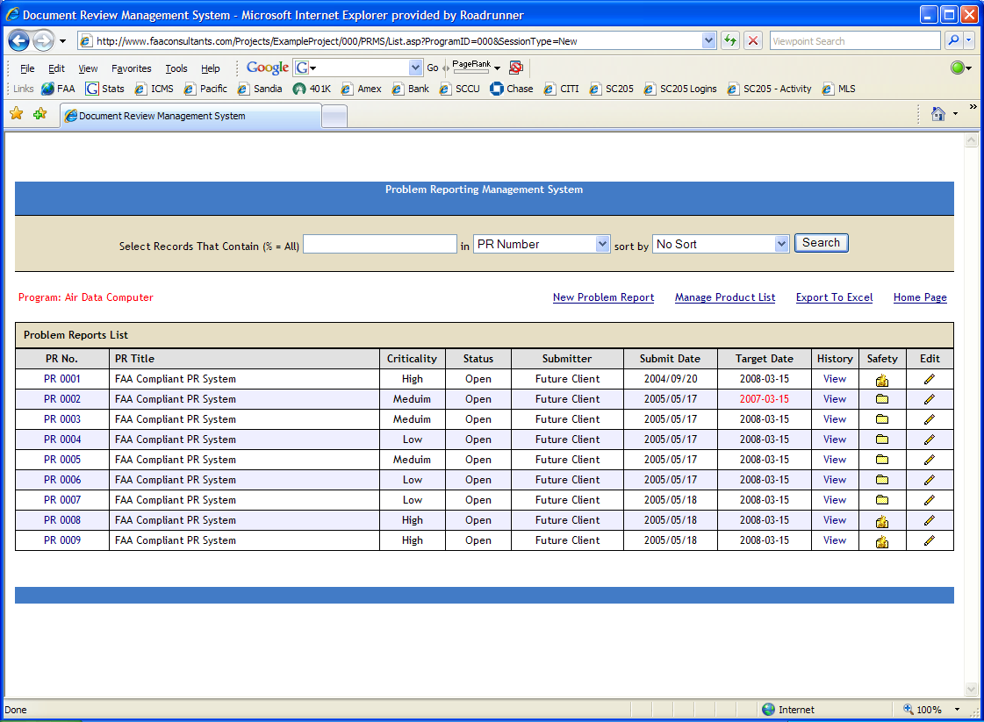

Document Review Management System
The Document Review Management System generates a unique database record for each document, provides a hyperlink to the document, automatically creates a checklist addressing all DO-254 Section 10 objectives, and creates an action item sub-system for recording and managing inputs from individuals reviewing the document and provides email notification.

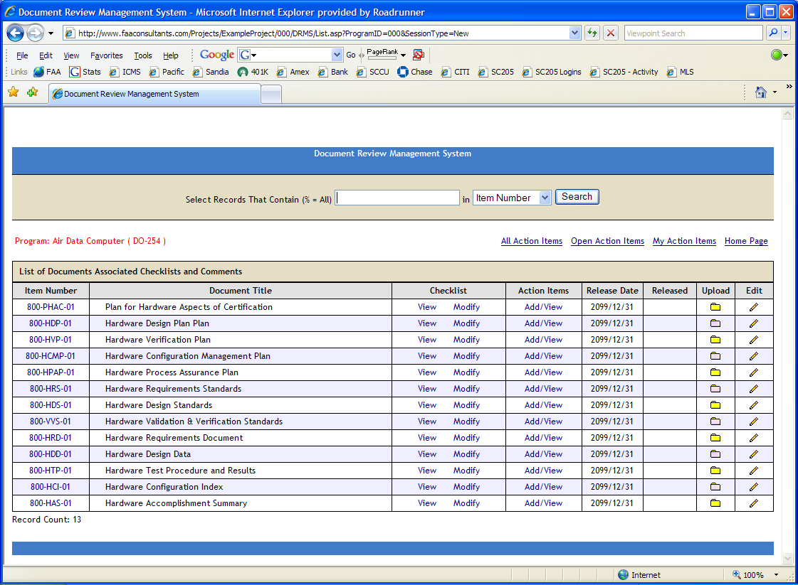

Action Item Management System
The Action Item Management System generates a unique database record for each meeting, automatically creates checklists addressing DO-254 objective, creates a list of documents required for the review, and creates an attendees list and an action item sub-system for recording and managing action items.

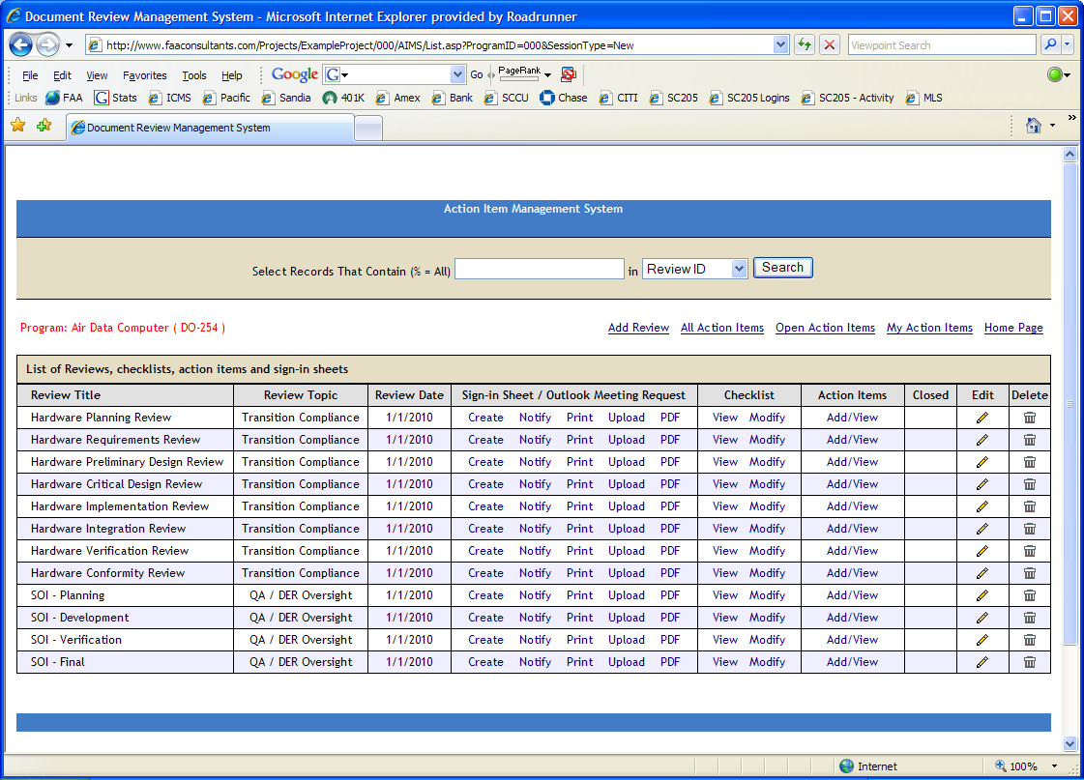

Requirements Traceability Management System
The Requirements Traceability Management System generates a unique database record for each requirement. Requirements definition is from the System Level to the High Level Hardware Requirements to the Low Level Hardware Requirements to the Hardware Module to the Test Cases. Exportable System Requirements are Document Matrix, Hardware Requirements Document Matrix, Hardware Design Document Matrix and Top Down / Bottom Up Traceability Matrix.

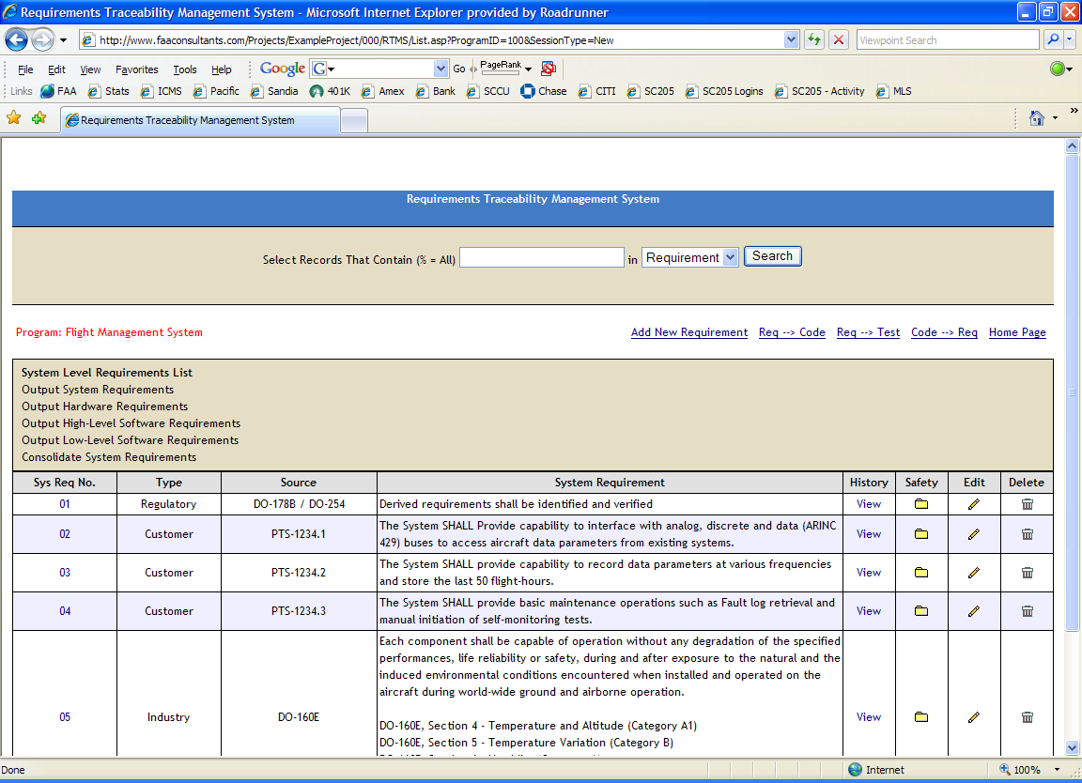

Verification standards
The verification standards define the rules, procedures, methods, criteria and tools used to verify the requirements, design and implementation. Verification can occur at any point in the design process, but for certification credit, a formal verification procedure shall be performed on a configured item.

Reviews
Reviews are qualitative evaluation to assess the plans, requirements, design data, design concept or design implementation to demonstrate to a high degree of confidence that the requirements have been or will be met. The following reviews will always be conducted. The review information is detailed in the Hardware Validation and Verification Plan:

Hardware Requirements Review
The Hardware Requirements Review follows the Hardware Requirements Definition Process. The Hardware Requirements Review Checklist is used during the review.

Hardware Preliminary Design Review
The Hardware Preliminary Design Review (PDR) follows the Hardware Requirements Review. The Hardware PDR Checklist is used during the review.

Hardware Critical Design Review
The Hardware Critical Design Review (CDR) follows the Preliminary Design Review. The Hardware CDR Checklist will be used during the review.

Hardware Implementation Review
The System Implementation Review follows the Critical Design Review. The Hardware Implementation Review Checklist will be used during the review.

Hardware Verification Review
The Hardware Verification Review is conducted at the conclusion of the Hardware Testing Process. The Hardware Verification Review Checklist will be used during the review.

Production Transition Review
The Production Transition Review is conducted at the conclusion of the Hardware Testing Process. The Production Transition Review Checklist will be used during the review.

Hardware Conformity Review
The Hardware Conformity Review is conducted at the conclusion of the Lifecycle. The Hardware Conformity Review Checklist will be used during the review.

Analysis
Analysis is a detailed examination of the functionality, performance, traceability and safety implications of a hardware item and its relationship to other functions. Analysis activities alone or in combination with other verification methods provide evidence that a requirement is correctly implemented. The following peer reviews will always be conducted. The review information is detailed in the Hardware Validation and Verification Plan:

System/Safety Peer Review

See peer review criteria detailed in the checklists below.

Requirements Peer Review
See peer review criteria detailed in the checklists below.

Conceptual Design Peer Review
See peer review criteria detailed in the checklists below.

Detail Design Peer Review
See peer review criteria detailed in the checklists below.

Test Case Peer Review
See peer review criteria detailed in the checklists below.

Test procedure Peer Review
See peer review criteria detailed in the checklists below.

Test Results Peer Review (includes Coverage Results)
See peer review criteria detailed in the checklists below.

Production Transition Peer Review
See peer review criteria detailed in the checklists below.

HDL Simulation
The simulation method typically involves running an Active-HDL test bench script to execute a test. A test bench is the preferred way to test the design using HDL simulation. Each test bench should be set up to run multiple tests (typically around 10), as this will make the organization easier by reducing the number of test bench setups needed. For the timing simulation, the maximum propagation delay shall be used, to ensure the test is covering the worst case scenario implementation.

Test

For every test, there is information that shall be documented. It includes the following:
- the requirement or requirements being tested
- test conditions and steps
- pass/fail criteria
- identification of test equipment used
- the configuration identity of the hardware item under test

Functional Test
This is the preferred method because it comes closest to simulating “real world” conditions, and is less labor intensive. These tests will involve having test software run in the processor to exercise the hardware and output the results to then be verified either by a tool or manually.

In-Circuit Test
In circuit test involves using lab test equipment (such as oscilloscope) to accurately verify a measurement.

Simulation and On-Target Testing
Simulation will be used as a design analysis tool. It is recognized that simulation is an analysis and is not considered a test since the results of the simulation depend on the models and scenarios employed. As such, simulation results alone will not be used for the purpose of certification credit without supporting evidence of their validity. Simulation will be employed during the development process to ensure design correctness relative to the hardware requirements.
Where possible, all requirements will be exercised on the AEH/CEH target (i.e., FPGA, ASIC, PLD, etc.) in its intended operational environment (i.e., on the PDB or equivalent daughter board – under environmental conditions, if required). Based on the complexity of the design and the inability to reach some of the outputs on-target, there it is planned that there will be cases where testing is simply not feasible and other verification means should be employed (and justified). When it is not feasible to verify specific requirements by exercising the hardware item in its intended operational environment, other verification means will be provided, and justified to the Certification Authority.
Where simulation is used for certification credit (when it has been determined that it was not feasible to perform on-target testing), post-route simulation, using the released test benches (traceable to the applicable hardware requirements) with back annotation will be used. Where this is not possible, gate-level simulation would be used. In all cases for DAL A and B, this verification method will be performed with independence. If the outputs of the simulation are not independently verified for correctness, the simulator will be qualified per DO-254 Section 10.4.
Since hardware testing requires access to the design, a design constraint to the architecture is to provide a means to drive inputs and collect outputs (in a format that can be verified and used as objective evidence of compliance). This may include a tool that provides an interface (i.e., JTAG) that allows the Verification Engineer to run the test benches on-target and collect results. In addition, the design will contain an interface that provides you with pin-level access to verify correct timing.
Peer reviews are conducted to ensure that Hardware testing objectives have been satisfied. The following characteristics are evaluated and form the exit criteria for the peer review:
- Test cases are developed based primarily on the Hardware requirements.
- Test cases are developed to verify correct functionality and to establish conditions that reveal potential errors.
- Hardware requirements coverage and traceability analysis are used to determine what Hardware requirements were not tested.

Structural Coverage Analysis

One or more of the following coverage techniques may be applied to the development and testing of the HDL code, depending on the project and design assurance level. Coverage results are detailed in the Elemental Analysis Results Document.

Statement Coverage
Statement coverage will be used to provide a very quick overview of which parts of the design have failed to achieve 100% coverage and where extra verification effort is needed. Statement coverage will be applied to signal and variable assignments in HDL code and gives an indication of the number of times each assignment statement was executed when the design was simulated. Statement coverage will also be used in identifying exceedingly high execution counts that could cause potential bottlenecks during the simulation phase or could indicate sections of HDL code that would benefit from being re-written using a more efficient coding style.

Branch Coverage
Branch coverage will be used for diagnostics as to why certain sections of HDL code, containing zero or more assignment statements, were not executed. This coverage metric will be used to measure how many times each branch in an IF or CASE construct was executed and is particularly useful in situations where a branch does not contain any executable statements. Branch coverage will be used primarily to determine which branches have not been tested.

Condition and Expression Coverage
Condition and Expression coverage will be used to extend statement and branch coverage by looking at the reasons for taking the branches. This coverage method will be used to determine that the test bench has tested all combinations of the sub-expressions that are used in complex branches. Condition coverage is measured by dividing the number of total conditions exercised by the total number of conditions. Expression coverage is measured by calculating the minimum set of possible results and then lets you know if you’ve covered all of them. In other words, it ensures that every input to an expression has taken both the true and false values under conditions that allow the input to control the output.

Directed and Focused Expression Coverage
Focused expression coverage will be used and is based on the fact that when a Boolean expression is written, the expression is an equation with a number of inputs (signals or variables in the HDL description) combined with Boolean operators (AND, NAND, OR, NOR, NOT or EXOR). If a signal or variable is used as an input to an expression, then that input needs to control the output of the expression otherwise that input is redundant. Focused expression coverage requires that for each input there is a pair of test vectors between which only that input changes value and for which the output is true for one test and false for the other. This method of coverage ensures that each input variable is exercised so it uniquely and independently affects the expression output.

Toggle Coverage
Toggle coverage will be used to check that each bit in the registers and nets of a module change polarity (i.e. `toggles'') and are not stuck at one particular level. For a full toggle, a bit must change state, for example 0->1 and then change back again from 1->0. This method of coverage shows that the control logic of the design is functioning correctly and identifies areas in the logic where the transition doesn’t occur, resulting in a condition where the logic can’t exit a particular state.

Triggering Coverage
Triggering coverage will be applied to designs written using the VHDL hardware description language. It checks that every signal in the sensitivity list of a PROCESS or a WAIT statement changes without any other signal changing at the same time.
Triggering coverage also provides useful information as to the overall synchronous or asynchronous nature of the system by indicating if inputs to processes are changing simultaneously.

Signal Tracing Coverage
Signal tracing coverage will be used on the project and has a slightly different terminology and interpretation depending on whether the Verilog or VHDL hardware design language is being used. If Verilog is being used then signal tracing coverage is known as variable trace coverage and checks that variables (i.e. nets and registers) and combinations of variables take a range of values. If on the other hand VHDL is being used as the design language then signal tracing coverage will check that signals and combinations of signals within VHDL architectures take a range of values.
A data file, which is normally formatted as a simple text file, defines the names of the signals/variables to be traced, the type-declaration for the signals/variables and the lowest and highest possible values of the signals/variables to be traced.
Signal tracing coverage will be used in situations where a signal/variable represents the state of a system. Whenever a change in any of the selected variables is detected, the current values of all the variables is logged and used to build up a variable trace table. Selecting more than one signal/variable for analysis with tracing coverage allows the state of several FSMs to be monitored, so that the logged values of the signals/variables represent a particular concurrent state of the system. Signal tracing can also be used to monitor any combination of input variables to a block and thus can be extremely useful at the functional or black box testing level.

Test Procedure Structure

- Test Case & Procedure Identifier

- Test Objective

- Test Coverage

Test Case No. | Test Type | Requirement(s) Tested
Case 001 | Normal | 000.0000
Case 002 | Normal / Robust | 000.0000  000.0000  000.0000
Case 003 | Normal | 000.0000
Case 004 | Normal | 000.0000
Case 005 | Normal | 000.0000
Case 006 | Normal | 000.0000
Case 007 | Robust | 000.0000

- Assumptions

- Constraints

- Special Requirements

- Execution Summary

Setup Identification

Test Date:

Test Operator:

Test Support Equipment:

Test Setup:

Hardware Under Test:

Comments and Notes

Procedure Results

Check FAIL if the results of any verify statement in this test procedure produced a fail. Otherwise, check PASS.

PASS _____ FAIL _____
Optional Comment: _____________________________________________________________________
Signatures

Executed By:

Case and Procedure Descriptions

Case 001: Valid Set Command

Verification Environment

The verification environment includes a suite of tools used to provide review and analysis criteria for each peer and transition review, identify what is being reviewed; identify who is reviewing it (with independence, if required) and when the review occurred. These tools are also used to record document comments, action items and problem reports generated as a result of the reviews and analysis.

Problem Reporting Management System
The Problem Reporting Management System generates a unique database record for each problem / improvement request. A Problem Report can be created by anyone. Automatic email notification of Problem Report adds modifications and closures. Safety-related Problem Reports are flagged. Status updates and assignments are restricted / secure.

Document Review Management System
The Document Review Management System generates a unique database record for each document, provides a hyperlink to the document, automatically creates a checklist addressing all DO-254 Section 10 objectives, and creates an action item sub-system for recording and managing inputs from individuals reviewing the document and provides email notification.

Action Item Management System
The Action Item Management System generates a unique database record for each meeting, automatically creates checklists addressing DO-254 objective, creates a list of documents required for the review, and creates an attendees list and an action item sub-system for recording and managing action items.

Requirements Traceability Management System
The Requirements Traceability Management System generates a unique database record for each requirement. Requirements definition is from the System Level to the High Level Hardware Requirements to the Low Level Hardware Requirements to the Hardware Module to the Test Cases. Exportable System Requirements are Document Matrix, Hardware Requirements Document Matrix, Hardware Design Document Matrix and Top Down / Bottom Up Traceability Matrix.

Simulation and Testing Environment
The following development, simulation and testing tools will be used to verify the requirements, design, and implementation.

Tool Name | Tool Description | Qual  Required*
Mentor Graphics ModelSim/Questa | Compilation / Simulation | No*
FPGA: Vendor Test Boards | Bench Testing | No*
Mentor Graphics ModelSim/Questa | Statement and Branch Coverage | No**
Mentor Graphics ModelSim/Questa | Expression Coverage | No**
Mentor Graphics 0-In CDC | Clock-domain crossing analysis for prevention of metastability effects | No
Mentor Graphics  HDL Designer and Design checker | Integrity checking of re-used code, HDL standards checking, visualization and documentation | No
Mentor Graphics ReqTracer | Requirements Traceability Management System | No
*Tool qualification is not required when the output of the tool is verified. Output of the simulation tool is verified during on-target testing. Therefore, none of the DO-254 objectives are eliminated, reduced, or automated by the use of a hardware tool without its output being verified.

**DO-254 Section 11.4.1(4) states "If the tool is used to assess the completion of verification testing, such as in an elemental analysis as described in Appendix B, Section 3.3.1.1.2, no further assessment is necessary.”

Qualification of Verification Tools
RTCA/DO-254 requires that each verification tool must be independently assessed or have relevant history. Otherwise, it requires qualification that can demonstrate that it complies with its Tool Operational Requirements under normal operating conditions and that it is controlled in accordance with Control Category 2. This project does not use verification tools in a manner requiring qualification, as per the description in the introduction of 7.4.

