
DISCLAIMER

Copyright 2017, Airworthiness Certification Services, Inc. (ACS) in partnership with the Avionics Certification Academy.

All rights reserved.

These Templates are perpetually licensed for a single company, for the site and/or project team who initially purchased. The purchaser can use the Templates, or any customized variant of them, on as many projects as desired. The Templates may not be shared outside of the purchasing company with the exception of interactions with customers and program auditors. The Purchaser agrees to these terms as part of the sale. If a worldwide Corporate License is desired, which provides unlimited access for all sites and project teams within a company, contact info@avionics-certification-academy.com for details and a quote.

This Template is proprietary to ACS. and should not be distributed or copied in its original format without written permission. It is to be used solely as the basis of documentation for the purchaser of this template. Also, it should not be viewed as FAA opinion or regulatory guidance and presents only opinion and interpretation of FAA information by ACS.

All references to DO-178C and/or DO-254 material are copyrighted by and used with permission from:
RTCA, Inc.
1150 18th Street NW, Suite 910
Washington, DC 20036
(202) 833-9339
www.rtca.org

ACS hereby disclaims all warranties and conditions with respect to these Templates, either express, implied or statutory, including, but not limited to, the implied warranties and/or conditions of merchantability, of satisfactory quality, of fitness for a particular purpose, of accuracy, or quiet enjoyment, and non-infringement of third party rights. ACS does not warranty against interference with clients enjoyment of the Templates, that the functions contained in the Templates will meet the client’s requirements, that the Templates will be error-free or that defects in the templates will be corrected.
No oral or written information or advice given by ACS or by an ACS authorized representative shall create a warranty should the Templates prove defective, client assumes the entire cost of all necessary servicing, repair or correction.

Downloading and using these templates signifies you have read and accepted these conditions.

Please direct all questions or concerns to:
Airworthiness Certification Services
25327 SE Mirrormont Blvd Issaquah WA 98027
Phone: 206-226-6561, email: info@airworthinesscert.com

NOTE: YOU MAY REMOVE THIS PAGE FROM YOUR TEMPLATES AFTER READING THIS DISCLAIMER


Hardware Configuration Management Plan
for the
<Program Name>
Document No: <Doc Number>
Revision: -

__________________________________________________ |  |  | ___________
<Name>, Program Manager |  | Date
__________________________________________________ |  | ___________
<Name>, Technical Project Lead |  | Date
__________________________________________________ |  | ___________
<Name>, Engineer |  | Date
__________________________________________________ |  | ___________
<Name>, Quality Engineer |  | Date

Notice
This document and the information contained herein are the property of <Company Name>. Any reproduction, disclosure or use thereof is prohibited except as authorized in writing by <Company Name>. Recipient accepts the responsibility for maintaining the confidentiality of the contents of this document.

REVISIONS
Rev. | Reason/Description | Requested/ Changed By | Date

Table of Contents

Section Page
1.0 INTRODUCTION 7
1.1 Purpose 7
1.2 Scope 7
1.3 Acronyms and Abbreviations 8
1.4 Applicable Documents 9
1.4.1 External Documents 9
1.4.2 Internal Documents 9
2.0 HARDWARE CONFIGURATION MANAGEMENT METHODS 10
2.1 Hardware Configuration Management Objectives 10
2.2 Configuration Identification 11
2.3 Configuration Status Accounting 11
2.3.1 Material Control System (Item Master) 11
2.3.2 Status Accounting System 11
2.3.3 Bill of Material (BOM) System 11
2.4 Requirements Traceability 11
2.5 Hardware Lifecycle Data Controls 13
2.5.1 Hardware Configuration Management Data 14
3.0 HARDWARE BASELINES 19
3.1 Assignment and Construction of hardware document numbers 19
3.2 Baselines and Traceability 21
3.2.1 Functional Baseline 21
3.2.2 Allocated Baseline 21
3.2.3 Development Baseline 22
3.2.3.1 Pre-Release Hardware Identification and Tracking 23
3.2.4 Product Baseline 24
4.0 PROBLEM REPORTING AND RESOLUTION 25
4.1 Problem Reporting Process 25
4.2 Open Problem Reports 26
4.2.1 Acceptable Open Problem Report Types 26
4.2.2 Unacceptable Open Problem Report Type 27
5.0 Change Control 28
5.1 Relationship Between Problem Reports and Change Orders 28
5.2 Propose Changes 30
5.3 Perform Change Impact Analysis 30
5.4 Develop an Implementation Strategy 31
5.5 Implement Changes 31
5.6 Verify Changes 31
5.6.1 Inspect, Review, or Analyze Changes 31
5.6.2 Perform Regression Testing 31
5.6.3 Perform Other Verification 32
5.7 Finalize Change Impact Analysis 32
5.8 Report and Analyze Problems 32
5.9 Address Problems 32
5.10 Fix Problems, As Required 33
5.11 Release Hardware 33
6.0 STORAGE AND RETRIEVAL 34
6.1 Archive and Retrieval Process 34
7.0 ENVIRONMENT CONTROL 35
7.1 Hardware Lifecycle Environment Controls 35
7.2 Hardware Configuration Index 35
8.0 CONFIGURATION MANAGEMENT TOOLS 36
8.1 Tools and Methods 36
8.1.1 Item Master 36
8.1.2 Bill of Material (BOM) 36
8.1.3 Visual Source Safe (VSS) 36
8.1.4 Change Order System 38
9.0 HARDWARE CM DATA 39
9.1 HCM Records 40

INTRODUCTION

Purpose
The purpose of this Hardware Configuration Management Plan is to establish the Hardware Configuration Management (HCM) related policies and methods to be adopted and implemented during Lifecycle development. This plan specifically addresses HCM methods related to identification, change control, change review, status accounting, and baseline development and review of program documentation and Hardware Configuration Items (HWCIs). In addition, this plan establishes and provides the basis for a uniform and concise HCM policy during the Planning and design phases of the Program.

Scope
This document presents the plan by which Hardware artifacts associated with this project will be identified, configured, controlled, archived, and tracked. This Hardware Configuration Management Plan complies with the documentation requirements of RTCA/DO-254 Section 10.1.5.

Acronyms and Abbreviations
<PROJ> <Add Project Acronyms in Alphabetical Order>
AIMS Action Item Management System
ALU Arithmetic Logic Unit
ARP Aerospace Recommended Practice
ASIC Application Specific Integrated Circuit
COTS Commercial-Off-The-Shelf
DRMS Document Review Management System
HAS Hardware Accomplishment Summary
HC1 Hardware Control Category 1
HC2 Hardware Control Category 2
HCMP Hardware Configuration Management Plan
HWCI Hardware Configuration Item
EUROCAE European Organization for Civil Aviation Equipment
FAR Federal Aviation Regulations
FFP Functional Failure Path
FFPA Functional Failure Path Analysis
FHA Functional Hazard Assessment
F-FMEA Functional Failure Modes and Effects Analysis
FTA Fault Tree Analysis
HDL Hardware Description Language
JAR Joint Aviation Requirements
LRU Line Replaceable Unit
PHAC Plan for Hardware Aspects of Certification
PLD Programmable Logic Device
PSSA Preliminary System Safety Assessment
RTMS Requirements Traceability Management System
SAE Society of Automotive Engineers
SC Special Committee
SSA System Safety Assessment
WG Working Group

Applicable Documents
The following documents are listed for reference only. Each document is applicable to this plan only to the extent specified herein.

External Documents
RTCA/DO-254 Design Assurance for Airborne Electronic Hardware
FAA Order 8110.4C Type Certification
FAA Order 8110.105 FAA, Simple and Complex Electronic Hardware Approval Guidance
AC 20-152 Advisory Circular, RTCA Inc., Document DO-254, Design Assurance for Airborne Electronic Hardware
<Spec Number> <Customer Specification>
<Spec Number> <Regulatory Specification>

Internal Documents

<Ref Doc> Plan for Hardware Aspects of Certification (Ref. DO-254, 10.1.1)
<Ref Doc> Hardware Design Plan (Ref. DO-254, 10.1.2)
<Ref Doc> Hardware Verification Plan (Ref. DO-254, 10.1.4)
<Ref Doc> Hardware Configuration Management Plan (Ref. DO-254, 10.1.5)
<Ref Doc> Hardware Process Assurance Plan (Ref. DO-254, 10.1.6)
<Ref Doc> Hardware Requirements Standards (Ref. DO-254, 10.2.1)
<Ref Doc> Hardware Design Standards (Ref. DO-254, 10.2.2)
<Ref Doc> Validation and Verification Standards (Ref. DO-254, 10.2.3)
<Ref Doc> Hardware Requirements Document (Ref. DO-254, 10.3.1)
<Ref Doc> Hardware Design Data (Ref. DO-254, 10.3.2)
<Ref Doc> Hardware Test Procedures (Ref. DO-254, 10.4.4)
<Ref Doc> Hardware Lifecycle Environment Configuration Index (Ref. CAST 27)
<Ref Doc> Hardware Configuration Index (Ref. CAST 27)
<Ref Doc> Hardware Accomplishment Summary (Ref. DO-254, 10.9)

HARDWARE CONFIGURATION MANAGEMENT METHODS
This section contains the description of and reference to the policies, procedures, standards, and methods to be used to identify, manage, and control the hardware and its life cycle data.

Hardware Configuration Management Objectives

DO-254 Table A-8 Configuration Management Process
 | Objective | Method of Compliance
1 | Configuration items are uniquely identified and documented.  (Reference 7.1-1) | Documents Checklist(s)  Hardware Configuration Index  Hardware Accomplishment Summary  Review Checklist(s)  Conformity Review
2 | Consistent and accurate replication of configuration items is ensured.  (Reference 7.1-2) | Documents Checklist(s)  Hardware Configuration Index  Hardware Accomplishment Summary  Review Checklist(s)  System Verification Review  Conformity Review
3 | A controlled method of identifying and tracking modification to configuration items is provided.  (Reference 7.1-3) | Documents Checklist(s)  Problem Reports  Engineering Change Orders  Review Checklist(s)  System Verification Review  Conformity Review

Configuration Identification
Every hardware and documentation configuration item has a unique identification number. In addition, every high-level and derived requirement will have a unique identification number. With the exception of requirement numbers, identification numbers will be generated from and stored in the Item Master. Requirement numbers are generated based on the schema defined in the Hardware Requirements Standards. Revisions of documents will be maintained with sequential revision letters in the Status Accounting System; the first baseline version of a document will be a Rev. -, the second Rev A, and so on.
The HWCI will be uniquely identified by both name and part number. This Hardware part number is displayed on the Unit nameplate along with the Mod Status. The Hardware developed specifically in support of a program is designated and controlled as Unique Hardware. The Hardware Configuration Index (HCI) will identify, by use of the identification numbering, each Line Replaceable Unit (LRU).

Configuration Status Accounting
The objective of Status Accounting is to provide data for the configuration management of the Lifecycle process with respect to configuration identification, baseline development and release, problem and enhancement reporting, and change control. This activity includes, but is not limited to, reporting on CI identification, baseline identification, problem and enhancement implementation status, change history, and release status.
Configuration Management Status Accounting and the HCI are the recording activities of CM. It is concerned with relating fully approved changes to drawings, specifications, and other baselined documentation. Several systems are used to accomplish status accounting. Specific systems used during the status accounting process are as follows:

Material Control System (Item Master)
The purpose of the Item Master is to record the unique identity of each configuration item and maintain pertinent information relating to each unique identity. See Section 4.2 of this document for screen shots of this system.

Status Accounting System
The purpose of the Status Accounting System is to record and report the as-designed revision and change status of each HWCI and its associated technical documentation.

Bill of Material (BOM) System
The purpose of the BOM is to generate and maintain hierarchical lists that fully identify HWCIs. The BOM lists all assemblies and subassemblies, including components/piece parts required to build the product. In addition, the BOM is used to link impact documents (documents that are likely to change when its associated assembly or subassembly changes) to their associated assemblies. Once a BOM is approved, it is released into the Status Accounting System and controlled by CM.

Requirements Traceability
Requirements traceability is maintained through the use of a Web-based, on-line Requirements Traceability Management System (RTMS). The requirements traceability matrix is contained in the Hardware Requirements Document. The matrix shows the decomposition of system requirements to high-level Hardware. Derived requirements are traced as necessary for decomposition (derived requirements, by definition, may not trace upwards). All high-level requirements must be associated with one or more test cases. All test cases must be associated with one or more test procedures. Many-to-many relationships will be supported throughout. CM coordinates changes to requirements, ensuring that new, changed and/or deleted requirements flow back into the appropriate Lifecycle process.

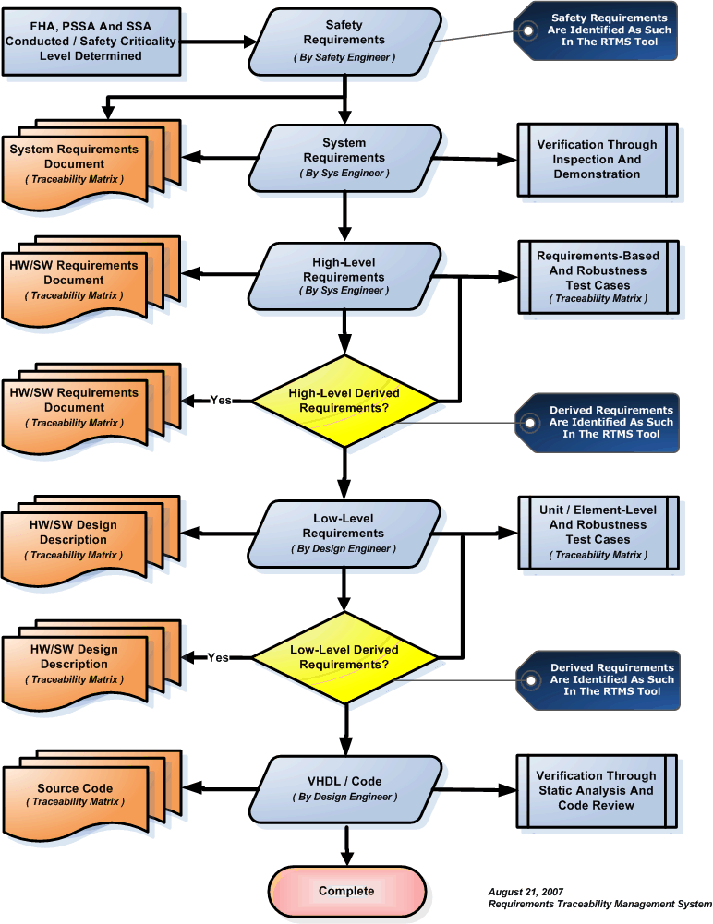

Hardware Lifecycle Data Controls
Two categories associated with the configuration management of data items are defined: hardware control category 1 (HC1) and hardware control category 2 (HC2). HC1 requires all configuration management activities to be performed while HC2 is less restrictive. Data items classified as HC2 are not expected to change incrementally, but will be superseded by new data. Applicable Control Categories are identified with their associated lifecycle data in Section 5.

Reference | Configuration Management Activity | HC1 | HC2
7.2.1 | Configuration Identification | x | x
7.2.2 (1),(2),(3) | Baselines | x
7.2.2 (4) | Baseline Traceability | x | x
7.2.3 | Problem Reporting | x
7.2.4 (1),(2) | Change Control - integrity and identification | x | x
7.2.4 (3),(4),(5),(6) | Change Control – records, approvals and  traceability | x
7.2.5 (1) | Release | x
7.2.5 (2) | Retrieval | x | x
7.2.5 (3) | Data Retention | x | x
7.2.5 (4a) | Protection Against Unauthorized Changes | x | x
7.2.5 (4b),(4c),(4d) | Media Selection, Refreshing, Duplication | x

Hardware Configuration Management Data
Hardware Configuration Management data consists of the hardware life cycle data produced by the Configuration Management process. The following table details the Hardware Configuration Management data associated with the Hardware development effort.

Document Title | DO-254 Ref | Abbr. | Control Category | Availability
Plan for Hardware Aspects of Certification | 10.1.1 | PHAC | HC1 | Submit To FAA
Plan for Hardware Aspects of Certification | The PHAC defines the processes, procedures, methods, and standards to be used to achieve the objectives of this document and obtain certification authority approval for certification of the system containing hardware items. The PHAC, once approved, represents an agreement between the certification applicant and the certification authority on the processes and activities to be conducted and the resultant evidence to be produced to satisfy the hardware aspects of certification.
Hardware Design Plan | 10.1.2 | HDP | HC2 | On File in CM
Hardware Design Plan | The hardware design plan describes the procedures, methods, and standards to be applied and the processes and activities to be conducted for the design of the hardware item. This plan is included in the PHAC.
Hardware Validation Plan | 10.1.3 | HVP | HC2 | Submit To FAA
Hardware Validation Plan | The validation plan describes the procedures, methods, and standards to be applied and the processes and activities to be conducted for the validation of the hardware item-derived requirements to achieve the validation objectives of this document.
Hardware Verification Plan | 10.1.4 | HVP | HC2 | Submit To FAA
Hardware Verification Plan | The verification plan describes the procedures, methods, and standards to be applied and the processes and activities to be conducted for the verification of the hardware items to achieve the verification objectives of this document.

Document Title | DO-254 Ref | Abbr. | Control Category | Availability
Hardware Configuration Management Plan | 10.1.5 | HCMP | HC1 | On File in CM
Hardware Configuration Management Plan | The hardware configuration management plan describes the policies, procedures, standards, and methods to be used to satisfy the configuration management objectives of DO-254.
Hardware Process  Assurance Plan | 10.1.6 | HPAP | HC2 | On File in CM
Hardware Process  Assurance Plan | The hardware process assurance plan describes the procedures, methods, and standards to be applied and the processes and activities to be conducted for achieving the process assurance objectives of DO-254.
Hardware Requirements Standards | 10.2.1 | HRS | HC2 | On File in CM
Hardware Requirements Standards | Requirements standards may be used during the requirements capture process to define the rules, procedures, methods, guidance, and criteria for developing the requirements. Requirements standards may include methods and criteria for developing and specifying requirements, methods, and criteria for validating the requirements, notations used to express the requirements, guidance on the use of requirements specification tools, and the means used to provide derived requirements to the system design process.
Hardware Design Standards | 10.2.2 | HDS | HC2 | On File in CM
Hardware Design Standards | Hardware design standards may be used during the conceptual design process and detailed design process to define the rules, procedures, methods, guidance, and criteria for developing and specifying the hardware design.
Validation and Verification Standards | 10.2.3 | HVVS | HC2 | On File in CM
Validation and Verification Standards | Hardware validation and verification standards may be used during the validation and verification processes to define the rules, procedures, methods, guidance, and criteria for validating and verifying the hardware design and implementation.

Document Title | DO-254 Ref | Abbr. | Control Category | Availability
Hardware Archive Standards | 10.2.4 | HAS | HC2 | On File in CM
Hardware Archive Standards | Hardware archive standards may be used to define the procedures, methods, and criteria used to retain and archive product data and develop and maintain program and project archives. Hardware archive standards may include archive content, format, and medium standards, rules, methods, and criteria. This information is in the Hardware Configuration Management Plan.
Hardware Requirements Document | 10.3.1 | HRD | HC1 | On File in CM
Hardware Requirements Document | The requirements specify the functional, performance, safety, quality, maintainability, and reliability requirements for the hardware item being developed.
Hardware Design Description | 10.3.2.1 | HDD | HC2 | On File in CM
Hardware Design Description | The hardware design representation data provides a definition of the hardware item and is comprised of the set of drawings, documents, and specifications used to build the hardware item. The following paragraphs define some typical hardware design data and their content. The type of data, drawings, and documents are produced for a given hardware.
Top-Level, Assembly and Installation Control Drawings | 10.3.2.2.x | DWG | HC1 | Submit To FAA
Top-Level, Assembly and Installation Control Drawings | The top-level drawing uniquely identifies the hardware item and identifies all assemblies, subassemblies, components, and relevant documentation that define the hardware item. Assembly drawings include additional detailed information needed to assemble the hardware item, assembly, or subassembly. Installation control drawings ensure correct installation of a hardware item into a system or correct installation of a hardware item into another hardware item. For some lower level hardware item, assembly drawings for the next higher hardware item or assembly may act as the installation control drawing. The performance of the hardware as determined by the requirements specification may depend upon the configuration of the hardware by the Hardware, calibration of the hardware by the Hardware, or upon a necessary interaction between the hardware and Hardware.

Document Title | DO-254 Ref | Abbr. | Control Category | Availability
Traceability Data | 10.4.1 | HTD | HC2 | On File in CM
Traceability Data | Hardware traceability establishes a correlation between the requirements, detailed design, implementation, and verification data that facilitates configuration control, modification, and verification of the hardware item.
Reviews and Analysis Procedures and Results | 10.4.2 / 10.4.3 | HRAP | HC1 | On File in CM
Reviews and Analysis Procedures and Results | Hardware review and analysis procedures define the process and criteria for conducting reviews and analyses. Hardware review and analysis results are the evidence that the reviews and analyses have been completed to approved procedures and criteria.
Test Procedures and Results | 10.1.1 | HTPR | HC1 | On File in CM
Test Procedures and Results | Hardware test procedures define the methods, environment, and instructions for conducting both functional and environmental qualification testing used for the verification of the hardware item. Hardware test results are the objective evidence that the tests have been completed to approve procedures in support of the verification of the hardware item.
Acceptance Test Criteria | 10.5 | ATP | HC2 | On File in CM
Acceptance Test Criteria | This data provides the criteria and assessment data that the test and associated test results are capable of ensuring that an item is manufactured or repaired correctly.

Document Title | DO-254 Ref | Abbr. | Control Category | Availability
Problem Reports | 10.4.1 | HTD | HC2 | On File in CM
Problem Reports | Problem reports are a means to identify and record the resolution to hardware design problems, process non-compliance with hardware plans and standards, and deficiencies in hardware life cycle data.
Hardware Configuration Management Records | 10.4.2 / 10.4.3 | HRAP | HC1 | On File in CM
Hardware Configuration Management Records | The results of the configuration management process activities are recorded in configuration management records. These may include configuration identification lists, baseline or electronic records, change history reports, problem report summaries, tool identification data, archive records, and release records.
Hardware Process Assurance Records | 10.1.1 | HTPR | HC1 | On File in CM
Hardware Process Assurance Records | The results of the process assurance process activities are recorded in process assurance records. These may include review or audit reports, meeting minutes, records of authorized process deviations, or conformity review records.
Hardware Accomplishment Summary | 10.5 | ATP | HC2 | On File in CM
Hardware Accomplishment Summary | The Hardware Accomplishment Summary is the primary data item for showing compliance to the PHAC and demonstrating to the certification authority that the objectives of this document have been achieved for the hardware items. This summary may be combined with the system accomplishment summary.

HARDWARE BASELINES

This section contains the methods used to assign and construct hardware document numbers and identify hardware configuration items. It also contains the description of the methods and procedures used to establish design and product baselines and provide baseline traceability.

Assignment and Construction of hardware document numbers

XXX-X XXXX-XX
| | | |
| | | |________Production Release Identifier
| | |______________Next Sequential Number
| |_________________Product Line Code
|_____________________Identification Prefix

The following generic codes (first, second, & third digits) are used to uniquely identify hardware and hardware design control documents.

Hardware Lifecycle Data

900 System Requirements Document
901 Plan for Hardware Aspects of Certification
902 Hardware Design Plan
903 Hardware Validation & Verification Plan
904 Hardware Configuration Management Plan
905 Hardware Process Assurance Plan
906 Hardware Requirements Standards
907 Hardware Design Standards
908 Hardware Validation & Verification Standards
909 Hardware Archive Standards
910 Hardware Requirements Document
911 Hardware Design Document
912 Functional Failure Path Analysis
920 Hardware Low Level Verification Cases and Procedures
922 Hardware System Verification Cases and Procedures & Results
922 Hardware System Verification Cases and Procedures & Results
923 Elemental Analysis Results
930 Hardware Life Cycle Environment Configuration Index
931 Hardware Configuration Index
932 Hardware Accomplishment Summary

Hardware Packages

840 CSCI Package (Production Library Disk)
851 CSCI Package Images (Production Library Disk)
852 CSCI Binaries
854 Library Package
855 Web Site Sources

Miscellaneous Hardware Packages

882 Customer Purchased/Vendor Property Hardware Package
883 Customer Purchased/Vendor CD Rom Hardware Package

Product Line Code

The Product Line Code (fourth digit).

Next Sequential Number

The next sequential number (fifth, sixth, seventh, & eight digits) are obtained from the Engineering Release Notebook, which represents an allocation of numbers from the drawing number assignment record. Separate books are kept and maintained for various product lines and/or departments.

Production Release Identifier

The ninth and tenth digits shall be used for specifying the Production Release. For example:

00 = Initial Production Release
01 = Production Release
02 = Production Release

The first release of the product will begin with 00 as its initial production release.

Within Visual Source Safe a "Label" is applied to the software project. This label will reference Internal Release (I.R.) for baseline builds or "Release" (Rel) for production releases. A note will be applied with the Released label referencing the part number version and the revision level of the software.

Baselines and Traceability
Baselines are established in controlled environments including software libraries and the Status Accounting System to ensure their integrity. Once a baseline is established, it is subject to formal change control procedures as defined later in this plan. Configuration Management procedures ensure that new baselines are traceable to the baselines from which the new baselines were derived.
Four baselines are used to effectively identify the system configuration throughout the hardware life cycle. The baselines are:
- Functional Baseline
- Allocated Baseline
- Development Baseline
- Product Baseline
These baselines and the method used to ensure traceability between baselines are defined in the following sections.

Functional Baseline
This is the initial baseline build standard for the system, defined by the Marketing Requirements document, where functions are specified in a descriptive manner and qualified by performance parameters. This is the starting point for establishing the engineering requirements level documentation and requirements traceability. The functional baseline is established at the end of the Requirements Process.
Step1: Review and Sign Life Cycle Documents
Step2: Check Documents into Visual Source Safe
Step3: Update Configuration Index Document
Step4: Check Configuration Index Document into Visual Source Safe
Step5: Create Visual Source Safe Label

Allocated Baseline
This is the documentation baseline used to define both the hardware and software configuration items. Documents identified in the allocated baseline have been “allocated” from system requirements defined in the Functional Baseline or are part of a higher-level configuration item. The allocated baseline is established at the end of the Design Process.
Step1: Review and Sign Life Cycle Documents
Step2: Release Documents into Status Accounting System
Step3: Create Preliminary Configuration Index Document
Step4: Create Visual Source Safe Label

Development Baseline
The Development Baseline is a baseline used to perform design verification testing or to identify and baseline a red-label unit. The following diagram describes this process:

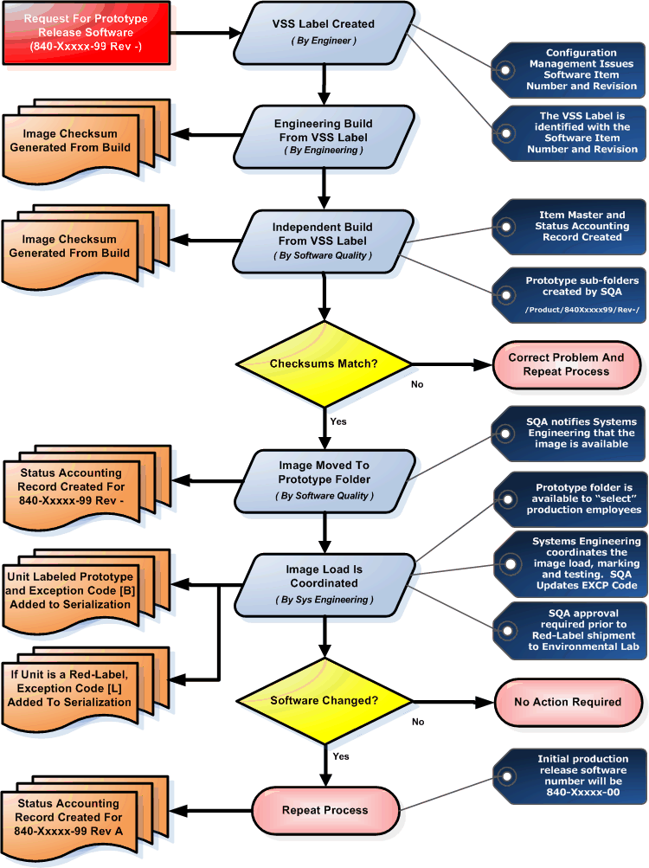

Pre-Release Hardware Identification and Tracking
Prior to formal release, hardware will be identified with a -99 designator. This provides the ability to create an Item Number for the hardware and track revision status in the Status Accounting System. The first production release will contain a -00 designator.
Once a unit is identified as pre-release, and prior to the pre-release hardware being installed, the Director of Systems Engineering will contact Process Assurance, who will mark the serialization Exception Code of that unit with [ B ], identifying it as pre-production. This status is checked prior to shipment. A status of [ B ] ensures that the unit will not be shipped. In addition to the Exception Code designation, a note will be placed in the record indicating that the unit was delivered, and is being controlled by, Systems Engineering.
The Preliminary Product baseline also describes the detailed requirements of the approved Hardware Design Description in a manner that can be used to begin software design. The approved SDD, authentication of supporting data will be accomplished. These include, but are not limited to, the assignment of the CSCI requirements to specific lower level CSCs; the overall information flow between software units, the methods by which each unit gains control, and the sequencing of units relative to each other; the detailed design characteristics of all interfaces, including their data source destination, and interface names and relationships; detailed characteristics of the database structure, including all files, records, fields and items; and access rules, such as how file sharing will be controlled, procedures for data recovery/regeneration from a system failure, rules for data manipulation, rules for maintaining file integrity, rules for usage reporting, and rules for governing the types and depth of access are defined within this baseline.
Under internal Engineering/CM control, this baseline evolves throughout the development cycle and represents the definition of the hardware and software at any stage of the development. As stated, the preliminary product baseline may be established at several points during the Coding Process. As such, this baseline represents an ongoing process as opposed to a static event.
Step1: Review and Sign Life Cycle Documents
Step2: Release Documents into Status Accounting System
Step3: Check HDL code into Visual Source Safe
Step4: Create Preliminary Configuration Index Document
Step5: Create Visual Source Safe Label
A Preliminary Product Baseline is always established prior to initiation of regression testing. This baseline represents the Engineering produced and integrated configuration of both the hardware and software. This baseline is otherwise known as the Quality Test Baseline.

Product Baseline
The Product Baseline is established upon successful completion the Integration and QA Verification Process. The Product Baseline is a final accumulation of requirements, design, and test documents, including completed HWCI and CSCI test reports. The Product Baseline is represented by the Plan for Hardware Aspects of Certification, Hardware Configuration Index Document and the Hardware Accomplishment Summary. This baseline is re-established each time a new release is implemented.
Step1: Update All Impacted Documents and Traceability
Step2: Check HDL code into Visual Source Safe
Step3: Review and Updated Sign Life Cycle Documents
Step4: Update Hardware Verification Cases and Procedures with New Test Cases
Step5: Update Configuration Index Document
Step6: Create / Update Hardware Accomplishment Summary
Step7: Release Configuration Index Document and Hardware Accomplishment Summary
Step8: Create Visual Source Safe Label
Step9: Generate and Process New Hardware Release (Changing Dash Configuration)
Step10: Submit Formal Letter
Step11: Generate and Process Engineering Change Order
Step12: Update Technical Manuals and Issue Field Service Bulletin

PROBLEM REPORTING AND RESOLUTION

The purpose of problem reporting is to report and track problems, deficiencies, non-compliance's, or to recommend enhancements to the product.

Problem Reporting Process
The Problem Reporting process is depicted in the diagram that follows.

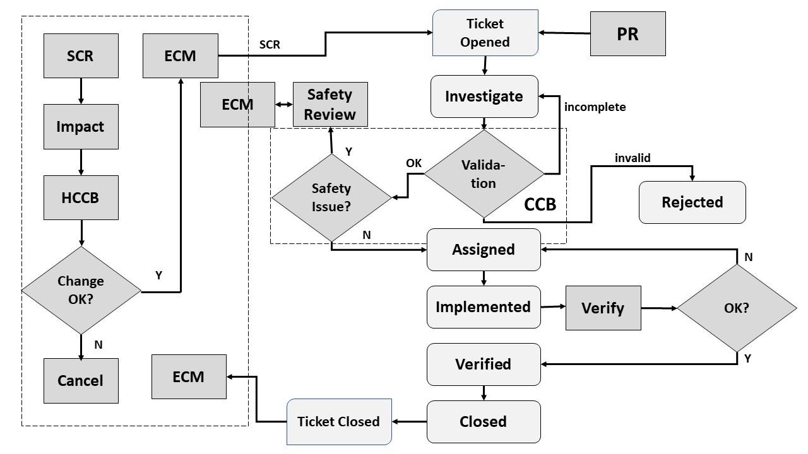

The Table below defines the states and actions associated with each step in the problem reporting flow.

Table: PR States and Action Definitions
Task | Action on Tools
Problem Identified | - ECM from Patmos Engineering Services or internal issue received  - New Ticket is initiated on trac by problem identifier and set as a Problem Type and further classification of the type is set.  - Status is set to Open
Problem Report Investigated | - Ticket is accepted and reviewed by CM Manager and any other changes to the ticket are made such as problem type, priority, milestone, version etc.  - Status is set to investigate.  CM Manager will convene the CCB to analyze the validity. If it was invalid, it will be rejected. If it was incomplete, it will be reassigned. If it was valid then the safety impact is assessed.
Problem Report is Rejected | - If the PR invalid, it is rejected (not closed or deleted)
Problem Report is Assigned | - Once investigated CM Manager will assign to the person who is responsible in making the reported changes.  - Ticket is accepted by the individual to make the reported changes.
Corrective Action Implemented | - Correct action is taken by the assignee of the ticket and changes are implemented in the version mentioned in the ticket.  - Status is set to Implemented  - CM Manager assigns PR to the Verifier
Corrective Action Verified | - Ticket is accepted by the verifier and correct action is taken by the verifier to validate the implementation  - Status is set to:  - Verified, if no issues were seen the ticket is assigned to the CM Manager for final closing of the ticket.  - Investigate, and re-assigned to the person responsible for the changes to re-implement changes until Verified
Problem Report Closed | - Ticket is accepted by the CM Manager. The process evaluated and checked.  - Status is set to Closed  - ECM issued to Patmos Engineering Services if the ticket was an SCR

Open Problem Reports
Open Problem Reports against the Hardware Requirements are acceptable and may be proposed at certification if they do not affect safety. A tabulation of the Open Problem Reports is recorded in the Hardware Accomplishment Summary.

Acceptable Open Problem Report Types

Type 1: a problem whose consequence is a possible failure – under certain conditions- of the system; having no safety impact on the aircraft (this needs to be confirmed by the aircraft manufacturer). If agreed between aircraft manufacturer and supplier, this type should be divided into two sub-types:

- Type 1A: failure with a “significant” functional consequence; the meaning of “significant” should be defined in the context of the related system in agreement between aircraft manufacturer and equipment supplier (for instance “cockpit effect”).

- Type1B: failure with no “significant” functional consequence.

Type2: a fault which does not result in a failure (i.e.: no system functional consequence, fault not detectable by the crew in foreseeable operating conditions).

Type3: Any problem which is not type 0, 1 or 2, but a deviation to the rules (plans or development standards, applicable CRI’s). If agreed between aircraft manufacturer and supplier, this type should be divided into two sub-types:

- Type 3A: a “significant” deviation whose effects could be to lower the assurance that the software or the CDD behaves as intended and has no unintended behavior

- Type3B: a non-“significant" deviation to the methodology (plans) that does not affect the assurance obtained.

Unacceptable Open Problem Report Type

Unacceptable open problem reports include a problem whose consequence is a possible failure (under certain conditions) of the system with a safety impact.

Change Control
The objective of change control is to provide for recording, evaluation, resolution, and approval of changes throughout the product Lifecycle. For this program, change control will preserve the integrity of the configuration items and baselines by providing protection against unauthorized changes. All changes to items under configuration control are recorded, approved, and tracked.

Relationship Between Problem Reports and Change Orders

The following diagram illustrates the relationship between the Problem Reporting System formal change control process.

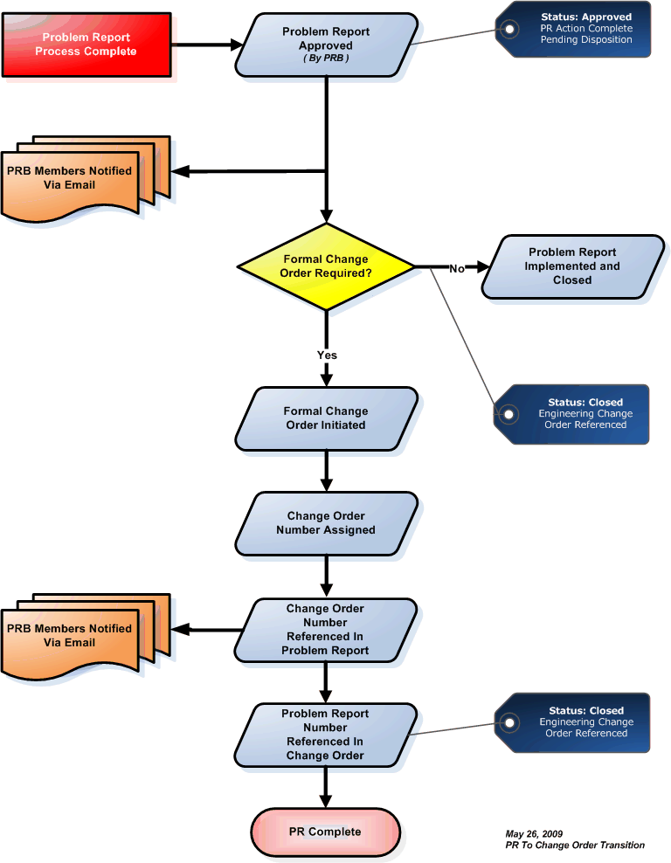
The following diagram illustrates the change control process. The steps illustrated on the diagram are detailed below.

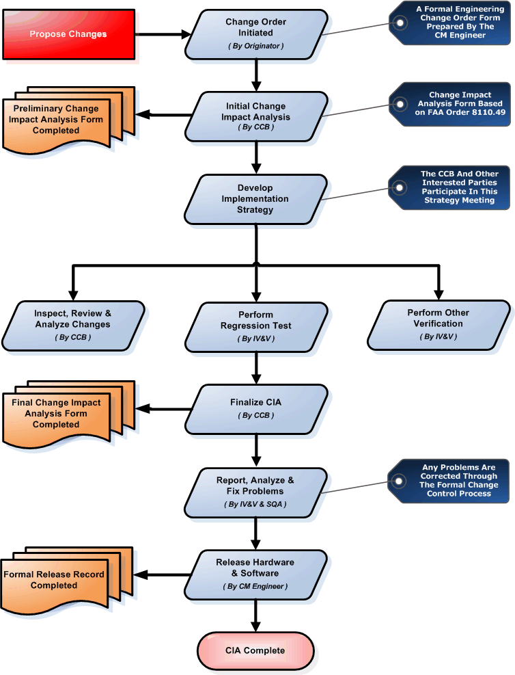

Propose Changes
The first step of the change process is to identify the proposed change(s). The proposed changes may be written to request replacement of obsolete parts, fix bugs found in the design, add new features, or to modify existing features.

Perform Change Impact Analysis
All changes scheduled to be integrated into the Product Baseline are reviewed by the Configuration Control Board to determine of they are technically possible, financially feasible, and/or necessary to meet customer requirements. Each change is initially assessed to determine whether it will be implemented, deferred, or closed with no action. Considerations for technical feasibility, safety, cost, and customer satisfaction weigh heavy in the decision. Initial change impact analysis is used as a vehicle to help with this assessment. Each change is analyzed to determine the potential impact. There are many components of the change impact analysis. Some of the analysis can be done roughly to initially determine the feasibility of the change, but should be repeated after the Hardware change is implemented to assure the original performance, safety, and resource constraints have not been compromised.
The change impact analysis process addresses the items below. The items fall roughly into two categories: performance-related analysis and safety-related analysis.
The following items are related to the overall performance characteristics of the system:
- Traceability analysis to identify the requirements, design elements, code, test cases, and procedures may be either directly or indirectly affected by the change. Forward traceability of changes identifies design components affected by the change. Backward traceability helps determine other design features and requirements that may be inadvertently affected by the change. Overall, the requirements traceability helps determine the impact of change on the Hardware project.
- Development environment and process analyses to identify any change(s) that may adversely impact the Hardware product.
- Partitioning analysis to assure that the changes do not impact any protective mechanisms incorporated in the design. If architectural means are employed as part of the partitioning scheme, the change must not affect those strategies. For example, data should not be passed from a less critical partition to a more critical partition.

The change impact analysis also assesses whether the change could adversely affect safe operation of the system or product. The following areas are reviewed to determine if there is an adverse impact on safety or operation and are addressed during this process:
- Safety-related information is changed.
- Operational or procedural characteristics are changed in a manner that could adversely affect flight safety as a result of the Hardware change.
- New functions or features are added to the existing system functions that could adversely impact flight safety or could affect the basis for the original certification approval.
- Hardware life cycle data (e.g., requirements, design, architecture, test cases/procedures) is significantly changed in such a way that it could adversely affect safety. This analysis is facilitated when safety-related Hardware requirements are identified and a safety assessment is maintained.

Change impact analysis will document Hardware life cycle data (e.g., requirements, design, architecture, test cases, and procedures) affected by the change and verification activities (e.g., reviews analyses, inspections, tests) needed to assure that no adverse affects on the system are introduced during the change.

Develop an Implementation Strategy
Once Hardware changes to be implemented into a previously developed baseline are identified, an implementation strategy is developed and executed. The implementation strategy specifies the change process, hardware life cycle data to be updated, activities to be implemented, resources needed, schedules to be applied, etc.
The implementation strategy also describes the verification activities that will be needed to verify the changes and to verify that there are no adverse effects on the system. The change impact analysis addresses how changes which could adversely affect performance or safe operation of the system or aircraft will be verified, such that the changed and unchanged Hardware will continue to satisfy their requirements for safe operation. These verification activities may include reviews, analyses, regression testing, requirements-based testing, bench testing, etc., including re-evaluation of existing analyses, re-execution of existing tests, and new test procedures and cases (for added functionality or previously deficient testing).
Additionally, the implementation strategy describes the resources needed to perform and assure the changes, the schedule for changes and verification activities, the Hardware life cycle data to be updated, and any other programmatic details needed for success.

Implement Changes
The implementation of Hardware changes follows the documented plans. During the actual implementation of changes, there may be additional issues identified. These might require modification to the change impact analysis or plans.

Verify Changes
Once the changes have been implemented, they are verified. Verification includes reviews, inspections, analyses, and tests of the hardware. The verification process is divided into three tasks. These tasks are detailed below:

Inspect, Review, or Analyze Changes
This task includes many of the non-testing aspects of the verification process (i.e., reviews, analyses, inspections, and walkthroughs). In this task, the Hardware life cycle data (e.g., requirements, design, architecture, code, test cases, and procedures) are reviewed for accuracy and consistency.

Perform Regression Testing
Regression testing is another aspect of the verification process that is addressed when hardware changes. Hardware progresses through several versions before one is ready for release. Regression testing is performed on each version of Hardware. Any specific change can (a) fix only the problem that was reported, (b) fail to fix the problem, (c) fix the problem but adversely affect some other function or aspect that was previously working, or (d) fail to fix the problem and adversely affect something else. Since it is not always possible to re-run every test on every version of hardware, analysis is used to determine which tests should be run on the interim versions.
The following “types” of tests are performed during the regression testing process:
- Failure verification tests – run to verify that the fix addresses the problem and didn’t introduce additional problems.
- Regression test pass with a regression test suite – running regressions tests that have been automated.
- Regression test pass on closed failures – rerunning the regression tests even after the failures have been “fixed”. Includes robustness tests.
- Regression test pass without a test suit – manually running regression tests. Includes robustness tests.
It is standard practice that the most important tests are run first in order to quickly validate operation and assess risks. In some cases, regression testing may be run in parallel with other development activities. Generally, a test that has passed twice should be considered as regressed, unless the code has been frequently changed. A test that has failed once should not be re-executed unless the developer informs the test team that the defect has been fixed.
For tests that have already passed once, the second execution is reserved for the final regression pass, unless frequent changes to the code indicate otherwise. In every case, the change impact analysis must lead to a set of regression tests that are unique to the set of changes being proposed. All of these identified regression tests are run on the final version of the Hardware prior to release.

Perform Other Verification
In addition to the inspections, reviews, analyses, and regression testing, other types of verification activities are performed. Some of these activities are performed at the hardware level, some at the system level, and some at the integrated system level. For example, requirements-based tests, acceptance tests, bench tests, etc. may need to be performed. These additional verification activities will vary, depending on the extent of the change and the function(s) affected. In all cases, these tests are planned after the change impact analysis is performed and agreed upon.

Finalize Change Impact Analysis
Early in the change process, it is impossible to fully evaluate the impact of the Hardware changes. Therefore, once the changes have been implemented and verified, the change impact analysis is finalized. This review is performed by scheduling a Configuration Control Board meeting. Changes to impact analysis are fed back into the change control process where appropriate.

Report and Analyze Problems
Each problem discovered during the previous step is documented in a formal Engineering Change Order. The Engineering Change Order includes a place to identify affected documents, problem analyses, and proposed resolution.

Address Problems
All problems documented in an action request are addressed in some manner. The problem can be fixed or determined to have no safety, performance, or operational affects. It is unacceptable to finish a project with open action requests.

Fix Problems, As Required
As mentioned above, all problems are fixed and go through the change control and verification processes.

Release Hardware
Once the necessary changes have been implemented, problems have been addressed, Hardware has been re-verified, and documentation has been updated, the hardware is ready for production release.

STORAGE AND RETRIEVAL
This section contains the description of the procedures for release, archival, and retrieval of hardware design life cycle data. The description should include archive content, format, and medium standards, rules, methods, and criteria.
The objective of the archive and retrieval activity is to ensure that the product's Lifecycle data can be retrieved in case of the need to duplicate, regenerate, retest, or modify the product. The objective of the release activity is to ensure that only authorized product CIs are used, especially for manufacturing, in addition to being archived and retrievable.

Archive and Retrieval Process
Standard backup archive and retrieval processes will be followed during development. These procedures will ensure that all of the Hardware Life Cycle Data is archived to a tape or CD using Microsoft Backup for Windows NT archival system. At a minimum, archival will be done weekly and after each release. To ensure that the archival data is complete and accurate the following will be performed.
- Two copies of each release will be created.
- Each tape or CD will be verified, at creation, as valid and password protected. The final release will be installed, for verification purposes.
- One tape or CD will be stored on the premises in a secure location.
- One tape or CD will be stored off-site in a secure location.
- The archival tapes will be regenerated every four years to ensure the integrity of the media and data.

Each tape or CD will have a label with the following information:
- Date Created
- Version number of the of the release (if applicable)
- Description of what is on the tape or CD.

The archive process will archive the following Hardware life cycle data:
- HDL code
- Build Procedures
- Load-Control Procedures
- Log of what is on the tape or CD. For final release, an installable version of the operating system and all development and verification tools, defined in the SECI, must be included.

ENVIRONMENT CONTROL
This section contains the description of the method and procedures for identifying and controlling the tools used for developing and verifying the hardware.

Hardware Lifecycle Environment Controls
The objective of Hardware Lifecycle environment control is to ensure that the tools used to produce and verify the hardware are identified, controlled, and are retrievable. The Hardware Lifecycle environment tools are initially defined in the Hardware Development Plan and then finalized in this document prior to formal qualification testing. The tools identified in this document are subject to the appropriate HCM controls.

Hardware Configuration Index
The Hardware Configuration Index (HCI) identifies the baselined configuration of the Hardware.
For this program, it will identify the:
- Hardware product
- Each HDL code component
- Hardware Lifecycle data
- Archive and release media

CONFIGURATION MANAGEMENT TOOLS
This section contains the description of the tools and resources used for the configuration management process and activities.

Tools and Methods
The following sections describe the configuration management tools that will be used to maintain HCM records for the project. The tools are grouped into four categories; Configuration Identification Tools, Configuration Change Control Tools, Configuration Status Accounting Tools, and Configuration Audit and Reporting Tools.

Item Master
The Item Master is used to assign unique numbers to hardware, Hardware, and documentation.

Bill of Material (BOM)
The BOM System is used to generate the parent/child relationship between elements.

Visual Source Safe (VSS)
Microsoft Visual SourceSafe CMS will be used to control specific planning, development, verification, and certification work products until transitioning to the Applicant configuration-control environment after the successful completion of the Test Readiness Review.
During development, all Hardware planning, design, test, HDL code, assembly instructions, build files, and configuration files will be maintained under version control in the CMS. The CMS automatically records modifications made to the HDL code set, noting the date and time. The system retains all intermediate versions of the HDL code back to the original implementation. Each file checked into the CMS will have a version number that is initialized to 1. This version number will be incremented by 1 each time the file is revised (by first checking out the file, revising the file, and then checking the file back into CMS). The information tracked by the CMS allows the engineering team to identify the specific version of each file that is required to build an executable configuration. The CMS system has facilities for restricting or completely eliminating modifications to controlled items, which will be used to control configurations. This mechanism, combined with a regular backup routinely administered by systems administration staff, ensures the ability to retrieve and build any given Hardware configuration.
The CMS environment will reside on an internal server and will be accessible to a network of PC-compatible workstations. Access control will be managed by user name and password, and will provide access to the network areas associated with the CMS.
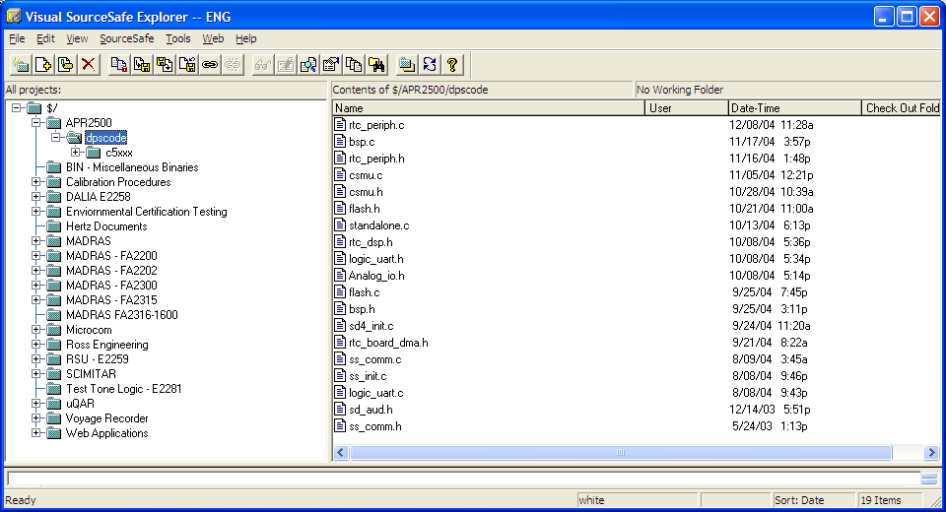

Change Order System
The Change Order System is the formal change approval, affectivity, and tracking system.

HARDWARE CM DATA
HCM data consists of the hardware life cycle data produced by the HCM process. This includes, but may not be limited to, HCM Records, the Hardware Configuration Index and Hardware Life Cycle Environment Configuration index. Documents are verified and release authorization is obtained via the flow described below.
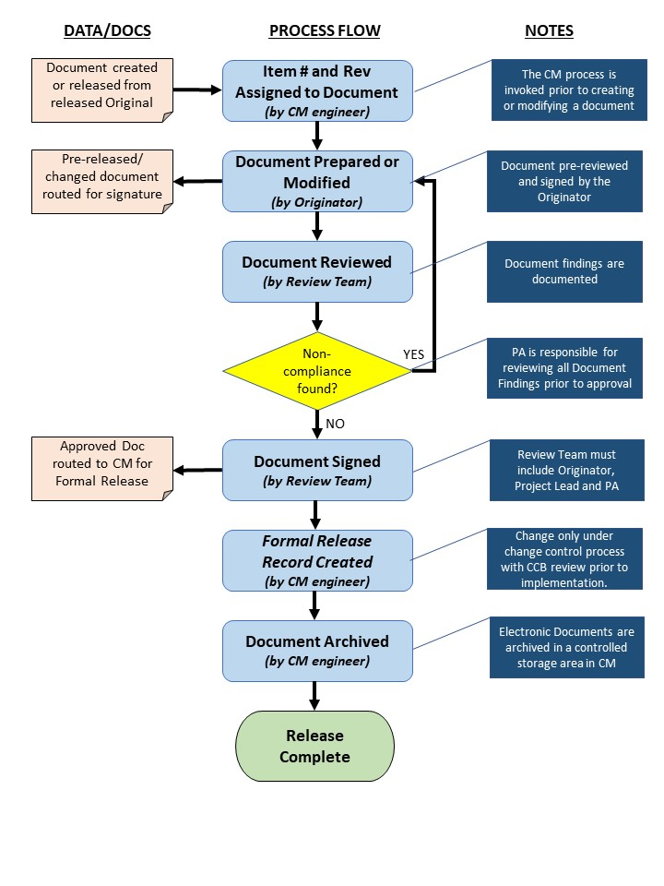

HCM Records
The following table details the HCM data associated with the hardware development effort.

Document Title | See HCI for Rev Data
Plan for Hardware Aspects of Certification
Plan for Hardware Aspects of Certification | The PHAC defines the processes, procedures, methods, and standards to be used to achieve the objectives of this document and obtain certification authority approval for certification of the system containing hardware items. The PHAC, once approved, represents an agreement between the certification applicant and the certification authority on the processes and activities to be conducted and the resultant evidence to be produced to satisfy the hardware aspects of certification.
Hardware Design Plan
Hardware Design Plan | The hardware design plan describes the procedures, methods, and standards to be applied and the processes and activities to be conducted for the design of the hardware item. This plan is included in the PHAC.
Hardware Validation Plan
Hardware Validation Plan | The validation plan describes the procedures, methods, and standards to be applied and the processes and activities to be conducted for the validation of the hardware item-derived requirements to achieve the validation objectives of this document.
Hardware Verification Plan
Hardware Verification Plan | The verification plan describes the procedures, methods, and standards to be applied and the processes and activities to be conducted for the verification of the hardware items to achieve the verification objectives of this document.

Document Title | See HCI for Rev Data
Hardware Configuration Management Plan
Hardware Configuration Management Plan | The hardware configuration management plan describes the policies, procedures, standards, and methods to be used to satisfy the configuration management objectives of DO-254.
Hardware Process
Assurance Plan
Hardware Process  Assurance Plan | The hardware process assurance plan describes the procedures, methods, and standards to be applied and the processes and activities to be conducted for achieving the process assurance objectives of DO-254.
Hardware Requirements Standards
Hardware Requirements Standards | Requirements standards may be used during the requirements capture process to define the rules, procedures, methods, guidance, and criteria for developing the requirements. Requirements standards may include methods and criteria for developing and specifying requirements, methods, and criteria for validating the requirements, notations used to express the requirements, guidance on the use of requirements specification tools, and the means used to provide derived requirements to the system design process.
Hardware Design Standards
Hardware Design Standards | Hardware design standards may be used during the conceptual design process and detailed design process to define the rules, procedures, methods, guidance, and criteria for developing and specifying the hardware design.
Validation and Verification Standards
Validation and Verification Standards | Hardware validation and verification standards may be used during the validation and verification processes to define the rules, procedures, methods, guidance, and criteria for validating and verifying the hardware design and implementation.

Document Title | See HCI for Rev Data
Hardware Archive Standards
Hardware Archive Standards | Hardware archive standards may be used to define the procedures, methods, and criteria used to retain and archive product data and develop and maintain program and project archives. Hardware archive standards may include archive content, format, and medium standards, rules, methods, and criteria. This information is in the Hardware Configuration Management Plan.
Hardware Requirements Document
Hardware Requirements Document | The requirements specify the functional, performance, safety, quality, maintainability, and reliability requirements for the hardware item being developed.
Hardware Design Description
Hardware Design Description | The hardware design representation data provides a definition of the hardware item and is comprised of the set of drawings, documents, and specifications used to build the hardware item. The following paragraphs define some typical hardware design data and their content. The type of data, drawings, and documents are produced for a given hardware.
Top-Level, Assembly and Installation Control Drawings
Top-Level, Assembly and Installation Control Drawings | The top-level drawing uniquely identifies the hardware item and identifies all assemblies, subassemblies, components, and relevant documentation that define the hardware item. Assembly drawings include additional detailed information needed to assemble the hardware item, assembly, or subassembly. Installation control drawings ensure correct installation of a hardware item into a system or correct installation of a hardware item into another hardware item. For some lower level hardware item, assembly drawings for the next higher hardware item or assembly may act as the installation control drawing. The performance of the hardware as determined by the requirements specification may depend upon the configuration of the hardware by the Hardware, calibration of the hardware by the Hardware, or upon a necessary interaction between the hardware and Hardware.

Document Title | See HCI for Rev Data
Traceability Data
Traceability Data | Hardware traceability establishes a correlation between the requirements, detailed design, implementation, and verification data that facilitates configuration control, modification, and verification of the hardware item.
Reviews and Analysis Procedures and Results
Reviews and Analysis Procedures and Results | Hardware review and analysis procedures define the process and criteria for conducting reviews and analyses. Hardware review and analysis results are the evidence that the reviews and analyses have been completed to approved procedures and criteria.
Test Procedures and Results
Test Procedures and Results | Hardware test procedures define the methods, environment, and instructions for conducting both functional and environmental qualification testing used for the verification of the hardware item. Hardware test results are the objective evidence that the tests have been completed to approve procedures in support of the verification of the hardware item.
Acceptance Test Criteria
Acceptance Test Criteria | This data provides the criteria and assessment data that the test and associated test results are capable of ensuring that an item is manufactured or repaired correctly.

Document Title | See HCI for Rev Data
Problem Reports
Problem Reports | Problem reports are a means to identify and record the resolution to hardware design problems, process non-compliance with hardware plans and standards, and deficiencies in hardware life cycle data.
Hardware Configuration Management Records
Hardware Configuration Management Records | The results of the configuration management process activities are recorded in configuration management records. These may include configuration identification lists, baseline or electronic records, change history reports, problem report summaries, tool identification data, archive records, and release records.
Hardware Process Assurance Records
Hardware Process Assurance Records | The results of the process assurance process activities are recorded in process assurance records. These may include review or audit reports, meeting minutes, records of authorized process deviations, or conformity review records.
Hardware Accomplishment Summary
Hardware Accomplishment Summary | The Hardware Accomplishment Summary is the primary data item for showing compliance to the PHAC and demonstrating to the certification authority that the objectives of this document have been achieved for the hardware items. This summary may be combined with the system accomplishment summary.

