
DISCLAIMER

Copyright 2017, Airworthiness Certification Services, Inc. (ACS) in partnership with the Avionics Certification Academy.

All rights reserved.

These Templates are perpetually licensed for a single company, for the site and/or project team who initially purchased. The purchaser can use the Templates, or any customized variant of them, on as many projects as desired. The Templates may not be shared outside of the purchasing company with the exception of interactions with customers and program auditors. The Purchaser agrees to these terms as part of the sale. If a worldwide Corporate License is desired, which provides unlimited access for all sites and project teams within a company, contact info@avionics-certification-academy.com for details and a quote.

This Template is proprietary to ACS. and should not be distributed or copied in its original format without written permission. It is to be used solely as the basis of documentation for the purchaser of this template. Also, it should not be viewed as FAA opinion or regulatory guidance and presents only opinion and interpretation of FAA information by ACS.

All references to DO-178C and/or DO-254 material are copyrighted by and used with permission from:
RTCA, Inc.
1150 18th Street NW, Suite 910
Washington, DC 20036
(202) 833-9339
www.rtca.org

ACS hereby disclaims all warranties and conditions with respect to these Templates, either express, implied or statutory, including, but not limited to, the implied warranties and/or conditions of merchantability, of satisfactory quality, of fitness for a particular purpose, of accuracy, or quiet enjoyment, and non-infringement of third party rights. ACS does not warranty against interference with clients enjoyment of the Templates, that the functions contained in the Templates will meet the client’s requirements, that the Templates will be error-free or that defects in the templates will be corrected.
No oral or written information or advice given by ACS or by an ACS authorized representative shall create a warranty should the Templates prove defective, client assumes the entire cost of all necessary servicing, repair or correction.

Downloading and using these templates signifies you have read and accepted these conditions.

Please direct all questions or concerns to:
Airworthiness Certification Services
25327 SE Mirrormont Blvd Issaquah WA 98027
Phone: 206-226-6561, email: info@airworthinesscert.com

NOTE: YOU MAY REMOVE THIS PAGE FROM YOUR TEMPLATES AFTER READING THIS DISCLAIMER


Hardware Requirements Standards
for the
<Program Name>
Document No: <Doc Number>
Revision: -

__________________________________________________ |  |  | ___________
<Name>, Program Manager |  | Date
__________________________________________________ |  | ___________
<Name>, Technical Project Lead |  | Date
__________________________________________________ |  | ___________
<Name>, Engineer |  | Date
__________________________________________________ |  | ___________
<Name>, Quality Engineer |  | Date

Notice
This document and the information contained herein are the property of <Company Name>. Any reproduction, disclosure or use thereof is prohibited except as authorized in writing by <Company Name>. Recipient accepts the responsibility for maintaining the confidentiality of the contents of this document.

REVISIONS
Rev. | Reason/Description | Requested/ Changed By | Date

Table of Contents

Section Page
1.0 INTRODUCTION 5
1.1 Purpose 5
1.2 Scope 5
1.3 Acronyms and Abbreviations 6
1.4 Applicable Documents 7
1.4.1 External Documents 7
1.4.2 Internal Documents 7
2.0 HARDWARE REQUIREMENTS STANDARDS 8
2.1 Characteristics of Requirements Data 10
2.1.1 Unambiguous 10
2.1.2 Complete 10
2.1.3 Verifiable 10
2.1.4 Consistent 10
2.1.5 Modifiable 10
2.1.6 Traceable 11
2.1.7 Unique 11
3.0 DEVELOPMENT METHODS 12
3.1 System Level Requirements 12
3.1.1 System Level Requirements Output 13
3.2 Hardware Requirements 13
3.2.1 Input Requirements 15
3.2.2 Functional Requirements 15
3.2.3 Output and Performance Requirements 15
3.2.4 Timing Requirements 15
3.2.5 Boolean Requirements 15
3.2.6 Textual Case Format 16
3.2.7 Robustness Requirements 16
3.2.7.1 Behavioral Hardware Requirements 17
3.2.7.2 Structural Hardware Requirements 18
3.2.7.3 Physical Hardware Requirements 18
3.2.8 Hardware Requirement Review Criteria 19
4.0 REQUIREMENTS NOTATION 20
4.1 System Level Requirement Notation 20
4.1.1 System Level Place Holder for Derived Requirements 20
4.1.2 System Level Requirements Identification 20
4.2 Hardware Requirements Notation 21
4.3 Derived Hardware Requirements Notation 21
4.4 Requirements Traceability 22
5.0 DERIVED HARDWARE REQUIREMENTS 23
5.1 Output of Derived Hardware Requirements That Are Not Traceable 23
5.2 Output of Derived Hardware Requirements That Are Traceable 23
6.0 REQUIREMENTS DEVELOPMENT TOOLS 24
6.1 Requirements Traceability Management System 24
7.0 APPENDIX A: Hardware Requirements Document Example 25
8.0 SYSTEM OVERVIEW 26
8.1 System Functional Description 26
8.2 System Architecture 26
8.3 2.3 System Requirements 27
9.0 HARDWARE OVERVIEW 29
9.1 Hardware Functions 29
9.2 Hardware Architecture 29
9.2.1 Computation 30
9.2.2 Entry/Exit sensor 31
9.2.3 Keypad Entry Panel 31
9.2.4 Display Panel 31
9.2.5 PIC Controller Interface & Fault Monitoring 32
9.2.5.1 PIC Controller & ARINC 429 FPGA Interface 33
9.3 Hardware Safety and Partitioning 34
10.0 HARDWARE REQUIREMENTS IDENTIFICATION 35
10.1 System Level Requirements Allocated to Hardware 35
10.2 High-Level Hardware Requirements Definition 35
10.3 Regulatory Compliance 35
10.4 Computation 35
10.5 Entry / Exit Detection 36
10.6 Keypad Entry 36
10.7 Display 36
10.8 Fault Monitoring and ARINC 429 Data Transmit 37
11.0 REQUIREMENTS TRACEABILITY MATRIX 40

INTRODUCTION

Purpose
This plan describes the Hardware Requirements Standards and has been prepared in accordance with the requirements of RTCA/DO-254.

Scope
This standard will be used during the requirement definition process to define the methods, rules, and tools to be used to develop the high-level requirements. Once approved, it is implemented during the development and product life cycle of the deliverable airborne Hardware. This Hardware Requirements Standards document complies with the documentation requirements of RTCA/DO-254.

Acronyms and Abbreviations
<PROJ> <Add Project Acronyms in Alphabetical Order>
AIMS Action Item Management System
ALU Arithmetic Logic Unit
ARP Aerospace Recommended Practice
ASIC Application Specific Integrated Circuit
DRMS Document Review Management System
HAS Hardware Accomplishment Summary
HC1 Hardware Control Category 1
HC2 Hardware Control Category 2
COTS Commercial-Off-The-Shelf
EUROCAE European Organization for Civil Aviation Equipment
FAR Federal Aviation Regulations
FFP Functional Failure Path
FFPA Functional Failure Path Analysis
FHA Functional Hazard Assessment
F-FMEA Functional Failure Modes and Effects Analysis
FTA Fault Tree Analysis
HDL Hardware Description Language
JAR Joint Aviation Requirements
LRU Line Replaceable Unit
PHAC Plan for Hardware Aspects of Certification
PLD Programmable Logic Device
PSSA Preliminary System Safety Assessment
RTMS Requirements Traceability Management System
SAE Society of Automotive Engineers
SC Special Committee
SSA System Safety Assessment
WG Working Group

Applicable Documents
The following documents are listed for reference only. Each document is applicable to this plan only to the extent specified herein.

External Documents
RTCA/DO-254 Design Assurance for Airborne Electronic Hardware
FAA Order 8110.4C Type Certification
FAA Order 8110.105 FAA, Simple and Complex Electronic Hardware Approval Guidance
AC 20-152 Advisory Circular, RTCA Inc., Document DO-254, Design Assurance for Airborne Electronic Hardware
<Spec Number> <Customer Specification>
<Spec Number> <Regulatory Specification>

Internal Documents

<Ref Doc> Plan for Hardware Aspects of Certification (Ref. DO-254, 10.1.1)
<Ref Doc> Hardware Design Plan (Ref. DO-254, 10.1.2)
<Ref Doc> Hardware Verification Plan (Ref. DO-254, 10.1.4)
<Ref Doc> Hardware Configuration Management Plan (Ref. DO-254, 10.1.5)
<Ref Doc> Hardware Process Assurance Plan (Ref. DO-254, 10.1.6)
<Ref Doc> Hardware Requirements Standards (Ref. DO-254, 10.2.1)
<Ref Doc> Hardware Design Standards (Ref. DO-254, 10.2.2)
<Ref Doc> Validation and Verification Standards (Ref. DO-254, 10.2.3)
<Ref Doc> Hardware Requirements Document (Ref. DO-254, 10.3.1)
<Ref Doc> Hardware Design Data (Ref. DO-254, 10.3.2)
<Ref Doc> Hardware Test Procedures (Ref. DO-254, 10.4.4)
<Ref Doc> Hardware Lifecycle Environment Configuration Index (Ref. CAST 27)
<Ref Doc> Hardware Configuration Index (Ref. CAST 27)
<Ref Doc> Hardware Accomplishment Summary (Ref. DO-254, 10.9)

HARDWARE REQUIREMENTS STANDARDS
The purpose of the Hardware Requirements Standards is to define the methods, rules, and tools to be used to develop the high-level requirements. This includes, but may not be limited to:
- The methods to be used for developing Hardware requirements
- Notations to be used to express requirements, such as data flow diagrams and formal specification languages.
- Constraints on the use of requirements development tools
- The method to be used to provide derived requirements to the system process

All System Requirements are analyzed, including functional, safety, and interface requirements allocated to Hardware and translate the same into Hardware High Level Requirements. The objective of this analysis is to:
- Ensure that system requirements allocated to hardware and Hardware do not have ambiguities, inconsistencies, or undefined conditions. Clarification, if any, will be made from requirement source and system life cycle processes.

Hardware Requirements include functional requirements, safety requirements, interface requirements, capability requirements, data element requirements, adaptation requirements, programming requirements, design constraints, human factor requirements, and algorithmic requirements.
The Hardware Requirements Document lists all Hardware requirements, including requirements with safety implications. With the exception of derived requirements, all High Level Requirements are traceable to one or more System Requirements.

Requirements Definition / Traceability Flow
The following diagram details the requirements definition and traceability process.

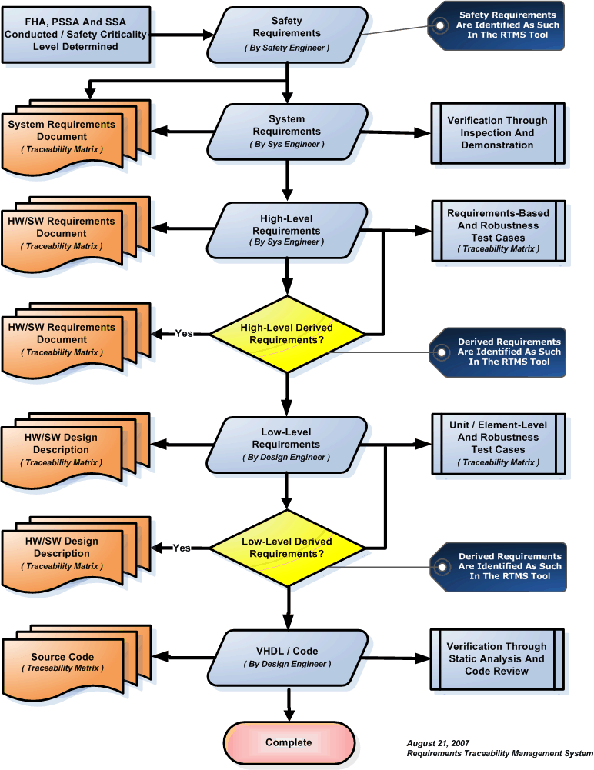

Characteristics of Requirements Data
The purpose of the hardware Requirements Data is to correctly define all the hardware requirements. It shall not describe design or verification details, except for required design constraints. The hardware Requirements Data shall limit the range of valid solutions but shall not specify particular design, thus providing the engineer with flexibility. The hardware Requirements Data shall be unambiguous, complete, verifiable, consistent, modifiable, traceable, and usable during the operational life of the hardware, and the requirements shall be uniquely defined. In order to facilitate these characteristics, the project will store all requirements in the RTMS requirement tool. The hardware Requirements Data will be generated from the RTMS tool/database. Each of these characteristics is described in the following paragraphs.

Unambiguous
The hardware Requirements Data is unambiguous if every requirement stated has only one interpretation. This requires that each characteristic of the final product be described using a single unique term.

Complete
The hardware Requirements Data is complete if it:
- Includes all significant requirements relating to functionality, performance, design constraints, and external interfaces.
- Contains full labeling and referencing of all its figures, tables, and diagrams, and defines all terms and units of measure.
- Conforms to these hardware Requirements Standards.

Verifiable
The hardware Requirements Data is verifiable if there is a finite, cost-effective method by which a person or machine can check that the hardware meets the requirements.

Consistent
The hardware Requirements Data is consistent if no sets of individual requirements are in conflict. Requirements in conflict might:
- Use different terms for the same object.
- Specify different characteristics for the same object.
- Specify illogical or impossible relationships between actions.

Modifiable
The hardware Requirements Data is modifiable if its structure and style are such that any necessary changes can be made easily, completely, and consistently. This generally requires the hardware Requirements Data to have a coherent and easy-to-use organization, with a table of contents and an optional index. In addition, it shall not be redundant, i.e.: the same requirement shall not appear in more than one place, since this could lead to errors later if the requirement needs to be modified. The use of the RTMS tool allows requirements data to be easily modifiable, while maintaining traceability.

Traceable
The hardware Requirements Data is traceable if its corresponding requirements in the system specification are clear (backward traceability) and if it facilitates the referencing of each requirement in the design and verification data (forward traceability). Backward traceability depends on each requirement referencing its source in previous documents. Forward traceability depends on each requirement in the hardware Requirements Data having a unique name or reference number. RTMS accomplishes both forward and backward traceability.

Unique
The hardware requirements shall be distinctively defined such that each requirement statement consists of a single requirement and a single reference tag number. RTMS only allows a single reference tag per requirement.

DEVELOPMENT METHODS
Structured methods will be used to perform requirements identification and traceability. These methods will result in the identification and traceability of System Level Requirements, Hardware Requirements, Low-Level Hardware Requirements, and Derived Hardware Requirements. Using this method, requirements will be written that are unambiguous, consistent, and verifiable.

System Level Requirements
System requirements are inspection requirements (i.e., weight, measurement, power, etc.) and categories for high-level requirements (i.e., the system shall support ARINC 429 messages). System requirements are not verifiable through Test or Analysis. Engineering is responsible for producing the System Requirements Document. This document is the starting point for requirement definition and traceability.
System requirements are categorized into the following types:
- Industry Requirement
- Regulatory Requirement
- Customer Requirement
- System Driven Requirement
- Mechanical Requirements

System Level Requirements Output
The RTMS tool outputs each system requirement in a table format (see example below). The table includes the unique system requirement number, type, system requirement, source of the requirement, and will identify if the requirement is safety related.

SYS 001 | Type: | Regulatory
Derived requirements shall be identified and verified.
Req Source: | DO-254
Safety Related: | False

SYS 002 | Type: | Customer
The System SHALL Provide entry and exit detection.
Req Source: | PTS-1234.1
Safety Related: | True

Hardware Requirements
Hardware requirements are verifiable through test. They are used by the System Architect and Design Engineer to develop the architecture and detailed design and by the Test Engineering to develop requirements-based and robustness test cases. They are also used to develop test benches, used in simulation to perform Elemental Analysis (coverage).
Hardware requirements include functional path requirements, including I/O, bus, electrical, and timing requirements of components that directly interface to the complex device. Other requirements include in-circuit and behavioral device-level requirements. Hardware requirements are written as individually testable requirements. Special focus will be given to hardware requirements, as they form the basis for requirements-based testing.
In order to facilitate better hardware design and test case generation, the requirements analysis should proceed systematically; aggregating functionally-related requirements together. Since any hardware consists of inputs, processing, and outputs, it is convenient to classify requirements into input requirements, computational requirements, and output requirements. The following diagram summarizes the decomposition of the system requirements allocated to hardware requirements and design:

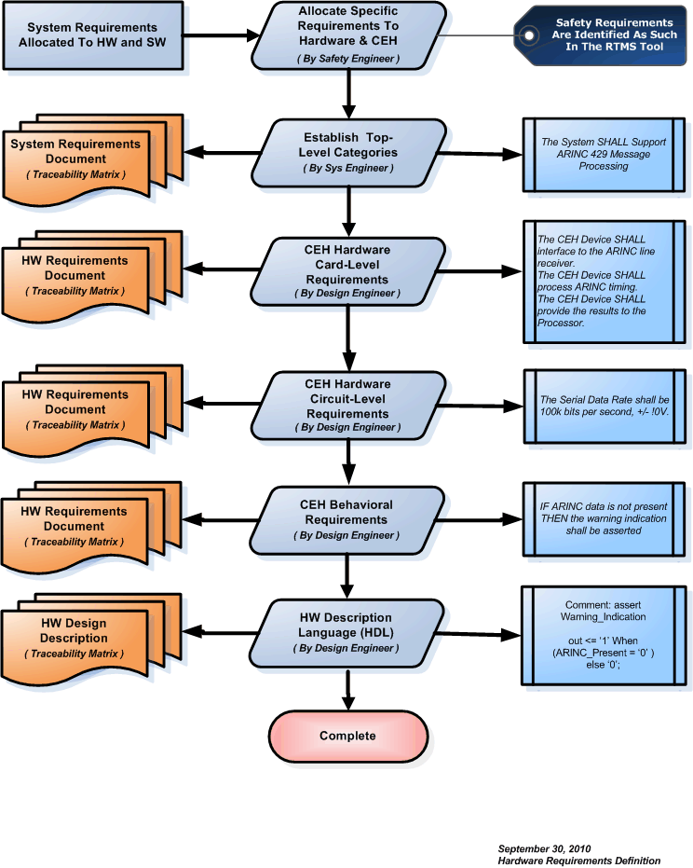
High-level requirements are identified with the following categories:

Input Requirements
Input requirements consist of a list or reference to the appropriate interface documents for all analog, discrete, and serial digital inputs to the system. List or reference the appropriate interface documents for all the inputs to the hardware from external interface devices. For all inputs, listed or referenced, state the voltage, current, and frequency. State the pre-processing requirements for all inputs. This covers de-bouncing for discrete inputs. Describe the algorithms to be used. Use logical notation and flow charts as necessary. Enter all this requirements data into RTMS.

Functional Requirements
Once the requirements for the inputs to the hardware are captured, the definition functional requirements may begin. The functional requirements describe in detail the functions to be performed by the system. Describe the designs that are used to meet the functional requirements. Describe the built-in test requirements. Enter these requirements into RTMS.

Output and Performance Requirements
Finally specify the output and performance requirements of the hardware. List or reference the appropriate interface document all discrete and serial digital outputs specifying their voltage, current, frequency, and the rate of update. Enter all this requirements data into RTMS.

Timing Requirements
The interactions between the hardware and associated devices are subject to timing constraints. List all of the setup/hold times and frequency constraints from data sheets. Enter the timing constraint data into RTMS.

Boolean Requirements
Boolean requirements are the most predominant technique used during requirements definition. They are written in terms of conditional cause and effect expressions as follows:
If X is true and Y is false, A shall do B.
In this case, the requirements are laid out in table format so it is immediately clear whether or not something has been missed (requirements tracking shows you haven't missed implementing and testing your requirements but doesn't so clearly show missed requirements). Examples include:
X false, Y false => A shall do C ------- X false, Y true => A shall do D
X true, Y false => A shall do B -------- X true, Y true => A shall do E
In addition, requirements should be separated by preconditions and stimulus to account for static conditions (e.g. internal system state, external input states) that must exist for the requirement to even apply, followed by the specific stimulus (e.g. input or time-out) that requires the response to occur. The response is then the same 'subject shall action’.

Textual Case Format
Textual use case format for system and high level requirements is also used. The advantages include the ability to capture the purpose, key preconditions, the actors and then, as a set of statements like format A, the sequence of events. While this seems like a lot, it may just be 2 or 3 sentences.
By expanding a nominal case into alternate and exception cases, the development and verification engineer can check if all the values and interactions make sense and uncover any new requirements along the way.
Nominal Case Example:
The system does B when proper X and Y inputs are applied.
Precondition X=True, Y= False.
Verify: A does B
This is a simple example; however, the technique is also used with some of the complex interactions. In this case, the engineer write requirements in this form and capture a lot of information. This also tells a story which the verification engineer, responsible for developing the requirements-based normal and robustness test cases can understand.
Exception Case 1:
Precondition X !=True, Y= False.
Verify A does not do B, but better to say A does C which is usually not open-ended.
Exception Case 2:
Precondition X =True, Y!= False.
Verify Exception Condition is reached.

Robustness Requirements

This Standard is written in compliance with FAA Order 8110-105, Section 6-2 Verification Processes, where it states that RTCA/DO-254 doesn’t explicitly address robustness testing, but the note in Section 5.1.2(4) calls for safety-related derived requirements to address abnormal (worst case) and boundary conditions on input data range, state machines, power-supply and electrical signals. As such, the requirements process shall include the capture of abnormal operating conditions as derived requirements, and address them in the tests. In addition to normal range testing and to demonstrate robustness, applicants will define requirements-based testing to cover normal and abnormal operating conditions.
Robustness requirements are documented during the requirements process. The purpose of documenting robustness requirements, in addition to normal hardware requirements, is to promote the implementation of a robustness strategy early in the development process. This strategy has two benefits. First, by identifying the vulnerable areas of the design early, architectural mitigation can more easily be implemented during the conceptual and detail design process. Secondly, by including key individuals in the process of robustness requirements definition, it helps to ensure complete and creative robustness test cases. These individuals include, but may not be limited to, Requirements Engineering, Systems Engineering, Safety Engineering and Verification Engineering.
The following represent common types of robustness requirements:
- Exercising fault conditions individually, in sequence and in combination.
- Exercising (high, low, mid and outside) range requirements
- Exercising variables using equivalence class selection of invalid values.
- Exercising System initialization during abnormal conditions.
- Exercising protection mechanisms for exceeded frame times.
- For state transitions, requirements should be developed to provoke transitions that are not allowed by the requirements.

Behavioral Hardware Requirements

The highest level of abstraction is the behavioral level that describes a system in terms of what it does (or how it behaves) rather than in terms of its components and interconnection between them. A behavioral description is used to specify the relationship between the input and output signals. This is typically represented as a Boolean expression or a more abstract description such as the Register Transfer or Algorithmic level.

The following is an example of a good hardware behavioral requirement that will result in a circuit that warns car passengers when the door is open or the seatbelt is not used whenever the car key is inserted in the ignition lock.
Using the correct Boolean requirement structure (If X is true and Y is false, A shall do B), the following requirement will result:
- Hardware Requirement 01: IF the Ignition is off THEN the warning indication shall not be asserted
- Hardware Requirement 02: IF the Ignition is on AND the Door is open THEN the warning indication shall be asserted
- Hardware Requirement 03: IF the Ignition is on AND the Seatbelt Indicator is off THEN the warning indication shall be asserted

In this case, the following logical expression would result:

- Warning = Ignition_on AND ( Door_open OR Seatbelt_off)

Structural Hardware Requirements

The structural level, on the other hand, describes a system as a collection of gates and components that are interconnected to perform a desired function. A structural description could be compared to a schematic of interconnected logic gates. It is a representation that is usually closer to the physical realization of a system. For the example above, the structural representation is shown in the following figure.

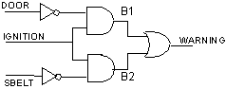

A digital system is described either at the structural or the behavioral level. The behavioral level can be further divided into two kinds of styles: Data flow and Algorithmic. The dataflow representation describes how data moves through the system. This is typically done in terms of data flow between registers (Register Transfer level). The data flow model makes use of concurrent statements that are executed in parallel as soon as data arrives at the input. In contrast, sequential statements are executed in the sequence that they are specified. HDL is used for both concurrent and sequential signal assignments that will determine the manner in which they are executed.

Physical Hardware Requirements

Examples of physical hardware requirements for a fictitious Fault Monitoring and ARINC 429 Data Transmit circuit are as follows:

Hardware Requirement 01: The serial data rate shall be 100k bits per second.

Hardware Requirement 02: The serial data rate shall not vary by more than 1%.

Hardware Requirement 03: The serial data shall be converted to a differential (line A & B) tri-level RZ state modulation output consisting of “HI,” “NULL” and “LO” states.

Hardware Requirement 04: The serial data’s differential output signal across the specified output terminals (balanced to ground at the transmitter) shall be +10V with +/-1.0V from line A to line B for a "HI" state when the transmitter is open circuit.

Hardware Requirement 05: The serial data output transmitter's Rise and Fall Time shall be 1.5 micro seconds with a +/-0.5 micro second tolerance.

Hardware Requirement Review Criteria
As the hardware requirements are expressed in text, the use of unambiguous words and correct language are essential. Pre-release reviews of the hardware Requirements Data shall use the following criteria:
- Watch for persuasive connectors such as certainly, therefore, or obviously, and ask why they are present.
- Ensure vague terms such as some, usually, or most are clarified. However, avoid the use of vague terms as a general rule.
- Look for statements containing always, every, never, or other terms that imply certainty and ask for proof.
- Ensure lists are complete. Eliminate use of phrases like etc., and so on, or such as.
- Beware of vague verbs such as handled, processed, or eliminated that can be interpreted in many ways.
- Always include units in stated ranges of variables.
- When a term is explicitly defined in one place, make sure that definition applies for other occurrences of the same term.
- If necessary, when a structure is described in words, draw a picture or a table to aid in understanding it.
- When a series of logical conditions are stated, consider the use of formal notation, logic and/or flow diagrams as a more effective way of expression.

REQUIREMENTS NOTATION

System Level Requirement Notation

System Level Place Holder for Derived Requirements

System | HL Hardware | Description
01 |  | Place Holder For Derived Requirements

System Level Requirements Identification
System level requirements are identified as one-up numbers between 02 and 99.

System | HL Hardware | Description
02 |  | First System Level Requirement
.  .  . |  | On-Up Numbering
99 |  | Last System Level Requirement

Hardware Requirements Notation
Requirements are identified as one-up numbers between 002 and 999.

System | Hardware | Description
02 | 002 | First High Level Hardware Level Requirement
03 | 003 | Second High Level Hardware Level Requirement
03 | 004 | Third High Level Hardware Level Requirement
03 | 005 | Forth High Level Hardware Level Requirement
03 | 006 | Fifth High Level Hardware Level Requirement
04 | 007 | Sixth High Level Hardware Level Requirement
04 | 008 | Seventh High Level Hardware Level Requirement

Derived Hardware Requirements Notation
Derived requirements are identified using the system level placeholder [01] and the next applicable one-up reference number at the high-level.

System | Hardware | Description
01 | 001 | First Derived Requirement
01 | 002 | Second Derived Requirement
01 | 003 | Third Derived Requirement
01 | 004 | Forth Derived Requirement
01 | 005 | Fifth Derived Requirement

Requirements Traceability

Trace data establishes the associations between life cycle data items contents. Trace data will be provided that demonstrates bi-directional associations between:

- System requirements allocated to hardware and hardware requirements.
- High-level requirements and detail design (typically HDL).
- Hardware Requirements and test benches (for Elemental Analysis – coverage).
- Hardware Requirements and on-target test cases.
- Test cases and test procedures.
- Test procedures and test results.

The Trace Data between test procedures and test results is part of the Hardware Verification Results. The following will be provided as objective evidence of compliance:

- Trace data, showing the bi-directional association between system requirements allocated to hardware and hardware requirements, is developed to enable verification of the complete implementation of the system requirements allocated to hardware and give visibility to the derived hardware requirements.

- Trace data, showing the bi-directional association between the high-level requirements and the detailed design (typically HDL), is developed to enable verification of the complete implementation of the hardware requirements and give visibility to the derived requirements and the architectural design decisions made during the hardware design process.

The following activities will be performed (still need to add the who, what, where and when information):

- The traceability between the hardware requirements and the Detail Design (typically HDL) is accomplished by the requirements-based coverage analysis.

- The traceability between the hardware requirements and the test benches is accomplished by the requirements-based coverage analysis.

- The traceability between the hardware requirements and the on-target test cases is accomplished by the requirements-based coverage analysis.

- The traceability between the hardware requirements and the test results (including Elemental Analysis Results for DAL A and B) is accomplished by the requirements-based test analysis and elemental analysis.

DERIVED HARDWARE REQUIREMENTS
Derived requirements are those requirements that may not be directly traceable to higher level requirements. In order to facilitate a logical flow of requirements traceability data, a system level-derived requirement placeholder may be established (if this type of untraceable derived requirement is anticipated). In this case, this would be recorded as the first system level requirement and is identified as 01.

Output of Derived Hardware Requirements That Are Not Traceable

01.001 | Category: | Functional & Operational
01.001 | Type: | Regulatory
Sys Requirement ( 01 )
Derived requirements shall be identified and verified.
HW Requirement
The hardware shall do something testable.
Req Source: | System Requirements Document
Req Number: | SYS 01 |  | Paragraph: | 4.0
Safety Related: | False |  | Req Test Case:
Reference: | Customer Spec 5.12.3

Output of Derived Hardware Requirements That Are Traceable

03.056 | Category: | Functional & Operational
03.056 | Type: | Derived
<Same as above>

REQUIREMENTS DEVELOPMENT TOOLS

Requirements Traceability Management System
The Requirements Traceability Management System generates a unique database record for each requirement. Requirements definition is recorded from the System Level to the High Level Hardware Requirements.
The system outputs tables that are directly inserted into the System Requirements Document and Hardware Requirements Document.

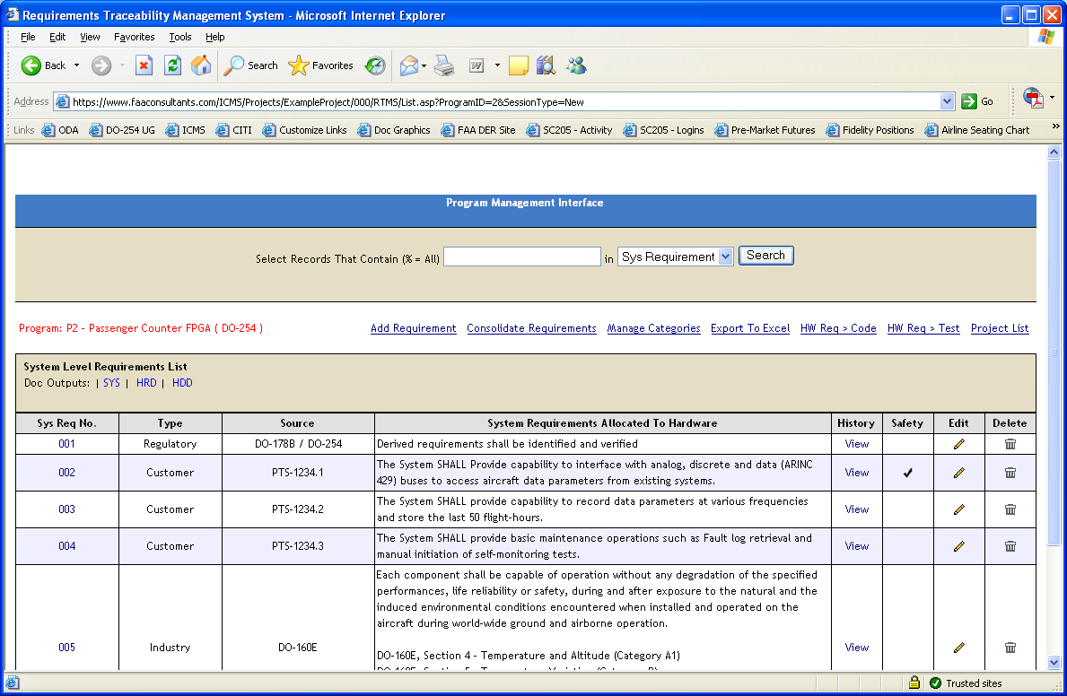

APPENDIX A: Hardware Requirements Document Example

SYSTEM OVERVIEW

System Functional Description

The Avionics Passenger Counter is a module that will keep track of how many passengers are currently in the aircraft/cabin. The current number of passengers in the cabin will be displayed on a display panel in real-time. The system will have a keypad entry so that the flight attendant can enter a passenger headcount correction/adjustment. The passenger headcount and any fault status information collected will be transmitted via ARINC 429 via the PIC processor and ARINC 429 I/O FPGA.

System Architecture

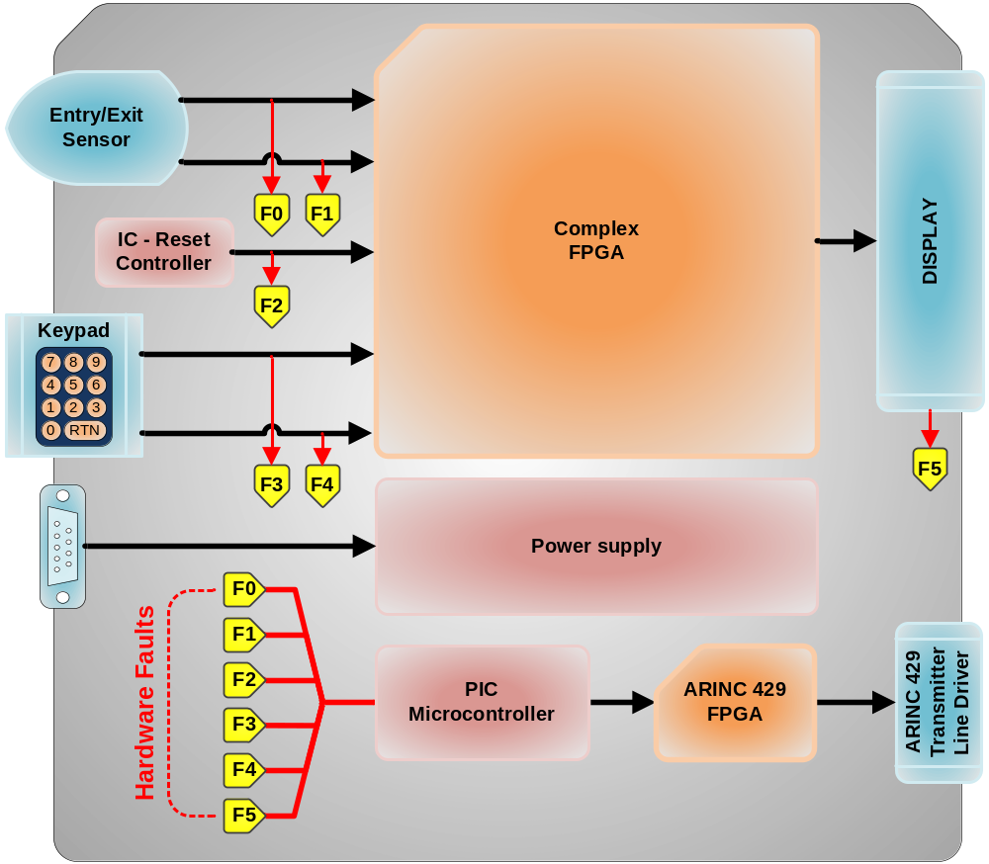

The passenger headcount function is performed by counting the number of entries and exits. The module uses an Entry/Exit-Sensor to detect passengers’ movements in and out of the cabin. The number of passengers in the cabin is tracked by an up/down counter in an FPGA. The passenger load is displayed in real-time on the display panel. The keypad entry can asynchronously load the counter thereby adjusting/correcting the passenger load on the display/system.

2.3 System Requirements

SYS 001 | Type: | Regulatory
Derived requirements shall be identified and verified.
Req Source: | DO-254
Safety Related: | False

SYS 002 | Type: | Customer
The System SHALL Provide entry and exit detection.
Req Source: | PTS-1234.1
Safety Related: | True

SYS 003 | Type: | Customer
The System SHALL provide keypad entry capability.
Req Source: | PTS-1234.2
Safety Related: | False

SYS 004 | Type: | Customer
The System SHALL provide a display.
Req Source: | PTS-1234.3
Safety Related: | False

SYS 005 | Type: | Customer
The System SHALL provide fault monitoring and 429 data transmit capability.
Req Source: | PTS-1234.4
Safety Related: | False

HARDWARE OVERVIEW
This section describes the hardware functions, hardware items, architecture, new technologies to be used, and any fail-safe, fault tolerant redundancy and partitioning techniques to be used.

Hardware Functions

There are five main hardware functions:

- Computation (Derived)
- Entry/Exit Detection
- Keypad entry
- Display
- Fault monitoring and ARINC 429 data transmit

Hardware Architecture

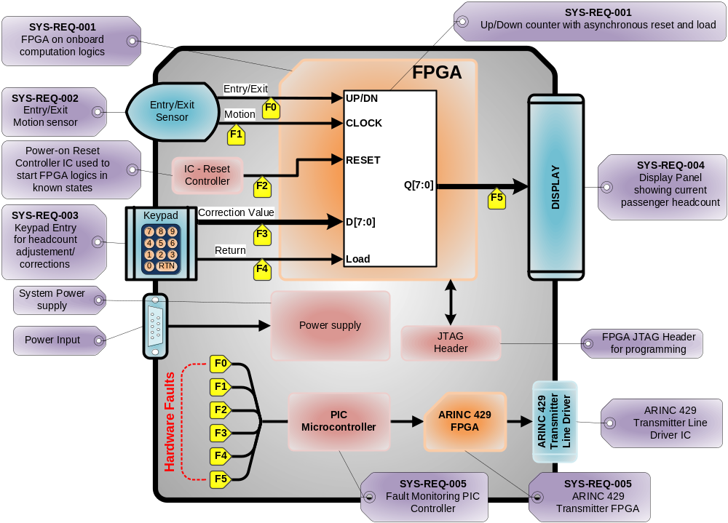

Computation

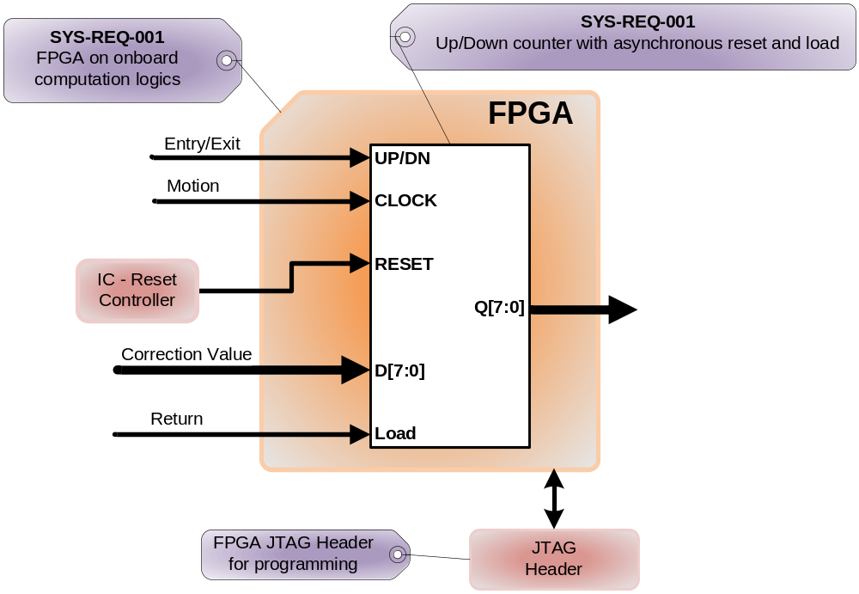

The headcount function is done by an up/down counter inside the FPGA. Every time the Entry/Exit motion sensor detects an entry or an exit, the counter increments or decrements accordingly. Ever time the user presses return, the current headcount output is loaded with previously typed value. The truth table is shown below.

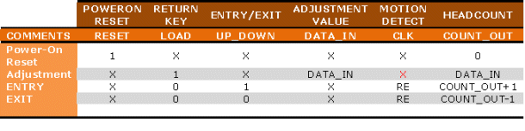

Entry/Exit sensor

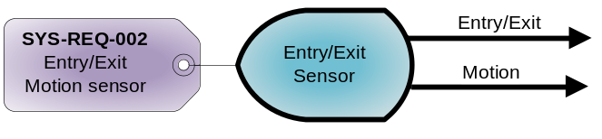
The Entry/Exit Detection function is performed by the Entry/Exit sensor. This sensor will detect human motion and decipher whether the motion is inward or outward. The information is then sent to the FPGA for headcount computation.

Keypad Entry Panel

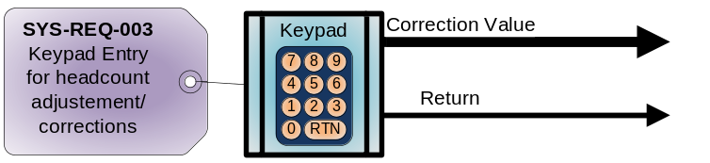

The headcount adjustment/correction data is generated by the keypad entry panel. This panel puts out a value typed by the user as well as a return key strobe signal. Both signals are sent to the FPGA for headcount adjustment/correction. The return key strobe signal is used to latch the value typed by the user into the FPGA logics.

Display Panel

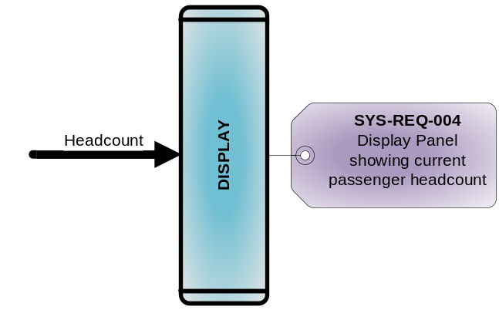
The display panel simply displays the current headcount outputted by the FPGA.

PIC Controller Interface & Fault Monitoring

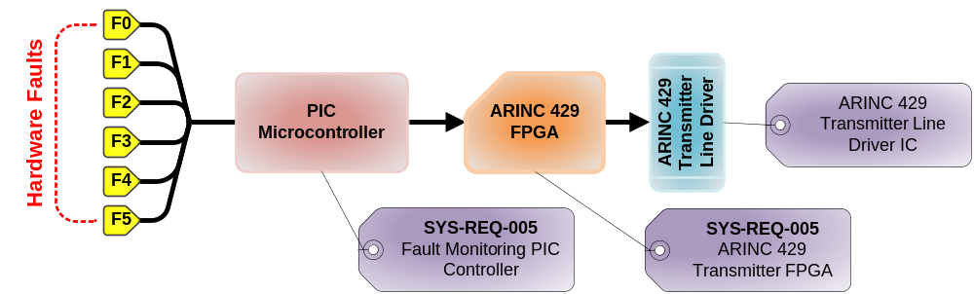

The Fault monitoring circuit monitors the sequences, timings and states of the Entry / Exit Detection sensor, Reset controller, keypad entry and the display panel. All of this information is fed to and analyzed by the PIC microcontroller. The PIC microcontroller’s software knows all the correct signal sequences, timing & states for all the interfaces. A fault is detected when a signal set is not within the predetermined constraints. The PIC controller then generates a fault message in the form able to fit into two 429 words which are sent to the FPGA. The FPGA then generates the appropriate serial ARINC 429 streams to the line driver which translates it out into the appropriate ARINC 429 signal level. The fault message is then sent to the maintenance computer via the ARINC 429 link. The cockpit multifunction display is used in maintenance aspects of the system. This is not a critical function and is used for maintenance and information only in the cockpit. The display reader provides the current passenger headcount to the flight attendant as the critical record for total headcount.

PIC Controller & ARINC 429 FPGA Interface

The ARINC 429 FPGA is connected to the PIC Microcontroller via a standard 8-bit bus interface. There are 8-bit data, 8-bit address and a chip-select (CE) line. There is also one GPIO that is used as an input to the PIC Microcontroller to indicate when the ARINC 429 FPGA is busy / sending data.

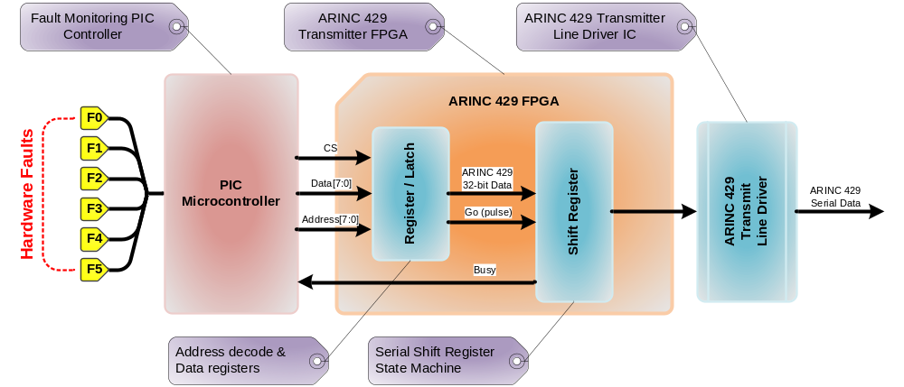

The ARINC 429 FPGA has to internal blocks: the Latch and the Shift Register. The Latch contains four 8-bit register that the Microcontroller can write to: each representing ¼ of the full ARINC 429 packet. These four register are made available to the next block in the form of a complete 32-bit bus/register to be loaded to the shift register. The Latch also contains a dummy register which, when written to, will send short pulse to the Shift Register. This short pulse will trigger the next block, the Shift register to load the data and serially shift out the data in the appropriate ARINC 429 format.

The final block in the ARINC 429 FPGA is the Shift Register. This block is really combination of a state machine and a shift register (shown in the figure below). The sole purpose of this block is to serially shift the 32-bit ARINC 429 data with the appropriate timings.

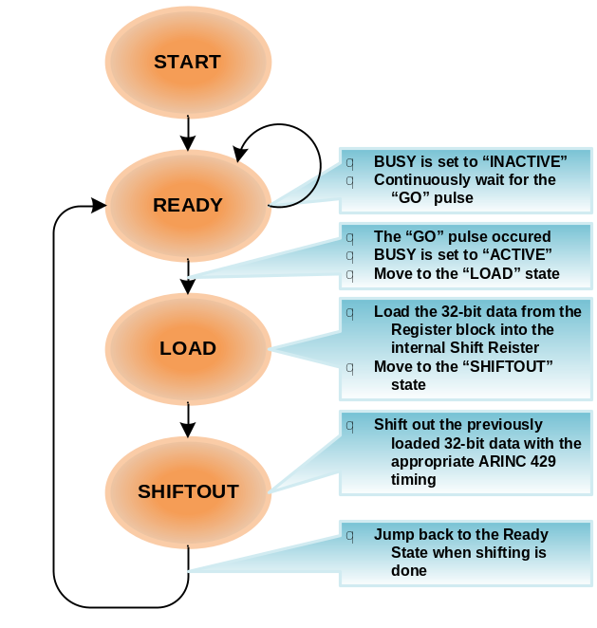

When a fault is detected, the PIC controller determines that a message needs to be sent. It internally constructs the 32-bit ARINC 429 packet in four bytes and writes them out into the FPGA Registers. The Microcontroller then waits for the Busy signal (from the FPGA Shift Register block) to indicate a ready state (inactive). When the Busy signal indicates a “ready” state, the controller writes to a dummy register to initiate the serial transfer.

Hardware Safety and Partitioning

The system is composed of diagnostics and other fail-safe mechanisms used to ensure that failures of the system are detected and that the system goes to a safe state if it's unable to perform a safety function. The hardware will be designed so that it will continue to operate, possibly at a reduced level, rather than failing completely, when some part of the system fails. During this condition, a visible fault indication will be present.

HARDWARE REQUIREMENTS IDENTIFICATION

System Level Requirements Allocated to Hardware

Section 3.2 of this document contains all system level requirements allocated to hardware. Each system level requirement is identified by a unique number and will be used to derive high level hardware requirements. Tables listed in this section are generated from outputs of the Requirements Traceability Management System.

High-Level Hardware Requirements Definition

This section also lists the high-level hardware requirements. Each requirement is identified by a unique number associated with primary sections.

Regulatory Compliance

001.0001 | Derived requirements shall be identified and verified

Computation

001.0002 | For each entry, the system shall increment the passenger headcount accordingly.

001.0003 | For each exit, the system shall decrement the passenger headcount accordingly.

Entry / Exit Detection

002.0004 | The system shall have a sensor to detect passenger entry and exit motions.

002.0005 | The system's Entry/Exit motion sensor shall be capable of distinguishing entry from exit.

Keypad Entry

003.0006 | The system shall have a numerical keypad entry.

003.0007 | The numerical keypad entry shall have an "enter"/"return" button.

003.0008 | The system shall update the passenger headcount by the keypad's value when the user presses the "return" button.

Display

004.0009 | The system shall have a numerical display.

004.0010 | The systems numerical display shall display the current passenger headcount.

Fault Monitoring and ARINC 429 Data Transmit

005.0011 | The fault monitoring system shall monitor signal waveforms between the FPGA and the peripheral components to determine if established thresholds have been violated.

005.0012 | When a fault condition is detected by the fault monitoring circuit, an ARINC 429 label word shall be created by the Microcontroller.

005.0013 | The microcontroller shall write the ARINC 429 word into the ARINC 429 FPGA.

005.0014 | The ARINC 429 FPGA, when signaled by the microcontroller, shall serially shift out the previously loaded data.

005.0015 | The serial data rate shall be 100k bits per second.

005.0016 | The serial data rate shall not vary by more than 1%.

005.0017 | The serial data shall be converted to a differential (line A & B) tri-level RZ state modulation output consisting of “HI,” “NULL” and “LO” states.

005.0018 | The serial data’s differential output signal across the specified output terminals (balanced to ground at the transmitter) shall be +10V with +/-1.0V from line A to line B for a "HI" state when the transmitter is open circuit.

005.0019 | The serial data’s differential output signal across the specified output terminals (balanced to ground at the transmitter) shall be +0V with +/-0.5V from line A to line B for a "NULL" state when the transmitter is open circuit.

005.0020 | The serial data’s differential output signal across the specified output terminals (balanced to ground at the transmitter) shall be -10V with +/-1.0V from line A to line B for a "LO" state when the transmitter is open circuit.

005.0021 | The serial data’s differential output signal across the specified output terminals (balanced to ground at the transmitter) shall be +5V with +/-0.5V from line A to ground for a "HI" state when the transmitter is open circuit.

005.0022 | The serial data’s differential output signal across the specified output terminals (balanced to ground at the transmitter) shall be +0V with +/-0.25V from line A to ground for a "NULL" state when the transmitter is open circuit.

005.0023 | The serial data’s differential output signal across the specified output terminals (balanced to ground at the transmitter) shall be -5V with +/-0.5V from line A to ground for a "LO" state when the transmitter is open circuit.

005.0024 | The serial data’s differential output signal across the specified output terminals (balanced to ground at the transmitter) shall be +5V with +/-0.5V from line B to ground for a "HI"state when the transmitter is open circuit.

005.0025 | The serial data’s differential output signal across the specified output terminals (balanced to ground at the transmitter) shall be +5V with +/-0.5V from line B to ground for a "HI"state when the transmitter is open circuit.

005.0026 | The serial data’s output signal across the specified output terminals (balanced to ground at the transmitter) shall be +0V with +/-0.25V from line B to ground for a "NULL"state when the transmitter is open circuit.

005.0027 | The serial data’s differential output signal across the specified output terminals (balanced to ground at the transmitter) should be -5V with +/-0.5V from line B to ground for a "LO"state when the transmitter is open circuit.

005.0028 | The serial data’s “HI” state shall be at the beginning of the bit interval returning to a “NULL” state before the end of the same bit interval signifies a logic “one.”.

005.0029 | The serial data’s “LO” state after shall be at the beginning of the bit interval returning to a “NULL” state before the end of the same bit interval signifies a logic “zero.”.

005.0030 | The serial data’s output word shall be synchronized by reference to a gap of four bit times (minimum) between the periods of word transmissions. The beginning of the first transmitted bit following this gap signifies the beginning of the new word.

005.0031 | The serial data output transmitter's Rise and Fall Time shall be 1.5 micro seconds with a +/-0.5 micro second tolerance.

REQUIREMENTS TRACEABILITY MATRIX

  - Hardware Requirements To HDL Element

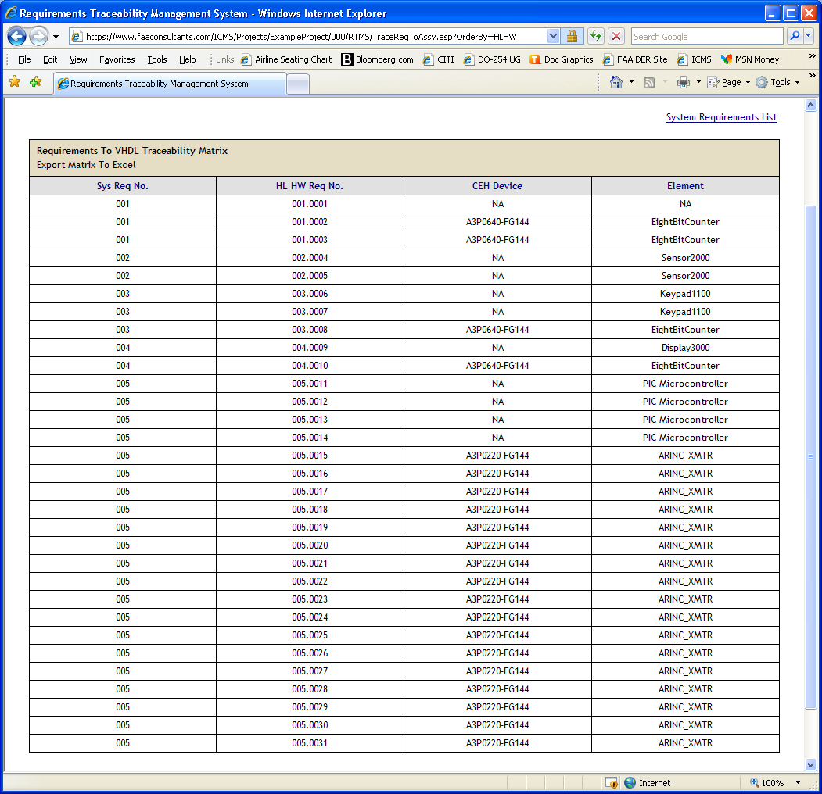
6.2 Hardware Requirements To Target Test Case and Test Bench

