Downing, Samuel

Jacques, Steven

Kumar, Raushan

Venkata, Sriraghav Pullabatla

Vyapuri, Muthukumar

5/3/2018

Mitigating Tampa Traffic with Transit Oriented Development

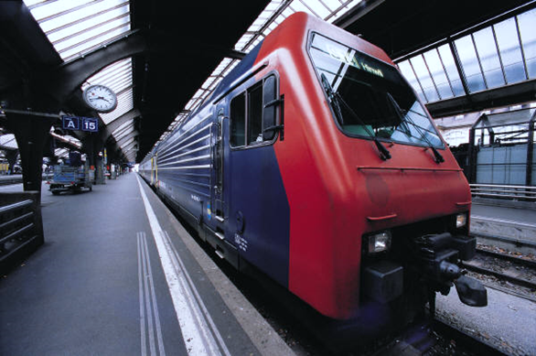

Table of Contents

Executive Summary 2

Project Background 3

Data Source 3

Hypothesis 4

Modeling and Quality Checks 4

Recommendations 4

References 5

Appendix 6

# Executive Summary

This project provides actionable solutions to the Tampa Bay region’s perennial traffic congestion problem through statistical analysis of factors that may result in the reduction of urban sprawl. The analysis reveals that an increase in population, the number of transportation served in an area, and the type of station developed can have a positive impact on intersection density, otherwise known as the number of intersections per road network. By employing a more prudent development strategy that keeps high-density in mind, Tampa Bay can mitigate its congestion issues by reducing reliance on automobiles and promoting healthier lifestyles through increased walkability.

The problem of traffic congestion has been getting worse with a constant increase of population, widening roads, and the inevitability of running out of land for development. As these issues continue to manifest themselves, Hillsborough County planning officials are presented with two options: continue low-dense development that results in more pronounced urban sprawl or pursue mixed-use zoning through Transit Oriented Development (TOD). The current state of Tampa Bay’s traffic infrastructure suggests that the latter will provide a more sustainable solution.

Analysis was conducted by utilizing data sourced from the Maryland Transit Administration (MTA). The MTA has pursued a policy based on TOD, and as such, is an ideal example of how increased density can be useful in reducing traffic congestion, and thus leveraged for Tampa Bay. Linear regression was used to analyze transit data, with multiple models run to measure the project team’s hypothesis centered around intersection density. Consequently, the main model selected coincides with the idea that areas of high population and transit mode provision contribute to intersection density. Quality checks were also performed that ensured model integrity, which allowed the project team to recommend actionable solutions supported by statistical analysis.

# Project Background

The Tampa Bay region is well-known for its traffic problem. It is routinely ranked among the worst cities in the United States for congestion, as a 2008 Forbes ranking placed Tampa as the sixth most congested city in the nation. The main reason for this appellation is largely due to urban sprawl. Nevertheless, for years Tampa has planned for a growing population by building large residential communities separate from commercial and industrial areas and widening roads to account for the traffic increase emanating from these newly developed residential plots. Since these residential communities are built further away from areas where people commute for work, the low population density results in longer traffic delays – on average, commuters are stuck in traffic 45 hours a year, and 7% take longer than an hour to arrive at work. Even worse, developers are running out of land in Hillsborough County.

To address the urban sprawl problem and reduce traffic congestion in the Tampa Bay region, the Hillsborough County Board of County Commissioners has requested the services of our project team to analyze this growing issue and determine a lasting solution.

# Data Source

Since this project seeks to analyze the effects of Transit Oriented Development (TOD) on a community that has implemented it and provide recommendations for the Tampa Bay region based on such analysis, the data for this project was sourced from the Maryland Transit Administration (MTA). The data set held over 80-plus variables measuring all kinds of factors contributing in the scale of the MTA. The variables range from simple, self-explanatory columns as the TOD Station’s names, IDs and types. The stations types were referred to as Urban, Neighborhood, Walk-up and Anchor. Each of these types held special characteristic that was utilize for this data set. Such as the walk-up station refer to the accessibility of the station from a pedestrian within a mile radius. There were also many robust variables we decided to highlight. The first in particular was the metro rail ridership. This was calculated by gathering all the metro gate exit counts. While the light rail ridership is an estimation using a statistical sampling approved by the Federal Transit Administration (FTA).

After analyzing the data, we noticed the most appropriate dependent variable would be intersection density (1 Mile Diameter). This will be the key factor in the decision making for targeting the most desirable Transit Oriented Development(TOD) location in Tampa Bay areas. **Intersection Density focus on the amount of relational measured by a ratio involving the number of intersections in the street/road network. This directly aligns with the pedestrian walkability to a mode/ metro transit site**. Our independent variables are modes served, area population, station type and state designated TOD. All have a significant effect on determining the strength of this model.

# Hypothesis

Since intersection density is identified with Transit Oriented Development (TOD), the provision of public transit, and a reduction of automobile reliance (hence, less traffic congestion), the core hypothesis posited by this analysis is that increased population, the number transit modes served in an area, whether or not an area is designated as TOD, and the area’s station type increase intersection density. In short, the higher the intersection density of an area, the less likely it is that people will use vehicles to travel to work or for commercial purposes.

To test this hypothesis, a linear regression model was used. Regression was run utilizing the R programming language, along with RStudio, a development environment used for writing R. Further, multiple models that utilized different dependent variables were used to explore potential hypotheses, yet the main model employed by this project sought to explore the impact of meaningful independent variables on intersection density.

# Descriptive Analysis

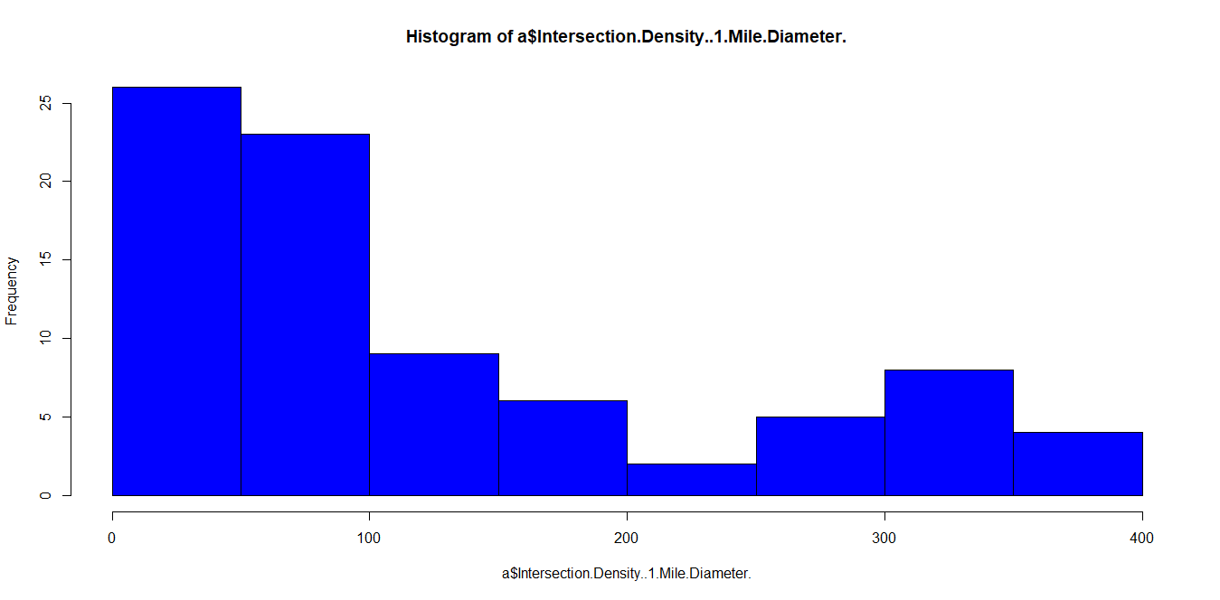

Intersection density is one of the most important predictors of walking in a community, along with access to various destinations especially public transits stops to work and other activities. Intersection density helps in improving community’s air quality and reduces carbon emissions at the same time.

From the above histogram we can observe that the intersection density of most of the stations in Maryland ranges from 50-150 which is higher than the US average.

The average intersection density per 1 mile diameter in Maryland is 119. 32.

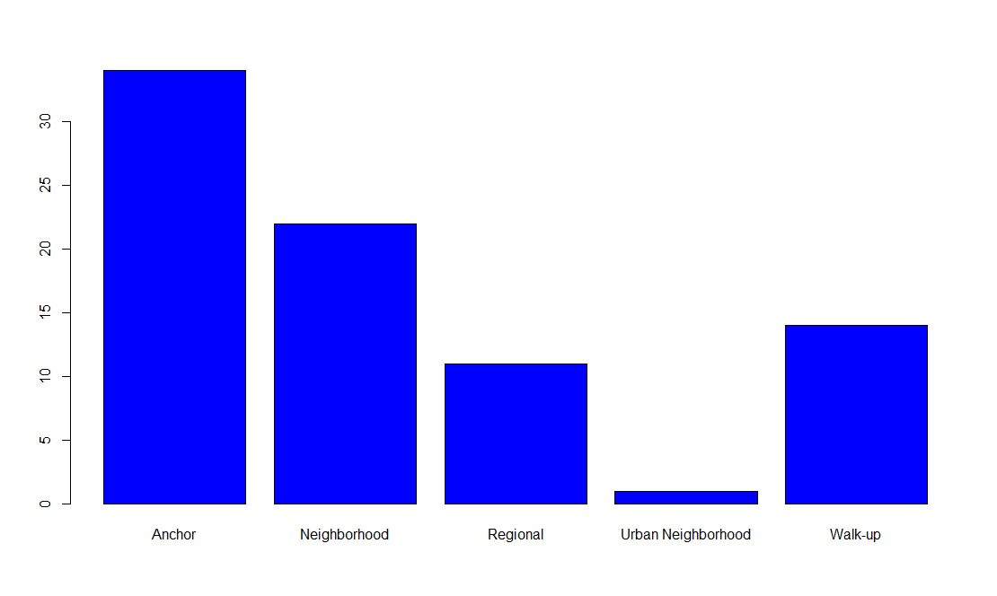

From the above plot on Station types, we observe that Anchor and Neighborhood station types are the highest in Maryland.

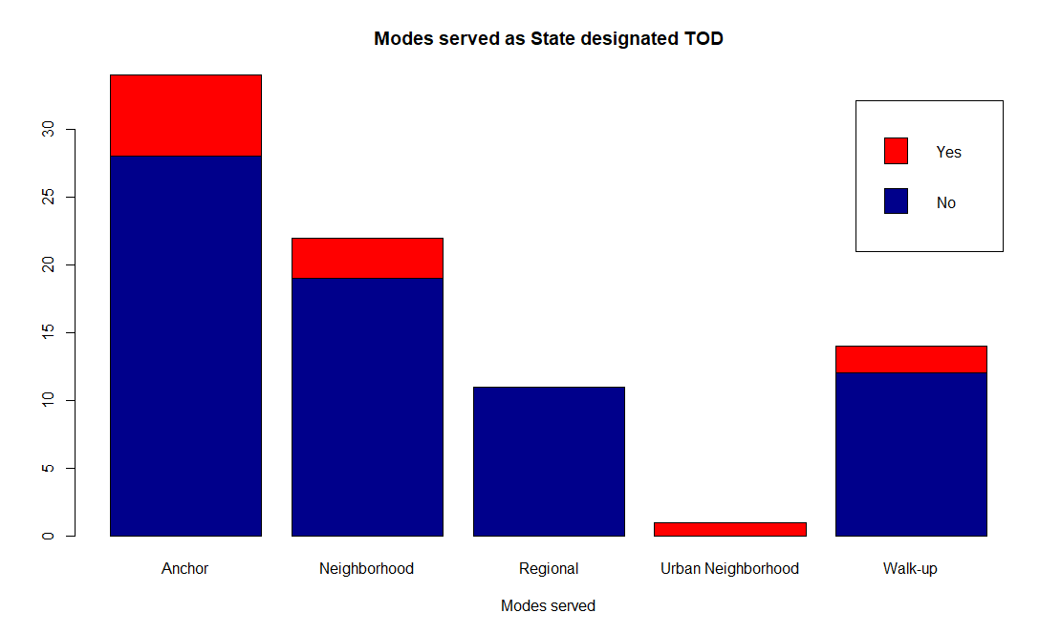

While Anchor, Neighborhood and regional are the highest station types in the area. The plot above clearly shows most of them are NOT stated designated TOD.

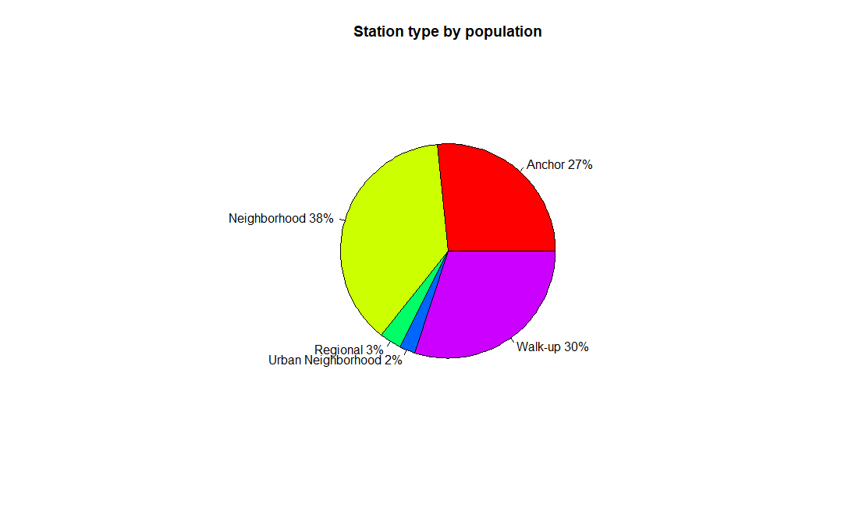

From the pie chart above, 42% of the populations in Maryland live near stations which is either neighborhood, regional or Urban type.

# Modeling and Quality Checks

A total of three models were developed that analyzed different dependent variables. Of the three models compared in this project, the first model was chosen to formulate and test the core hypothesis. The two other models, while not ultimately chosen as the flagship model, still provide valuable information that supports the pursuit of smart development that mitigates traffic congestion.

## Model 1

Model 1 is the main model used to measure the project team’s hypothesis, utilizing intersection density as the dependent variable. The number of modes served in an area, whether or not an area was designated as Transit Oriented Development (TOD) by the state, an area’s population, and station type were chosen as the independent variables that could potentially have a positive impact on intersection density. As expected, an increase in population, modes served, and urban neighborhood/walk-up station types have a statistically significant and positive impact on intersection density.

Quality checks were also implemented to ensure that the devised model was statistically sound. Analysis indicated that the model was generally normal in its distribution, linear, and none of the independent variables were related to each other, thereby preserving the independence of each. Lastly, the model appears to account for much of the potential uncertainty that could impact intersection density, which means most of the variability is captured in the model.

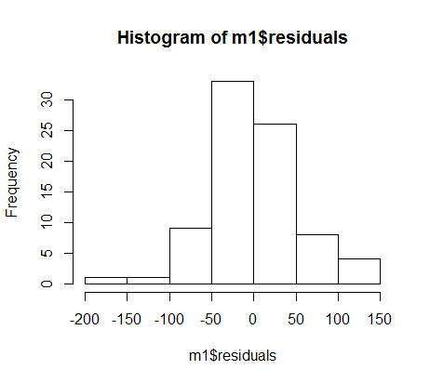 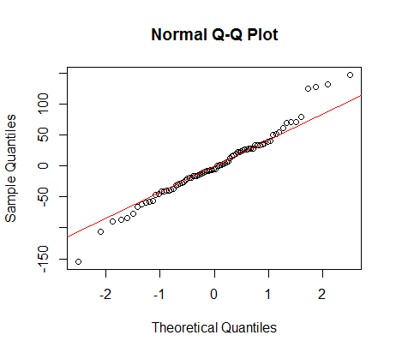

1. Data is quite normally distributed.
2. In short, the positive impact of the statistically significant independent variables suggests that when developing communities, keeping high population, walk-up/urban station types in mind will increase the intersection density.
3. This is consistent with short commutes home, to work, and to transit centers that will reduce demand for automobiles, and therefore congestion.

## Model 2

Model 2 looks at the weekday ridership based on certain variables, and how it will likely to impact the number of riders using one of the transit mode. Variables such as Intersection Density, Population of that Area, Frequency of the services on, weekdays, Type of Station, that is, is it Urban, rural, regional or Walk-up and Type of the station, If the state has designated that area as a Transit Oriented Development we used.

Quality checks were run to see if the model has a normal distribution, not biased, and homoscedtatic.

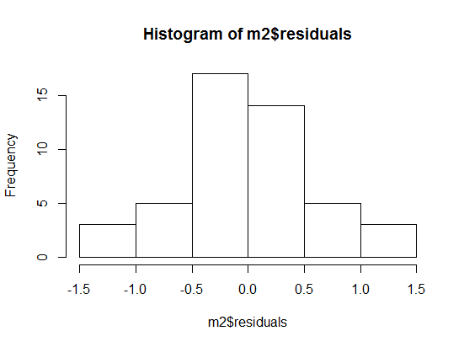 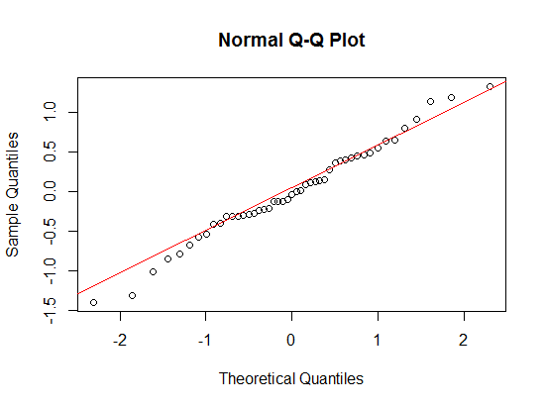 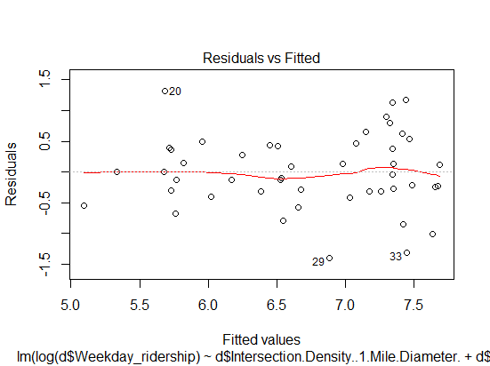

1. Data is normally distributed.
2. From this model we observe that if the frequency of service is increased, then it encourages more commuters to take the public transport than their own vehicles.

Model 3

We decided to have the significant independent variables for model three will be the area population and mode served. Short Trip Opportunity Analysis (1 Mile Buffer) was chosen as the dependent due to I felt it complement the usefulness of picking a TOD location. The attributes such as the existing bike racks, parking lots, garages play a role in pointing out a desirable new location. This analysis is base from the thinking of having a convenient place to park your car and bikes to a close mode location. Will eventually encourage people to actually use the mass transit more frequently.

Quality checks were run to see if the model was statistically sound.

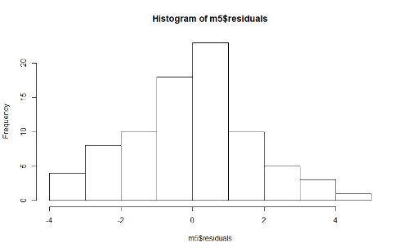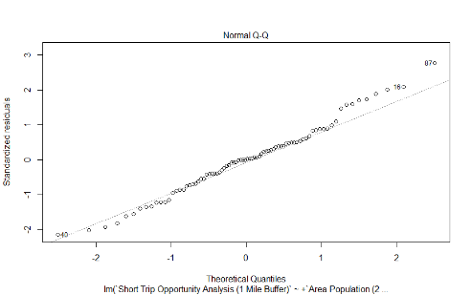

1. Data seems normally distributed.
2. From this model we found that if the area density is high, it needs to be services by multiple lines and modes of transport.
3. In case of multiple lines & modes of transport, like 4 lines in a station and other transport modes like buses need to be connected.

# Recommendations

The project goal is to reduce traffic congestion, and by extension, alleviate urban sprawl. As such, the models run by the project team coincide with the hypothesis that areas with higher density can achieve this goal. Specifically, using intersection density as the standard by which communities can be planned, the County can identify different locations in Tampa that would be ideal places to build a transit station. Some of the factors determining such a location would be the population of the area, what type of station to be built (such as a walk-up, neighborhood, or regional station), or how many modes of transport will be provided.

While Model 1 was used to support the project team’s hypothesis, the team also reviewed the outcomes of the other two models to make additional recommendations to the board. Thus, the following recommendations are the result of comprehensive analysis to provide actionable solutions to Tampa’s traffic problem:

1. Development should incorporate mixed-use methods that will zone neighborhoods in residential and commercial parts, thereby promoting higher intersection density. Since commercial and residential areas are proximate to each other, people can reach areas in which they work or shop without getting into a vehicle. As shown by Model 1, a higher intersection density may promote walkability will can relieve traffic congestion.
2. If an area is highly populated within a small neighborhood, this would be an ideal location to have a walk-up station, that is, a location where people can easily walk to the transit station. This will also free up more space that would have originally been used for parking areas.
3. The County should increase the frequency of service during peak, office hour commutes. This will further encourage people to take mass transit instead of their own vehicles.
4. When planning development, additional modes of transit should be considered to provide additional options for residents, whether it be light rail, bus, or both. Analysis suggests that the provision of additional modes may promote more dense neighborhoods, thereby reducing reliance on automobiles.

# References

# Appendix

* **Intersection Density**: Dependent variables. Calculate transit intersection density in diameter of 1 mile.
* **Rail Lines served:** The rail line service could be Metro, Light Rail.
* **TOD Place Type:**  The Transit Oriented Place type are downtown, Suburban, Urban Neighborhood or an Employment center.
* **Weekday_Ridership:** The number of riders travelling on week days.
* **Weekday_Ridership_Metro:** The number of riders travelling in Metro on week days.
* **Weekday_Ridership_Light Rail:** The number of riders travelling in Light Rail on week days.
* **Station Type :** The station for rail lines in an area could be Regional, Neighborhood, Anchor or Walk-up.
* **Transit Score:** Transit score of any particular area based on multiple factors. These multiple factors are Station Facility Score, Parking Score, Bike Access Score, Ped Access Score, TOD Zoning Score, Development Market & Total Rail Lines.
* **Transit Connection:** This is about, how transit are connected with each other. In this data Transits are connected with different types of buses.