Ex - 7 Develop Feedback Management Module using MVC Layout, Partial View & Validation. (HTML Helpers, Validation, Layouts)

Source Code:-
1. Program.cs
var builder = WebApplication.CreateBuilder(args);

// Register MVC (Controllers + Views)
builder.Services.AddControllersWithViews();

var app = builder.Build();

app.UseStaticFiles();
app.UseRouting();

app.MapControllerRoute(
name: "default",
pattern: "{controller=Feedback}/{action=Index}/{id?}");

app.Run();
2. Models/Feedback.cs
using System.ComponentModel.DataAnnotations;

namespace FeedbackApp.Models
{
public class Feedback
{
public int Id { get; set; }

[Required(ErrorMessage = "Name is required")]
[StringLength(50, MinimumLength = 3, ErrorMessage = "Name must be 3 to 50 characters")]
[Display(Name = "Full Name")]
public string Name { get; set; } = string.Empty;

[Required(ErrorMessage = "Email is required")]
[EmailAddress(ErrorMessage = "Enter a valid email address")]
[Display(Name = "Email Address")]
public string Email { get; set; } = string.Empty;

[Required(ErrorMessage = "Phone number is required")]
[RegularExpression(@"^[6-9]\d{9}$", ErrorMessage = "Enter a valid 10-digit mobile number")]
[Display(Name = "Phone Number")]
public string Phone { get; set; } = string.Empty;

[Required(ErrorMessage = "Please select a category")]
public string Category { get; set; } = string.Empty;

[Range(1, 5, ErrorMessage = "Please select a rating between 1 and 5")]
public int Rating { get; set; }

[Required(ErrorMessage = "Comments are required")]
[StringLength(500, MinimumLength = 10, ErrorMessage = "Comments must be 10 to 500 characters")]
[DataType(DataType.MultilineText)]
public string Comments { get; set; } = string.Empty;

[Display(Name = "Submitted On")]
[DataType(DataType.DateTime)]
public DateTime SubmittedOn { get; set; }
}
}
3. Controllers/FeedbackController.cs
using FeedbackApp.Models;
using Microsoft.AspNetCore.Mvc;
using Microsoft.AspNetCore.Mvc.Rendering;

namespace FeedbackApp.Controllers
{
public class FeedbackController : Controller
{
// In-memory store with some seed data
private static readonly List<Feedback> _store = new()
{
new Feedback { Id = 1, Name = "Aarav Shah", Email = "aarav.shah@gmail.com", Phone = "9876543210",
Category = "Faculty", Rating = 5, Comments = "Excellent teaching and doubt solving.",
SubmittedOn = new DateTime(2026, 10, 10, 10, 15, 0) },
new Feedback { Id = 2, Name = "Meera Patel", Email = "meera.patel@gmail.com", Phone = "9123456780",
Category = "Infrastructure", Rating = 4, Comments = "Labs are good, Wi-Fi can be improved.",
SubmittedOn = new DateTime(2026, 10, 11, 14, 40, 0) },
new Feedback { Id = 3, Name = "Kunal Mehta", Email = "kunal.mehta@gmail.com", Phone = "9988776655",
Category = "Library", Rating = 4, Comments = "Good collection of technical books.",
SubmittedOn = new DateTime(2026, 10, 12, 11, 5, 0) }
};

// GET: /Feedback
public IActionResult Index()
{
var list = _store.OrderByDescending(f => f.SubmittedOn).ToList();
return View(list);
}

// GET: /Feedback/Create
[HttpGet]
public IActionResult Create()
{
ViewBag.Categories = GetCategories();
return View(new Feedback());
}

// POST: /Feedback/Create
[HttpPost]
[ValidateAntiForgeryToken]
public IActionResult Create(Feedback model)
{
// Custom (server side) validation: block duplicate submissions
if (_store.Any(f => string.Equals(f.Email, model.Email, StringComparison.OrdinalIgnoreCase)
&& f.Comments == model.Comments))
{
ModelState.AddModelError("", "This feedback has already been submitted.");
}

if (!ModelState.IsValid)
{
ViewBag.Categories = GetCategories();
return View(model); // redisplay form with error messages
}

model.Id = _store.Max(f => f.Id) + 1;
model.SubmittedOn = DateTime.Now;
_store.Add(model);

TempData["Success"] = $"Thank you, {model.Name}! Your feedback has been submitted.";
return RedirectToAction(nameof(Index));
}

private static List<SelectListItem> GetCategories() => new()
{
new SelectListItem("Course Content", "Course Content"),
new SelectListItem("Faculty", "Faculty"),
new SelectListItem("Infrastructure", "Infrastructure"),
new SelectListItem("Library", "Library"),
new SelectListItem("Other", "Other")
};
}
}
4. Views/_ViewImports.cshtml
@using FeedbackApp
@using FeedbackApp.Models
@addTagHelper *, Microsoft.AspNetCore.Mvc.TagHelpers
5. Views/_ViewStart.cshtml
@{
Layout = "_Layout";
}
6. Views/Shared/_Layout.cshtml (Layout)
<!DOCTYPE html>
<html lang="en">
<head>
<meta charset="utf-8" />
<meta name="viewport" content="width=device-width, initial-scale=1.0" />
<title>@ViewData["Title"] - Feedback Management</title>
<link rel="stylesheet" href="https://cdn.jsdelivr.net/npm/bootstrap@5.3.0/dist/css/bootstrap.min.css" />
</head>
<body>
<header>
<nav class="navbar navbar-expand-sm navbar-dark bg-primary mb-4">
<div class="container">
@Html.ActionLink("Feedback Portal", "Index", "Feedback", null, new { @class = "navbar-brand" })
<ul class="navbar-nav">
<li class="nav-item">
@Html.ActionLink("All Feedback", "Index", "Feedback", null, new { @class = "nav-link" })
</li>
<li class="nav-item">
@Html.ActionLink("Give Feedback", "Create", "Feedback", null, new { @class = "nav-link" })
</li>
</ul>
</div>
</nav>
</header>

<div class="container">
<main role="main" class="pb-3">
@RenderBody()
</main>
</div>

<footer class="border-top text-muted py-3 mt-4">
<div class="container">&copy; @DateTime.Now.Year - Feedback Management Module (ASP.NET Core MVC, .NET 7)</div>
</footer>

@await RenderSectionAsync("Scripts", required: false)
</body>
</html>
7. Views/Shared/_ValidationScriptsPartial.cshtml
<script src="https://cdnjs.cloudflare.com/ajax/libs/jquery/3.7.0/jquery.min.js"></script>
<script src="https://cdnjs.cloudflare.com/ajax/libs/jquery-validate/1.19.5/jquery.validate.min.js"></script>
<script src="https://cdnjs.cloudflare.com/ajax/libs/jquery-validation-unobtrusive/3.2.12/jquery.validate.unobtrusive.min.js"></script>
8. Views/Shared/_FeedbackSummary.cshtml (Partial View)
@model IEnumerable<FeedbackApp.Models.Feedback>

<div class="row text-center">
<div class="col-md-4">
<div class="card border-primary">
<div class="card-body">
<h6 class="text-muted">Total Feedback</h6>
<h3>@Model.Count()</h3>
</div>
</div>
</div>
<div class="col-md-4">
<div class="card border-success">
<div class="card-body">
<h6 class="text-muted">Average Rating</h6>
<h3>@(Model.Any() ? Model.Average(f => f.Rating).ToString("0.0") : "0.0") / 5</h3>
</div>
</div>
</div>
<div class="col-md-4">
<div class="card border-warning">
<div class="card-body">
<h6 class="text-muted">5-Star Reviews</h6>
<h3>@Model.Count(f => f.Rating == 5)</h3>
</div>
</div>
</div>
</div>
9. Views/Feedback/Create.cshtml
@model FeedbackApp.Models.Feedback
@{
ViewData["Title"] = "Give Feedback";
}

<div class="row justify-content-center">
<div class="col-md-8">
<div class="card shadow-sm">
<div class="card-header bg-primary text-white">
<h4 class="mb-0">Submit Your Feedback</h4>
</div>
<div class="card-body">

@using (Html.BeginForm("Create", "Feedback", FormMethod.Post))
{
@Html.AntiForgeryToken()
@Html.ValidationSummary(true, "", new { @class = "text-danger" })

<div class="mb-3">
@Html.LabelFor(m => m.Name, new { @class = "form-label" })
@Html.TextBoxFor(m => m.Name, new { @class = "form-control", placeholder = "Enter your full name" })
@Html.ValidationMessageFor(m => m.Name, "", new { @class = "text-danger" })
</div>

<div class="mb-3">
@Html.LabelFor(m => m.Email, new { @class = "form-label" })
@Html.TextBoxFor(m => m.Email, new { @class = "form-control", placeholder = "name@example.com" })
@Html.ValidationMessageFor(m => m.Email, "", new { @class = "text-danger" })
</div>

<div class="mb-3">
@Html.LabelFor(m => m.Phone, new { @class = "form-label" })
@Html.TextBoxFor(m => m.Phone, new { @class = "form-control", placeholder = "10-digit mobile number" })
@Html.ValidationMessageFor(m => m.Phone, "", new { @class = "text-danger" })
</div>

<div class="mb-3">
@Html.LabelFor(m => m.Category, new { @class = "form-label" })
@Html.DropDownListFor(m => m.Category, (IEnumerable<SelectListItem>)ViewBag.Categories,
"-- Select Category --", new { @class = "form-select" })
@Html.ValidationMessageFor(m => m.Category, "", new { @class = "text-danger" })
</div>

<div class="mb-3">
@Html.LabelFor(m => m.Rating, new { @class = "form-label d-block" })
@for (int i = 1; i <= 5; i++)
{
<div class="form-check form-check-inline">
@Html.RadioButtonFor(m => m.Rating, i, new { @class = "form-check-input", id = "rating" + i })
<label class="form-check-label" for="rating@(i)">@i</label>
</div>
}
@Html.ValidationMessageFor(m => m.Rating, "", new { @class = "text-danger d-block" })
</div>

<div class="mb-3">
@Html.LabelFor(m => m.Comments, new { @class = "form-label" })
@Html.TextAreaFor(m => m.Comments, 4, 40, new { @class = "form-control", placeholder = "Write your comments..." })
@Html.ValidationMessageFor(m => m.Comments, "", new { @class = "text-danger" })
</div>

<button type="submit" class="btn btn-primary">Submit Feedback</button>
@Html.ActionLink("Cancel", "Index", null, new { @class = "btn btn-secondary ms-2" })
}
</div>
</div>
</div>
</div>

@section Scripts {
@{ await Html.RenderPartialAsync("_ValidationScriptsPartial"); }
}
10. Views/Feedback/Index.cshtml
@model IEnumerable<FeedbackApp.Models.Feedback>
@{
ViewData["Title"] = "All Feedback";
}

@if (TempData["Success"] != null)
{
<div class="alert alert-success">@TempData["Success"]</div>
}

<div class="d-flex justify-content-between align-items-center mb-3">
<h2>Feedback Received</h2>
@Html.ActionLink("+ Give Feedback", "Create", null, new { @class = "btn btn-primary" })
</div>

@* Partial view *@
@await Html.PartialAsync("_FeedbackSummary", Model)

<table class="table table-striped table-bordered mt-3">
<thead class="table-dark">
<tr>
<th>#</th>
<th>@Html.DisplayNameFor(m => m.First().Name)</th>
<th>@Html.DisplayNameFor(m => m.First().Email)</th>
<th>@Html.DisplayNameFor(m => m.First().Category)</th>
<th>@Html.DisplayNameFor(m => m.First().Rating)</th>
<th>@Html.DisplayNameFor(m => m.First().Comments)</th>
<th>@Html.DisplayNameFor(m => m.First().SubmittedOn)</th>
</tr>
</thead>
<tbody>
@foreach (var item in Model)
{
<tr>
<td>@item.Id</td>
<td>@Html.DisplayFor(modelItem => item.Name)</td>
<td>@Html.DisplayFor(modelItem => item.Email)</td>
<td>@Html.DisplayFor(modelItem => item.Category)</td>
<td class="text-warning">@(new string('\u2605', item.Rating))</td>
<td>@Html.DisplayFor(modelItem => item.Comments)</td>
<td>@item.SubmittedOn.ToString("dd-MMM-yyyy hh:mm tt")</td>
</tr>
}
</tbody>
</table>

Output:-
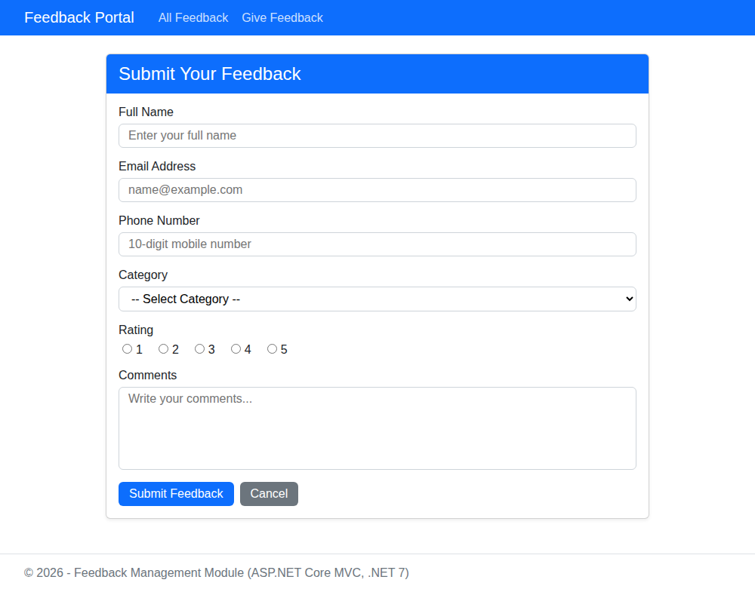  Fig 1: Give Feedback page (Layout + HTML Helpers) - empty form | 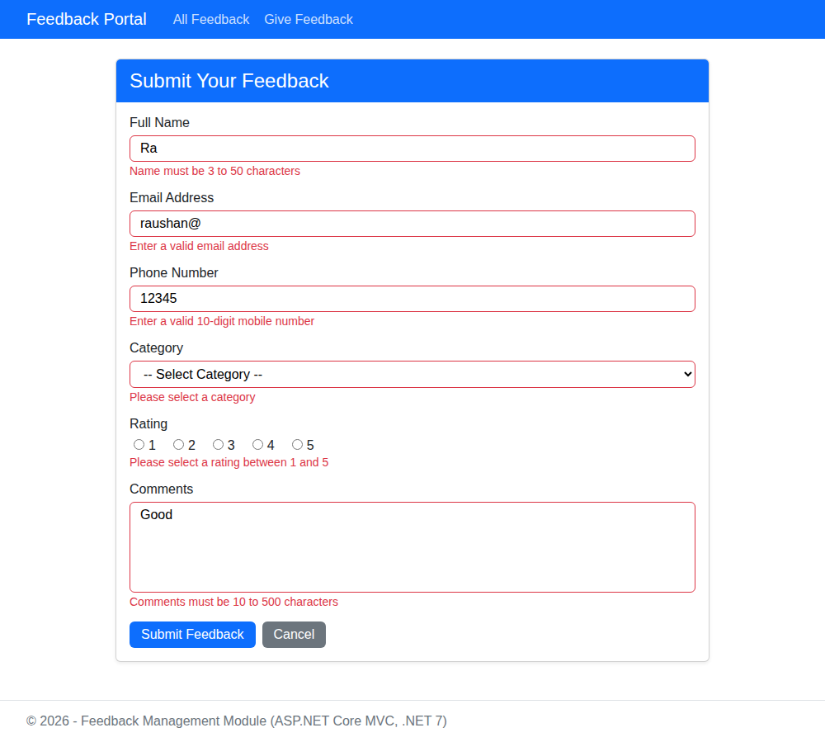  Fig 2: Validation error messages for invalid input
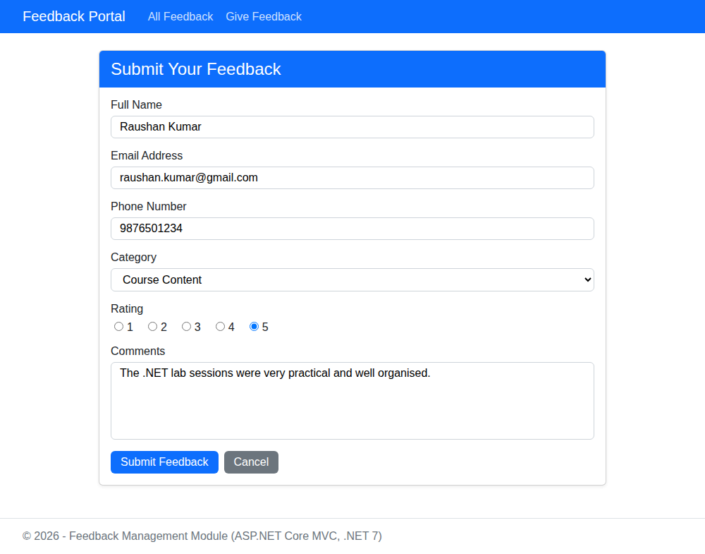  Fig 3: Valid data entered in the form | 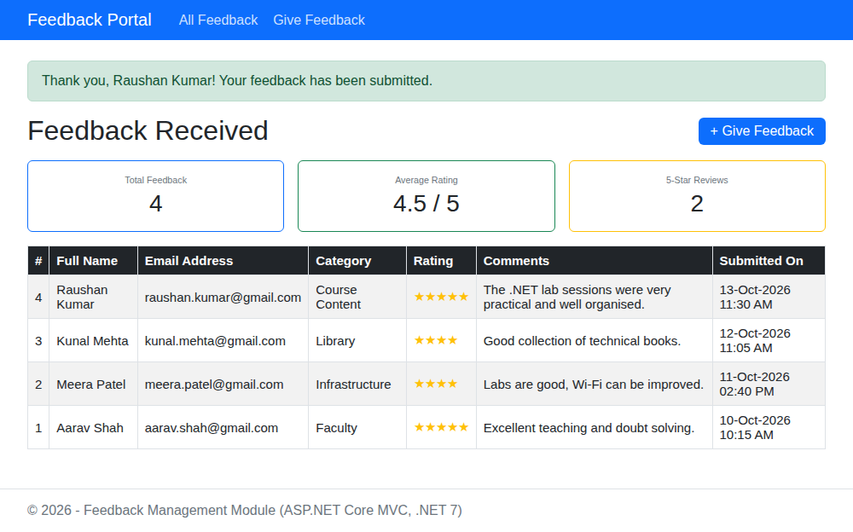  Fig 4: Success message and Feedback list with Partial View summary

