If you like to store your Circuit Diagrams outside of the vm...

Select “File”, “Save As”:

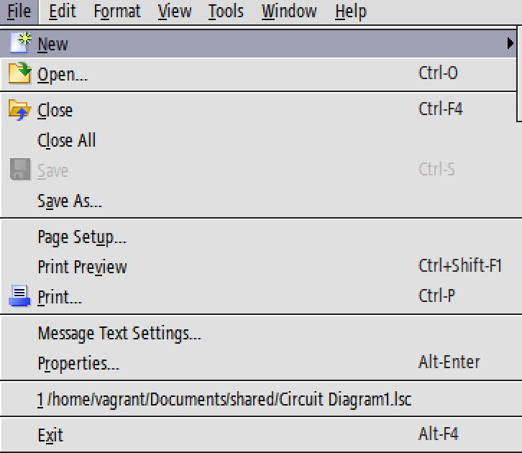

Navigate to...
/home/vagrant/Documents/shared
ans press “Save”:
