Press the icon on the Desktop:
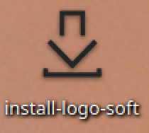

Select your language and press OK:

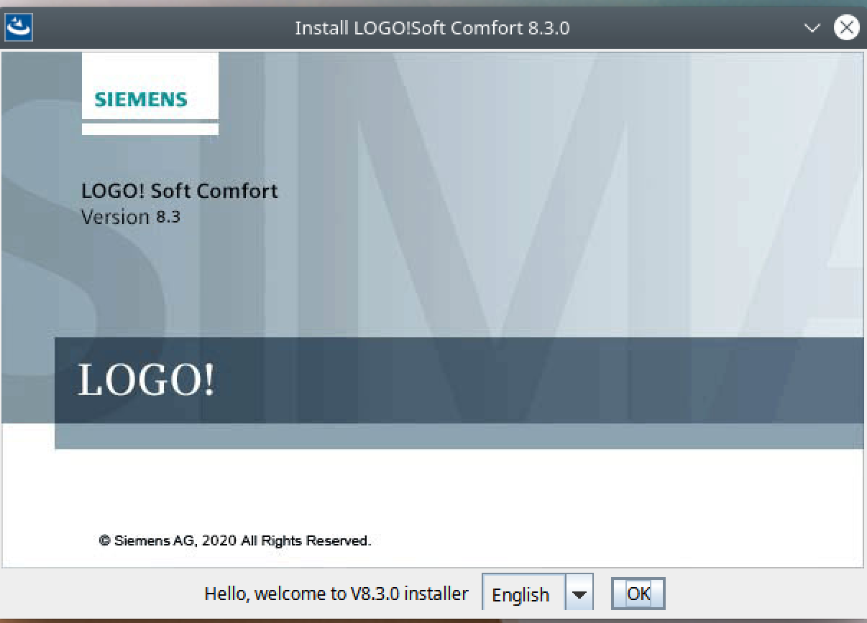

Press “Choose...”
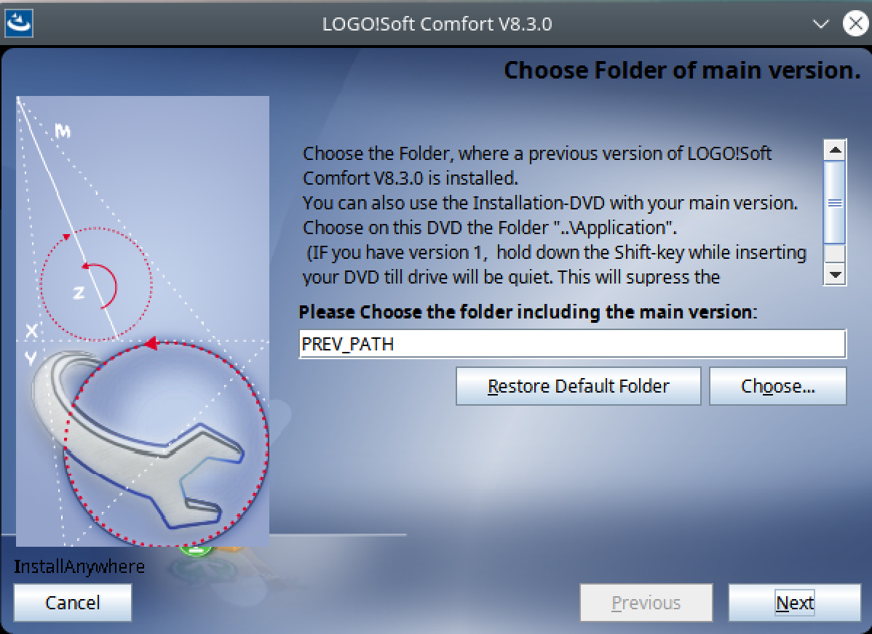

Follow the path…
/home/vagrant/Downloads/install/cd/Linux/Tools/Application
and selecht “Next”.
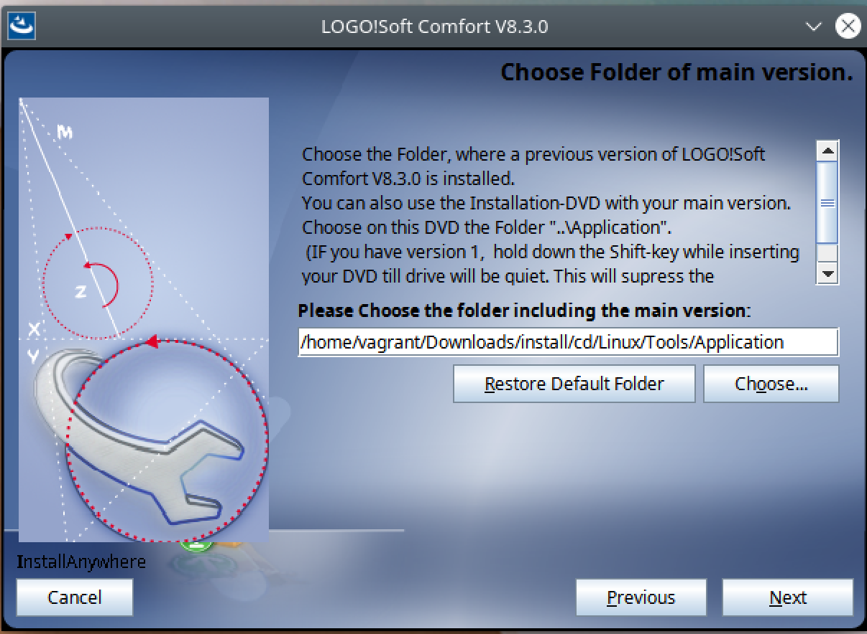

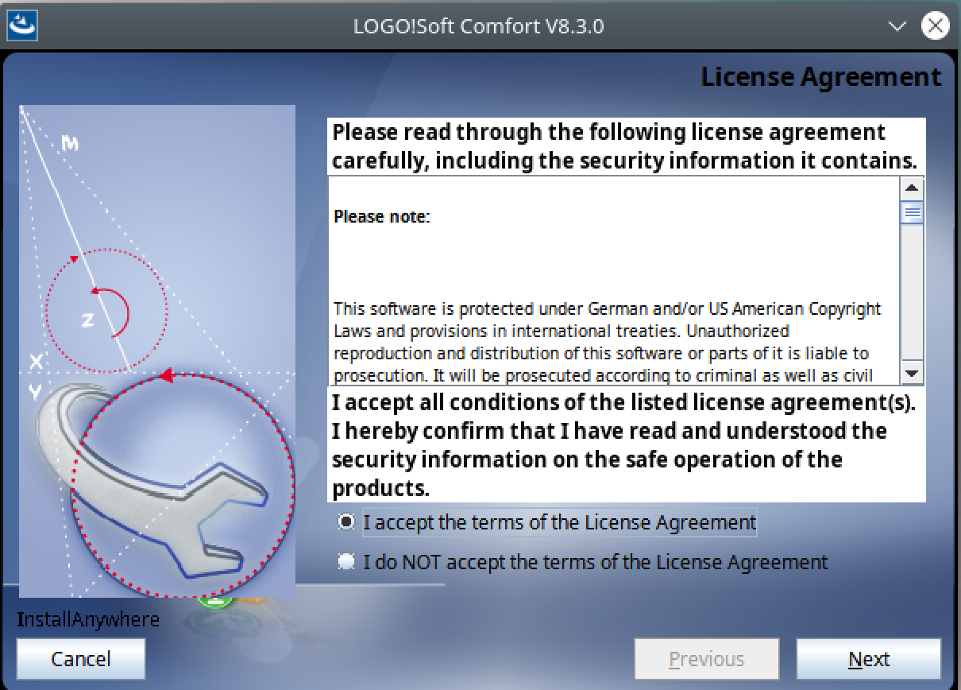
Select “I accept the terms of the License Agreement” and select “Next”

Change the default path and press “Choose…”
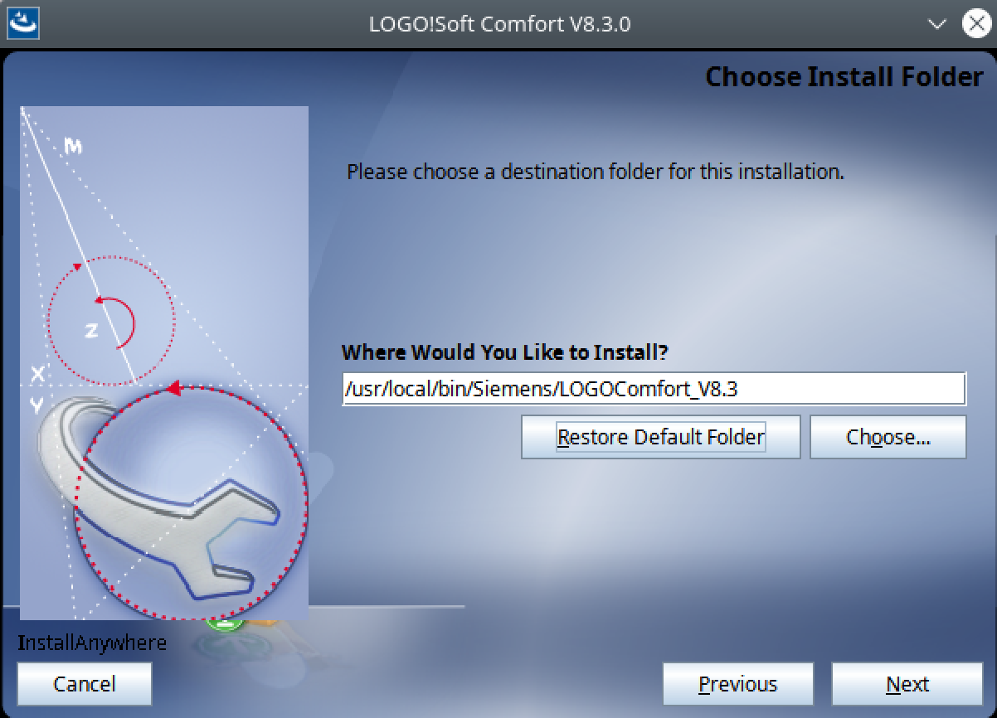

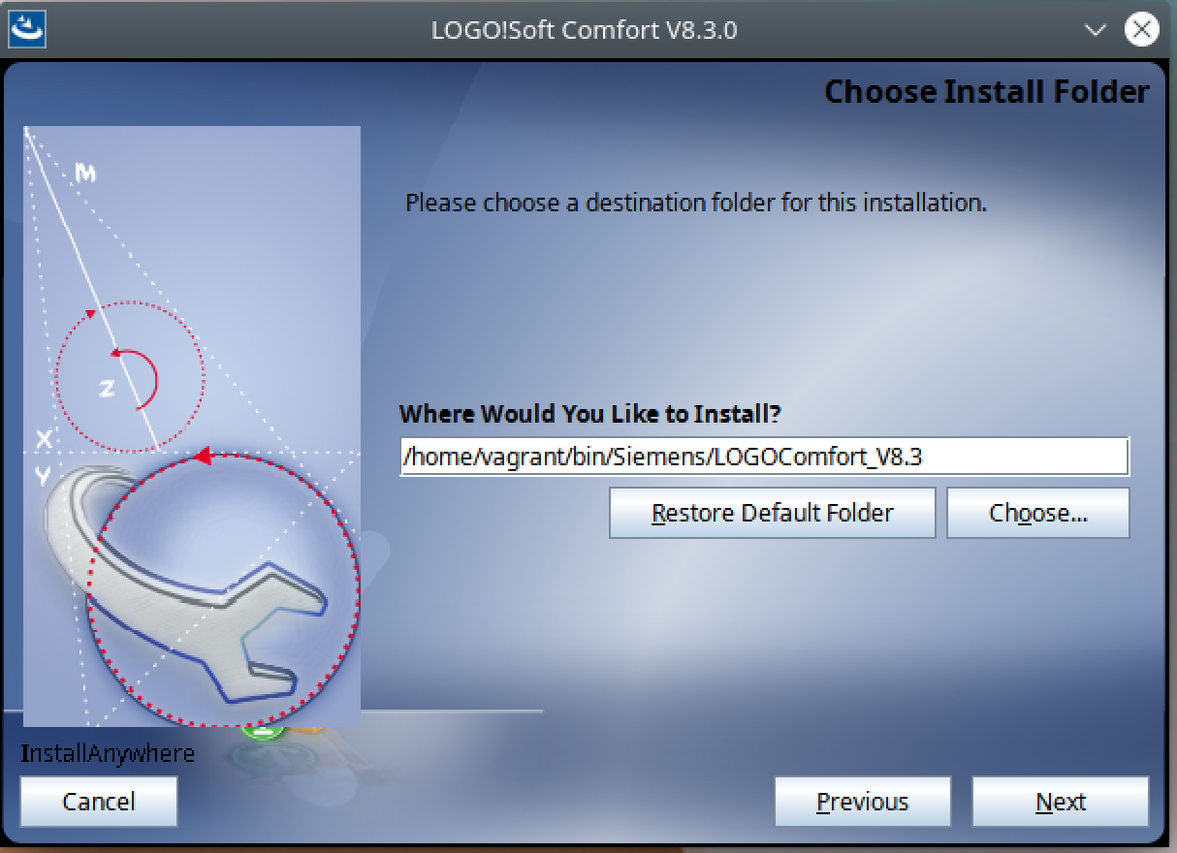
Select the path:
/home/vagrant/bin/Siemens/LOGOComfort_V8.3

Select “Other:”
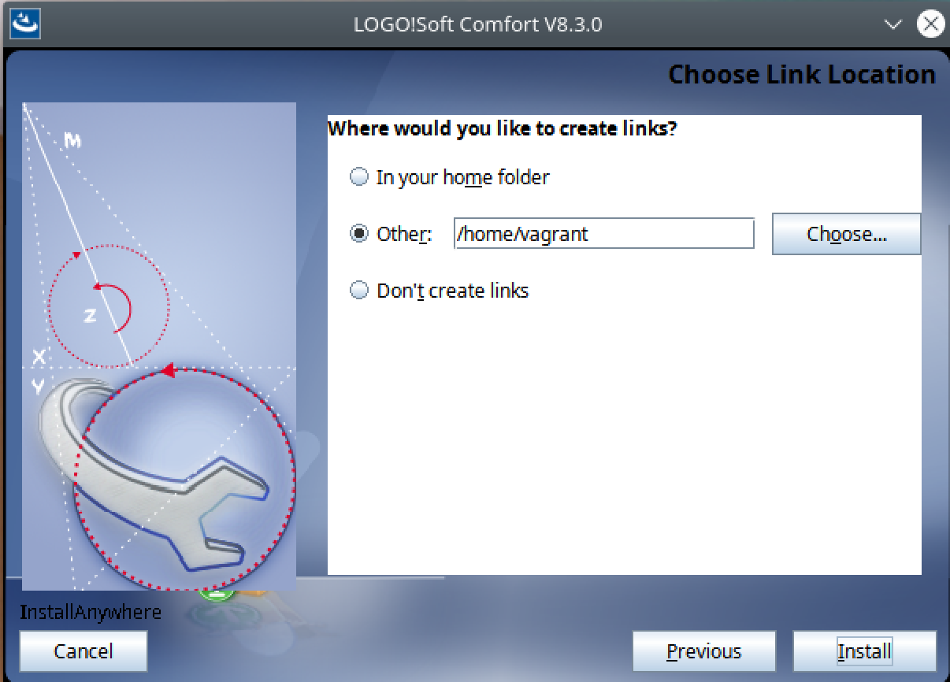

Press “Choose..”
/home/vagrant/Desktop
and “Install”
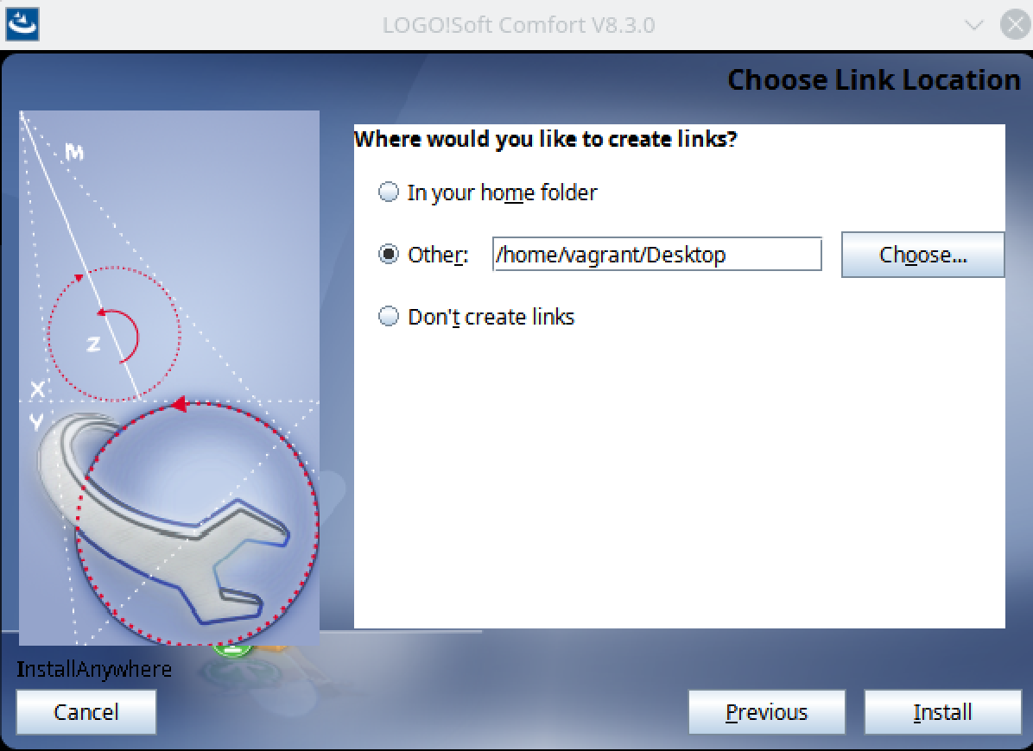

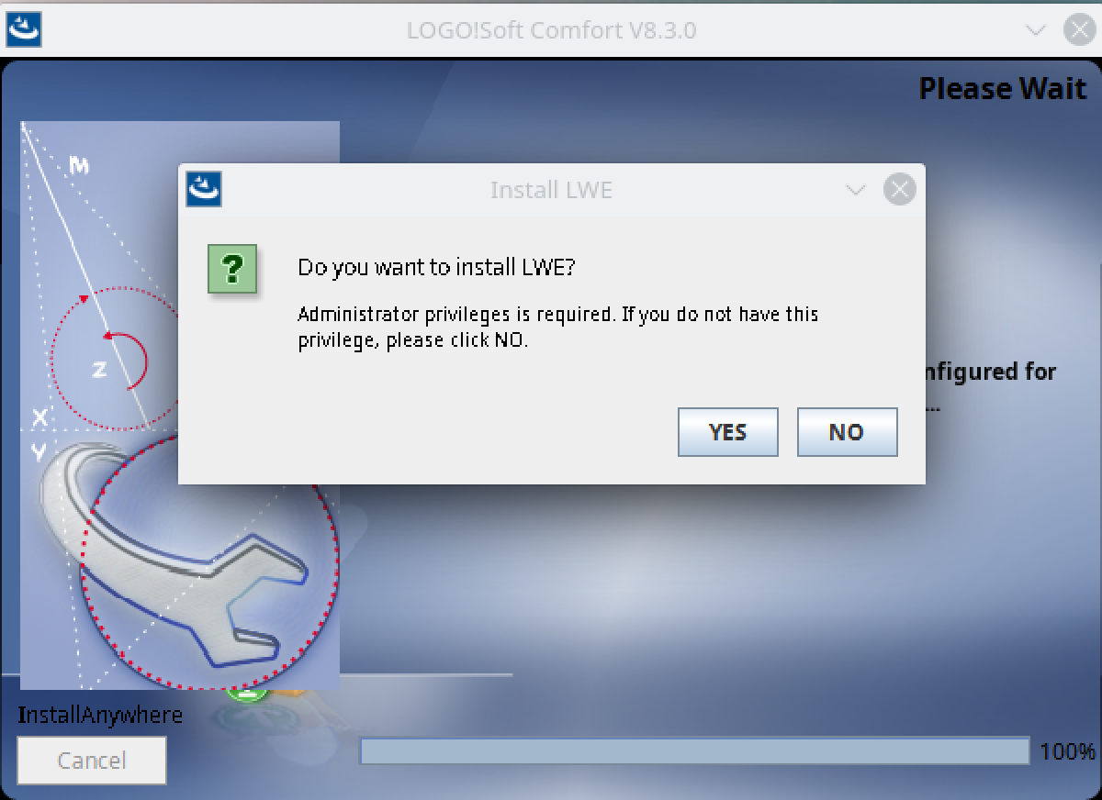
I choosed “NO”:

Press “Done”:
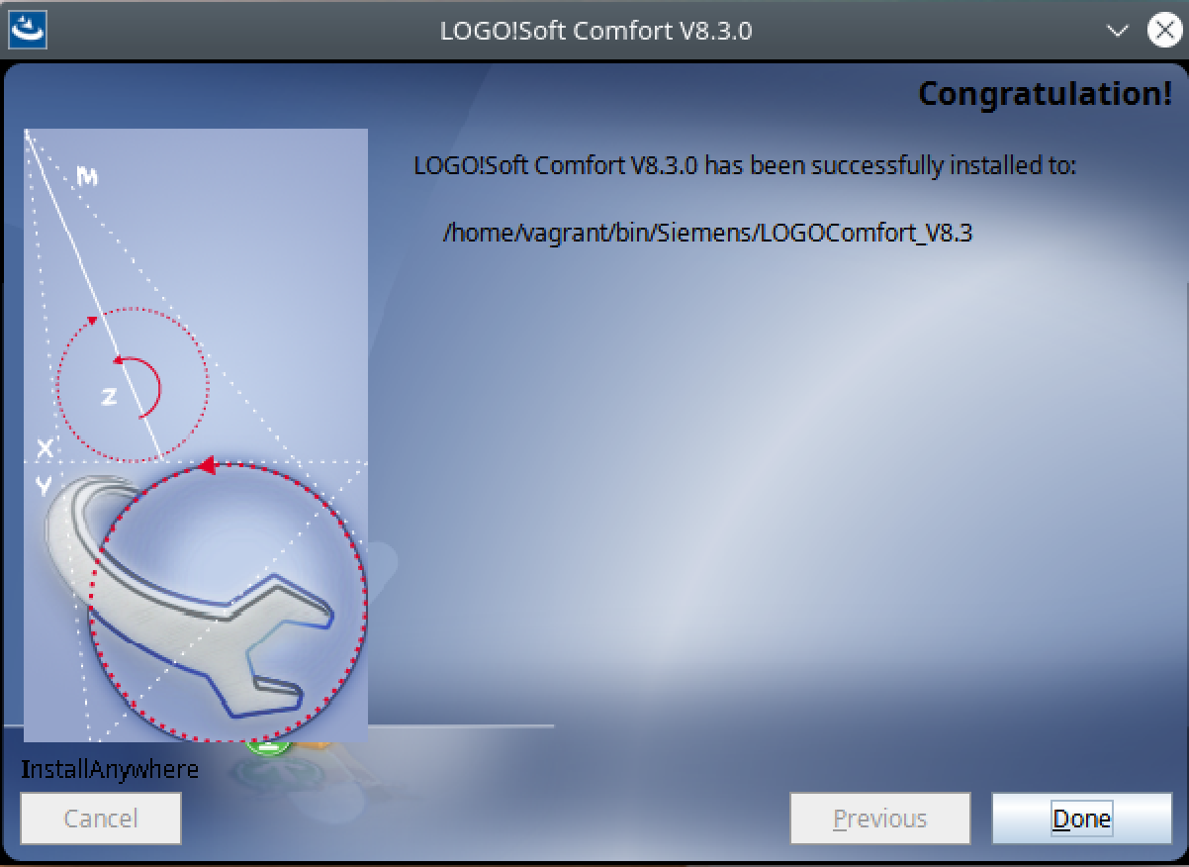

Select the Desktop Icon “LOGOComfort to start the application:
