

A PROJECT REPORT SUBMITTED BY

- OJASVIRAJ CHAUHAN: BATCH :- 67
SAP ID:- 590028446
- KUNAL RAUTHAN: BATCH :- 67
SAP ID:- 590028431

PAPER NAME : PROGRAMMING IN C
subject code CSEG 1025
PROJECT GUIDE : OJASVIRAJ CHAUHAN AND KUNAL RAUTHAN
B.TECH 1ST YEAR

2025
UNIVERSITY OF PETROLEUM AND ENGEERING STUDIES,
P.O, Bidholi Via, Prem Nagar, Dehradun, Misraspatti, Uttarakhand 248007

 Certificate
Certified that this project report "Movie Ticket(s) Booking" is the bonafide work of :
- OJASVIRAJ CHAUHAN: SAP ID: 590028446
- KUNAL RAUTHAN: SAP ID: 590028431
of B.Tech 1st year who carried out this project work under our supervision.

..............................................................
Examiner's Signature

 Acknowledgement
The partial completion of this project could not have been accomplished without the support of our teachers and guide, OJASVIRAJ CHAUHAN and KUNAL RAUTHAN. Thank you for allowing us your time to research and write.

We are also very thankful to my respected teachers for their co-operation and suggestion regarding the project work.

Last but not the least we are very thankful to our Prof. VINOD KUMAR, for giving me an opportunity of doing such an interesting project work.

OJASVIRAJ CHAUHAN:
SAP ID:590028446
KUNAL RAUTHAN:
SAP ID:590028431

MOVIE TICKET(S) BOOKING SYSTEM
PROGRAMMING FOR PROBLEM SOLVING LAB PROJECT : 1st YEAR : 2019

Problem Definition 01
Method. 02
Flow Chart. 03
Algorithm. 04
Output and Discussion. 05

Introduction to C programming Language :
C is a general-purpose programming language that is extremely popular, simple and flexible. It is machine-independent, structured programming language which is used extensively in various applications.
C was the basics language to write everything from operating systems (Windows and many others) to complex programs like the Oracle database, Git, Python interpreter and more.
It is said that 'C' is a god's programming language. One can say, C is a base for the programming. If you know 'C,' you can easily grasp the knowledge of the other programming languages that uses the concept of 'C'
It is essential to have a background in computer memory mechanisms because it is an important aspect when dealing with the C programming language.

History of C programming Language :
The base or father of programming languages is 'ALGOL.' It was first introduced in 1960. 'ALGOL' was used on a large basis in European countries. 'ALGOL' introduced the concept of structured programming to the developer community. In 1967, a new computer programming language was announced called as 'BCPL' which stands for Basic Combined Programming Language. BCPL was designed and developed by Martin Richards, especially for writing system software. This was the era of programming languages. Just after three years, in 1970 a new programming language called 'B' was introduced by Ken Thompson that contained multiple features of 'BCPL.' This programming language was created using UNIX operating system at AT&T and Bell Laboratories. Both the 'BCPL' and 'B' were system programming languages.
In 1972, a great computer scientist Dennis Ritchie created a new programming language called 'C' at the Bell Laboratories. It was created from 'ALGOL', 'BCPL' and 'B' programming languages. 'C' programming language contains all the features of these languages and many more additional concepts that make it unique from other languages.
'C' is a powerful programming language which is strongly associated with the UNIX operating system. Even most of the UNIX operating system is coded in 'C'. Initially 'C' programming was limited to the UNIX operating system, but as it started spreading around the world, it became commercial, and many compilers were released for cross-platform systems. Today 'C' runs under a variety of operating systems and hardware platforms. As it started evolving many different versions of the language were released. At times it became difficult for the developers to keep up with the latest version as the systems were running under the older versions. To assure that 'C' language will remain standard, American National Standards Institute (ANSI) defined a commercial standard for 'C' language in 1989. Later, it was approved by the International Standards Organization (ISO) in 1990. 'C' programming language is also called as 'ANSI C'.


Where we use C Programming Language ?
    - 'C' language is widely used in embedded systems.
    - It is used for developing system applications.
    - It is widely used for developing desktop applications.
    - Most of the applications by Adobe are developed using 'C' programming language.
    - It is used for developing browsers and their extensions. Google's Chromium is built using 'C' programming language.
    - It is used to develop databases. MySQL is the most popular database software which is built using 'C'.
    - It is used in developing an operating system. Operating systems such as Apple's OS X, Microsoft's Windows, and Symbian are developed using 'C' language. It is used for developing desktop as well as mobile phone's operating system.
    - It is used for compiler production.
    - It is widely used in IOT applications.

How C works ?
C is a compiled language. A compiler is a special tool that compiles the program and converts it into the object file which is machine readable. After the compilation process, the linker will combine different object files and creates a single executable file to run the program. The following diagram shows the execution of a 'C' program

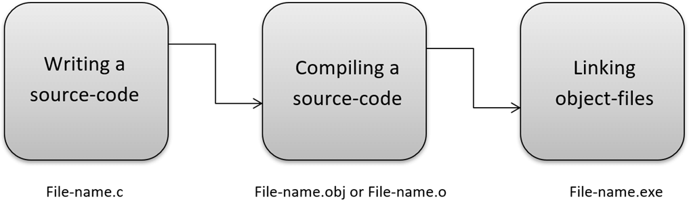

Nowadays, various compilers are available online, and you can use any of those compilers. The functionality will never differ and most of the compilers will provide the features required to execute both 'C' and 'C++' programs.

Following is the list of popular compilers available online:
- Clang compiler
- MinGW compiler (Minimalist GNU for Windows)
- Portable 'C' compiler
- Turbo C

Movie Ticket Booking System :
Simple Movie Ticket Booking System is based on a concept of recording and booking customer’s movie ticket details. Here the user can perform all the tasks like booking a movie show, receiving tickets, and card registration and view all movie show details. There’s no login

system for this project. This project contains fewer features but the essentials ones.

Talking about the features of the Simple Movie Ticket Booking System, a user can select any movie provided in the list. After selecting a show, he/she has to select timings, then the system asks for personal information which include Name, contact number. There are two types of seat class i.e. Normal class and Gold Class. For certain purpose, he/she can also make payment using the card.
He/she has to provide card number, expiry date, and CVV. After that, the system automatically displays the final outcome which is the user’s bill. For the system, the user can also register DT Card from the system.

This project uses classes and file handling features of C++. In order to store all the user’s data, an external file (DAT file) is created by the system, so every time we get into the system we can operate with the existing records. Simple Movie ticket booking System is developed using C++ Programming Language and different variables, strings have been used for the development of it. Simple Movie Ticket Booking System in C++ Programming with source code is free to download. Use for educational purposes only! This project provides the simplest system for managing movie booking system.

The METHOD of the following Movie Ticket Booking is decribed as follows -


Method of the program :
Today, it is believed that the application of computer technology in any activity would go a long way in making that activity much easier.
To the researcher, this statement remains a theory until proven otherwise by the implementation of online movie ticket reservation system.
It also believed that the benefit and advantages of using computer out weight that of the manual methods beyond doubt by the researcher through the implementation of the new system.
The main aim of this study is to design and implement an online movies ticket reservation system. This system will achieve the following objectives.
- To establish an efficient way to promote the film on the internet.
- To minimize the number of staff at the ticket box.
- To increase the profit and obtain statistical information from the booking record.
- To provide an anytime, anywhere service for the customers to book their movie ticket.
- To create a reliable database of movies in the case study with their description.
- For research purpose (project writing and defuse.

This research project will be unnecessary if it does not have significance to humanity.
- The newly designed system is faster, more convenient and you do not have to go to station twice.
- Online ticket reservation is always a safe option, unless the website is insecure.
- Booking online ticket is safe if the company you plan to use, uses a Secure Server Software (SSS).
This basically hides year private information from there.
- It saves a lot of money in printing cost because the company do not need to printout ticket to give to customers which get binned after the film anyway.
- It also saves a lot of time for the customers because, they do not need to arrived early to queue for ticket in case they are all sold out.

Definition of Terms :
In order to do away with ambiguity, some terms and keywords in the context of this research are here by defined.
Implementation : Is the building of system and installation to ensure that it solve a particular task.
System : Is a combination of related parts into a complex whole.
Database : It is a collection of interrelated data stored together with controlled redundantly to serve one or more application in an optional fashion.
Reservation : Is the act of reserving something e.g hotel accommodation, a seat on an aeroplane, in a theatre.
Ticket : Is a piece of paper, cardboard, etc, showing that the holder is entitled to certain rights, such as travel on a train or bus, entry to a place of public.

- Flowchart Of the Program :
INPUT DATE
INPUT TIME
INPUT TIME
GENERATING TICKETS WITH THE PROVIDED DATAS I.E. NAME, DATE, TIME, PRICE AND THE BILL

INPUT TIME

END

INPUT NAME

INPUT NAME
START
INPUT MOVIE NAME
NO. OF AUDIENCE
NO. OF AUDIENCE
NO. OF AUDIENCE
INPUT NAME

INPUT DATE

INPUT DATE

ALGORITHM :
The Movie Ticket Booking project is based on the C program. The codes are given below
#include<stdio.h> int main()
{
int n,t,i,temp; float rs;
char name[12],movie; char id,date;
printf("~~~~~~~~~~WELCOME IN OUR OFFICIAL PAGE~~~~~~~~\n\n\n"); printf("Printing the name of the movies:\n"); printf("1.Housefull 4\n2.Made In China\n3.Jumanji\n\n\n"); printf("Choose the movie:\n");
scanf("%d",&id); temp=id; if(id==1)
{
printf("Entering into the Housefull 4. \n");
}
else if(id==2)
{
printf("Entering into the Made In China. \n");
}
else if(id==3)
{
printf("Entering into the Jumanji. \n");

}
else
{
printf("Database error.....\n Please Enter write Digits");
return 0;
}
printf("You Entering into the Movie Ticket Booking Section\n\n\n"); printf("The amount of movie is 350 Rs.per audience\n"); printf("Number of Audience\n");
scanf("%d",&n); n=n-1;
if (n==1)
{
printf("Enter the name of the Audience\n"); scanf("%s",&name[n]);
}
else
{
printf("Enter the names of the Audiences\n");

for(i=0;i<=n;i++)
{
scanf("%s",&name[n]);
}
}
printf("In which date you want to see the movie_:10:2019\n"); scanf("%d",&date);
printf("Choose the time\n 1.10:30\n 2.1:30\n 3.3:30\n 4.7:00\n\n\n"); scanf("%d",&t);
if(t==1)
{
printf("Your time is:10:30\n");
}
else if(t==2)
{
printf("Your time is:1:30\n");
}
else if(t==3)
{

}
else
{
}
printf("Your time is:3:30\n");

printf("Your time is:7:00\n");

printf("Printing all the details of the tickits. \n");
puts(name);
if(temp==1)
{
printf("Movie name : Housefull 4\n");
}
else if(temp==2)
{
printf("Movie name : Made In China\n");
}
else if(temp==3)
{
printf("Movie name : Jumanji\n");
}
else

{
printf("Database problem\n");

}
printf("Date:%d:10:2019\n",date); rs=(n+1)*350;
printf("Amount of Rs:%f\n",rs);

if(t==1)
{

printf("Time is:10:30\n");
}
else if(t==2)
{
printf("Time is:1:30\n");
}
else if(t==3)
{

}
else
{
}
printf("Time is:3:30\n");

printf("Time is:7:00\n\n\n");

printf("~~~~~~~~~~Thanking you for entering into the server~~~~~~~\n");
return 0;
}

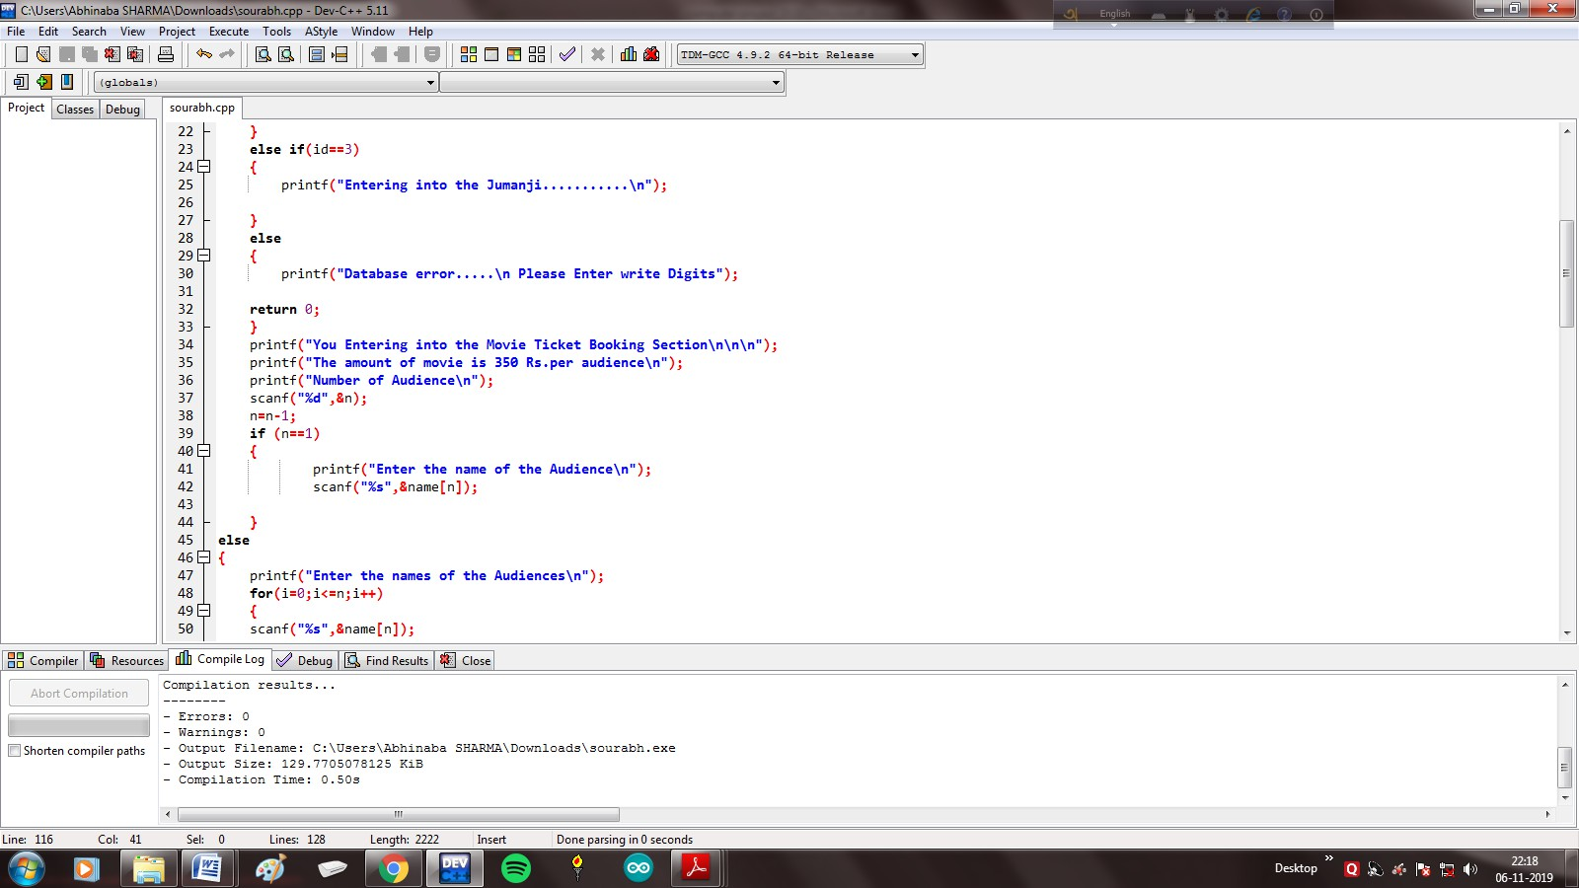

Output of the Program :
- Entering the code of the program by using F9 the whole program is run and compiled and showed no error at the end of the compilation.

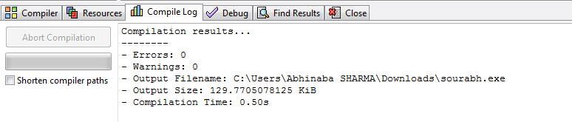
- As the compilation shows no error, then we run the program using F10 key and saw this following results -
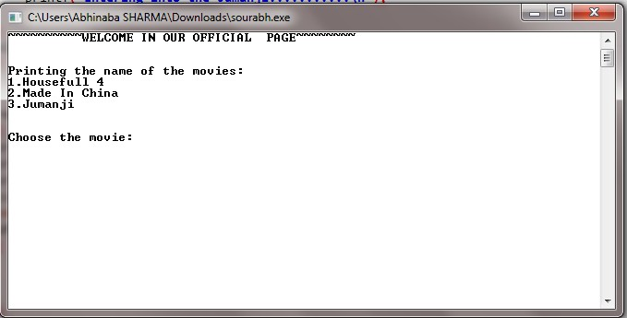

- Then we have to choose the movie that we want to select. For example, we choose the movie named "Made In China". Hence we have to enter no. 2 and we enter that -
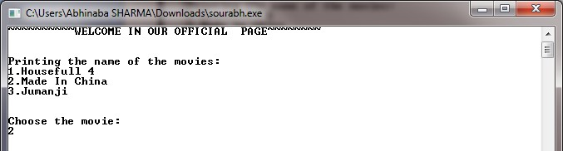

- Entering the no. 2 we got the following blanks where we have to fill up that how many audiences are booking their seats at that time or the number of tickets that we have buy -
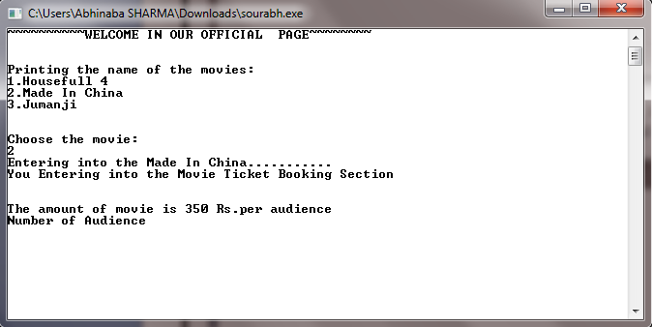
- At the time of entering the no. of audience we entered 2 audiences as a result it brings us to another blank which consists the name of the audiences -
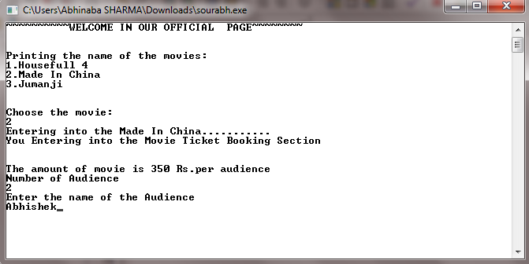

- After entering the name we have to select the date of the show and also the time in the successive patterns -
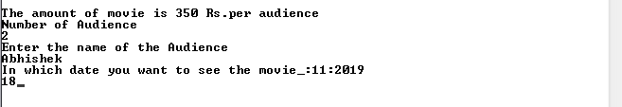

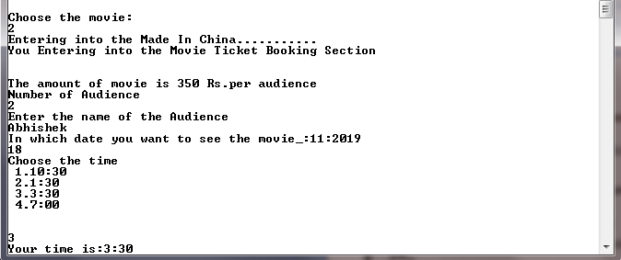

- After entering all those credentials the program takes you to the end part of the system where the bill is generated by the computer and the computer takes out the bill to the customer
-
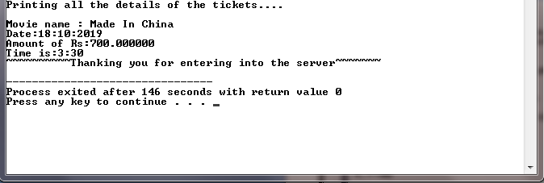
Online movie ticket reservation system is basically made for providing the customer’s, anywhere and anytime service for booking seat in movie hall and together. Information about the movies online. The user can easily be able to know about the movies released and then make choice. It is a web-based system. The customers can buy ticket online and cancel the seat at a suitable time (2 days before the show to 1hour before the show). To enhance the refund function, all the customers have to register to become a number before buying the ticket. Staff can use the system to insert and delete data (example film description, time table) which will update the webpage. Also staff can check the statistic information from the system. The system is to provide an alternate and convenient way for a customer to buy movie tickets. It is an automatic system. After the data has been fed into the database, the staff does not need to do anything with the order once it is received through the system.



