Supplementary Information
Antibodies read protein sequence conventionally and protein shape unconventionally: a matched comparison of antibody and co-evolved protein interfaces

Contents
Section | Contents | Items
S1 | Corpus composition and redundancy structure | Table S1
S2 | Antigen length floor sensitivity | Table S2
S3 | Interface physicochemistry, full comparison | Table S3
S4 | Confound controls with size-matched nulls | Table S4
S5 | Paratope composition against two backgrounds | Table S5
S6 | Burial thermodynamics | Table S6
S7 | Interface geometry | Table S7
S8 | Verification checks and corrected errors | Text, Tables S8 to S10
S9 | Analysis code and the purpose of each script | Tables S11 to S13
S10 | Supplementary figures | Figs. S1 to S23
S11 | Supplementary data files | Table S14
Table of contents for the supplementary information.

S1. Corpus composition
Property | Antibody-antigen | Protein-protein
Structures analysed | 512 | 2,292
cluster30 independence units | 233 | 1,326
Residue-pair contacts | 36,810 | 406,397
Atom-atom contacts mapped | 182,442 | 1,767,916
Median resolution (A) | 1.83 | 1.80
Experimental method | 100% X-ray | predominantly X-ray
Largest cluster share | 8.8% | 3.6%
Singleton units | 149 of 233 | 719 of 1,326
Table S1 Corpus composition and redundancy structure.

S2. Antigen length floor sensitivity
Minimum antigen length (residues) | Structures retained
0 | 774
30 | 530
50 (adopted) | 512
80 | 481
Table S2 Sensitivity of the antibody corpus to the antigen length floor.

S3. Interface physicochemistry, full comparison
Property | Antibody median | PPI median | Effect | p
Residue pairs per interface | 59.000 | 86.321 | -0.314 | 2.81e-13
Probe-side interface residues | 25.000 | 37.417 | -0.330 | 1.62e-14
Target-side interface residues | 23.500 | 33.000 | -0.269 | 3.93e-10
Atom contacts per interface | 350.000 | 467.500 | -0.239 | 2.46e-08
Mean closest approach (A) | 3.587 | 3.641 | -0.405 | 3.53e-21
Hydrogen bond fraction | 0.253 | 0.200 | +0.436 | 3.35e-24
Salt bridge fraction | 0.033 | 0.033 | -0.044 | 3.00e-01
van der Waals fraction | 0.652 | 0.684 | -0.254 | 3.43e-09
Aromatic stacking fraction | 0.000 | 0.000 | +0.015 | 6.50e-01
Opposite-charge pair fraction | 0.051 | 0.051 | -0.040 | 3.50e-01
Like-charge pair fraction | 0.011 | 0.016 | -0.163 | 1.23e-04
Apolar-apolar fraction | 0.145 | 0.261 | -0.518 | 1.38e-33
Aromatic involvement | 0.431 | 0.306 | +0.528 | 8.12e-35
Cation-pi fraction | 0.056 | 0.032 | +0.339 | 2.77e-15
Read via target side chain | 0.731 | 0.711 | +0.090 | 3.69e-02
Table S3 Interface properties compared across cluster30 units by Mann-Whitney U test. Effect is the rank-biserial correlation.

S4. Confound controls
Confound | Test | Observed r | Reference | Verdict
Secondary structure | loop to loop | 0.190 | null 0.348 [0.252, 0.428] | below null
Secondary structure | target loop | 0.239 | null 0.372 [0.293, 0.460] | below null
Secondary structure | target strand | 0.264 | null 0.330 [0.234, 0.388] | within null
Fold class | mainly alpha | 0.167 | null 0.242 [0.168, 0.336] | not raised
Fold class | mainly beta | 0.260 | null 0.312 [0.214, 0.394] | not raised
Fold class | alpha/beta | 0.172 | null 0.279 [0.175, 0.353] | not raised
Resolution | better than 2.0 A | 0.356 | null 0.401 [0.373, 0.453] | not raised
Resolution | 2.0 A or worse | 0.230 | null 0.264 [0.171, 0.348] | not raised
Redundancy | drop 5 largest clusters | 0.449 | baseline 0.406 | unchanged
Redundancy | leave one cluster out | 0.382 to 0.457 | baseline 0.406 | unchanged
H-bond criterion | 3.0 / 3.2 / 3.5 A | 0.300 / 0.317 / 0.276 | - | stable
Antibody format | Fab vs single domain | 0.179 | ceiling 0.253 [0.117, 0.370] | within ceiling
Table S4 Confound controls. Each stratified comparison is referenced to a null drawn at the same sample size, because restriction reduces sample size and attenuates correlation independently of biology.

S5. Paratope composition against two backgrounds
Residue | log2 vs PPI interface | log2 vs antibody own surface
R | -0.12 | +0.74
K | -1.09 | -1.77
H | -0.64 | +0.98
W | +1.15 | +3.05
Y | +1.72 | +2.71
F | -0.17 | +1.86
Q | -0.70 | -1.36
N | +0.42 | +0.47
S | +1.14 | -0.69
T | +0.22 | -0.93
P | -0.85 | -1.47
G | +0.44 | -0.45
A | -0.75 | -0.52
M | -2.35 | +0.99
I | -1.19 | +1.09
L | -1.18 | -0.02
V | -0.85 | -0.65
C | -2.33 | +0.63
D | +0.30 | +0.29
E | -0.95 | -0.85
Table S5 Paratope residue enrichment scored against two backgrounds. Residues whose sign differs between the two columns are enriched relative to other interfaces but not relative to what the antibody itself presents.

S6. Burial thermodynamics
Quantity | Antibody | Protein-protein | Effect | p
Total buried surface (A^2) | 1810.93 | 2851.25 | -0.344 | 1.29e-13
Apolar fraction of buried surface | 0.50 | 0.58 | -0.518 | 5.90e-29
dCp (cal/mol/K) | -172.74 | -393.96 | +0.512 | 2.78e-28
dCp per 1000 A^2 (cal/mol/K) | -93.64 | -151.28 | +0.518 | 5.83e-29
Table S6 Buried surface and heat-capacity change computed from atom-level solvent accessibility.

S7. Interface geometry
Quantity | Antibody | Protein-protein | Effect | p
Probe patch radius of gyration (A) | 10.66 | 16.30 | -0.318 | 4.17e-24
Probe patch planarity | 0.85 | 0.79 | +0.251 | 1.24e-15
Probe spatial sub-patches | 2.00 | 2.00 | -0.227 | 8.05e-14
Target patch radius of gyration (A) | 10.49 | 16.03 | -0.278 | 9.47e-19
Target patch planarity | 0.87 | 0.82 | +0.197 | 3.20e-10
Target spatial sub-patches | 2.00 | 2.00 | -0.012 | 6.85e-01
Table S7 Geometric properties of the contacted patch.

S8. Verification checks
Thirty-nine automated checks re-derive reported quantities by independent routes. Five errors were identified and corrected during development, all of which produced superficially plausible output: duplicated protein-protein contacts inflating Fisher sample size; a dihedral sign convention displacing every side-chain rotamer by 60 degrees, which passed a Ramachandran sanity check because it preserved the sign of phi; asparagine N-glycosylation sites recorded as post-translational modifications through MODRES records; an omitted sign in the heat-capacity relation that inverted the thermodynamic interpretation; and a direction mismatch when matching partner identity across the two arms, which compared each protein against its partner rather than against itself.

S8.1 Secondary-structure cross-validation
Quantity | Value
Reference implementation | pydssp 0.9.1, numpy backend
Chains compared | 432
Residues compared | 79,977
Three-state agreement | 0.9825
Cohen kappa | 0.9733
Failures | 0
Helix recall / precision | 0.994 / 0.961
Strand recall / precision | 0.986 / 0.997
Loop recall / precision | 0.972 / 0.986
Table S8 Agreement between the in-house Kabsch-Sander implementation and an independent implementation of the same algorithm. Both assign from a single ordered backbone array, so this establishes fidelity to the algorithm and does not address inter-chain beta bridges.

S8.2 Validation against the DSSP program
Quantity | Value
Reference | DSSP, whole structure, via PDB-REDO
Structures compared | 97
Residues compared | 65,336
Three-state agreement | 0.9767
Cohen kappa | 0.9646
Helix recall | 0.9984
Strand recall | 0.9503
DSSP strand assigned loop here | 940 of 18,916
Table S9 Agreement with the DSSP program itself. Residues were matched by alpha-carbon coordinate. The one-directional strand disagreement quantifies the per-chain limitation of the in-house implementation.

S8.3 Section 3.6 recomputed on DSSP assignments
Stratum | Antibody contacts | Cross-group r | Size-matched null | Verdict
all contacts | 35,839 | 0.387 | - | reference value
probe loop | 23,242 | 0.342 | 0.389 [0.327, 0.449] | within null
loop to loop | 12,229 | 0.190 | 0.348 [0.252, 0.428] | below null
target loop | 18,676 | 0.239 | 0.372 [0.293, 0.460] | below null
target strand | 9,294 | 0.264 | 0.330 [0.234, 0.388] | within null
target helix | 7,869 | 0.235 | 0.315 [0.231, 0.389] | within null
Table S10 The Section 3.6 loop-confound test repeated with secondary structure taken from the DSSP program rather than from the in-house assignment. Annotations were available for 2,767 of 2,804 corpus entries, labelling 1,999,321 residues. Loop-weighted composition at the interface, in the same weighting, is 63.9% loop for the paratope, 48.8% for the epitope, 42.0% and 44.9% for the two protein-protein sides. The loop-to-loop and target-loop strata remain below their nulls, so the conclusion does not depend on the per-chain limitation quantified in Table S9.

S9. Analysis code
All analyses were implemented as standalone scripts sharing a single statistical engine. Each script writes its results to a JSON file and its figures to disk, so every number reported in the manuscript can be traced to the script that produced it. Scripts are listed below in the order they are run.

S9.1 Shared engine and corpus preparation
Script | Purpose
aa_common.py | Statistical engine shared by every analysis. Loads contact tables, assigns independence units and weights, builds 20 by 20 matrices, computes log odds against the marginal-product null, runs the unit bootstrap and the Fisher plus Benjamini-Hochberg procedure, and deduplicates the two-direction protein-protein tables where a true sample size is required.
phase0_provenance_audit.py | Re-derives contacts from raw coordinates with an independently written extractor and compares them with the inherited tables. Also tests corpus overlap between the two groups and quantifies redundancy.
phase1_manifest.py | Builds the 3,084-structure corpus manifest, joins Structural Antibody Database metadata, and records exclusion reasons for structures that do not enter the analysis.
Table S11 Shared engine and corpus preparation scripts.

S9.2 Feature extraction and core analyses
Script | Purpose
phase2_inventory.py | Collapses contacts to one record per interface and computes bond-type composition, charge and aromatic content, interface size and packing.
aa_heatmap.py | Builds the 20 by 20 recognition matrices for both groups, at both independence-unit definitions, with bootstrap stability and multiple testing control, plus the chemical-class collapse and the bond-type decomposition.
phase4_conservation.py | Correlates the two grammars overall, per bond type and with cysteine masked, and classifies cells as universal, group-specific or opposed.
phase5_readout.py | Splits every contact between target side chain and target main chain and rebuilds the matrices separately for the two readout channels.
phase6a_structural.py | Single structural pass over 1,512 complexes. Implements Kabsch and Sander secondary structure, computes backbone and side-chain torsions, and computes solvent-accessible surface in complex and in isolation.
phase6a_fix_dihedrals.py | Recomputes torsion angles after correction of the dihedral sign convention, asserting the routine against a reference implementation before writing.
phase6b_functional_groups.py | Maps every atom-atom contact to one of fourteen chemical functional groups and builds the functional-group recognition maps.
phase6c_conformation.py | Tests whether the antibody signature is loop context, by recomputing the cross-group correlation within matched secondary structure. Also produces Ramachandran, rotamer and burial distributions.
phase6d_folds.py | Retrieves CATH and SCOP assignments and repeats the comparison within matched fold class.
phase7_paratope.py | Transfers IMGT numbering onto the corpus by exact alpha-carbon coordinate matching, assigns complementarity-determining regions, and scores paratope composition against two backgrounds.
phase8_differential.py | Permutation test of grammar identity, differential map with intervals on the difference, matrix asymmetry test and dynamic-range test.
phase9_modified.py | Scans raw coordinates for post-translational modifications and glycans at interfaces, which the contact tables exclude by construction.
phase10_literature.py | Assembles the concordance between measured quantities and published claims.
phase11_controls.py | Resolution, redundancy, hydrogen-bond criterion and antibody-format controls.
Table S12 Feature extraction and core analysis scripts.

S9.3 Extended analyses, case studies and verification
Script | Purpose
add1_transfer.py | Uses each matrix as a threading potential and measures native-versus-decoy discrimination with self and cross potentials under leave-one-unit-out validation.
add2_thermodynamics.py | Computes buried apolar and polar surface at atom level and derives the heat-capacity change on association.
add3_shape_complementarity.py | Computes shape complementarity from surface points and normals on the van der Waals contact surface.
add4_pca_geometry.py | Computes patch radius of gyration, planarity and sub-patch counts, then projects all interface descriptors and measures class separability with unit-grouped cross-validation.
add5_epitope_logic.py | Scores each interface against its own protein's accessible surface, and measures relative accessibility and protrusion.
add6_functional_sites.py | Defines functional sites by proximity to bound biological ligands and measures interface overlap with them.
immunodominance.py | Normalises antigen residue numbering across depositions and maps contact frequency across all antibodies raised against one antigen.
case_lysozyme.py | Case study combining immunodominance, catalytic-site targeting and sequence conservation from aligned homologues.
case_matched_targets.py | Identifies proteins solved both with an antibody and with a natural partner and measures overlap between the two interfaces.
pymol_mechanism.py | Renders tyrosine hydroxyl hydrogen bonds to the antigen main chain in high-resolution complexes.
pymol_immunodominance.py | Paints antibody contact frequency onto the antigen surface.
audit_phases.py | Thirteen checks on the statistical machinery, including an independent reimplementation of the multiple-testing procedure and verification that the vectorised bootstrap matches explicit resampling.
audit_full.py | Twenty-six checks across all analyses, each re-deriving a reported quantity by an independent route.
build_manuscript.py | Generates the manuscript and this supplementary file, drawing numerical values from the result files so that text cannot drift from results.
Table S13 Extended analyses, case studies and verification scripts.

S10. Supplementary figures
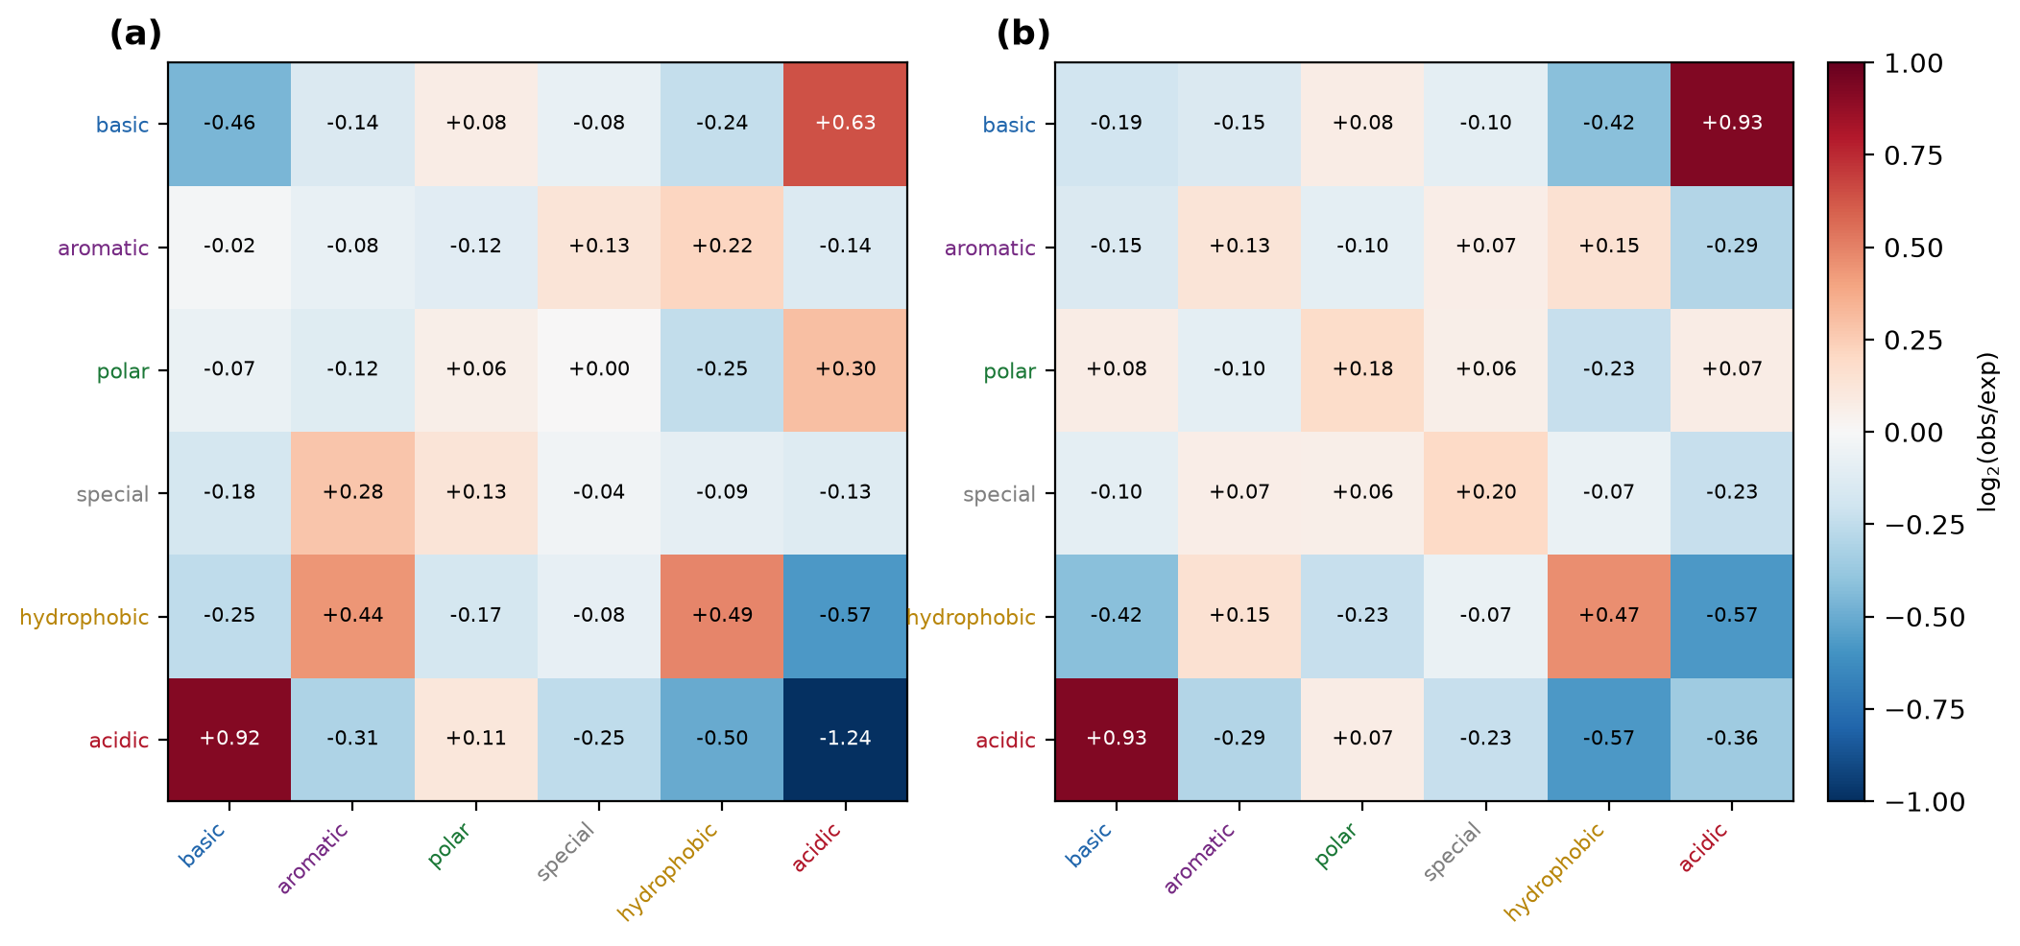
Fig. S1 Chemical-class collapse of the recognition matrices. (a) Antibody-antigen. (b) General protein-protein. Cell values are log2(observed/expected).
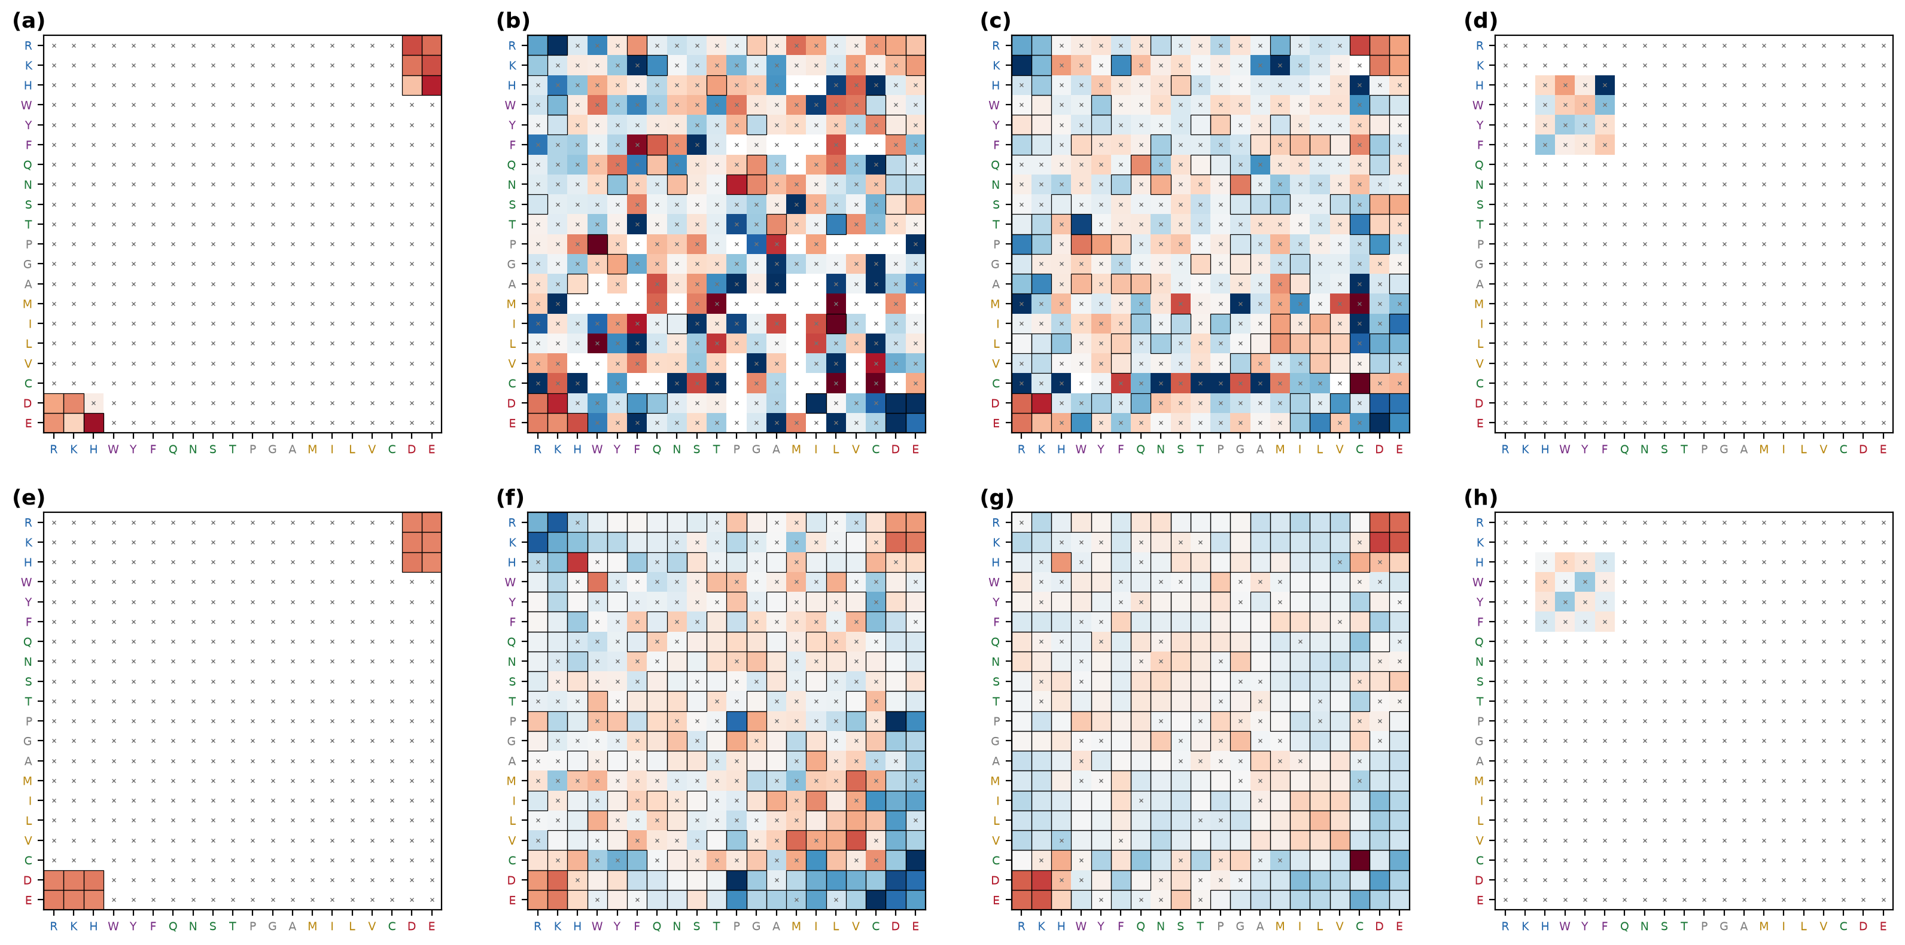
Fig. S2 Recognition matrices decomposed by bond type. (a) to (d) Antibody-antigen, showing salt bridge, hydrogen bond, van der Waals and aromatic stacking respectively. (e) to (h) The same four decompositions for general protein-protein interfaces.
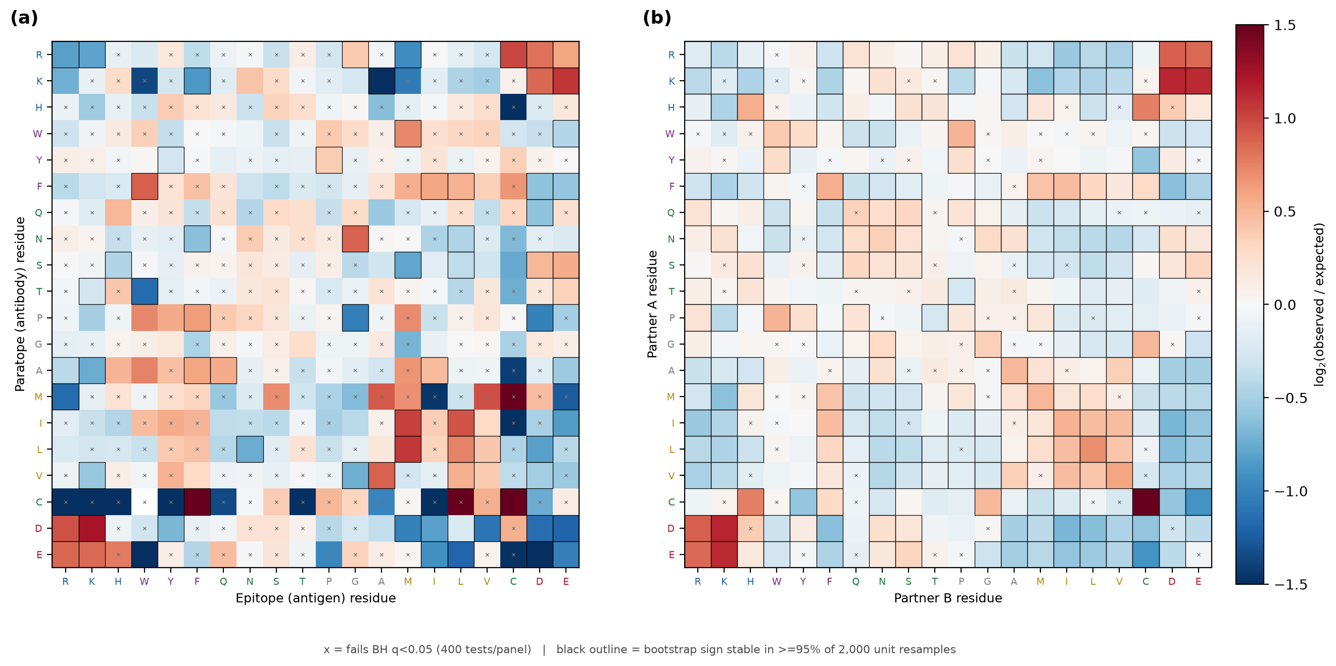
Fig. S3 Recognition matrices computed with UniProt accession as the independence unit, as a sensitivity analysis on the cluster30 definition used throughout. (a) Antibody-antigen. (b) General protein-protein.
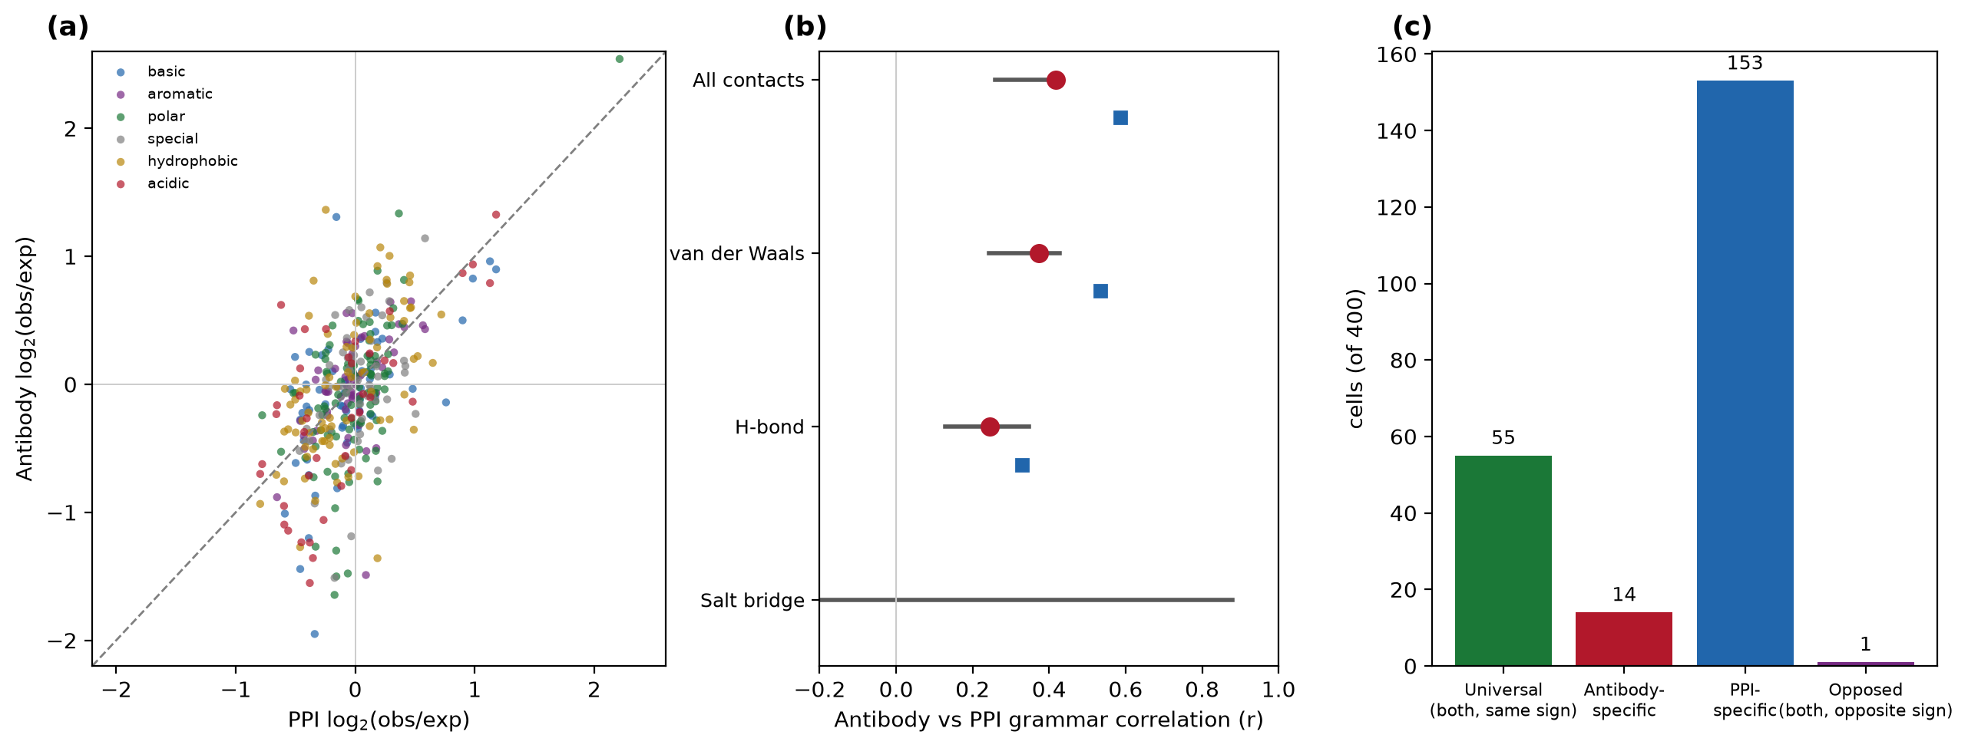
Fig. S4 Conservation of recognition chemistry between the two classes. (a) Cell-by-cell agreement, coloured by the chemical class of the probe residue. (b) Correlation by bond type, with and without cysteine. (c) Classification of cells as universal, class-specific or opposed.
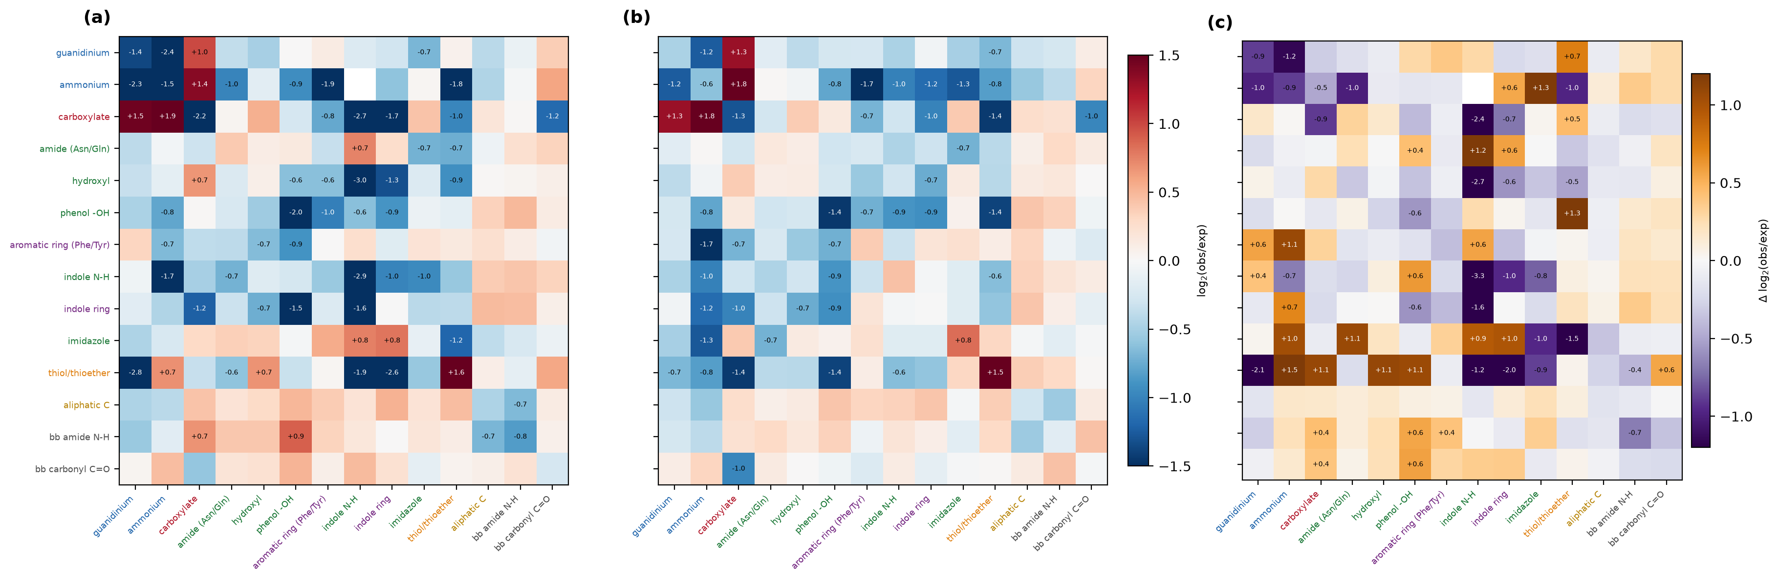
Fig. S5 Functional-group recognition maps over fourteen chemical groups. (a) Antibody-antigen. (b) General protein-protein. (c) Difference between them, with orange indicating antibody enrichment.
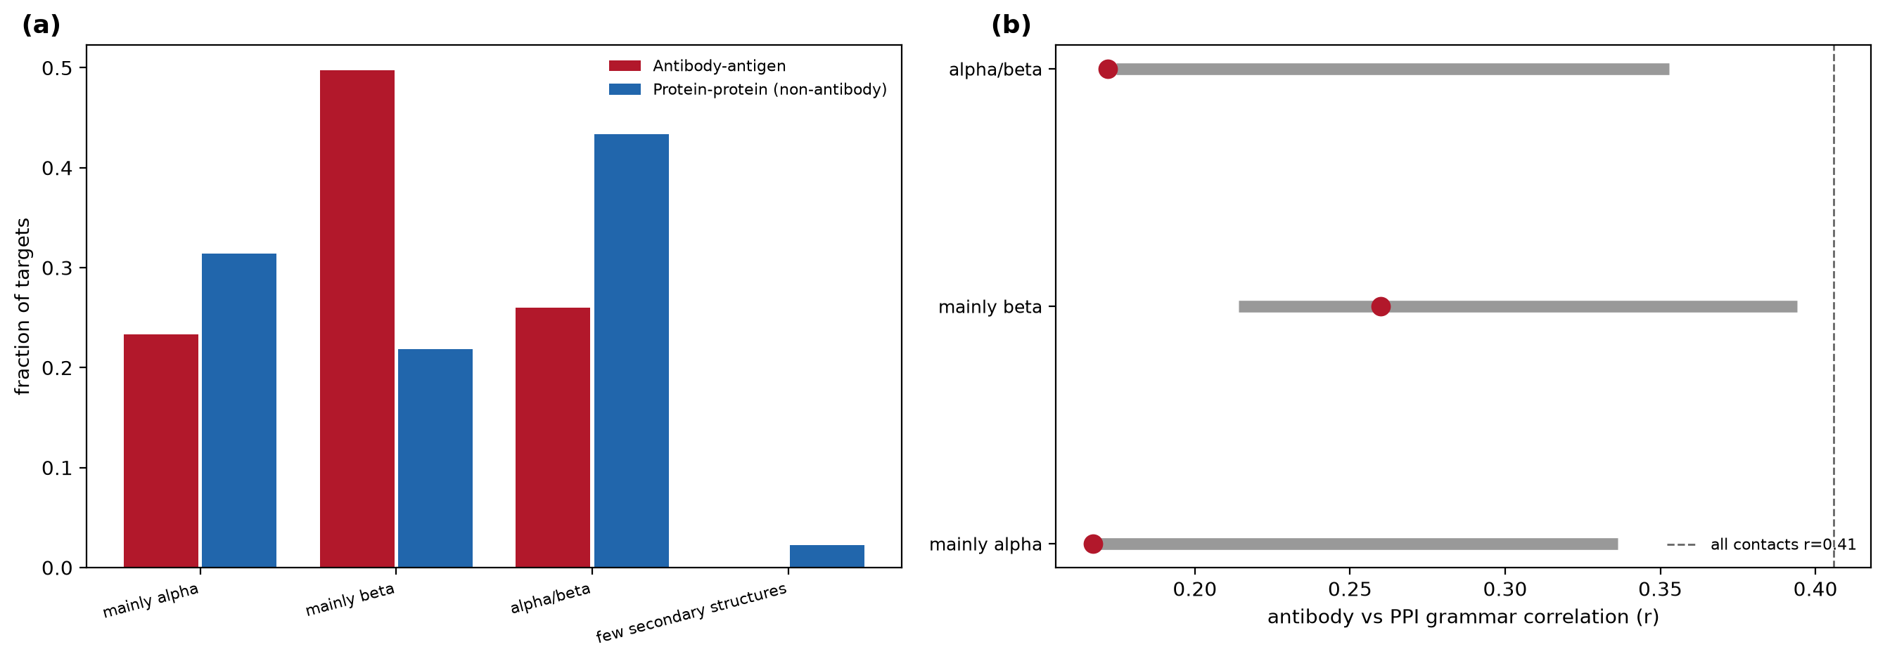
Fig. S6 Fold composition and the fold-matched control. (a) CATH class of the recognised protein in each group. (b) Cross-class grammar correlation within matched fold class, against size-matched nulls shown in grey.
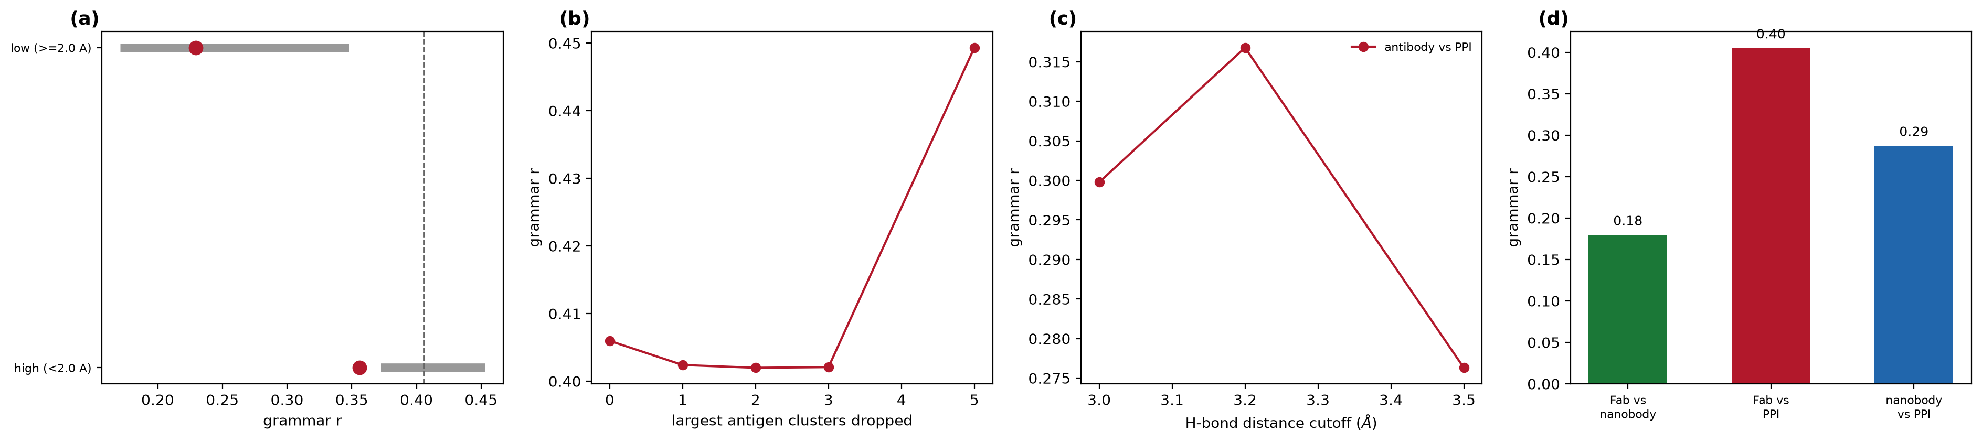
Fig. S7 Robustness controls. (a) Resolution stratification against size-matched nulls. (b) Effect of removing the largest antigen clusters. (c) Sensitivity to the hydrogen-bond distance criterion. (d) Fab against single-domain antibodies, with the within-format reliability ceiling.
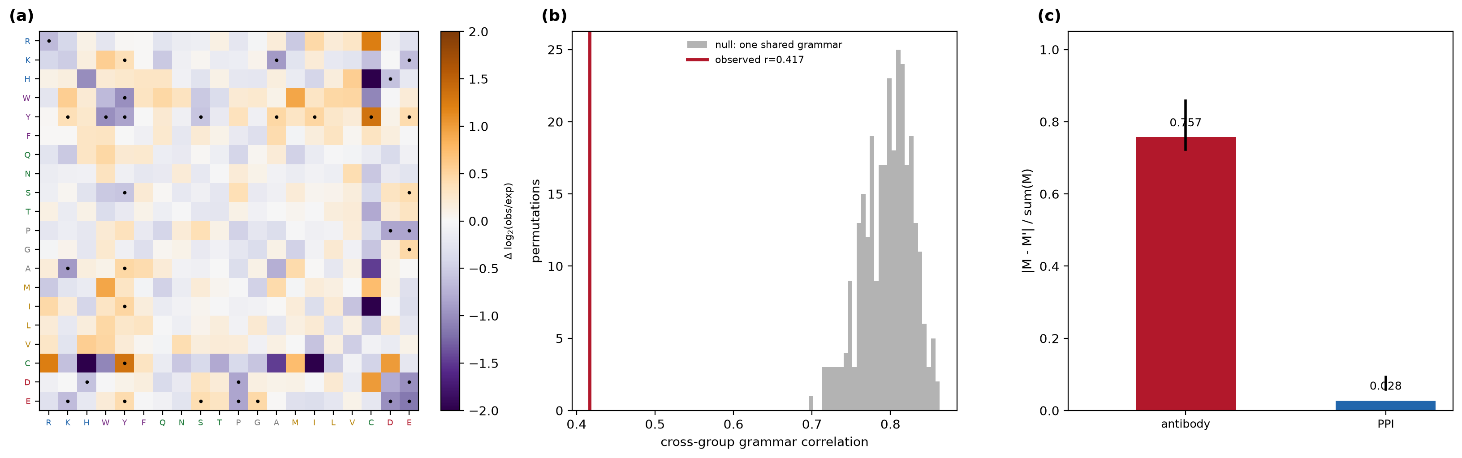
Fig. S8 Formal comparison of the two grammars. (a) Differential map, antibody minus protein-protein, with dots marking cells whose interval excludes zero. (b) Permutation test against the null of one shared grammar. (c) Matrix asymmetry for each class.
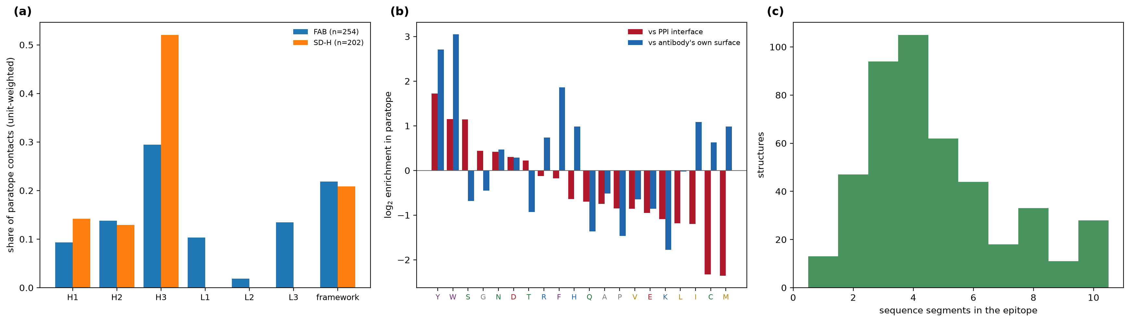
Fig. S9 Paratope architecture and epitope character. (a) Share of paratope contacts by CDR loop and framework, split by construct type. (b) Paratope residue enrichment scored against two backgrounds. (c) Number of sequence segments per epitope.
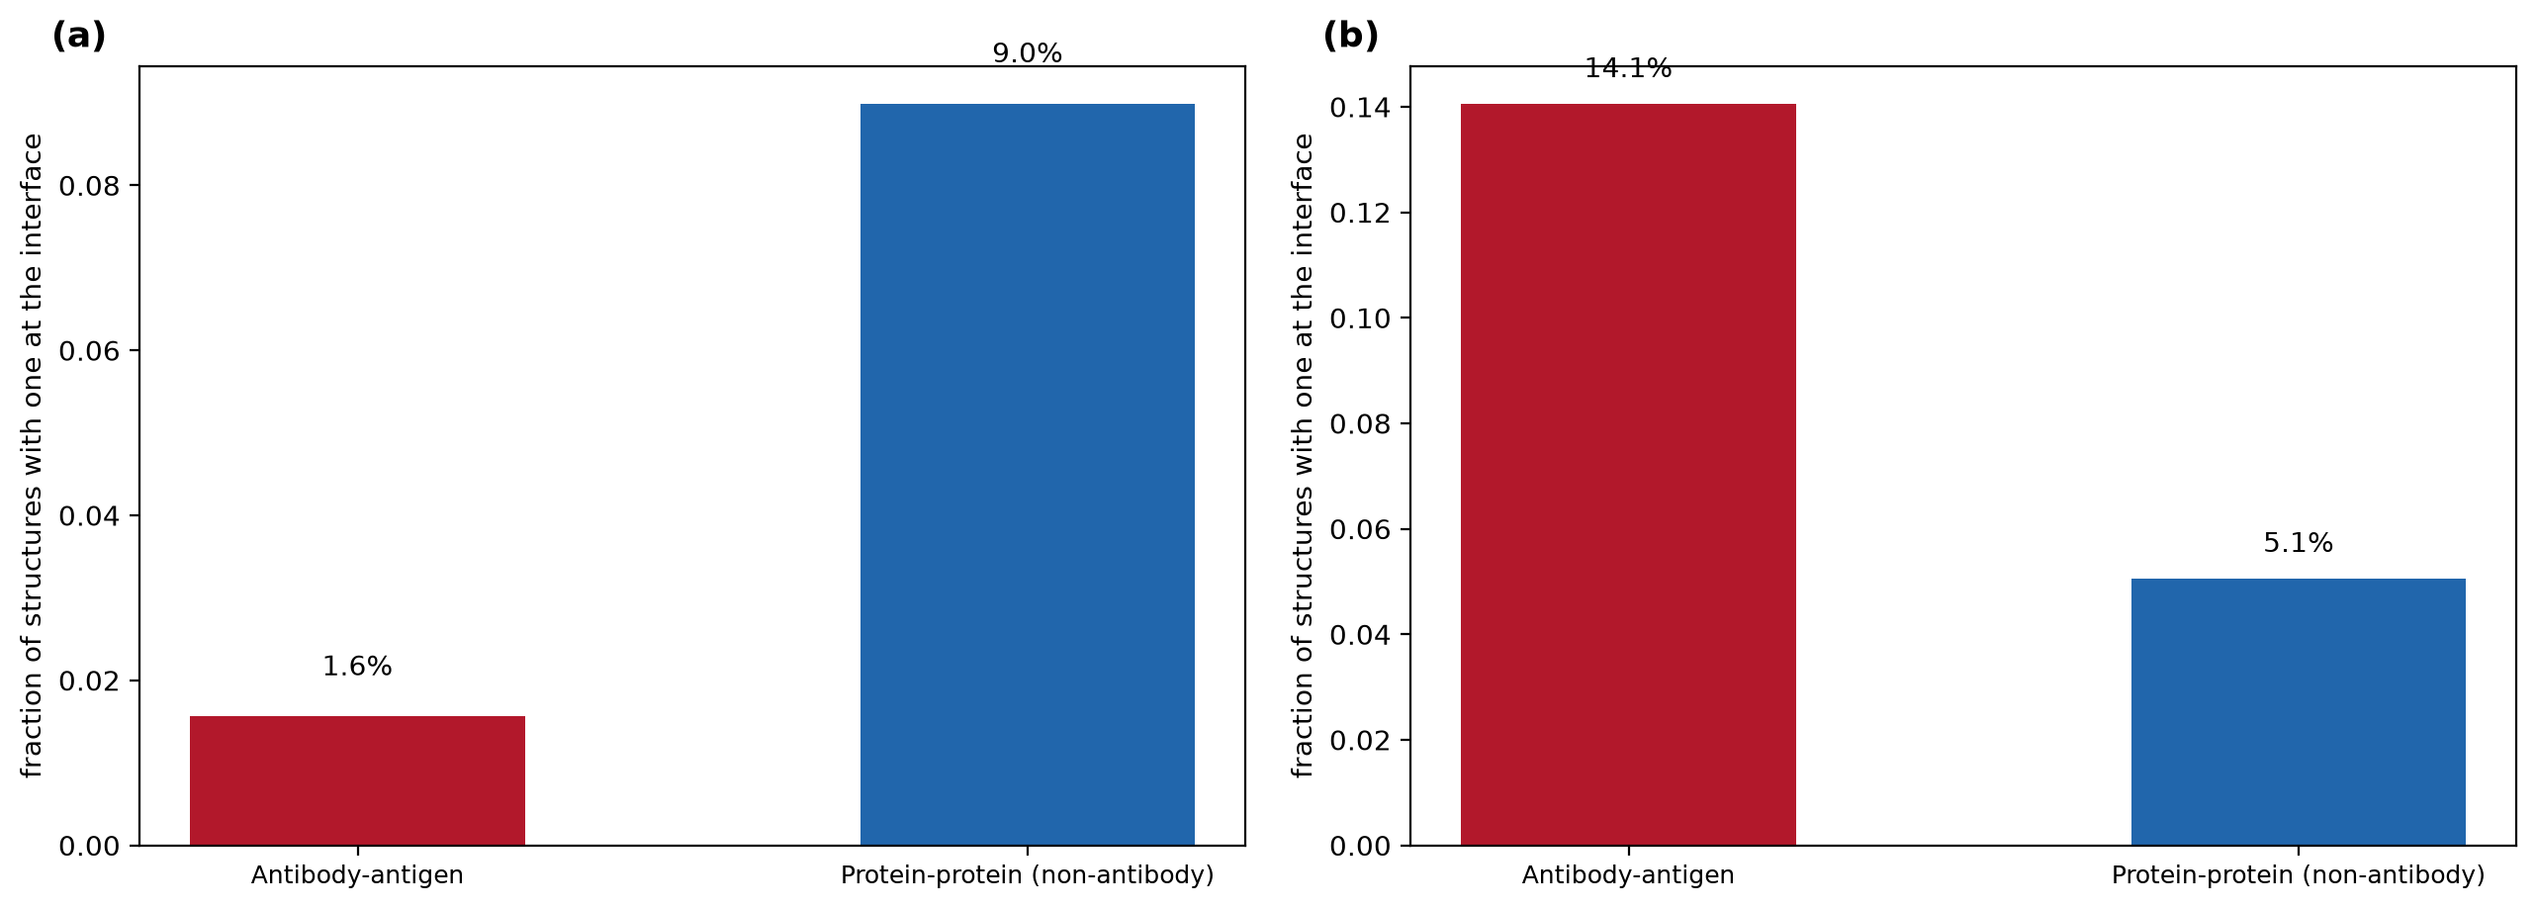
Fig. S10 Modified residues and glycans at interfaces. (a) Post-translational modifications. (b) Glycans. Bars give the fraction of structures with at least one such group contacting the partner.
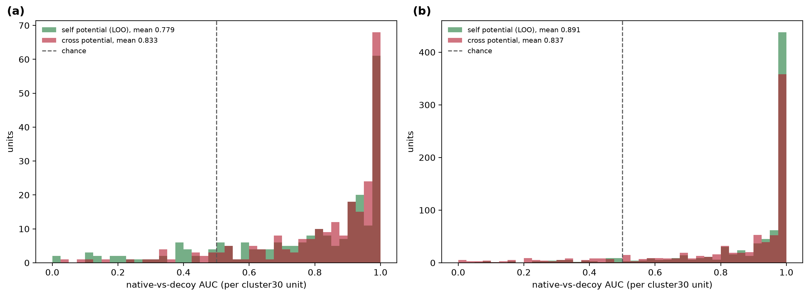
Fig. S11 Native-versus-decoy discrimination using each matrix as a threading potential. (a) Antibody interfaces scored by the antibody potential under leave-one-unit-out validation and by the protein-protein potential. (b) The equivalent comparison for protein-protein interfaces.
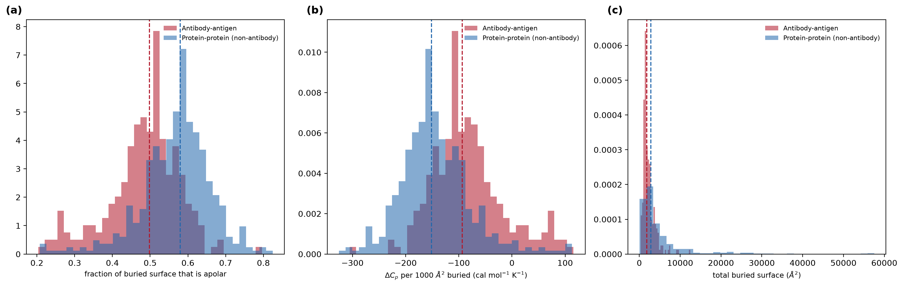
Fig. S12 Burial thermodynamics from atom-level solvent accessibility. (a) Fraction of buried surface that is apolar. (b) Heat-capacity change per 1000 square angstroms buried. (c) Total buried surface. Distributions are over cluster30 units.
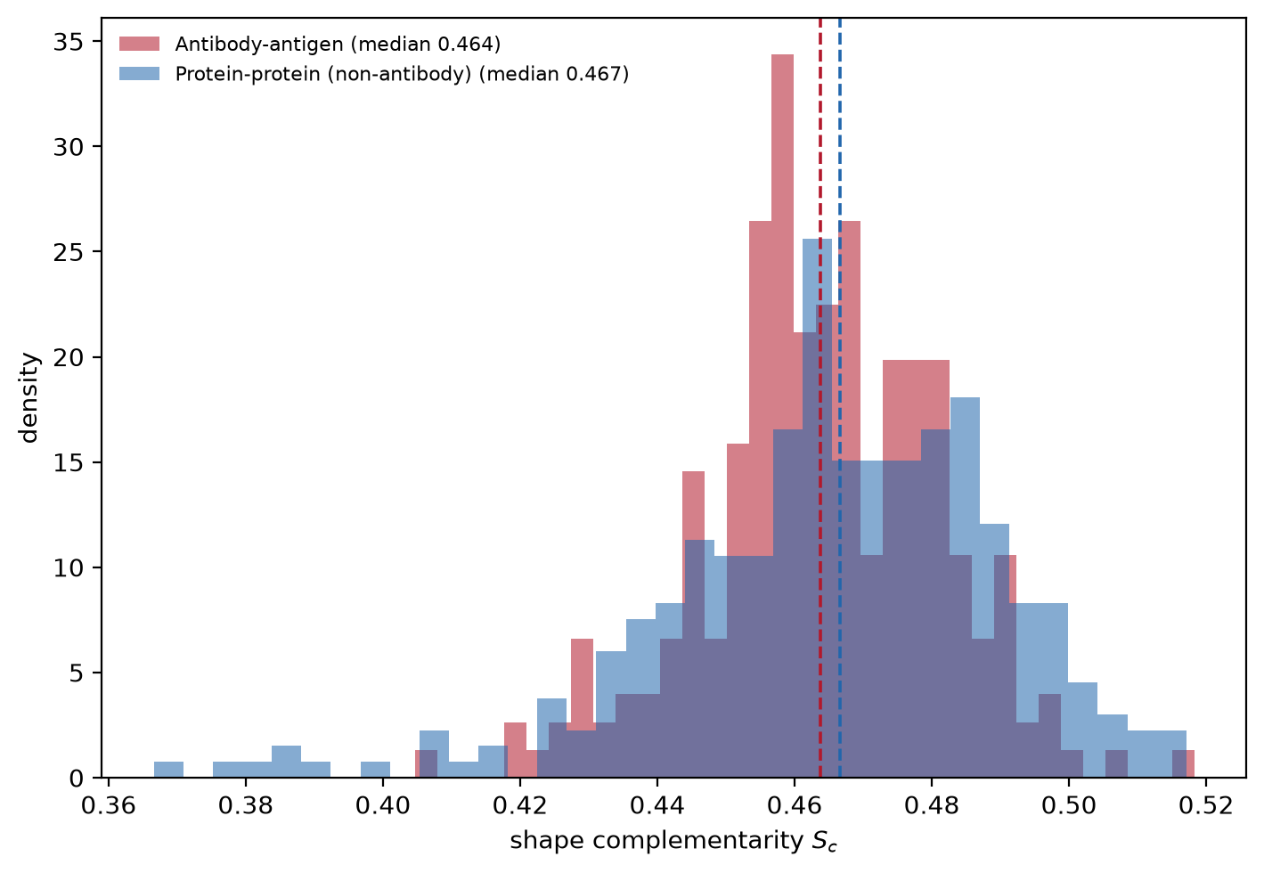
Fig. S13 Shape complementarity of the two interface classes, computed on the van der Waals contact surface. Values are not directly comparable with published figures because re-entrant surface is omitted; the between-class comparison is internally valid.
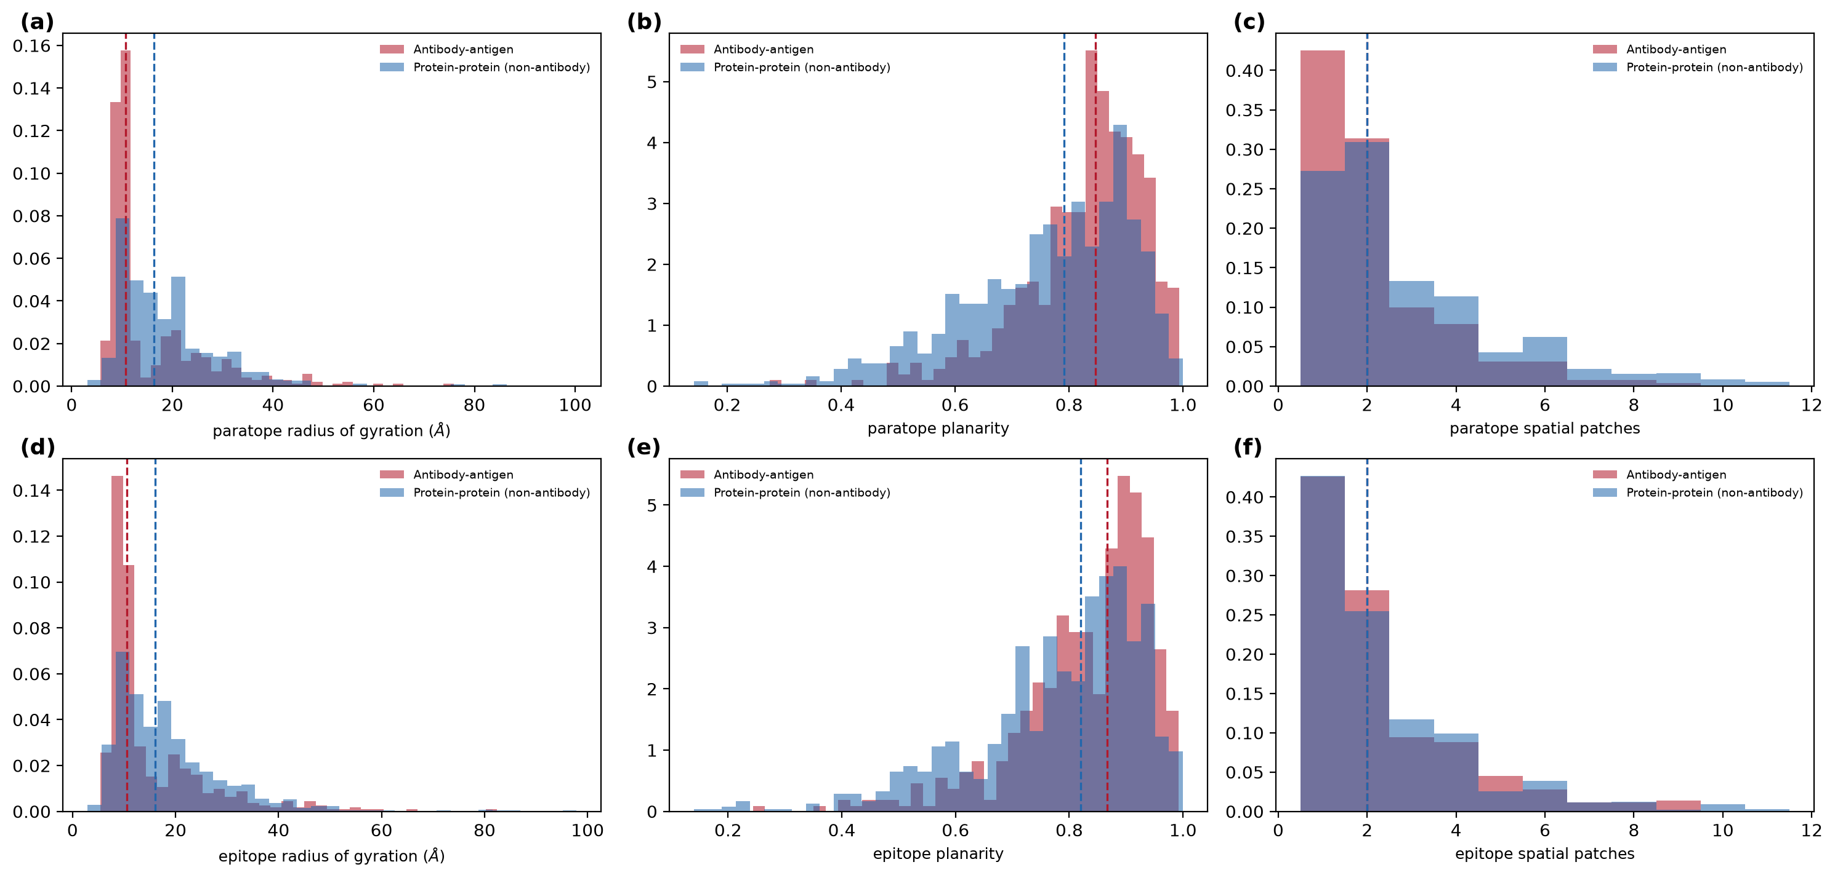
Fig. S14 Geometric spread of the contacted patch. (a) to (c) Probe side: radius of gyration, planarity, and number of spatially separate sub-patches. (d) to (f) The same three quantities for the target side.
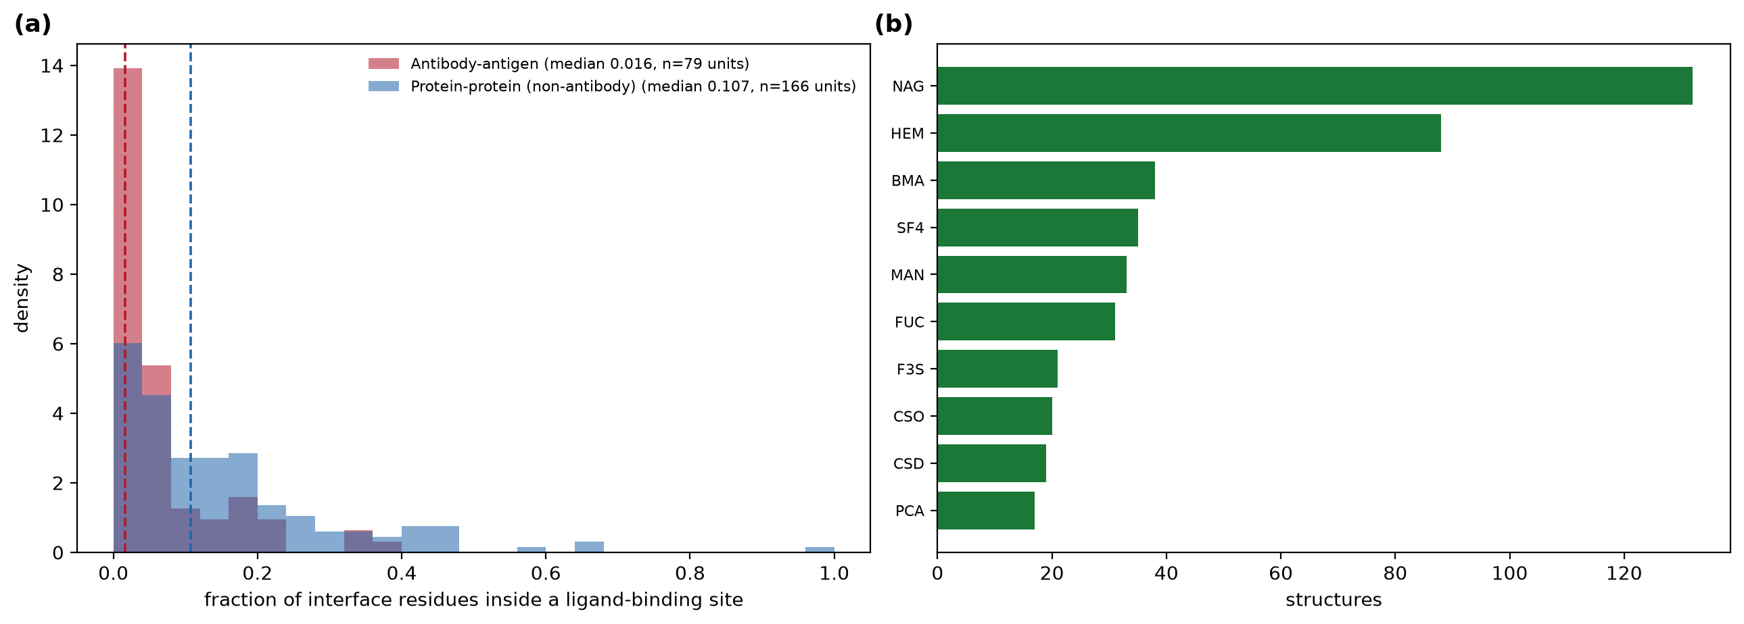
Fig. S15 Overlap between interfaces and ligand-binding sites. (a) Fraction of interface residues lying within a ligand-binding site. (b) Ligands most often defining those sites.
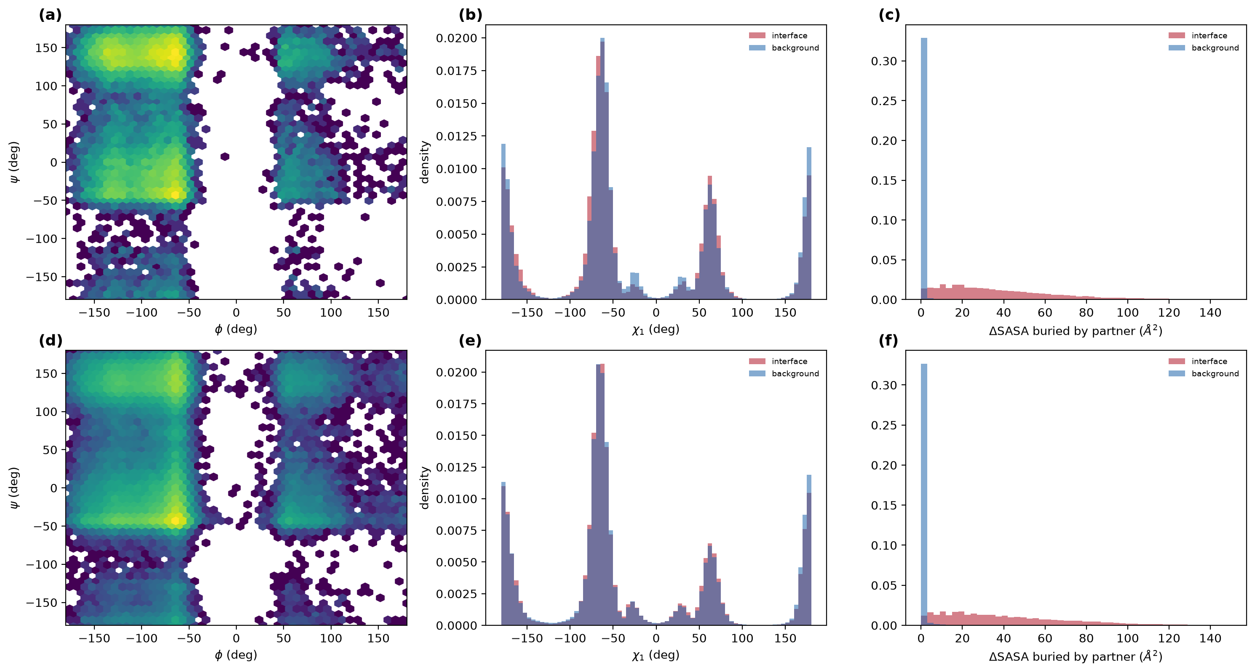
Fig. S16 Backbone dihedrals, side-chain rotamers and burial. (a) to (c) Antibody-antigen: Ramachandran distribution of interface residues, chi1 for interface against background, and buried surface per residue. (d) to (f) The same three for general protein-protein interfaces.
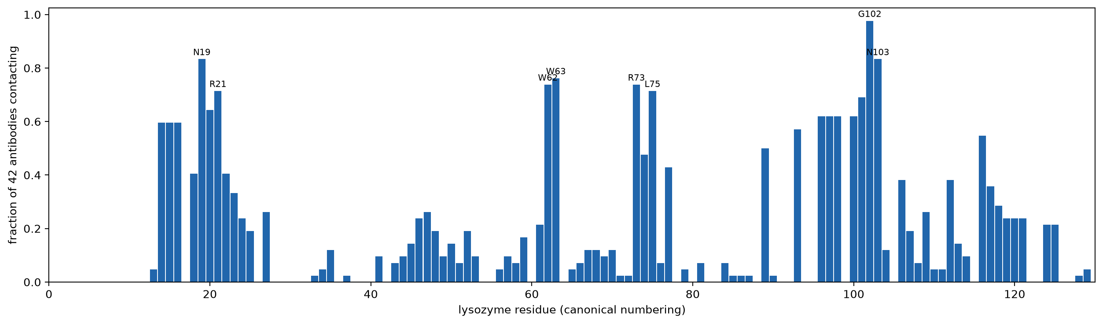
Fig. S17 Per-position contact frequency across 42 independently raised antibodies against lysozyme C, in canonical numbering. Labelled positions are the eight most frequently contacted.
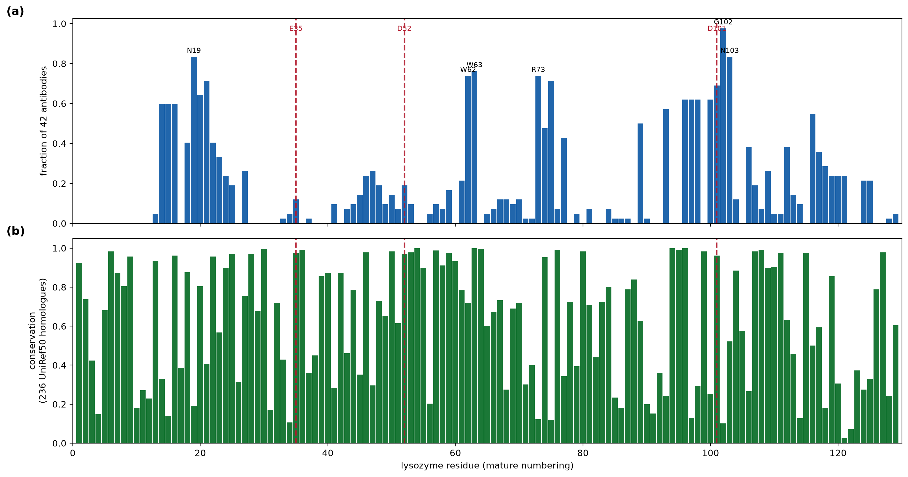
Fig. S18 Lysozyme C case study. (a) Fraction of the 42 antibodies contacting each position, with catalytic residues marked by dashed lines. (b) Sequence conservation at each position from 236 aligned UniRef50 homologues.
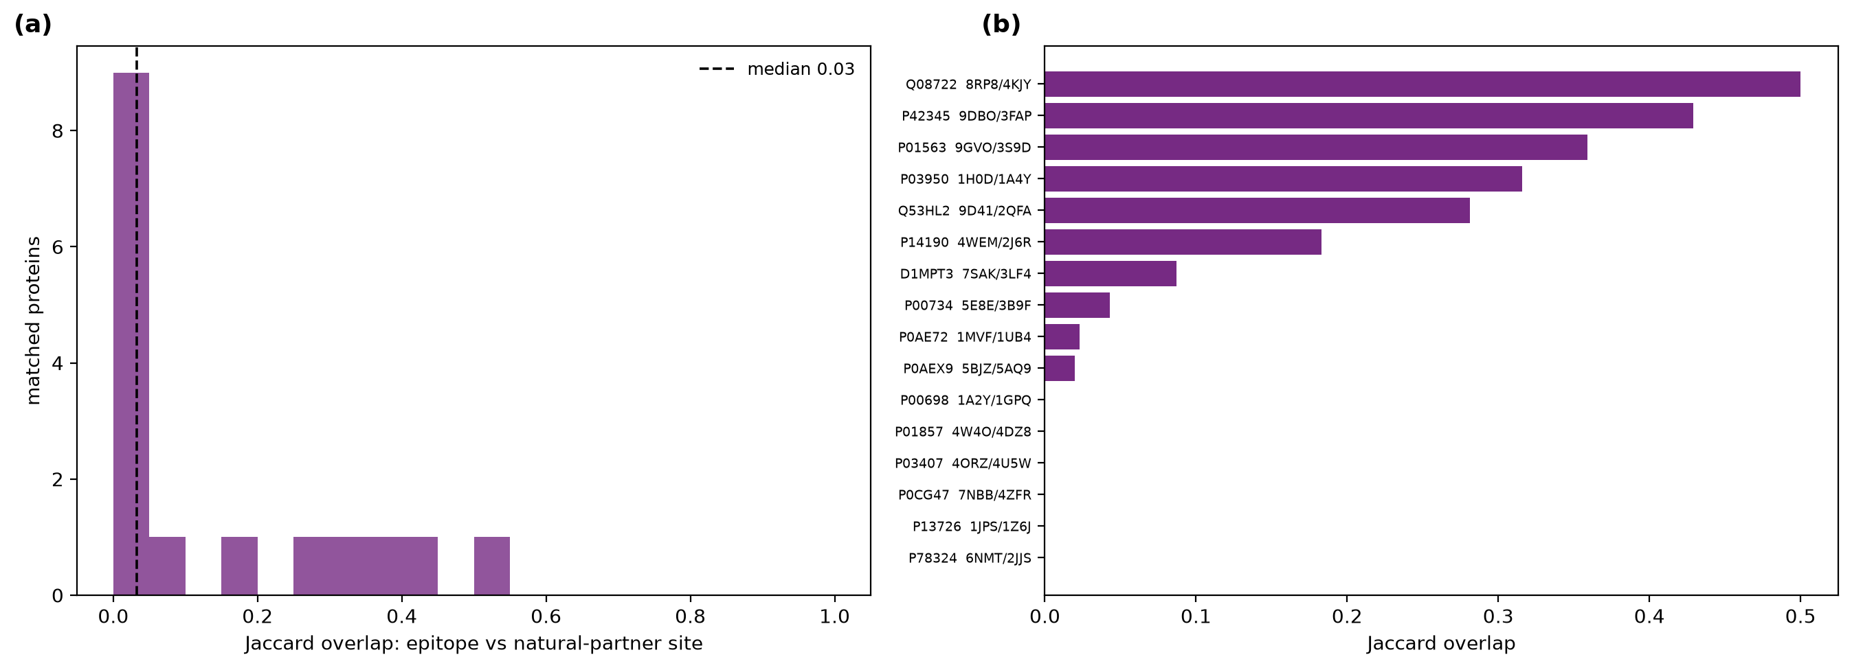
Fig. S19 Proteins solved both with an antibody and with a natural partner. (a) Distribution of Jaccard overlap between the epitope and the partner site across 16 matched proteins. (b) The highest-overlap pairs individually.
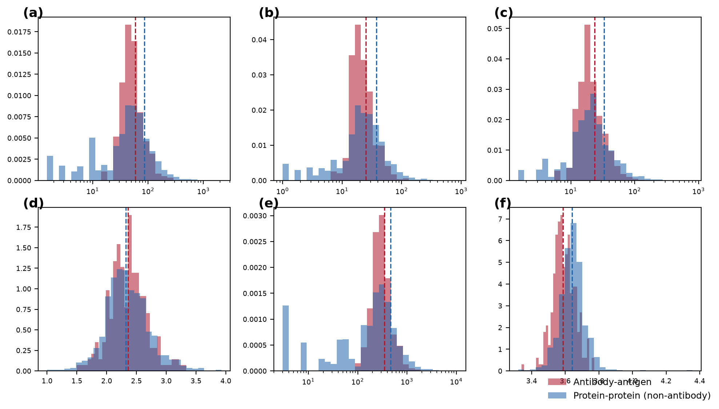
Fig. S20 Interface size and packing. (a) to (f) Residue pairs per interface, interface residues on each side, atom contacts, contacts per probe residue, and mean closest-approach distance. Distributions are over cluster30 units.
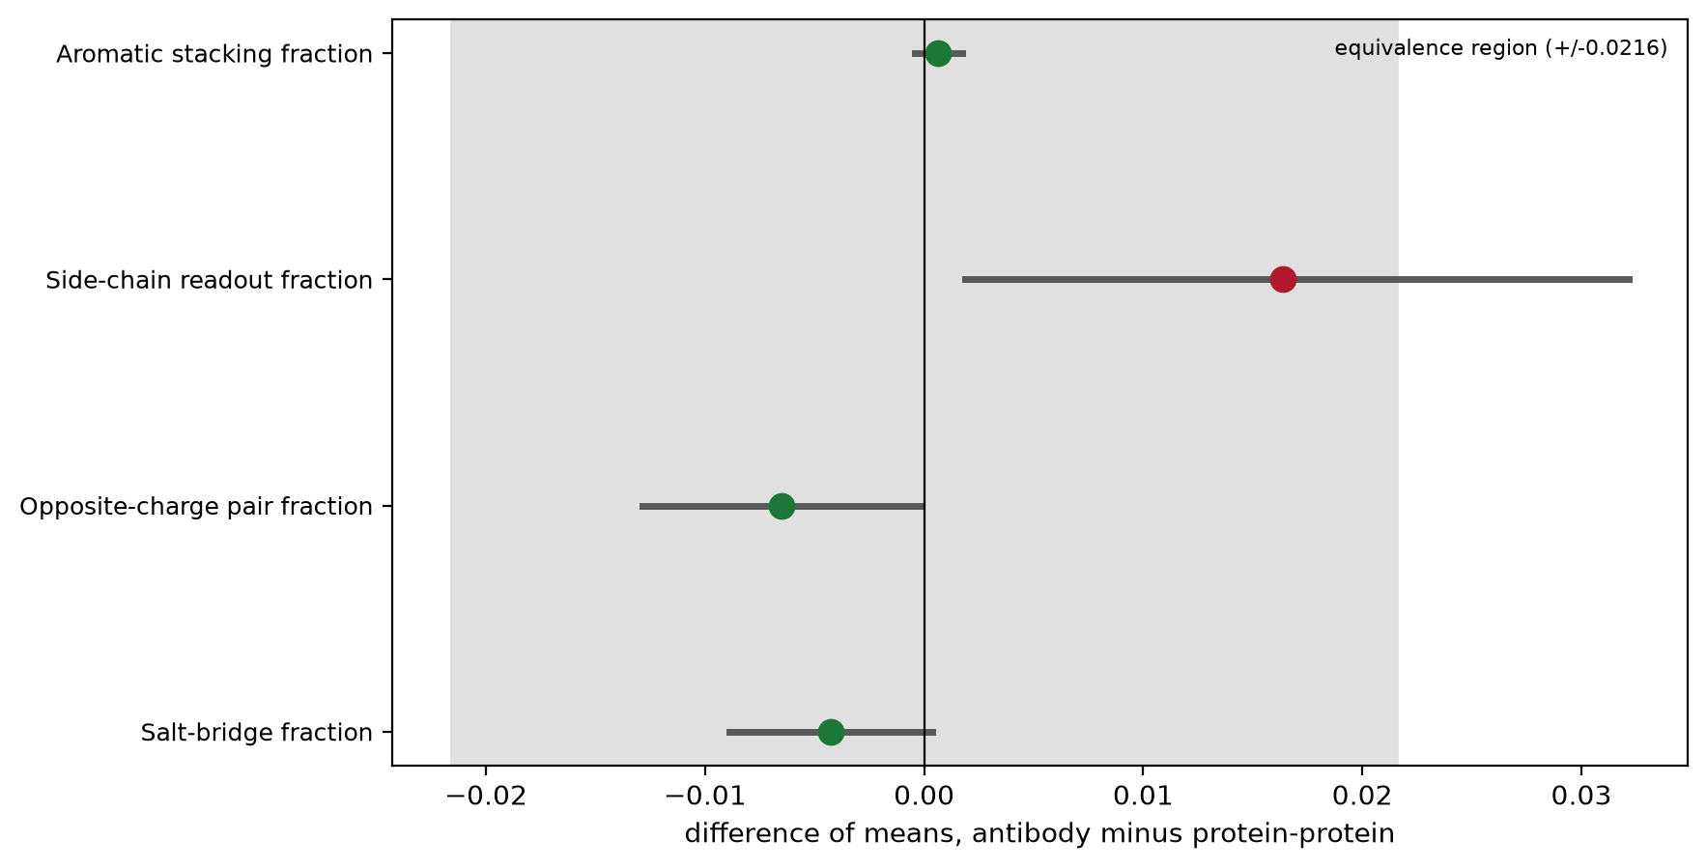
Fig. S21 Equivalence testing of the reported null results. Points give the difference of means between the classes, bars the bootstrap interval, and the shaded band the equivalence margin. Green marks quantities established as equivalent.
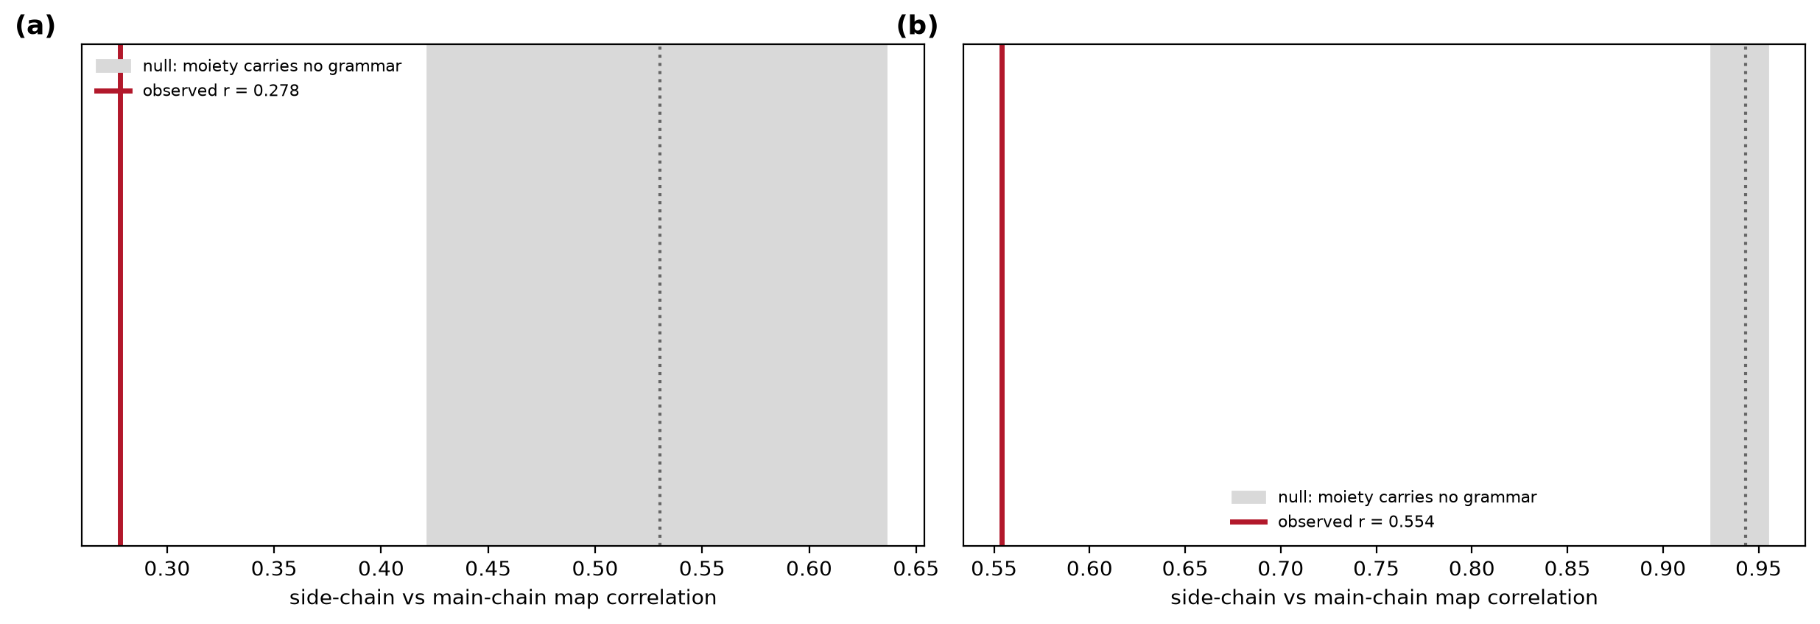
Fig. S22 Permutation null for readout-channel independence. (a) Antibody-antigen. (b) General protein-protein. The shaded band is the correlation expected if the moiety of a contact carried no grammar information.
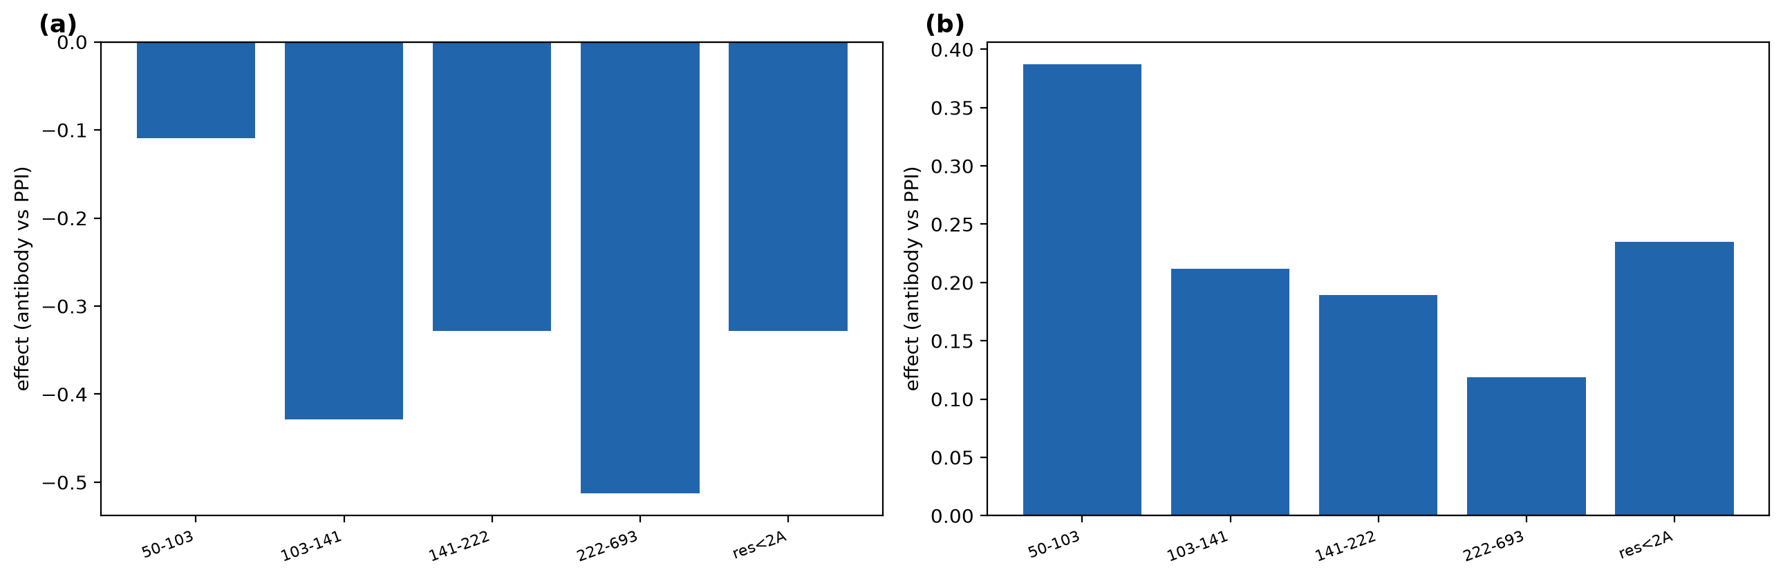
Fig. S23 Test of whether the interface geometry difference reflects crystallisability. (a) Radius of gyration and (b) planarity effects within quartiles of bound-protein length and within the high-resolution subset.

S11. Supplementary data files
File | Contents
corpus_manifest.csv | All 3,084 structures with descriptions, chains, resolution, units and exclusion reasons
matrix_antibody_cluster30.csv | Per-cell log odds, q values, bootstrap stability and counts
matrix_ppi_cluster30.csv | As above for the protein-protein group
fgroup_matrix_antibody.csv | Functional-group contact matrix
fgroup_matrix_ppi.csv | As above for the protein-protein group
interface_inventory.csv | Per-interface bond and chemistry composition
structural_residues.csv | 1,019,571 residues with secondary structure, torsions and buried surface
interface_geometry.csv | Patch radius, planarity and sub-patch counts
thermodynamics.csv | Per-interface buried apolar and polar surface
shape_complementarity.csv | Per-interface shape complementarity
paratope_regions.csv | Every paratope contact with its IMGT region
differential_cells.csv | Per-cell differences with intervals
modified_contacts.csv | Modified residues and glycans at interfaces
Table S14 Supplementary data files provided with this manuscript.

