An integrated, evidence-tiered census of the human and Caenorhabditis elegans tubulin interactome, from partner to pocket
Meenakshi Iyer^{1,*} and Meetrayu Raut¹
¹ School of Biology, MIT World Peace University, Pune, Maharashtra, India.
* Corresponding author. E-mail: meenakshi.iyer@mitwpu.edu.in
Working draft, resource-paper format modelled on RBP2GO, ENPD and RBPbase. Every number is recomputed from the data files and verified (_scripts/verify_claims.py, 109 of 109). Placeholders in {{ }} await author input; affiliations are provisional.

Abstract
Microtubules organise the interior of every eukaryotic cell, and the alpha/beta tubulin heterodimer is their subunit. The proteins that fold, modify, sever, stabilise and move along tubulin number in the thousands, yet the catalogues that describe them seed on a few abundant isotypes, pool curated and predicted evidence into one flat list, and keep the partner list apart from the structural and disease knowledge that gives a partner meaning. We adapted the census framework built for human actin-binding proteins (Iyer et al., 2023) and applied it to tubulin at full isotype resolution, seeding on all nineteen human isotypes, nine alpha and ten beta, together with fifteen C. elegans orthologs. Three orthogonal routes populate the census: physical interaction from six primary databases with HIPPIE as an integrative layer, domain content from thirty-four microtubule-associated Pfam families resolved through pfam2go, and pathway membership from KEGG and Reactome. The census holds 3,187 unique human partners, each carrying an evidence tier that separates experimental from compiled and predicted support. We corroborated the map with hu.MAP complexes, literature text-mining, cross-arm correlation, dense-complex recovery, a benchmark against the EBI Complex Portal, and a genetic co-dependency arm that uses no interaction data at all; we then analysed the partners across pathway, disease, drug, localisation, modification, motif and evolutionary-conservation layers and mapped the conservation, the drug pockets and the disease variants onto the folded dimer. Benchmark recall is structured rather than uniform, high for the chaperone machinery that folds tubulin at 62.5 percent and low for the wider microtubule system at 27.7 percent. The resource is delivered as a queryable MongoDB database with a web interface, a Python query module and a claim verifier that recomputes every published number from its source; every partner carries a composite Tubulin-Interaction Score, an isotype-specificity index and, where applicable, its role as a writer, eraser or reader of the tubulin code.
Keywords: tubulin; microtubule; interactome; evidence tiers; evolutionary trace; isotype; pfam2go; Complex Portal; drug pocket.
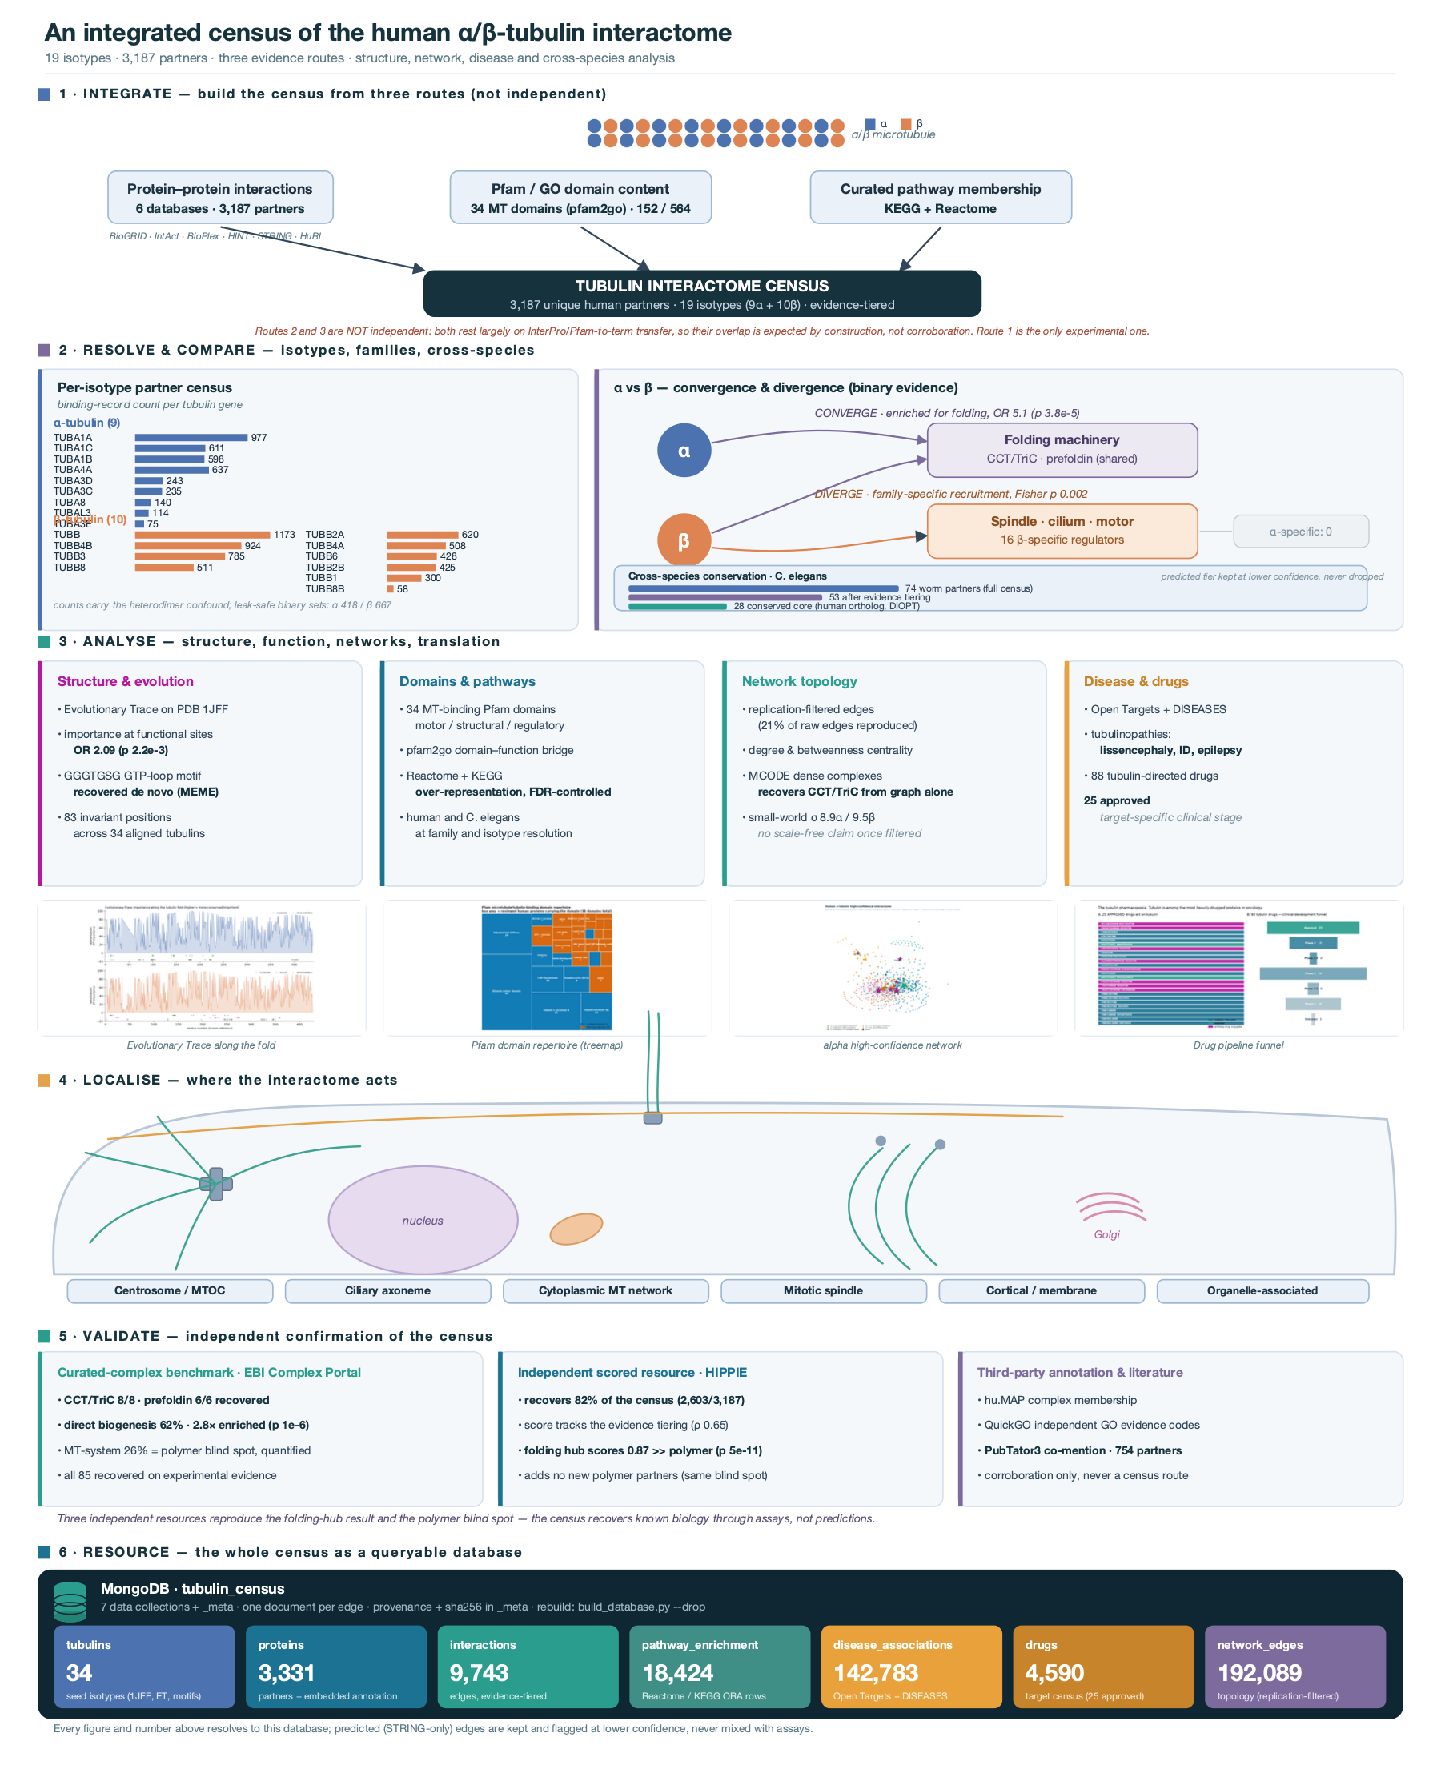
Graphical abstract. Integrated overview: the census, its three routes, the analysis arms, the localisation map, the validation, and the queryable database. All numbers current.

1 Introduction
Microtubules build the mitotic spindle, the tracks for intracellular transport, the axoneme of cilia and flagella, and the cortical arrays that shape a cell. Their subunit is the alpha/beta tubulin heterodimer, and the set of proteins that bind, fold, modify, sever, stabilise or walk along tubulin runs into the thousands. A complete and well-organised map of these partners is a foundation for cell biology, for the tubulinopathies, and for the many cancer drugs that act on tubulin directly.
Humans express nineteen tubulin isotypes from distinct genes, nine alpha and ten beta, and a recent survey sets this membership out in full (Nair, Saroj and Kunwar, 2026) [1]. The isotypes share more than ninety percent identity across the folded body and diverge mainly in their disordered carboxy-terminal tails and in where they are expressed. This variation tunes which partners bind and which functions a microtubule serves, so a map of tubulin’s partners is a map that should be read one isotype at a time. Most catalogues do not read that way. They seed on a few abundant isotypes, so low-abundance members such as TUBA3E and TUBAL3 are absent rather than reported as sparse; they pool interaction evidence of very different strength into one list; and they keep the partner list apart from the structural conservation, the disease variants and the drug pockets that give a partner its meaning.
Census resources exist for other binding-protein families and show the value of the approach. The framework we follow was built for human actin-binding proteins by Iyer, Rao, Mayor and Sowdhamini (2023) [41], who assembled a multi-route, evidence-tiered actin census; pan-species catalogues of RNA-binding proteins such as RBP2GO [42] and RBPbase [44], and the eukaryotic nucleic-acid-binding protein database ENPD [43], each integrate many primary studies under an explicit confidence scheme and expose the result as a queryable resource. No equivalent isotype-resolved, evidence-tiered census exists for tubulin. We built one, seeded on all nineteen human isotypes and fifteen worm orthologs, assembled from three orthogonal routes, and carried through structural, functional, network, disease, drug and orthogonal-genetic analysis on one platform. The methods build the census; the results describe it, corroborate it and analyse it; and the resource is delivered as a database that a reader can query.

2 Materials and Methods
The census is assembled by one reproducible pipeline, summarised in Figure 1. Nineteen human isotypes and fifteen C. elegans orthologs seed three orthogonal routes to partnership: physical interaction from six primary databases with HIPPIE as an integrative layer, domain content resolved through pfam2go, and pathway membership from KEGG and Reactome. Every partner is harmonised to a UniProt accession, assigned an evidence tier, and cross-referenced against the orthogonal resources that supply annotation, pathway, disease, drug and structural context. The resource is stored as a MongoDB database whose every published number is recomputed from source by an accompanying verifier. The three coloured arms of the schematic map onto the three results streams that follow: the tiered census, the domain and pathway arms, and the structural, drug and validation layers.
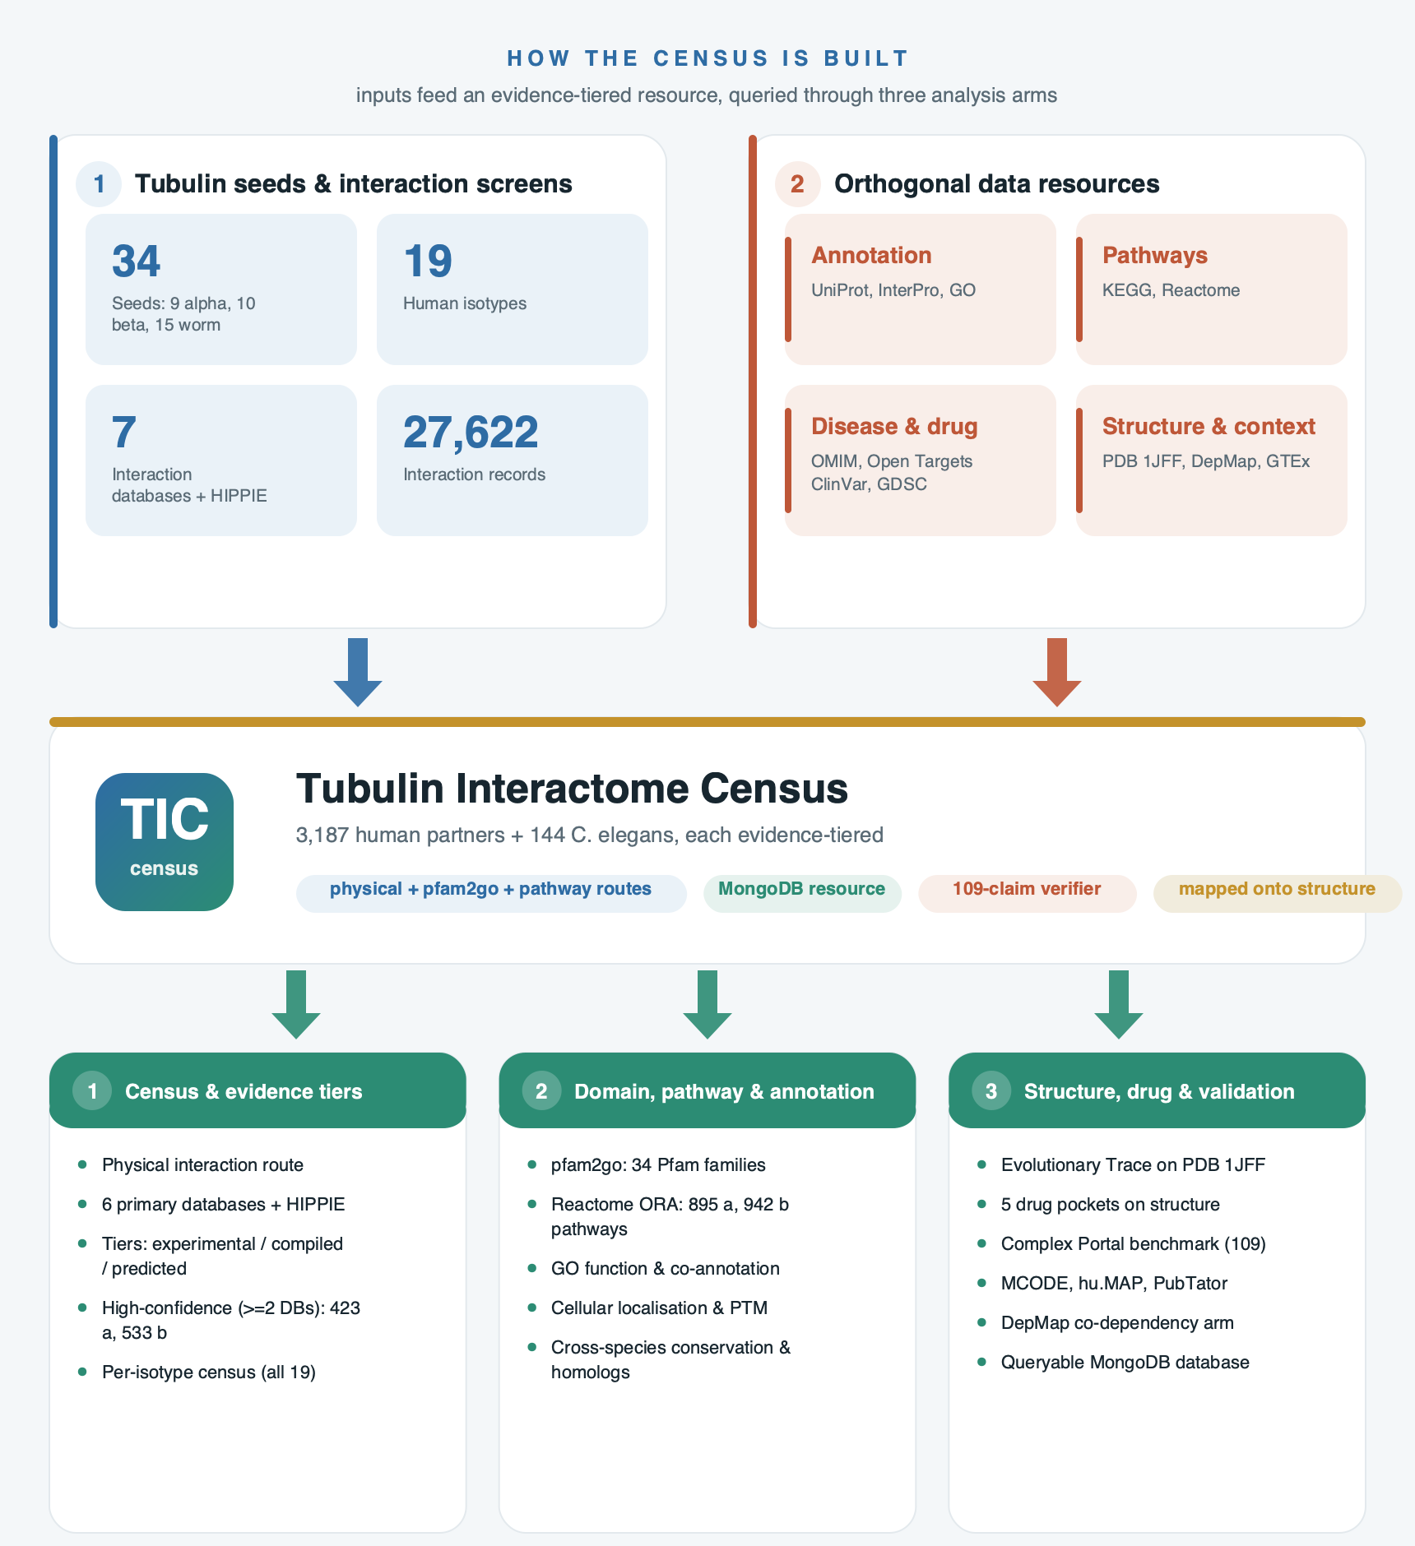
Figure 1. Methodology overview. The tubulin seeds and interaction screens (blue) and the orthogonal data resources (red) feed the evidence-tiered census, which is queried through the three analysis arms (green). All counts are drawn from the verified census.

2.1 Seeds and scope
Nineteen reviewed human tubulin entries were taken from UniProt [10] as the only baits, nine alpha (TUBA1A, TUBA1B, TUBA1C, TUBA3C, TUBA3D, TUBA3E, TUBA4A, TUBA8, TUBAL3) and ten beta (TUBB, TUBB1, TUBB2A, TUBB2B, TUBB3, TUBB4A, TUBB4B, TUBB6, TUBB8, TUBB8B), together with fifteen C. elegans tubulins. TUBA4B was held out as a 241-residue tubulin-like protein. A single shared module defines the seed set for every downstream script.

2.2 Route 1: physical interaction and evidence tiers
Interaction records were pulled from BioGRID [2], IntAct [3], BioPlex [4], HINT [6], HuRI [5] and STRING [7], parsed per source and harmonised to UniProt accessions, with non-protein interactors removed by an explicit filter. HIPPIE [8] was re-extracted from its current bulk release against the nineteen seed Entrez identifiers and added as an integrative layer. Every partner carries one of three tiers: experimental (seen in an assay), compiled (reaching the census through an integrative resource), or predicted (STRING only, kept but flagged). A partner is high-confidence when reported by at least two primary databases, a definition that excludes STRING by construction.

2.3 Route 2: the pfam2go domain arm
The domain route rests on pfam2go [13], the curated mapping from a Pfam [12] domain to the Gene Ontology terms it implies. We began with eleven curated microtubule/tubulin-binding Pfam domains, each verified on InterPro [11], and used pfam2go to add every further domain carrying a direct microtubule- or tubulin-binding GO term, then resolved each domain to its reviewed human proteins. A protein is admitted on the strength of the fold it carries even where no interaction has been recorded, which recovers mechanism the interaction assays miss.

2.4 Route 3: the pathway arm
The pathway route took the single KEGG [15] cytoskeleton-motor pathway (Motor proteins, hsa04814 / cel04814) and twenty-two microtubule-related Reactome [14] pathways, resolved to their member proteins, admitting a protein that acts in a tubulin-relevant process.

2.5 Corroboration, structure, annotation and database
Corroboration used hu.MAP 2.0 [23] complex membership, PubTator3 [18] literature co-mention (symbols resolved through mygene.info [36]), cross-arm Pearson correlation, MCODE [30] dense complexes, the EBI Complex Portal [9] benchmark (hypergeometric recall per complex and tier), and a genetic co-dependency arm from DepMap [21]. The thirty-four sequences were aligned with MAFFT [26]; real-valued evolutionary trace [29] was computed and mapped onto PDB 1JFF [24]; MEME [27] and STREME [28] discovered motifs de novo over non-redundant sets clustered with MMseqs2 [31], with solvent accessibility by Shrake-Rupley [37]. Reactome and KEGG over-representation was Benjamini-Hochberg corrected [33]. Enrichment of the shared alpha and beta partners was tested by the hypergeometric distribution against the reviewed human proteome; the tubulin-versus-partner disorder contrast by a one-sided Mann-Whitney U test; and the evolutionary-trace enrichment at functional sites by Fisher’s exact test on the top fifteen percent of trace-ranked residues. Partners were annotated for InterPro domains, GO terms [40], PTM sites, MobiDB disorder, localisation, CATH [38] and SCOP [39] structure classes, OMIM [16] and Open Targets [17] disease and drug links, with disease variants from ClinVar [19] and cBioPortal [20] and tissue expression from GTEx [25]. Drug pockets were mapped on PDB structures 1JFF, 1SA0, 1Z2B, 4O4H and 5FNV; durability combined ET percentile, isotype Shannon entropy across the nineteen isotypes and burial. Cancer stratification correlated DepMap CRISPR dependency with GDSC [22] drug sensitivity per lineage. The analysis was implemented in Python with Biopython [34] and NetworkX [35], and the high-confidence interactomes were laid out with ForceAtlas2 [32]. The census is loaded into a MongoDB instance stamped with source-file checksums, and a verifier holds 109 numerical claims that recompute from the data files.

3 Results

3.1 The census in numbers
The census resolves interaction records to unique partners after harmonising to UniProt, and tiers every partner (Table 1, Table 2). The nine alpha seeds gave 1,955 partners across 11,303 records (1,788 experimental, 131 compiled, 36 predicted; 423 high-confidence). The ten beta seeds gave 2,518 partners across 15,891 records (2,012, 122, 384; 533 high-confidence). The worm seeds gave 144 partners across 428 records, 74 of them assay-backed. Across the two human families the union is 3,187 unique partners (per-isotype breakdown in Table 3). Each of the three routes finds partners the others miss, so the census is a union, not one assay repeated (Figure 2), and the per-source contribution (Table 2) shows BioGRID, IntAct and HIPPIE as the largest contributors and HuRI the sparsest.

Table 1. The census in numbers: records, routes and confidence
Layer | Human alpha | Human beta | C. elegans
Interaction records (raw) | 11,303 | 15,891 | 428
Physical (PPI) partners, assay-backed | 1,788 | 2,012 | 74
+ domain-only (Pfam / GO) | +94 | +94 | +44
+ pathway-only (KEGG / Reactome) | +383 | +383 | +59
High-confidence (>=2 primary DBs) | 423 | 533 | 10
Full census (union, all tiers) | 1,955 | 2,518 | 144

Table 2. Data sources and their contribution to the census
Source | Type | Access | Records: alpha | beta | worm | Role
BioGRID | Physical PPI | Bulk tab3 | 3,149 | 4,138 | 142 | Primary experimental
IntAct | Physical PPI | REST API | 2,450 | 3,086 | 10 | Primary experimental
BioPlex | AP-MS | Bulk TSV | 669 | 966 | 0 | Primary experimental
HINT | Integrative binary | Bulk TSV | 1,517 | 2,015 | 16 | Primary experimental
HuRI | Y2H (binary) | Bulk TSV | 7 | 0 | 0 | Primary experimental
STRING | Functional assoc. | REST API | 383 | 1,783 | 260 | Predicted (flagged)
HIPPIE | Integrative | Bulk (re-extracted) | 3,128 | 3,903 | 0 | Compiled (validation layer)
Pfam / pfam2go | Domain content | InterPro + GO | 34 MT domains | n/a | n/a | Domain route
KEGG + Reactome | Pathway membership | API / bulk | motor + 22 MT pathways | n/a | n/a | Pathway route

Table 3. Per-isotype partner census (all nineteen human isotypes)
Isotype | Family | Partners | Interaction records
TUBA1A | alpha | 977 | 3,672
TUBA4A | alpha | 637 | 2,136
TUBA1C | alpha | 611 | 1,906
TUBA1B | alpha | 598 | 1,685
TUBA3D | alpha | 243 | 512
TUBA3C | alpha | 235 | 529
TUBA8 | alpha | 140 | 409
TUBAL3 | alpha | 114 | 280
TUBA3E | alpha | 75 | 174
TUBB | beta | 1,173 | 3,242
TUBB4B | beta | 924 | 2,447
TUBB3 | beta | 785 | 2,354
TUBB2A | beta | 620 | 1,568
TUBB8 | beta | 511 | 2,048
TUBB4A | beta | 508 | 1,209
TUBB6 | beta | 428 | 1,010
TUBB2B | beta | 425 | 1,103
TUBB1 | beta | 300 | 844
TUBB8B | beta | 58 | 66
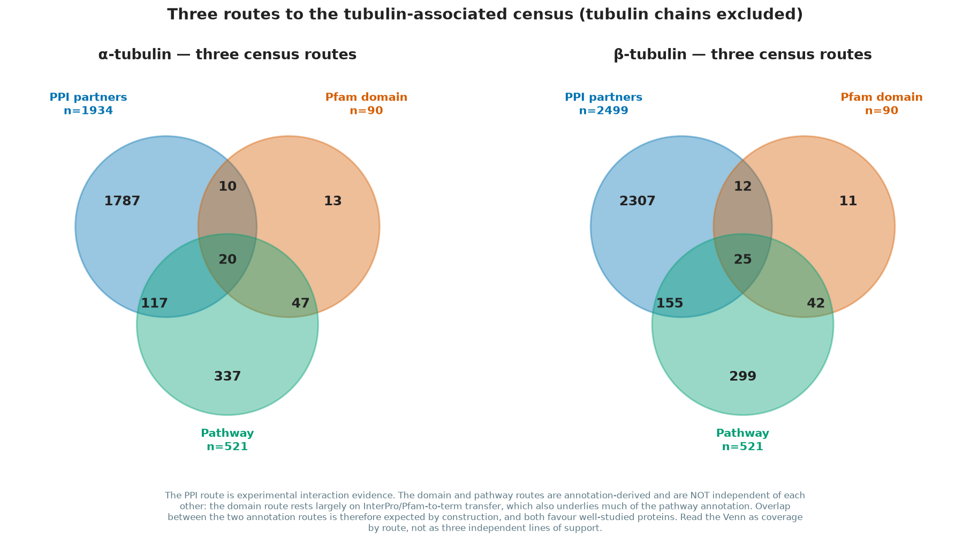
Figure 2. The three orthogonal routes to the census (physical interaction, Pfam domain, pathway), per family.

3.2 The pfam2go domain repertoire
pfam2go expanded the eleven curated domains to thirty-four microtubule-associated Pfam families (Figure 3; full list in Table 4). The largest by protein count is the kinesin motor domain with 45 proteins, the single biggest class of microtubule-binding protein, then the Tubulin/FtsZ GTPase domain with 24, the tubulin carboxy-terminal domain with 22, the tubulin-tyrosine ligase family with 14, the CAP-Gly domain with 10, doublecortin with 8 and GAS2 with 7. The domain families divide into motor, structural and regulatory classes, and mapping them against the physical-interaction route shows how mechanism meets interaction: of the domain-carrying genes, a shared core is recovered by PPI in both families while a tail of domain-only genes carries a tubulin-binding fold without a recorded assay (Figure 4). The domain route therefore adds tubulin-binding proteins the assays have not yet caught.
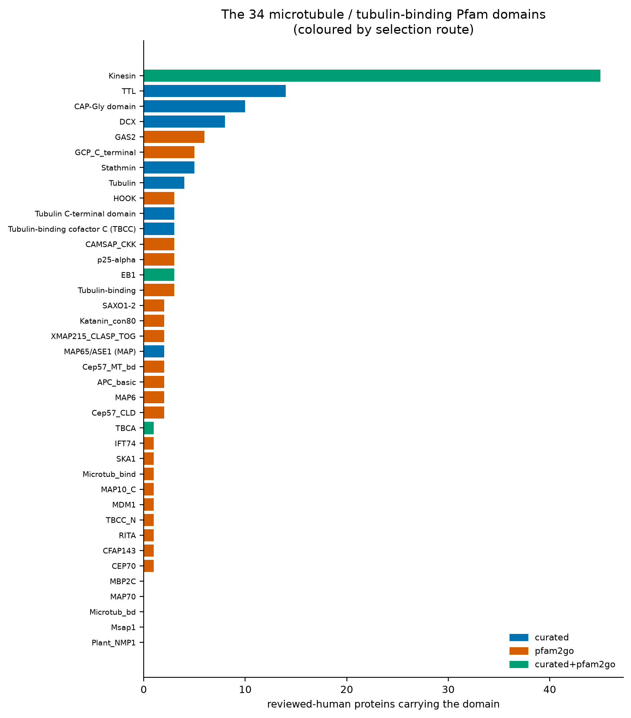
Figure 3. The microtubule/tubulin-binding Pfam domain repertoire after pfam2go; 34 domains, box area = reviewed human proteins carrying the domain.
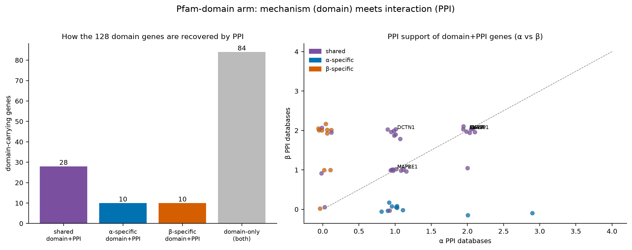
Figure 4. The Pfam-domain arm meets the interaction arm: how the domain-carrying genes are recovered by PPI, alpha vs beta.

Table 4. Microtubule/tubulin-binding Pfam domain repertoire after pfam2go
Pfam domain | Proteins
Kinesin motor domain | 45
Tubulin/FtsZ GTPase domain | 24
Tubulin C-terminal domain | 22
Tubulin-tyrosine ligase (TTL) | 14
CAP-Gly domain | 10
Doublecortin (DCX) | 8
GAS2 | 7
Stathmin | 5
GCP_C_terminal | 5
EB1-like C-terminal motif | 3
Tubulin-binding cofactor C (TBCC) | 3
Tubulin-binding | 3
p25-alpha | 3
HOOK | 3
CAMSAP_CKK | 3
MAP65/ASE1 (MAP) | 2
SAXO1-2 | 2
APC_basic | 2
Cep57_MT_bd | 2
Katanin_con80 | 2
Cep57_CLD | 2
XMAP215_CLASP_TOG | 2
MAP6 | 2
Tubulin-binding cofactor A (TBCA) | 1
SKA1 | 1
Microtub_bind | 1
MAP10_C | 1
MDM1 | 1
TBCC_N | 1
RITA | 1
CFAP143 | 1
CEP70 | 1
IFT74 | 1
33 domains total; 8 curated, 27 pfam2go-derived, 3 both.

3.3 Pathways: where alpha and beta diverge
Reactome over-representation, Benjamini-Hochberg corrected, gave 895 significant alpha pathways and 942 for beta. Rolled up to the Reactome top level, the alpha and beta partner sets superimpose across most branches, which indicates a shared function, while beta reaches substantially more cell-cycle pathways than alpha and smaller gaps appear in DNA Repair, Gene Expression and the Neuronal System (Figure 5). The strongest single enrichment is the CCT/TriC tubulin-folding route at p = 3.8e-29, recovered whole with every curated member present. Unsupervised clustering of the nine alpha isotypes by shared partners splits them into a broadly expressed folding and cell-cycle group (TUBA1A, TUBA1B, TUBA1C, TUBA4A) and a tissue-restricted trafficking and aggrephagy group (TUBA3C, TUBA3D, TUBA8), with TUBA3E joining the testis-restricted set and TUBAL3 standing apart as a sequence outlier; beta instead restricts a few isotypes to single tissues while the rest are broadly expressed.
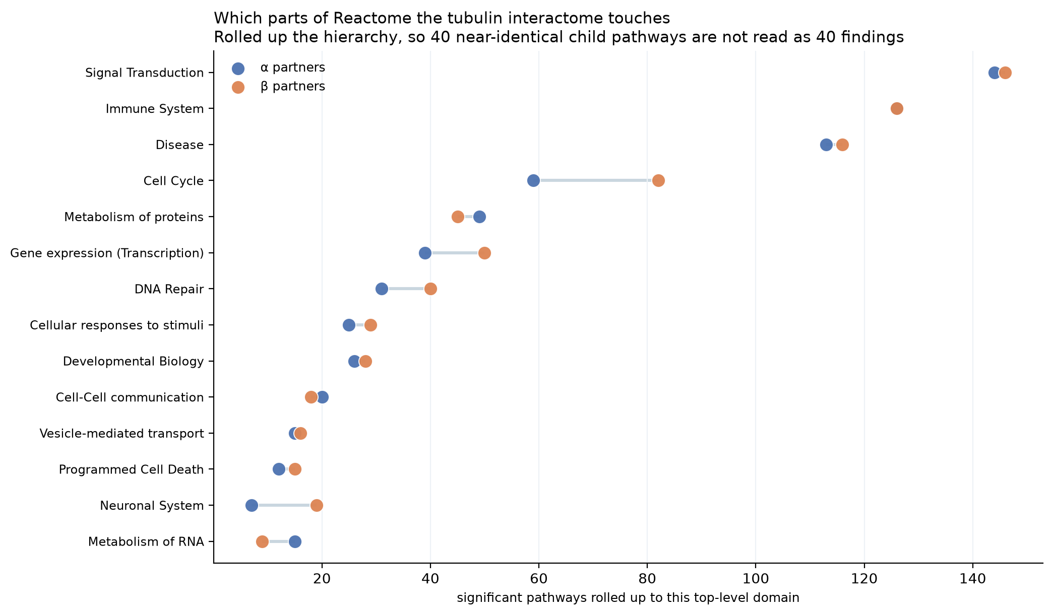
Figure 5. Reactome top-level domains; alpha and beta partner counts per domain, joined by a bar.
Resolving the pathway signal to the level of the individual isotype shows that enrichment is graded rather than shared uniformly (Figure 6). Across all nineteen isotypes the microtubule and cytoskeleton terms remain the common backbone, yet the strongest columns belong to the broadly expressed isotypes TUBA1A, TUBB4B and TUBB2B, whose large partner sets drive deep enrichment of organelle organisation, the cell cycle and the CCT/TriC folding route. The tissue-restricted alpha isotypes TUBA3E, TUBA8 and TUBAL3, and the minor beta isotypes TUBB1 and TUBB8B, enrich the same core terms weakly or not at all, consistent with their smaller and more specialised interactomes. The folding and aggrephagy rows stay lit across both families, marking tubulin biogenesis as the one pathway every isotype shares. This per-isotype view confirms that the alpha and beta pathway profiles superimpose on a common core while differing in depth, not in kind.
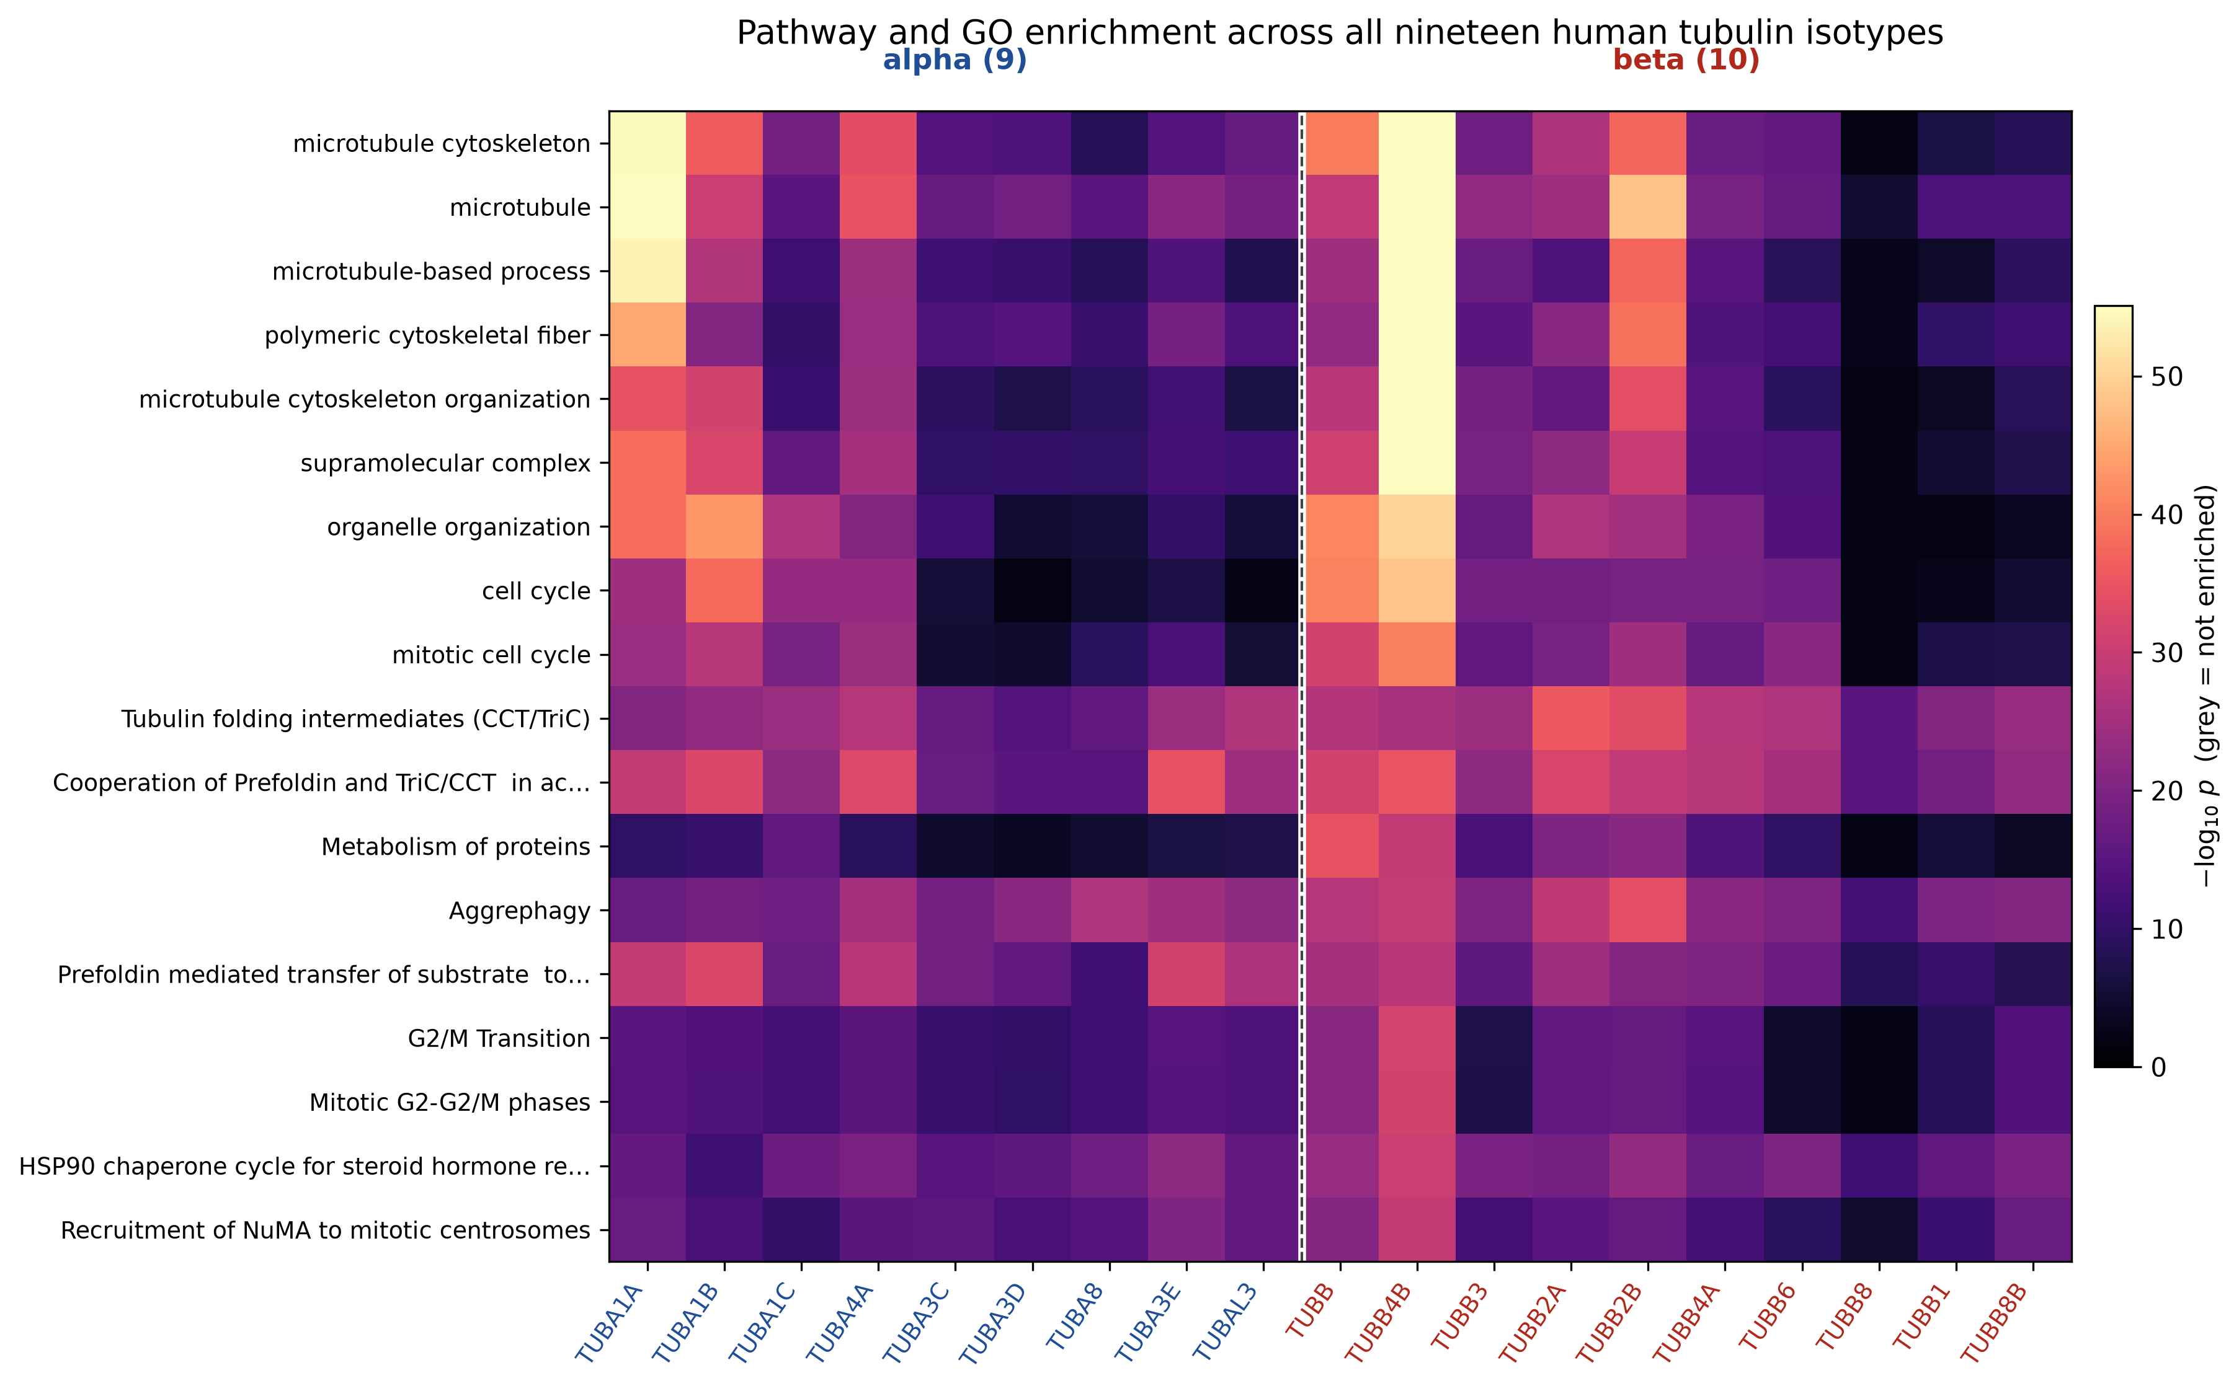
Figure 6. Pathway and GO over-representation across all nineteen human isotypes (nine alpha, ten beta). Colour is -log10 p from the per-isotype g:Profiler runs; grey marks terms not enriched.

3.4 The disease layer concentrates in the shared partners
The partners shared between alpha and beta, 1,207 against an expected 202 (a 5.98-fold enrichment), are where the disease signal concentrates (Figure 7). The enriched disease pathways are led by TNF-alpha signalling and by HDAC6 interactions in the central nervous system, HDAC6 being a deacetylase that removes the acetyl mark from tubulin itself, followed by the Parkin ubiquitin proteasome pathway and by cancer, MAPK and glioblastoma signalling. The shared hubs, not the family-specific ones, carry the disease weight.
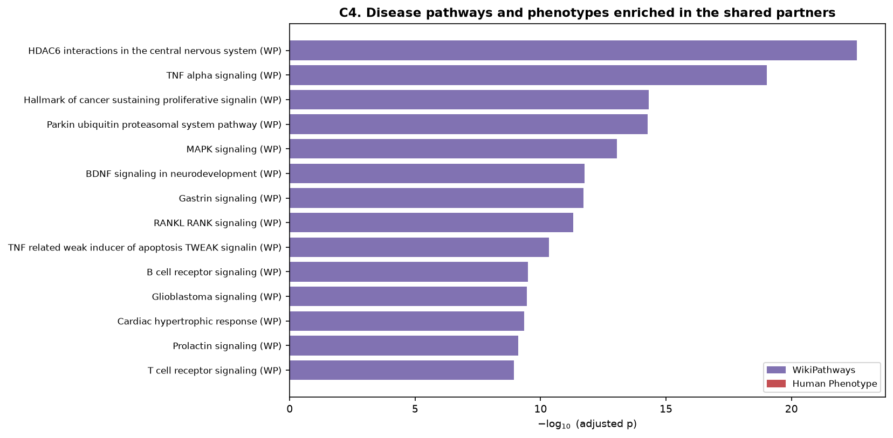
Figure 7. Disease pathways and phenotypes enriched in the shared alpha and beta partners.
A closer reading of the disease layer separates two clinical faces of the same interactome (Figure 8). Of the 2,757 partners that carry any disease association, the great majority, 2,486 or ninety percent, are implicated in both neoplastic and constitutional disease, so the tubulin partners are broadly pleiotropic rather than split into cancer genes and disease genes. What differs is the mutational route to the two disease classes. Cancer associations carry somatic-mutation evidence for 15.2 percent of their entries and germline evidence for 11.5 percent, whereas the constitutional disorders are almost entirely germline, 50.8 percent genetic and 0.2 percent somatic. Read as an inference from the census, the tubulin machinery reaches cancer through acquired somatic lesions in the same proteins that, when altered in the germ line, produce the developmental and neurological tubulinopathies. This dual burden concentrates in the shared, high-connectivity partners rather than the isotype-specific tail.
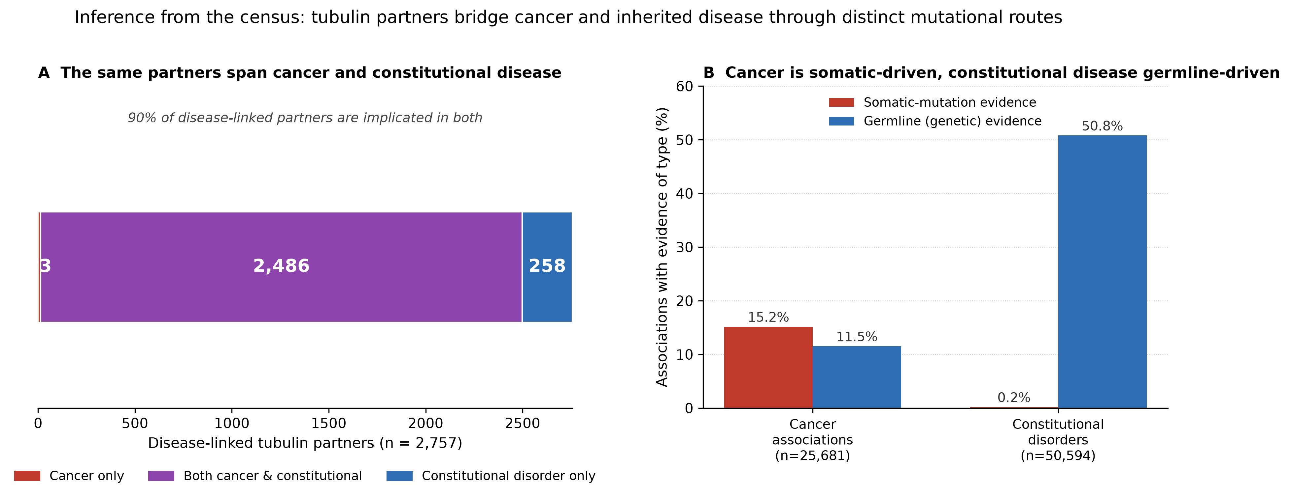
Figure 8. Cancer versus constitutional disorders, inferred from the census. A: overlap of disease-linked partners. B: somatic versus germline evidence for cancer and non-cancer associations (Open Targets).

3.5 Cross-species conservation
Every worm partner was resolved to its human ortholog through the Alliance/DIOPT multi-method consensus. Of the 144 worm partners, 28 form a conserved worm-to-human core (Figure 9), including the folding cofactors, the gamma-complex and the Parkinson-disease ligase PRKN, recovered from its worm ortholog pdr-1. A partner conserved across half a billion years of evolution is unlikely to be a reagent artefact, and the core provides an evolutionary floor under the census.
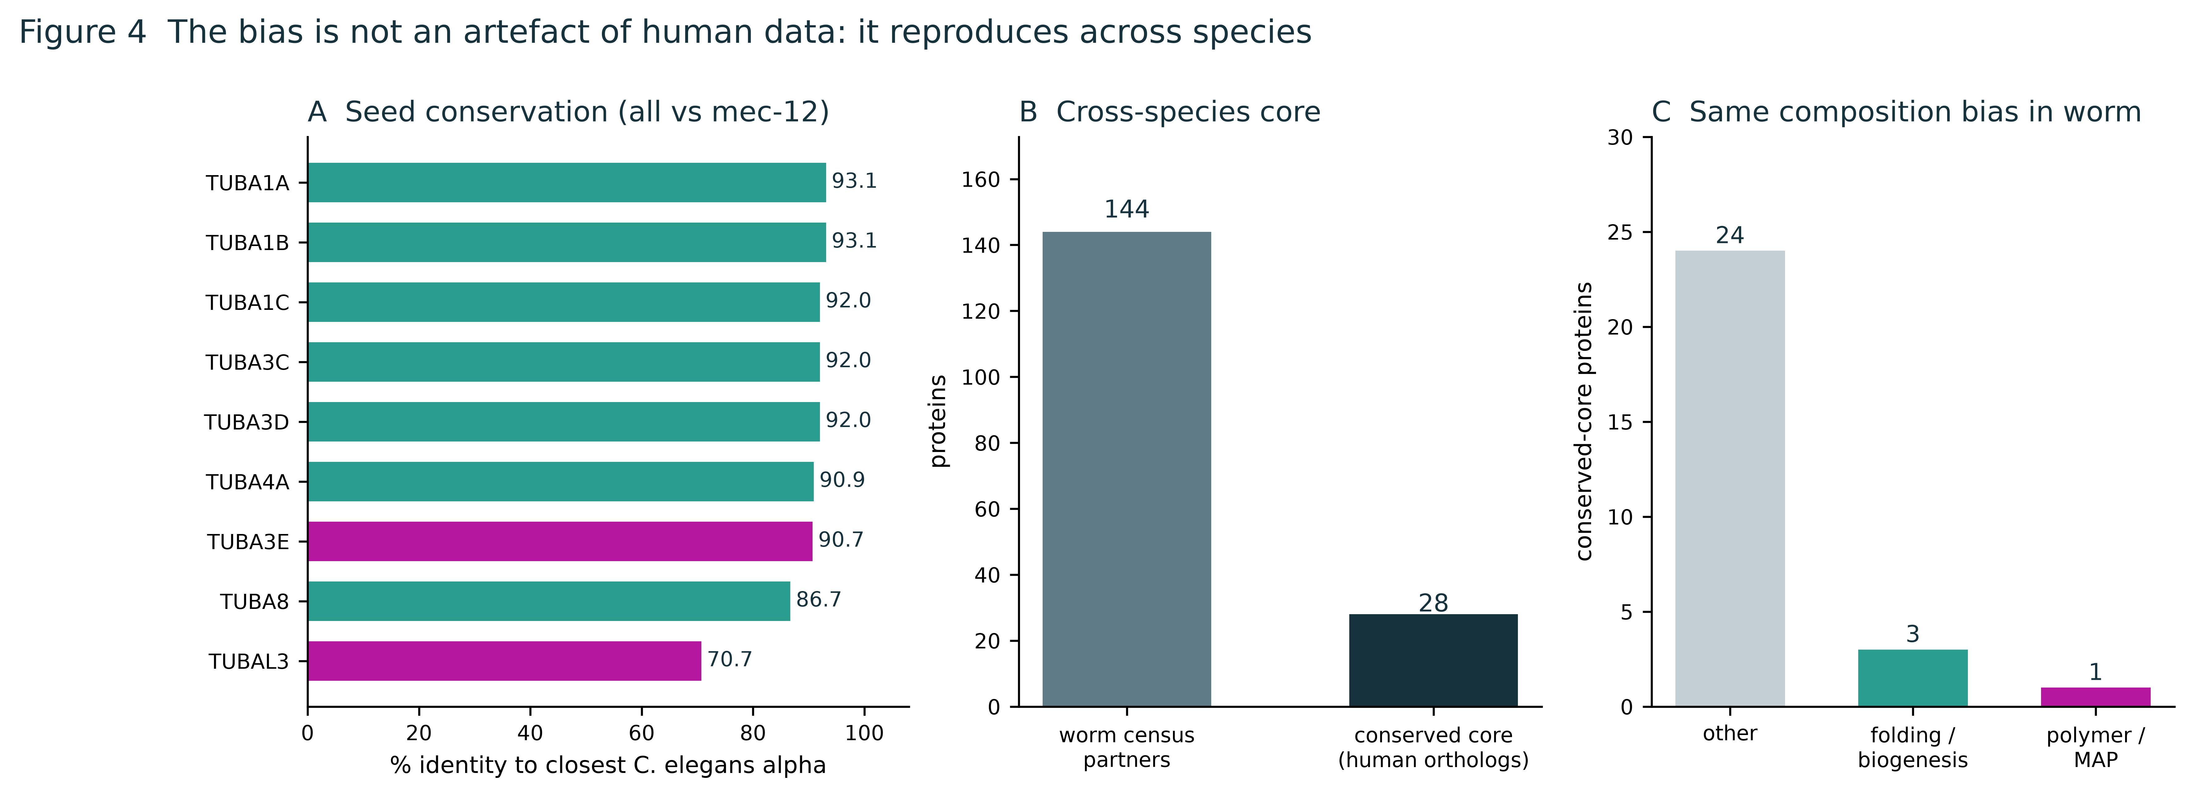
Figure 9. Cross-species conservation: seed conservation to C. elegans and the conserved worm-to-human core.
Extending the conservation analysis from the seeds to the whole partner set traces how deep the interactome runs (Figure 10). Scored against a nine-species ortholog matrix, the fraction of partners with a detectable ortholog falls smoothly with evolutionary distance, from 82 percent in mouse to 42 percent in budding yeast, and 28 percent of partners are retained across all nine species as a universal core. Resolving that core by function shows it is not uniform: the folding machinery is the most ancient, with the prefoldin and CCT/TriC modules present in a mean of 8.7 of 9 species, while the spindle and centrosome partners average close to five and the ciliary partners only 3.2. The interactome therefore contracts toward an ancient tubulin-folding heart as one moves away from vertebrates, with the division and ciliary machinery layered on more recently. The pattern mirrors the pathway result, where the CCT/TriC route is the single enrichment shared by every isotype.
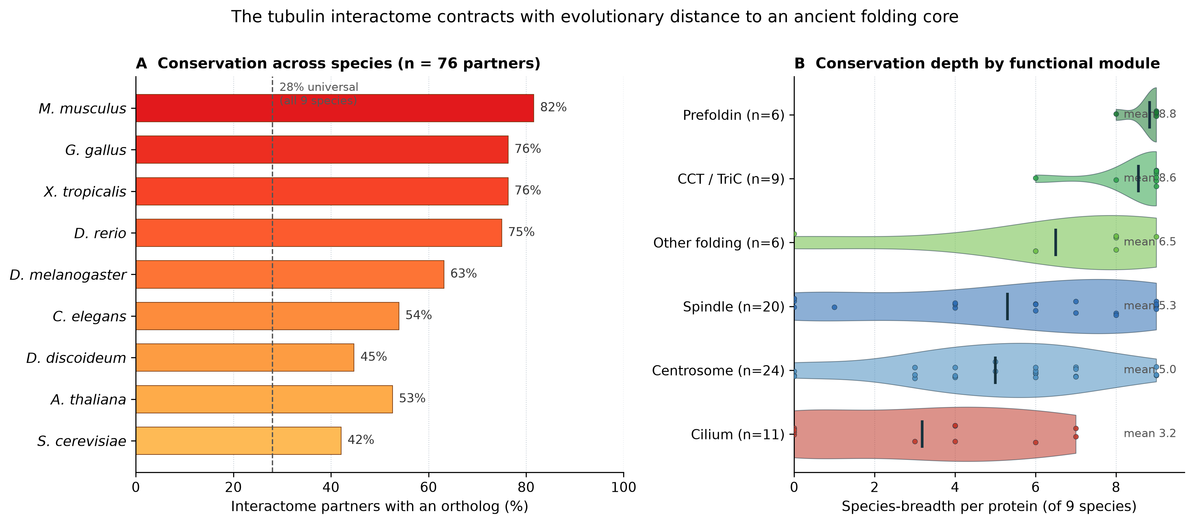
Figure 10. Cross-species conservation of the interactome. A: fraction of partners with an ortholog per species. B: conservation depth by functional module (violin of species-breadth; points are individual proteins).

3.6 Structure and evolution: where the conserved residues sit
Real-valued evolutionary trace over the thirty-four-tubulin alignment identified 83 invariant alignment columns and placed the importance of every residue on the alpha/beta dimer (Figure 11). Sustained high plateaus fall around residues 90 to 150 and 170 to 230, the core of the fold, and top-trace residues are enriched at functional sites with a Fisher odds ratio of 2.09 at p = 2.2e-3, an enrichment carried by contacts to the bound nucleotides and ligands; sixty-nine residues that are exposed in a lone monomer bury on dimerisation. Motif discovery recovered the glycine-rich GGGTGSG nucleotide loop and the VVEPYN core strand de novo, and the method recovers the GTP N-site (19 alpha contacts), the GDP E-site (15 beta contacts), the taxane pocket including the M-loop at 272 to 278, and the zinc and magnesium sites without being told where they are (Table 5), which is the positive control the analysis needed.
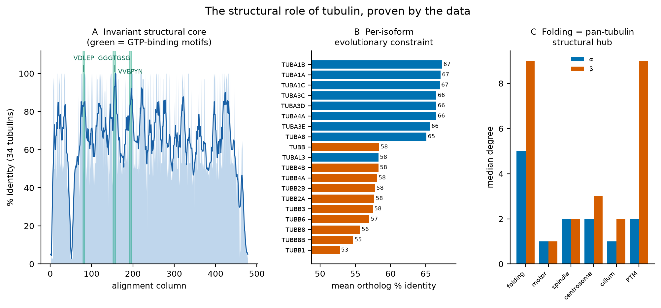
Figure 11. Evolutionary trace along the tubulin fold. A: per-column identity across the 34-tubulin alignment with the GTP-binding motifs marked. B: per-isoform mean ortholog identity, showing the alpha isotypes as the more constrained. C: median partner degree by functional module, placing folding as the pan-tubulin structural hub.

Table 5. Nucleotide-contact residues recovered on the structure
Tubulin | Site | No. | Residues (PDB 1JFF numbering)
alpha | GTP | 19 | 10, 11, 12, 15, 99, 100, 101, 140, 143, 144, 145, 146, 171, 179, 183, 206, 224, 227, 228
beta | GDP | 15 | 10, 11, 12, 15, 140, 142, 143, 144, 145, 146, 179, 183, 206, 224, 228

3.7 Corroboration by independent arms
Three arms confirm the census without repeating its evidence. Literature text-mining (PubTator3) ranked partners by specificity, co-mentions divided by total mentions, and put the microtubule machinery at the top, the gamma-tubulin ring complex (TUBGCP4 at 75 percent, then TUBGCP3, TUBGCP2, NEDD1, TUBG1), the modifying enzymes SVBP and TTL, and the ciliary and centrosomal proteins. Cross-arm correlation across seven evidence features shows the arms agree, degree and records at r = 0.70 in both families and database support and literature co-mention at 0.52 and 0.62 (Figure 12). hu.MAP 2.0 corroborated 48 partners at the complex level and flagged the novel ones. Two structural checks close the corroboration. MCODE, told nothing about tubulin folding, returned as its densest complex the CCT5, CCT6A, CCT7 and CCT8 subunits of the CCT/TriC chaperonin plus the mitotic kinases AURKA and AURKB (Figure 13). The EBI Complex Portal benchmark of 109 curated complexes (284 members) shows recall is not uniform (Figure 14): direct tubulin-biogenesis machinery at 62.5 percent (2.76-fold, p = 1.5e-6) and the wider microtubule system at 27.7 percent, overall 31.3 percent, with the CCT/TriC chaperonin recovered whole at 8 of 8 and prefoldin at 6 of 6 while the gamma-tubulin ring complex reaches 5 of 10 and the polyglutamylase complex none (Table 6). Recoveries are assay-backed, 85 of 89. Current assays see the stable complexes that build tubulin far better than the transient assemblies tubulin builds.
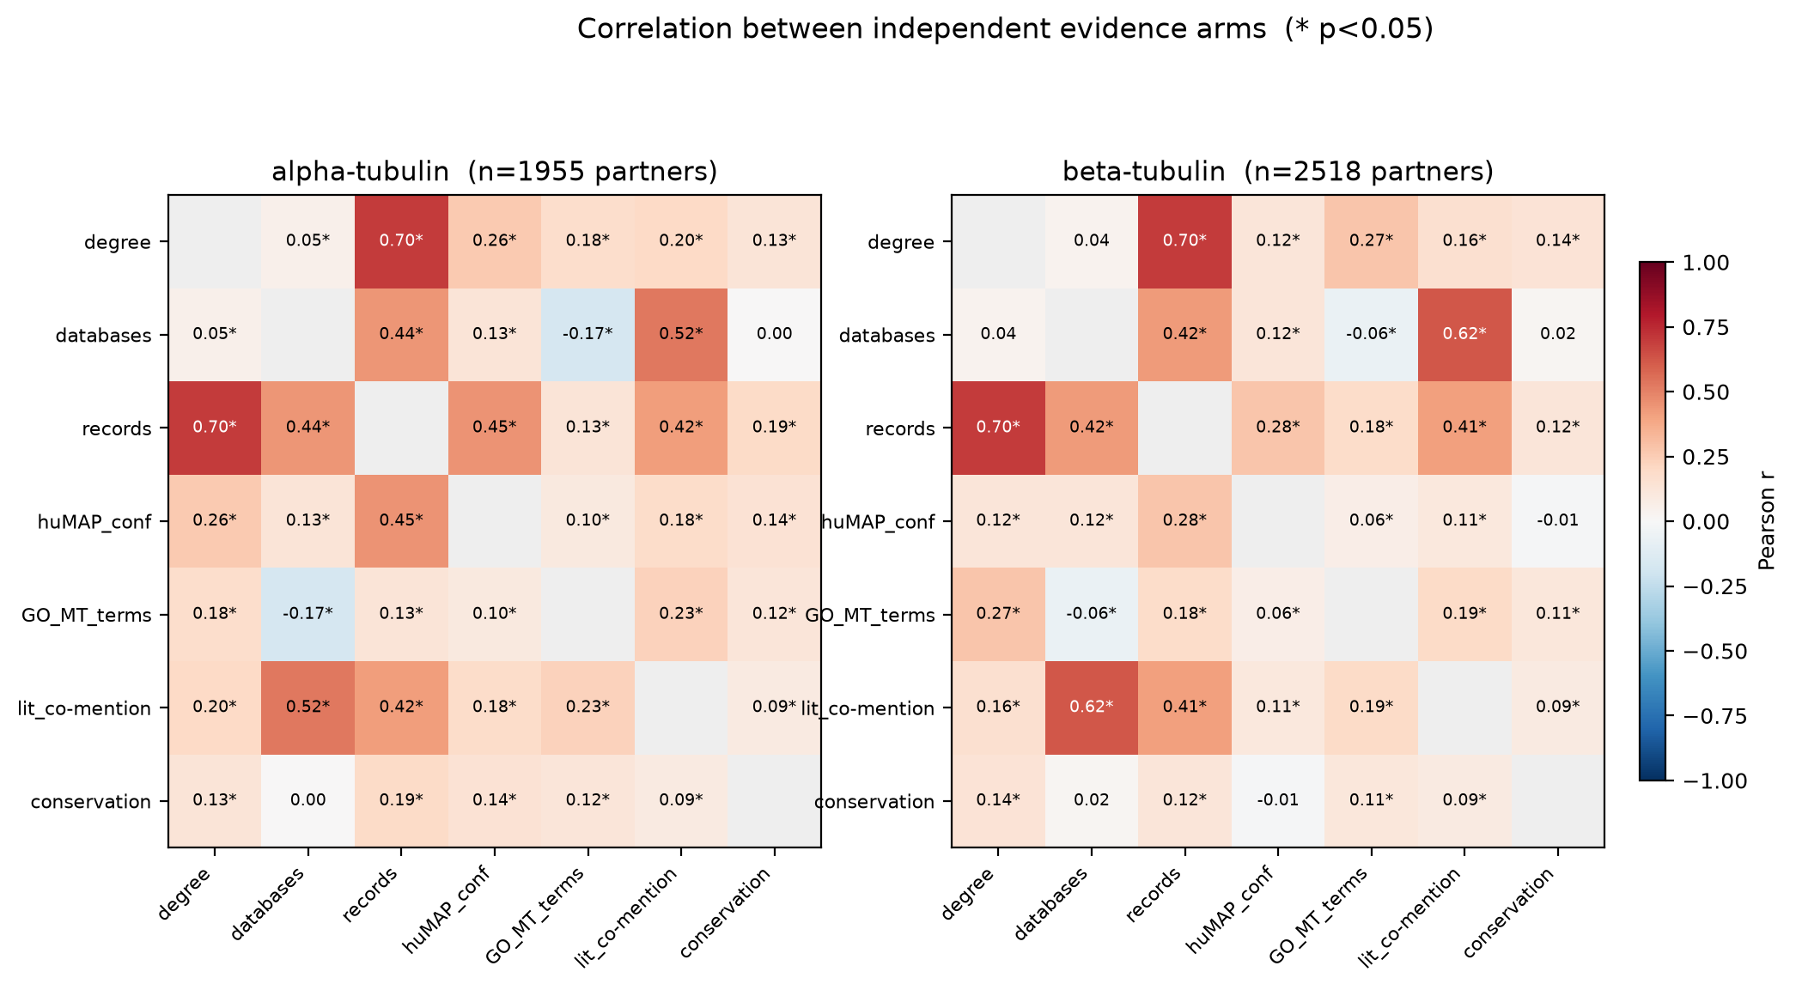
Figure 12. Correlation between the seven independent evidence arms; alpha (n = 1,955) and beta (n = 2,518). Asterisks mark p < 0.05.
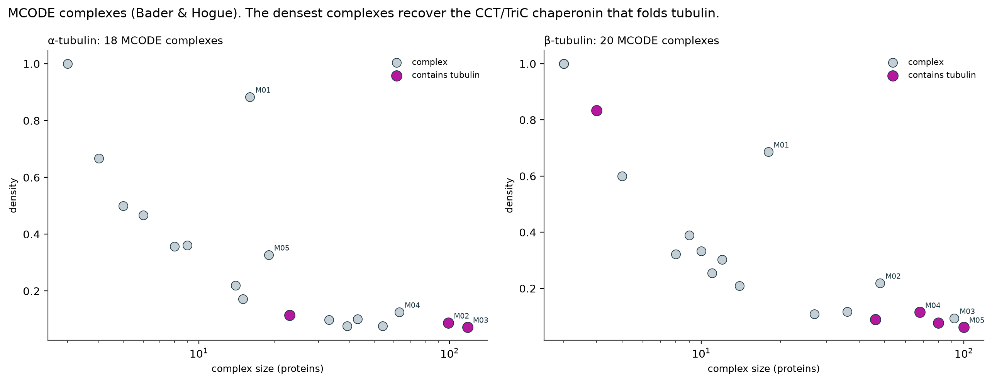
Figure 13. MCODE dense complexes; the densest recovers the CCT/TriC chaperonin from graph topology alone.
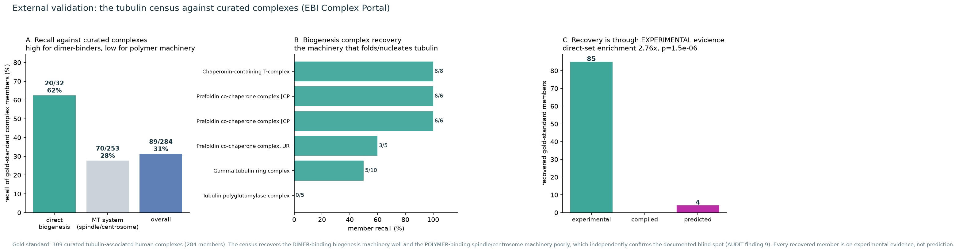
Figure 14. EBI Complex Portal benchmark: the recall asymmetry and its assay backing.
The literature arm is shown in full in Figure 15. Ranking every partner by tubulin-specificity, the co-mentions with tubulin divided by its total literature mentions, puts the gamma-tubulin ring complex at the very top, TUBGCP4 at 75 percent, TUBGCP3 at 74 and TUBGCP2 at 73, followed by the polyglutamylation adaptor SVBP, the cofactor TBCB, the templating factor NEDD1 and the tyrosine ligase TTL. Placing the partners on a plane of how well studied against how specific separates a specific core, the folding, templating and modifying machinery, from proteins that are heavily studied but only incidentally tubulin-associated such as MAPT and SQSTM1. The specificity ranking is computed independently of the interaction assays, so its recovery of the same biogenesis machinery that tops the benchmark and the MCODE result is a genuine cross-validation rather than a restatement.
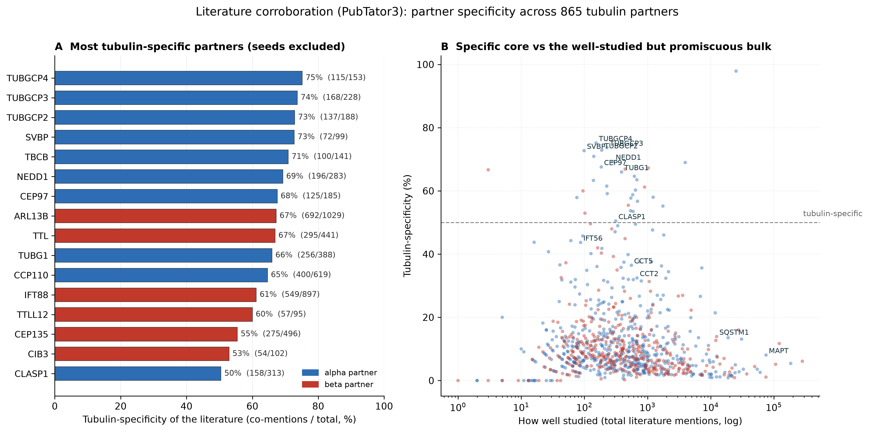
Figure 15. Literature corroboration (PubTator3). A: most tubulin-specific partners with the seeds removed. B: every partner placed by total mentions against tubulin-specificity.

Table 6. EBI Complex Portal benchmark: per-complex recovery (direct biogenesis)
Complex | Recovered / members | Recall | Category
Chaperonin-containing T-complex | 8/8 | 100% | direct biogenesis
Prefoldin co-chaperone complex [CPX-6149] | 6/6 | 100% | direct biogenesis
Prefoldin co-chaperone complex [CPX-25767] | 6/6 | 100% | direct biogenesis
Prefoldin co-chaperone complex, URI1 variant | 3/5 | 60% | direct biogenesis
Gamma tubulin ring complex | 5/10 | 50% | direct biogenesis
Tubulin polyglutamylase complex | 0/5 | 0% | direct biogenesis

3.8 The high-confidence interactomes, drawn
The census assembles into modular small-world maps. The human alpha high-confidence map holds 385 proteins and 1,559 replicated edges at a modularity of Q = 0.38 (Figure 16), the beta map 499 proteins and 2,535 edges at Q = 0.32 (Figure 17), and the C. elegans map 77 proteins and 292 edges at Q = 0.25, built the same way from worm BioGRID and HINT (Figure 18). Each map resolves the folding, spindle, centrosome, cilium and membrane modules as separate coloured neighbourhoods around the tubulin seeds, and the CCT/TriC ring is visible in the alpha map.
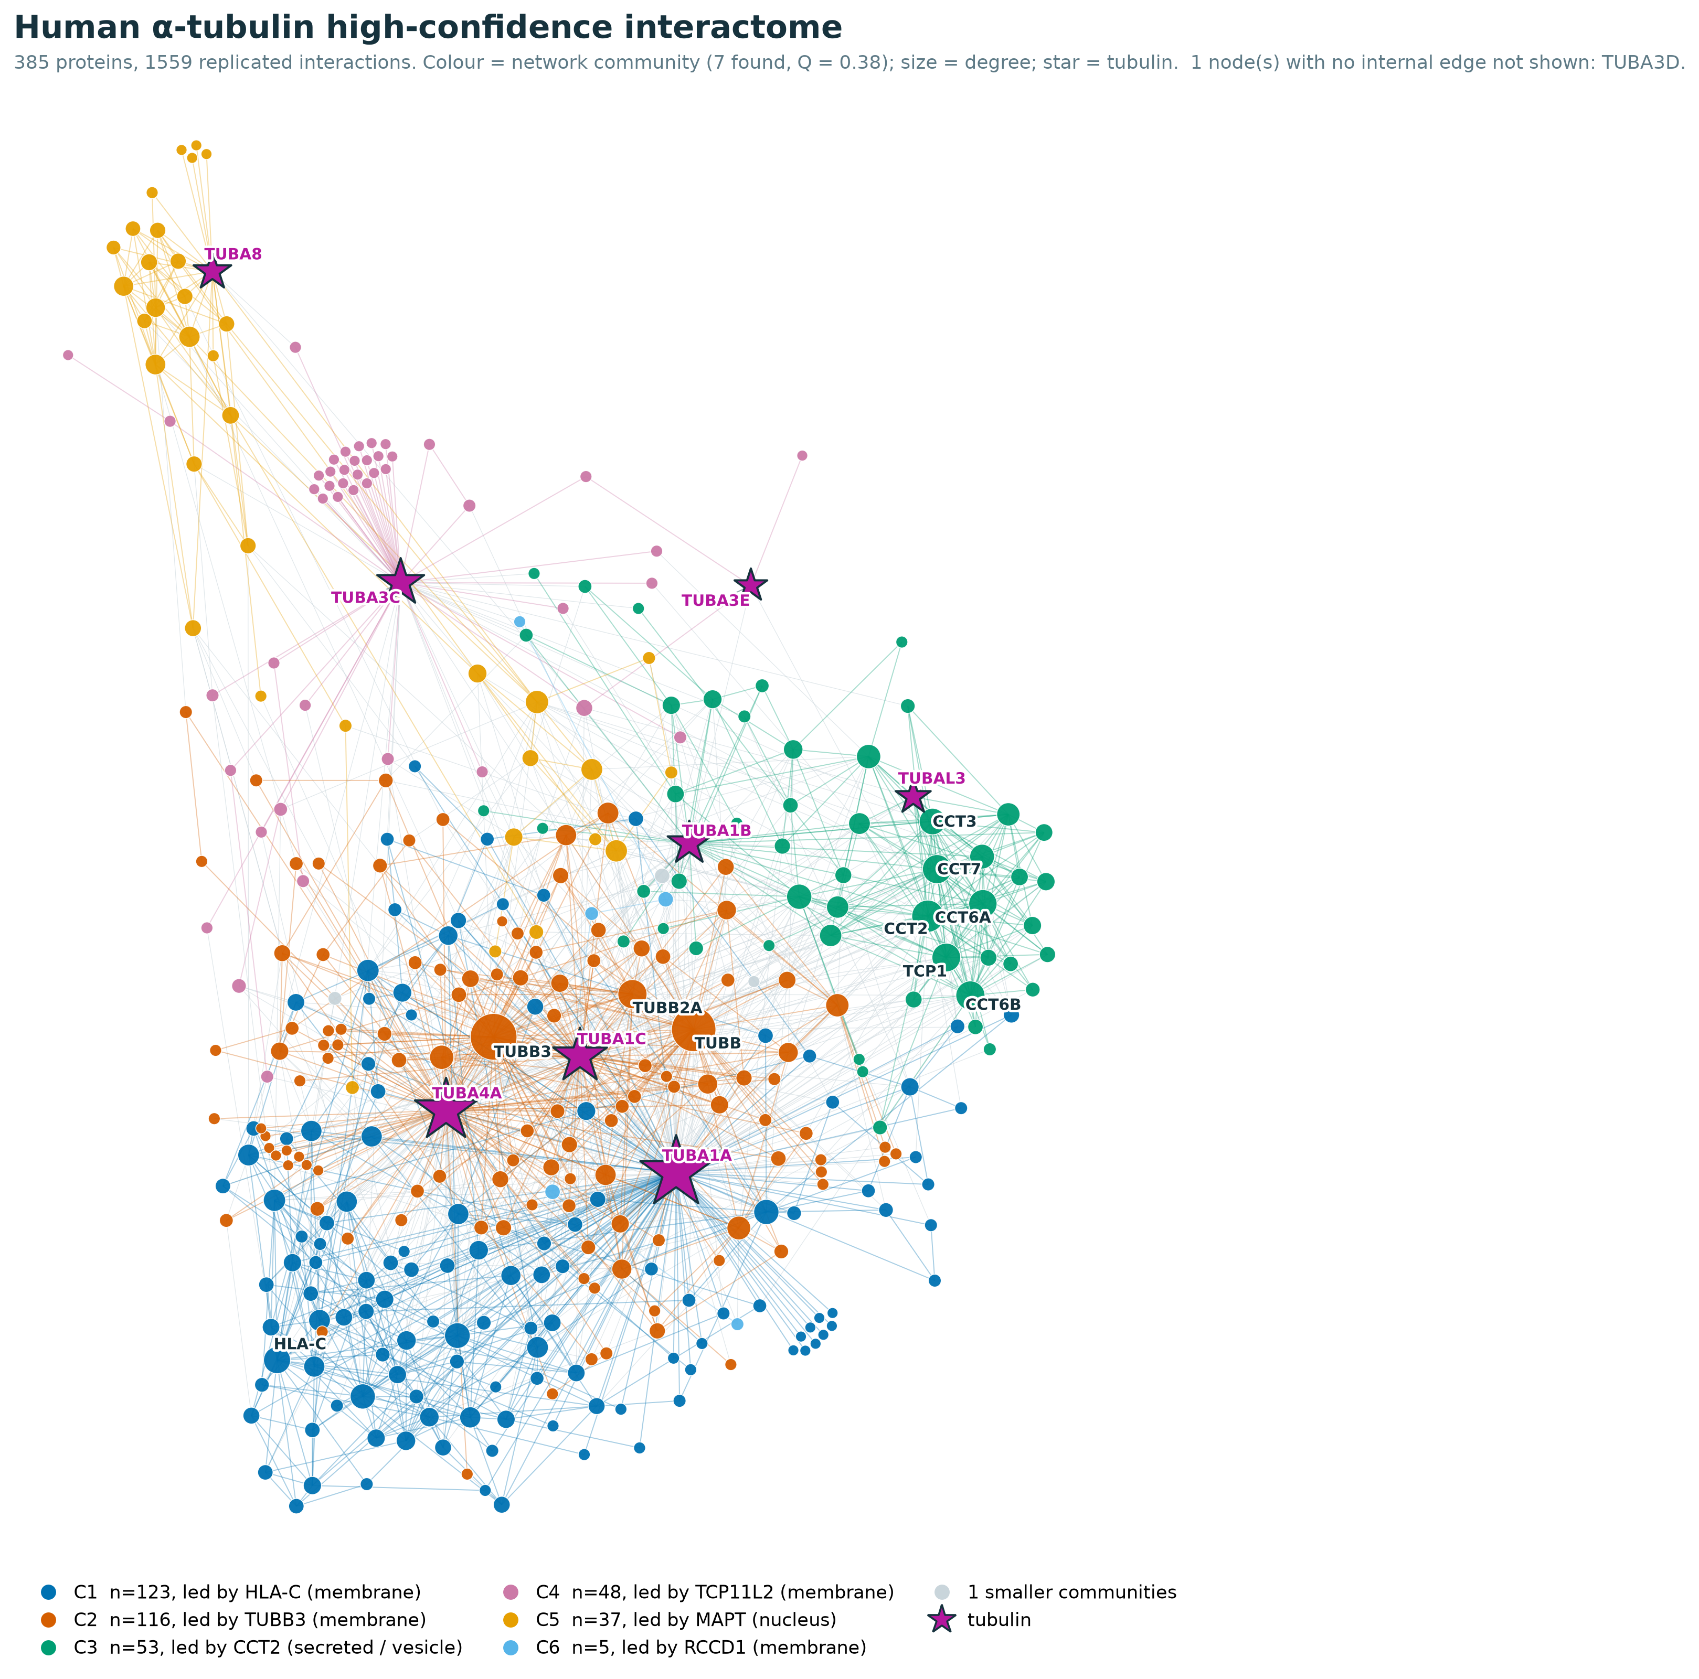
Figure 16. Human alpha-tubulin high-confidence interactome (385 proteins, 1,559 replicated edges, Q = 0.38).
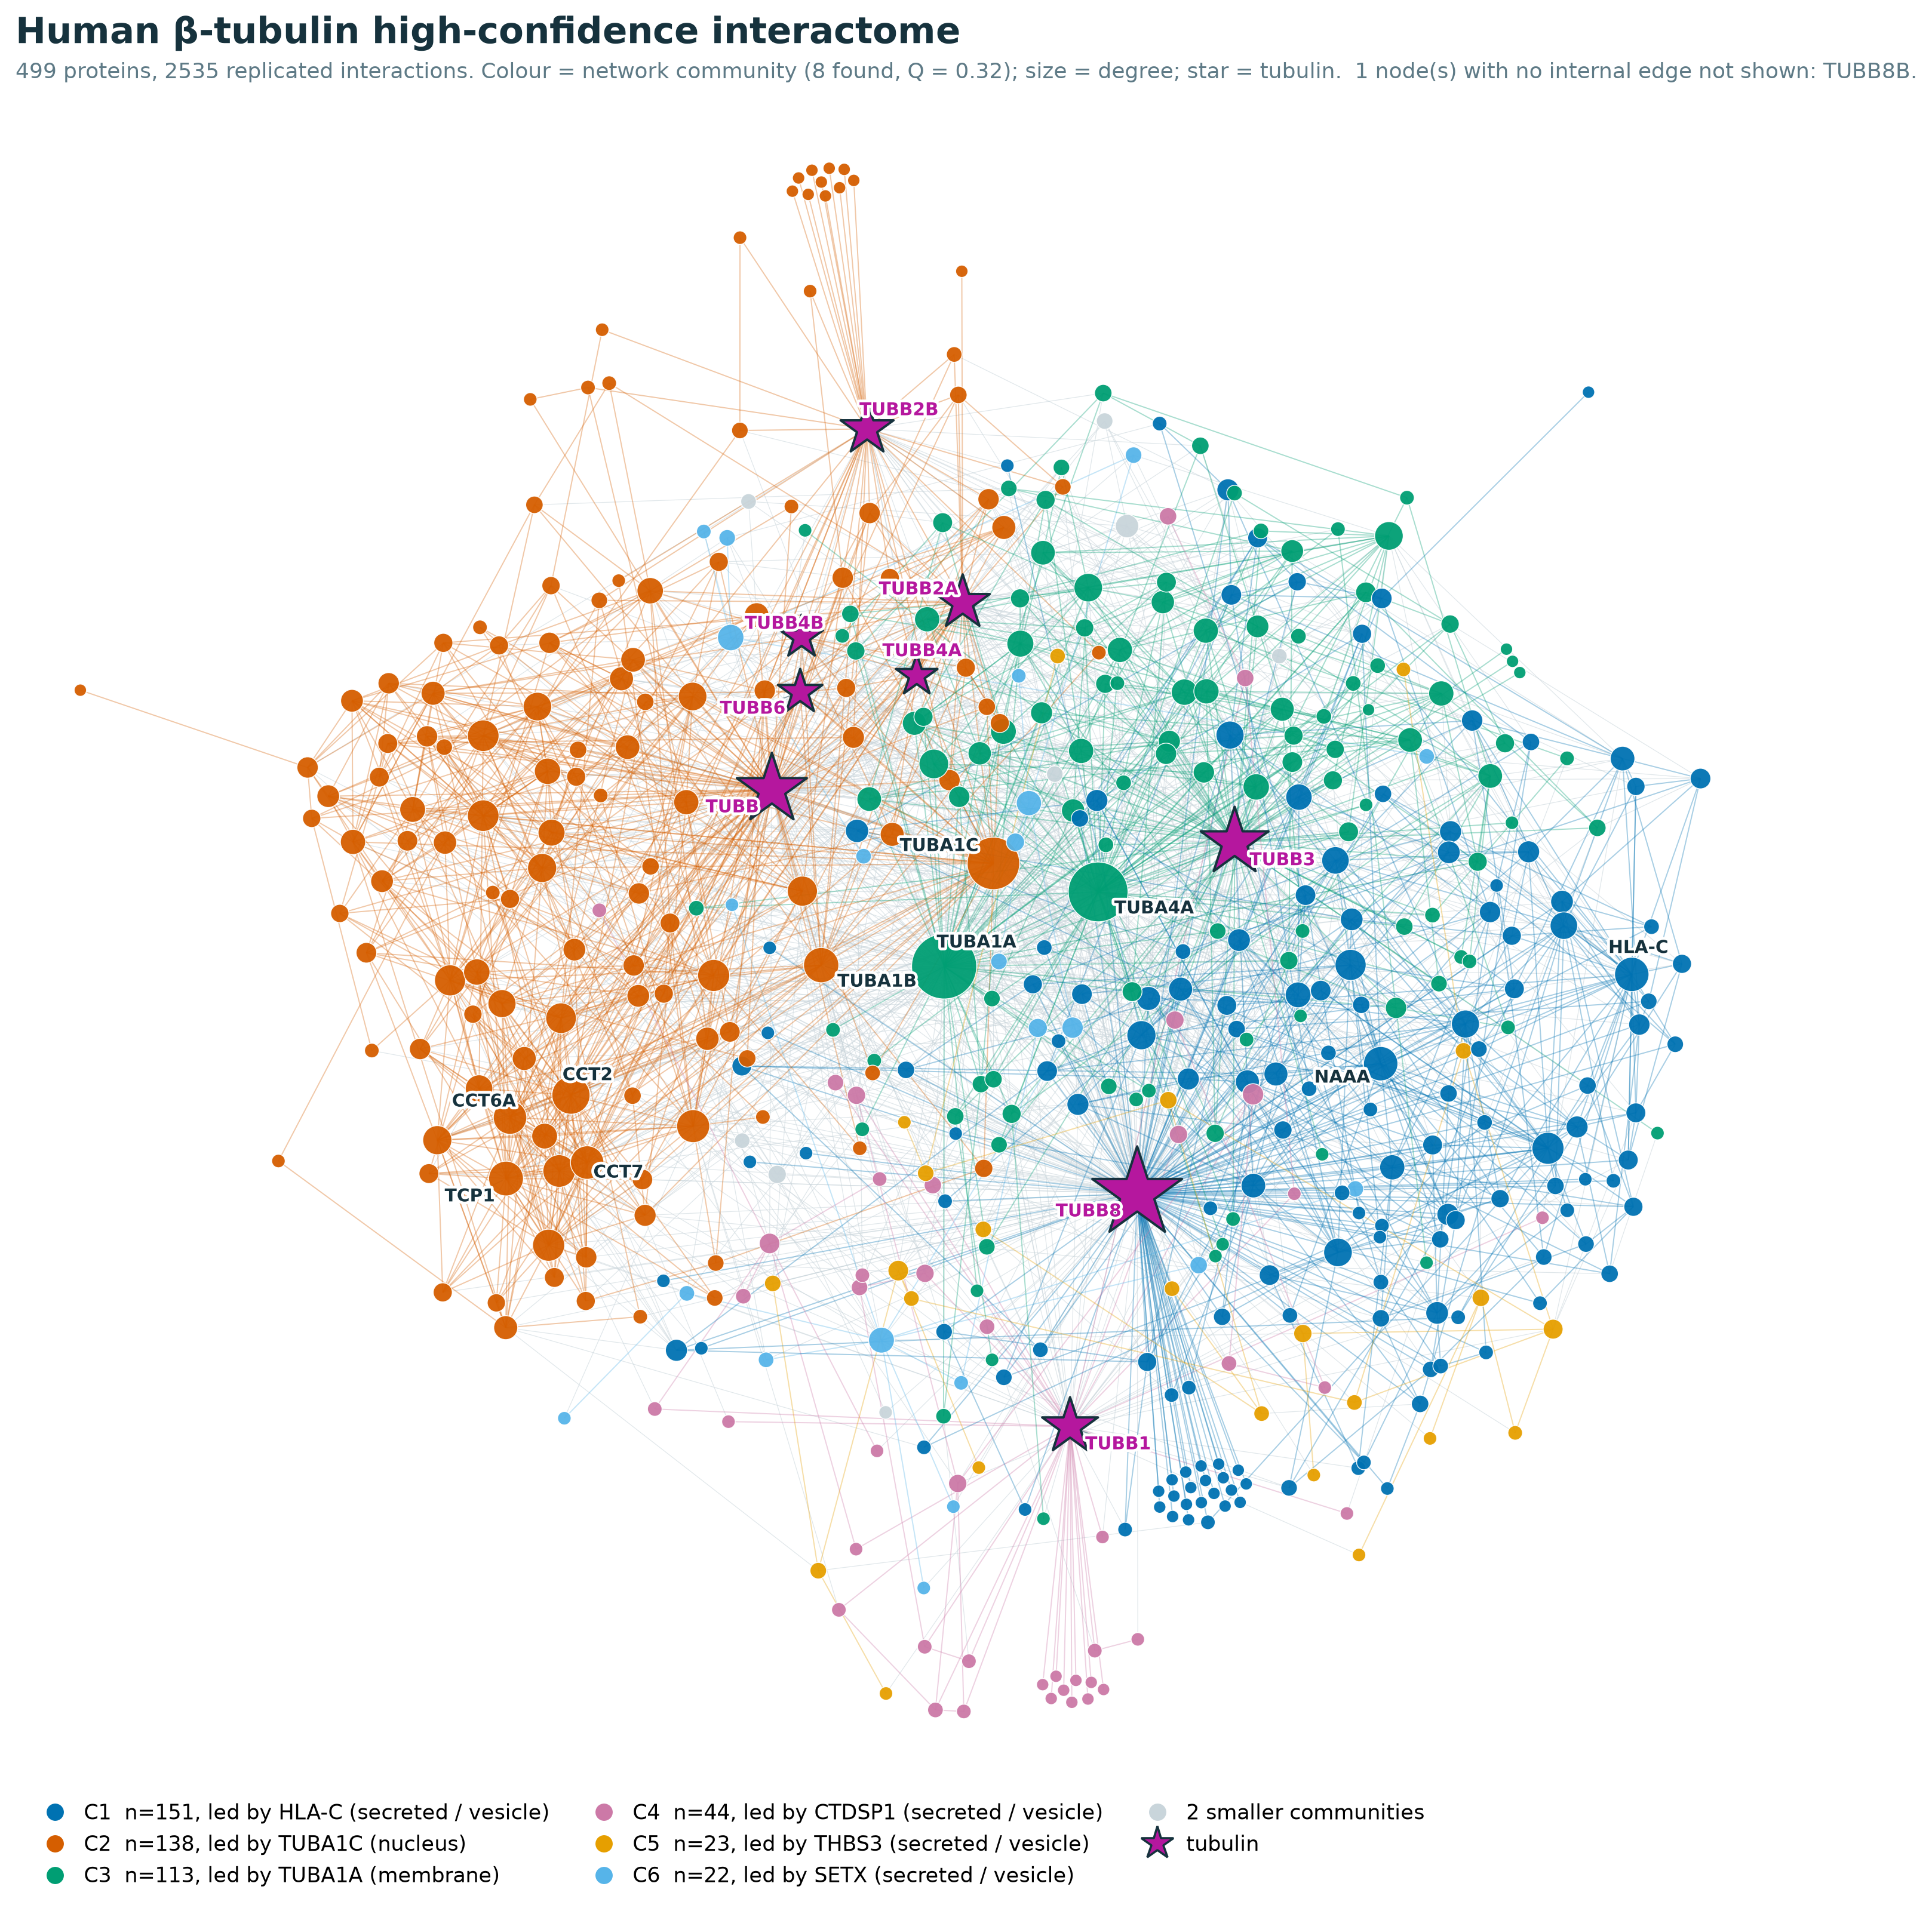
Figure 17. Human beta-tubulin high-confidence interactome (499 proteins, 2,535 replicated edges, Q = 0.32).
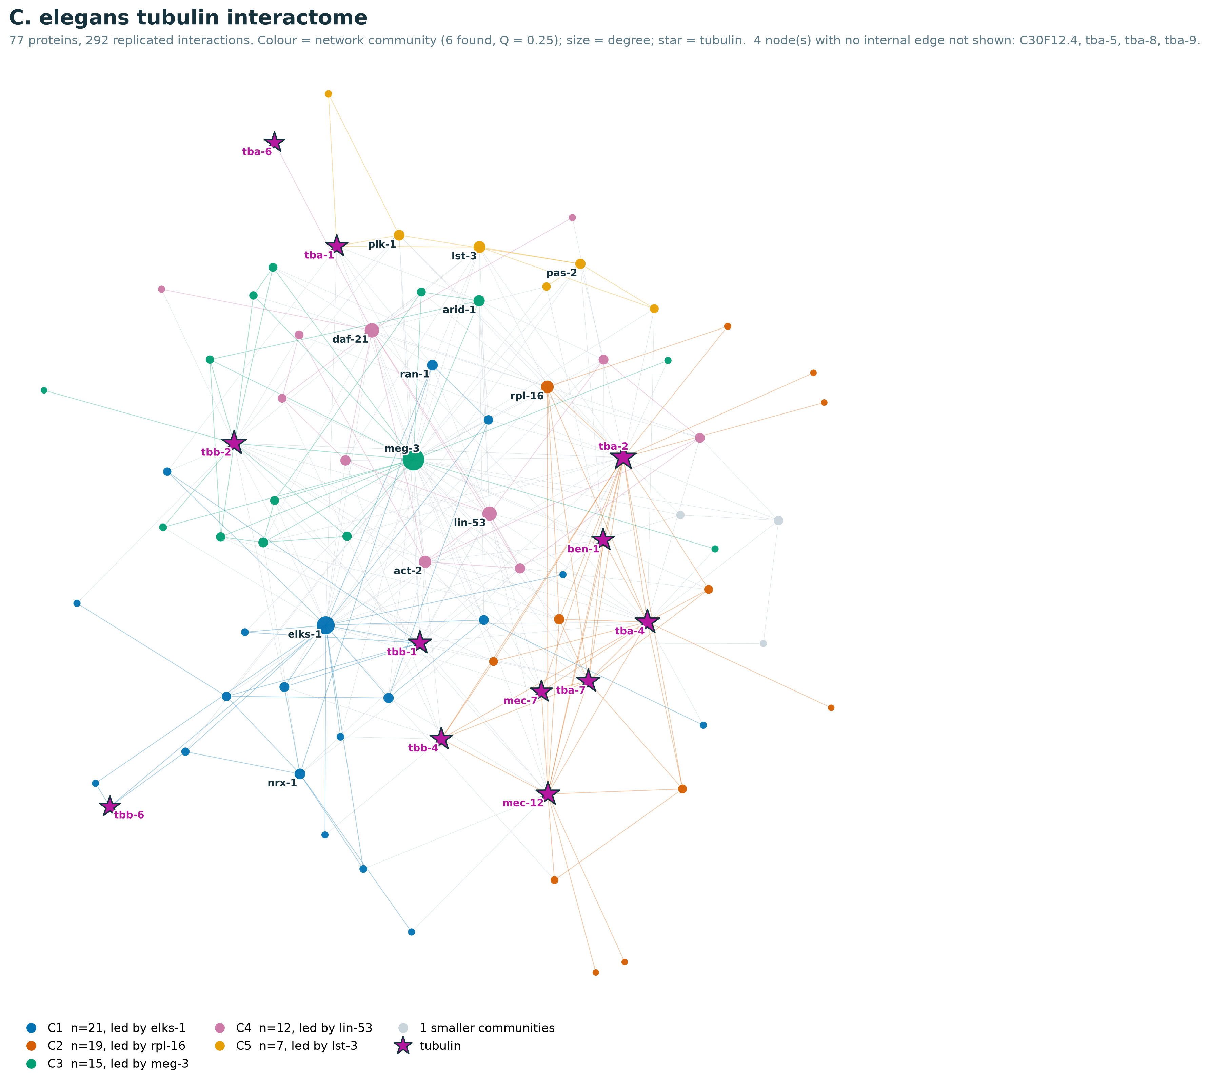
Figure 18. The C. elegans tubulin interactome (77 proteins, 292 edges, Q = 0.25).

3.9 Annotation: coverage, function, structure and localisation
The census is not a bare edge list. Every partner with a UniProt accession, the full set of 2,732 tubulin-associated proteins rather than a curated subset, carries a complete annotation layer, and its coverage is high and even (Figure 19): Gene Ontology cellular component and Pfam reach 98 percent, OMIM 96 percent, UniProt subcellular location 92 percent, the structure classifications CATH and SCOP 86 and 82 percent, and post-translational sites 70 percent, with the sparser curated-disease, glycosylation and lipidation layers at 35, 19 and 6 percent. This is what the annotation tells about the database: a reader can pull the domain architecture, the fold class, the location, the modifications, the disease links and the conservation of essentially any partner from one record.
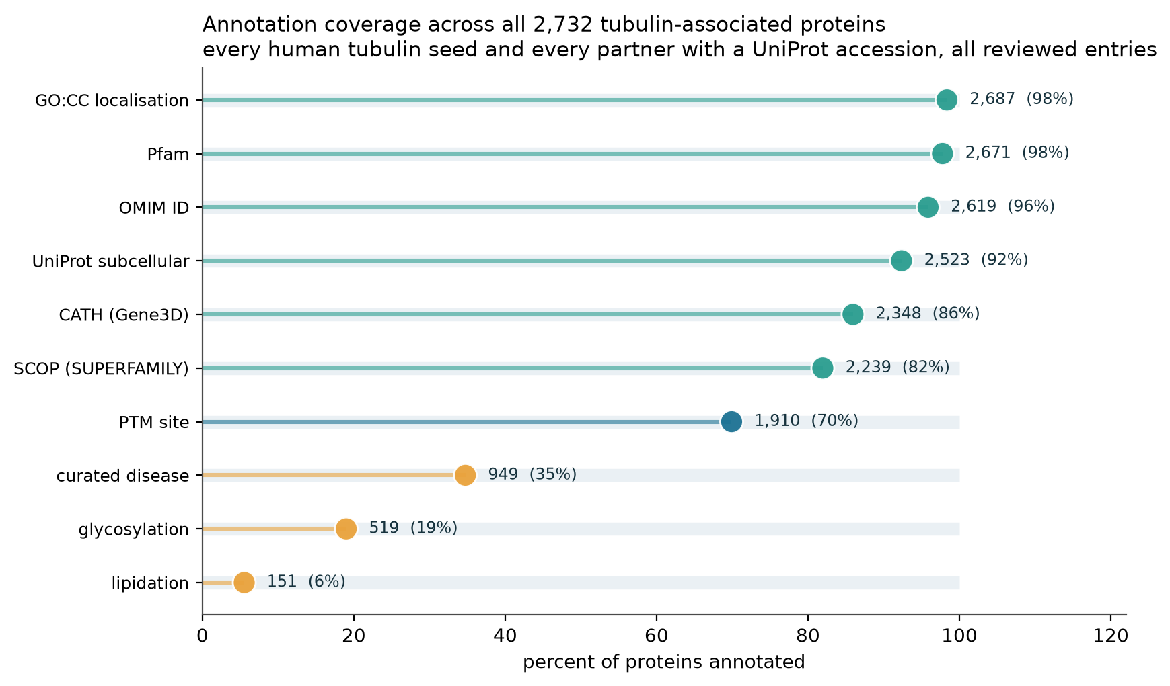
Figure 19. Annotation coverage across all 2,732 tubulin-associated proteins.
Functional and structural annotation. By molecular function the census is a collection of enzymes and adaptors. The commonest Gene Ontology molecular-function terms are catalytic activity acting on a protein (665 proteins), transferase activity (565), hydrolase activity (464) and DNA binding (301), and at the fold level CATH and SCOP resolve the partners into the kinase, GTPase, chaperonin, WD40 and coiled-coil superfamilies that the domain route already implies. Order itself is a discriminator: the median MobiDB-Lite disorder of the tubulin seeds is 0.050 against 0.159 for the partners (p = 5.7e-6), so tubulin is a compact, ordered hub that recruits more disordered partners, and the disorder concentrates in the same carboxy-terminal regions the tubulin code decorates.
Correlations drawn through the Pfam annotations. The pfam2go route links a partner’s Pfam domain to the Gene Ontology terms it implies, and this lets the mechanism a domain encodes be checked against the process a pathway records and the interaction an assay reports. A co-annotation chord diagram of the domain-derived Gene Ontology terms against the curated Reactome membership (Figure 20) shows broad agreement, with catalytic, transferase and hydrolase activity feeding Metabolism of Proteins, the Immune System, Signal Transduction and Disease, so the fold, the pathway and the interaction tell the same story. The domain route also meets the interaction route directly (Figure 4): the domain-carrying genes are largely recovered by physical interaction in both families, and the domain-only tail marks tubulin-binding folds the assays have not yet caught, so the Pfam annotation both corroborates and extends the physical census.
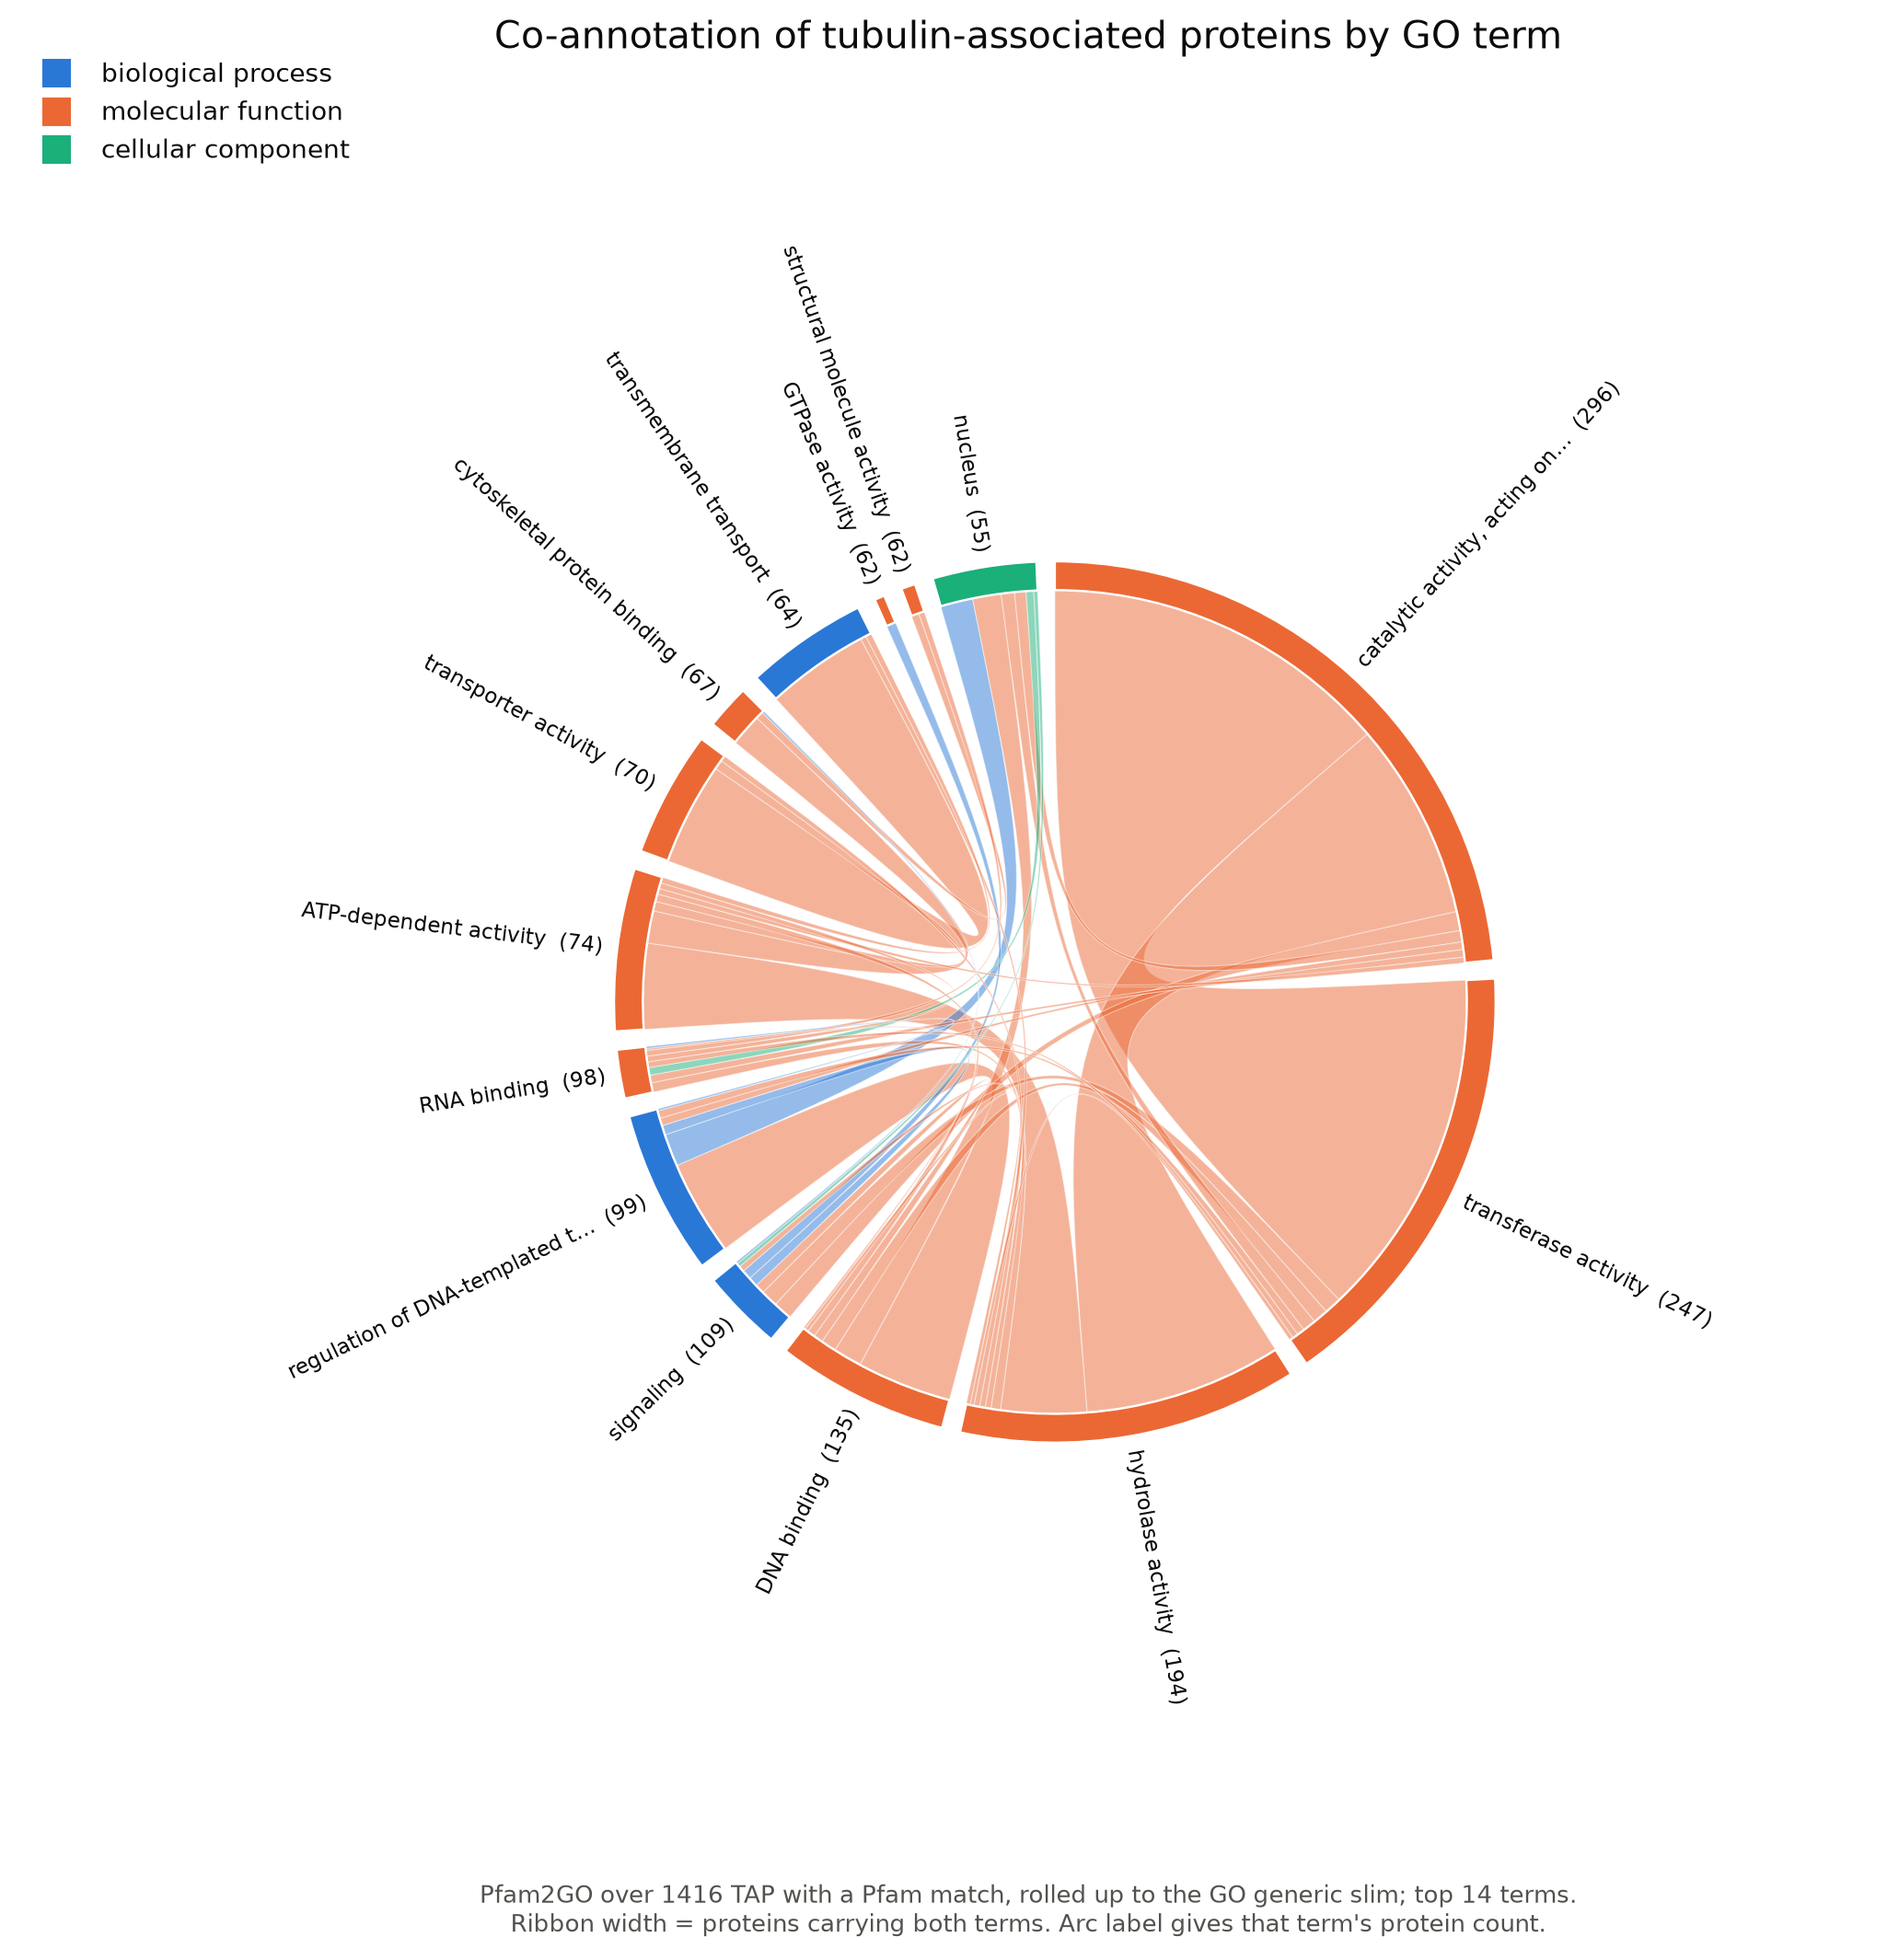
Figure 20. Co-annotation by GO term and domain-derived GO versus curated Reactome; the census is dominated by enzymes.
Cellular localisation. By location the partners live mostly in the cytosol, the nucleus and the cytoplasm, then the nucleoplasm, the plasma membrane and the extracellular exosome (Figure 21). Collapsed into compartment classes the same partners are membrane (50 percent), nuclear (48 percent), secreted or vesicular (42 percent), cytoskeletal or microtubule-associated (22 percent) and mitochondrial (12 percent) at once, the classes summing above 100 percent because a single protein can carry several localisations. The breadth is itself a result: the tubulin interactome reaches across the whole cell rather than sitting only on the cytoskeleton.
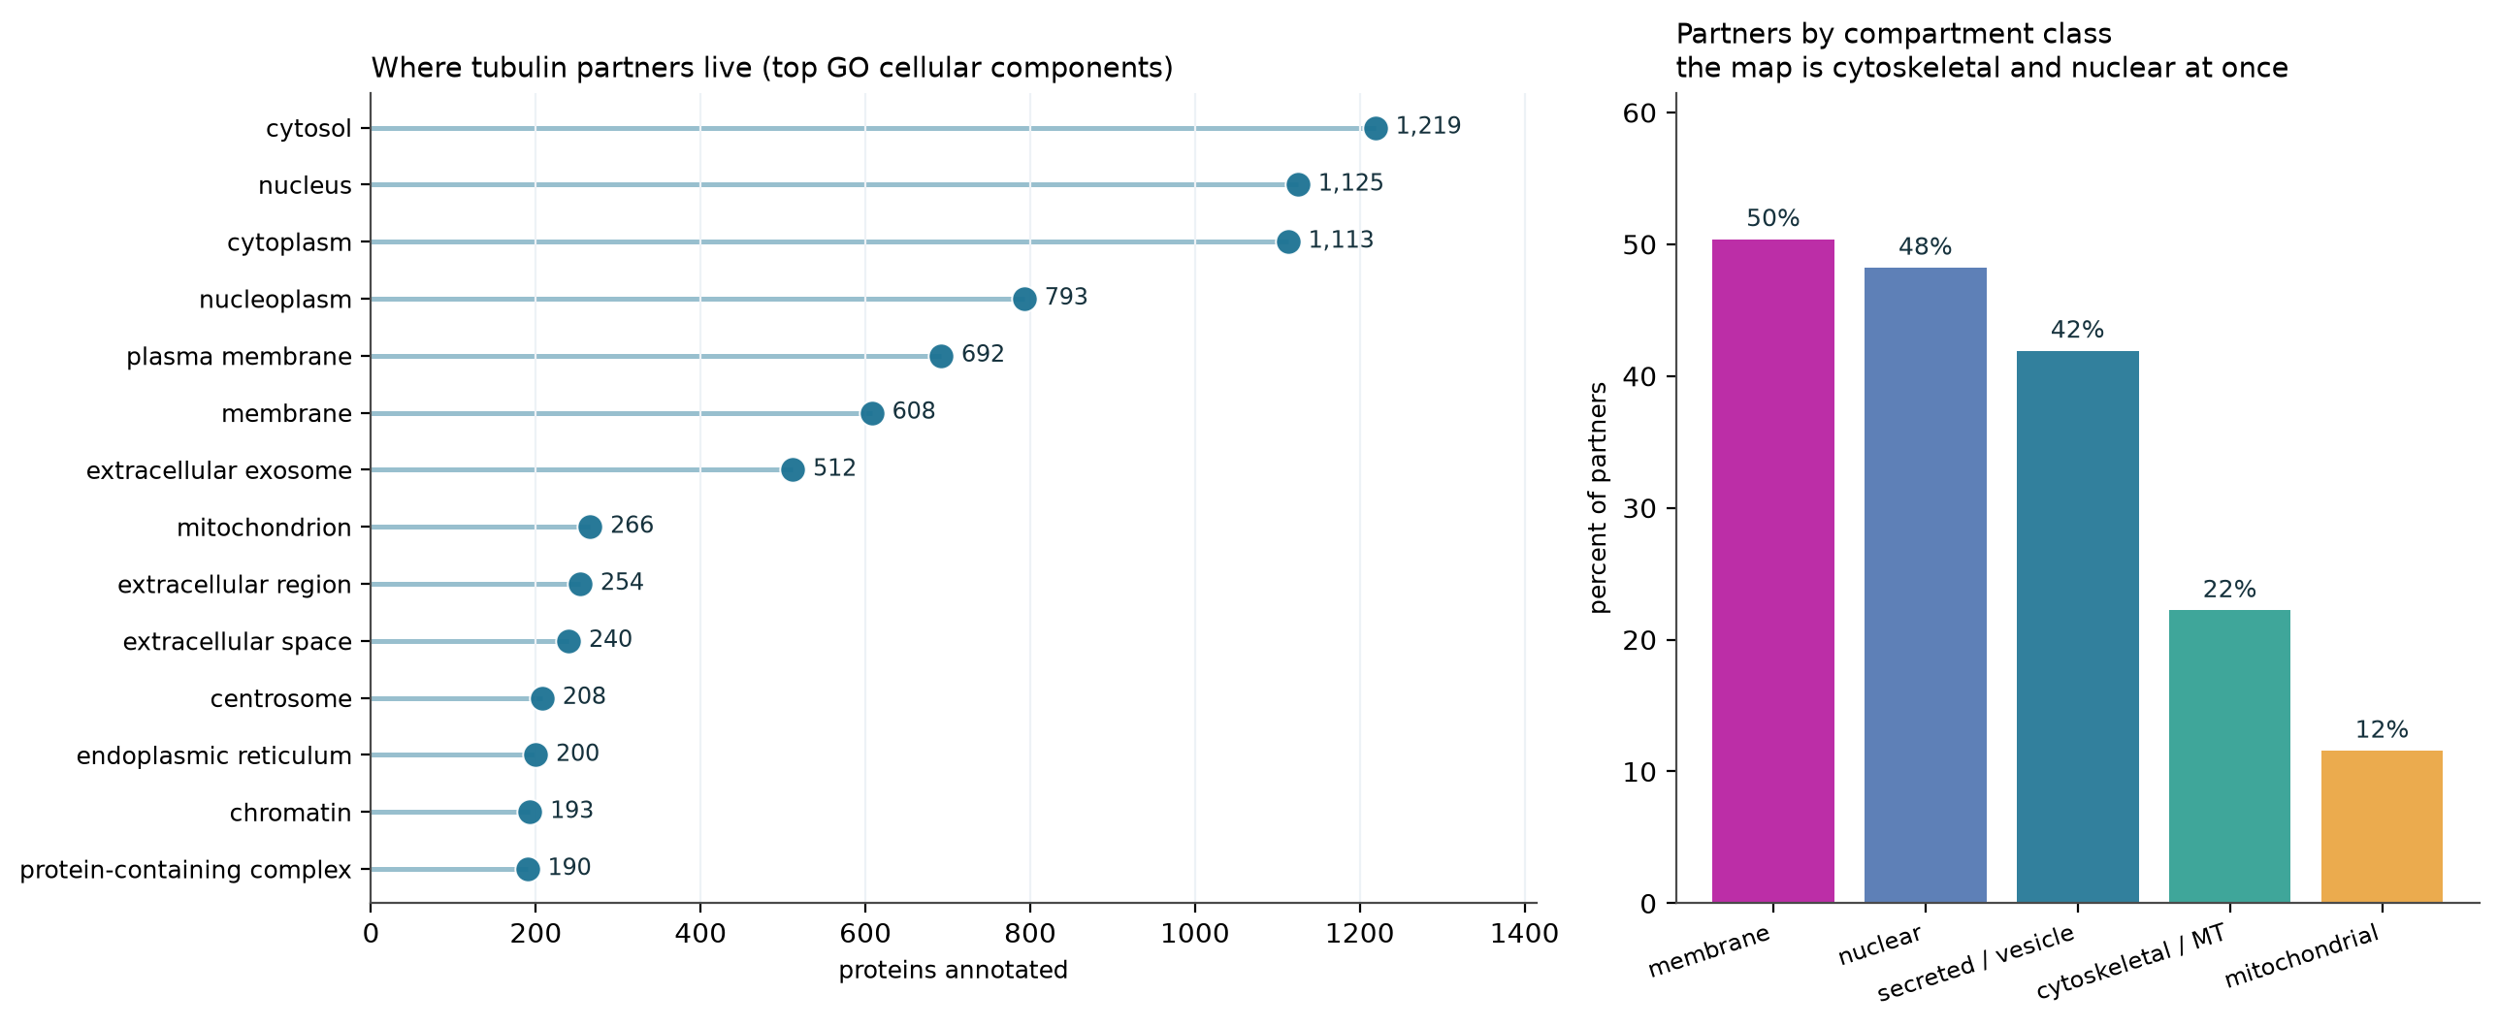
Figure 21. Cellular localisation: top GO cellular components and collapsed compartment classes.
Post-translational modification. The set carries 17,754 modification sites dominated by phosphorylation, with N-linked glycosylation and acetylation next (Figure 22). On the tubulin seeds these pile onto the carboxy-terminal tail, 43 percent of the sites in the last twenty-five residues, exactly where the evolutionary trace shows conservation is lowest, so the ordered body is fixed and the tail is the tunable surface that carries the detyrosination, polyglutamylation and acetylation marks of the tubulin code.
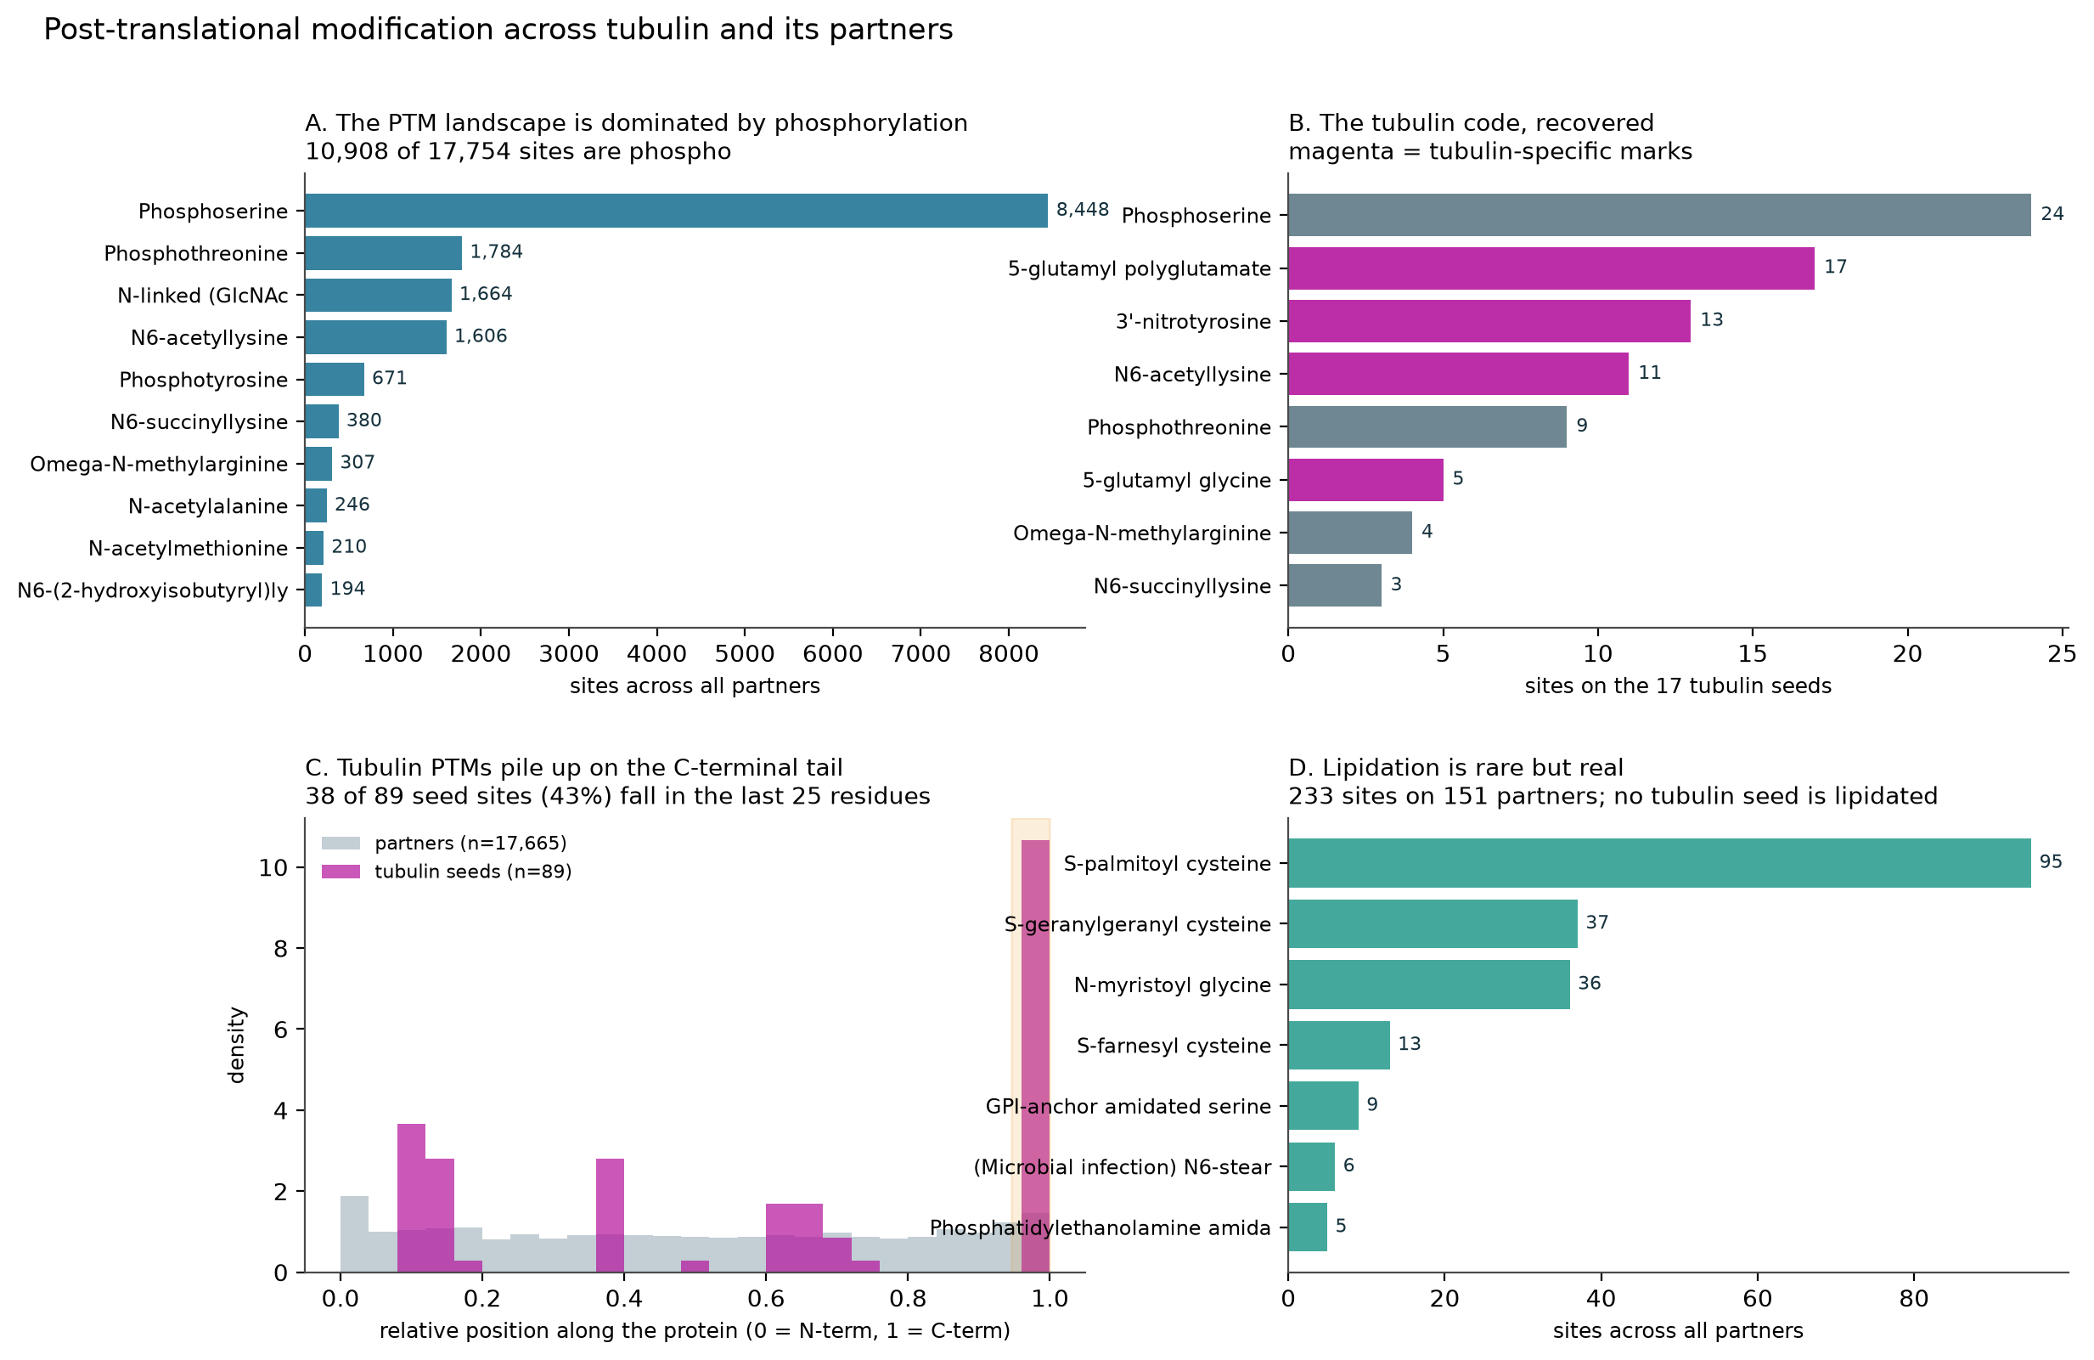
Figure 22. Post-translational modification across tubulin and its partners. A: the modification landscape, dominated by phosphorylation (10,908 of 17,754 sites). B: the tubulin-code marks recovered on the seeds (magenta). C: seed modifications pile onto the carboxy-terminal tail, 43 percent in the last twenty-five residues. D: lipidation is rare (233 sites on 151 partners; no seed is lipidated).

3.10 Sequence motifs across the three species
Running MEME separately on the human alpha, human beta and worm partner sets found family-level motifs, chiefly the kinase catalytic and activation loops, which reflects the many kinases in the interactome (Figure 23). Cross-set matches are few, two between alpha and worm, two between alpha and beta and one between beta and worm; the shared word is the nucleotide-binding machinery itself rather than a generic linker. The kinase catalytic loop (HRDLKP) and the activation segment recur between the alpha and beta partner sets, and the Walker A P-loop of the kinesin and wider NTPase families links the alpha partners to the worm. At the motif level the census is a set of enzymes and nucleotide-handling motors that share their most conserved catalytic words across species.
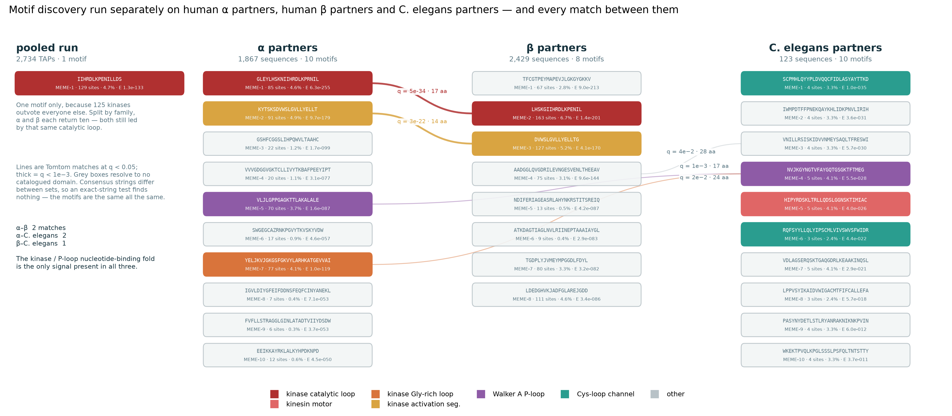
Figure 23. Sequence motifs across human alpha, human beta and C. elegans partner sets, and the few cross-set links.
The motifs themselves are shown as information-content logos in Figure 24. The dominant signal in every partner proteome is the protein-kinase module: the catalytic loop with its invariant His-Arg-Asp triad and downstream asparagine, the DFG-anchored activation segment, and the glycine-rich loop with its GxGxxG print. All three are recovered in both the alpha and beta sets. Alongside them the Walker A P-loop, GxxxxGKT, marks the wider family of P-loop NTPases, and the same fold appears as the kinesin motor motif in the worm set. The recurrence of the kinase and P-loop nucleotide-binding fold across the alpha, beta and worm partner sets is the sequence-level echo of the pathway and benchmark results, where the nucleotide-handling and folding machinery is the part of the interactome that assays and conservation agree on most strongly.
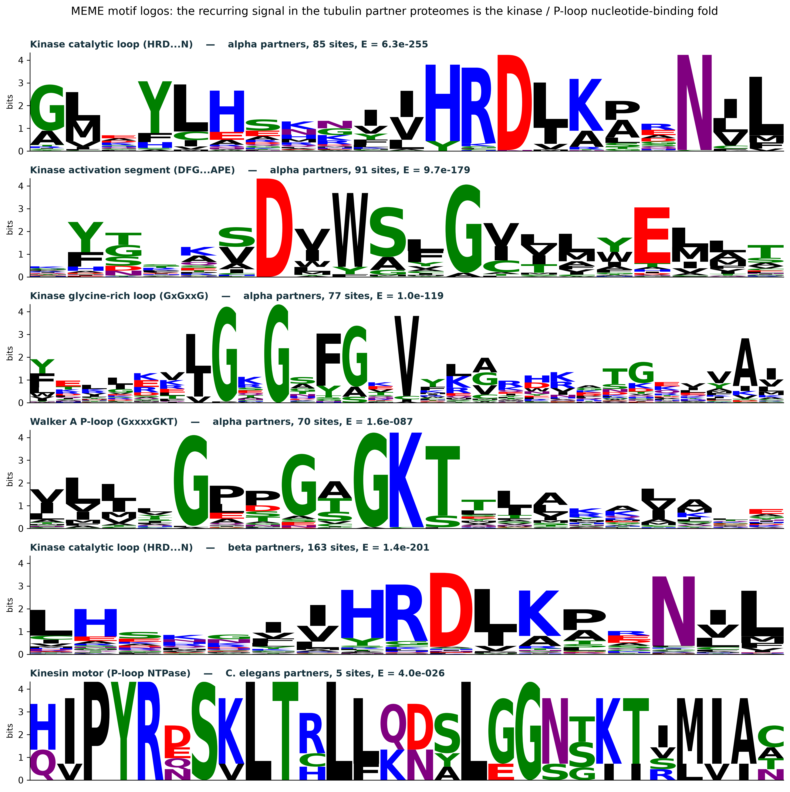
Figure 24. MEME sequence logos of the headline motifs (bits): the kinase catalytic loop, activation segment, glycine-rich loop and Walker A P-loop recovered in the alpha partners, the catalytic loop in the beta partners, and the kinesin-motor P-loop in the worm partners.

Table 7. MEME sequence motifs across the tubulin partner sets
Set | Motif | Assigned family | Sites | % of set | E-value | Consensus
All TAPs (pooled) | MEME-1 | kinase catalytic loop | 110 | 3.6 | 2.0e-308 | IIHRDLKPRNILL
All TAPs (pooled) | MEME-2 | kinase activation seg. | 100 | 3.2 | 7.5e-240 | KSDVWSLGVLLYE
Alpha partners | MEME-1 | kinase catalytic loop | 85 | 4.6 | 6.3e-255 | HRDLKPRNIL
Alpha partners | MEME-2 | kinase activation seg. | 91 | 4.9 | 9.7e-179 | KSDVWSLGVLLYELL
Alpha partners | MEME-5 | Walker A P-loop | 70 | 3.7 | 1.6e-87 | VLJLGPPGAGKTTLA
Alpha partners | MEME-7 | kinase Gly-rich loop | 77 | 4.1 | 1.0e-119 | JKVJGKGSFGKVYLAR
Beta partners | MEME-2 | kinase catalytic loop | 163 | 6.7 | 1.4e-201 | IIHRDLKPENIL
Beta partners | MEME-3 | kinase activation seg. | 127 | 5.2 | 4.1e-170 | DVWSLGVLLYELLTG
C. elegans partners | MEME-4 | Walker A P-loop | 5 | 4.1 | 5.5e-28 | GYNGTVFAYGQTGSGKT
C. elegans partners | MEME-5 | kinesin motor | 5 | 4.1 | 4.0e-26 | HIPYRDSKLTRLLQDS

3.11 Orthogonal evidence: the census without interaction data
Every arm to this point rests on co-purification or curation. A final arm tests the census with genetic co-dependency from DepMap CRISPR screens across 1,208 cell lines, evidence that uses no interaction data at all (Figure 25). This arm nearly shipped an artefact: the uncorrected ranking was dominated by genes screened in only four or five cell lines, olfactory receptors, keratins and endogenous retroviral proteins such as OR4F17 at r = 0.81, a joint-observation artefact removed by requiring at least two hundred jointly screened lines with principal-component correction. After correction the co-essential partners recover tubulin’s own folding and motor machinery, and the arm provides independent support that promotes 61 predicted-tier partners to a higher confidence. Expression profiling across GTEx tissues validates the alpha two-group split, with the tissue-restricted isotypes TUBA3C, TUBA3D, TUBA3E, TUBA8, TUBAL3 and the beta outliers TUBB1, TUBB8 and TUBB8B separating from the broadly expressed set (Figure 26).
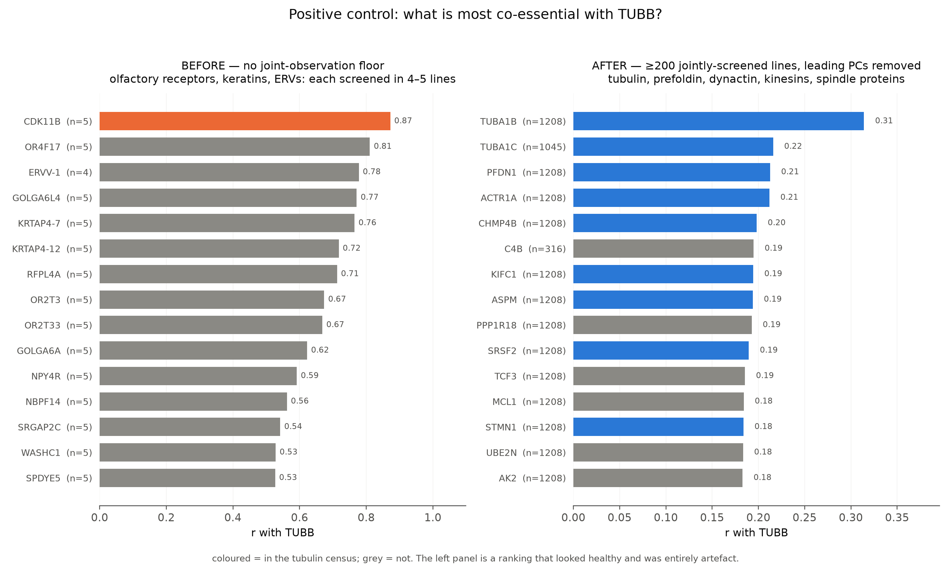
Figure 25. Orthogonal genetic co-dependency (DepMap): the co-essentiality signal before and after removing the screening artefact.
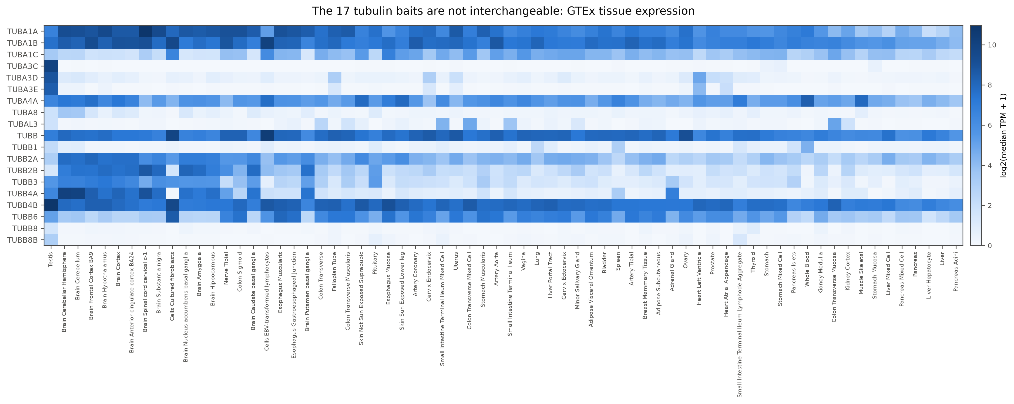
Figure 26. Isotype tissue-expression heatmap (GTEx), validating the alpha two-group split and tissue-restricted outliers.

3.12 Tubulin as a drug target: pockets on structure
Tubulin is among the most heavily drugged proteins in oncology: 88 agents act on tubulin and 25 are approved, from paclitaxel and docetaxel to the vinca alkaloids and the maytansinoid warheads of antibody-drug conjugates. The five clinical pockets, taxane, colchicine, vinca, laulimalide and pironetin, were mapped on their own crystal structures, taxane on 1JFF, colchicine on 1SA0, vinca on 1Z2B, laulimalide on 4O4H and pironetin on 5FNV, and are not distributed evenly between the chains (Figure 27). Ranking them by a durability score built from evolutionary conservation, isotype entropy and burial (Figure 28) puts the pironetin pocket on alpha and the vinca pocket at the interdimer interface as most durable, at 0.59 and 0.56, conserved, isotype-invariant and buried, while the laulimalide pocket on the beta exterior is least durable at 0.34 with the highest isotype entropy, making it isotype-selective and resistance-prone. Documented resistance mutations track this ranking, the taxane pocket carrying the highest proportion of resistance sites on its isotype-variable residues while the durable pockets carry almost none, and the partner-drug couplings split by tumour lineage into pan-cancer modifiers such as DNLZ and PGK1 with docetaxel and lineage-specific ones such as RBBP4 in ovarian and breast tumours (Figure 29). A pocket that is conserved, isotype-invariant and buried is one an isotype switch cannot remodel, which is the structural property a durable drug target needs.
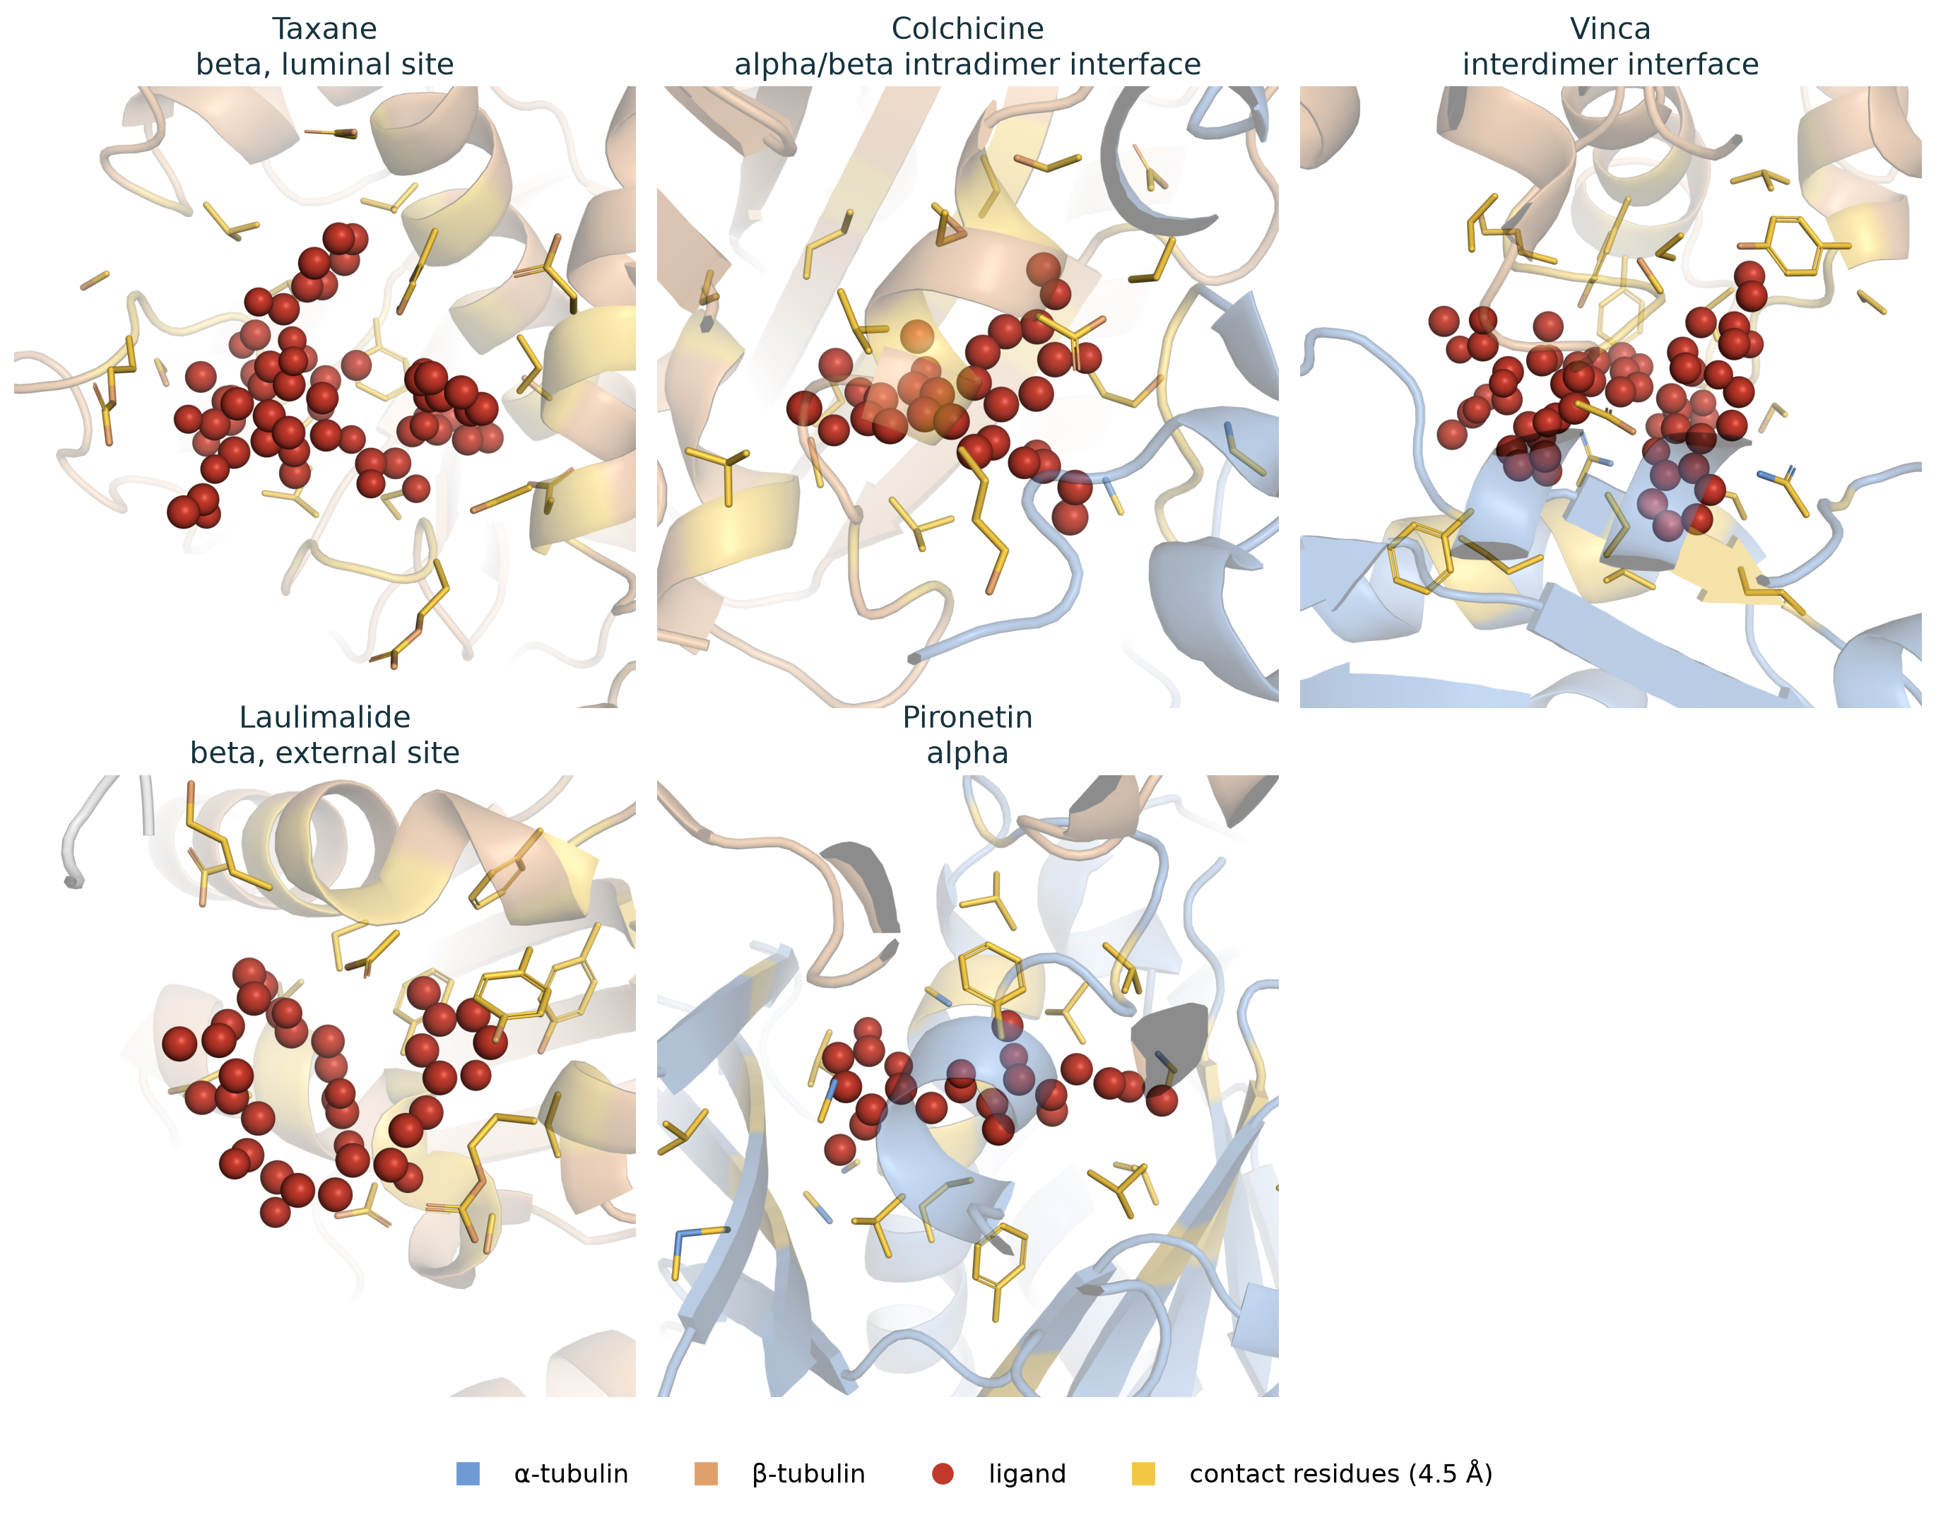
Figure 27. The five clinical drug pockets rendered on their crystal structures (1JFF, 1SA0, 1Z2B, 4O4H, 5FNV).
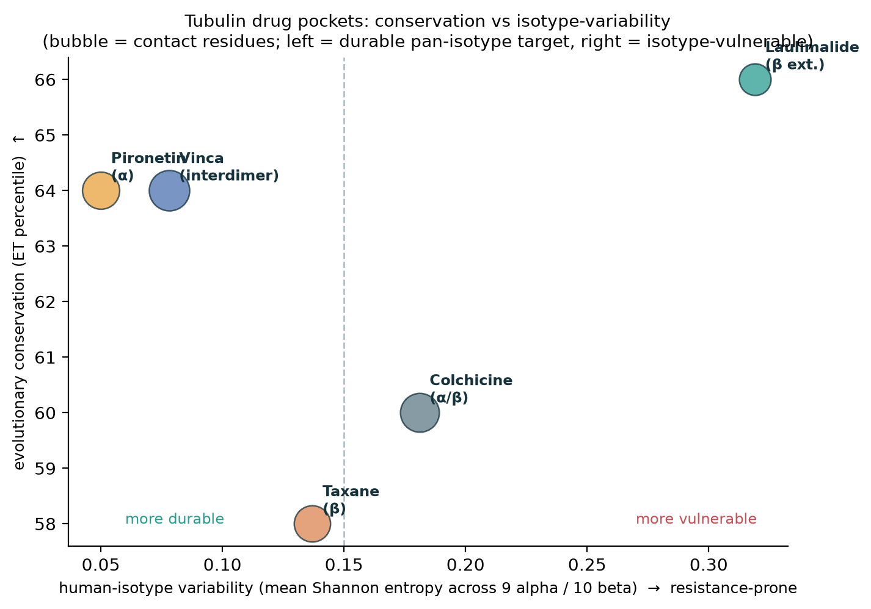
Figure 28. Drug-pocket durability: conservation against isotype variability across the nineteen isotypes.
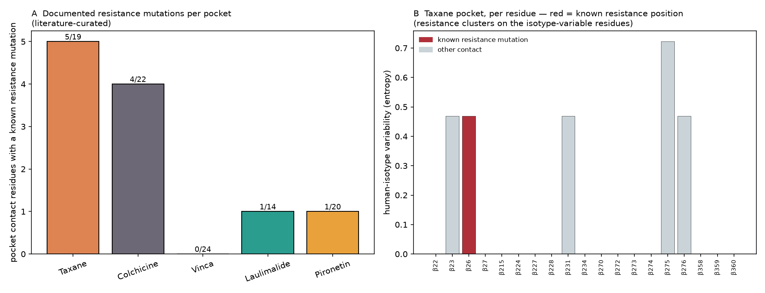
Figure 29. Resistance mutations per pocket and their overlap with the isotype-variable pocket residues.
Each isotype also causes its own disease: genetic evidence links TUBB4A to torsion dystonia, TUBB8 to fertilisation failure, TUBA1A to lissencephaly and TUBA4A to amyotrophic lateral sclerosis, and 408 partners share a genetic disease with the very tubulin they bind, the strongest single link between the interactome and the clinic.

4 Database access and use
The census is delivered as a MongoDB database, tubulin_census, of twelve collections indexed for query and stamped with the checksums of its source files in a _meta collection. Seven hold the core census (tubulins, proteins, interactions, pathway_enrichment, disease_associations, drugs and network_edges) and four hold the analysis arms (drug_pockets, cross_species_conservation, orthogonal_coessentiality and literature_specificity); every partner document in proteins carries its evidence tier, its corroboration layer (external-evidence score, hu.MAP co-complex flag, Gene Ontology microtubule terms, Pfam domains and literature specificity), its annotation counts, and the three integrative layers described below.
The resource is queried three ways. A protein search returns a partner’s tier, supporting databases, domains, pathways, disease and drug links, localisation, conservation and integrated score in one record. A reverse search returns every partner of a chosen isotype, or every isotype that binds a chosen partner, so the map reads from either side. An advanced search composes filters over family, tier, shared status, disease, druggability, cross-species conservation, integrated score and domain. Predicted STRING-only edges are kept and flagged at lower confidence rather than mixed with the assay-backed edges, so a query can be restricted to the experimental tier with a single filter. Access is offered at three levels for three kinds of user: a web interface with the three search modes and a browse view over the ranked partners, the drug pockets and the tubulin-code enzymes, for the reader; a documented Python query module (TubulinCensus) for the analyst; and a flat data package of every table and figure, together with the 109-claim verifier that recomputes each published number from its source, for download without registration. The web interface, the loader, the query module and the verifier are all provided; the public instance is served at {{URL}}.
Three integrative layers convert the raw census into a resource that ranks and classifies its own entries. A composite Tubulin-Interaction Score (0 to 100) sums the independent, orthogonal support for each partner, the evidence tier, the number of primary databases, the record count, the hu.MAP co-complex flag, the domain and Gene Ontology signal, pathway membership, cross-species conservation depth, genetic co-dependency and literature specificity, with a stored per-component breakdown so the number is never a black box. The score places the tubulin-folding and plus-end machinery at the top, TBCD, CCT5, ARL2, EML4 and CLIP1 among the highest-scoring non-tubulin partners. An isotype-specificity index records, for each partner, the isotype it prefers and how sharply its records concentrate on one isotype rather than spreading across the family. A tubulin-code layer classifies partners as writers, erasers or readers of the post-translational code; the erasers are well represented, the deacetylases HDAC6 and SIRT2 and the detyrosinating VASH1, VASH2 and SVBP, while the polyglutamylating TTLL writers are largely absent from the interaction data, a coverage gap that follows from their transient, enzymatic contacts.

5 Conclusion and future directions
The resource joins in one place what is usually kept apart: a tiered partner census across all nineteen human isotypes, a domain and pathway layer, an independent corroboration that includes genetic co-dependency, and an evolutionary trace on the folded dimer. A single partner can be read on many axes at once, whether it is assay-backed, which pathways and diseases it touches, where it lives, how it is modified, whether it is conserved to worm, and where on the tubulin surface its likely contact sits. The isotype resolution corrects a real attribution error and lets the two isotype groups of alpha be read apart.
The benchmark carries a message past tubulin. Recall against the Complex Portal was strongly asymmetric, high for the chaperone machinery that folds tubulin and low for the transient and structural assemblies tubulin forms, so any interactome study of a polymer-forming protein should read its coverage in that light, and the complexes recovered at zero are a prioritised list for proximity-labelling methods. Limitations are stated plainly: the heterodimer confound limits the alpha-versus-beta convergence to the binary subset, the domain and pathway routes rest on InterPro-to-term transfer and are not independent of each other, the compiled tier re-aggregates ingested sources, the two low-abundance isotypes remain sparse, the worm arm is thin, and TUBAL3 is a sequence outlier. One bias runs through the whole census and is stated separately: the partner counts track study intensity as well as biology. The public interaction databases over-represent well-studied proteins, so the broadly expressed, long-known isotypes such as TUBA1A and TUBB accrue far more partners than the recently added or tissue-restricted ones such as TUBA3E and TUBAL3, and the per-isotype totals should be read as a floor set by current evidence rather than a complete biological degree. The same caution applies to the cancer-versus-constitutional contrast: the somatic-heavy cancer evidence and the germline-heavy disorder evidence partly reflect how each disease class has been sequenced, so the split in mutational route is evidence-weighted rather than a pure biological rate. Future directions follow the database: proximity labelling for the zero-recovery complexes, and the durable pironetin and vinca pockets as isotype-agnostic drug targets.

6 Declarations
Data availability. The census database, a flat package of every table and figure, and a supplementary data workbook are available at {{URL}} and archived at {{DOI}}. The queryable web instance is served at {{URL}}. Interaction data derive from BioGRID, IntAct, BioPlex, HINT, HuRI, STRING and HIPPIE; annotation from UniProt, InterPro, GO, Reactome, KEGG, OMIM and Open Targets; structure from PDB 1JFF, 1SA0, 1Z2B, 4O4H and 5FNV; variants from ClinVar and cBioPortal; expression from GTEx; co-dependency from DepMap; drug response from GDSC.
Code availability. The full pipeline, the MongoDB loader, the Python query module, the web server and frontend, the figure generators and the 109-claim verifier are provided at {{URL}} under an open licence. The verifier recomputes every published number from its source file.
Author contributions. M.I. and M.R. designed the study, built and analysed the resource, and wrote the manuscript.
Competing interests. The authors declare no competing interests. Funding. {{FUNDING}}.

References
- Nair S, Saroj S, Kunwar A. The tubulin isotypes of humans. Biomolecules. 2026;16(1):81.
- Oughtred R, Rust J, Chang C, et al. The BioGRID database: a comprehensive biomedical resource of curated protein, genetic, and chemical interactions. Protein Sci. 2021;30(1):187-200.
- Del Toro N, Shrivastava A, Ragueneau E, et al. The IntAct database: efficient access to fine-grained molecular interaction data. Nucleic Acids Res. 2022;50(D1):D648-D653.
- Huttlin EL, Bruckner RJ, Navarrete-Perea J, et al. Dual proteome-scale networks reveal cell-specific remodeling of the human interactome (BioPlex 3.0). Cell. 2021;184(11):3022-3040.
- Luck K, Kim DK, Lambourne L, et al. A reference map of the human binary protein interactome (HuRI). Nature. 2020;580(7803):402-408.
- Das J, Yu H. HINT: High-quality protein interactomes and their applications in understanding human disease. BMC Syst Biol. 2012;6:92.
- Szklarczyk D, Kirsch R, Koutrouli M, et al. The STRING database in 2023. Nucleic Acids Res. 2023;51(D1):D638-D646.
- Alanis-Lobato G, Andrade-Navarro MA, Schaefer MH. HIPPIE v2.0: enhancing meaningfulness and reliability of protein-protein interaction networks. Nucleic Acids Res. 2017;45(D1):D408-D414.
- Meldal BHM, Bye-A-Jee H, Gajdos L, et al. Complex Portal 2022: new curation frontiers. Nucleic Acids Res. 2022;50(D1):D578-D586.
- UniProt Consortium. UniProt: the Universal Protein Knowledgebase in 2023. Nucleic Acids Res. 2023;51(D1):D523-D531.
- Paysan-Lafosse T, Blum M, Chuguransky S, et al. InterPro in 2022. Nucleic Acids Res. 2023;51(D1):D418-D427.
- Mistry J, Chuguransky S, Williams L, et al. Pfam: The protein families database in 2021. Nucleic Acids Res. 2021;49(D1):D412-D419.
- Ashburner M, Ball CA, Blake JA, et al. Gene Ontology: tool for the unification of biology. Nat Genet. 2000;25(1):25-29; Gene Ontology Consortium. The Gene Ontology knowledgebase in 2023. Genetics. 2023;224(1):iyad031.
- Gillespie M, Jassal B, Stephan R, et al. The Reactome pathway knowledgebase 2022. Nucleic Acids Res. 2022;50(D1):D687-D692.
- Kanehisa M, Furumichi M, Sato Y, et al. KEGG for taxonomy-based analysis of pathways and genomes. Nucleic Acids Res. 2023;51(D1):D587-D592.
- Amberger JS, Bocchini CA, Scott AF, Hamosh A. OMIM.org: leveraging knowledge across phenotype-gene relationships. Nucleic Acids Res. 2019;47(D1):D1038-D1043.
- Ochoa D, Hercules A, Carmona M, et al. The next-generation Open Targets Platform. Nucleic Acids Res. 2023;51(D1):D1353-D1359.
- Wei CH, Allot A, Lai PT, et al. PubTator 3.0: an AI-powered literature resource for unlocking biomedical knowledge. Nucleic Acids Res. 2024;52(W1):W540-W546.
- Landrum MJ, Lee JM, Benson M, et al. ClinVar: improving access to variant interpretations and supporting evidence. Nucleic Acids Res. 2018;46(D1):D1062-D1067.
- Cerami E, Gao J, Dogrusoz U, et al. The cBio Cancer Genomics Portal. Cancer Discov. 2012;2(5):401-404; Gao J, Aksoy BA, Dogrusoz U, et al. Sci Signal. 2013;6(269):pl1.
- Tsherniak A, Vazquez F, Montgomery PG, et al. Defining a Cancer Dependency Map. Cell. 2017;170(3):564-576.
- Iorio F, Knijnenburg TA, Vis DJ, et al. A landscape of pharmacogenomic interactions in cancer (GDSC). Cell. 2016;166(3):740-754.
- Drew K, Wallingford JB, Marcotte EM. hu.MAP 2.0: integration of protein interaction evidence into a reference map of the human protein complexome. Mol Syst Biol. 2021;17(5):e10016.
- Lowe J, Li H, Downing KH, Nogales E. Refined structure of alphabeta-tubulin at 3.5 A resolution (PDB 1JFF). J Mol Biol. 2001;313(5):1045-1057.
- GTEx Consortium. The GTEx Consortium atlas of genetic regulatory effects across human tissues. Science. 2020;369(6509):1318-1330.
- Katoh K, Standley DM. MAFFT multiple sequence alignment software version 7. Mol Biol Evol. 2013;30(4):772-780.
- Bailey TL, Johnson J, Grant CE, Noble WS. The MEME Suite. Nucleic Acids Res. 2015;43(W1):W39-W49.
- Bailey TL. STREME: accurate and versatile sequence motif discovery. Bioinformatics. 2021;37(18):2834-2840.
- Mihalek I, Res I, Lichtarge O. A family of evolutionary trace methods. J Mol Biol. 2004;336(5):1265-1282; Lichtarge O, Bourne HR, Cohen FE. An evolutionary trace method. J Mol Biol. 1996;257(2):342-358.
- Bader GD, Hogue CWV. An automated method for finding molecular complexes in large protein interaction networks (MCODE). BMC Bioinformatics. 2003;4:2.
- Steinegger M, Soding J. MMseqs2 enables sensitive protein sequence searching for the analysis of massive data sets. Nat Biotechnol. 2017;35(11):1026-1028.
- Jacomy M, Venturini T, Heymann S, Bastian M. ForceAtlas2, a continuous graph layout algorithm. PLoS One. 2014;9(6):e98679.
- Benjamini Y, Hochberg Y. Controlling the false discovery rate. J R Stat Soc B. 1995;57(1):289-300.
- Cock PJA, Antao T, Chang JT, et al. Biopython: freely available Python tools for computational molecular biology and bioinformatics. Bioinformatics. 2009;25(11):1422-1423.
- Hagberg AA, Schult DA, Swart PJ. Exploring network structure, dynamics, and function using NetworkX. Proc 7th Python in Science Conf (SciPy). 2008:11-15.
- Wu C, MacLeod I, Su AI. BioGPS and MyGene.info: organizing online, gene-centric information. Nucleic Acids Res. 2013;41(D1):D561-D565.
- Shrake A, Rupley JA. Environment and exposure to solvent of protein atoms. Lysozyme and insulin. J Mol Biol. 1973;79(2):351-371.
- Sillitoe I, Bordin N, Dawson N, et al. CATH: increased structural coverage of functional space. Nucleic Acids Res. 2021;49(D1):D266-D273.
- Andreeva A, Kulesha E, Gough J, Murzin AG. The SCOP database in 2020. Nucleic Acids Res. 2020;48(D1):D376-D382.
- Binns D, Dimmer E, Huntley R, et al. QuickGO: a web-based tool for Gene Ontology searching. Bioinformatics. 2009;25(22):3045-3046.
- Iyer MS, Rao M, Mayor S, Sowdhamini R. A census of the human actin-associated proteome. (2023). Exact journal/volume to be confirmed by the authors.
- Caudron-Herger M, Jansen RE, Wassmer E, Diederichs S. RBP2GO: a comprehensive pan-species database on RNA-binding proteins, their interactions and functions. Nucleic Acids Res. 2021;49(D1):D425-D436.
- Leung SK, et al. ENPD: a database of eukaryotic nucleic acid binding proteins. Nucleic Acids Res. 2019;47(D1):D322-D330. First-author list to be confirmed.
- Gerstberger S, Hafner M, Tuschl T. RBPbase: a database integrating high-throughput RNA-binding protein detection studies. EMBL; https://apps.embl.de/rbpbase/. Citation to be confirmed.

