Aarogyam project report
Pranav Raut & Prit Thombare

Sipna College of Engineering and Technology, Amravati
BE. CSE.

Abstract
Healthcare systems worldwide continue to face the persistent challenge of low health literacy, which limits patients’ and caregivers’ ability to interpret prescriptions, medical reports, and treatment guidelines. Misinterpretation of healthcare information often results in skipped medication, incorrect dosage, and reduced treatment adherence, ultimately compromising patient outcomes. This issue is particularly significant in multilingual contexts such as India, where linguistic diversity further complicates access to medical knowledge.
To address these concerns, this project presents Aarogyam, an AI-powered health literacy mobile application developed as part of the IBM SkillsBuild Hackathon 2025. Aarogyam leverages Flutter/Dart for a cross-platform user interface, SQLite and Firebase for offline storage and synchronization, and IBM Cloud services for advanced AI-driven functionality. Core modules include prescription analysis with automated reminders, a Retrieval-Augmented Generation (RAG) chatbot for Ayurvedic and health guidance, a first-aid knowledge base stored on IBM Cloud Object Storage, and multilingual support (English, Hindi, Marathi) enhanced by IBM’s speech-to-text and text-to-speech services. Outputs are further tailored to user demographics such as age, gender, and allergies, ensuring personalized healthcare insights.
The prototype was successfully deployed locally on Android devices and tested under real-world conditions. All major features, including reminder automation, chatbot interaction, and multilingual accessibility, performed as intended. The project was showcased at The Corinthians Club, Pune on 31 January 2025 during the final round of the IBM Hackathon, where Aarogyam was recognized as a state-level winning project.
In summary, Aarogyam demonstrates how modern AI and cloud technologies can bridge the health literacy gap by transforming medical complexity into clarity. By integrating traditional knowledge systems like Ayurveda with advanced AI models and ensuring multilingual inclusivity, Aarogyam not only empowers patients and caregivers but also sets a foundation for scalable, holistic digital healthcare solutions.

Table of Contents
Chapter 1: Introduction
1.1 Background and Motivation
1.2 Project Overview
1.3 Hackathon Context and Training Timeline
1.4 Team and Mentorship
1.5 Chapter Outline
Chapter 2: Problem Statement
2.1 Health Literacy Challenges
2.2 Survey Insights and Evidence
2.3 Real-World Implications
2.4 The Core Challenge
Chapter 3: Objectives
Chapter 4: Literature Review / Background
4.1 Health Literacy as a Global Concern
4.2 Existing Digital Health Solutions
4.3 Identified Gaps in Current Solutions
4.4 Aarogyam’s Contribution and Uniqueness
Chapter 5: Technology Used & Architecture
5.1 Overview
5.2 Frontend Development
5.3 Backend and Cloud Integration
5.4 Database Management
5.5 IBM Cloud Services and AI Models
5.6 System Architecture
Chapter 6: Wow Factors / Unique Features
6.1 Introduction
6.2 Distinctive Features
6.3 Summary
Chapter 7: End Users
7.1 Introduction
7.2 User Groups
7.3 Summary
Chapter 8: Methodology & Implementation
8.1 Introduction
8.2 Prescription Analyzer
8.3 Smart Reminder Module
8.4 Chatbot (Sanjeevani)
8.5 First-Aid Guide
8.6 Multilingual Layer
8.7 Personalized Output
8.8 Summary
Chapter 9: Results
9.1 Introduction
9.2 Application Interface and Modules
9.3 Deployment and Accessibility
9.4 Live Demonstration
9.5 Recognition and Achievements
9.6 Summary
Chapter 10: Conclusion
10.1 Summary of Work
10.2 Addressing the Health Literacy Gap
10.3 Impact and Relevance
10.4 Closing Statement
Chapter 11: Future Scope
11.1 Introduction
11.2 Proposed Enhancements
11.3 Summary
Chapter 12: Team & Acknowledgements
12.1 Development Team
12.2 Faculty Mentorship
12.3 Industry Support
12.4 Acknowledgements
Chapter 13: Achievements
13.1 Recognition at IBM Hackathon
13.2 Live Presentation at The Corinthians, Pune
13.3 Deployment and Testing
13.4 Summary
Chapter 14: GitHub Repository
14.1 Repository Overview
14.2 Repository Structure
14.3 Summary
Chapter 15: References

Chapter 1: Introduction

1.1 Background and Motivation
The rapid advancement of artificial intelligence (AI), cloud computing, and mobile applications has transformed the global healthcare ecosystem. Despite these developments, one challenge continues to limit accessibility and quality of care: low health literacy. Patients and caregivers frequently face difficulties in interpreting prescriptions, diagnostic reports, and treatment instructions. Such barriers often lead to confusion, skipped medication, and in severe cases, mismanagement of treatment.
Motivated by this challenge, the project Aarogyam was envisioned as a solution to bridge the gap between medical complexity and user comprehension. It aims to simplify healthcare information, integrate multilingual accessibility, and provide personalized guidance by combining modern AI capabilities with traditional health knowledge such as Ayurveda.

1.2 Project Overview
Aarogyam is an AI-powered mobile application designed to enhance health literacy and empower individuals to take control of their medical care. The application provides prescription analysis and generates automated medication reminders to ensure compliance. It integrates a Retrieval-Augmented Generation (RAG) chatbot enriched with Ayurvedic knowledge and first-aid instructions, thus providing reliable health-related assistance on demand.
The system further incorporates IBM’s speech-to-text and text-to-speech services, enabling hands-free and accessible interaction for users of all age groups. A key strength of Aarogyam lies in its multilingual support—English, Hindi, and Marathi—allowing users from diverse backgrounds to benefit from the application. With this approach, Aarogyam transforms complicated medical content into easy-to-understand insights, thereby promoting inclusivity and patient independence.

1.3 Hackathon Context and Training Timeline
The application was conceptualized and developed as part of the IBM SkillsBuild Hackathon 2025, organized by the Edunet Foundation in collaboration with IBM. The hackathon included training sessions that introduced participants to cutting-edge technologies such as IBM Cloud, Watsonx.ai, and RAG-based chatbot development, along with speech-processing tools and AI integration into mobile applications.
The timeline of the hackathon was as follows:
- 16–20 January 2025 – Training on IBM Cloud, Watsonx.ai, RAG chatbots, STT/TTS, and application development.
- 28 January 2025 – Project submission deadline.
- 31 January 2025 – Final showcase and winner announcement at The Corinthians Club, Pune.
Aarogyam was recognized as a state-level winning project, presented live in front of industry mentors, faculty, and fellow participants.

1.4 Team and Mentorship
The project was developed under the collaborative guidance of academic and industry mentors. The development team consisted of Pranav Raut and Prit Thombare as student developers. The faculty mentors, Prof. Neha Rathi and Prof. Ashwin Ade, provided academic direction and domain expertise, while Mr. Aditya Dambhale from Edunet Foundation served as an industry mentor, offering technical support in IBM technologies. The teamwork between students and mentors played a pivotal role in shaping the project into a functional and impactful solution.

Chapter 2: Problem Statement

2.1 Health Literacy Challenges
Health literacy is a critical determinant of healthcare outcomes, yet it remains a persistent challenge across diverse populations. Patients and caregivers are often confronted with complex medical prescriptions, diagnostic reports, and technical language that are difficult to interpret without medical training. The lack of clarity in medical information frequently results in confusion, missed medication doses, incorrect administration, and reduced adherence to treatment plans. These challenges highlight the urgent need for interventions that simplify healthcare communication and make it more accessible to all users, irrespective of their educational or medical background.

2.2 Survey Insights and Evidence
The magnitude of this problem is reflected in survey findings related to patient understanding of medical information:
- Only 32% of individuals reported that they could fully understand the information provided in their patient information leaflets.
- 55% of patients struggled with reading or comprehending the details presented.
- The remaining 13% were able to partially manage but still faced significant difficulties.
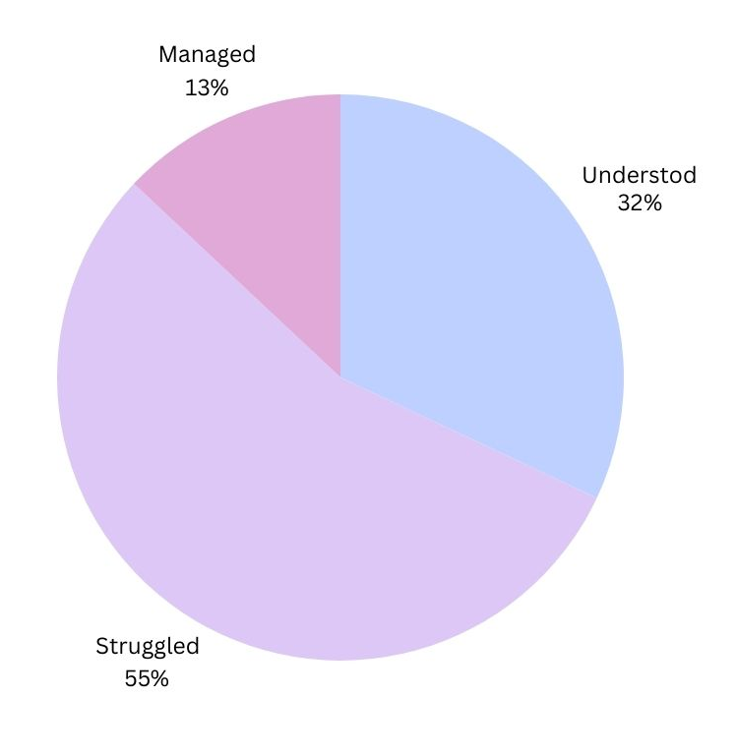
These figures underline the knowledge gap that exists between healthcare providers and end users. Such a gap can undermine treatment effectiveness, create dependency on others for interpretation, and ultimately reduce patient confidence in managing their own health. (Source: https://www.nationalhealthexecutive.com/articles/most-patients-dont-understand-their-medicines-new-report-shows?)

2.3 Real-World Implications
The consequences of low health literacy are severe and multifaceted. Misinterpretation of prescriptions can lead to incorrect dosage or medication misuse, while skipped doses can compromise treatment effectiveness. Inaccurate understanding of diagnostic reports may also delay timely medical interventions. Moreover, the lack of accessibility in regional languages exacerbates these issues, particularly in multilingual countries like India, where large sections of the population may not be comfortable with English-only healthcare resources.

2.4 The Core Challenge
The primary challenge is therefore to design a solution that makes healthcare information simple, accurate, and accessible to a wide audience. This solution must not only present medical information in clear and user-friendly terms but also ensure multilingual support to reach diverse users. Additionally, it must leverage modern technologies such as AI and cloud computing to provide contextualized and personalized healthcare insights. Aarogyam was developed as a response to this challenge, seeking to transform healthcare complexity into clarity.

Chapter 3: Objectives
The Aarogyam project was conceived with the primary aim of addressing the challenges of low health literacy by developing a mobile application that bridges the gap between medical complexity and patient understanding. The objectives were carefully defined to ensure that the solution not only simplifies medical information but also empowers patients and caregivers to actively participate in their own healthcare journey.
The specific objectives of the project are as follows:
- Simplification of Medical Prescriptions: Transform complex prescriptions and diagnostic reports into clear, layman-friendly explanations that can be easily understood by non-medical users.
- AI-Driven Reminders and Personalized Suggestions: Automate medication reminders and deliver personalized health insights tailored to individual needs, thereby improving adherence to treatment plans.
- Development of a RAG-Based Chatbot: Integrate a Retrieval-Augmented Generation chatbot capable of providing guidance on Ayurveda, first-aid measures, and general health-related queries.
- Multilingual Support: Ensure accessibility for a diverse user base by providing services in English, Hindi, and Marathi, thereby addressing the linguistic diversity of Indian users.
- Empowerment of Patients and Caregivers: Enhance user confidence and independence in healthcare decision-making by offering accessible, reliable, and personalized information.
By fulfilling these objectives, Aarogyam seeks to create a healthcare application that is practical, inclusive, and impactful, while leveraging the power of AI and cloud technologies to deliver meaningful societal value.

Chapter 4: Background

4.1 Health Literacy as a Global Concern
Health literacy has been widely recognized as a critical determinant of public health outcomes. According to reports by the World Health Organization (WHO), inadequate health literacy is associated with poor understanding of medical prescriptions, decreased compliance with treatment regimens, and higher risks of mismanagement of chronic conditions. Globally, millions of patients face barriers in accessing or interpreting medical information, which contributes to disparities in healthcare delivery and patient outcomes. In the Indian context, where healthcare systems are already under strain, this challenge is compounded by linguistic diversity and varying levels of education among patients and caregivers.

4.2 Existing Digital Health Solutions
In recent years, a variety of digital health applications have been developed to address patient engagement and health management. Popular examples include teleconsultation platforms, e-prescription tools, and mobile health apps that provide reminders and health tips. While these solutions represent significant progress, most are designed with a generalized approach and often remain limited in terms of accessibility for individuals with low literacy. Furthermore, the reliance on English or region-specific languages restricts their usability for a wide demographic.

4.3 Identified Gaps in Current Solutions
Despite the availability of digital health platforms, several limitations persist:
- Limited integration of traditional healthcare systems: Very few apps provide support for Ayurvedic remedies or indigenous medical practices, which are still widely relied upon in India.
- Weak multilingual support: Many existing tools lack comprehensive multilingual capabilities, excluding large groups of users who are not comfortable with English or dominant regional languages.
- Lack of personalization: Most applications offer generic information without adapting outputs to user-specific factors such as age, gender, allergies, or prior health history.
These gaps highlight the need for a solution that is inclusive, culturally relevant, and adaptive to user needs.

4.4 Aarogyam’s Contribution and Uniqueness
Aarogyam distinguishes itself from existing solutions by combining the strengths of modern AI with user-centric design. Its key differentiators include:
- Simplification of Reports and Prescriptions: Medical information is translated into layman-friendly language that enhances understanding.
- Integration of Ayurveda with AI: By leveraging Retrieval-Augmented Generation (RAG) techniques and curated datasets, the app introduces Ayurvedic insights alongside modern medical guidance.
- Multilingual Accessibility: Support for English, Hindi, and Marathi ensures inclusivity across linguistic barriers.
- Smart Reminders and Personalization: Automated medication reminders and outputs tailored to user demographics create a personalized healthcare experience.
Through these features, Aarogyam addresses the critical shortcomings of current digital health solutions while creating an innovative bridge between technology, tradition, and accessibility.

Chapter 5: Technology Used & Architecture

5.1 Overview
The development of Aarogyam required the integration of multiple technologies across frontend design, backend services, cloud infrastructure, and artificial intelligence. The system was deliberately designed to be modular, scalable, and user-friendly, ensuring smooth operation even on resource-constrained mobile devices. The choice of technologies reflects a balance between modern software development frameworks and robust cloud-based AI services.

5.2 Frontend Development
The frontend of Aarogyam was built using Flutter, a cross-platform framework that enables responsive and consistent user interfaces across Android and iOS devices. Flutter’s widget-based design facilitated the creation of an intuitive and visually appealing interface. The application logic was implemented in Dart, the programming language used by Flutter, which supports seamless integration with both local storage and cloud APIs.

5.3 Backend and Cloud Integration
The backend of the system relies on IBM Cloud for computation, data storage, and AI services. Through Watsonx.ai and related APIs, Aarogyam integrates powerful machine learning models capable of performing tasks such as natural language understanding, retrieval-augmented generation, and personalized response generation. IBM Cloud also provides secure and scalable infrastructure for managing health-related datasets.

5.4 Database Management
A dual-database strategy was adopted to ensure both offline functionality and real-time synchronization:
- SQLite was employed as the local database for storing user preferences, reminders, and temporary health data. This allows the app to function even without an internet connection.
- Firebase was used for user authentication and synchronization of reminders and settings across devices, enabling real-time consistency and secure user management.

5.5 IBM Cloud Services and AI Models
Several IBM services formed the backbone of Aarogyam’s intelligence and interactivity:
- Watsonx.ai – Provided access to large language models such as Mixtral-12B and Granite-13B-Chat, used for natural language processing, report simplification, and conversational support.
- RAG Chatbot (Sanjeevani) – Implemented to deliver contextual guidance on Ayurveda, first-aid, and general health FAQs. This was fine-tuned using curated datasets, including sources from AAYUSH.
- IBM Speech-to-Text (STT) and Text-to-Speech (TTS) – Enabled hands-free and accessible interaction for users, improving usability across different age groups.
- IBM Cloud Object Storage – Served as a repository for structured knowledge bases, such as the first-aid dataset, which could be retrieved dynamically within the app.

5.6 System Architecture
The overall architecture of Aarogyam integrates the frontend, backend, and AI services into a seamless pipeline:
- The user interacts with the Flutter app.
- Inputs are processed locally and stored in SQLite for offline access.
- Data requiring cloud interaction is authenticated and synchronized through Firebase.
- Requests are sent to IBM Cloud APIs, where Watsonx.ai models and the RAG chatbot perform inference.
- Outputs (simplified prescriptions, reminders, chatbot responses, or voice interactions) are delivered back to the user in a personalized format.
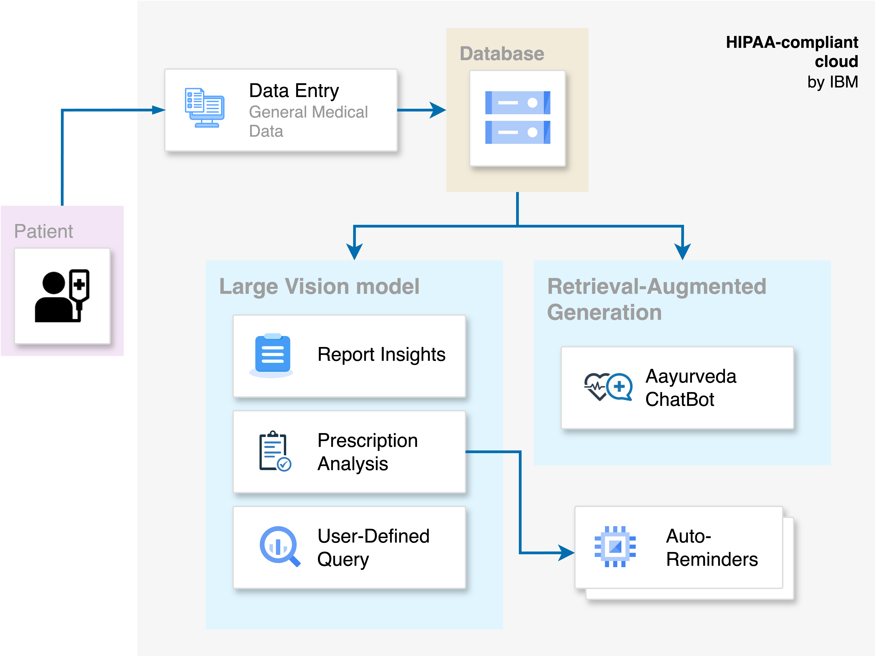
This architecture ensures efficiency, modularity, and resilience, making Aarogyam adaptable for future expansion.

Chapter 6: Wow Factors / Unique Features

6.1 Introduction
One of the defining strengths of Aarogyam lies in its ability to combine cutting-edge AI technologies with practical healthcare features that directly address user needs. Unlike many existing health applications that provide generic information, Aarogyam integrates personalization, cultural relevance, and accessibility into its design. The following unique features distinguish Aarogyam from conventional solutions.

6.2 Distinctive Features
- Prescription Analysis with Automated Reminders: The application extracts data from prescriptions and automatically generates medication reminders, reducing the risk of missed doses and enhancing treatment adherence.
- Ayurvedic Chatbot: Leveraging Retrieval-Augmented Generation (RAG) techniques and datasets curated from AAYUSH, Aarogyam provides Ayurvedic remedies and guidance, thus integrating traditional health practices with modern AI.
- First-Aid Guide: A structured first-aid knowledge base, stored on IBM Cloud Object Storage, ensures users can quickly access emergency instructions in a reliable manner.
- Multilingual Support: By supporting Marathi, Hindi, and English, the app reaches a wider audience across linguistic backgrounds, ensuring inclusivity for patients and caregivers in diverse communities.
- User-Specific Personalization: Outputs are tailored according to age, gender, allergies, and health profile, enabling more relevant and accurate recommendations.
- Voice-Enabled Interaction: Through IBM Speech-to-Text (STT) and Text-to-Speech (TTS) services, Aarogyam offers hands-free operation, enhancing accessibility for elderly patients, caregivers, and users with low literacy levels.

6.3 Summary
By combining these unique features, Aarogyam offers a solution that is innovative, inclusive, and practical. Its ability to simplify medical information, integrate traditional healthcare practices, and deliver personalized, multilingual, and voice-enabled outputs demonstrates a clear advancement over existing digital health platforms. These wow factors not only improve user engagement but also highlight Aarogyam’s potential for large-scale societal impact.

Chapter 7: End Users

7.1 Introduction
The effectiveness of any healthcare application depends on how well it addresses the needs of its intended users. Aarogyam was designed with inclusivity in mind, targeting a broad range of individuals who often face barriers in accessing or understanding medical information. The primary end users fall into four key categories, each with unique requirements that Aarogyam aims to fulfill.

7.2 User Groups
- Patients:
Patients often struggle to interpret complex medical reports and prescriptions. Aarogyam simplifies this information into clear, layman-friendly explanations, enabling patients to better understand their diagnosis, medication schedules, and treatment plans.
- Caregivers:
Family members or attendants responsible for managing the health of loved ones benefit from features such as automated medication reminders and personalized health insights. Aarogyam assists caregivers in reducing the cognitive load of managing multiple prescriptions and ensuring adherence.
- Non-Medical Users:
Individuals without a background in medicine frequently require accessible and trustworthy health information. Aarogyam provides multilingual support and voice-enabled features, ensuring that even users with low literacy or no prior medical knowledge can confidently engage with healthcare resources.
- Health Enthusiasts:
A growing segment of the population is interested in preventive healthcare and traditional remedies. Aarogyam integrates Ayurvedic knowledge and first-aid guidance, catering to enthusiasts seeking holistic and culturally relevant self-care practices.

7.3 Summary
By serving these diverse user groups, Aarogyam demonstrates its adaptability and inclusivity. The application not only addresses the immediate needs of patients and caregivers but also extends its utility to non-medical individuals and health-conscious users. This broad spectrum of applicability ensures that Aarogyam contributes meaningfully to improving health literacy across different segments of society.

Chapter 8: Methodology & Implementation

8.1 Introduction
The implementation of Aarogyam followed a modular approach, with each component designed to address a specific aspect of health literacy. The methodology combined optical character recognition (OCR), natural language processing (NLP), cloud-based AI services, and local storage mechanisms to deliver a seamless user experience. The following subsections describe the core modules of the system and their roles in achieving the project’s objectives.

8.2 Prescription Analyzer
The Prescription Analyzer forms the foundation of Aarogyam’s functionality. Using OCR techniques, it extracts textual data from medical prescriptions and diagnostic reports. The extracted content is then processed using NLP algorithms to identify medicines, dosages, and schedules. Once identified, this information is automatically converted into structured reminders, ensuring that patients and caregivers receive timely alerts for medication adherence.

8.3 Smart Reminder Module
The Smart Reminder Module is built on a dual-storage mechanism. SQLite enables offline storage of reminders and medication schedules, ensuring functionality in areas with limited internet access. In parallel, Firebase provides real-time synchronization and user authentication, allowing reminders to be securely stored and accessed across devices. This hybrid approach balances offline accessibility with cloud-enabled scalability.

8.4 Chatbot (Sanjeevani)
The Sanjeevani chatbot is powered by a Retrieval-Augmented Generation (RAG) pipeline integrated with Watsonx.ai models. The chatbot draws upon curated datasets, including Ayurvedic resources from AAYUSH, as well as modern health information. This enables Aarogyam to provide context-specific responses to user queries. Beyond answering basic health FAQs, the chatbot is capable of offering guidance on Ayurvedic remedies, yoga practices, and holistic approaches to well-being.

8.5 First-Aid Guide
A structured First-Aid Guide was incorporated into the system to provide quick responses during emergencies. This module is stored in IBM Cloud Object Storage, which enables reliable retrieval of first-aid content in a lightweight format. By hosting the guide on cloud storage, the app ensures that the data remains updated and accessible at all times.

8.6 Multilingual Layer
To address the linguistic diversity of users, Aarogyam integrates a multilingual support layer. IBM’s Speech-to-Text (STT) and Text-to-Speech (TTS) services enable voice-enabled interaction, making the app accessible even for users with low literacy levels. Additionally, manual translations were implemented for critical modules to provide content in English, Hindi, and Marathi, ensuring inclusivity across language barriers.

8.7 Personalized Output
Aarogyam emphasizes personalization to enhance relevance and user engagement. Outputs are tailored based on user demographics, such as age, gender, and allergy history. This customization ensures that health recommendations and reminders are aligned with the user’s profile, thereby improving accuracy and safety.

8.8 Summary
The methodology behind Aarogyam reflects a carefully engineered integration of AI, cloud services, and local storage mechanisms. Each module contributes to the overall goal of simplifying healthcare information while maintaining accessibility and personalization. This modular implementation ensures that the system remains scalable, adaptable, and capable of future expansion.

Chapter 9: Results

9.1 Introduction
The Aarogyam project was implemented and tested successfully during the IBM SkillsBuild Hackathon 2025. The prototype demonstrated the intended functionality of simplifying medical prescriptions, generating reminders, offering Ayurvedic chatbot support, and providing multilingual access. This chapter presents the key results achieved through development, deployment, and demonstration of the application.

9.2 Application Interface and Modules
The prototype included a fully functional user interface built with Flutter. Screens were developed for the Homepage, Prescription Analyzer, Medication Reminders, Sanjeevani Chatbot, and First-Aid Guide. Each module was available in both English and Marathi, validating the multilingual design of the system. The interfaces were tested with sample prescriptions and health queries, which confirmed the smooth integration of backend services with the frontend.

9.3 Deployment and Accessibility
The application was deployed locally on Android devices to validate its performance and user interaction. Although the app was not published on the Play Store, the local deployment confirmed the feasibility of the system. Offline functionality through SQLite, as well as real-time synchronization via Firebase, was tested successfully. The chatbot and speech-to-text/text-to-speech modules functioned as intended when connected to IBM Cloud services.

9.4 Live Demonstration
On 31 January 2025, the Aarogyam project was presented as part of the State-Level IBM Hackathon Showcase held at The Corinthians, Pune. During the live demo, the application successfully showcased its modules to faculty, industry mentors, and fellow participants. Features such as automated prescription-based reminders, multilingual chatbot responses, and voice-enabled interactions were highlighted as evidence of its practicality and innovation.

9.5 Recognition and Achievements
The effectiveness of Aarogyam was validated by its recognition as a state-level winning project in the hackathon. The demonstration emphasized not only the technological soundness of the system but also its potential societal impact in addressing healthcare literacy challenges. This achievement serves as an important milestone for future development and expansion of the project.

9.6 Summary
In summary, Aarogyam successfully delivered a working prototype that addressed the core objectives of the project. From multilingual support and automated reminders to the integration of Ayurvedic knowledge, the results demonstrated both technical feasibility and user relevance. The local deployment, live demo, and subsequent recognition at the hackathon further affirmed the project’s success.

Chapter 10: Conclusion

10.1 Summary of Work
The Aarogyam project was developed as a response to the pressing challenge of low health literacy, which often prevents patients and caregivers from effectively managing healthcare information. By leveraging artificial intelligence, cloud computing, and mobile technologies, the application translates medical complexity into accessible and user-friendly insights. In doing so, Aarogyam fulfills its central vision of converting “complexity into clarity.”

10.2 Addressing the Health Literacy Gap
Through features such as prescription analysis, automated medication reminders, and multilingual support, Aarogyam effectively bridges the knowledge gap between healthcare providers and patients. By integrating speech-based interaction and personalized outputs, it ensures inclusivity for individuals with varying levels of literacy and technological familiarity. The incorporation of Ayurvedic guidance further enriches the application by aligning with cultural contexts and offering holistic care options.

10.3 Impact and Relevance
The impact of Aarogyam lies in its ability to empower patients and caregivers with knowledge and tools that foster independence and confidence in managing health. By simplifying complex medical information and making it accessible in multiple languages, the application directly addresses barriers to understanding that often compromise treatment outcomes. Moreover, its integration of modern AI with traditional health systems demonstrates a unique and innovative approach, positioning Aarogyam as a meaningful step toward improving digital healthcare literacy in India.

10.4 Closing Statement
In conclusion, Aarogyam exemplifies the potential of AI-driven health applications to create real social impact. It demonstrates that technology, when thoughtfully applied, can transform healthcare from a space of confusion into one of clarity and empowerment. The project stands not only as a hackathon success but also as a prototype for future scalable solutions in the domain of health literacy.

Chapter 11: Future Scope

11.1 Introduction
While Aarogyam successfully addresses the immediate challenge of health literacy, the modular design of the application allows significant potential for expansion. The integration of advanced AI models, real-time data sources, and additional healthcare services can transform Aarogyam into a more comprehensive digital health platform. The following directions outline possible enhancements for future development.

11.2 Proposed Enhancements
- AI-Powered Symptom Checker: Incorporating advanced diagnostic models would allow users to input symptoms and receive preliminary health assessments, thereby extending Aarogyam’s role from literacy support to proactive health management.
- Wearable Device Integration: By connecting with wearable devices such as fitness trackers and smartwatches, Aarogyam can collect real-time vital data (e.g., heart rate, oxygen levels, physical activity) and provide timely health insights.
- Teleconsultation Module: A communication channel for virtual consultations with healthcare professionals could be embedded into the app, enabling patients to seek expert advice for unresolved queries.
- Disease Risk Prediction: Leveraging multimodal AI models that process audio and visual inputs (such as cough sounds or facial analysis) could enable prediction of certain health risks and conditions at an early stage.
- Real-Time Allergy Alerts: By integrating data from external health sources and wearable sensors, the application could provide timely alerts to users exposed to allergens, improving preventive care.
- Expanded Language Coverage: To reach a wider audience, Aarogyam can extend its multilingual capabilities beyond English, Hindi, and Marathi, ensuring inclusivity across more regional and international languages.

11.3 Summary
The outlined future scope reflects Aarogyam’s potential to evolve into a holistic healthcare companion. By expanding beyond health literacy into preventive care, teleconsultation, and personalized risk management, Aarogyam can significantly enhance its societal impact and scalability. These directions align with global trends in digital health transformation, ensuring the project remains relevant and adaptable to future healthcare needs.

Chapter 12: Team & Acknowledgements

12.1 Development Team
The Aarogyam project was developed by a dedicated student team that combined technical expertise with innovative thinking:
- Pranav Raut – Student Developer
- Prit Thombare – Student Developer
Their joint efforts in software development, integration of AI services, and system testing were central to the successful realization of the project.

12.2 Faculty Mentorship
The guidance of faculty mentors was instrumental in shaping the direction of the project.
- Prof. Neha Rathi – Faculty Mentor, Sipna College of Engineering and Technology
- Prof. Ashwin Ade – Faculty Mentor, Sipna College of Engineering and Technology
Their mentorship provided valuable insights into problem formulation, solution design, and academic presentation of the project.

12.3 Industry Support
The project also benefited greatly from the mentorship of:
- Mr. Aditya Dambhale – Industry Mentor, Edunet Foundation
His expertise in IBM technologies and industry practices ensured that the team could successfully integrate advanced tools such as Watsonx.ai, IBM Cloud services, and AI-driven pipelines into the application.

12.4 Acknowledgements
The team expresses sincere gratitude to the Edunet Foundation and IBM SkillsBuild program for providing the platform, training, and resources that made this project possible. The structured training sessions on IBM Cloud, Watsonx.ai, and AI-powered chatbots not only enhanced the team’s technical proficiency but also inspired the application of these technologies to solve real-world challenges.
The successful completion and recognition of the Aarogyam project is a testament to the collaborative efforts of students, faculty, and industry mentors.

Chapter 13: Achievements

13.1 Recognition at IBM Hackathon
Aarogyam was recognized as a winning project at the State-level IBM SkillsBuild Hackathon 2025, organized in collaboration with the Edunet Foundation. This achievement validated the project’s relevance, innovation, and potential societal impact. Competing among several innovative entries, Aarogyam stood out for its unique combination of AI-driven health literacy tools, multilingual accessibility, and integration of Ayurveda.

13.2 Live Presentation at The Corinthians, Pune
On 31 January 2025, the project was showcased at The Corinthians Club, Pune during the final round of the hackathon. The team presented Aarogyam live to a panel of academicians, industry mentors, and fellow participants. The demonstration highlighted the prescription analysis module, smart reminders, chatbot (Sanjeevani), multilingual support, and first-aid guide, all of which functioned successfully during the event.

13.3 Deployment and Testing
Although Aarogyam was not released on the Play Store, the project was successfully deployed locally on Android devices and tested under real conditions. All core features, including offline SQLite storage, Firebase synchronization, and IBM Cloud integrations, performed as expected. This confirmed the feasibility and technical robustness of the application within the given development timeline.

13.4 Summary
These achievements collectively demonstrate that Aarogyam not only met its intended objectives but also earned external validation from experts and peers. The recognition at the state-level hackathon serves as both a milestone and a motivation for future expansion of the project.

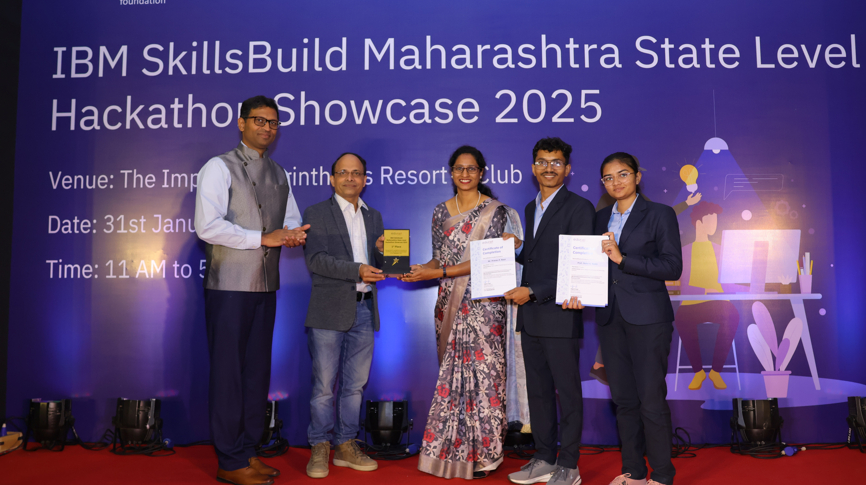
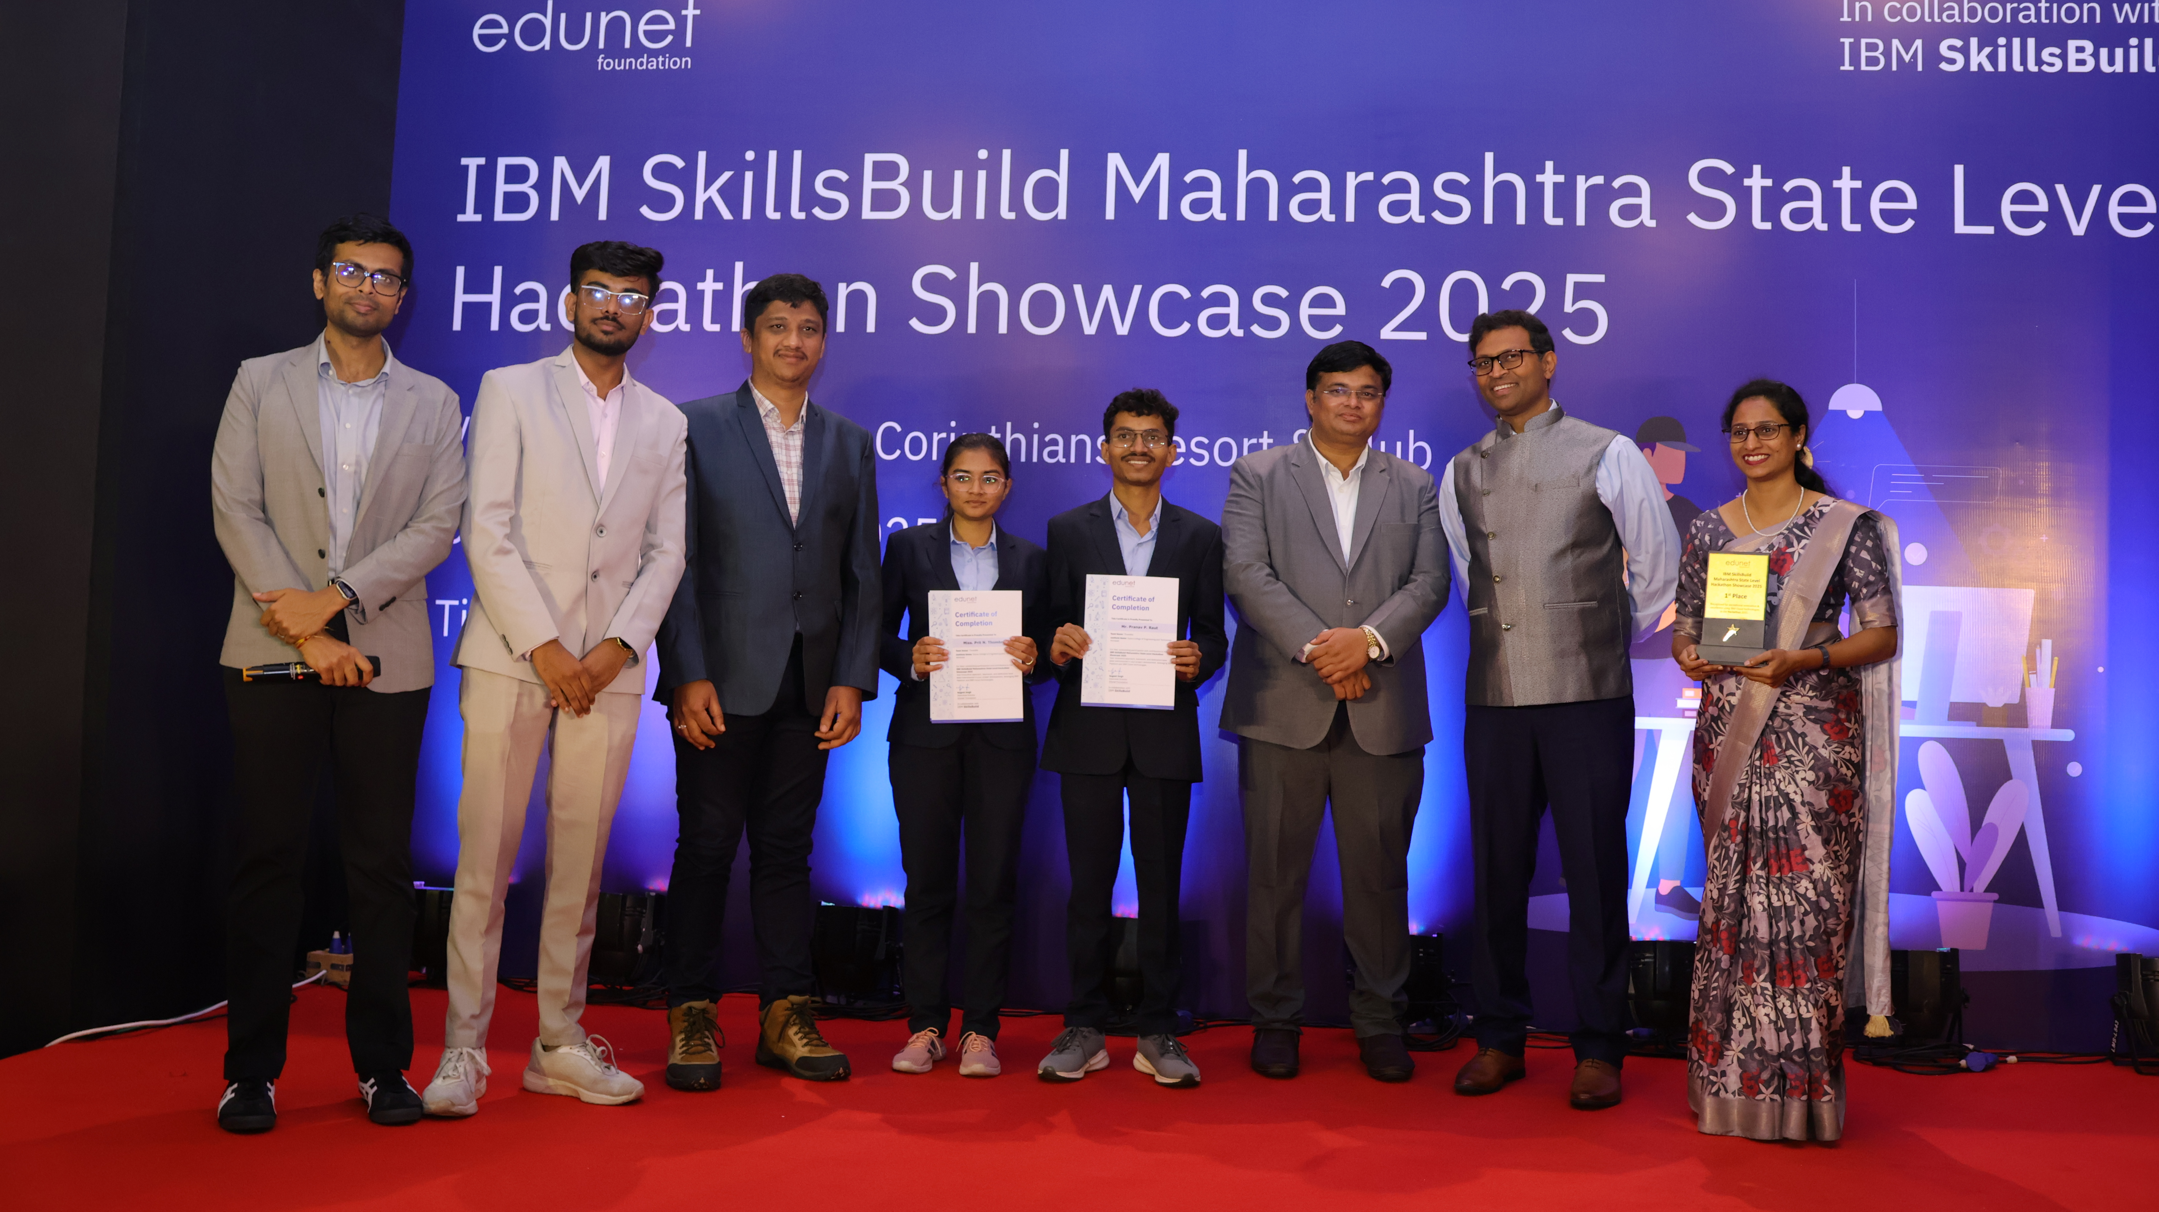

Chapter 14: GitHub Repository

14.1 Repository Overview
The source code and project resources for Aarogyam have been organized and published on GitHub to ensure transparency, reproducibility, and collaborative development. The repository structure reflects the modular design of the system, with separate folders for the mobile application, AI models, chatbot pipeline, and object storage integration. This modular organization allows developers and researchers to easily navigate, reuse, and extend the system for future applications.

14.2 Repository Structure
- Main Repository: Aarogyam-IBM
- Flutter Application: aarogyam-flutter
- Watsonx LVM Integration: lvm-watsonx
- RAG Chatbot (Sanjeevani): rag-chatBot
- First-Aid Guide Storage: firstaid-object-storage

14.3 Summary
By maintaining a well-documented GitHub repository, Aarogyam ensures that its codebase remains accessible for further research, academic use, and practical deployment. This open approach encourages collaboration, fosters innovation, and provides a foundation for scaling the project beyond the scope of the hackathon.

Chapter 15: References
- World Health Organization (WHO). Health Promotion: Health Literacy Resources. Available at: https://www.who.int/healthpromotion/health-literacy (Accessed: February 2025).
- IBM Cloud Documentation. Watsonx.ai, Speech-to-Text, Text-to-Speech, and Retrieval-Augmented Generation Services. Available at: https://cloud.ibm.com/docs (Accessed: February 2025).
- Flutter Documentation. Build Apps with Flutter and Dart. Available at: https://docs.flutter.dev (Accessed: February 2025).
- National Health Executive. Most patients don’t understand their medicines, new report shows. Available at: https://www.nationalhealthexecutive.com/articles/most-patients-dont-understand-their-medicines-new-report-shows (Accessed: February 2025).
- Edunet Foundation. IBM SkillsBuild Hackathon Training Materials. Internal resources provided during training sessions, 16–20 January 2025.

