**PROJECT REPORT**

**Real Time Implementation of AI-Face Mask Detector with MobileNetV2**

“Statistic under AI and its application to engineering sciences”

Rauzan Sumara

**Introduction**

The spread of COVID-19 is becoming increasingly concerning for everyone throughout the world. This virus can spread from person to person via droplets and airborne particles. According to WHO, in order to minimize the spread of COVID-19, everyone should wear a face mask, practice social distance, avoid crowds, and constantly keep a healthy immune system. As a result, in order to protect one another, everyone should wear a face mask when going outside. However, most selfish individuals will not properly use the face mask for a variety of reasons.

Therefore, this report is trying to create a robust face mask detection based on convolution neural network. In order to detect a face mask, we implement the object detection algorithm which is MobileNetV2 architecture. The rest of this report will be organized as follows: section two illustrates the datasets. Section three describes the face mask detection algorithm and section four presents the experimental results in real-time data. This work will be closed by the conclusion in section five.

**Datasets**

The dataset used for this task was created by Prajna Bhandary (https://github.com/prajnasb/observations). The dataset contains 1,376 images belonging to two classes, with mask: 690 images and without mask: 686 images. images without mask are actually artificial face mask datasets based on applying facial landmarks. Facial landmarks allow us to automatically infer the location of facial structures, including, eyes, eyebrows, nose, mouth, jawline, etc. The size of the training set chosen for this task is 80% of the images and the test set consists of remaining 20% of the images.

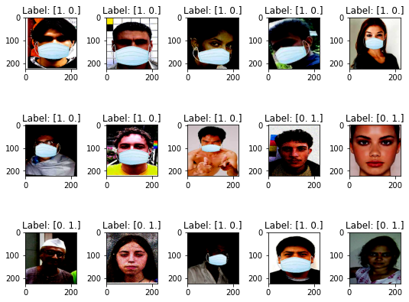

Figure 1. Selected instances of data from the images

**The MobileNetV2 Architecture**

As for the face mask detector method, this work implemented the convolutional neural network known as MobileNetV2 architecture. According to Sandler, et al. (2018), MobileNetV2 is a convolutional neural network architecture that seeks to perform well on mobile devices. It is based on an inverted residual structure where the residual connections are between the bottleneck layers. The intermediate expansion layer uses lightweight depth wise convolutions to filter features as a source of non-linearity. As a whole, the architecture of MobileNetV2 contains the initial fully convolution layer with 32 filters, followed by 19 residual bottleneck layers. By reflecting these results, it is suitable to implement the method into the real-time face mask detector where high detection accuracy is needed.

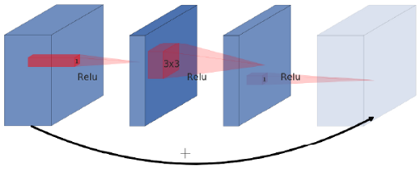

Figure 2. A residual block connects wide layers with a skip connection while layers in between are narrow

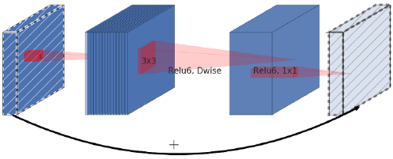

Figure 3. An inverted residual block connects narrow layers with a skip connection while layers in between are wide

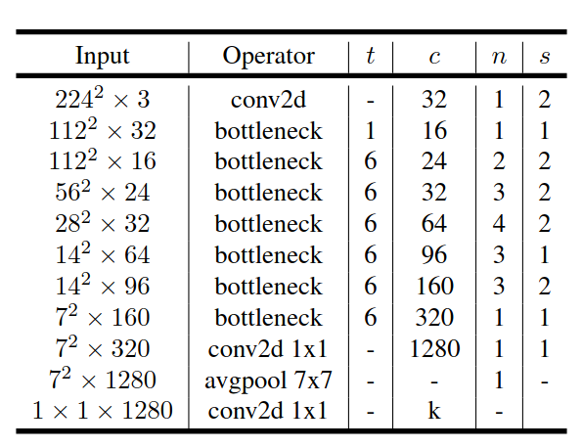

Table 1. Architecture of MobileNetV2

Now that we understand the building block of MobileNetV2 we can take a look at the entire architecture. In the table you can see how the bottleneck blocks are arranged. *t* stands for expansion rate of the channels. As you can see, they used a factor of 6 opposed to the 4 in our example. *c* represents the number of input channels and n how often the block is repeated. Lastly s tells us whether the first repetition of a block used a stride of 2 for the down sampling process. All in all, it’s a very simple and common assembly of convolutional blocks.

**Experimental Results**

We conducted our experiment using python programming language. The code and results have been posted on my GitHub ([*https://github.com/rauzansumara/face-mask-detector-based-on-mobilenetv2*](https://github.com/rauzansumara/face-mask-detector-based-on-mobilenetv2)). You can see that the validation loss and validation accuracy both are in sync with the training loss and training accuracy. The training and validation loss are decreasing and there is not much gap between training and validation accuracy. It shows that our model is not overfitting.

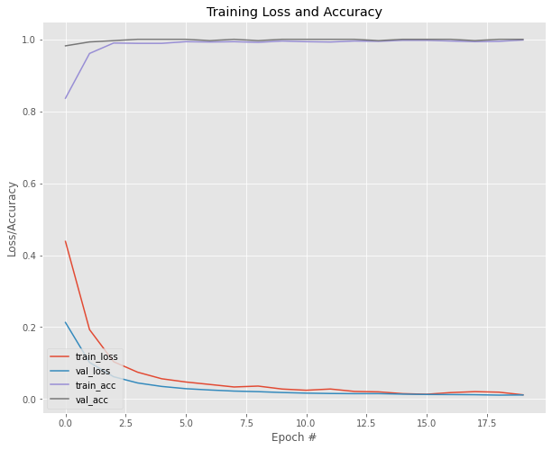

Figure 4. Accuracy and Loss on Training and Testing Sets

***Implement Model on Selected instances of Images***

we provided two examples of images to evaluate the model. After running the model following results were obtained:

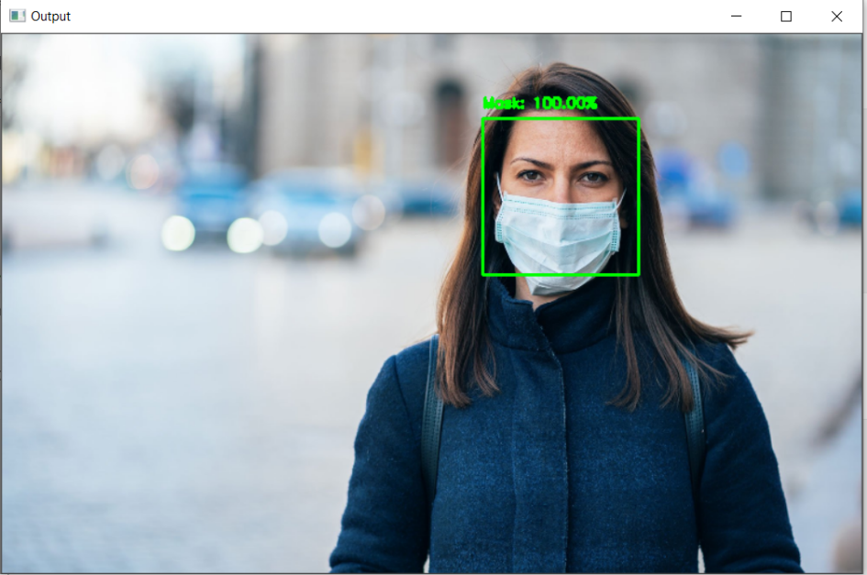

Figure 5. Selected instances of data from the first images

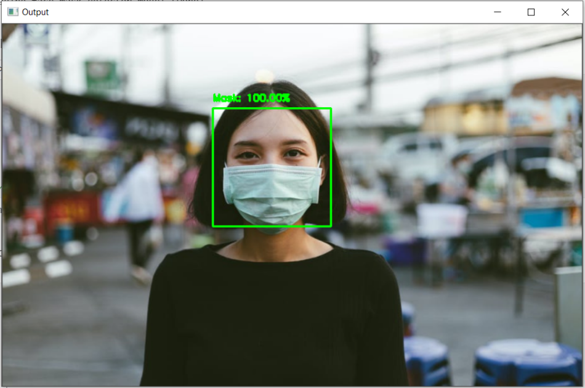

Figure 6. Selected instances of data from the second images

***Implement Model on Real-Time Video***

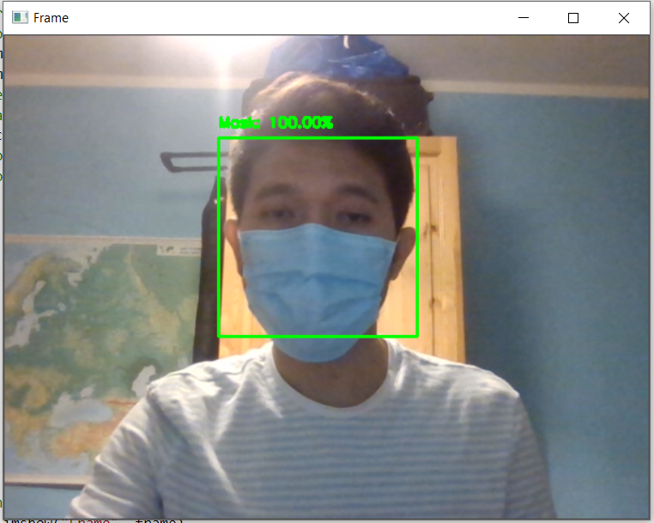

Figure 7. Real-Time Video using Laptop Webcam with Mask

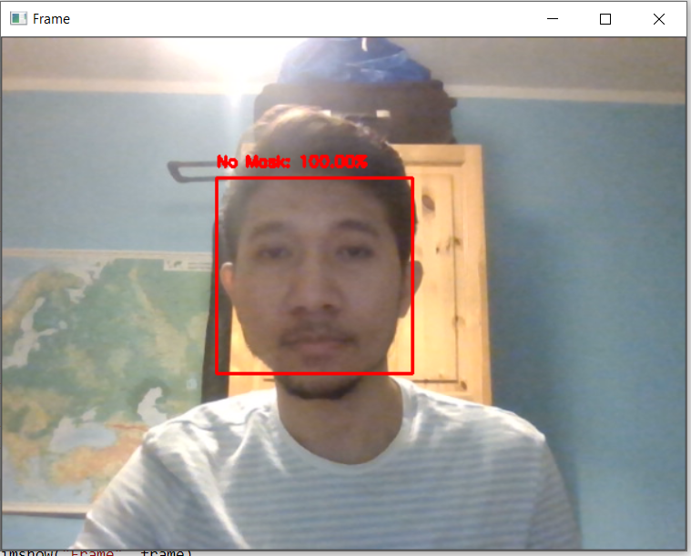

Figure 8. Real-Time Video using Laptop Webcam with Without Mask

***Implement Model on Based-Android Application***

**References**

Bhandary, Prajna. 2020. Mask and non-Mask Datasets [https://github.com/prajnasb/observations]

Prove, Paul-Louis. 2018. MobileNetV2: Inverted Residuals and Linear Bottlenecks [https://towardsdatascience.com/mobilenetv2-inverted-residuals-and-linear-bottlenecks]

Rosebrock, Adrian. 2017. Deep Learning for Computer Vision with Python: Practitioner Bundle. Pyimagesearch

Sandler, Mark, et al. 2018. ChenMobileNetV2: Inverted Residuals and Linear Bottlenecks. The IEEE Conference on Computer Vision and Pattern Recognition (CVPR), 2018, pp. 4510-4520 [https://arxiv.org/abs/1801.04381]

Sumara, Rauzan. 2022. AI-Face Mask Detector with MobileNetV2 [https://github.com/rauzansumara/face-mask-detector-based-on-mobilenetv2]