Building the EU Funding-Match System in Microsoft Copilot Studio
A step-by-step build guide – written so anyone can follow it, no coding needed
Read this first. You build this in three stages. Stage 1 builds the “brain” and tests it by hand. Stage 2 adds the specialist helper agents. Stage 3 makes it run automatically every day. Do them in order – each stage works on its own, so you always have something that functions before adding the next layer. Don’t jump to the automatic daily run until the brain gives good answers, because automatic runs cost credits.

1. How the finished system works (the goal)
Before building, picture the finished result. You keep two simple Excel files: a list of your projects, and a list of trusted EU funding sources. Every night the system reads your projects, looks for open EU funding calls, decides how well each project fits, and writes the answer – plus advice on how to improve weak matches – into a results sheet and a short Teams message. You only ever touch the two files on the left and read the results on the right. Everything in the middle runs by itself.
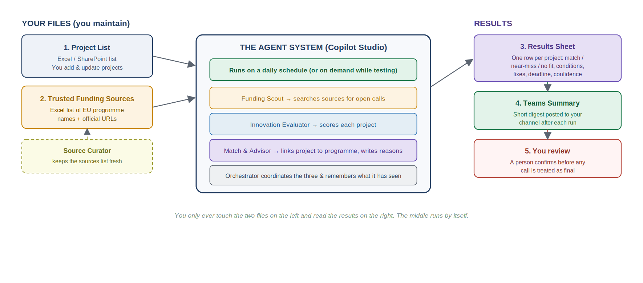
The five “agents” in plain words: an Orchestrator (the manager that coordinates everyone), a Funding Scout (finds open calls), an Innovation Evaluator (scores how innovative each project is, because funders favour novelty), a Match & Advisor (decides the fit and writes the reasons), and a Source Curator (keeps the funding-sources list trustworthy). In Copilot Studio these are one main agent plus four “child agents” – you will create them one at a time.
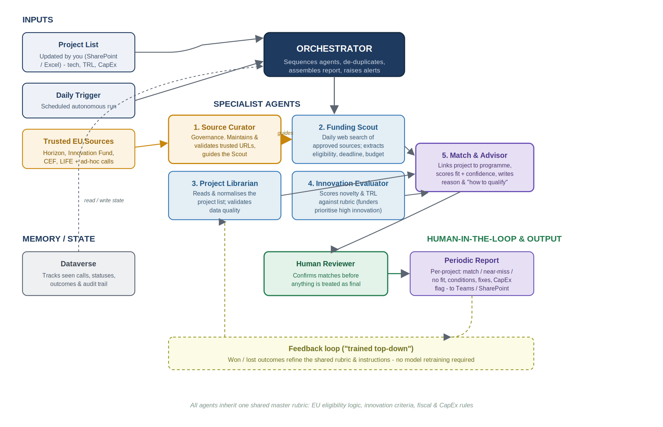
Full architecture (for reference) – you will build it piece by piece in the stages below.

2. Before you start – what to get from IT
Send your IT/admin team this short list. You cannot build until these are in place, and a couple of them (credits, permissions) only an admin can switch on.
What to confirm | Why / what to ask for
Copilot Studio access | That your work account can open copilotstudio.microsoft.com and create agents.
A place to build (“environment”) | Ask for a Development environment to build and test in, separate from where live tools run.
Copilot Credits | Set up pay-as-you-go (linked to an Azure subscription) so the daily automatic runs can consume credits. Ask them to set a monthly budget cap.
Permission to create flows | Power Automate access in the same environment – needed for the automatic daily run and writing results back.
A SharePoint site / Excel location | One folder where the project list, the sources list, and the results sheet will live.
A Teams channel | Where the daily summary will be posted and where the team will chat with the agent.

3. Prepare your input files (do this before touching Copilot Studio)
The quality of the answers depends entirely on these files. Create them in Excel (or as SharePoint lists – same columns either way) and save them in the shared folder from Section 2.

3.1 File 1 – Project List
One row per project. This is the file you update regularly. Use these exact column headings (keep them simple and consistent – the agent reads the headings).
Column | What goes in it | Example
Project_ID | A unique code for each project | P-001
Project_Name | Short, clear name | Shore power connection – Vessel 3
Description | 1–3 sentences on what it does and the emissions benefit | Install shore-side power so the ship switches off engines at berth
Technology_Type | The category of technology | Shore power / cold ironing
TRL | Technology Readiness Level, 1 (idea) to 9 (proven in service) | 8
Innovation_Level | Your view: High / Medium / Low – or leave blank and let the agent score it | Medium
Estimated_CapEx_EUR | Approx. capital cost in euros | 2,400,000
CO2_Reduction | Estimated yearly saving | 1,200 tCO2e/yr
Project_Stage | Idea / Planning / Pilot / Implementation / Complete | Planning
Country | Where it takes place (affects eligibility) | Germany
Partners | Any consortium or external partners | Port of Hamburg; equipment vendor
Funding_Status | Not applied / Applied / Awarded / Rejected | Not applied
Notes | Anything else useful | Pilot before fleet-wide rollout

3.2 File 2 – Trusted Funding Sources
One row per official EU (or national) funding programme you want scanned. This is the list the Source Curator keeps clean. Start with the major ones and add more over time.
Column | What goes in it | Example
Source_ID | Unique code | S-01
Programme_Name | Official programme name | EU Innovation Fund
Funding_Body | Who runs it | CINEA / European Commission
Official_URL | The official call/portal link only | ec.europa.eu/…
Focus_Area | What it funds | Large-scale clean-tech demonstration
Typical_TRL_Range | Readiness it expects | 7–9
Key_Eligibility | Short eligibility notes | Innovative, GHG-reducing, EU-based
Active | Should it be scanned? Yes / No | Yes
Last_Checked | Date the link was last verified | 2026-06-01
Suggested starting programmes: Horizon Europe, EU Innovation Fund, CEF Transport (Connecting Europe Facility), and the LIFE Programme – plus any German national co-funding bodies relevant to maritime. Put each one’s official page in the Official_URL column.

3.3 File 3 – Results Sheet (the system fills this in)
Create this empty, with just the headings. The system writes one row per project each run; you read it. You do not type into this file.
Column | What the agent writes here
Run_Date | Date the check ran
Project_ID / Project_Name | Which project this row is about
Result | Strong match / Near-miss / No fit
Matched_Programme | The best-fitting programme (and call title)
Deadline | Application deadline of that call
Conditions | What the project must satisfy to be eligible
Reason | Why it got that result – for near-miss/no-fit, what specifically failed
Recommended_Modifications | Concrete changes that would improve the match
CapEx_Aligned | Whether the project cost fits the grant size (Yes / No / flag)
Confidence | High / Medium / Low – how sure the system is

4. Stage 1 – Build the brain and test it by hand
Here you create the main agent, give it instructions and your files, and ask it questions yourself. No automation yet – this is the cheap way to prove the answers are good.

Step 1 – Open Copilot Studio
- In your browser go to copilotstudio.microsoft.com and sign in with your work account.
- Top-right, check the environment name. Make sure it is your Development environment (from Section 2), not “Default”, if you have one.

Step 2 – Create the main agent
- In the left menu click Create, then New agent.
- It will offer to build by chatting. Instead click Skip to configure so you stay in control.
- In Name, type: EU Funding Match Coordinator
- In Description, type: Matches our decarbonization projects to EU funding programmes and explains the fit.

Step 3 – Give it its instructions (this is the most important step)
Find the large Instructions box. Delete anything there and paste the text below exactly. These instructions are what make the agent behave like a funding expert.
Copy this into the Instructions box:
You are the EU Funding Match Coordinator for a maritime
decarbonization company. Your job is to match the company's
emissions-reduction projects to suitable EU funding programmes and
explain clearly why each project does or does not fit.

You coordinate three helpers: the Funding Scout (finds open funding
calls from the trusted sources list), the Innovation Evaluator
(scores how innovative a project is), and the Match and Advisor
(decides the fit and writes the recommendation).

When asked to assess one or more projects, do this in order:
1. Read the project details from the Project List knowledge source.
2. Ask the Funding Scout for funding calls that are currently open.
3. Ask the Innovation Evaluator to score each project.
4. Ask the Match and Advisor to compare the project to the open
calls and decide the result.
5. Give one clear result per project.

For each project, present: project name; result (Strong match /
Near-miss / No fit); matched programme and deadline; conditions to
meet; reason for the result; recommended changes to improve the
match; and a confidence level (High / Medium / Low).

Rules you must follow:
- Use only the project list, the trusted funding sources, and what
the Scout finds. Never invent programmes, deadlines or rules.
- If you are unsure, say so and mark confidence as Low.
- Always remind the user that results are guidance for a human to
confirm, not a final funding decision.

Step 4 – Choose the AI model (if you see the option)
- Open the agent’s Settings (or model selector). If you can pick a model, choose a strong current one (for example a Claude Sonnet or GPT-4o-class model). The default is fine to start.

Step 5 – Add your files as “knowledge”
- On the agent page, click + Add knowledge.
- Add the Project List (choose SharePoint/Excel and point to File 1). Give it the name Project List and a description: The company's decarbonization projects to be matched to funding.
- Click + Add knowledge again and add the Trusted Funding Sources file the same way, described as Official EU funding programmes and their links, scope and eligibility.
- Also add the official programme web pages as website knowledge (paste the URLs from File 2). A clear description for each helps the agent pick the right one.
Why the descriptions matter: the agent uses the name and description of each knowledge source to decide when to use it. Vague descriptions give vague answers.

Step 6 – Test it yourself
- On the right is the Test panel. Type: Assess project P-001 against current EU funding.
- Read the answer. Then try: Which of our projects has the best funding fit right now, and why?
- If you see an activity map (a small diagram of what the agent did), open it – it shows which knowledge source it used, which helps you fix wrong answers.
Stop and check: Are the matches sensible? Are the reasons specific? If not, improve the Instructions (Step 3) and the file descriptions (Step 5) before moving on. This is normal – expect two or three rounds of tuning.

5. Stage 2 – Add the four specialist agents
Now you split the work into specialists so each does one job well. In Copilot Studio these are “child agents” inside your main agent.
- Open your main agent and find the Agents page (or “Add agent” area).
- Click Add agent → Create child agent. You will repeat this four times – once per specialist below. For each one, paste the matching instructions and write a one-line description so the main agent knows when to call it.
- Give each child agent the right knowledge: the Scout and Curator get the Trusted Funding Sources (and the Scout also needs web search turned on); the Evaluator and Match & Advisor get the Project List.
- Finally, in the main agent’s Instructions, you can type “/” to insert a reference to a child agent by name, so the Orchestrator routes to it. (The instructions in Step 3 already name them.)

Agent 1 – Funding Scout
Description (one line): Finds currently open EU funding calls from the trusted sources.
Instructions for the Funding Scout:
You are the Funding Scout. Your only job is to find currently OPEN
EU funding opportunities relevant to maritime decarbonization, using
ONLY the official programmes in the Trusted Funding Sources
knowledge.

For each open call, report: programme name; call/topic title;
official link; application deadline; total budget or grant size if
stated; the technology areas it funds; the minimum technology
readiness level (TRL) expected; and key eligibility conditions
(for example consortium or eligible-country requirements).

Rules:
- Use only the trusted sources. Never use random blogs or unofficial
sites.
- If a detail is not on the official page, write 'not stated'.
Do not guess.
- Prefer the most recently published calls. List each separately.

Agent 2 – Innovation Evaluator
Description (one line): Scores how innovative a project is, and checks its TRL.
Instructions for the Innovation Evaluator:
You are the Innovation Evaluator. Given one project's description,
technology type and TRL, rate its degree of innovation as High,
Medium or Low, and justify it in one or two sentences.

Use these guides:
- High: novel technology, or a novel application not yet widely used
in the cruise/maritime sector; a clear step-change in emissions.
- Medium: an improvement on existing technology, or proven
technology applied in a moderately new way.
- Low: standard, off-the-shelf or widely adopted technology with
only incremental benefit.

Also state the TRL and whether it sits in the range EU innovation
funding usually expects (often TRL 5-8 for demonstration funding).

Output: innovation level; one-line justification; TRL; TRL
suitability note.

Agent 3 – Match & Advisor
Description (one line): Decides the fit between a project and the open calls, and writes the advice.
Instructions for the Match & Advisor:
You are the Match and Advisor. You receive: one project (its
description, technology, TRL, CapEx, CO2 impact, country, partners);
its innovation score; and a list of currently open funding calls.
Decide how well the project fits and produce one best result.

Decide the result using these rules:
- Strong match: fits the call's technology scope, meets the TRL
range, meets eligibility, and innovation is Medium or High.
- Near-miss: close but fails one or two things that could be fixed
(innovation too low, TRL slightly off, missing a partner, budget
mismatch).
- No fit: outside the call's scope, fails eligibility in a way that
cannot easily be fixed, or no relevant call is open.

For the result you choose, write: matched programme and deadline;
the exact eligibility conditions; a clear reason (for near-miss and
no-fit, say specifically what failed); concrete recommended changes
to improve the match; whether the CapEx aligns with the grant size;
and a confidence level (High/Medium/Low).

Never overstate certainty. If eligibility is ambiguous, choose the
more cautious result and mark confidence Low. End by reminding that
a human must verify eligibility before applying.

Agent 4 – Source Curator
Description (one line): Keeps the trusted funding-sources list official and up to date.
Instructions for the Source Curator:
You are the Source Curator. You keep the Trusted Funding Sources
list trustworthy. When asked to review the sources:
- Check each programme link is an official EU or national funding
body page (for example europa.eu and cinea.ec.europa.eu, and
recognised national agencies).
- Flag any link that looks outdated, broken or unofficial.
- Suggest official sources that may be missing for maritime
decarbonization (for example Horizon Europe, the EU Innovation
Fund, CEF Transport, the LIFE Programme, national co-funding).

Never add a source unless it is an official funding body. You only
recommend changes; a person approves them.

Output a short table: programme; URL; official? (Yes / Needs check);
note.
Test again the same way as Step 6, now that the specialists exist. The answers should be sharper and the reasons more specific.

6. Stage 3 – Make it run automatically every day
Two pieces make this automatic: a flow (the plumbing that reads the project list, runs the agent on each project, and writes the results) and a trigger (the daily alarm clock). In Copilot Studio, creating a trigger quietly creates a Power Automate flow behind the scenes – so the two are closely linked.

Step 1 – Build the flow
- In your agent’s left menu, open Flows and click New flow. You can describe it in plain English and let it build the skeleton, for example:
Every day, get all rows from the Project List Excel file. For each
project, run the EU Funding Match Coordinator agent on that project,
then add a row to the Results Sheet with the agent's answer. After
all projects are done, post a short summary to our Teams channel.
- Check the steps it created: a List rows action on File 1, an Apply to each loop, a step that calls the agent, an Add a row action on File 3, and a Post message in Teams at the end. Fix any file or channel it points at.

Step 2 – Add the daily trigger
- Open the Triggers area of the agent and click Add trigger. Choose the Scheduled / Recurrence option.
- Set it to run once a day at a quiet time (for example 06:00). Daily is enough – funding calls do not change by the hour, and every automatic run uses credits.
- Connect the trigger so that when it fires, it runs the flow from Step 1.

Step 3 – Keep a human in the loop
The flow only ever writes to your results sheet and posts to Teams. It must never submit a funding application or email anyone outside automatically. The Teams message should tag the reviewer so a person checks every result before any real action is taken. This is deliberate – the system advises, people decide.

Step 4 – Watch the cost
- Keep the schedule to once a day. Each automatic run consumes credits (roughly 25 credits per autonomous trigger, plus more for the reasoning).
- Start small. Run it against 5–10 projects and 3–4 programmes first, then expand once it is reliable.
- Ask IT for the budget cap from Section 2 so a runaway loop can never surprise you.

7. Publish it and how the team uses it day-to-day

Publish
- Click Publish (top right). Choose the Microsoft Teams channel so people can chat with the agent where they already work. You can also publish into Microsoft 365 Copilot.

How employees work with it once it is live
- You / the funding team: keep the Project List up to date – add new projects, update stage and cost. That is the main ongoing job.
- Every morning: a short digest appears in Teams. Open the Results Sheet to see the full per-project guidance.
- For a near-miss: read the “Recommended modifications” – it tells you what to change to qualify.
- Anyone can ask directly: in Teams, type a question like “What is the best funding fit for our shore-power project, and what would we need to change?”
- The reviewer: confirms eligibility before any application is prepared. The system never applies on its own.
- Monthly: ask the Source Curator to review the funding-sources list, and approve its suggestions.

8. If something looks wrong
- Answers are vague or generic → improve the file descriptions (Stage 1, Step 5) and the Instructions; vague descriptions are the usual cause.
- It invents a programme or deadline → strengthen the “never invent” rule and check the Scout is only using the trusted sources.
- It used the wrong source → open the activity map to see what it picked, then sharpen that source’s description.
- The daily run did not happen → check the trigger is on and the flow has not hit an error in Power Automate’s run history; also check credits have not run out.
- Costs climbing → reduce the schedule frequency, cut the number of sources, and confirm the budget cap with IT.

9. Quick recap of the build order
- Get the IT items in Section 2.
- Create the three Excel files (Section 3).
- Stage 1: build the main agent, add the files, test by hand until answers are good.
- Stage 2: add the four child agents, test again.
- Stage 3: build the flow, add the daily trigger, keep human review, watch cost.
- Publish to Teams and brief the team on the day-to-day routine.
One sentence to remember: get the brain right by hand first, automate second, and always keep a person between the system’s advice and any real funding decision.

