AI-Driven Funding-Match System for Decarbonization Projects
A multi-agent system in Microsoft Copilot Studio · Preliminary draft for manager discussion

1. Purpose
We run many emissions-reduction and resource-optimization projects, and EU bodies open funding calls frequently. Matching the two is currently manual, slow, and prone to missed fits – especially ad-hoc calls. The goal is an autonomous system that scans funding opportunities daily, scores each project against them, explains every gap, and advises how to close it.

2. What the system does
- Maintain a live project registry – fed and updated by you (tech, innovation level, TRL, CapEx, emissions impact, stage).
- Discover funding daily – search EU programmes (Horizon Europe, Innovation Fund, CEF Transport, LIFE, regional/national co-funding) plus ad-hoc calls.
- Match and score – assess each project against a programme’s eligibility, innovation threshold and conditions, with a confidence level.
- Explain the verdict – per project: opportunity (with conditions), near-miss (what to change to qualify), or no fit (and why).
- Report periodically – a project-by-project status output on a schedule, with the CapEx plan kept current and deadlines flagged.

3. Architecture – one orchestrator, five specialist agents
A single Orchestrator directs five specialists. This matches how Copilot Studio’s multi-agent orchestration is now designed to work: one conductor, a specialist per domain, rather than one over-loaded agent.
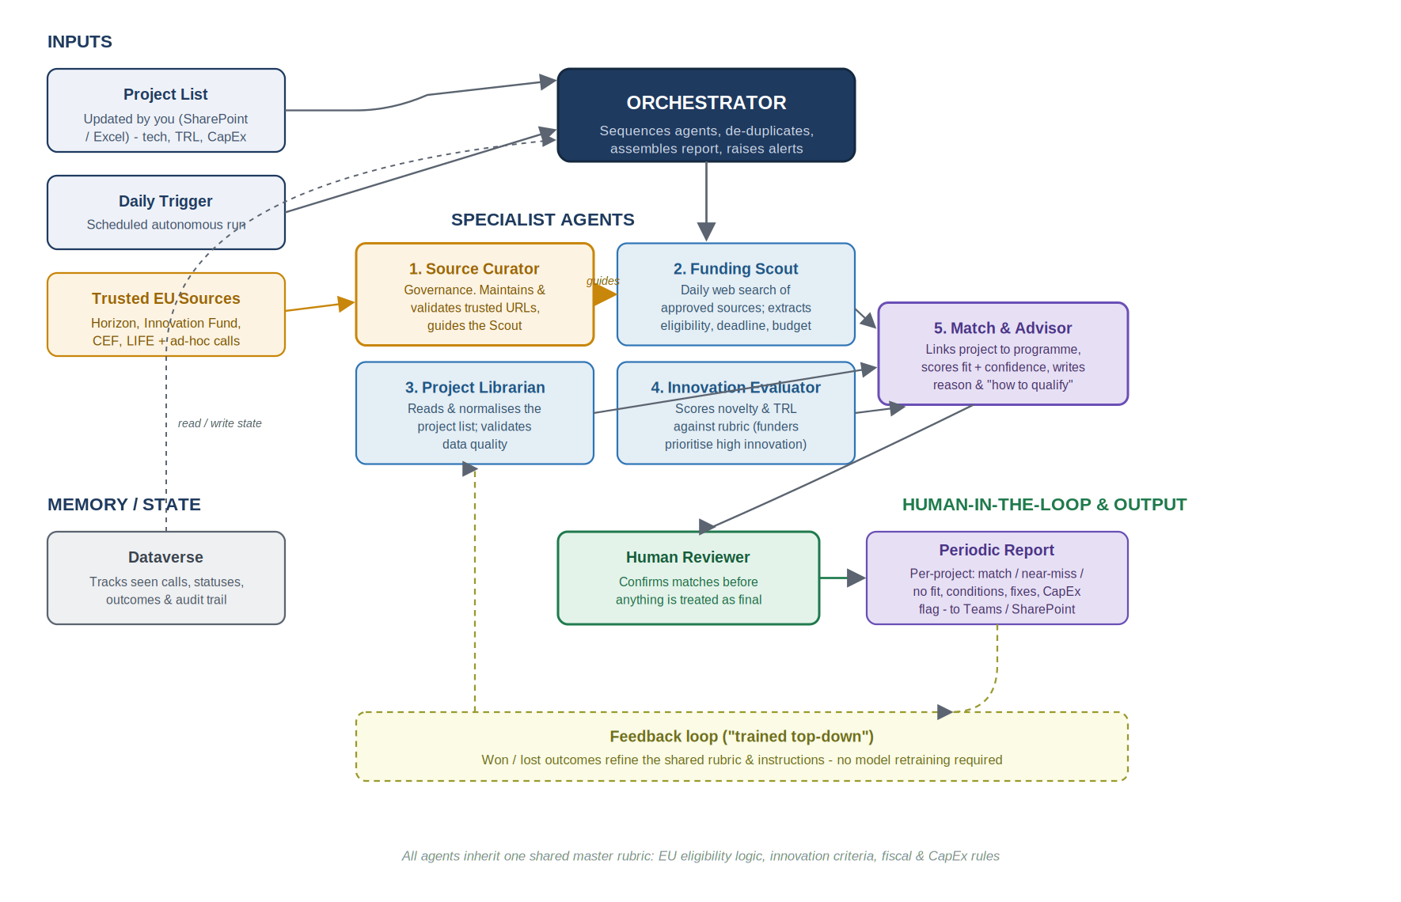
Agent | Role | Key data / tools
Orchestrator | Sequences the agents, de-duplicates against memory, assembles the report, raises deadline alerts | Copilot Studio orchestration
1. Source Curator | Governance agent. Maintains and validates the trusted-source list; guides the Scout on where to look and flags stale/dead links | Curated URL registry (Dataverse)
2. Funding Scout | Daily search of approved sources; extracts eligibility, deadline, budget and conditions | Web search, scheduled trigger
3. Project Librarian | Reads and normalises your project list; checks data quality before matching | SharePoint / Excel / Dataverse
4. Innovation Evaluator | Scores each project’s novelty and TRL against an agreed rubric (funders prioritise high innovation) | Shared rubric + grounding docs
5. Match & Advisor | Links project to programme, scores fit + confidence, writes the reason and the “how to qualify” guidance | Reasons over the other agents’ output
On “trained top-down”: this is best done as layered instructions plus a shared knowledge base – one master rubric (innovation criteria, EU eligibility logic, fiscal and CapEx rules) that every agent inherits – not model fine-tuning. A feedback loop then improves the rubric from won/lost outcomes. This is faster, auditable, and editable without retraining.

4. Which Copilot / licensing
This is not a “basic vs enterprise” choice. The product required is Microsoft Copilot Studio specifically (the agent-building platform), and the cost driver is credits for autonomous daily runs, not the number of users.
- Authoring/access: Microsoft 365 Copilot Enterprise (~$30/user/month) gives licensed users Copilot Studio access for internal agents – enough for the people who build and review. A standalone Copilot Studio subscription is the alternative.
- Autonomous triggers always cost extra. A scheduled daily scan runs without a user present; these autonomous triggers consume Copilot Credits (~25 credits per trigger) and are never bundled – even for M365 Copilot-licensed users.
- Pay for credits one of two ways: pay-as-you-go via an Azure subscription (no upfront commitment – best for the pilot), or prepaid capacity packs (~$200/pack/month for 25,000 credits; unused credits do not roll over).
- Also required: an Azure subscription to run agents, and Dataverse (Copilot Studio runs on it; ~15 GB included by default) for the system’s memory/state.
Recommendation: start the pilot on pay-as-you-go to stay flexible, then switch to capacity packs once daily consumption is predictable. Ask IT to confirm current tenant licensing and to set a credit budget cap – autonomous agents can accrue cost without user activity to track.

5. What’s possible now vs. what needs care
Possible today (no custom ML build): scheduled daily scanning, multi-agent orchestration, grounding on your project files, eligibility reasoning, and plain-language explanations – all native to Copilot Studio.
Needs care:
- Source reliability – portals change; the Source Curator keeps a curated trusted list and a person confirms before output is treated as final. Treat the system as decision-support, not the funding decision.
- Eligibility nuance – EU rules are detailed; ground the agents on the actual programme documents so they flag and recommend rather than invent.
- Innovation scoring – needs an agreed rubric up front, or scores drift between runs.
- Cost & governance – scope scan frequency and the number of sources; set a credit cap and a named owner.

6. Requirements to start
- Microsoft 365 + Copilot Studio licensing confirmed with IT (per Section 4).
- A structured project list (tech, TRL, CapEx, emissions impact, stage) in SharePoint or Excel.
- A curated list of trusted EU funding sources to scan.
- An agreed innovation + eligibility rubric.
- A named human reviewer for sign-off, and a credit-budget owner.

7. Suggested next step
A 4–6 week pilot. Build the Orchestrator + Source Curator + Funding Scout + Match & Advisor on 5–10 real projects against 3–4 known EU programmes, on pay-as-you-go credits. If the matches and explanations prove useful, add the Innovation Evaluator, the feedback loop, and the scheduled daily runs.

