Q No:1

def fib(n):
x,y=0,1
while y<n:
print(y)
x,y = y,x+y

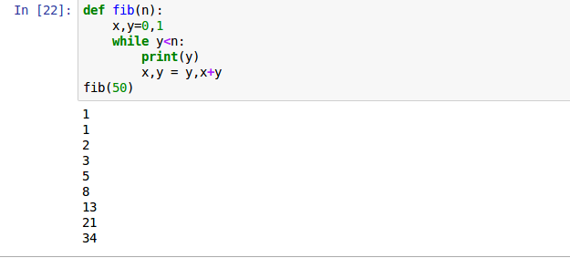

Q No:2

Month = raw_input('Enter Month:')
if Month == 'January':
print "No of days:",'31','days'
elif Month == 'Feb':
print "No of days:",'28/29','days'
elif Month == 'March':
print "No of days:",'31','days'
elif Month == 'April':
print "No of days:",'30','days'
elif Month == 'May':
print "No of days:",'31','days'
elif Month == 'June':
print "No of days:",'30','days'
elif Month == 'July':
print "No of days:",'31','days'
elif Month == 'August':
print "No of days:",'31','days'
elif Month == 'September':
print "No of days:",'30','days'
elif Month == 'October':
print "No of days:",'31','days'
elif Month == 'November':
print "No of days:",'30','days'
else:
Month == 'December'
print "No of days:",'31','days'

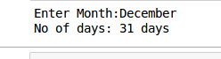

Q No:3

Character=raw_input('Enter Character:')
lst1 = ['a','i','o','u']
if Character in lst1:
print Character + " is a vowel"
else:
print Character + " is a consonant"

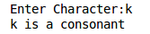
Q No:4

s = raw_input("Enter word:")
if type(s) == int:
print "The string is an integer"
else:
type(s) == str
print "The string is not an integer"



Q No:5

calculation=raw_input("Enter a string:")
var = 0
var1 =0
for k in calculation:
if k.isupper():
var += 1
else:
if k == " ":
continue
k.islower()
var1 += 1
print "Upper case" , var
print "Lower case" , var1

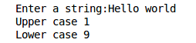

Q No:6

Month=raw_input("Enter month:")
Day=input("Enter day:")
if (Month == 'january') & (Day>=20) | (Month == 'febuary') & (Day<=19):
print "your Astrological sign is: Aquarius"
elif (Month == 'febuary') & (Day>=20) | (Month == 'march') & (Day<=20):
print "your Astrological sign is: Pisces"
elif (Month == 'march') & (Day>=21) | (Month == 'april') & (Day<=20):
print "your Astrological sign is: Aries"
elif (Month == 'april') & (Day>=21) | (Month == 'may') & (Day<=20):
print "your Astrological sign is: Taurus"
elif (Month == 'may') & (Day>=21) | (Month == 'june') & (Day<=20):
print "your Astrological sign is: Gemini"
elif (Month == 'june') & (Day>=21) | (Month == 'july') & (Day<=22):
print "your Astrological sign is: Cancer"
elif (Month == 'july') & (Day>=23) | (MOnth == 'august') & (Day<=22):
print "your Astrological sign is: Leo"
elif (MOnth == 'august') & (Day>=23) | (Month == 'september') & (Day<=22):
print "your Astrological sign is: Virgo"
elif (Month == 'september') & (Day>=23) | (Month == 'october') & (Day<=22):
print "your Astrological sign is: Libra"
elif (Month == 'october') & (Day>= 23) | (Month == 'november') & (Day<=22):
print "your Astrological sign is: Scorpio"
elif (Month == 'november') & (Day>=23) | (Month == 'decmber') & (Day<=21):
print "your Astrological sign is: Sagittarius"
else:
(Month == december) & (Day>=22) | (Month == 'january') & (Day<=19)
print "your Astrological sign is: Capricon"

