PROJECT REPORT
Smart Contactless Dining Platform
(DineFlow)
Project Documentation
Submitted by | Project guide
[Student name and roll number] | [Guide name]
[Student name and roll number] | [Department / institution]
[Degree / semester / academic year]
[College or institute name]

Acknowledgement
We express our sincere gratitude to our project guide, [Guide name], for guidance and feedback during the development of DineFlow. We also thank [Principal name], [Dean name], and the faculty of [Department / Institution] for their support.
We appreciate the contributions of everyone who helped us understand restaurant workflows, develop the application, and review its design. Their time and suggestions supported the project work documented here.
With sincere regards,
[Student name] ([Roll number])
[Student name] ([Roll number])

Table of Contents
Sr. No |  | Subject | Page Number
1 |  | Project Profile & Company Profile
2 |  | Introduction to tools
3 |  | System Study
 |  | Existing System
 |  | Proposed System
 |  | Scope of the Proposed System
 |  | Aim and Objective of the Proposed System
 |  | Feasibility Study
 |  | Operational Feasibility
 |  | Technical Feasibility
 |  | Economical Feasibility
4 |  | System Analysis
 |  | Requirements Specification (along with System Modules)
 |  | Use Case Diagram
 |  | Activity Diagram
 |  | Class Diagram
 |  | OR
System FlowChart
Functional Decomposition Diagram
DFD
- Context Level DFD
- First Level, Second Level ….
5 |  | System Design
 |  | Data Dictionary
 |  | Screen Layouts
 |  | Reports
6 |  | System Testing
 |  | Testing Strategies
 |  | Test Cases
7 |  | Future Enhancement
8 |  | Bibliography/References
9 |  | Reporting Report (to be collected from respective internal guide)

Project Profile
Profile field | Project details
Project Name | Smart Contactless Dining Platform (SCDP) / DineFlow
Type of Application | Responsive web application with service based backend
Project Description | QR initiated dine in menu browsing, ordering, table sessions and restaurant operations.
Team Size | [Enter team size]
Front End | React 18, Vite, Tailwind CSS, Redux Toolkit (project specification)
Back End | Spring Boot authentication service; Node.js / Express services
Tools used | PostgreSQL, MongoDB, Redis, Docker, Docker Compose, Nginx
Project Profile and Company Profile
DineFlow is an academic software project for contactless dine in operations. The supplied project context describes a restaurant platform and does not identify a commercial company; a company profile is therefore not applicable.
Project Overview
A guest scans a table QR credential, joins a table session, browses the digital menu, configures items and submits an order using a mobile browser. Staff manage restaurant tables and QR credentials. The wider design includes kitchen order handling, payment services, notifications and analytics.
The implementation timeline records the table domain/staff authorization and QR/session phases as complete. Customer menu and checkout work is in progress; online payment provider setup and live persistence verification remain open. Kitchen tracking, table revenue analytics and release readiness have not started.

Introduction to Tools
Front End Tool
React 18 is specified for the customer web app, kitchen display and administration interfaces. Vite supports development/build workflows, Tailwind CSS provides utility based styling, and Redux Toolkit is specified for shared application state. The customer interface is designed for mobile browsers and QR entry.
Back End Tool
Spring Boot and Spring Security provide the authentication and authorization service, including staff access controls and scoped customer table-session tokens. Node.js and Express provide service APIs for menu, order, payment and notifications. Domain responsibilities are separated so each service can own its data and business rules.
Database and Infrastructure Tools
PostgreSQL stores transactional data such as tables, sessions, orders and payments. MongoDB stores menu catalog documents, including products, variants and modifiers. Redis supports active session state, caching and event distribution. Docker and Docker Compose package the local services and dependencies; Nginx routes requests through the gateway.

System Study
Existing System
The project specification describes common difficulties in manual dine in operations: printed menus require staff distribution and updates; spoken order taking can lose customizations; guests have little visibility into kitchen progress; and staff handle repeated order-status and billing questions. These describe the project problem context and are not measured findings from a restaurant study.
Proposed System
DineFlow proposes a QR based mobile web workflow. A printed table QR identifies a restaurant and table; the server validates the credential and creates or reuses an active session. Customers browse current menu data and submit a server validated order. Staff use administrative tools for table and credential management. Kitchen, payments, live notifications and analytics are part of the target platform, with completion tracked in phases.
Scope of the Proposed System
• Restaurant scoped table records, staff table operations and QR credential lifecycle.
• QR scan validation, active table session initialization/reuse, and a customer token scoped to that session.
• Menu browsing and cart selection with server-side availability, modifier and price validation.
• Pay-at-counter order creation with transactional order and item/price snapshots.
• Planned capabilities include online payment, kitchen status synchronization, table revenue analytics and operational release readiness.
Aim and Objective of the Proposed System
Aim: provide a secure and convenient digital dine in ordering workflow while establishing a foundation for restaurant staff operations.
• Replace paper menu access with a mobile friendly digital menu.
• Use table QR credentials to initialize an authorized guest session.
• Enforce restaurant ownership and staff privileges on administrative operations.
• Revalidate item availability, variants, modifiers and prices at checkout.
• Persist orders and item snapshots transactionally.
• Extend the system in phases toward payments, kitchen tracking, analytics and release readiness.
Feasibility Study
Operational Feasibility
Guests use a phone browser and QR scan, so a separate app installation is not required. Staff table and QR workflows match familiar administration tasks. Adoption depends on network access, staff onboarding and restaurant operating procedures.
Technical Feasibility
The repository contains a multi-service implementation using the specified web stack. The order service includes customer JWT checks, active session validation, menu lookups, checkout rules and transactional order persistence. The phase timeline records remaining provider, live-stack, kitchen, analytics and release work; the full target architecture is not yet a fully completed deployment.
Economical Feasibility
The project uses open-source frameworks and self-hostable data services, which can reduce software licensing costs. Hosting, payment gateway, messaging, maintenance and support costs have not been estimated in the supplied project materials.

System Analysis
Requirements Specification (along with System Modules)
Functional Requirements
• Staff can manage restaurant-scoped tables and table status.
• Authorized staff can issue, rotate and revoke table QR credentials.
• A valid QR scan initializes or reuses an active session and issues a scoped customer token.
• Customers can retrieve active menu data and configure product variants and modifiers.
• Checkout validates the customer token and active session, rechecks catalog availability and selection rules, and calculates prices on the server.
• The current checkout accepts PAY_AT_COUNTER; online payment is unavailable until a provider is configured.
• Orders and item snapshots are persisted transactionally.
• Planned: kitchen status workflow, real-time updates, settlement/invoices and staff revenue reports.
Non-functional Requirements
• Security: JWT identity, role/privilege checks, restaurant-level tenant scoping and revocable QR credentials.
• Data consistency: transactional order writes and item snapshots preserve prices and selections.
• Usability: responsive mobile-first experience for customer menu and ordering.
• Maintainability: domain responsibilities are split into services; Docker Compose describes the local stack.
• Reliability: reconnect and status catch-up are planned for real-time status delivery.
System Modules
Module | Responsibility | Status in phase timeline
Authentication / table sessions | Staff authorization, QR credentials, session tokens | Phases 1-2 complete
Menu | Catalog categories, products, variants, modifiers | Integrated for phase 3 checkout
Order | Validation, order lifecycle, transactional persistence | Counter checkout implemented; phase 3 in progress
Payment | Intent, verification, settlement, refund, invoice | Provider not configured
Notification | Redis events and scoped real-time updates | Phase 4 not started
Analytics | Table revenue and reporting | Phase 5 not started
Web clients | Customer, administration and kitchen workflows | Partially delivered by phases
Use Case Diagram
Primary current customer use cases are scanning a table code, joining a session, viewing the menu, configuring an order and submitting a pay-at-counter checkout. Staff manage tables and QR credentials. Kitchen and revenue use cases are planned according to the current phase checklist.
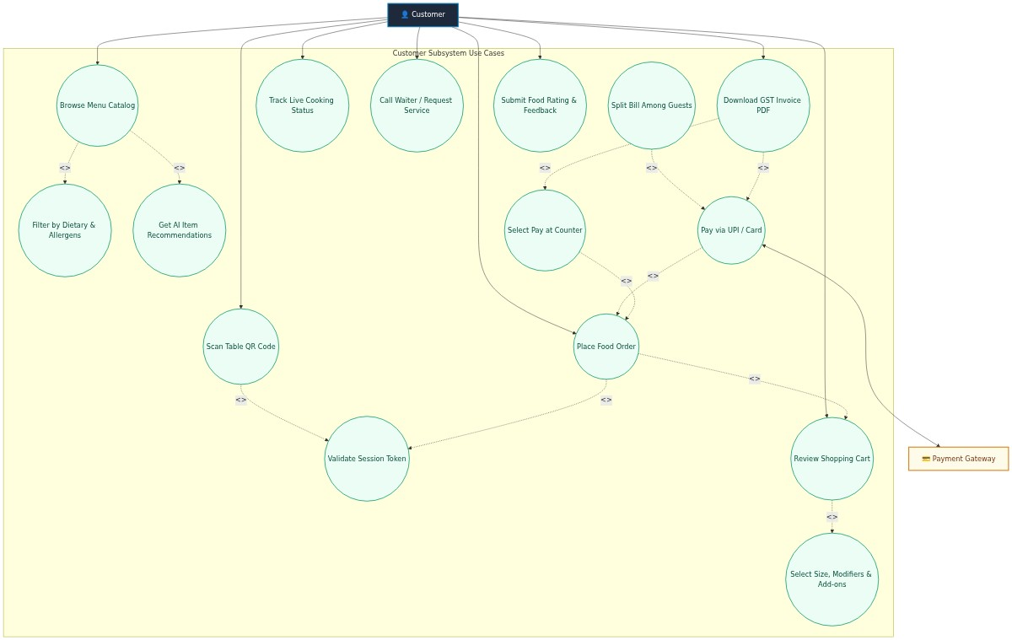
Customer subsystem use case diagram.
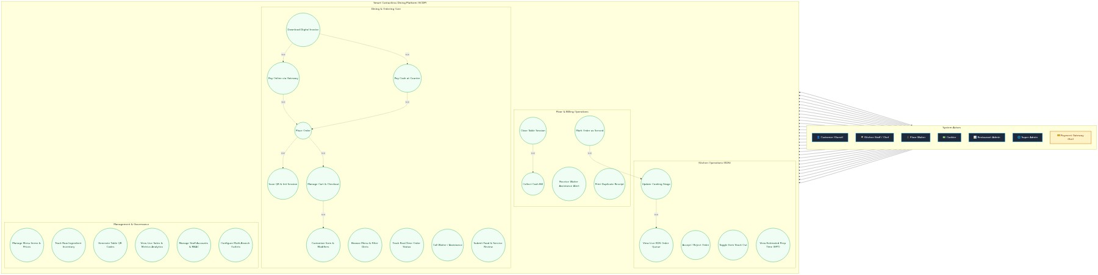
Complete system use case diagram; future modules are shown as target scope.
Activity Diagram
The activity flow begins when a guest scans a table QR code. The Auth Service validates the credential and table state, creates or reuses an active session, and returns a scoped token. The guest browses the menu and submits selections. The Order Service checks the active session and current catalog rules, calculates totals, stores the order and returns confirmation. Counter settlement and live kitchen updates follow later phases.
Class Diagram
The principal data relationships are Restaurant to RestaurantTable, RestaurantTable to TableSession, TableSession to Order, and Order to OrderItem and PaymentRecord. MenuItem belongs to a Category and may define variants and modifier groups. The project context does not provide a dedicated UML class diagram, so these entities are documented in the data dictionary and relationship summary rather than presenting an invented diagram.
System FlowChart / Functional Decomposition Diagram / DFD / Context Level DFD / First Level, Second Level
The supplied project context includes context-level and subsystem data-flow diagrams. The following figures describe the platform boundary and major subsystem exchanges.
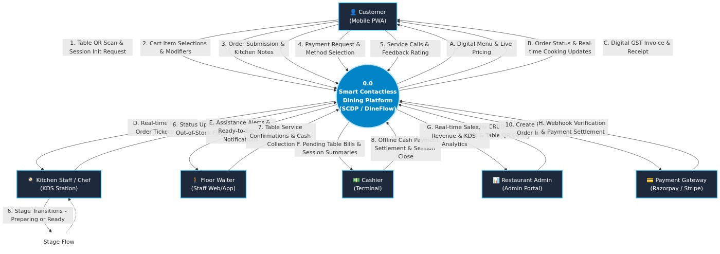
Context level data flow diagram.
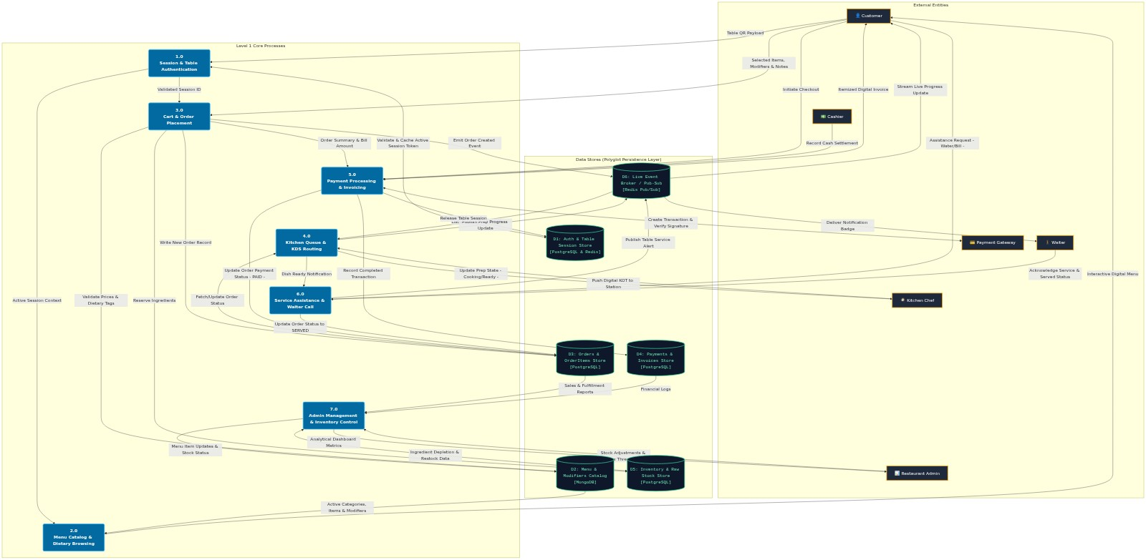
Level 1 subsystem data flow diagram.
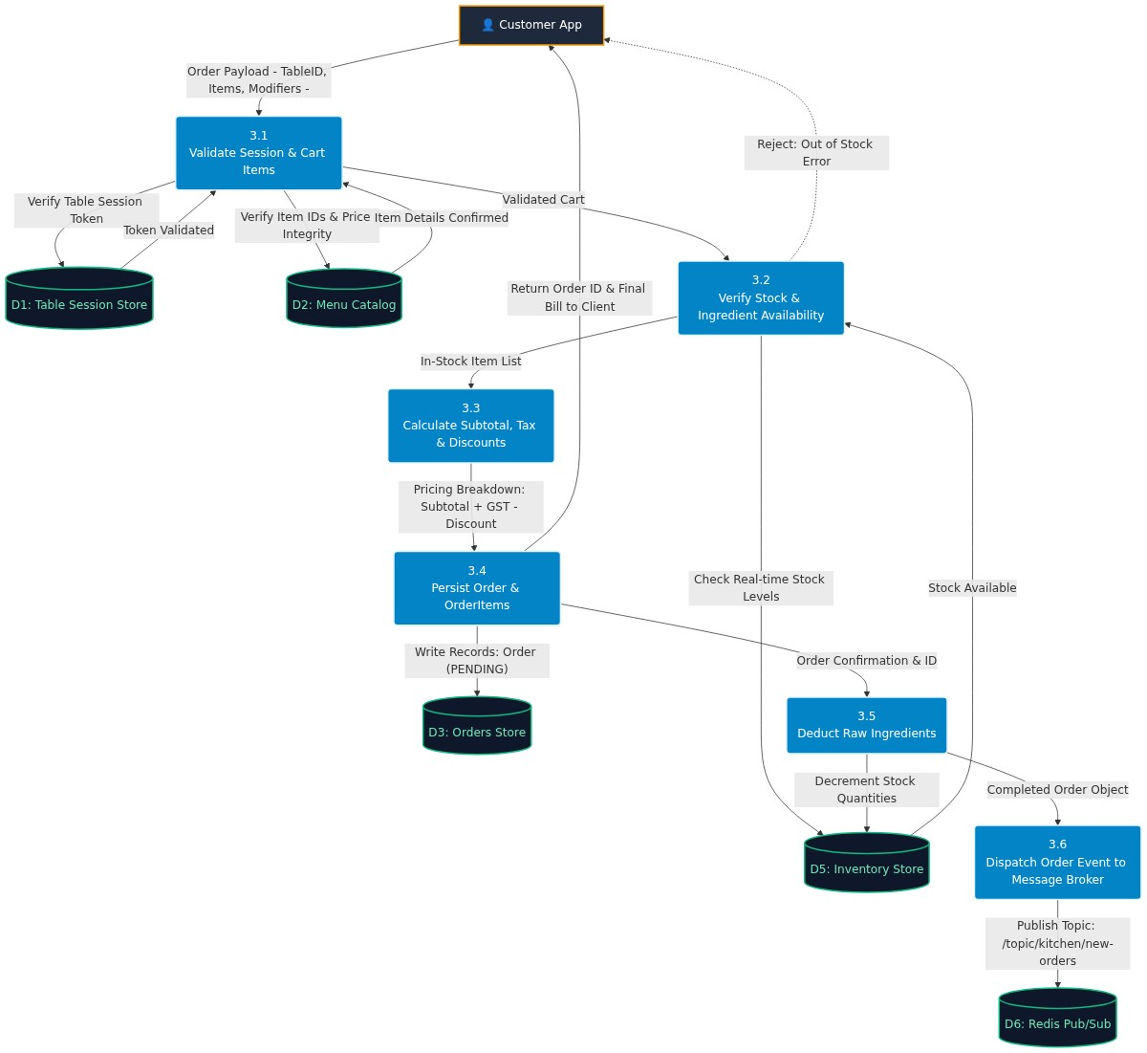
Level 2 order placement data flow diagram.

System Design
Architecture Design
Spring Boot owns identity and authorization for table sessions. Node.js services own menu, order, payment and notification domains. The customer app uses the Auth Service for QR session initialization and the Menu/Order services for browsing and checkout. PostgreSQL stores transactional records; MongoDB stores menu catalog documents; Redis provides active session state and event pub/sub. Nginx routes API traffic and Docker Compose defines the local multi-service stack.
Data Dictionary
Entity | Important fields | Description
RestaurantTable | id, restaurantId, tableNumber, status, qrCredentialVersion | Restaurant-owned table and current QR lifecycle state.
TableSession | id, tableId, startTime, endTime, sessionStatus | Guest session associated with a table.
MenuItem / Product | id, categoryId, restaurantId, basePrice, status, isAvailable | Catalog product and live availability.
Variant / Modifier | groupId, optionId, priceAdjustment, availability | Options selected by the guest and their price adjustments.
Order | id, restaurantId, tableId, tableSessionId, status, paymentMethod, paymentStatus, currency, subtotal, total | Transactional order summary.
OrderItem | id, orderId, productId, itemName, quantity, unitPrice, lineTotal, selections | Persisted item/price/configuration snapshot.
PaymentRecord | id, orderId, transactionId, method, status, amount, paidAt | Payment attempt/settlement/refund record; online provider flow pending.
Relationships: one restaurant owns many tables; each table has sessions over time; a session contains orders; an order has one or more item lines and may have payment records. Tenant identifiers should be retained on transactional records to support authorization and reporting.
Screen Layouts
Screen | Information and actions | Status
QR landing/session | Restaurant/table identity, session initialization, invalid/revoked/closed QR feedback | QR/session phase complete
Customer menu/cart | Categories, available products, options, quantities and checkout summary | Phase 3 in progress
Table/QR administration | Table details, status and credential display/rotation | Phases 1-2 complete
Kitchen display | Incoming queue and allowed order status actions | Planned phase 4
Table revenue report | Period, completed orders, gross, refunds, net revenue and currency | Planned phase 5
Reports
The proposed staff analytics report summarizes completed orders, gross settled revenue, refunds and net revenue for a selected table and date period. It is planned and is not claimed as implemented. The design calculates revenue from payment/order source records and excludes failed, pending and cancelled transactions.

System Testing
Project materials list automated menu, checkout, JWT/session and HTTP route tests. The timeline also identifies verification against the running PostgreSQL stack and Menu Service connectivity. The cases below express expected behavior; they are not a claim that every verification has been executed.
Testing Strategies
• Unit tests: checkout amount calculation, selection constraints, JWT verification, session state and repository behavior.
• Integration tests: API interactions, PostgreSQL transaction behavior, Redis session data and Menu Service lookup.
• End-to-end tests: staff table creation, QR scan, menu selection, checkout, settlement and kitchen tracking.
• Security tests: invalid/revoked credentials, cross-restaurant requests, privilege enforcement and duplicate payment events.
• Resilience tests: Redis/service unavailability and eventual real-time status recovery.
Test Cases
Test case | Expected result | Evidence/status
Customer places an available item with active session token | Order saves with correct table/session and server-calculated snapshot | Automated checkout tests are listed in project timeline
Closed or mismatched session checks out | Request rejected; no order created | Session validation exists in checkout service
Unavailable item or invalid modifier submitted | Checkout rejects stale/unavailable selection | Validation implemented in checkout service
Client tampers with price | Server price from catalog determines total | Server calculation implemented
Online payment selected before setup | Provider unavailable response; no false paid state | Implemented behavior
Database write fails mid-checkout | Order and item writes roll back together | Transaction implemented in repository
Invalid/revoked QR credential | Session initialization rejected | QR lifecycle test checklist complete per phase 2
Staff accesses another restaurant table | Authorization denies cross-tenant access | Required security verification

Future Enhancement
• Select and configure an online payment provider; implement server-side intent creation, callback/webhook verification and payment tests.
• Complete kitchen queue and allowed status transitions, Redis event publishing, and authenticated scoped WebSocket updates.
• Add customer order status view, reconnect behavior and REST catch-up.
• Implement staff-only table revenue aggregation with settled-payment/refund semantics and tenant isolation.
• Complete Docker health checks, migration/seed procedures, security/resilience/end-to-end verification and operational documentation.
• Consider optional recommendations, loyalty, bill splitting, forecasting and multi-branch administration after core workflows are complete.

Bibliography / References
• Project README, DineFlow overview and technology stack (Project/README.md).
• Project context, project.spec.md, version 2.0.0, updated 20 July 2026.
• Project context, project.architect.md, architecture specification.
• Project context, project.auth.md and project.endpoint.md, authentication/API design.
• Project context, QR_Table_Management_and_Revenue_Analytics.md, QR/table and analytics design.
• Project context, QR_Table_Management_Timeline.md, phase status and verification checklist.
• Project context, DineFlow_Menu_Service_Implementation.md and NEW_FEATURES.md.
• Project source: order-service/src/checkout-service.js, order-repository.js, session-store.js and catalog-client.js.
• Project context, diagrams/DATA_FLOW_AND_USE_CASE_DIAGRAMS.md and supplied diagram assets.
Stack choices, functionality and implementation status in this report are based on the supplied project documentation and source code. Missing student, guide and institution details are left for the project team to complete.

