Borrow-Box
Software Requirements Specification

Table of Contents
1. Introduction 3
1.1 Purpose 3
1.2 Scope 3
1.3 Definitions, Acronyms and Abbreviations 3
1.4 References 3
1.5 Overview 3
2. Overall Description 4
3. Specific Requirements 6
3.1 Functionality 6
3.2 Usability 6
3.3 Reliability 6
3.4 Performance 6
3.5 Supportability 6
3.6 Design Constraints 6
3.7 On-line User Documentation and Help System Requirements 6
3.8 Interfaces 6
3.8.1 User Interfaces 6
3.8.2 Hardware Interfaces 6
3.8.3 Software Interfaces 6
3.8.4 Communications Interfaces 6

Software Requirements Specification
- Introduction

  - Purpose
The purpose of this Software Requirements Specification (SRS) document is to describe the functional and non-functional requirements of the Online Renting System developed using the Django framework.
This document explains the system functionality, system constraints, user interactions, and interface requirements. It serves as a guideline for developers, stakeholders, and project evaluators to understand the system structure and expected behavior.

  - Scope
The Online Renting System is a web-based application that enables users to rent products from other users and also list their own products for rental.
The system promotes a shared economy, allowing individuals to generate income from unused items while providing affordable rental options to other users.
The platform provides features such as:
- User registration and authentication
- Listing items for rent
- Browsing and searching available items
- Rental request and booking management
- Payment options for renting items
- Admin approval and system management
- The system aims to create a convenient, transparent, and efficient rental platform.

  - Definitions, Acronyms and Abbreviations
Term | Description
Admin | System administrator responsible for managing the platform
User | A registered person who can rent or list items
Owner | A user who lists items for rent
Renter | A user who rents items
Django | Python-based web framework used for development

  - References
- Django Official
- Python Programming
- Tailwind css
- Razorpay Payment Gateway

  - Overview
This document provides a detailed overview of the Online Renting System including its overall description, system functionalities, requirements, and interfaces.
The document is structured into three major sections: Introduction, Overall Description, Specific Requirements.
- Overall Description

  - Product Perspective
The Online Renting System is designed as a web-based platform where users can rent items from others and list their own items for rental.
The system is built using the Django framework and follows the Model-View-Template (MVT) architecture.
The system consists of the following main modules:
User Module
Item/Product Module
Rental/Booking Module
Payment Module
Admin Module

📌 System Architecture Diagram:
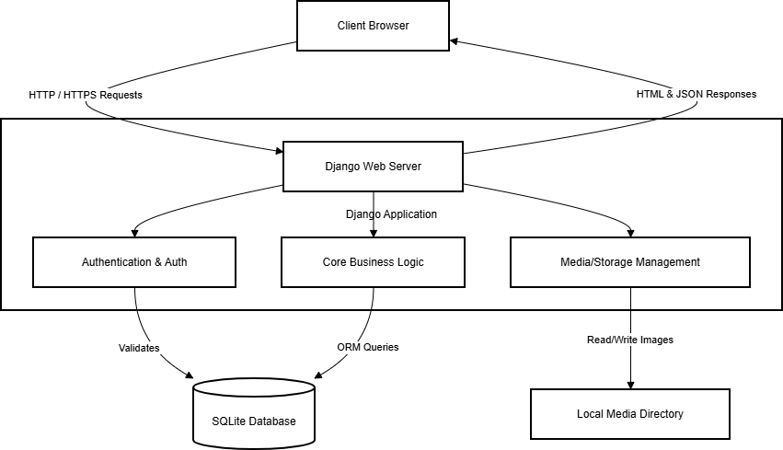

    - System Architecture Diagram

  - Product Functions
- Main functions of the system include:
- User registration and authentication
- Profile management
- Listing items for rent
- Browsing and searching items
- Sending rental requests
- Rental duration selection
- Booking status tracking
- Payment management
- Admin approval and system monitoring

  - User Classes and Characteristics
- User
Can register and login
Can list items for rent
Can browse and rent items
- Admin
Manages users and items
Approves item listings
Monitors rentals and payments

  - Operating Environment
The system operates in the following environment:
Operating System: Windows / Linux
Web Browser: Chrome, Firefox, Edge
Backend Technology: Python Django
Frontend: HTML, CSS, Tailwind css, JavaScript
Database: SQLite

  - Design and Implementation Constraints
The system must be developed using Django framework.
The application must run on web browsers.
The system must use a relational database (SQLite).

  - Assumptions and Dependencies
Users must have internet access.
Users must register before renting items.
Admin approval may be required before item listings become visible.

- Specific Requirements
  - Functional Requirements
FR1 – User Registration
The system shall allow users to create an account by providing necessary details such as username, email, and password.
FR2 – User Login
The system shall allow registered users to login securely using their credentials.
FR3 – Profile Management
Users shall be able to update their personal profile information.
FR4 – Item Listing
Users shall be able to list items for rent with details including item name, category, description, rental price, availability period, and images.
FR5 – Item Browsing
Users shall be able to browse and search available items using categories and keywords.
FR6 – Rental Request
Users shall be able to select rental duration and send rental requests.
FR7 – Booking Status Tracking
Users shall be able to track rental status such as pending, approved, rented, or returned.
FR8 – Rental History
Users shall be able to view history of items rented or listed for rent.
FR9 – Payment Management
The system shall support online payments or cash-based payment options.
FR10 – Admin Management
The admin shall be able to manage users, categories, items, and rental records.
📌 Insert Use Case Diagram here

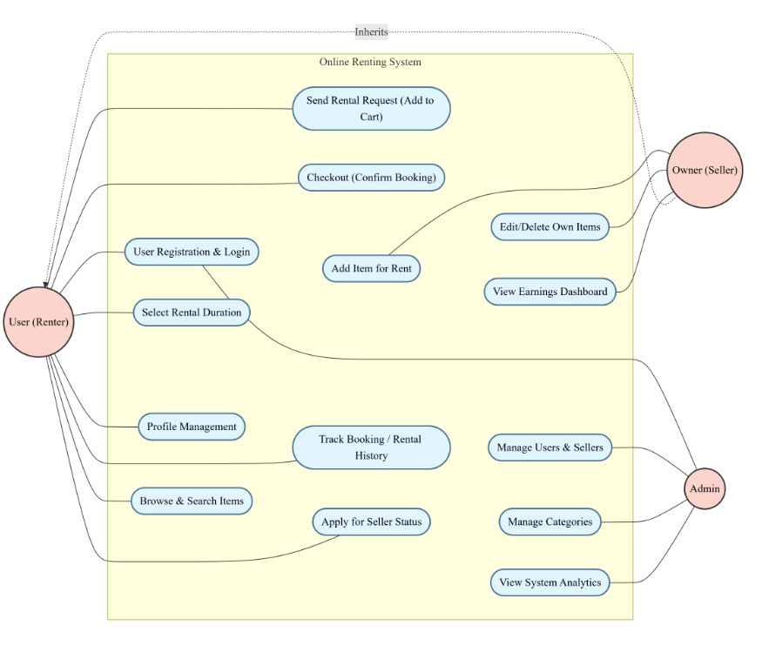
3.1.1.1 Use Case Diagram

  - Usability Requirements
The system must provide a user-friendly interface that allows users to easily navigate and perform actions without technical knowledge.
  - Reliability Requirements
The system must maintain consistent performance and ensure secure storage of user data.
  - Performance Requirements
The system should respond to user requests within 2–3 seconds under normal usage conditions.
  - Supportability Requirements
The system should be designed using modular architecture to allow easy maintenance and future enhancements.
  - Design Constraints
Django framework must be used for backend development.
System must support modern web browsers
  - Online User Documentation and Help System Requirements
The system should provide basic guidance and instructions to help users understand how to use the platform.
  - Interfaces
    - User Interface
Login Page
Registration Page
User Dashboard
Item Listing Page
Booking Page
Admin Dashboard
    - Hardware Interface
Laptop / Desktop
Smartphone
    - Software Interface
Django Framework
SQLite Database
Web Browsers
    - Communication Interface
HTTP / HTTPS internet communication

