**ASE Lab Assignment - 1**

By Ravali Bolem

UMKC ID: 16231463

1. UML Class Diagram for Chat Application:-

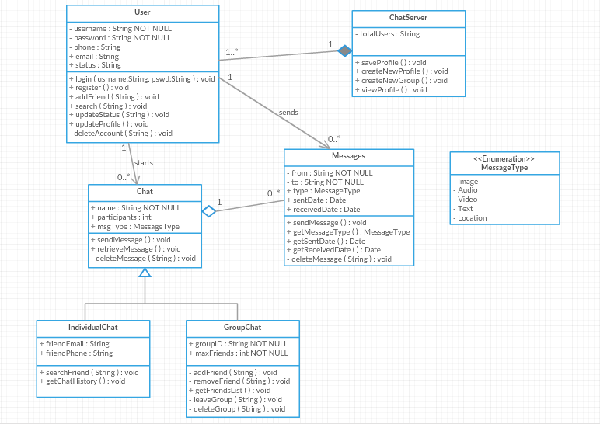

1. ZenHub:-

Here I created 8 sample issues (tasks) and 3 sample milestones (iterations) in total. Issues 1 and 2 are assigned to Milestone-1. Issues 3 and 4 are assigned to Milestone-2. Issues 5 and 6 are assigned to Milestone-3.

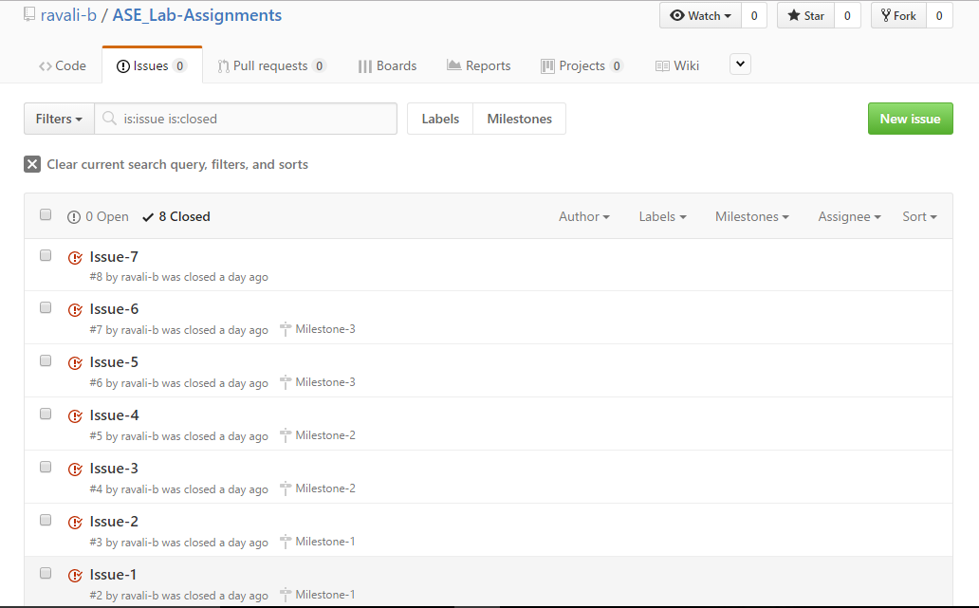

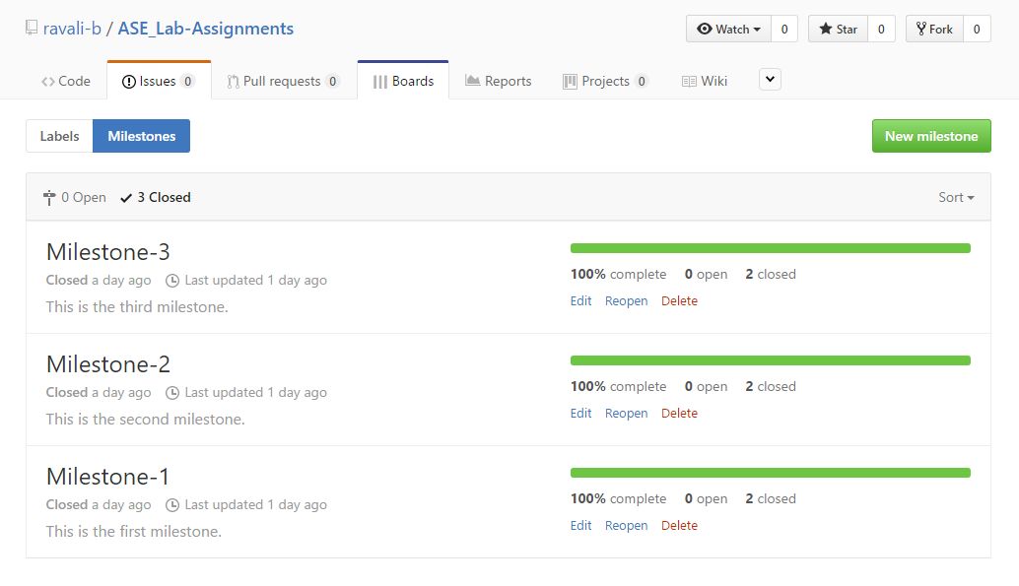

Analytics Graph(Burndown chart) for first milestone:-

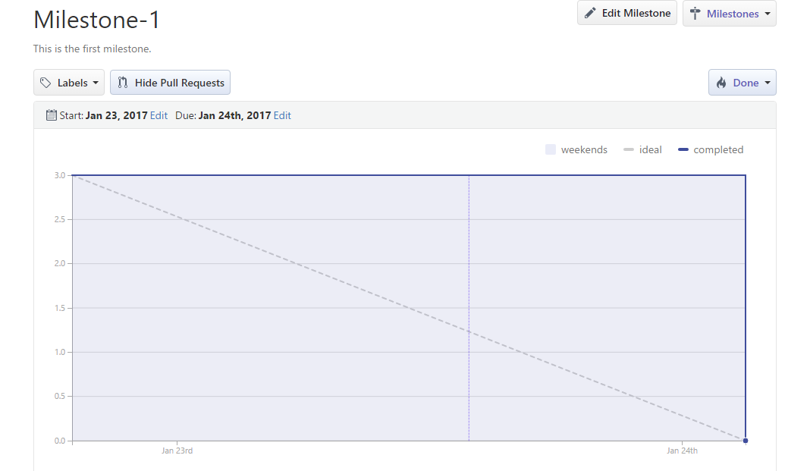

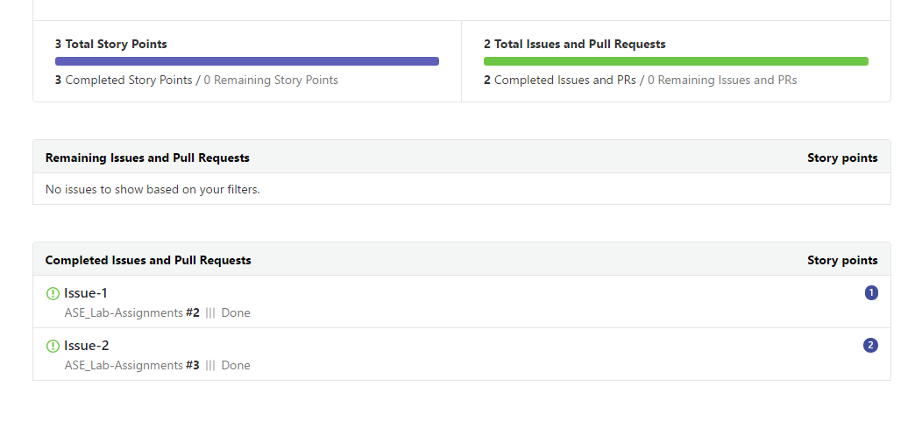

Analytics Graph(Burndown chart) for second milestone:-

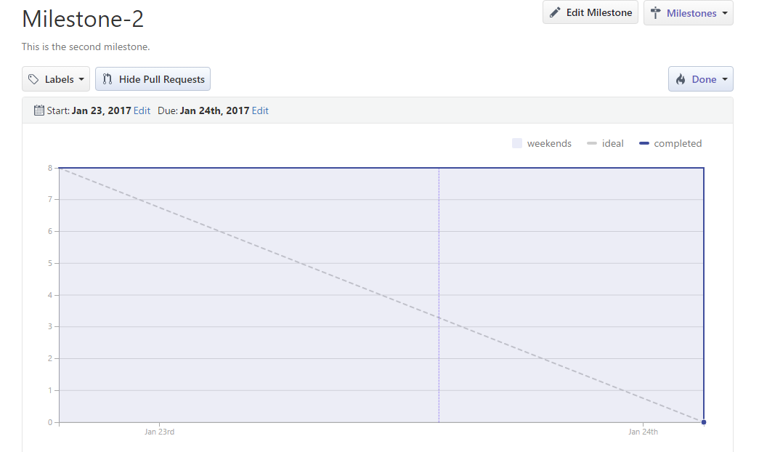

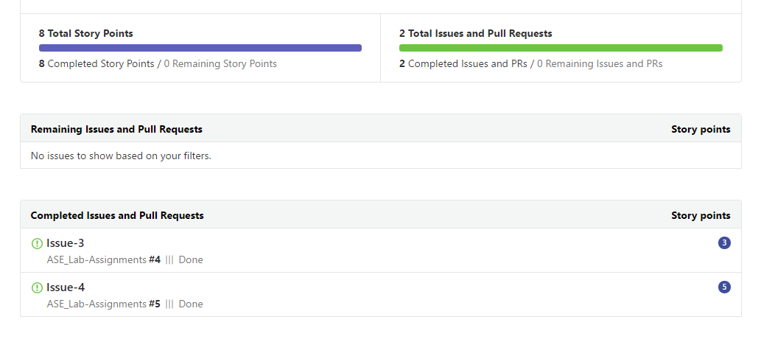

Analytics Graph(Burndown chart) for third milestone:-

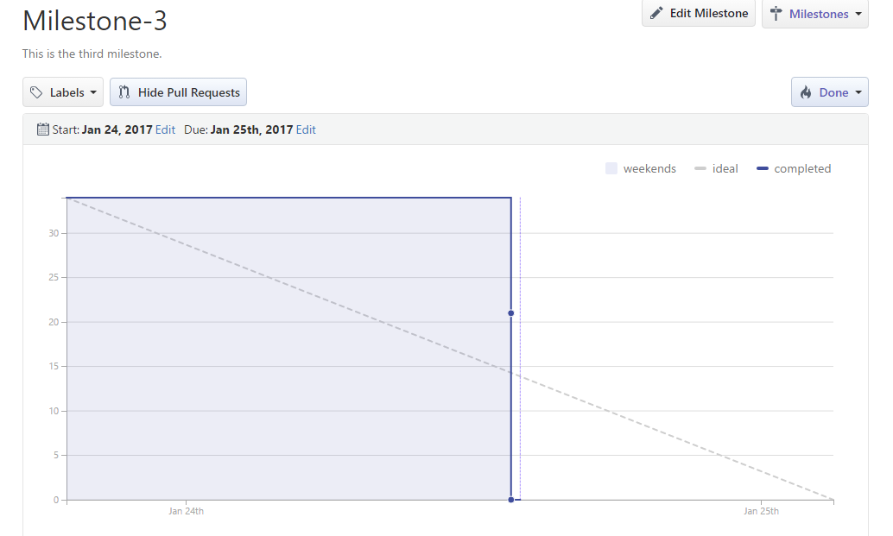

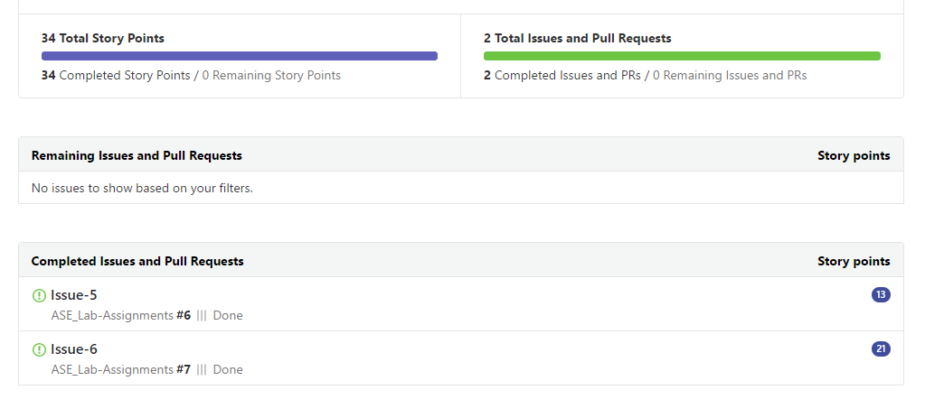

Velocity Tracking Graph:-

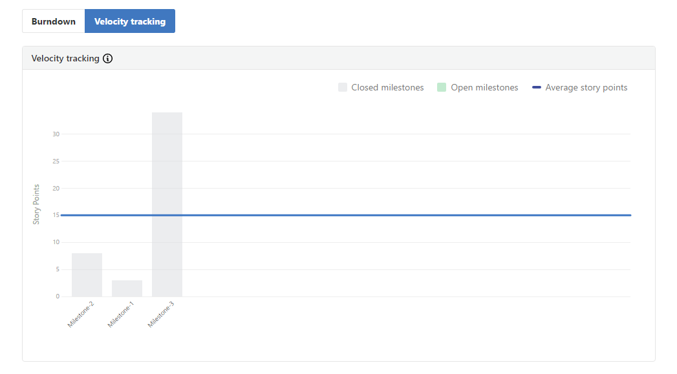

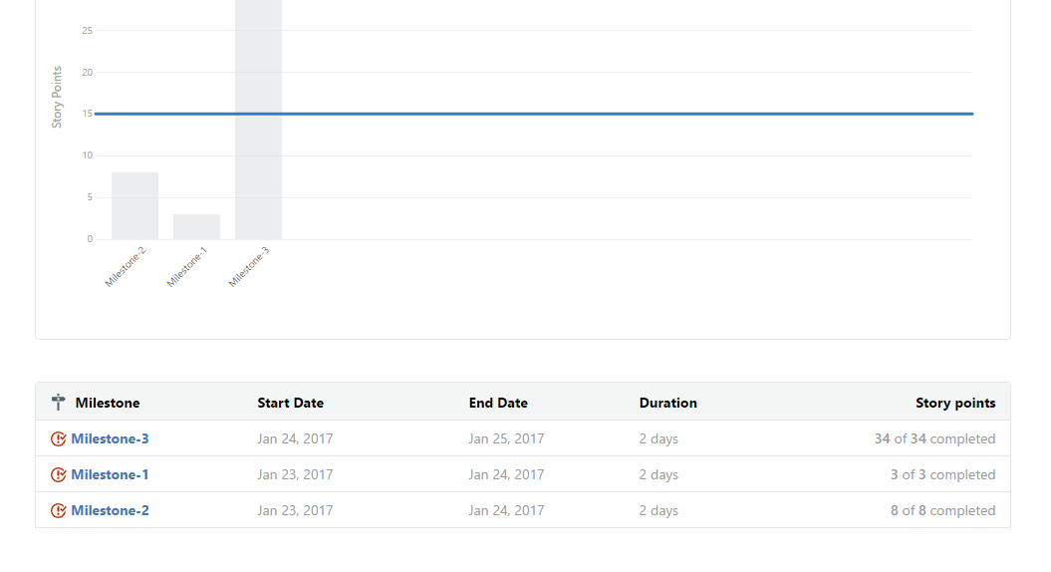

**4)** Repository in Remote Github:-

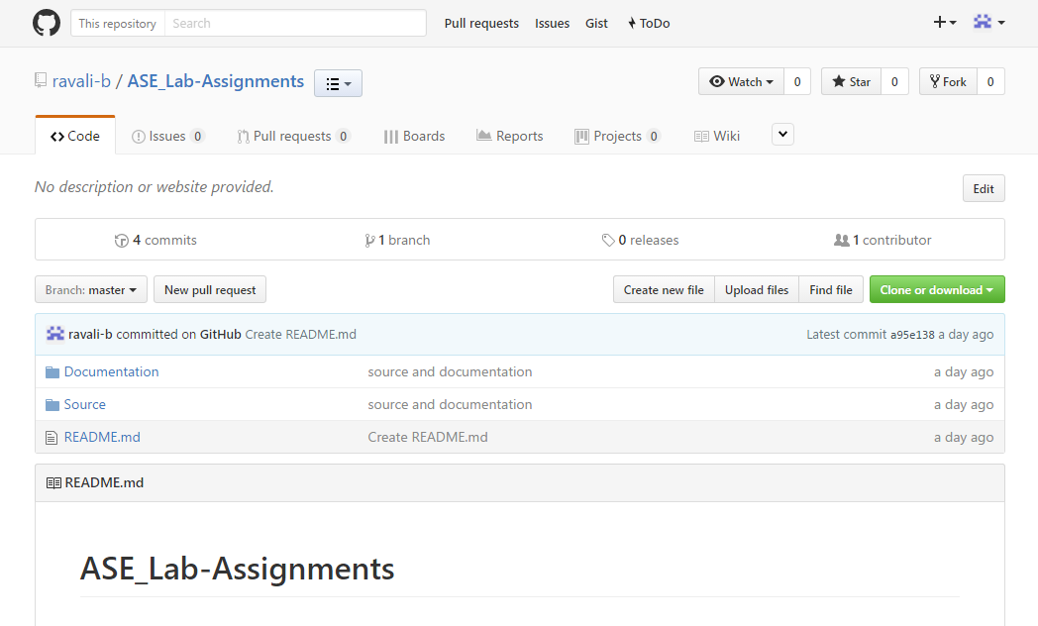

Cloned Repository in Remote GitHub to Local Machine:-

