**Job Referral Portal**

1. Project Information

Project Group - Innovators

Project Group Members:

* Rishika Dudipala
* Shiva Sai Kodandapuram
* Aravind Chitiprolu
* Ravali Kudaravalli
* Ramya Madhavareddy
* Rajini Vijetha Rudrarapu
* Gayatri Vigna Penmetsa
* Sreshta Chityala
* Trisha Reddy Nidjintha

2. Description- Job Referral Portal

Job Referral Portal is Web application that is useful to manage and simplify employee referrals in a company. The portal allows employees to refer potential candidates that they know from their personal or professional positions to relevant positions, the employees can look up available job roles and their descriptions, they also can track the status of the candidates that they have referred. HR personnel have the ability to manage job postings, they can update the status of the candidates and accept or reject a referral based on company requirements.

The portal serves two primary user groups: HR personnel and employees.

• Employee Functionalities:

o Refer Candidates: Employees can refer relevant candidates to open positions based on the job description.

o View Available Positions: Employees can look up the open job positions and it's description so that they can refer potential candidates accordingly.

o Check Referral Status: Employees are allowed to check on the status of the candidates whom they have referred.

o Employees have a leaderboard to see how many referrals they have given, and candidates referred by them have been selected to provide incentives.

• HR Functionalities:

o Manage Job Listings: HRs can post new jobs, edit them, or remove job openings within the company, in turn allowing employees to look at the job listings.

o Update/Review referrals: HR Staff can view employee referrals and can either accept or reject candidates, also update the status of candidate such as sending them to second technical round or HR round etc.

o Bulk Upload: for ease of HR, they can upload a job listing csv file so that they can upload several listings at once.

Development Languages Used:

Java, HTML, CSS

Frameworks:

Spring Boot, AngularJS

Database:

Oracle

Development Environment:

Node.JS

Maven

6. Timeline:

Milestone 1: Initial Project Planning and Risk Assessment

As part of this milestone, the key objectives and timeline for goals are outlined by the team. In this phase, we plan on creating a high-level architecture, also identify key functionalities for HR profile and Employee profile and identify potential risks and layout strategies to manage them. A detailed report including Gantt and PERT charts, A PowerPoint presentation is created.

Milestone 2: Detailed System Architecture and Asset Collection

In this milestone, A detailed system architecture and the system’s functional and technical specifications are finalized. Roles of user are defined, interaction flows, database structure, microservices and requirements such as performance, security and scalability which can be categorized as non-functional requirements are outlined.

Milestone 3: Implementation of Employee Portal and Core Functionalities

In this milestone,The functionalities include the login system, to check if a certain user is part of a company or not, job listings are published by dumping data directly into the database so that employees can see them, refer candidates to them. The status is updated manually and checked via employee screen if changes are visible, other features can be tested after integration is perfomed, for all the apis testing part is covered by unit testing with the help of JUnit.

Milestone 4: HR Management System Development

In HR System Development, the team will be implementing apis such that HR can post jobs via User Interface, other microservices to Update status of a referral, edit job listings, delete jobs. Unit testing will be performed with JUnit. Arrangements for smooth integration of HR and Employee modules are made.

Milestone 5: Final System Integration, Testing and Presentation

The team will be focusing on the complete system, end - to - end integration, testing is performed, any bugs that are arised due to integration are removed. The whole system will be thoroughly tested.The system is then made ready to be deployed. The final report is created to summarize the overall system design and the development process, and testing outcomes. Video Demo of Job Referral Portal is made as part of the final presentation.

Representation of Milestones using Gantt Chart:

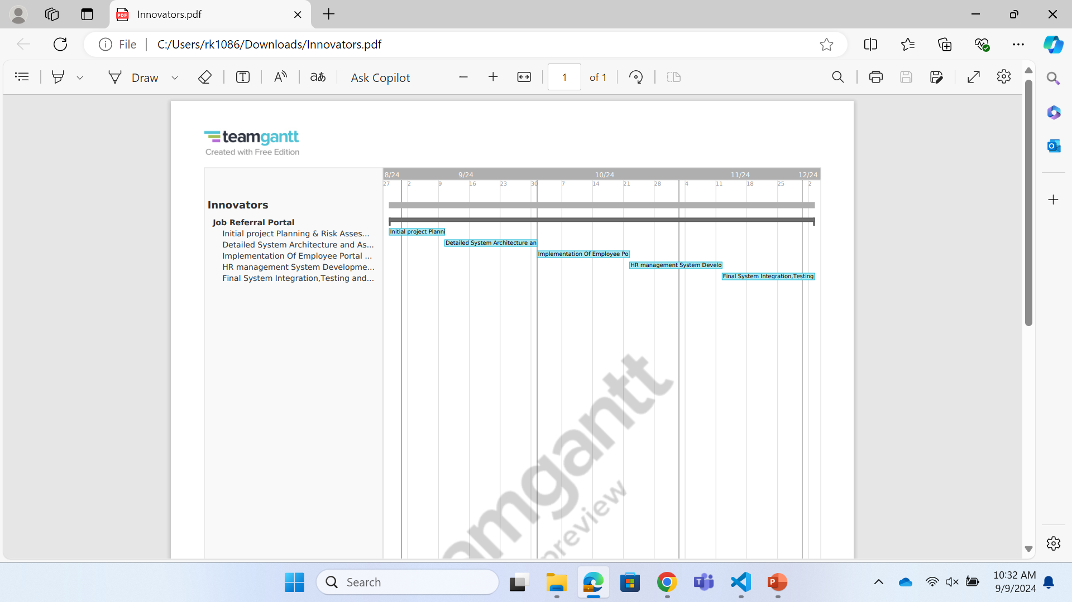

7. Risk Management:

Some of the Risk Mitigation plan for Job Referral portal:

1. Data Privacy and Security Issues:

Job portal store sensitive information and details of HR, employees, and users. This data could lead to unauthorized access and encryption of credentials, referrals, and status.

1.Monitoring:

We need to regularly review the code so that it will ensure a clean and maintainable code. We use some specialized tools to detect the area where the data is mishandled. We try to set up logging systems and monitor the system to track unauthorized access.

2.Re-evaluation:

Every time we add new features and upload jobs in the HR portal, we cross-validate the system to detect unusual activities and ensure privacy data such as passwords and logins.

3.Contingency Plan:

We make a backup plan in place such as shutting down the system or informing the system users when there is a security breach occurs. We Create a system that only a few people can access the data.

1. Technical Intricacy:

Ensuring a balance between managing the complexity of security systems involved when making changes or updates and filtering allows users and employees to work efficiently without any inconvenience.

Monitoring:

We try to implement the continuous integration with auto-testing tools and we create demos for new add-ons, this will help to identity any issue early when jobs are uploaded in bulk.

Re-evaluation:

The re-evaluation that makes the portal more stable and improve performance is when we run the program for operation like adding a new modification, and then review technical aspects to check whether any bugs are reported.

Contingency Plan:

We try to update the system based on feedback and implement libraries to manage the task. We cut down the insignificant features that are complex to build the system to avoid the delays.

1. Data Corruption:

Ensuring that the data is safe, correct and not lost during the upload/update process, this will provide a complete job listing and will not affect the portal data.

Monitoring:

Before completing the portal creating, we will monitor the uploads through the progress results and check the success and failure of login attempts, by the time if there is any missing field or format of the data is incorrect, we try to fix it.

Re-Evaluation:

We will analyse the failures and review them by logging systems, so that errors will be fixed and by using the feedback that is gathered from the whole process of job portal we conduct the test to make sure the system can handle the large data uploads without any issues.

Contingency plan:

We create a recovery plan before data uploads and use automatic recovery of previous data by adding a rollback feature, so that in case if there are any failures it will restore, and the data will not be lost. This keeps the system to run efficiently, and data is maintained properly.

8. Team Member’s Roles for this project:

* Rishika Reddy Dudipala - Project Management Lead
* Chitiprolu Aravind - Testing Lead
* Shiva Sai Reddy Kodandapuram - Implementation Lead for back end
* Ravali Kudaravalli - Design Lead
* Ramya Madhavareddy - Implementation Lead for front end
* Rajini Vijetha Rudrarapu - Demo and presentation Lead
* Gayathri Vigna Penmetsa – Configuration Management Lead
* Sreshta Chityala - Documentation Lead and System Administrator Lead
* Nidjintha Trisha Reddy - Requirements Lead

9. Member contribution table (should describe who wrote what parts of the report).

|  |  |  |  |
| --- | --- | --- | --- |
| Member Name | Contribution Description | Overall Contribution (%) | Note (If Applicable) |
| Rishika Reddy | 1. Created a detailed project plan with tasks.  Assigned team members based on their skills and project needs.  2. Outlined each member’s roles and responsibilities.  3. Planned and arranged team meetings to discuss about the project progress.  4. Participated in the video presentation.  Project management - 100 %  Video presentation - 33 % | 11.37 |  |
| Aravind Chitiprolu | 1. Planned and arranged team meetings on Deliverable-1 task, project progress.  2. Involved in ppt preparation.  3. Involved in video presentation.  4. Involved in reviewing documentation, ppt and video presentation.  5. Involved in gathering requirements and completed tasks for Deliverable-1 and submissions.  6. Working on testing requirements.  ppt prepation- 20%  Video presentation- 40% | 11.24 |  |
| Shiva Sai Kondapuram | 1. Started out by an empty spring boot project and pushed to repo.  2. Raised a pull request with required entity, repo and service packages, created few entities as well.  3. Had calls regarding the project description with teammates.  4. Proofreading and reviewing documentation and ppt  Backend : 100%  Gathering requirements: 60% | 12 |  |
| Ravali Kudaravalli | 1. Created detailed Documentation for deliverable-1.  2. Drafted the readme file for our project.  Documentation-90%  Readme- 100% | 12.15 |  |
| Ramya Madhavareddy | 1. I have involved in creating the basic project structure for the front-end code and pushed the basic structure to GitHub.  2. Adding to this I have created the power point presentation for the video to be presented by our group. | 11.26 |  |
| Sreshta Chityala | 1. Helped with the documentation.  2. Created Team summary report.  3. Created Gantt chart timeline. | 10.98 |  |
| Vigna Penmetsa | 1. After discussing with the backend team, I'm now working on setting up the application configuration to ensure it runs smoothly in different environments like development, testing, and production. This involves defining key settings like database connections, API keys, and environment variables. | 10 |  |
| Trisha Reddy Nidjintha | 1. Discussed with teammates on database connection.  2. Working on creation of test data. | 10 |  |
| Rajini Vijetha Rudrarapu | 1. Identified the risks and challenges involved in the project and developed mitigation plan for each risk.  2. Ensured that the system is running efficiently with no bugs.  3. Being the demo lead I created video presentation with few teammates which gives detailed description about the project goals, issues and backup plans. | 11 |  |