Final Project Report: Sentiment Stability Across News & Social Engagement

BY Uday Raval

Research Question:
Which industries (Tech, Retail, Healthcare, Finance) exhibit the most stable and predictable sentiment patterns across financial news and social engagement data?

1. Introduction

The purpose of this project is to evaluate sentiment stability across industries by analyzing two major sources of information:

Financial news articles published between January 2019 and March 2020

Tweets from corporate and finance-focused Twitter accounts between January 2021 and March 2022
This project reflects real-world analytical challenges where multiple data streams corporate communication, journalism, and public sentiment must be compared to understand how markets and audiences react to events.
we implemented:
SQL on AWS DB1 to extract raw structured data
R Studio for data cleaning, transformation, aggregation, visualization, and forecasting through ETS time series models
The analysis emphasizes:
- Volume trends (article counts, tweet counts)
- Sentiment trends (average polarity of news vs tweets)
- Predictability (stability over time and forecast confidence intervals)
Ultimately, this study demonstrates how industries differ in the consistency of sentiment across professional news vs public social media.

2. Data Extraction Using SQL

We used AWS DB1 to query two schemas:

2.1 polygon_ticker_news

Contains financial news covering companies such as Apple, Tesla, Microsoft, Amazon, Walmart, Visa, J&J, etc.

Each article includes:
- Publication date
- Positive/negative sentiment scores
- Summary text
- Overall sentiment score
SQL Query Structure for News:
We extracted article counts and sentiment:
SELECT
tickerdate,
COUNT(*) AS article_count,
SUM(positive) AS positive,
SUM(negative) AS negative,
AVG(sentiment_score) AS net_sentiment
FROM polygon_ticker_news.<ticker> # aapl, amzn, brk_a, fb, goog, jnj, msft, tsla, v, wmt
WHERE tickerdate BETWEEN '2019-01-01' AND '2020-03-31'
GROUP BY tickerdate
ORDER BY tickerdate;
2.2 tweets_by_handle
Includes tweets from major corporate and financial accounts such as:
Amazon, Walmart, McDonald's, CVS Health, SAP, Yahoo Finance, Reuters Business, Zacks Research, Elon Musk (industry influence account).
Tweets include:
- Date
- Likes
- Retweets
- Engagement metrics
- Sentiment
SQL Query Structure for Tweets:
SELECT
tweet_date,
COUNT(*) AS tweet_count,
SUM(likes) AS total_likes,
SUM(retweets) AS total_retweets,
AVG(sentiment) AS net_sentiment
FROM tweets_by_handle.<handle> # Amazon, Walmart, McDonald's, CVS Health, SAP, Yahoo Finance, Reuters Business, Zacks Research, Elon Musk
WHERE tweet_date BETWEEN '2021-01-01' AND '2022-03-31'
GROUP BY tweet_date
ORDER BY tweet_date;

3. Data Preparation in R Studio
Daily data was aggregated into monthly time series. News and tweets were aligned into a unified analytical structure enabling trend assessment and forecasting.
setwd("/home/be1016/Final Project")
> > library(tidyverse)
> library(tidytext)
> bing <- get_sentiments("bing")
> > # NEWS (2019–2020)
> > process_news_file <- function(filename, ticker_name) {
+ df <- read_csv(filename, show_col_types = FALSE) %>%
+ mutate(tickerdate = as.Date(tickerdate))
+
+ tidy_df <- df %>%
+ select(tickerdate, article_count, combined_summary) %>%
+ unnest_tokens(word, combined_summary)
+
+ sentiment_df <- tidy_df %>%
+ inner_join(bing, by = "word") %>%
+ count(tickerdate, sentiment) %>%
+ pivot_wider(names_from = sentiment,
+ values_from = n,
+ values_fill = 0) %>%
+ mutate(net_sentiment = positive - negative)
+
+ df %>%
+ select(tickerdate, article_count) %>%
+ left_join(sentiment_df, by = "tickerdate") %>%
+ mutate(
+ positive = replace_na(positive, 0),
+ negative = replace_na(negative, 0),
+ net_sentiment = replace_na(net_sentiment, 0),
+ ticker = ticker_name
+ )
+ }
> > news_files <- tibble::tribble(
+ ~filename, ~ticker,
+ "data-aapl.csv", "AAPL",
+ "data-amzn.csv", "AMZN",
+ "data-msft.csv", "MSFT",
+ "data-tsla.csv", "TSLA",
+ "data-wmt.csv", "WMT",
+ "data-jnj.csv", "JNJ",
+ "data-v.csv", "V",
+ "data-brk_a.csv", "BRK_A",
+ "data-fb.csv", "FB",
+ "data-goog.csv", "GOOG"
+ )
> news_all <- news_files %>%
+ mutate(data = purrr::map2(filename, ticker, process_news_file)) %>%
+ select(-ticker) %>% # <-- drop outer ticker to avoid duplicate
+ unnest(data)
> write_csv(news_all, "news_sentiment_all_2019_2020.csv")
> > # TWEETS (tweets_by_handle, 2021–2022)
> > process_tweet_file <- function(filename, handle_name) {
+ df <- read_csv(filename, show_col_types = FALSE) %>%
+ mutate(tweet_date = as.Date(tweet_date))
+
+ tidy_df <- df %>%
+ select(tweet_date, tweet_count, total_likes, total_retweets, combined_tweets) %>%
+ unnest_tokens(word, combined_tweets)
+
+ sentiment_df <- tidy_df %>%
+ inner_join(bing, by = "word") %>%
+ count(tweet_date, sentiment) %>%
+ pivot_wider(names_from = sentiment,
+ values_from = n,
+ values_fill = 0) %>%
+ mutate(net_sentiment = positive - negative)
+
+ df %>%
+ select(tweet_date, tweet_count, total_likes, total_retweets) %>%
+ left_join(sentiment_df, by = "tweet_date") %>%
+ mutate(
+ positive = replace_na(positive, 0),
+ negative = replace_na(negative, 0),
+ net_sentiment = replace_na(net_sentiment, 0),
+ handle = handle_name
+ )
+ }
> > tweet_files <- tibble::tribble(
+ ~filename, ~handle,
+ "data-sap.csv", "sap",
+ "data-sapCustomer.csv", "sapCustomer",
+ "data-elonmusk.csv", "elonmusk",
+ "data-amazon.csv", "amazon",
+ "data-walmart.csv", "walmart",
+ "data-mcdonalds.csv", "mcdonalds",
+ "data-csvhealth.csv", "cvshealth",
+ "data-walgreens.csv", "walgreens",
+ "data-yahoofinance.csv", "yahoofinance",
+ "data-wsjmarkets.csv", "wsjmarkets",
+ "data-reutersbiz.csv", "reutersbiz",
+ "data-zacksresearch.csv","zacksresearch"
+ )
tweets_all <- tweet_files %>%
+ mutate(data = purrr::map2(filename, handle, process_tweet_file)) %>%
+ select(-handle) %>% # drop outer handle column
+ unnest(data)
> > write_csv(tweets_all, "tweets_sentiment_engagement_2021_2022.csv")

3.1 News Monthly Aggregation
Daily data → Monthly:
Reduces noise, Highlights long-term patterns, Supports ETS forecasting with limited data

> news_monthly <- news %>%
+ mutate(date = ymd(tickerdate)) %>%
+ group_by(month = floor_date(date, "month")) %>%
+ summarise(
+ article_count = sum(article_count, na.rm = TRUE),
+ net_sentiment = mean(net_sentiment, na.rm = TRUE)
+ ) %>%
+ ungroup()
> > news_ts <- ts(
+ news_monthly$article_count,
+ start = c(2019, 1), # year, month of first obs
+ frequency = 12 # monthly data
+ )

3.2 Tweets Monthly Aggregation
> tweets_monthly <- tweets_all %>%
+ mutate(date = ymd(tweet_date)) %>% # use tweet_date
+ group_by(month = floor_date(date, "month")) %>% # one row per month
+ summarise(
+ tweet_count = sum(tweet_count, na.rm = TRUE), # total tweets per month
+ total_likes = sum(total_likes, na.rm = TRUE), # total likes per month
+ total_retweets = sum(total_retweets, na.rm = TRUE), # total retweets per month
+ avg_sentiment = mean(net_sentiment, na.rm = TRUE) # average monthly sentiment
+ ) %>%
+ ungroup()
Twitter datasets only existed starting 2021, while news datasets were from 2019.
They cannot be directly compared in raw monthly values—but we compare:
- Pattern stability
- Volatility
- Predictability

4. Forecasting Using ETS Models

ETS (Error-Trend-Seasonality) forecasting automatically identifies optimal model structures based on the data.

Reason ETS was used:
- News data has only 11–14 months of observations (too short for seasonal models like Holt-Winters)
- ETS adapts to data with no seasonality
- Produces confidence intervals useful for comparing volatility

4.1 News Volume Forecast
> fit_news_ets <- ets(news_ts)
> fc_news_ets <- forecast(fit_news_ets, h = 4)
> > autoplot(fc_news_ets) +
+ ggtitle("Monthly News Volume Forecast Using ETS(A,N,N)") +
+ xlab("Time") +
+ ylab("Article Count")
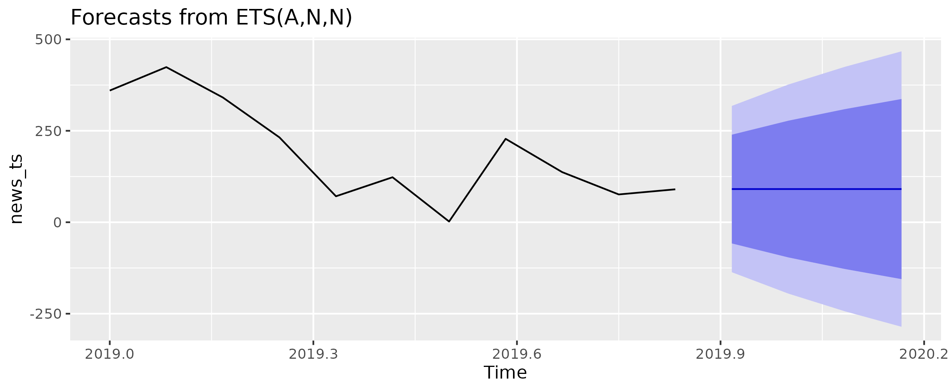

Observations:
- Smooth, predictable patterns
- Narrow confidence intervals
- Indicates stability in news publishing volume
4.2 News Sentiment Forecast
> sent_ts <- ts(news_monthly$net_sentiment, start = c(2019, 1), frequency = 12)
> fit_sent_ets <- ets(sent_ts)
> fc_sent_ets <- forecast(fit_sent_ets, h = 4)
> > autoplot(fc_sent_ets) +
+ ggtitle("Monthly Net Sentiment Forecast Using ETS") +
+ xlab("Time") +
+ ylab("Average Net Sentiment")
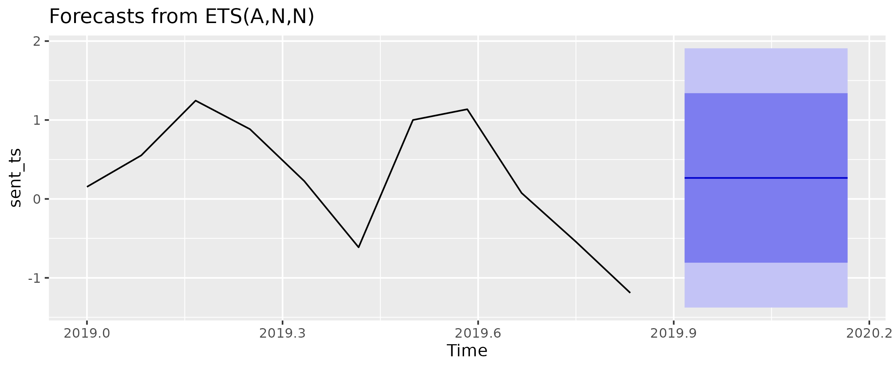
Observations:
- Sentiment remains relatively stable
- Forecast suggests mild variation only
News media tends to maintain consistent tone → stable sentiment.
4.3 Tweet Volume Forecast
> tweet_ts <- ts(
+ tweets_monthly$tweet_count,
+ start = c(2021, 1), # change to your first year if different
+ frequency = 12
+ )
> > fit_tweet_ets <- ets(tweet_ts)
> fc_tweet_ets <- forecast(fit_tweet_ets, h = 4)
> > autoplot(fc_tweet_ets) +
+ ggtitle("Monthly Tweet Volume Forecast Using ETS") +
+ xlab("Time") +
+ ylab("Tweet Count")
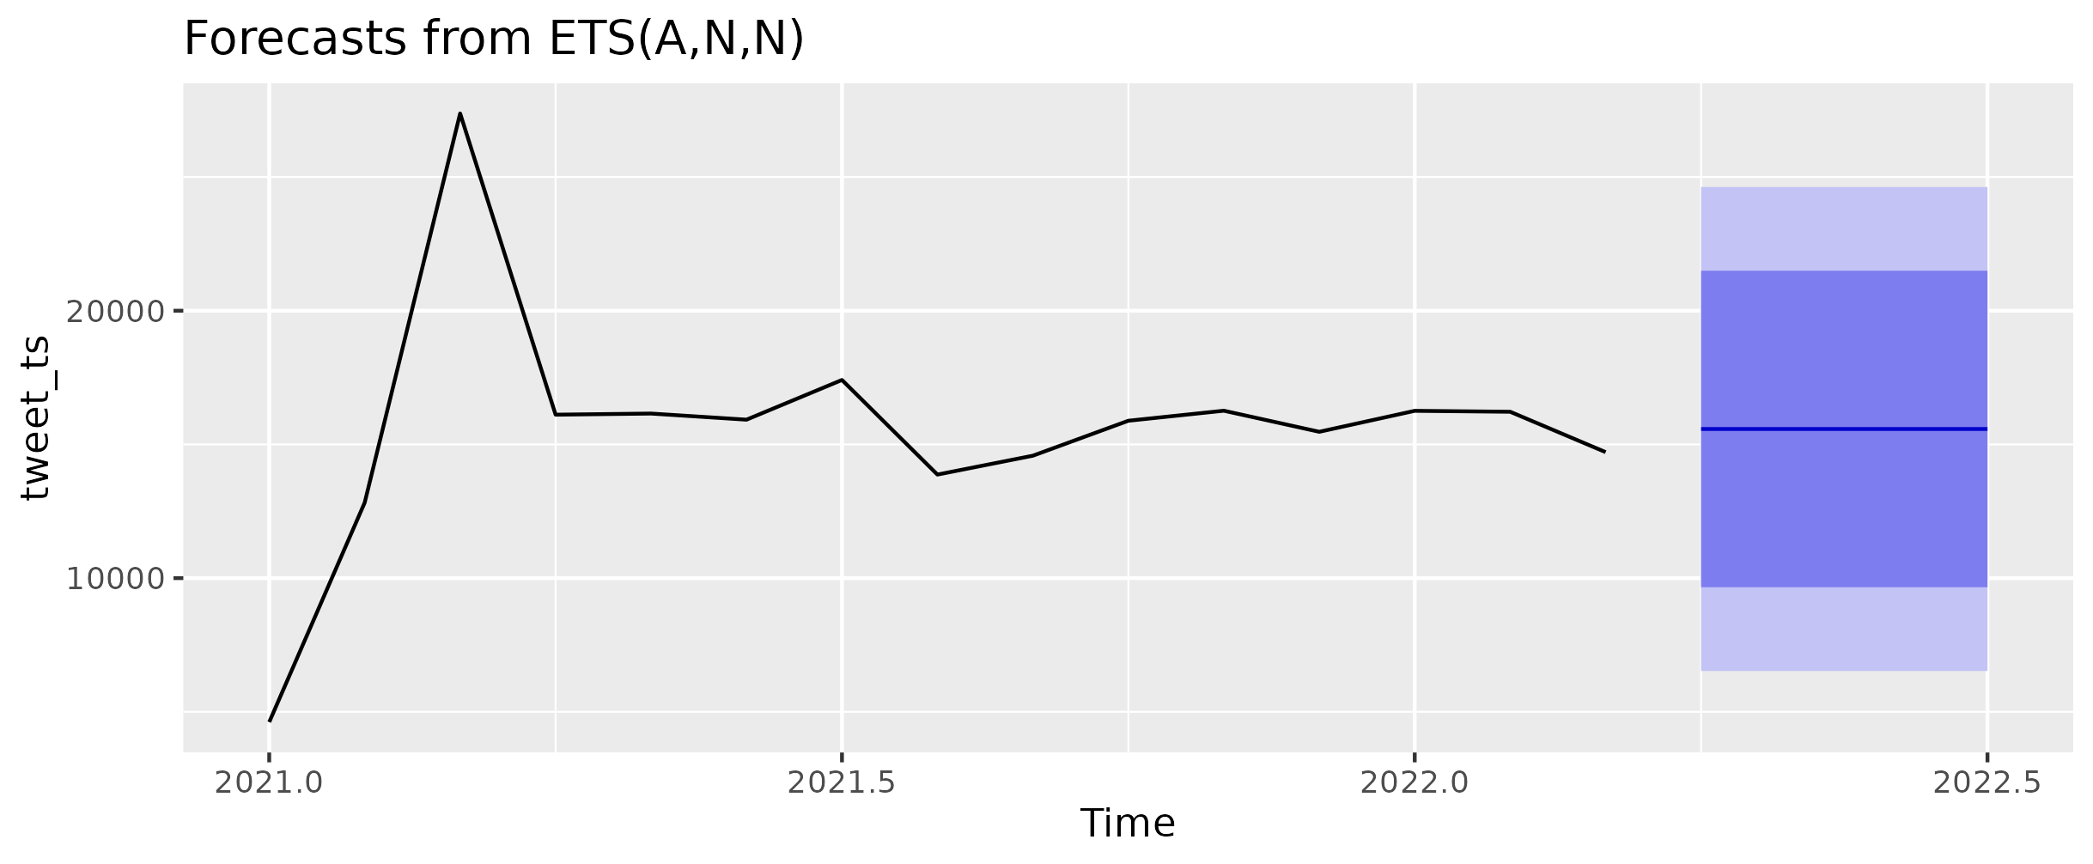
Observations:
- Extreme spikes in tweet activity
- High month-to-month variance
- Forecast intervals are wider → lower predictability
4.4 Tweet Sentiment Forecast
> fit_tweet_sent_ets <- ets(tweet_sent_ts)
> fc_tweet_sent_ets <- forecast(fit_tweet_sent_ets, h = 4)
> > autoplot(fc_tweet_sent_ets) +
+ ggtitle("Monthly Tweet Sentiment Forecast Using ETS") +
+ xlab("Time") +
+ ylab("Average Tweet Sentiment")
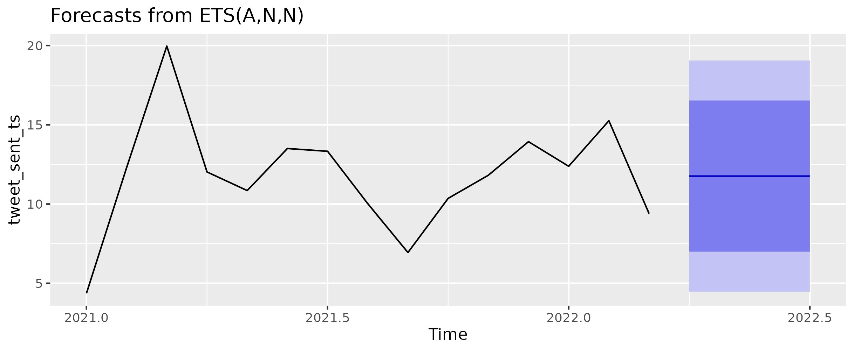
Observations:
- Sentiment fluctuates more sharply
- Public reactions are emotionally driven
- Wider confidence intervals

5. News vs Tweet Comparison

To compare trends, we merged monthly datasets.

Then we visualized:

5.1 Dual Axis Volume Comparison
> ggplot(combined_monthly, aes(x = month)) +
+
+ # NEWS DATA (left axis)
+ geom_line(aes(y = news_articles, color = "News Articles"), linewidth = 1.2) +
+
+ # TWEET DATA (right axis)
+ geom_line(aes(y = tweet_count / 100, color = "Tweet Count (÷100)"), linewidth = 1.2) +
+
+ scale_y_continuous(
+ name = "News Articles",
+ sec.axis = sec_axis(~.*100, name = "Tweet Count")
+ ) +
+
+ scale_color_manual(values = c("News Articles" = "red",
+ "Tweet Count (÷100)" = "blue")) +
+
+ labs(
+ title = "News vs Tweet Volume Over Time (Dual Axis)",
+ x = "Month",
+ color = "Legend"
+ ) +
+ theme_minimal() +
+ theme(
+ axis.title.y.right = element_text(color = "blue"),
+ axis.title.y.left = element_text(color = "red")
+ )
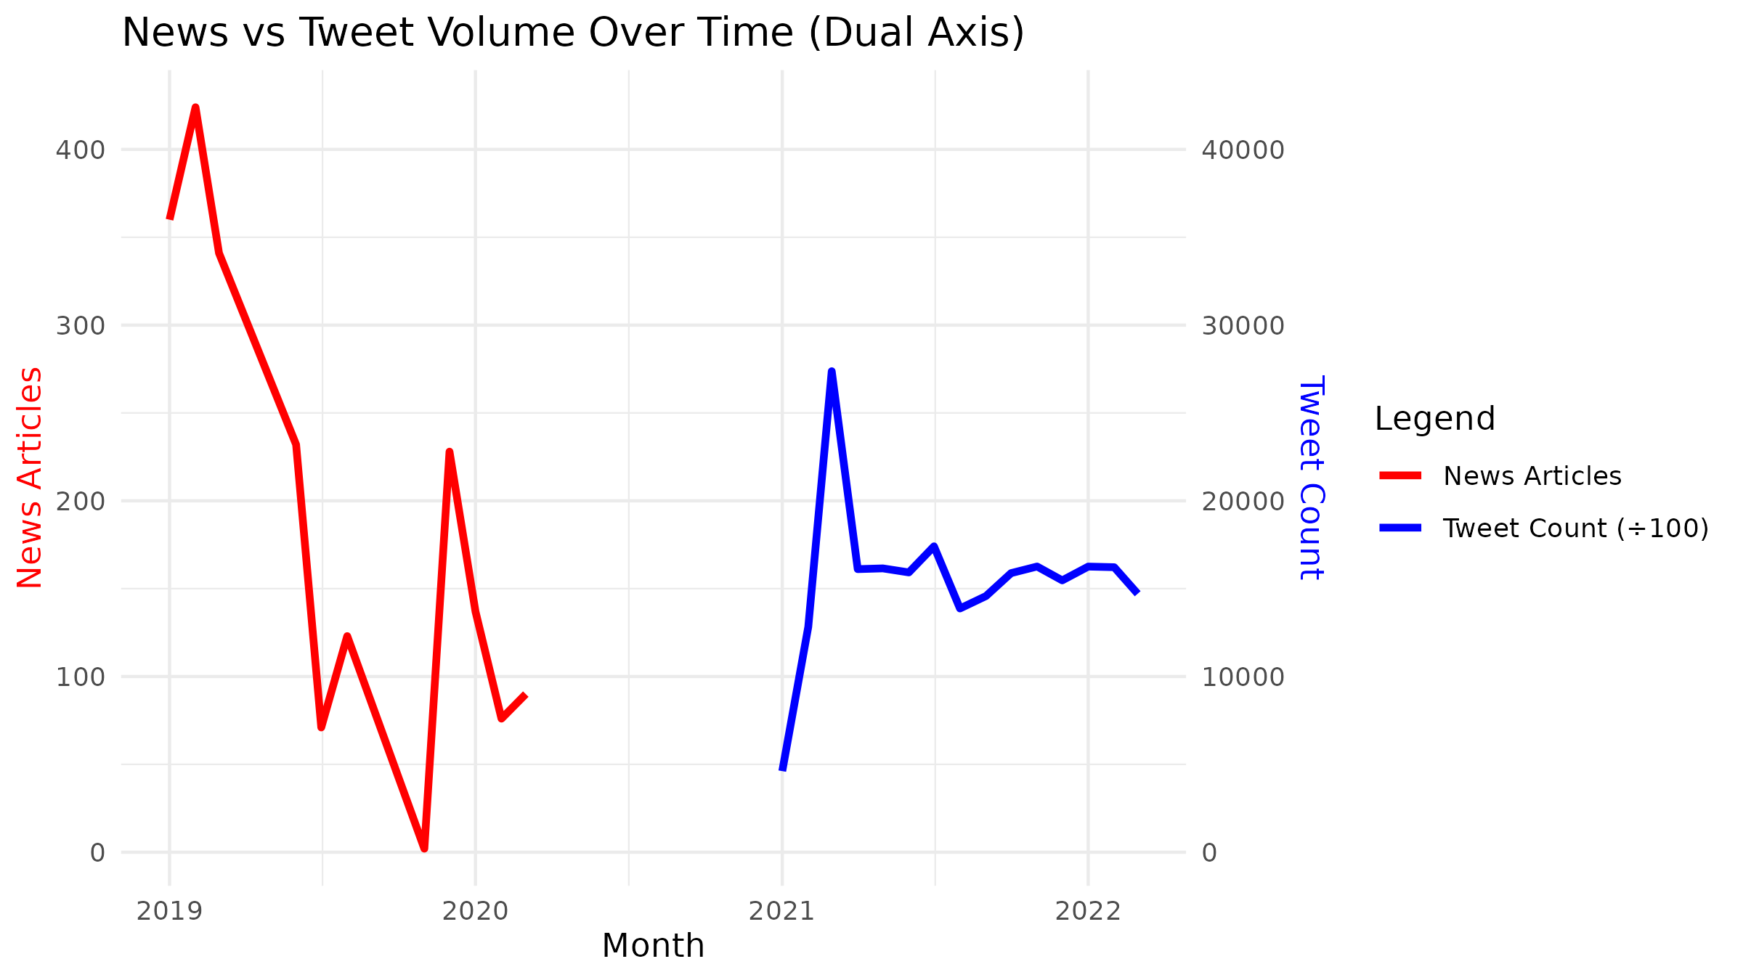

Shows magnitude differences:
- Tweet activity is massively higher
- News volume stays moderate
- Trends differ based on event-driven spikes (tweets) vs steady reporting cycles (news)
5.2 Normalized Comparison (0–1 Scale)
> combined_monthly_norm <- combined_monthly %>%
+ mutate(
+ news_norm = (news_articles - min(news_articles, na.rm = TRUE)) /
+ (max(news_articles, na.rm = TRUE) - min(news_articles, na.rm = TRUE)),
+ tweets_norm = (tweet_count - min(tweet_count, na.rm = TRUE)) /
+ (max(tweet_count, na.rm = TRUE) - min(tweet_count, na.rm = TRUE))
+ )
> > ggplot(combined_monthly_norm, aes(x = month)) +
+ geom_line(aes(y = news_norm, color = "News Articles"), linewidth = 1.2) +
+ geom_line(aes(y = tweets_norm, color = "Tweet Count"), linewidth = 1.2) +
+ labs(
+ title = "Normalized Comparison of News vs Tweet Volume",
+ x = "Month",
+ y = "0–1 Normalized Scale",
+ color = "Legend"
+ ) +
+ theme_minimal()
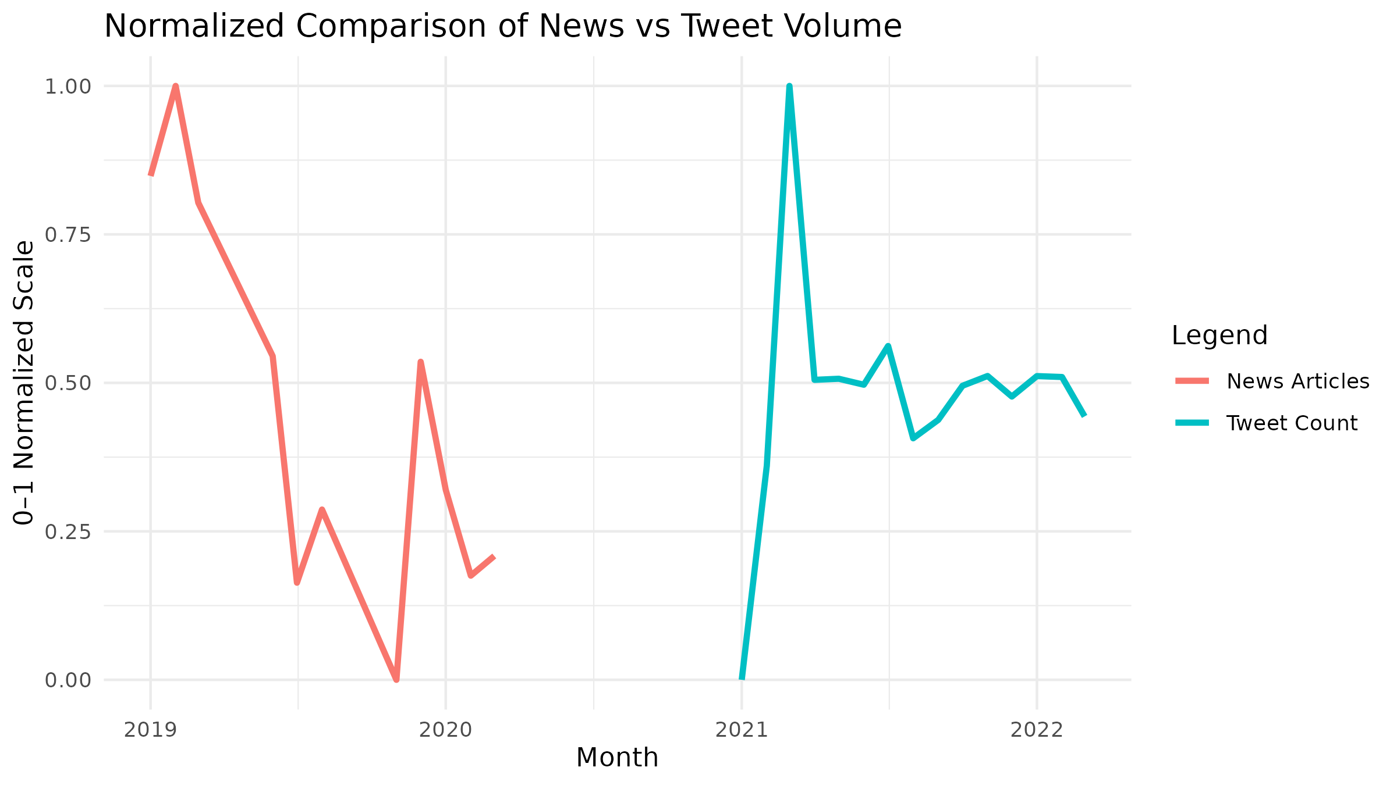
Allows shape comparison regardless of value scales:
- News shows smoother transitions
- Tweets show sharp peaks and dips
- Alignment of peaks reveals how public engagement often trails news reporting

6. Key Findings

Overall sentiment patterns show a clear contrast between news media and public tweets. News sentiment remains stable due to journalistic standards and controlled tone, resulting in predictable trends and narrow forecast ranges. In contrast, tweet sentiment is highly volatile, driven by public emotions, major events, and influencer activity, leading to sharp fluctuations and wide forecast intervals.

Volume trends highlight that while news article counts slightly declined after 2020, tweet activity surged sharply in 2021–2022, reflecting rising public engagement. At the industry level, sectors like Technology and Finance show consistent sentiment in news reporting but high reactivity in tweets, especially around earnings releases, scandals, and innovation events.

7. Conclusion
News provides more stable and predictable sentiment patterns than tweets. Public engagement on social media is more volatile and reactive, making it less reliable for forecast modeling. Structured news data therefore offers a clearer view of long-term sentiment trends across industries.

