

HTML, CSS, Javascript, Python, Java, C, PHP, Angular, Ionic, Laravel

* Certification of Course Completion in Introduction to Cybersecurity
* Certificate of Completion in Introduction to Mongodb
* Certificate of Completion in Introduction to NoSQL Database
* Statement of Accomplishment in Introduction to SQL
* Certificate of participation in Data Privacy Act Awareness
* Certificate of participation in Cybersecurity Awareness: How to avoid Phishing and Scamming

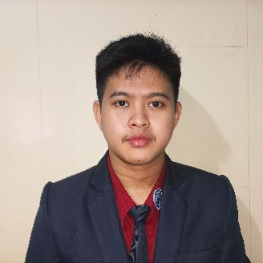

**CONTACT**

**EDUCATION**

johnravand@gmail.com

09468286919

Dolores Capas Tarlac

**PROFILE**



**SKILLS**

**CERTIFICATE**

A motivated, adaptable and responsible seeking a position in an IT position which will utilize the professional and technical skills developed through past work experience in this field.

**JOHN RAVAN A. DIZON**



**TERTIARY**

Bachelor of Science in Information Technology

Dominican College of Tarlac

**SECONDARY**

Science Technology Engineering and Mathematics

Capas High School

**PRIMARY**

San Juan Elementary School

San Juan Concepcion Tarlac