0000000000 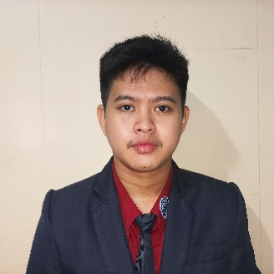

*You can visit my profile here: https://ravan-dizon.github.io/*

A motivated, adaptable, and responsible individual seeking a position in an IT position that will utilize the professional and technical skills developed through past studies in this field.

PROFILE



EDUCATION



**TERTIARY**

Bachelor of Science in Information Technology

Dominican College of Tarlac

**SECONDARY**

Science Technology Engineering and Mathematics

Capas High School

**PRIMARY**

San Juan Elementary School

San Juan Concepcion Tarlac

CERTIFICATE

* Certification of Course Completion in Introduction to Cybersecurity
* Certificate of Completion in Introduction to Mongodb
* Certificate of Completion in Introduction to NoSQL Database
* Statement of Accomplishment in Introduction to SQL
* Certificate of participation in Data Privacy Act Awareness
* Certificate of participation in Cybersecurity Awareness: How to avoid Phishing and Scamming



Date of Birt: March 20, 2001

Place of Birth: Concepcion Tarlac

Civil Status: Single

Religion: Roman Catholic

Sex: Male

Height: 5’6”

Weight: 110 lbs.

PERSONAL INFORMATION



SKILLS



**Languages**

C

Java

Python

VB

HTML

CSS

JS

PHP

Angular

**Applications**

MS Office

Photoshop

Gimp

Blender

Unity

**Database System**

MySQL



johnravand@gmail.com



0946-828-6919



Dolores Capas Tarlac

CONTACT



JOHN RAVAN A. DIZON