Name : Ravano Akbar Widodo

Major : Computer Science

Solution for Question 1 : Code Analysis and Correction Codes :

Analysis of the Given Code :

#include <stdio.h>

int main() {

int a, b;

float result;

printf("Enter two integers: ");

scanf("%d", &a, &b); // Kesalahan di sini

result = a / b; // Potensi kesalahan lain

printf("The division of %d and %d is %f\n", a, b, result);

return 0;

}

**Code Analysis Problems :**

The program is intended to take two integers as input, perform division, and print the result. However, there are logical and syntax errors, particularly related to input handling, arithmetic operations, and output formatting.

**Identified Errors :**

1. **Input Handling Error in scanf :**
   * The scanf function is used correctly to read integers, but it doesn't handle the case when b is zero, which would cause a division by zero error.
2. **Arithmetic Error in Division :**
   * The expression result = a / b; performs integer division, which truncates the decimal part. Since a and b are integers, this operation will result in an integer value, and the result is then stored as a float. For instance, 5 / 2 will result in 2, not 2.5.
3. **Output Format Error in printf :** 
   * The format specifier %f is used to print the float result, but result is a float, and %f is correct. However, the issue is more about precision, which needs attention.

**Correct Solution For This Problems :**

To fix these issues:

1. **Handle Division by Zero :** Add a check to ensure that the divisor b is not zero before performing the division.
2. **Correct Division Operation :** Cast either a or b to a float to ensure floating-point division rather than integer division.
3. **Improve Output Format :** Ensure the output is formatted properly, especially in terms of precision.

**Here's the corrected version of the code with explanations embedded :**

#include <stdio.h>

int main() {

int a, b;

float result;

printf("Enter two integers: ");

scanf("%d %d", &a, &b); // Correctly handles two integers input

// Check for division by zero

if (b == 0) {

printf("Error: Division by zero is not allowed.\n");

return 1; // Exit the program if b is zero

}

// Correct the division by casting to float to get accurate results

result = (float)a / b;

// Display the result with appropriate format specifier

printf("The division of %d and %d is %.2f\n", a, b, result); // Outputs the result with 2 decimal precision

return 0;

}

**Explanation Of Corrections Codes :**

1. **Division by Zero Check :** The if (b == 0) check ensures that division by zero is avoided, which would otherwise cause a runtime error.
2. **Floating-Point Division :** (float )a / b converts the integer a to a float, resulting in proper floating-point division.
3. **Output Formatting :** Using %.2f formats the output to show two decimal places, making it clearer and cleaner.

With these corrections, the program will now safely and accurately handle input and output, while avoiding common errors associated with integer arithmetic and division.

Answer Assignment For Question Number 2 :

Here Is The Picture Of Flowchart Calculating Gross Salary And Net Salary :

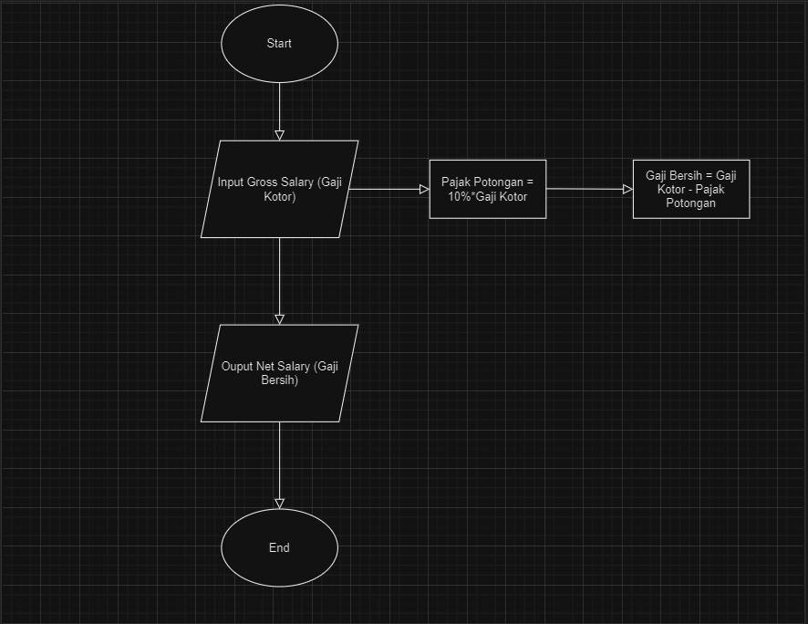

Thats All My Answer For This Assignment Thank You For Your Time And Attention Sir,

Ravano Akbar Widodo