|  |
| --- |
| Ravash inc. |
| Dylan’s Amazing Slot Machine! |
| **[Assignment 2** |
| Version #1.0  All work Copyright © 2012 by Ravash inc.  All rights reserved. |
| **Dylan Scott** |
|  |

**Insert a Company Logo here**

|  |
| --- |
| May 16th 2012 |

**Table of Contents**

1. **Version History**
2. **Detailed Game Description**
3. **Game Play Mechanics**
4. **Controls**
5. **Screen Description**
6. **Scoring**

# Version History

Version 0.1-

The GUI for the game without the slot machine code, very basic GUI started the foundation for the project.

Version 0.2-

This version has the GUI finished and some of the original Slotmachine.py code working with the GUI.

Version 0.3-

This version has the GUI finished and most of the original Slotmachine.py code working with the GUI.

Version 0.4 –

This version has the GUI Completely finished with a few touch ups from the 0.3 Version. All is done except for the reel and the images.

Version 1.0 –

This is the most recent version of my program. The GUI is complete as well with the rest of the code. I've updated the Reels so they actually work with images. I've changed the Jack Pot to actually give the player the Jack pot money if he wins it which it hasn't been doing since I've switched the program code over to the GUI.

# Detailed Game Description-

My slot machine is very simple to use. On start-up the player initially starts out at 1000$ and the machine has a jackpot value of 500$. Upon using the reset button the program will re-default the values and the player will start over. The objective of the game is to get as much money as possible and to not lose your money. By click the Spin button the program spins the reels and outputs the pictures and you either win or lose money depending on what reels you got. The player can increase and decrease the amount of money he/she wishes to use to bet against the machine.

# Game Play Mechanics –

The gameplay for a slot machine is very simple, click a button and pray for the best. The higher value of picture that appears on the reel, the more money you get. The more times an image appears on the reel, the more money you get. The player has an opportunity to win the jackpot which increases as the player bets more money.

# Controls –

My game has 7 buttons on it for controls. The spin button makes the application spin the reels and is the main button in the game. There is a reset button that resets all the money, jackpot and bets back to their default values. The quit button ends the game. The other 4 buttons are beside the bet label and allow the user to raise and lower their bet by increments of +10, +100, -10 and – 100.

# Screen Descriptions –

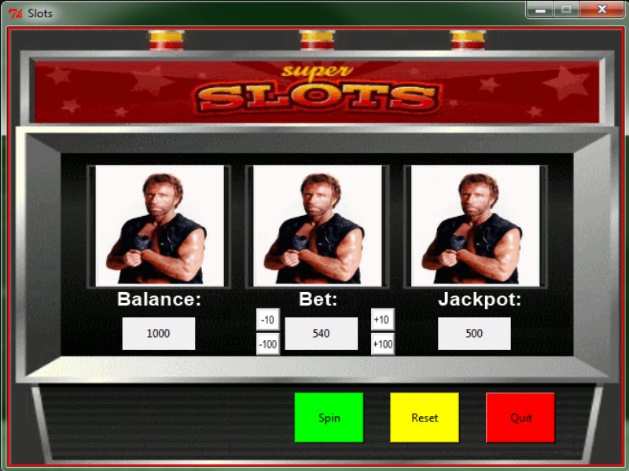

# Scoring –

Scoring is based on what the player bets when the Spin button is clicked. Depending on what images appear on the reel, the winnings are increased or decreased or the player may not win any money at all.