<PS_Template_Document_2019>

September 2019

<AuthorName>, Consulting Engineer, <Region>

Table of Contents

<PS_Template_Document_2019> 1

<Customer> 1

1 Solution Design 3

2 Solution Components 3

2.1 Veeam Backup Enterprise Manager 3

2.2 Veeam ONE 4

2.3 Veeam Backup Server 4

2.4 MSSQL Server 4

2.5 Proxy Servers 4

2.6 Backup Repositories 5

2.7 Tape Servers 5

2.8 WAN Accelerators 6

3 Jobs 6

3.1 Protection Policies 6

3.2 Backup Jobs 6

3.3 Replication Jobs 6

3.4 Backup Copy Jobs 7

3.5 SureBackup Jobs 7

3.6 Tape Jobs 7

# Solution Design

<insert description of the solution design>

<insert diagram>

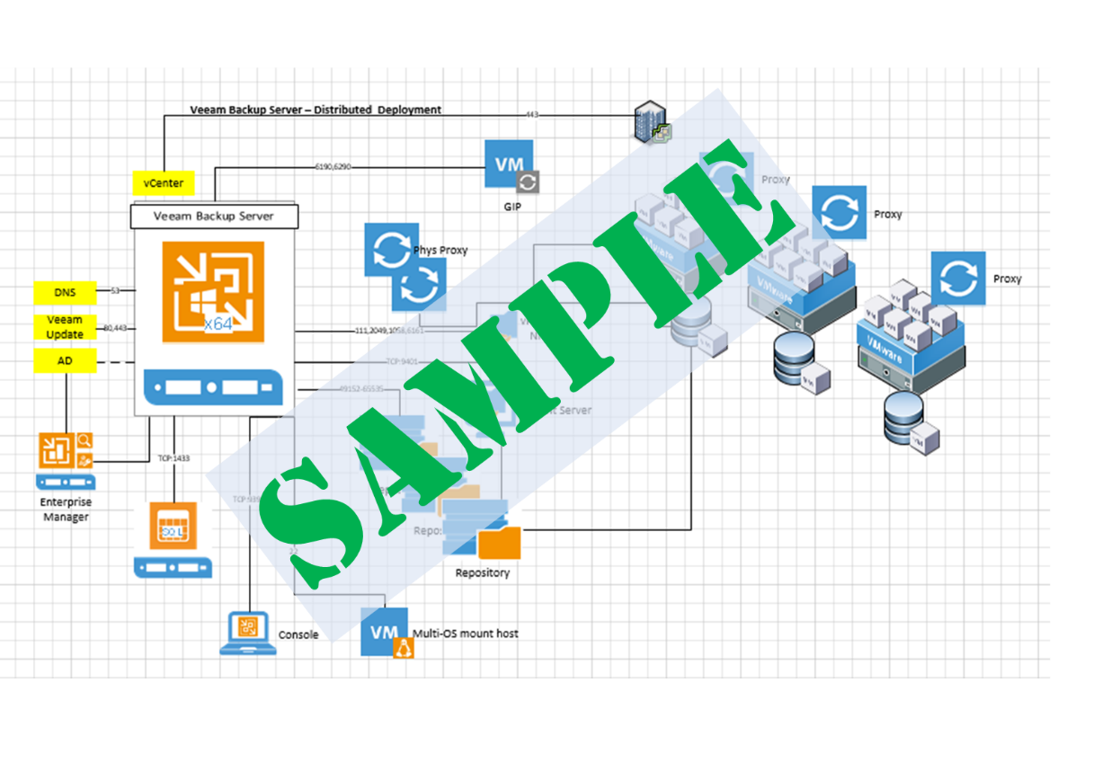

Figure 1 High Level Overview of <Customer> Environment

# Solution Components

Table 1 Backup Infrastructure Table

<insert backup infra table>

## Veeam Backup Enterprise Manager

<insert VBEM description>

Table 2 Enterprise Manager Servers

<insert VBEM table>

## Veeam ONE

<insert VONE description>

Table 3 Veeam ONE

<insert VONE table>

## Veeam Backup Server

<insert VBR description>

## MSSQL Server

<insert MSSQL description>

Table 4 Database Servers

<insert MSSQL table>

## Proxy Servers

<insert proxy description>

Table 5 VMware Proxy Servers

<insert vmw proxy servers table>

Table 6 Hyper-V Proxy Servers

<insert hv proxy servers table>

## Backup Repositories

<insert repo description>

Table 7 Backup Repositories

<insert repo table>

Table 8 Scale Out Backup Repositories

<insert sobr table>

Table 9 Scale Out Backup Repositories – Extents

<insert sobr extents table>

Table 10 Scale Out Backup Repositories – Capacity Tier

<insert capacity extents table>

Table 11 Gateway Servers

<insert gw table>

## Tape Servers

<insert tape server description>

Table 12 Tape Servers

<insert tape server table>

## WAN Accelerators

<insert wan acc description>

Table 13 WAN Accelerators

<insert wan acc table>

# Jobs

## Protection Policies

<insert backup window interval>

Table 14 Backup Window

<insert backup window table>

Table 15 Job Overview

<insert job overview table>

## Backup Jobs

Table 16 Backup Jobs

<insert backup jobs table>

<insert backup jobs>

## Replication Jobs

Table 17 Replication Jobs

<insert replication jobs table>

<insert replication jobs>

## Backup Copy Jobs

Table 18 Backup Copy Jobs

<insert backup copy jobs table>

<insert backup copy jobs>

## SureBackup Jobs

Table 19 Sure Backup Jobs

<insert surebackup jobs table>

<insert surebackup jobs>

## Tape Jobs

Table 20 Tape Jobs

<insert tape backup jobs table>

<insert tape jobs>