<ProjectID>_PED_LLD_<ComponentName>

Document Path | \\5gtechads\5GPAL\PROCESS_TEMPLATES\PROJECT ENGINEERING
Document Version | 2.0
Document Date | 12/6/2008
Document Status | Final
Circulation Type | Internal
Circulation List | ALL @ 5G

Abstract: The paragraphs written in blue and red color are for the benefit of the person writing the document and should be removed before the document is finalized. The paragraphs written with red color are taken from PMG-PRD-LLD-Business.

Revision History

Ver No. & Date | Added/  Revised By | Content Added/  Changed | Reviewed/  Approved  By | Approved  Date | Broadcast  Date | Effective Date
1.0 |  | Initial Document
2.0/ Jun 12, 2008 | 5GPG | Comments updated | Asokan | 25/6/2008 | 25/6/2008 | 25/6/2008

The Revision History given above is the history of the template, hence needs to be replaced with the history of the live document.

Table of Contents

1. Summary 4
2. Modules Overview 4
2.1 <Module 1> 5
2.1.1 <Module 1 – Functionality1> 6
2.1.2 Presentation Layer 6
2.1.3 Business Layer 12
2.1.4 Data Layer 12
3. Other Design considerations 13
3.1 Conversion Modules 13
3.2 Archive and Purge Modules 14
3.3 Backup and Recovery Design 14
3.4 Security Architecture 14
3.5 System Interfaces 14
3.6 Performance and Response Time Considerations 14
3.7 Platform Dependence and Installation Considerations 14
3.8 Localization Considerations 15
3.9 Other Modules 15
4. Detailed Design to Functional Requirement Cross Reference Matrix 15

Summary
This document describes the detailed architectural design for the system. It specifies all known components needed to deliver a complete system.

Example: [Summary taken from PMG-PRD-LLD-Business]
Maintenance Gateway Business Configuration Manager is a desktop application, the part of Enterprise Manufacturing Intelligence (EMI) software called Enterprise Gateway (EG) for building the Real Time Enterprise. As such, the software can manipulate all downloaded real time plant structures data with non-real time data. So it delivers the manipulated items to the enterprise by collaborating with multiple enterprise applications, and vice versa.

Modules Overview
List the modules of that this document intends to cover and describe them in one sentence. Detailed module descriptions can occur later.

Example: [First few lines of Modular Design taken from PMG-PRD-LLD-Business]
Maintenance Gateway Business application has the following modules:
2.1 Business Context (BC)
2.2 Reference Mapping
2.3 Process Aggregation Counter (PAC)
2.4 Discrete Aggregation Counter (DAC)
2.5 Rules
2.6 Actions
2.7 Constants

<Module 1>
Describe the functional aspect of the module and define each function with its features, screens and reports in the subsequent sections. Develop a UML class diagram that represents the static class structure. Also create UML state and interaction diagrams to show dynamic interaction between classes.

Example: [Few lines of Module description & functionalities taken from PMG-PRD-LLD-Business]

2.1 Business Context (BC) Description
- A business context is a user defined “cluster” of data items intended to fulfill a “business (process) need”.

The data items can be grouped from multiple sources and/or from multiple categories of the same source. A business context can be used for storing “related” real time and/or non real time information and third party systems can query the business context in real time to get the “current” values of such data items that are stored in the Business Contexts. Hierarchical relationships can be built from business context to aggregate real time items as they are being generated from real time events.

Since a Business Context has the capability to link multi-dimensional data which are both time variant and invariant from disparate sources, it serves as a powerful utility for abstracting, capturing, segregating, aggregating, monitoring, displaying and analyzing data that are important and relevant to a specific business need.
More importantly, class relations could associate the data items in a business context and the values of the business context items could also be manipulated, either symbolically (linguistic) or arithmetically, to transform the values to a different reference system.

Functionalities
2.1.1 List out all Business Contexts
2.1.2 BC Creation/Modification
2.1.3 Plant Process exposure
2.1.4 Setting Real-time attributes
Each function is defined with its features, screens, and reports in the following sections

<Module 1 – Functionality1>
Description of the functionality.

Example: [Few lines of Functionality description taken from PMG-PRD-LLD-Business]
2.1.1 List out all Business Contexts
The Business Context Summary screen lists out all Business Contexts except System Business Contexts (Reference BC) using the list view control with multiple headers such as Business Context Name, Description, and Number of Records in each Business Contexts. The list view items are also associated with one more invisible header (tag) called Business Context ID that should be used to modify the existing items.

Constraints
For every functionality there will be some criteria and its mandatory to list as explained in the example.

Example: [Few lines of Functionality description taken from PMG-PRD-LLD-Business]
- Business Context operation like Modify, delete, Selected BC Export, Activate/Deactivate, Dependency cannot be performed without selecting BC
- System Business Contexts (Reference BC) cannot be viewed in Summary screen
- BC cannot be deleted when any of that BC column is used (as expression/direct bind) in some other BC’s

Presentation Layer

This section describes all the screens and reports needed to deliver all the functional requirements. Include screen descriptions, screen shots, report descriptions and report shots. The client should understand that the final product may not be exactly as listed here but the functionality will stay the same. During coding, we may merge or separate screens to achieve a nicer user interface and to promote reusability of components.

Example: [Few lines of Functionality description taken from PMG-PRD-LLD-Business]
2.1. PL Business Context
This section describes all the screens and reports available under Business Context module.

Screen Design
List all the available screens of this module and provide the following details for each screen in the subsequent sections.

Example: [Few lines of Functionality description taken from PMG-PRD-LLD-Business]
The screens available in the Business Context are as follows:
- Business context summary screen
- Business context detail screen
- Dependency Tool to expose BC attributes re-use.
- Linguistic Manipulation

Description | < Describe the purpose of the screen as to ensure the client and developer agrees on its functionality.>
Security Group | < List the security groups that may use the screen >
Data | < Describe each field on the screen and how it is derived >
Actions | < Describe each action that can be performed from this screen. This usually involves command buttons, menu items, etc.>

Example: [Few lines of Functionality description taken from PMG-PRD-LLD-Business]

Description | The Business Context Summary screen lists out all Business Contexts except System Business Contexts (Reference BC) using the list view control with multiple headers such as Business Context Name, Description, and Number of Records in each Business Contexts.
Security Group | N/A
Data | Business Context Name, Description, and Number of Records, Business Context ID
Actions | - List out all Business Contexts  - Provision to Create new business context

Reports
List all the reports of this module and provide the following details for each screen in the subsequent sections.

Example: [Few lines of Functionality description taken from PMG-PRD-LLD-Business]

- BC Summary – Excel Format
- BC Summary – XML Format

Description | < Describe the purpose of the report as to ensure the client and developer agrees on its functionality.>
Security Group | < List the security groups that may use the report >
Data | < Describe each field on the report and how it is derived >
Groupings | < Describe how the report should be grouped and/or sorted >
Total | < Describe the sub and grand totals needed on the report >
Filters | < Describe any filter or selection criteria needed for the report. How is this selection criteria entered?>
Export Formats | < Describe the export format of the report (print preview, printer, MS Word, MS Excel, HTML, etc.)>
Frequency | < If this report should be run periodically, specify the frequency (Daily, Weekly, Monthly, Quarterly, Yearly, On Demand)>
Functional Component # | <component number>

Example: [Few lines of Functionality description taken from PMG-PRD-LLD-Business]

Description | All non-real-time BC Columns with values will be exported the single excel sheet. If all the Business Contexts are selected to export, each BC will be exported to the single sheet within the same Excel file
Security Group | N/A
Data | Non-real-time BC Columns (Attributes) and their corresponding manipulated values
Groupings | N/A
Total | N/A
Filters | N/A
Export Formats | MS Excel
Frequency | On Demand
Functional Component # | 1.1.9

Files and Classes
All the files and classes should be listed in the following format.

Files | Namespace.Class | Assemblly
<filename> | <Class Name> | <Assembly Name>

Example: [Few lines of PL Module1 description taken from PMG-PRD-LLD-Business]

Files | Namespace.Class | Assemblly
frmBCSummary.cs | EGBusiness.frmBCSummary | EGBusiness
frmBCDetail.cs | EGBusiness.frmBCDetail | EGBusiness

Class Diagram
Example: [Class diagram taken from EG-PRD-LLD-Action-Agent]
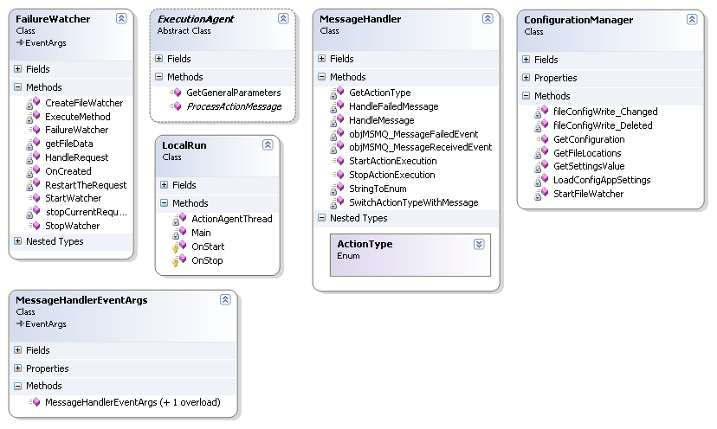

Activity Diagram

Example: [Activity diagram taken from EG-PRD-LLD-Action-Agent]

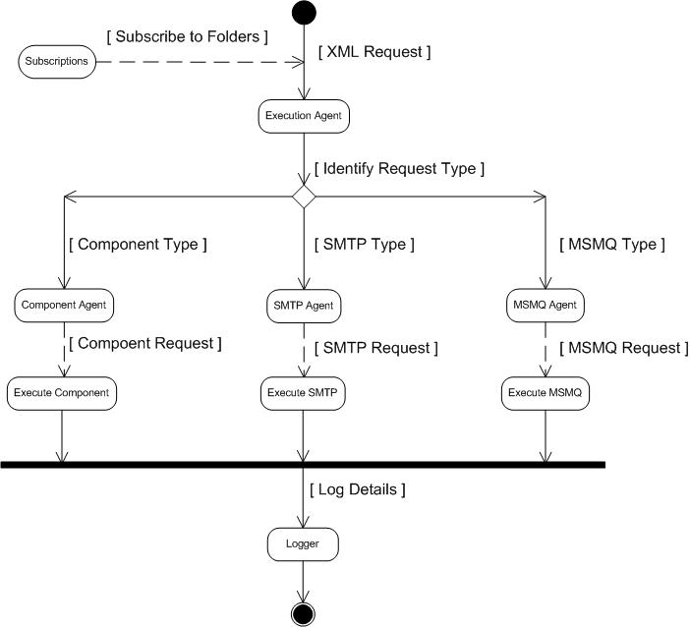

Business Layer
Define all of the objects necessary to support the presentation layer. First show the object hierarchies then include the Microsoft Visual Modeler file.

All the files and classes are listed in the following format.

Files | Namespace.Class | Assemblly
<filename> | <Class Name> | <Assembly Name>

Example: [First few lines of BL Module 1 taken from PMG-PRD-LLD-Business]
Files | Namespace.Class | Assemblly
BusinessContext.cs | EGServerBL.BusinessContext | EGServerBL
Common.cs | EGServerBL.Common | EGServerBL

Primary Methods
public DataTable GetDataTypes()
public string GetDataTypeName(string dataTypeID)
public string GetDataTypeID(string SQLDataType)
public string GetDisplayDataTypeName(string dataTypeID)

Data Layer

Define all of the tables/columns/views/stored procedures necessary to support the business layer along with an Entity-To-Relationship diagram. Include the ERD file.

Tables/Views/Stored Procedure/DTS
Describe all the tables, views, functions, stored procedures and DTS used in this module.
Example: [DL Module 1 taken from PMG-PRD-LLD-Business]
TABLES
Column Name | Data Type | Allow Nulls | Description
<Column name> | <Data Type> |  | <description>

Example: [Table taken from PMG-PRD-LLD-Business]

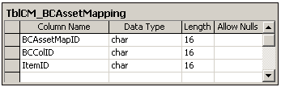

Files and Classes
Files | Namespace.Class | Assemblly
<filename> | <Class Name> | <Assembly Name>

Example: [First few lines of DL Module 1 taken from PMG-PRD-LLD-Business]
Files | Namespace.Class | Assemblly
BusinessContext.cs | EGServerDL.BusinessContext | EGServerDL
Common.cs | EGServerDL.Common | EGServerDL

Primary Methods
Example: [First few lines of DL Module 1 taken from PMG-PRD-LLD-Business]
public DataTable GetDataTypes()
public string GetDataTypeName(string dataTypeID)

Other Design considerations

Conversion Modules
Describe any programs that are used to import, convert data.

Archive and Purge Modules
Describe any programs that are used to perform special functions like purging and archiving.

Backup and Recovery Design
Describe the process for backing up and recovering lost data.

Security Architecture
Describe how security will be enforced and at what level (or groups). If using NT, address the NT security model, IIS security, Secure Socket Layers, etc. if applicable.

System Interfaces
Describe how we will feed or receive feeds from other systems. This may be via replication, BCP, SQL Loader, etc. Describe the data that will flow between the systems, how often it will be updated, and who the system owners for each system are.

Performance and Response Time Considerations
Explain how we will design for maximum response time. This includes the use of Stored Procedures, de-normalized data (if applicable), server configuration (size, memory, etc), programming techniques, and the use of database tools such as Oracle’s Explain Plan and SQL Server’s Show Plan.

Platform Dependence and Installation Considerations
Explain the installation (or setup) process in which the client must use to get the system up and running along with our plan for ensuring it will run on all the platforms requested by the client (Windows 95, 98, NT 4, 5, etc).
Example: [Performance and Response Installation Consideration taken from PMG-PRD-LLD-Business]
Operating Systems:

Business Context is one of the modules of Maintenance Gateway Business component. It can be installed in the following operating systems:
Windows family of OS with .Net framework 1.1 installed
Dependencies:
It can be executed in association with MG Server installation.

Localization Considerations
Explain our design for handling issues specific to localization (European date and postal code format, etc.), if any.

Other Modules
Describe any other miscellaneous programs.

Detailed Design to Functional Requirement Cross Reference Matrix
To ensure all functional requirements have been captured in the detailed design, cross-reference each functional requirement with its associated Detailed Design element.

Functional Requirement | Detailed Design

Example: [Detailed Design to Functional Requirement Cross Reference Matrix taken from PMG-PRD-LLD-Business]

Functional Requirement | Detailed Design
Create New Business Context | Refers to 1.1.2
Modify existing Business Context | Refers to 1.1.2

