Queries executed via Mongo Compass:

1. Find the total number of flights for each airline, showing the airline code, name, and the count of flights.

-db.flights.aggregate([

{ $group: { _id: { Airline_Code: "$Airline_Code", Airline_Name: "$Airline_Name" }, totalFlights: { $sum: 1 } } },

{ $project: { _id: 0, Airline_Code: "$_id.Airline_Code", Airline_Name: "$_id.Airline_Name", Total_Flights: "$totalFlights" } }

]);

1. Calculate the average departure delay for each airline, showing the airline code, name, and the average delay.

db.flights.aggregate([

{ $group: { _id: { Airline_Code: "$Airline_Code", Airline_Name: "$Airline_Name" }, avgDelay: { $avg: "$DEP_DELAY_NEW" } } },

{ $project: { _id: 0, Airline_Code: "$_id.Airline_Code", Airline_Name: "$_id.Airline_Name", Average_Departure_Delay: "$avgDelay" } }

]);

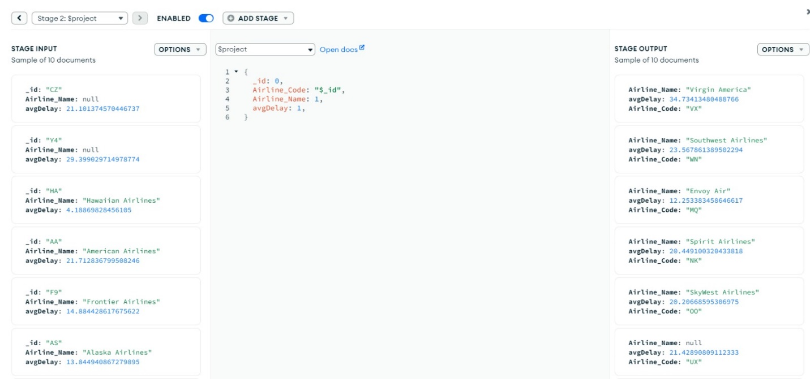

1. Show the count of canceled flights and the cancellation reasons.

db.flights.aggregate([

{ $match: { CANCELLED: 1 } },

{ $group: { _id: "$CANCELLATION_CODE", count: { $sum: 1 } } },

{ $project: { _id: 0, Cancellation_Code: "$_id", Count: "$count" } }

]);

1. List the top 5 busiest airports based on the total number of departures and arrivals.

db.flights.aggregate([

{ $group: { _id: "$ORIGIN_AIRPORT_ID", totalFlights: { $sum: 1 } } },

{ $sort: { totalFlights: -1 } },

{ $limit: 5 },

{ $lookup: { from: "airports", localField: "_id", foreignField: "AIRPORT_ID", as: "AirportInfo" } },

{ $project: { _id: 0, Airport_ID: "$_id", Airport_Name: "$AirportInfo.ORIGIN", Total_Flights: "$totalFlights" } }

]);

1. Show the distribution of departure delays with categories (e.g., early, on time, minor delay, moderate delay, severe delay).

db.flights.aggregate([

{

$project: {

_id: 0,

Flight_ID: 1,

Dep_Delay_Category: {

$cond: [

{ $eq: ["$DEP_DELAY_NEW", 0] }, "On Time",

{ $lt: ["$DEP_DELAY_NEW", 15] }, "Minor Delay",

{ $lt: ["$DEP_DELAY_NEW", 60] }, "Moderate Delay",

"Severe Delay"

]

}

}

},

{ $group: { _id: "$Dep_Delay_Category", count: { $sum: 1 } } }

]);

1. Calculate the average departure delay for each day of the week.

db.flights.aggregate([

{ $group: { _id: "$DAY_OF_WEEK", avgDelay: { $avg: "$DEP_DELAY_NEW" } } },

{ $project: { _id: 0, Day_Of_Week: "$_id", Average_Departure_Delay: "$avgDelay" } }

]);

1. Find the airline with the maximum weather delay, showing the airline code and name.

db.flights.aggregate([

{ $match: { WEATHER_DELAY: { $gt: 0 } } },

{ $sort: { WEATHER_DELAY: -1 } },

{ $limit: 1 },

{ $project: { _id: 0, Airline_Code: "$Airline_Code", Airline_Name: "$Airline_Name", Max_Weather_Delay: "$WEATHER_DELAY" } }

]);

1. Show the total number of flights for each month.

db.flights.aggregate([

{ $group: { _id: { $month: "$FL_DATE" }, totalFlights: { $sum: 1 } } },

{ $project: { _id: 0, Month: "$_id", Total_Flights: "$totalFlights" } }

]);

1. Determine the busiest day of the week based on the total number of flights.

db.flights.aggregate([

{ $group: { _id: "$DAY_OF_WEEK", totalFlights: { $sum: 1 } } },

{ $sort: { totalFlights: -1 } },

{ $limit: 1 },

{ $project: { _id: 0, Busiest_Day: "$_id", Total_Flights: "$totalFlights" } }

]);

Show the count of on-time, delayed, and canceled flights for each route (origin-destination pair).

db.flights.aggregate([

{

$project: {

_id: 0,

Route: { $concat: ["$ORIGIN", "-", "$DEST"] },

Flight_Status: {

$switch: {

branches: [

{ case: { $eq: ["$CANCELLED", 1] }, then: "Canceled" },

{ case: { $gte: ["$DEP_DELAY_NEW", 15] }, then: "Delayed" },

{ case: { $and: [ { $eq: ["$CANCELLED", 0] }, { $eq: ["$DEP_DELAY_NEW", 0] } ] }, then: "On Time" }

],

default: "Unknown"

}

}

}

},

{ $group: { _id: { Route: "$Route", Flight_Status: "$Flight_Status" }, count: { $sum: 1 } } }

]);

Queries executed via Mongo Shell:

Calculate the average departure delay for each airport (origin and destination combined).

Determine the busiest day of the week based on the total number of flights.



Identify the peak departure times during the day.

